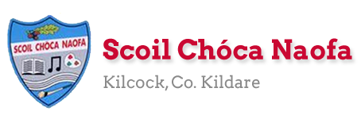
Work for First Class (D. Shanley) - Monday 22th.June 2020
Well done to you all on all your hard work. This week (and Monday and Tuesday of next week) I’ve written down less work for everyone as it is the last week and a half of schoolwork. Keep sending me on emails of your work. There is a fun activity for everyday as well. The last zoom meeting is on this Thursday at 1pm and I’m looking forward to seeing you all. You can show a piece of Art or a favourite book and talk about it or you can tell the class some news. Have a great week.
Monday
English: Starlight -Read p.50 (How to Make Cupcakes)
Just Phonics p.69
Maths: Master Your Maths -next Test

Tuesday
English: Starlight – Read p.54 (The Great Outdoors)
Just Phonics p.70
Maths: Master Your Maths – next Test
Build your own blanket fort.

Wednesday
English: Starlight- Read p. 58 (Noises in the Night)
Just Phonics p.71
Maths: Master Your Maths – next Test

Five minute ice cream

Thursday
English: Starlight – Read p.62 (Our Summer Bucket List)
Go With the Flow p.48

Maths: Master Your Maths – next Test

Nature Craft

Friday
English: Starlight – Read p.66 (The Circus Comes to Town)
Go With the Flow p. 49
Maths: next test at back of Master Your Maths
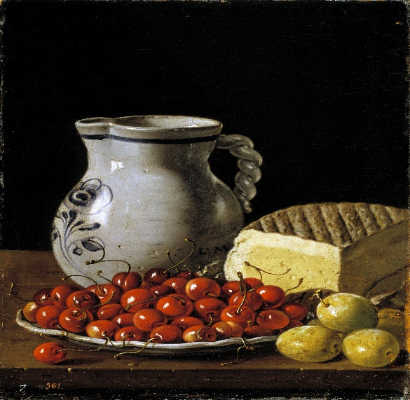
This Photo by Unknown Author is licensed under CC BY-NC
Art : This is a Still Life by Diego Velazquez. Can you set up your own Still Life at home using a jug, a plate, some fruit and cheese? Then draw/ paint it.

Monday
English: Just Phonics p. 72
Go With the Flow p.50

.
Art: Look at this work by Bridget Riley. What happens when you look at this picture? Can you create your own picture like this?
Tuesday
English: Just Phonics p. 73
Go With the Flow p. 51
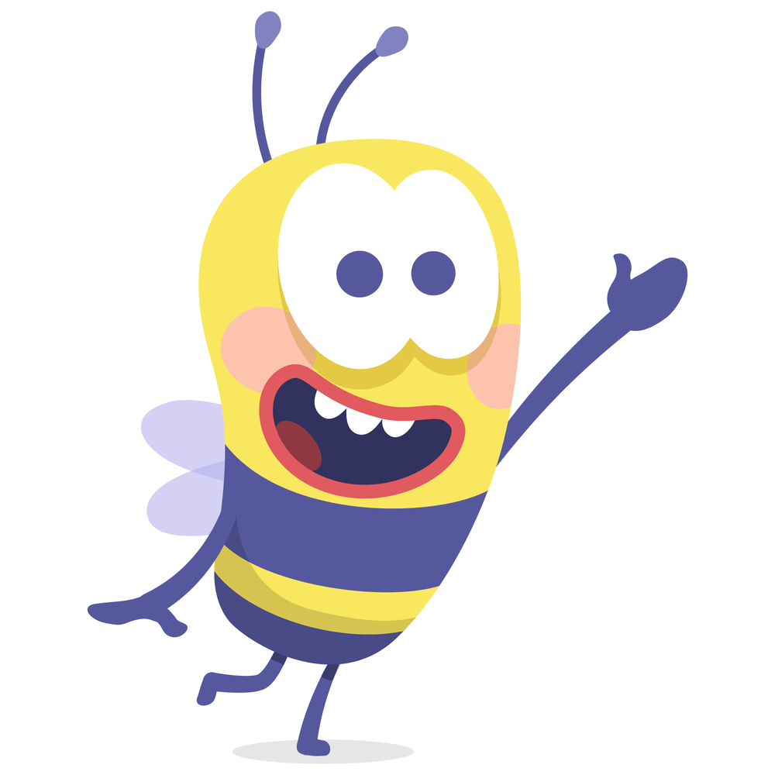
W e l l D o n e. H a v e a G r e a t S u m m e r e v e r y o n e !

Contact : msshanley@scoilchoca.ie, mssheil@scoilchoca.ie, msheffernan@scoilchoca.ie
SEN/EAL work
Teacher: Ms.Sheil
Note: Hello everybody,
This is the last week of lessons for this year.I know that you are looking forward to the holidays.I am not sending you the usual work but instead I would like you to try to make these pancakes.Enjoy them and I look forward to seeing you all at the end of August.
This is your work for this week:
Baking pancakes with bananas, topped with yogurt, fruit and nuts if you like .
This involves reading the ingredients and recipe first, your mum or Dad might help you. After you read the recipe, find out what you need, check your press or fridge first.
Then look at the video on this link, maybe look at it another time, then have a go yourself. Enjoy the healthy pancakes with your family.

Ingredients
3 bananas,
1 egg,
Wholemeal self-raising flour/white self-raising flour
Ground cinnamon
Fruit and nut mix
Yogurt (Greek style/whatever you prefer)

Instructions
Fill a large mug with the flour, pour into the bowl.
Fill a mug of milk, pour into the bowl with the flour.
Crack in 1 egg into the mixture, mix well together with a whisk.
Mix up the batter.
Add in a level teaspoon of cinnamon.
Leave the batter in the bowl.
Next take the bananas, peel them and cut down longways down the centre of the banana.
Put a tiny bit of olive oil on the pan, place the banana on the pan for ½ a minute, until it gets a little brown.
Now take the batter mixture and put 3 dessert spoons over the banana.
Leave it cook for 3 minutes, then flip it over, cook for another 2 minutes on the other side.
Serve on a plate, place some yogurt on top , sprinkle some fruit and nut mixture over the pancake.
Yum !! Now enjoy with your family.

Fluffy banana pancakes | Tesco with Jamie Oliver
https://www.youtube.com/watch?v=3ndMcnkvg4g

