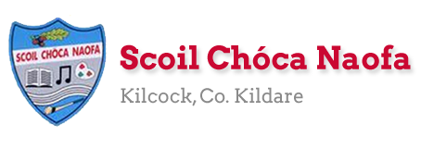
Dear 4th Class,
You’ve done it! We have come to the end of one of the most challenging school years you will ever have. I’m very proud of you. I know your families are too. It wasn’t easy, it was very difficult at times and the last few weeks have been even more difficult, but you got through it. You’ll remember this experience for a long time. As you get older you can use this experience to help you. If you go through a challenging time you now know that you can overcome a serious change of plan and overcome it.
I hope you enjoyed the virtual school tours last week. You have one more virtual tour in the plan over the next few days. We also have one last Zoom call before the summer on Thursday, June 25th at 10am.
Thank you to your families for coming into school last week to collect and drop off books. By now you will have received your booklists and school reports. If you didn’t, please email me and I will send them to you.
This is the last plan you will receive from me this year. It consists of material for seven days rather than five as we were due to be in school on Monday, June 29th and Tuesday, June 30th. Instead of sending a separate plan for those days I have included them here. A lot of the work this week is really useful information that you should know. Maybe you already do, great! If not, learn your Eircode, emergency service numbers and parent’s/guardian’s phone numbers.
This week is our Scoil Chóca Naofa Bake Off! Use recipe books at home or look for recipes online. You could bake something that you just love to bake at home, you could perfect a previous recipe you tried or even something that your family like to bake. Do you have a recipe that has been handed down through the family? Send pictures to mssmith@scoilchoca.ie. If you and your family would like, you can donate €1 to Temple Street Children’s Hospital via this link: www.templestreet.ie/event/great-irish-bake/.
Girls, you really are a great class and I really enjoyed teaching you this year. Unfortunately, the year didn’t end how we would have liked but we will see each other in September. Until then, stay safe. Be kind to yourselves and to others. Enjoy your summer holidays!
Ms. Smith
Wishing Moya Murphy a very Happy Birthday.
Work for Ms. Smith’s 4th Class:
Monday 22/06/20 – Tuesday 30/06/20
Monday  22/06 | English:  - Research a recipe for the Scoil Chóca Bake Off.’  - Discuss the recipe with an adult and make a plan for what you want to bake.  Maths:  - List the ingredients needed and make a shopping list for ingredients. Go shopping. Ask permission to do this, gather the ingredients you need in the shop, estimate the cost, pay, calculate and check your change.  Gaeilge:  - Léigh sa bhaile – read the text. Writing out the answers is optional.  PE:  - Sit up a challenge - How many can you do in 1 minute?  - Press up challenge - How many can you do in 1 minute?  - Run 500m/1km/2km - Choose a distance.
Tuesday  23/06 | Maths:  - Measure out the ingredients. With an adult, heat oven to required temperature.  - Be aware of cooking and cooling time.  English:  - Write out your recipe - list the ingredients and write your method/instructions.  Other: Scoil Chóca Great Irish Bake  - Get baking. Good luck  PE:  - Wheelie Bin Challenge - Try to kick or throw a ball into the bin from 5 metres/10 metres/15 metres- Have 10 attempts from each distance.  Gaeilge:  - Léigh sa Bhaile – read the text. Writing out the answers is optional.
Wednesday  24/06 | English:  - Time Capsule Activity  Maths:  - Learn your parent/guardian’s phone number off by heart in the case of an emergency.  Gaeilge:  - Léigh sa Bhaile – read the text. Writing out the answers is optional.  PE:  - Go 5kms on wheels - bike, scooter, roller blades
Thursday  25/06 | English:  - Read your book/magazine/newspaper for 15 minutes.  Gaeilge:  - Léigh sa Bhaile – read the text. Writing out the answers is optional.  Maths:  - Learn the phone number to contact emergency services: 112  - Mathletics  Other: Class Assembly Zoom Call @ 10 am
Friday  26/06 | Maths:  - Learn your Eircode off by heart - this is vital in the case of an emergency at home.  - Mathletics  Art:  - My Summer Vision activity - Draw your vision for your summer holidays in the sunglasses.  PE:  - Go outside and be active for 30 minutes.  Other: Virtual School Tour  - African Safari - your live safari experience from Massai Mara, Kenya and Great Kruger Park, South Africa.  https://wildearth.tv/kids/
Monday  29/06 | English:  - Summer Wordsearch  Gaeilge:  - Bris an cód/Crack the code  Other: PAWS - Primary Aquatics Water Safety  - https://watersafety.ie/wp-content/uploads/2019/10/PAWS-3-Presentation.pdf  - Read through this document when you have the time. It can be done whenever suits you. It is good information to know before the summer holidays about Water Safety.
Tuesday  30/06 | English:  - End of year memories writing activity  Art:  - Summer Mindfulness colouring activity  Other: PAWS (Primary Aquatics Water Safety)  - http://paws.edco.ie/third-and-fourth-classes/ - once you have read the information on Water Safety you can try some activities here to test your knowledge before the summer holidays.

Teacher : Ms Wilson 22/6/2020
Literacy Group
This work is based on the pack of work that you received in the post.
This week I would like you to:
- Try Brain Break Breathing – Try Butterfly Breaths and Rainbow Breaths
- 15 Minute Memory Activities – Try number 2 – The Tray Game
- Complete the next session of SNIP.
- Complete the Cloze Reading Exercise – The Stone Age
- Newell Literacy

- P.60 Reading real and nonsense words
- P. 59 Reading and Dictation. Ask an adult to call one or two sentences each day. See if you can write them. Use the sheets to check your spelling.
- P.62 and p.63 Fill the gaps

Continue reading and let me know what you are reading.

EAL Group – Ms Wilson.
Theme : Food –Baking

- Think of a recipe of your choice. It can be a recipe for a cake, tart, bun or biscuit.
- Write down the list of ingredients you need for the recipe.
- Name the equipment you need.
- Now write down the method you use. Try to write clear instructions using your own words.
- Illustrate the steps if possible.

Contact SEN Teacher: mswilson@scoilchoca.ie

Teacher: Ms. Heffernan 22nd June 2020 4th Class
Speech and Language | How about a game of Yes/No?  You choose a person, place or thing and the other person can ask you 20 questions to figure out what you’re thinking of. You can only answer yes or no. Take turns.  Or a game of Last letter?  Choose a topic that interests you such as animals, food, TV shows or whatever you like. Take turns with another person to say words belonging to that group but each new word must start with the last letter of the one before.  For example: Animals: cow, wolf, frog, giraffe, elephant, tiger.......  Write/record 5 sentences telling me what activities you enjoyed most while learning from home.  Did you enjoy the anagram riddles? Here’s another lot below. See how you get on!  Keep reading!  If anybody needs any more reading material, please let me know. If you’ve read or listened to a story, I’d love to hear what you thought about it.  Send me an email to let me know how you’re getting on-I’d love to hear from you!
Maths | You can keep playing games to help you with your mental maths.  https://www.topmarks.co.uk/maths-games/hit-the-button  https://www.topmarks.co.uk/maths-games/daily10  You will be incorporating a lot of maths skills if you decide to bake this week-calculating, weighing, checking the time, so enjoy!!  I’ve added an easy peasy recipe.  If you need any help, just send me an email.

Contact SEN Teacher: msheffernan@scoilchoca.ie

Gaeilge: Monday
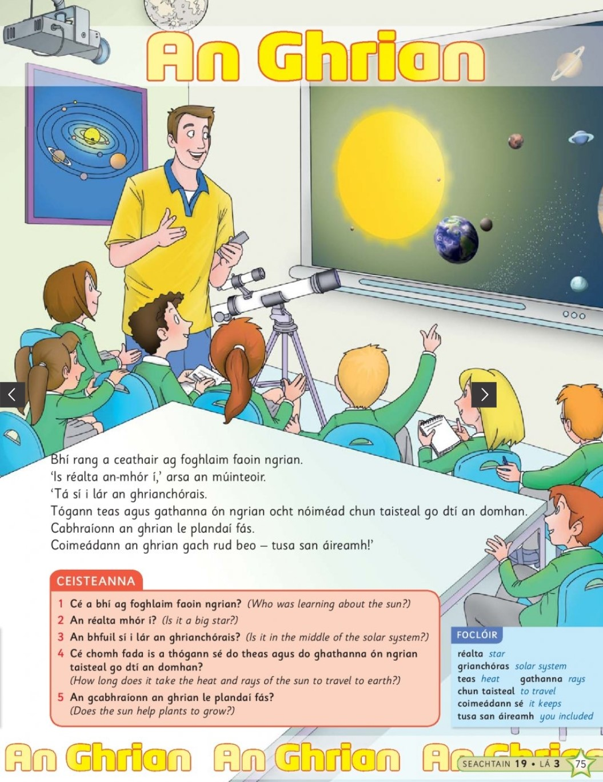

Gaeilge: Tuesday
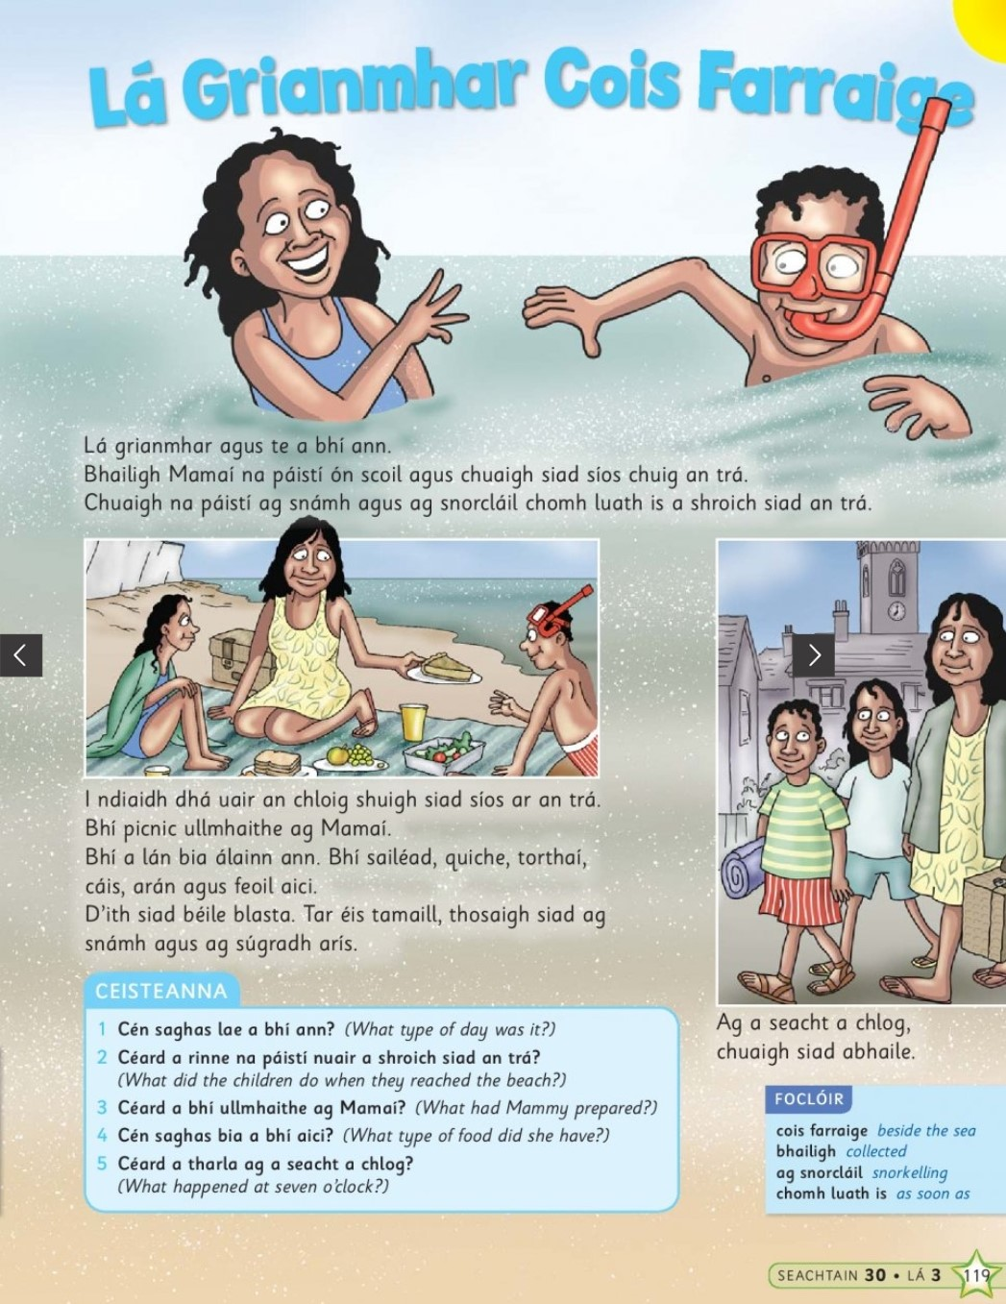

Gaeilge: Wednesday
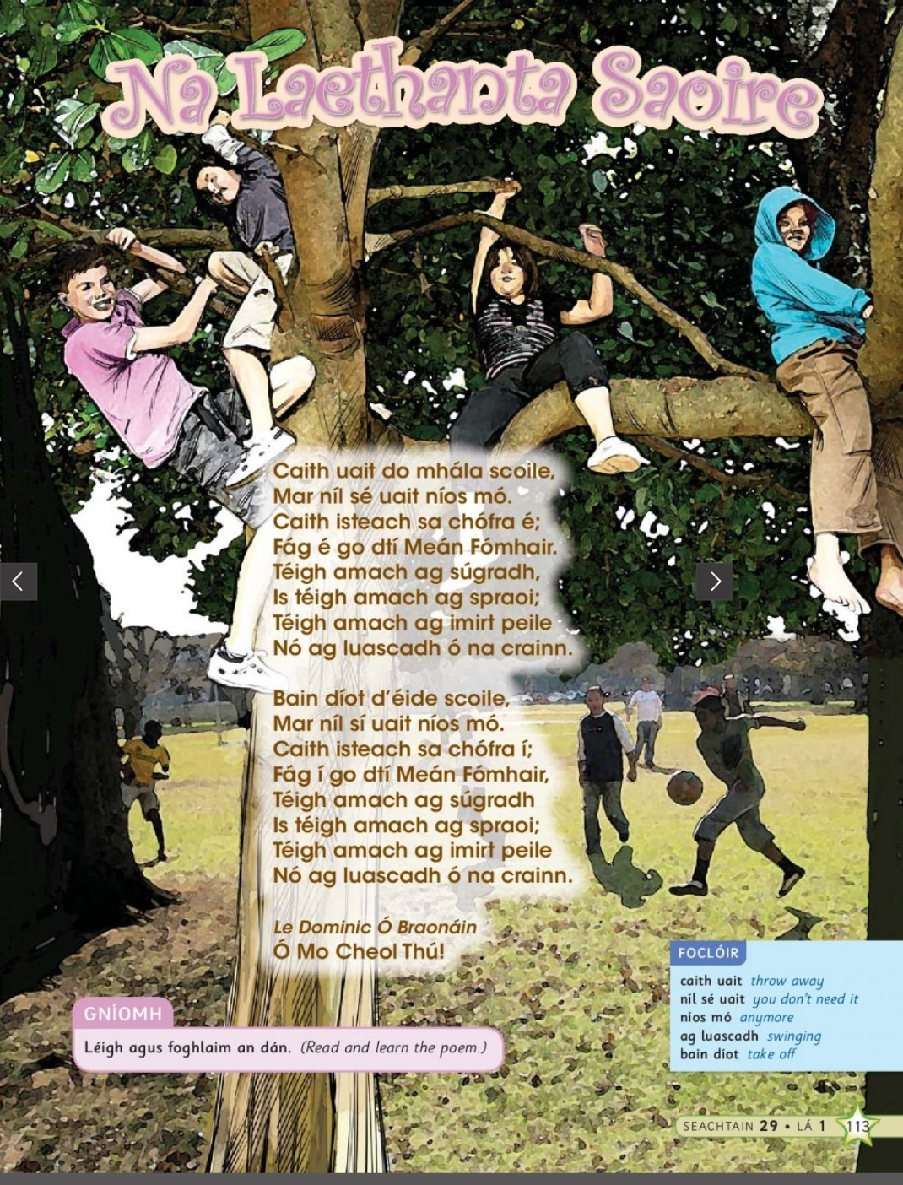

Gaeilge: Thursday
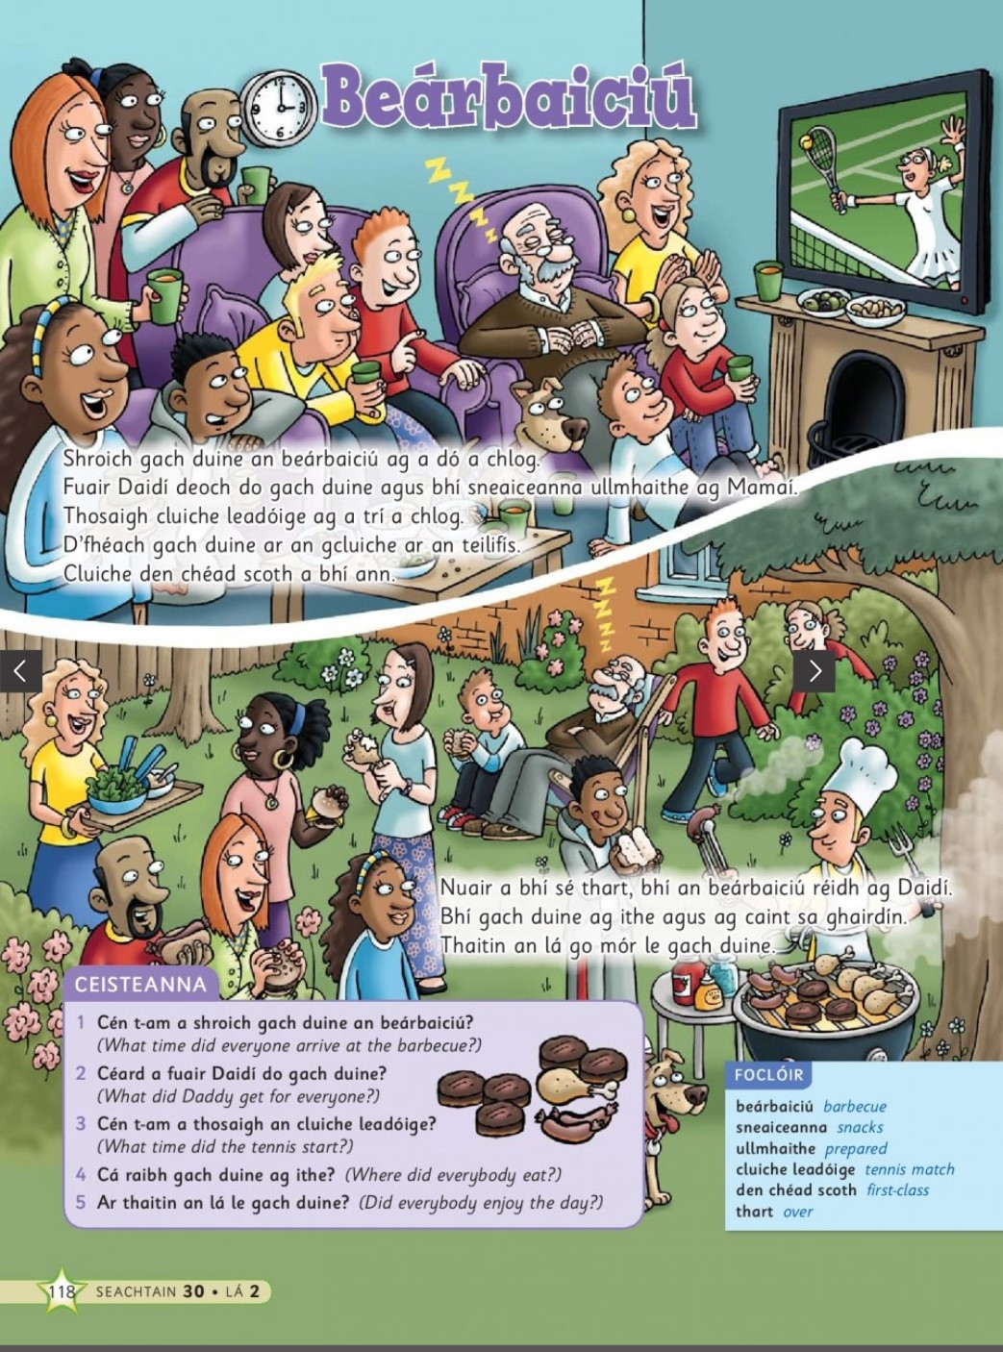

Wednesday: Time Capsule
