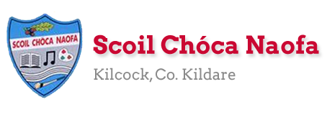
Dear 4th Class,
I hope you and your family are safe and well this week and that you have been making the most of the fine weather we are having. Last week, you completed the RSE programme at home. Well done
This week is Sports Week. We would like to you to get outside in the fresh air and get active. Play some ball games, do some skipping, go for a walk/cycle/run, even create your own game. There are 3 videos on the school website: a staff video and 2 videos of some famous sports people you might recognise. If you haven’t seen them yet, make sure to check them out.
I would love to see some photos of you being active this week. A gentle reminder that photos with your face in them will not be used on the school website. A certificate is attached at the end of this document for you to print off on completion of Sports Week. Best of luck
We had our first zoom call this week. It was so lovely to see you all again. I enjoyed catching up with you and hearing what you have been up to. I would like to commend you on your wonderful behaviour during the meeting. Details of the next zoom call will be sent to your parents in the coming days. I am looking forward to it already.
Ask an adult to send 3-6 pictures of your work per email, if possible. Your parent/guardian can email me more than once throughout the week if they wish to do so - whatever suits your family. Ask an adult to email: mssmith@scoilchoca.ie

Enjoy Sports Week,
Ms. Smith
mssmith@scoilchoca.ie

Work for Ms. Smith’s 4th Class:
Monday 08/06/20 – Friday 12/06/20
Monday | English:  - Sports Star fact-file writing activity- Research your favourite sports star.  Irish:  - Cuardach Focal/Wordsearch: Lá Spóirt/Sports Day  P.E: Sports Week  - 100 points challenge  - Video: Choose one of the videos below as a daily bonus activity.
Tuesday | English:  - Sports Day Reading Comprehension: Read and answer the questions  Maths:  - Angles scavenger hunt  P.E: Sports Week  - 100 points challenge  - Video: Choose one of the videos below as a daily bonus activity.
Wednesday | Maths:  - Make a map challenge- Draw a plan of the area of your house and garden. Plan a treasure hunt/maths trail for your family giving them different clues to solve.  Art:  - Outdoor Art: Get creative with chalk (see ideas below) / Mindfulness art  P.E: Sports Week  - 100 points challenge  - Video: Choose one of the videos below as a daily bonus activity.
Thursday | English:  - Active Week Acrostic Poem  Irish:  - Léigh ‘Foireann na Scoile’ agus freagair na ceisteanna.  P.E: Sports Week  - 100 points challenge  - Video: Choose one of the videos below as a daily bonus activity.
Friday | Maths:  - Outdoor Maths Challenge: Build a bug hotel (See below for details)  English:  - Sports Day Word Unscramble  PE: Sports Week  - 100 points challenge  - Video: Choose one of the videos below as a daily bonus activity.

Teacher : Ms Wilson 8/6/2020
Literacy Group
This work is based on the pack of work that you received in the post.
This week I would like you to:
- Try Brain Break Breathing – Try the Sun Breaths or the Waves on the Ocean Breaths
- 15 Minute Memory Activities – Try number 4 – The Concentration game
- Complete the next session of SNIP.
- Complete the Cloze Reading Exercise – Understanding the Internet and the World Wide Web.
- Newell Literacy

- P.52 Dictation. Ask an adult to call one or two sentences each day. See if you can write them. Use the sheets to check your spelling.
- P. 53 Try to spell some of the real and nonsense words here. Again ask an adult to help you.

Continue reading and let me know what you are reading.

It is ok if you don’t get to everything assigned here. I know that you are busy with Sports Week. Just try to do a little bit each day. Enjoy Sports Week.
EAL Group – Ms Wilson.
Theme : Myself – Sports/Hobbies
- List as many sports as you can think of. (Try to think of at least 15).

- Look at the sports listed when you click on the link below on worldbook online. Click on more information (on top left of screen under back button).
- Pick three sports you are not familiar with.
- Read the article about them.
- Now write three new things you found out about each of these sports.
https://www.worldbookonline.com/kids/home#article/ar831362

- Try this wordsearch based on Sports Day
https://www.twinkl.ie/resource/t2-pe-008-sports-day-word-search

Contact SEN Teacher: mswilson@scoilchoca.ie

Teacher: Ms. Heffernan 8th June 2020 4th Class
Speech and Language | This week is Sports Week so we’re just going to do some fun activities to give you more time to get out and be active!  How many words can you make from SPORTS WEEK?  Try the Sports wordsearch below.  Write/record 5 sentences telling me what activities you enjoyed or what you thought about the videos on the website.  Keep reading!  If anybody needs any more reading material, please let me know. If you’ve read or listened to a story, I’d love to hear what you thought about it.  Send me an email to let me know how you’re getting on-I’d love to hear from you!
Maths | You can keep playing games to help you with your mental maths.  https://www.topmarks.co.uk/maths-games/hit-the-button  https://www.topmarks.co.uk/maths-games/daily10  Your teacher is giving you fun Maths activities this week. You will also be using your Maths skills to help you keep your scores in all your sporting activities! If you need any help, just send me an email.

Contact SEN Teacher: msheffernan@scoilchoca.ie

Ms. Heffernan’s wordsearch
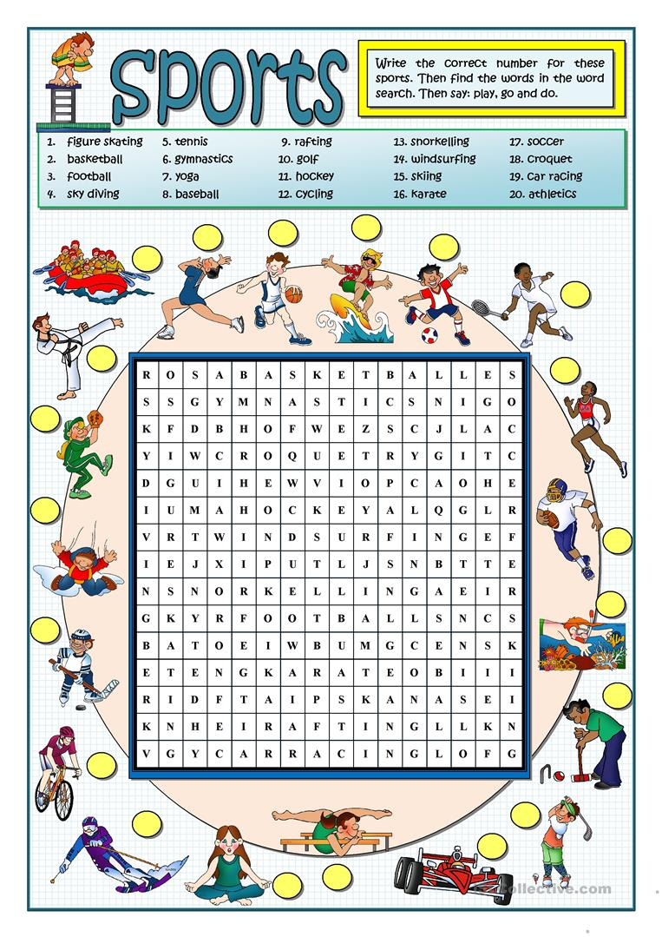

Sports Week 100 Points Challenge:
Sports Week
STAY ACTIVE CHALLENGE
BUILD YOUR POINTS WITH EXERCISE
What I have to do: Every day you have to accumulate 100 points by completing a variety of different activities. Each activity gives you different points. The Daily Bonus Activity can be any other activity that is not listed. Some suggestions might be a training session from your GAA or Soccer club, a dance class, a gymnastics class or even a family workout!
Outdoor Challenges
Running (15 minutes) | 60 points
Cycle (30 minutes) | 60 points
Walk (30 minutes) | 50 points
Kick about | 40 points
Trampoline (20 minutes) | 40 points
Skipping (10 minutes) | 40 points
Basketball games (20 minutes) | 40 points
Puck around | 40 points
Hopscotch (5 minutes) | 10 points
Indoor Challenges
Running up and down stairs x 5 | 40 points
Online yoga class | 50 points
Online dance class | 50 points
Pressups x 20 | 20 points
Squats/Frog Jumps x 20 | 20 points
Hula Hooping x 20 | 20 points
Table Tennis | 20 points
Balloon keepie uppie (15 min game) | 20 points
Plank Hold (30 seconds x 5) | 30 points
***Daily Bonus Activity*** 100 points

Sports videos for a daily bonus activity:
https://www.youtube.com/watch?v=xB0sg8nQXDc&list=PLt3aHDpWcOx0KJFmNWegn4eTv50f9Qgu_&index=2&t=0s
This is a family dance class.

https://www.youtube.com/channel/UC_4CVGZ-aQH2V6cLGYmKMAg
This is a video with soccer skills suitable for primary school children

https://www.youtube.com/watch?v=hmMobq5velU
This is a dance to “Sorry” by Justin Beiber.
https://www.facebook.com/180216932023233/videos/895787854180836/
This is Triathlon Ireland Fitness Video for kids
https://www.facebook.com/SportIrelandCampusFitness/videos/311157616522289/
This is Sport Ireland’s family PE at Home Workout
https://www.youtube.com/watch?v=M5ffOxDIcwc&amp;list=RDCMUCyqR7WkL8i1b6xtSssDmW9w&amp;index=4
This is a dance to ‘Can’t stop this feeling’ by Justin Timberlake

Sports Star Fact File:
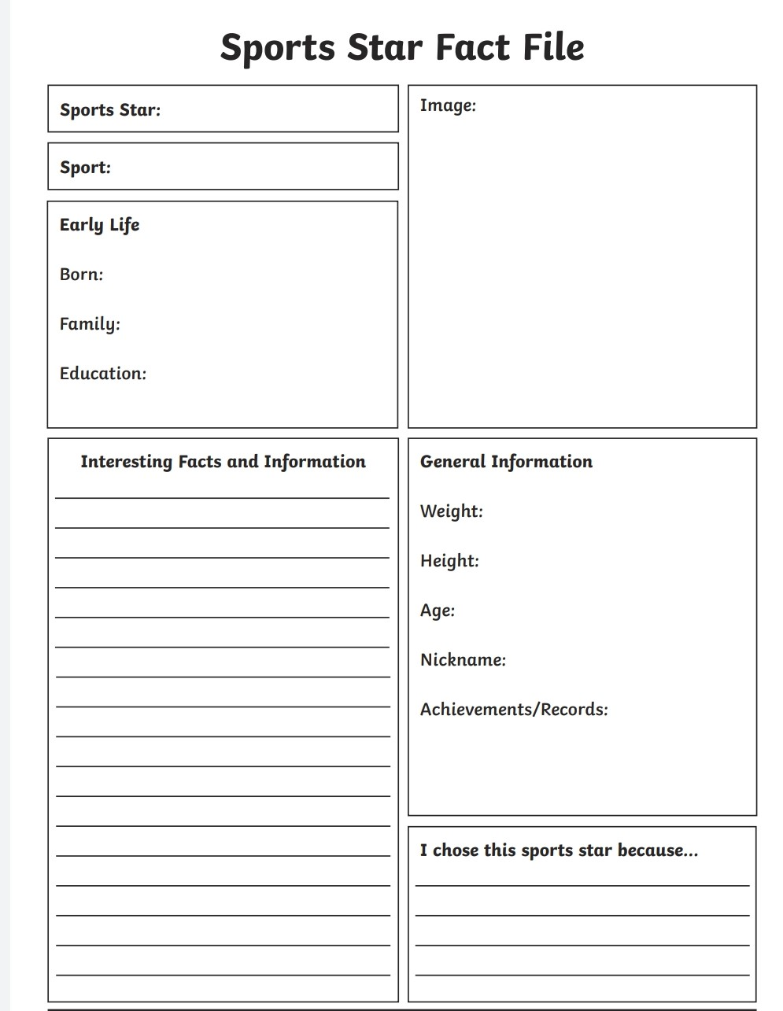

Cuardach Focal- Lá Spóirt:
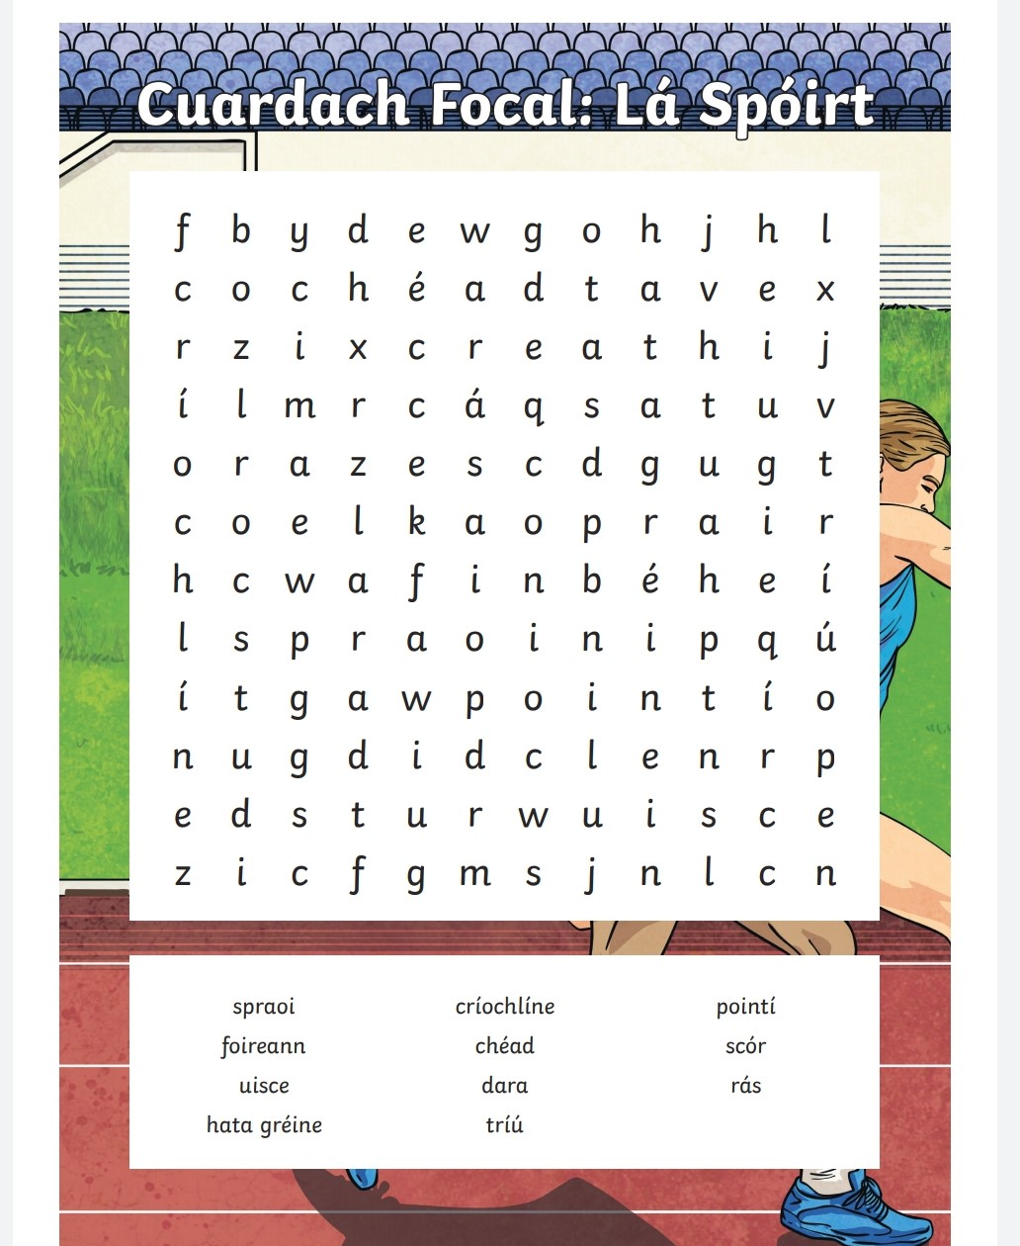

spraoi=fun críochlíne= finish line pointí= points
foireann=team chéad= 1st scór= score
uisce=water dara= 2nd rás= race
hata gréine= sunhat tríú= 3rd
4th Class: Reading Comprehension
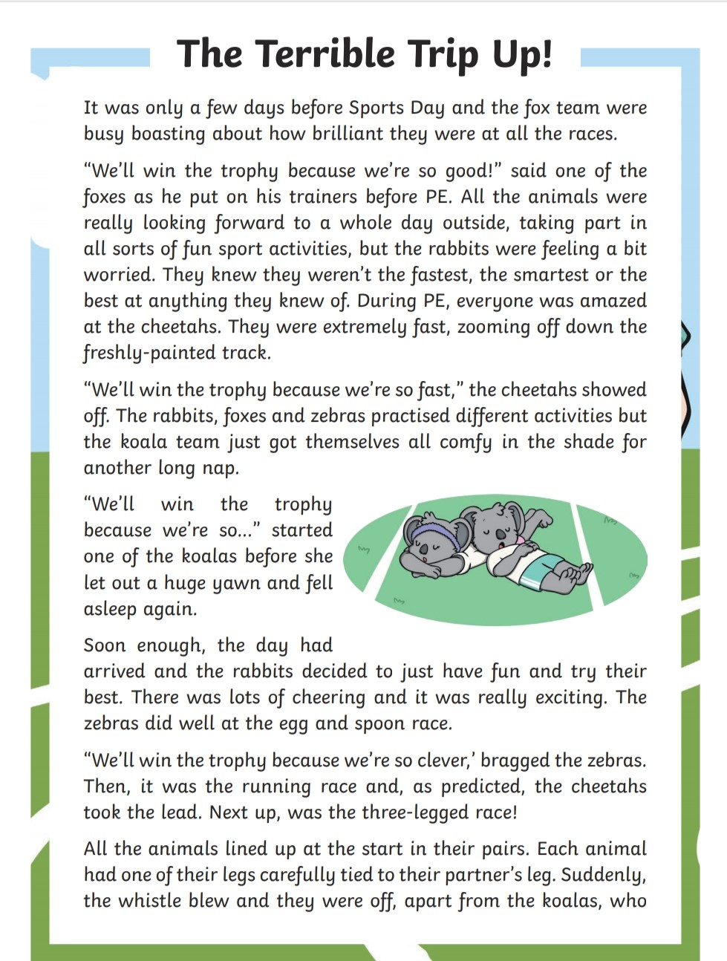

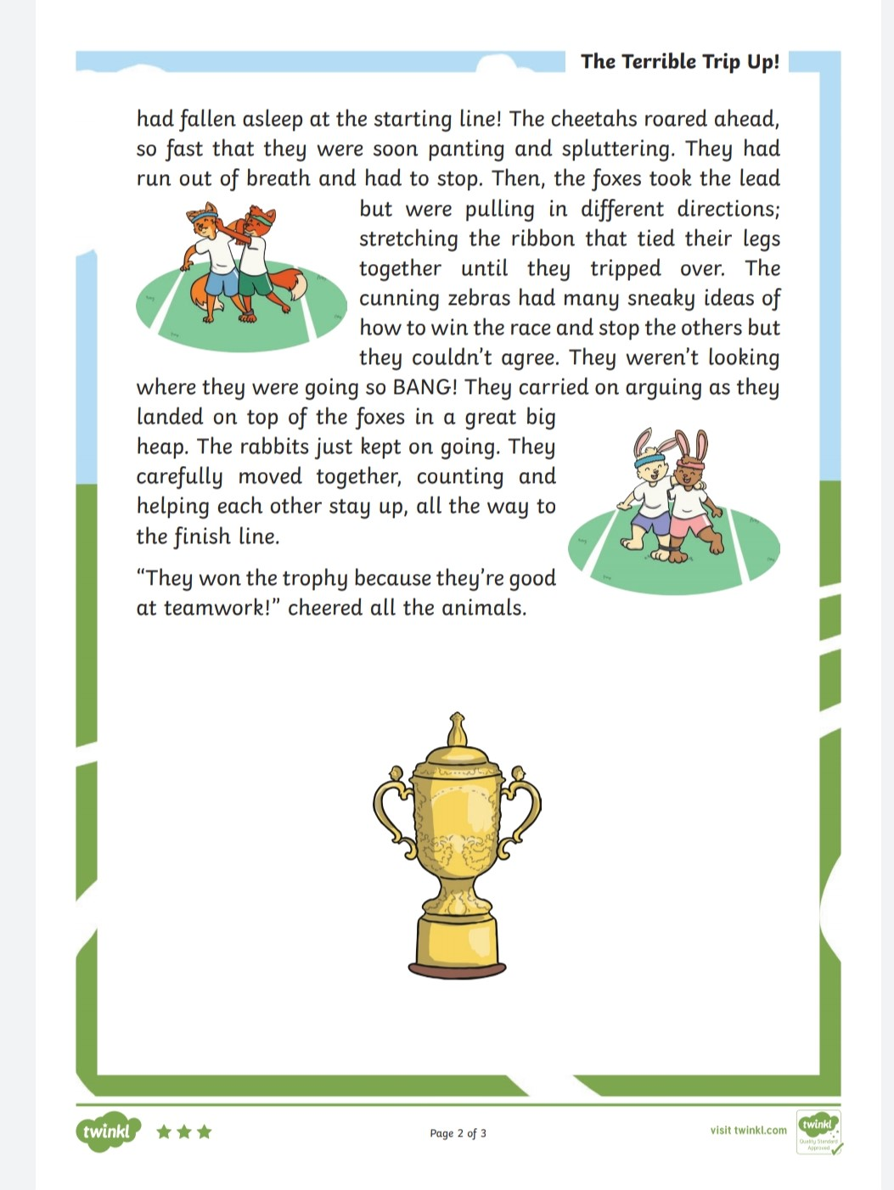

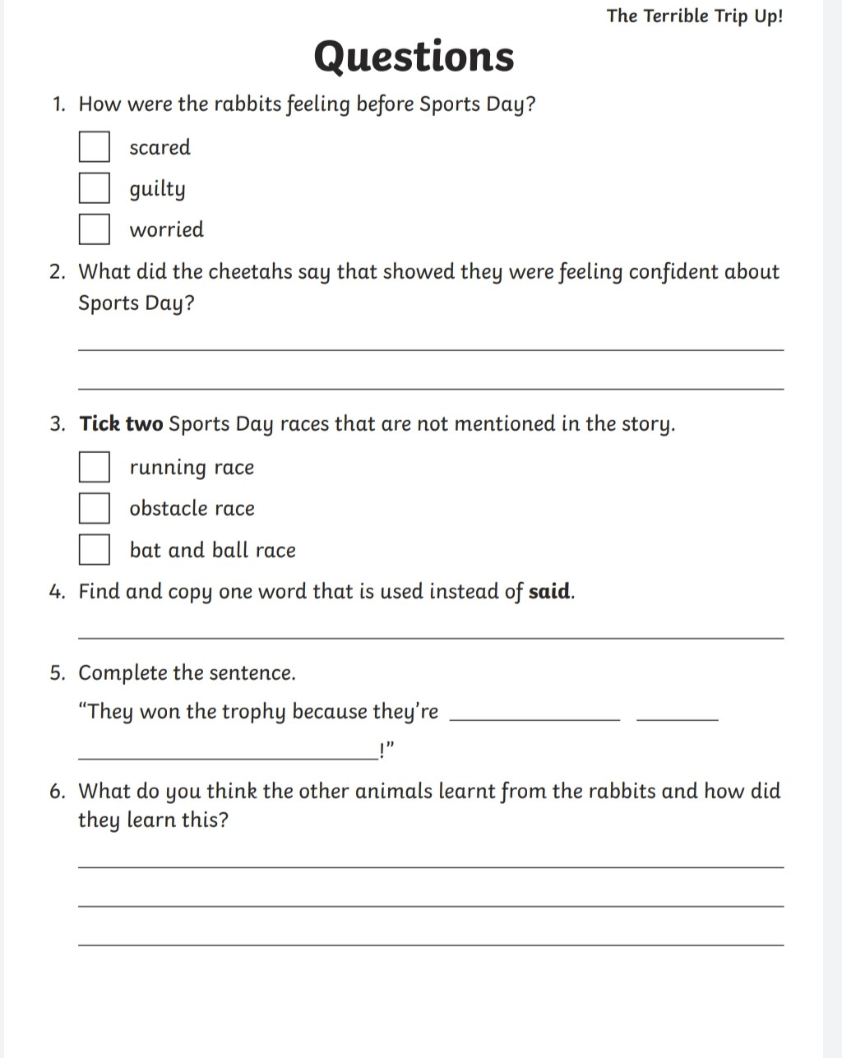

Angles Scavenger Hunt
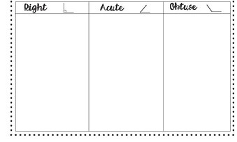

Outdoor Art Ideas Using Chalk:

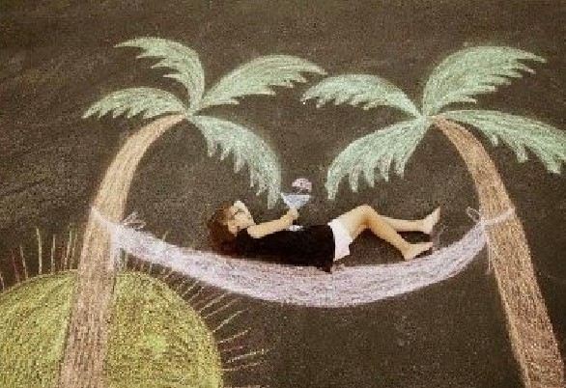

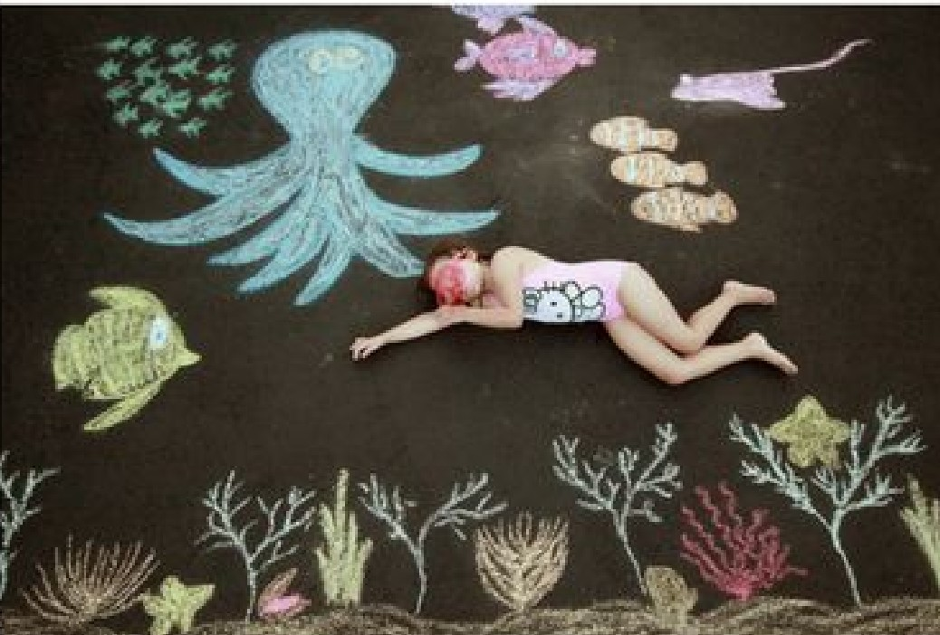

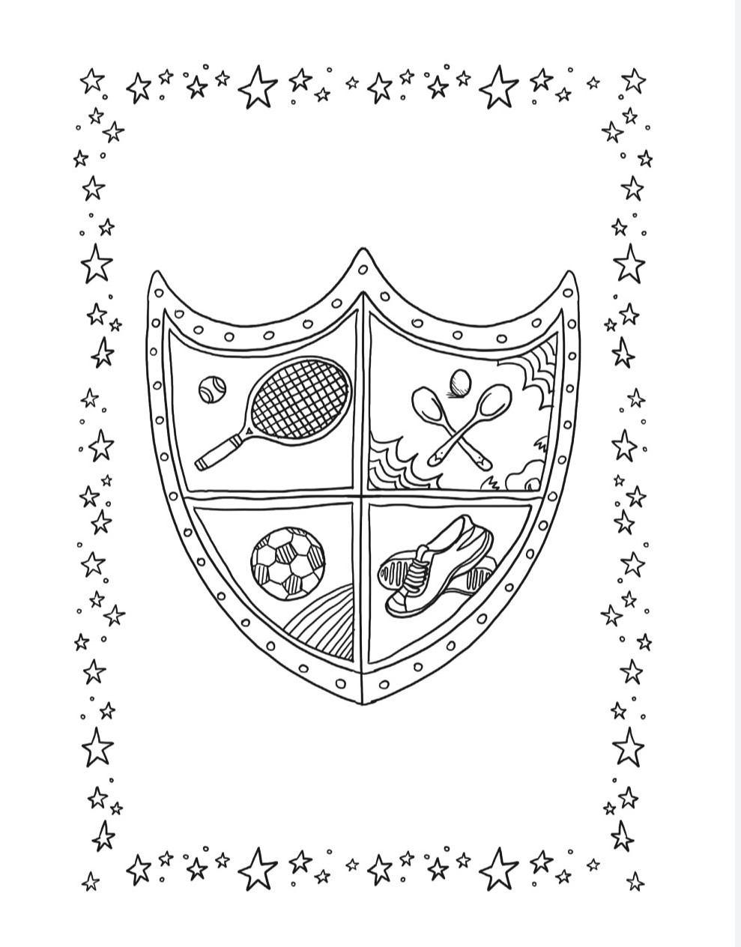
Mindfulness Art:

Active Week Acrostic Poem:
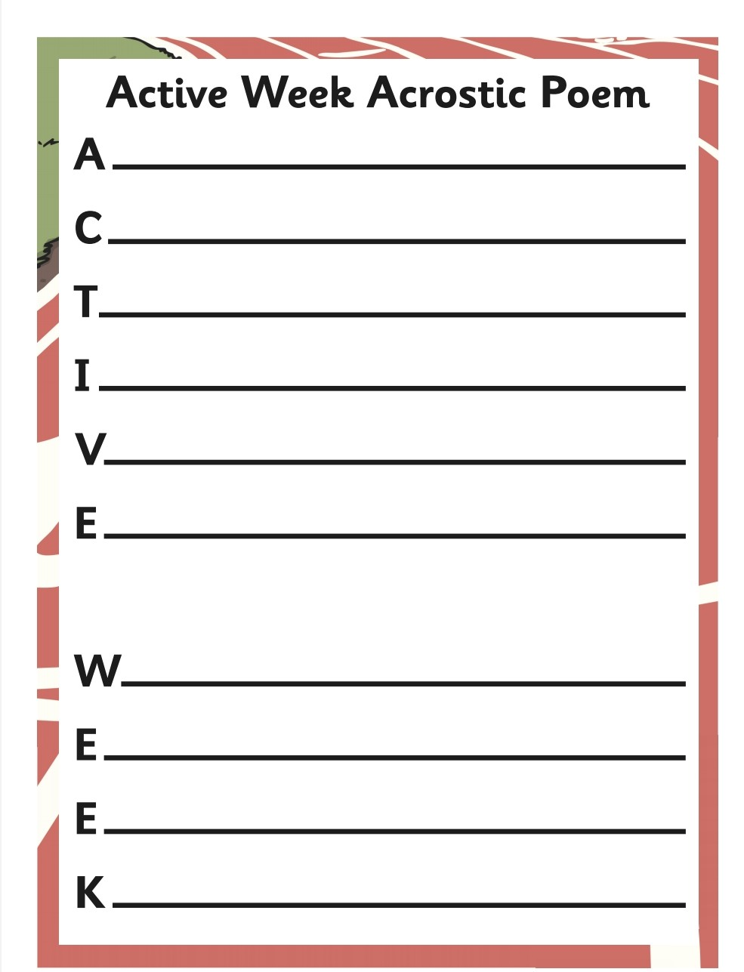

Léigh sa Bhaile- Foireann na Scoile
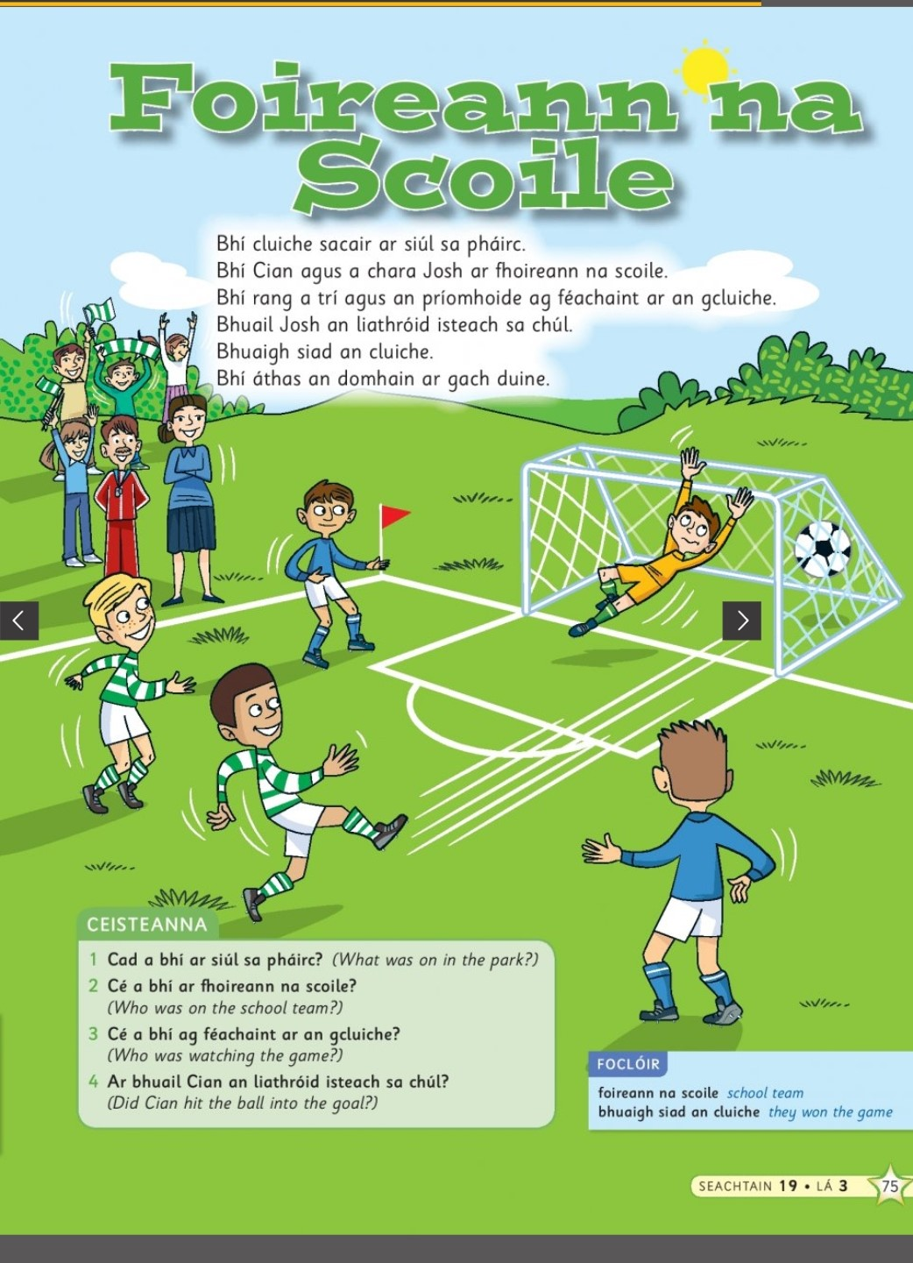

(Double click the icon to listen to the story)

Outdoor Maths Challenge: Build a Bug Hotel
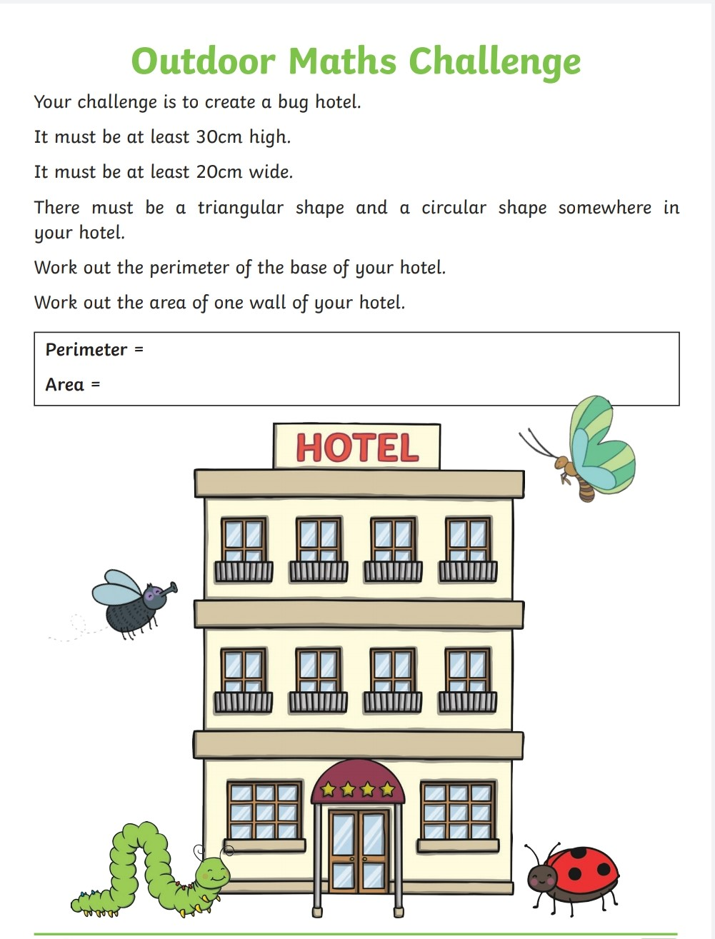

Sports Day Word Unscramble:
throw, javelin, sack race, hurdles, egg and spoon, relay, target, skipping, races, running, long jump, sport
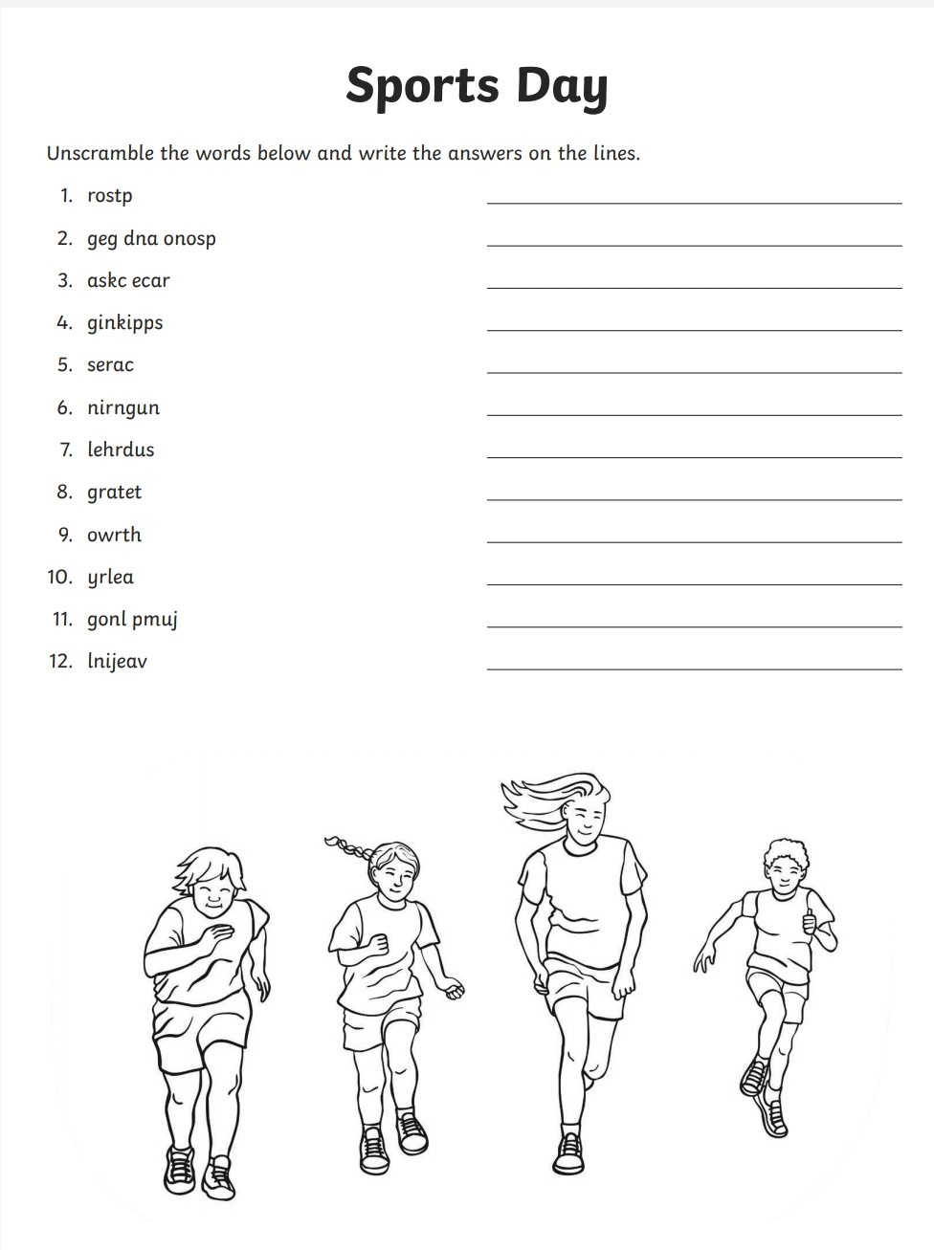
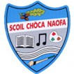
  - Scoil chÓca Naofa

_______________________

Congratulations on taking part in Sports Week

June 2020

