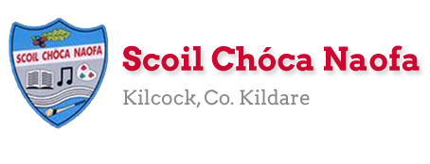

Work for Fifth Class: 8th of June – 12th of June 2020
WELCOME TO SPORTS WEEK!
See the first page below the plan for your sports week active challenges sheet!

We have given lots of activities that get you active and outdoors this week. If you want additional work there are some suggestions provided at the end of the plan! For many of the activities remember to stay 2m apart from your friends, be polite and respectful if out and about, ask parental permission if necessary and adhere to the current guidelines.

Ms. Heffernan’s and Ms. Tone’s groups will find some work for them attached to the end of this plan.
Please send us pictures of the activities you completed this week! We love hearing from you.
Our e-mail addresses are msfield@scoilchoca.ie and msmahon@scoilchoca.ie
Mon | English | Read for 10 minutes or more.  Write a selection of clues and lead a family member/friend on an outdoor treasure hunt.
 | Maths | Create a map to go with your treasure hunt. (See sample below for inspiration).
 | Gaeilge | Téigh amach, luí síos agus léigh lch 117 i Léigh sa Bhaile. (Go outside, lie down and read..)  Is dán (poem) é: Laethanta Saoire ón Scoil.  An dtuigeann tú é? (Do you understand it?)
 | PE | Collect 100 points! Complete active challenges to add up 100 points. (See below)  Extra: Soccer Skills from Coach Eoghan (FAI Soccer Skills)  https://www.youtube.com/channel/UC_4CVGZ-aQH2V6cLGYmKMAg
Tue | English | Read for 10 minutes or more.  Go outside and write an acrostic poem inspired by nature. e.g. GREEN  Green grass lazy in the wind  Ripples slowly along  Early morning traffic din  Endless with birdsong  Nothing better, nothing wrong.
 | Maths | Go outside and find something that is:  - Symmetrical - Hexagonal  - Oval - Longer than 1 metre  - Circular - Shorter than 1 metre  - Perpendicular - Parallel
 | Gaeilge | Téigh amach, luí síos agus comhaireamh na héin atá ag eitilt sa spéir as Ghaeilge.  (Go outside, lie down and count the birds flying in the sky in Irish.)  An féidir leat comhaireamh suas go dtí céad as Ghaeilge?  (Can you count up to one hundred in Irish?)  Haon, dó, trí, ceathair, cúig, sé, seacht, ocht, naoi, deich, aon déag, dó dhéag, trí déag, ceathair déag, cúig déag, sé déag, seacht déag, ocht déag, naoi déag, fiche…  Watch TG4 @ 10:00-10:30 Cúla 4 ar Scoil.
 | PE | Collect 100 points! Complete active challenges to add up 100 points. (See below)
Wed | English | Read for 10 minutes or more.  Go outside and write down 5 things you can see, 4 things you can touch, 3 things you can hear, 2 things you can smell and 1 thing you can taste.  Creative Schools TV - Drama Improvisation with Naomi Cahill and Aisling Byrne  Have fun trying this out with your family. Listen to the whole video from Creative Schools – it is great fun!  https://www.rte.ie/learn/2020/0528/1143222-creative-schools-tv-drama-improvisation/
 | Maths | Go outside and measure the height of grass in a spot that is usually shaded and compare it to grass in a spot that is usually sunny. Is there a difference? If so, why?  Do the same for flowers and other plants if you can.
 | Gaeilge | Féach ar TG4 @ 10:00-10:30 Cúla 4 ar Scoil.
 | PE | Collect 100 points! Complete active challenges to add up 100 points. (See below)
Thurs | English | Read for 10 minutes or more.  Go outside, find a quiet place and write a letter to yourself to be opened on your first day back to school. Give yourself some words of wisdom and advice. Remind yourself of all the great things you’ve learned during this time. Be kind to your future self. Seal the letter and remember to open it on your first day!
 | Maths | Go outside and create a chart like the sample below. Count how many cars, pedestrians, cyclists and others pass by. Fill in the chart. Stay outside for as long as you like. (We recommend spending at least 10 minutes for a fair test.)  Q: Can you figure out what fraction were:  a) in a car  b) walking  c) on their bike
 | Gaeilge | Can amhrán atá agat as Ghaeilge. (Sing a song you know in Irish.)  Mar shampla: Oró, sé do bheatha ‘bhaile… Dúirt mé dia duit cén chaoi a bhfuil tú?...  Féach ar TG4 @ 10:00-10:30 Cúla 4 ar Scoil.
 | PE | Collect 100 points! Complete active challenges to add up 100 points. (See below)  Extra: Family Dance Challenge by Trisha McDermott  http://www.rosactive.org/events/family-dance-challenge/
Fri | English | Read for 10 minutes or more.  Go outside with a skipping rope and recite a skipping rhyme. See below for some suggestions. Try to add some moves to your jumps that match what the rhyme says.  Can you make up your own rhyme and add some challenging moves?  (If you don’t have a skipping rope, bath-robes have a great rope replacement that you could borrow – with parental permission!)
 | Maths | Go outside and try to measure out a metre without using a ruler/measuring tape. Mark out your metre using two items to show where it starts and finishes. Get your ruler/tape and check to see how close you were.  (Remember 1 metre = 100 centimetres) Can you do it for 2 metres/4 metres/ 10 metres?
 | Gaeilge | Téigh amach agus scríobh litir chuig do chara as Ghaeilge.  Inis do chara faoi do theaghlach, do theach, na caitheamh aimsire atá agat ag an am seo… (Tell your friend about your family, house, pastimes at the moment...)
 | PE | Collect 100 points! Complete active challenges to add up 100 points. (See below)
Sports Week
STAY ACTIVE CHALLENGE
BUILD YOUR POINTS WITH EXERCISE
What I have to do: Every day you have to accumulate 100 points by completing a variety of different activities. Each activity gives you different points. The Daily Bonus Activity can be any other activity that is not listed. Some suggestions might be a training session from your GAA or Soccer club, a dance class, a gymnastics class or even a family workout!
Outdoor Challenges
Running (15 minutes) | 60 points
Cycle (30 minutes) | 60 points
Walk (30 minutes) | 50 points
Kick about | 40 points
Trampoline (20 minutes) | 40 points
Skipping (10 minutes) | 40 points
Basketball games (20 minutes) | 40 points
Puck around | 40 points
Hopscotch (5 minutes) | 10 points

Indoor Challenges
Running up and down stairs x 5 | 40 points
Online yoga class | 50 points
Online dance class | 50 points
Pressups x 20 | 20 points
Squats/Frog Jumps x 20 | 20 points
Hula Hooping x 20 | 20 points
Table Tennis | 20 points
Balloon keepie uppie (15 min game) | 20 points
Plank Hold (30 seconds x 5) | 30 points

***Daily Bonus Activity*** 100 points
Sports Week
Photos: If you have any sports photos please send them to us and we might include them on the school website. Please do not have your face in the photo. Ask permission for the photo to be uploaded.

Extra Activities - Optional
The Weather
- Create a poster/fact-file on clouds and cloud types
- Keep a cloud diary every day for the week
http://www.weatherwizkids.com/weather-clouds.htm
- Watch the weather forecast and record what they predict versus what actually happens each day
- Use a recycled container to collect rainwater this week. Measure how much you collected at the end of the week. Use it to water the plants/flowers when you’re finished.
- Look up and record information on the bog fires near Donadea. Find out what may have caused the fire and how the fire services mangaed to control it. https://www.leinsterleader.ie/news/home/546926/kildare-fire-service-units-continue-fighting-bog-fires-near-donadea.html

The Bronze Age
- Create a poster/fact-file on the bronze age
- Look up how bronze was made, objects invented and used in the Bronze Age, warriors of the Bronze Age and beliefs during the Bronze Age.
- Research Bronze Age settlements and sketch/create a 3-D model of Bronze Age settlement using recycled materials.
- https://www.dkfindout.com/uk/search/bronze-age/

Sports Day
Make up your own Sports Day. Ask 2-3 friends to join you. Why not try a sack race with a pillow case, egg and spoon race, sprint race, hopping race, skipping race, football dribbling, water in plastic bucket race etc.

Bird Song from Birdwatch Ireland Kildare Branch.
Listen to the video below.
https://www.facebook.com/watch/?v=909334629544159
Set your alarm for early Wednesday morning. When your alarm goes off open your bedroom window, lie back in bed and listen to the beautiful birdsong. Warning… it will be very loud!

Scavenger Hunt
- Scavenger Hunt. The challenge is to locate the following 20 items, take a photo of them (using tips from Monday’s video clip). This might be a nice activity to do with your friend. Be respectful taking photos!
- A church 11. A swan
- A Volkswagen Beetle 12. A lily pad
- Stop sign 13. A newsagent shop front
- A bicycle 14. A red door
- A white flower 15. A lawnmower
- Black cat 16.Something round
- A restaurant 17. Something funny
- Bird box 18. A secondary school
- Potted plant 19. Post box
- Dandelion 20. A duck

Bawnogues Flowers
Spot these flowers at the bawnogue in Kilcock (the running track/walking path near the playground)
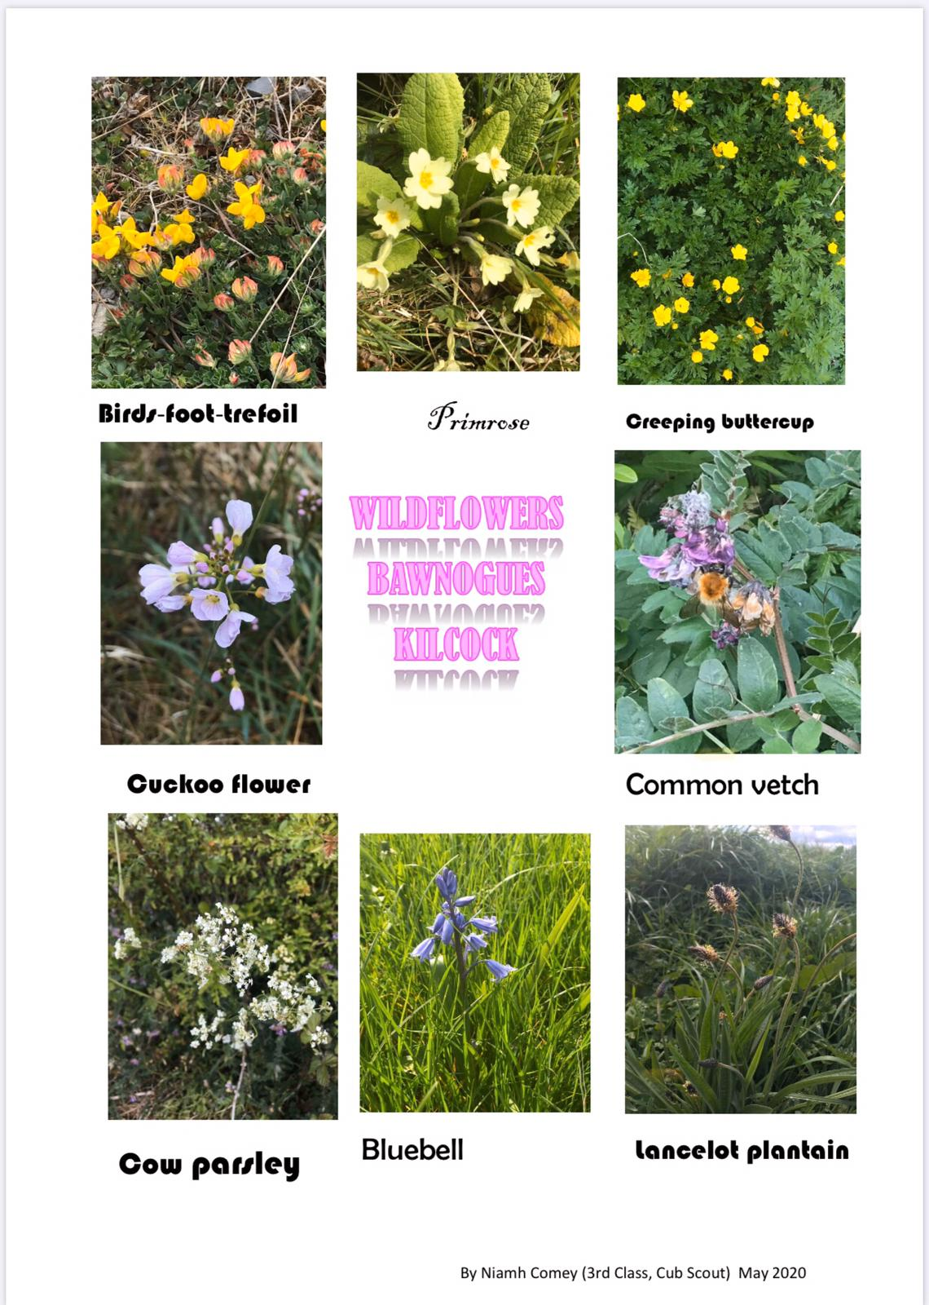

Free eBooks access: https://www.oxfordowl.co.uk/for-home/find-a-book/library-page/?view=image&query=&type=book&age_group=Age+9-11&level=&level_select=&book_type=&series=#

Treasure Hunt Map Sample
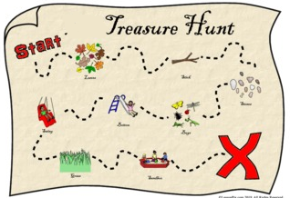
Maths Chart Sample
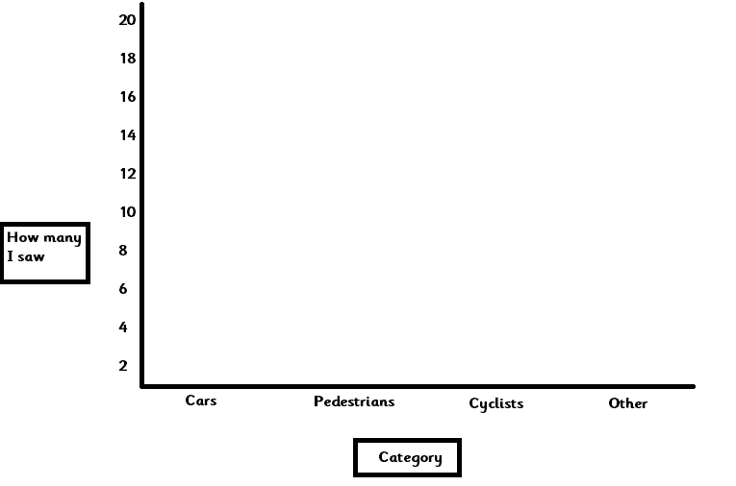

Skipping Rhyme Samples

Cinderella, dressed in yellow
Went upstairs to kiss her fellow
Made a mistake
And kissed a snake
How many doctors
Did it take?
1, 2, 3, 4, 5...

Five little monkeys,
Jumping on the bed.
One fell off,
And bumped his head
Mama called the doctor,
And the doctor said:
"No more monkeys
jumping on the bed!"

Teddy Bear, Teddy Bear,
Turn around.
Teddy Bear, Teddy Bear,
Touch the ground.
Teddy Bear, Teddy Bear
Touch your shoe.
Teddy Bear, Teddy Bear
That will do.
Teddy Bear, Teddy Bear,
Go upstairs.
Teddy Bear, Teddy Bear,
Say your prayers.
Teddy Bear, Teddy Bear,
Turn out the light.
Teddy Bear, Teddy Bear
Say good night!

Plean Seachtaine: 8^{ú} –12^{ú} Meitheamh

Múinteoir: Ms Tone

Class Group: 5th Literacy
Children: ECB, KM, MU, CAG, PZ, MOS Teachers: Ms Mahon / Ms Field

Class Group: 5th Maths

Children: MC, KM, CA Teacher: Ms Mahon

SEN work

Teacher: Ms Tone

Note: SEN teachers have added work on to the teachers’ plan. Children can decide to do this work instead of something the teacher has assigned. It is not extra work. Also, we would be delighted if you could email on a picture of something that your child has done and is proud of so we can see their lovely work again!

Literacy | - Keep a diary to record what you are doing each day. It is Active Week, so you are probably doing lots of sports.  Write 3 sentences.  - Draw a picture of a sport you like.
Numeracy | Challenges:  - How many hops can you do in 20 seconds?  - How many jumping jacks can you do in 20 seconds?  - Can you skip with a rope for a minute without stopping?  - Time yourself: Run from the bottom end of your garden to the top. Try it again and go faster!  - Roll a €1 coin on the ground. Measure how far it went.  - Count how many times you can bounce a tennis ball off a racket without letting it fall.  - How many times can you throw and catch a ball to someone without letting it fall?

Contact SEN Teacher: mstone@scoilchoca.ie

SEN work 5th Class week beginning 8th June 2020
Teacher: Ms. Heffernan
Note: SEN teachers have added work on to the teachers’ plan. Children can decide to do this work instead of something the teacher has assigned. It is not extra work. Also, we would be delighted if you could email on a picture of something that your child has done and is proud of so we can see their lovely work again!
Literacy | Keep reading! If any of you need more reading material, just let me know. If you’ve read or listened to a story, let me know what you thought about it.  Do a little writing every day. Keep a diary. Keep a gratitude journal-write down 3 things you are grateful for each day.  Use www.writereader.com to create your own book.  Keep practising your TTRS. See if you can still type while covering your hands with a towel!  This week is Sports Week so we’re just going to do some fun activities to give you more time to get out and be active!  How many words can you make from SPORTS WEEK?  Try the Sports wordsearch below.  Write/record 5 sentences telling me what activities you enjoyed or what you thought about the videos on the website.  Send me an email to let me know how you’re getting on-I’d love to hear from you!
Numeracy | Keep doing your Mathletics.  Your teacher is giving you fun Maths activities this week. You will also be using your Maths skills to help you keep your scores in all your sporting activities! If you need any help, just send me an email.  You might like to try these worksheets!  They are about making number sentences. You have to choose between addition, subtraction, multiplication or division.  Keep practising your mental maths.  https://www.topmarks.co.uk/maths-games/hit-the-button  https://www.topmarks.co.uk/maths-games/daily10  Send me an email to let me know what you have done or if you need help.
Contact SEN Teacher: msheffernan@scoilchoca.ie

