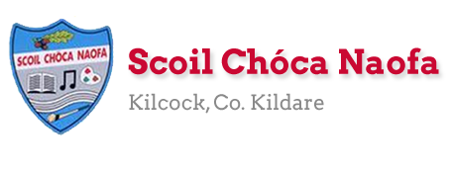
Dear 4th Class,
You’ve done it! You have come to the end of one of the most challenging school years you will ever have. I’m very proud of you. I know your parents are too. It wasn’t easy, it was very difficult at times and the last few weeks have been even more difficult, but you got through it. You’ll remember this experience for a long time. As you get older you can use this experience to help you. If you go through a challenging time you now know that you can overcome a serious change of plan and overcome it.
I hope you enjoyed the virtual school tours last week. You have one more virtual tour in the plan over the next few days. We also have one last Zoom call before the summer holidays on Thursday, June 25th at 12 pm.
Thank you to your parents for coming into school last week to collect and drop off books. By now you will have received your booklists and school reports. If you didn’t, please email me and I will send them to you.
This is the last plan you will receive from me this year. It consists of material for seven days rather than five as we were due to be in school on Monday, June 29th and Tuesday, June 30th. Instead of sending a separate plan for those days I have included them here. A lot of the work this week is really useful information that you should know. Maybe you already do, great! If not, learn your Eircode, emergency service numbers and parent’s phone numbers.
This week is our Scoil Chóca Naofa Bake Off! Use recipe books at home or look for recipes online. You could bake something that you just love to bake at home, you could perfect a previous recipe you tried or even something that your family like to bake. Do you have a recipe that has been handed down through the family? Send pictures to mstierney@scoilchoca.ie. If you and your parents would like, you can donate €1 to Temple Street Children’s Hospital via this link: www.templestreet.ie/event/great-irish-bake/.
Ms. Heffernan is working for the next seven school days and would be delighted to hear from those children who work with her. Her email address is msheffernan@scoilchoca.ie
Girls, you really are a great class and I really enjoyed teaching you this year. Unfortunately, the year didn’t end how we would have liked but I hope we will see each other soon. Until then, stay safe. Be kind to yourselves and to others. Enjoy your summer holidays!

Ms. Tierney

Work for Ms. Tierney’s 4th Class:
Monday 22/06/20 – Friday 30/06/20
Monday  22/06 | English:  - Research a recipe for the Scoil Chóca Bake Off.  - Discuss the recipe with a parent and make a plan for what you want to bake.  Maths:  - List the ingredients needed and make a shopping list for ingredients. Go shopping. Ask permission to do this, gather the ingredients needed in the shop, estimate the cost, pay, calculate and check your change.  Gaeilge:  - Léigh sa bhaile- Read the text. Writing the answers is optional.  PE:  - Sit up challenge- How many can you do in 1 minute?  - Press up challenge- How many can you do in 1 minute?  - Run 500m/1km/2km- Choose a distance.
Tuesday  23/06 | Maths:  - Measure out the ingredients. With a parent, heat oven to required temperature.  - Be aware of cooking and cooling time.  English:  - Write out your recipe- list the ingredients and write your method/instructions.  Other: Scoil Chóca Bake Off!  - Get baking. Good luck . Send me a photo of the finished product.  PE:  - Wheelie Bin Challenge- Try to kick or throw a ball into the bin from 5 metres/10 metres/15 metres- Have 10 attempts from each distance.  Gaeilge:  - Léigh sa Bhaile- Read the text. Writing the answers is optional.
Wednesday  24/06 | English:  - Time Capsule Activity  Maths:  - Mathletics  - Learn your parent/guardian’s number off by heart in the case of an emergency.  Gaeilge:  - Léigh sa Bhaile- Read the text. Writing the answers is optional.  PE:  - Go 5kms on wheels- bike, scooter, roller blades
Thursday  25/06 | English:  - Read your book/magazine/newspaper for 15 minutes.  - Acrostic Poem- My School Year  Gaeilge:  - Léigh sa Bhaile- Read the text. Writing out the answers is optional.  Maths:  - Mathletics  - Learn the phone number to contact emergency services: 112  PE:  - Ninja Fitness Rocks are back in the Bawnogue in Kilcock. They are spaced out around the 1km loop with lots of fun exercises for all.  Other: Weekly Zoom Call at 12pm.
Friday  26/06 | Maths:  - Learn your Eircode off by heart- this is vital in the case of an emergency at home.  Art:  - My Summer Vision activity- Draw your vision for your summer holidays in the sunglasses.  PE:  - Go outside and be active for 30 minutes.  Other: Virtual School Tour  - African Safari- your live safari experience from Massai Mara, Kenya and Great Kruger Park, South Africa.  https://wildearth.tv/kids/
Monday  29/06 | English:  - End of school year Wordsearch  Gaeilge:  - Bris an cód/Crack the code  Other: PAWS (Primary Aquatics Water Safety)  - Read through this document when you have the time. It can be done whenever suits you. It is important information to know before the summer holidays about Water Safety.  https://watersafety.ie/wp-content/uploads/2019/10/PAWS-3-Presentation.pdf
Tuesday  30/06 | English:  - End of year memories writing activity  Other: PAWS (Primary Aquatics Water Safety)  - Once you have read the information on Water Safety you can try some activities here to test your knowledge before the summer holidays.  http://paws.edco.ie/third-and-fourth-classes/  Art:  - Summer Mindfulness colouring activity  Give yourself a clap on the back for surviving a crazy school year.  Relax and enjoyed a well-deserved summer holiday. Yipppeee.

Ms. Heffernan’s SEN Groups
Teacher: Ms. Heffernan
Note: SEN teachers have added work on to the teachers’ plan. Children can decide to do this work instead of something the teacher has assigned. It is not extra work. Also, we would be delighted if you could email on a picture of something that your child has done and is proud of so we can see their lovely work again!
Language | How about a game of Yes/No?  You choose a person, place or thing and the other person can ask you 20 questions to figure out what you’re thinking of. You can only answer yes or no. Take turns.  Or a game of Last letter?  Choose a topic that interests you such as animals, food, TV shows or whatever you like. Take turns with another person to say words belonging to that group but each new word must start with the last letter of the one before.  For example: Animals: cow, wolf, frog, giraffe, elephant, tiger.......  Write/record 5 sentences telling me what activities you enjoyed most while learning from home.  Did you enjoy the anagram riddles? Here’s another lot below. See how you get on!  Or you might like to try this easy peasy recipe (see below) for the Bake Off!  Keep reading!  If anybody needs any more reading material, please let me know. If you’ve read or listened to a story, I’d love to hear what you thought about it.  Send me an email to let me know how you’re getting on-I’d love to hear from you!
Contact SEN Teacher: msheffernan@scoilchoca.ie

Ms. Heffernan’s Work
Anagrams are words that contain the same letters but arranged in a different order. For example, act is an anagram of cat. The answers to the clues below are anagram pairs.

Ex) | A person who makes bread. |  | The opposite of repair.
1. | What you call a person. |  | Hair around a lion’s neck.
2. | What superheroes wear. |  | A place to see stars and planets.
3. | Beef or pork. |  | A group of athletes.
4. | Another word for strange. |  | Less narrow.
5. | One of the four directions. |  | A place to sit.
6. | A place to grow flowers. |  | Something to be careful of.
7. | Another word for big. |  | An angry stare.
8. | What polite people say. |  | Not awake.
9. | A time when things are cheap. |  | A marine mammal.
10. | Person who fibs. |  | A dragon’s home.

Ms. Heffernan’s 3 Ingredient Cookies

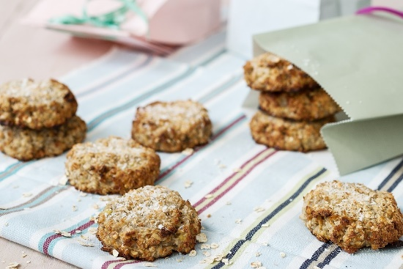

What you need:
- 125g/4oz Porridge Oats (or Gluten Free Porridge Oats)
- 50g/2oz Coconut
- 2-3 medium Bananas, mashed (the riper the better!)
How to:
- Preheat oven to 180°C/350°F/Gas 4. Lightly grease a flat baking tray.
- Combine the oats, coconut and mashed bananas in a bowl.
- Place spoonfuls of the mixture on the baking tray and flatten to form cookies.
- Bake for 10-15 minutes until golden brown.
- Enjoy warm from the oven or cool completely and store in an airtight container.

Notes
- For a gluten free version, make sure your porridge oats are gluten free.
- Also delicious with chocolate chips, chopped nuts or dried fruit.
Léigh sa Bhaile: Monday
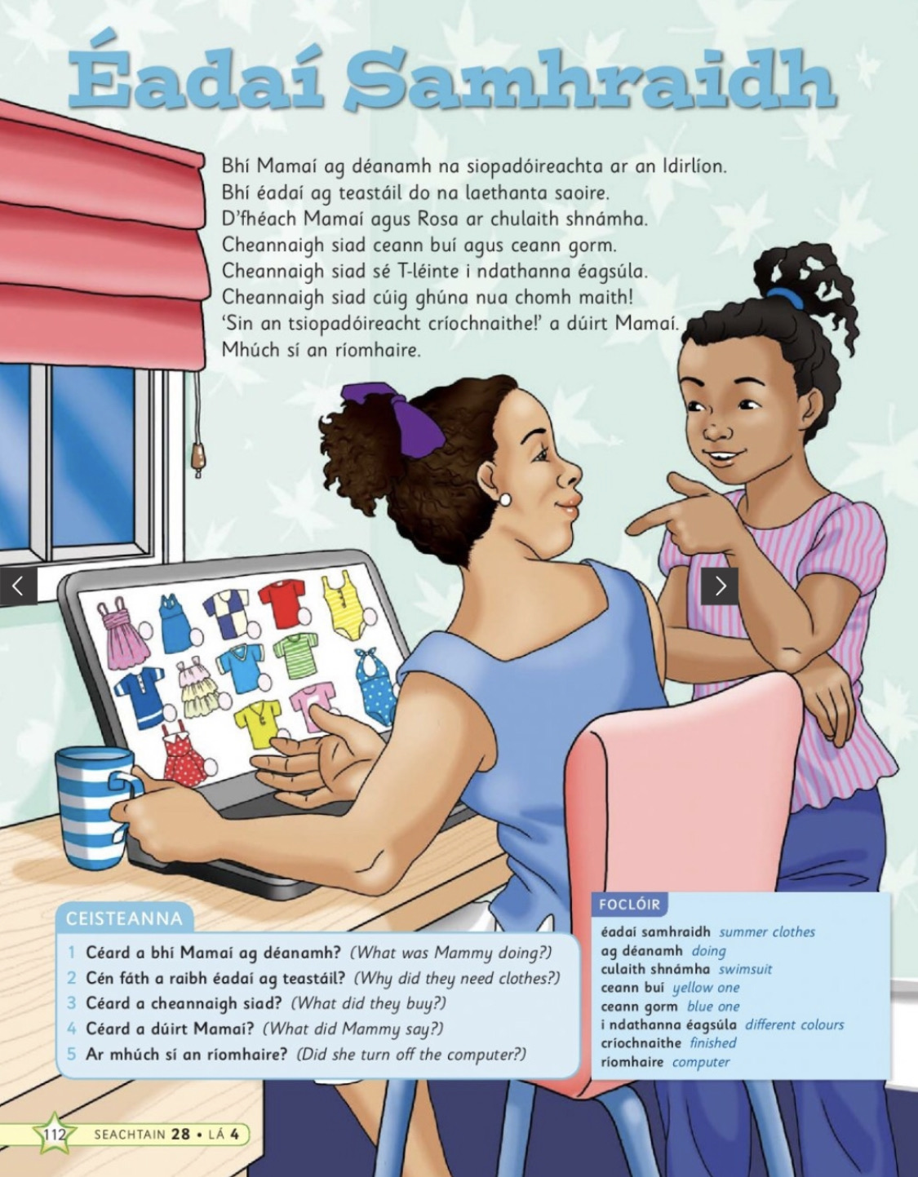

Tuesday: Recipe template
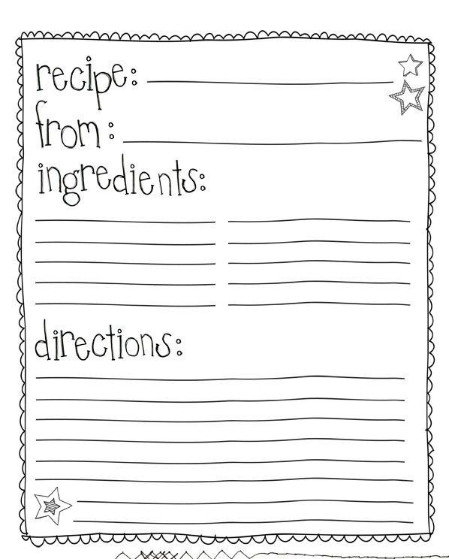

Léigh sa Bhaile: Tuesday
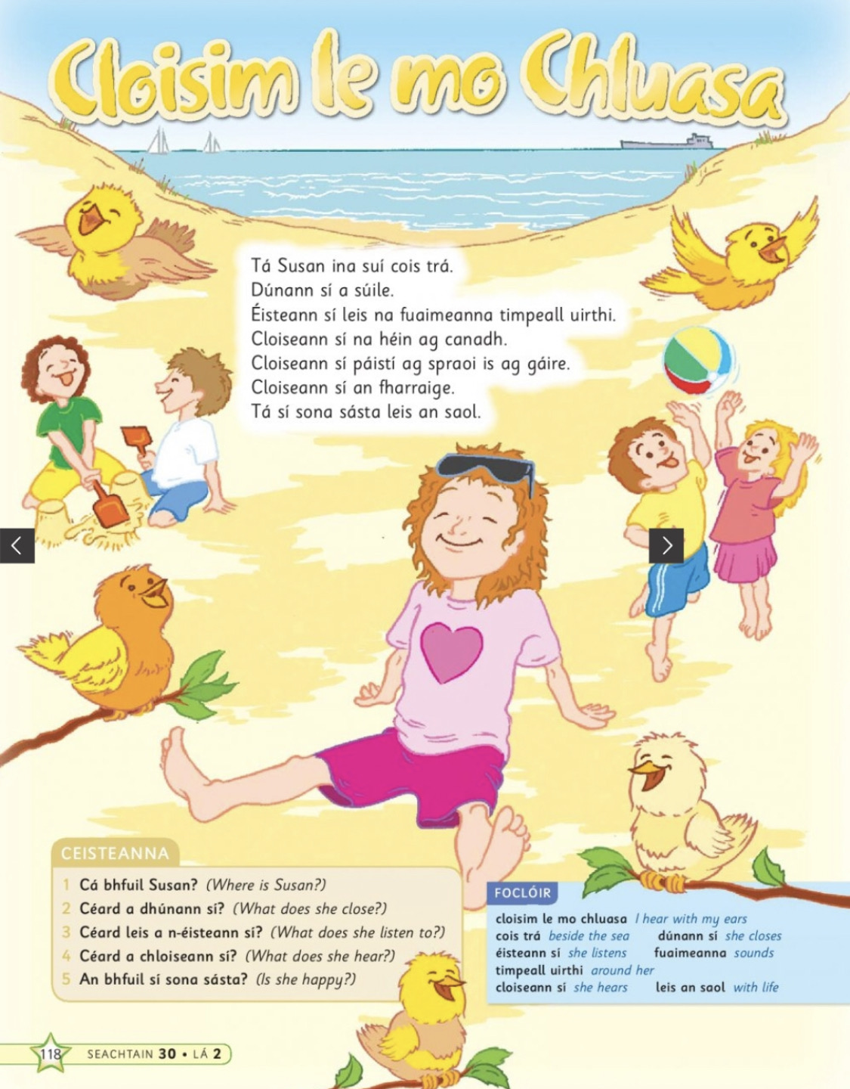

Time Capsule: Wednesday

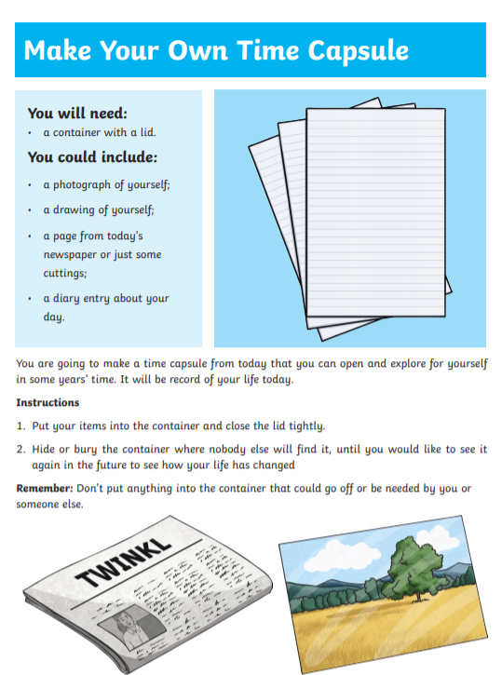

Léigh sa Bhaile: Wednesday
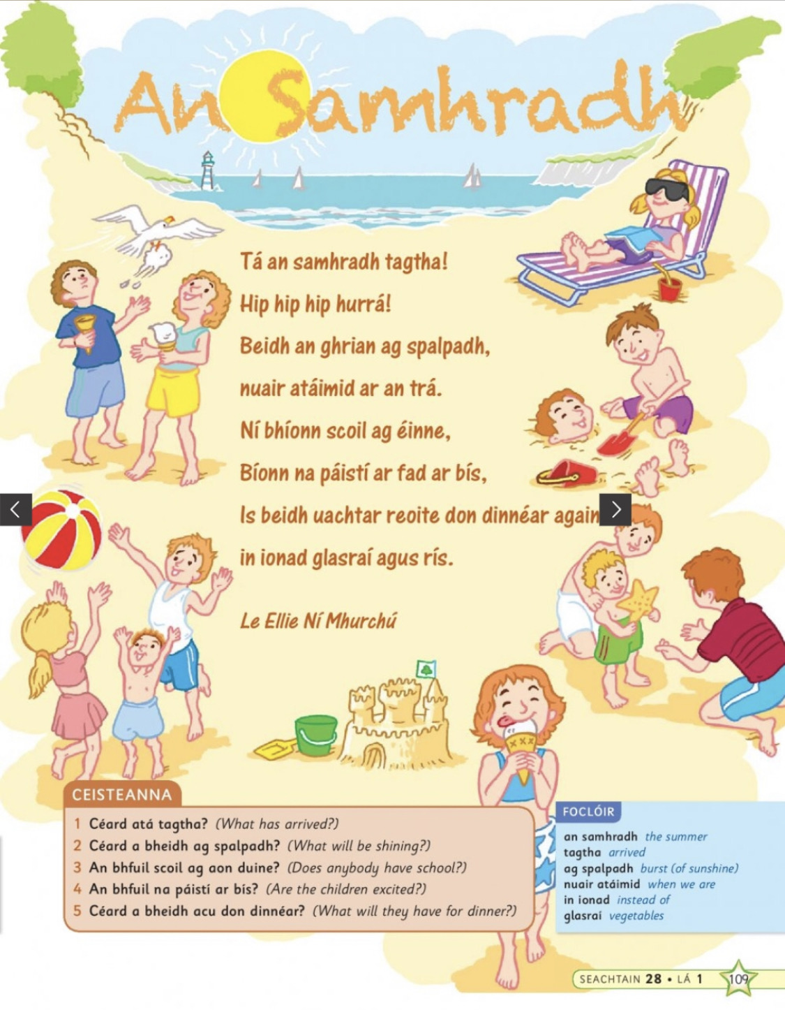

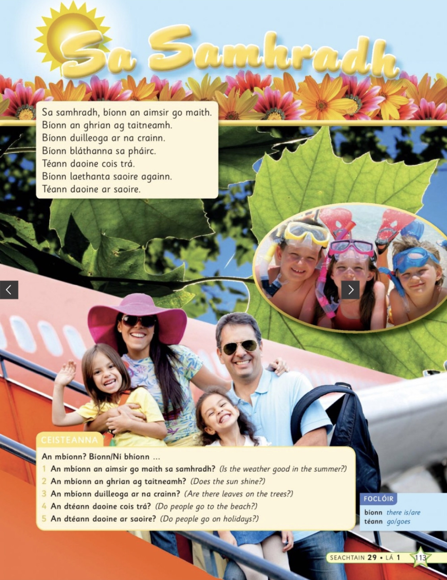
Léigh sa Bhaile: Thursday

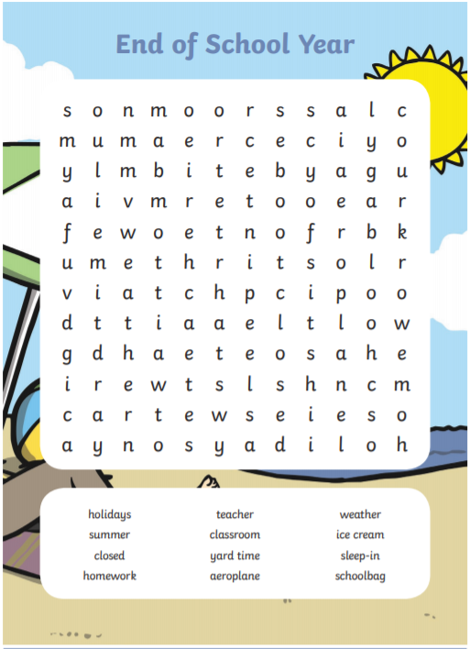
Monday- End of school year word search:

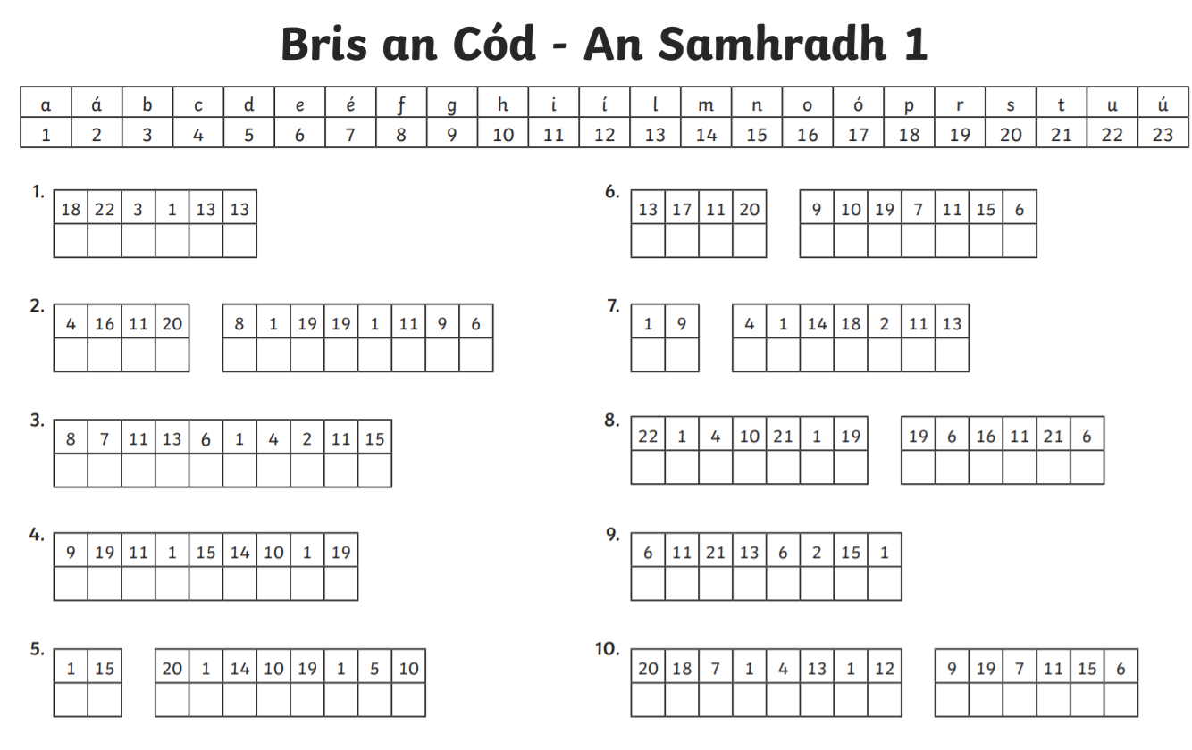
Monday- Bris an Cód: An Samhradh

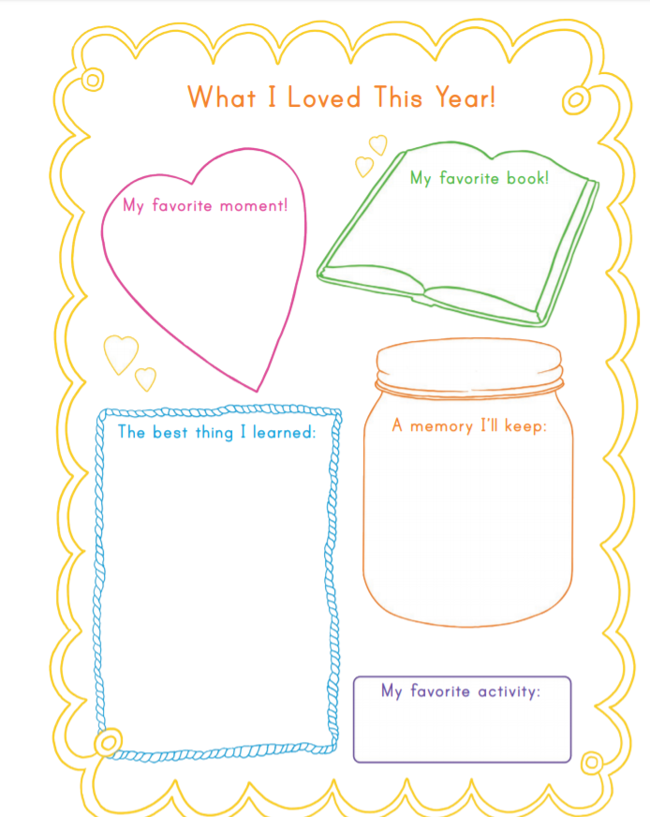
Tuesday: End of year memories writing activity
Tuesday: Mindfulness Colouring activity

