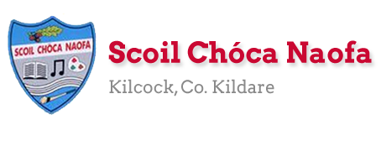
Dear 3rd Class,
You’ve done it! You have come to the end of one of the most challenging school years you will ever have. I’m very proud of you. I know your parents are too. It wasn’t easy, it was very difficult at times and the last few weeks have been even more difficult, but you got through it. You’ll remember this experience for a long time. As you get older you can use this experience to help you. If you go through a challenging time you now know that you can overcome a serious change of plan and overcome it.
I hope you enjoyed the virtual school tours last week. You have one more virtual tour in the plan over the next few days. We also have one last Zoom call before the summer holidays on Thursday, June 25th at 12 pm.
Thank you to your parents for coming into school last week to collect and drop off books. By now you will have received your booklists and school reports. If you didn’t, please email me and I will send them to you.
This is the last plan you will receive from me this year. It consists of material for seven days rather than five as we were due to be in school on Monday, June 29th and Tuesday, June 30th. Instead of sending a separate plan for those days I have included them here. A lot of the work this week is really useful information that you should know. Maybe you already do, great! If not, learn your Eircode, emergency service numbers and parent’s phone numbers.
This week is our Scoil Chóca Naofa Bake Off! Use recipe books at home or look for recipes online. You could bake something that you just love to bake at home, you could perfect a previous recipe you tried or even something that your family like to bake. Do you have a recipe that has been handed down through the family? Send pictures to mstierney@scoilchoca.ie. If you and your parents would like, you can donate €1 to Temple Street Children’s Hospital via this link: www.templestreet.ie/event/great-irish-bake/.
Mrs Mc Cabe and Ms. Curran are both working for the next seven school days and would be delighted to hear from those children who work with them. Their email addresses are mscurran@scoilchoca.ie & msmccabe@scoilchoca.ie.
Boys and girls, you really are a great class and I really enjoyed teaching you this year. Unfortunately, the year didn’t end how we would have liked but I hope we will see each other soon. Until then, stay safe. Be kind to yourselves and to others. Enjoy your summer holidays!

Ms. Tierney

Work for Ms. Tierney’s 3rd Class:
Monday 22/06/20 – Friday 30/06/20
Monday  22/06 | English:  - Research a recipe for the Scoil Chóca Bake Off.  - Discuss the recipe with a parent and make a plan for what you want to bake.  Maths:  - List the ingredients needed and make a shopping list for ingredients. Go shopping. Ask permission to do this, gather the ingredients needed in the shop, estimate the cost, pay, calculate and check your change.  Gaeilge:  - Léigh sa bhaile- Read the text. Writing the answers is optional.  PE:  - Sit up challenge- How many can you do in 1 minute?  - Press up challenge- How many can you do in 1 minute?  - Run 500m/1km/2km- Choose a distance.
Tuesday  23/06 | Maths:  - Measure out the ingredients. With a parent, heat oven to required temperature.  - Be aware of cooking and cooling time.  English:  - Write out your recipe- list the ingredients and write your method/instructions.  Other: Scoil Chóca Bake Off!  - Get baking. Good luck . Send me a photo of the finished product.  PE:  - Wheelie Bin Challenge- Try to kick or throw a ball into the bin from 5 metres/10 metres/15 metres- Have 10 attempts from each distance.  Gaeilge:  - Léigh sa Bhaile- Read the text. Writing the answers is optional.
Wednesday  24/06 | English:  - Time Capsule Activity  Maths:  - Mathletics  - Learn your parent/guardian’s number off by heart in the case of an emergency.  Gaeilge:  - Léigh sa Bhaile- Read the text. Writing the answers is optional.  PE:  - Go 5kms on wheels- bike, scooter, roller blades
Thursday  25/06 | English:  - Read your book/magazine/newspaper for 15 minutes.  - Acrostic Poem- My School Year  Gaeilge:  - Léigh sa Bhaile- Read the text. Writing out the answers is optional.  Maths:  - Mathletics  - Learn the phone number to contact emergency services: 112  PE:  - Ninja Fitness Rocks are back in the Bawnogue in Kilcock. They are spaced out around the 1km loop with lots of fun exercises for all.  Other: Weekly Zoom Call at 12pm.
Friday  26/06 | Maths:  - Learn your Eircode off by heart- this is vital in the case of an emergency at home.  Art:  - My Summer Vision activity- Draw your vision for your summer holidays in the sunglasses.  PE:  - Go outside and be active for 30 minutes.  Other: Virtual School Tour  - African Safari- your live safari experience from Massai Mara, Kenya and Great Kruger Park, South Africa.  https://wildearth.tv/kids/
Monday  29/06 | English:  - End of school year word search  Gaeilge:  - Bris an cód/Crack the code  Other: PAWS (Primary Aquatics Water Safety)  - Read through this document when you have the time. It can be done whenever suits you. It is important information to know before the summer holidays about Water Safety.  https://watersafety.ie/wp-content/uploads/2019/10/PAWS-3-Presentation.pdf
Tuesday  30/06 | English:  - End of year memories writing activity  Other: PAWS (Primary Aquatics Water Safety)  - Once you have read the information on Water Safety you can try some activities here to test your knowledge before the summer holidays.  http://paws.edco.ie/third-and-fourth-classes/  Art:  - Summer Mindfulness colouring activity  Give yourself a clap on the back for surviving a crazy school year.  Relax and enjoyed a well-deserved summer holiday. Yipppeee.

SEN/EAL work 3rd/4th Class OT June 22nd-30th Teachers: Ms. McCabe & Ms.Curran.
Note: As we begin our final week-and-a-bit, we really hope that each one of you can contact us to say ‘goodbye’! This week, ask your parent to give you a Quick Fire table test, a mix of 50 multiplication & division tables. Email us the results! COUNT IN 6’s, 7’s, 8’s, 9’s. Stay active, with a fun outdoor activity every day. It’s almost holiday time!!!
EAL: Local and Wider Community | ORAL: Tell your parents about all the SERVICES we have in Kilcock.  WRITE: Add in these services to the map of Kilcock that you drew, last week!  Also, write 5 sentences about the service you use most often....maybe the library, or the bus service?
Speech and Language | Each day, this week, tell your parents about something that you would love to do during the Summer holidays.  Explain the idioms ‘ You hit the nail on the head’ and ‘I smell a rat’.....to your family.  Conversation Starters – Pick your 7 favourite sentences to repeat....one each day for final week.
Literacy A & B | SNIP programme....finish out final session, session 15.  Phonics/Digraphs: Practice spelling the ‘ch’ words, if an adult can call them out for you. Read all the dictations/sentences from Lesson 55 & write 2 or 3 sentences of your own, using as many ‘ch’ words as possible.  http://theschoolhouse.us/lessons/lesson55.html  Cloze procedure : Fill the Blanks. Try another one of the Memory Activities!  Please keep up the reading, every day!  https://www.oxfordowl.co.uk/for-school/oxford-owl-ebook-collection  These are free ebooks and you can find your level.
Toe by Toe | Final SNIP lesson....session 25. Well done, everyone!  Cloze procedure: Fill the Blanks.  Pick a different Memory Activity each day, ones that you liked.  Please read and ask an adult to read with you.
SEN Individuals | Continue doing one Mindful Brain Break Activity each day:  https://www.twinkl.ie/resource/us-p-12-mindful-minute-brain-break-cards  Fry’s Words: Go back over any trickey words on all of the sheets.  Check in with Laces challenge for June!  Cloze procedure: Fill the Blanks.  Do the last 2 lessons from below: (When I Feel.../Why Can’t....)  https://www.twinkl.ie/resource/social-situations-to-help-children-during-the-coronavirus-pandemic-t-s-2548781  Talk about one nice thing you want to do during your holidays, each day.
Contact SEN Teachers: msmccabe@scoilchoca.ie mscurran@scoilchoca.ie
Ms. McCabe & Ms. Curran are both working until the end of the year.

Léigh sa Bhaile: Monday
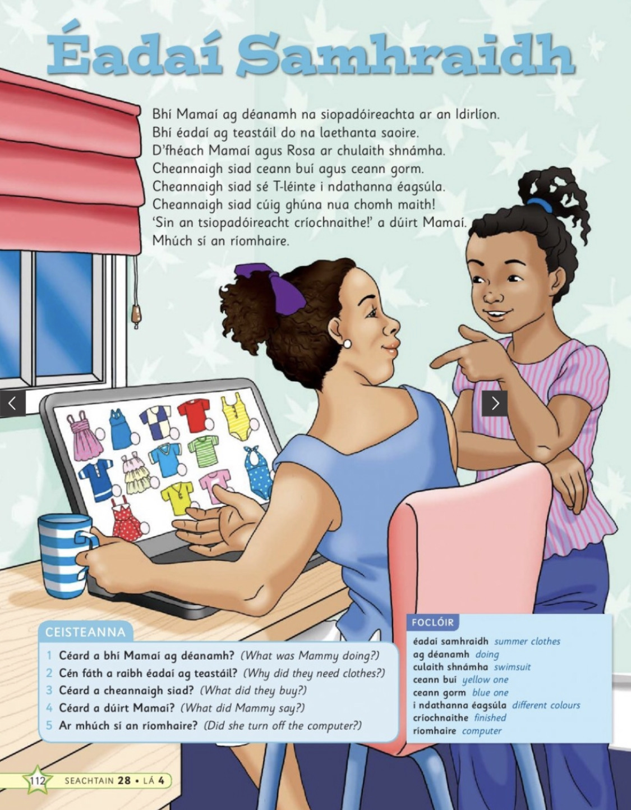

Tuesday: Recipe template
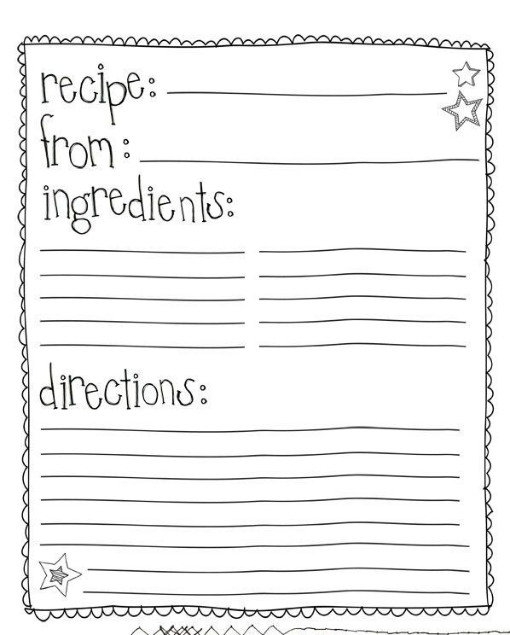

Léigh sa Bhaile: Tuesday
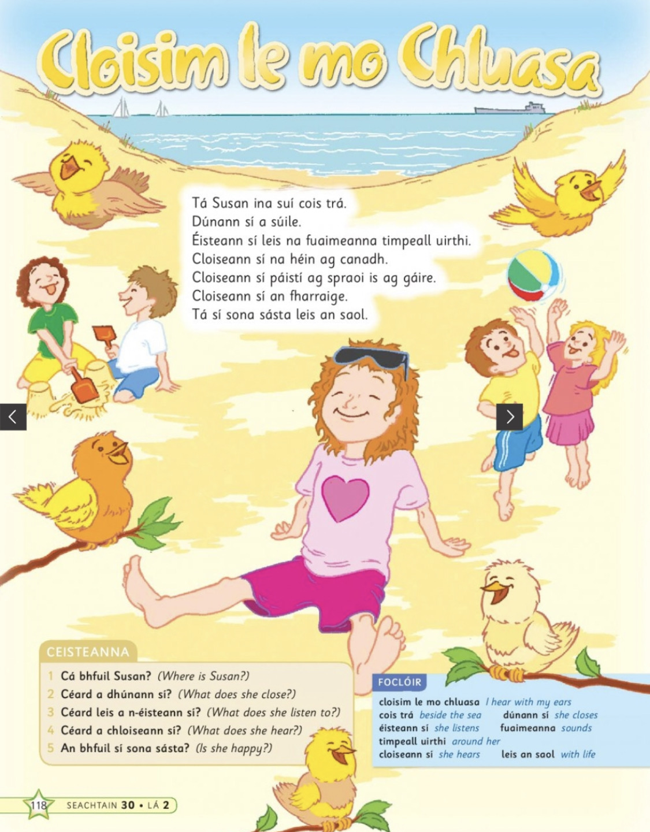

Time Capsule: Wednesday

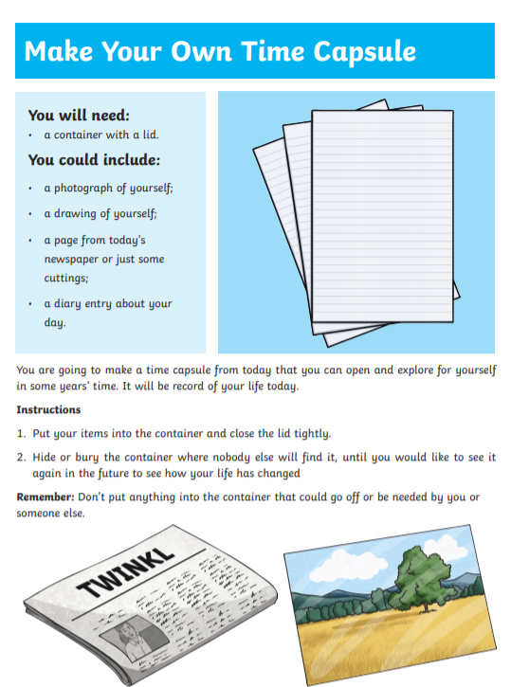

Léigh sa Bhaile: Wednesday
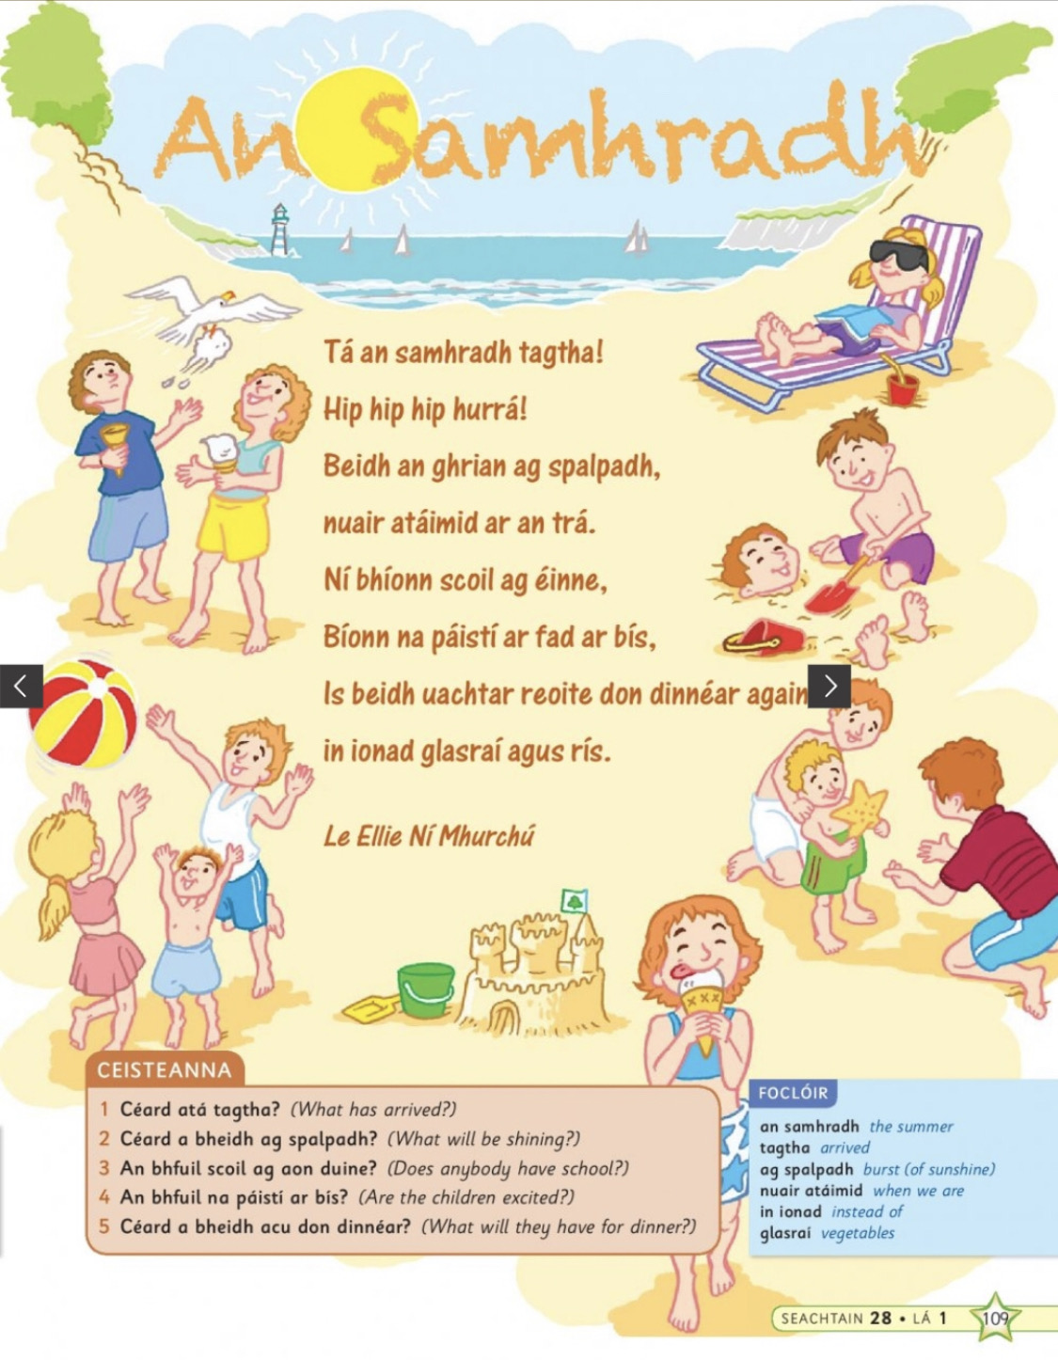

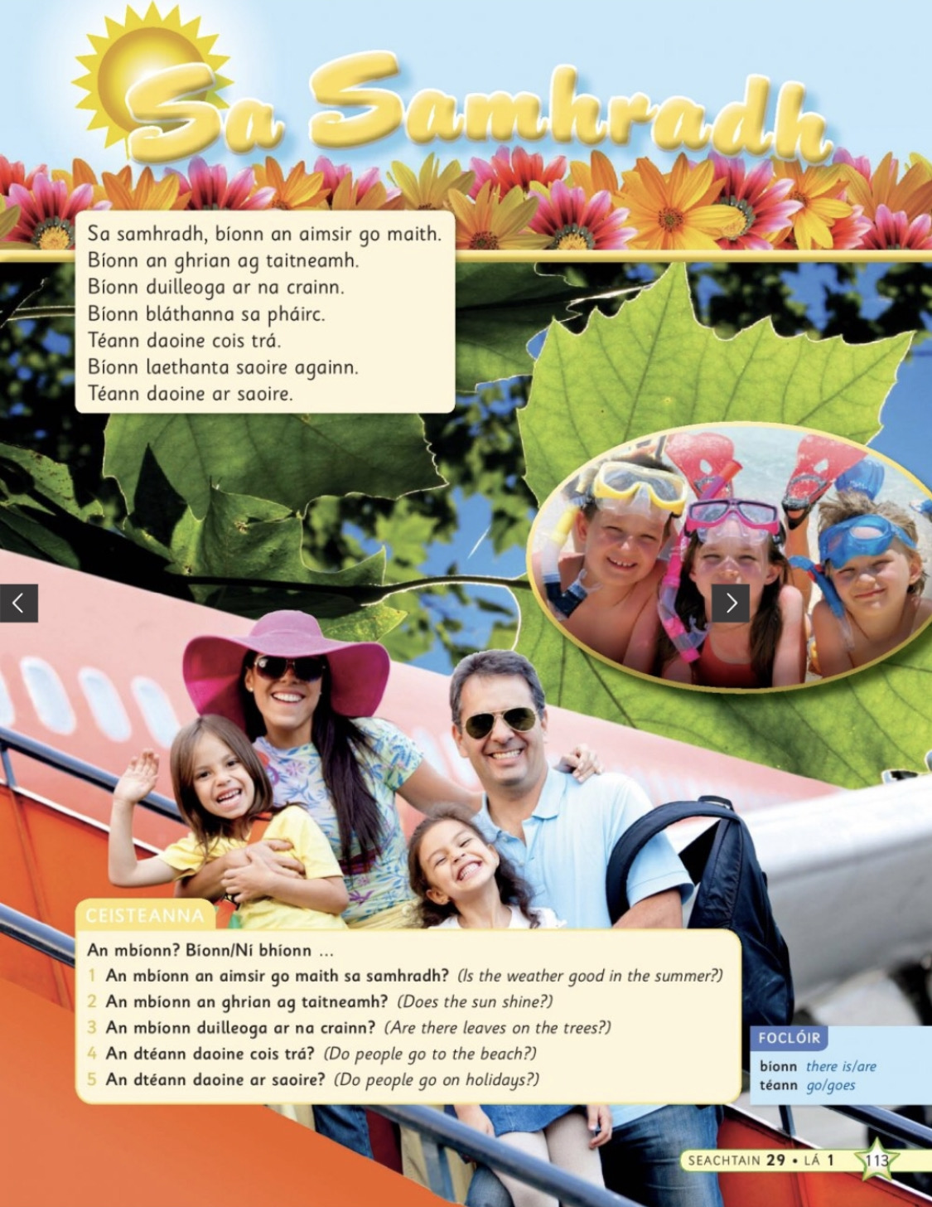
Léigh sa Bhaile: Thursday

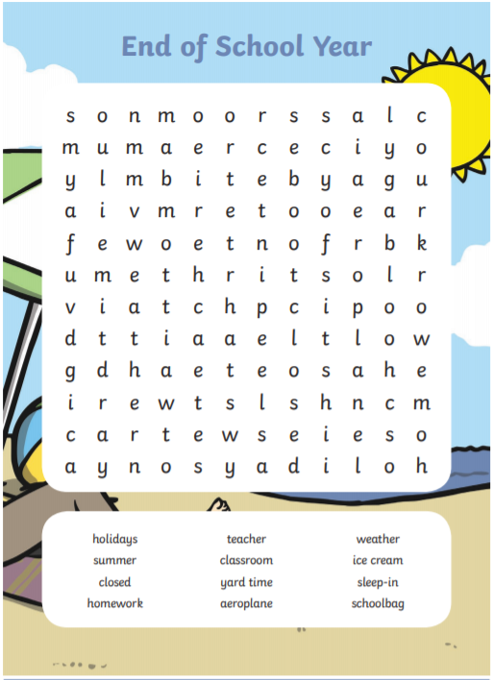
End of school year word search:

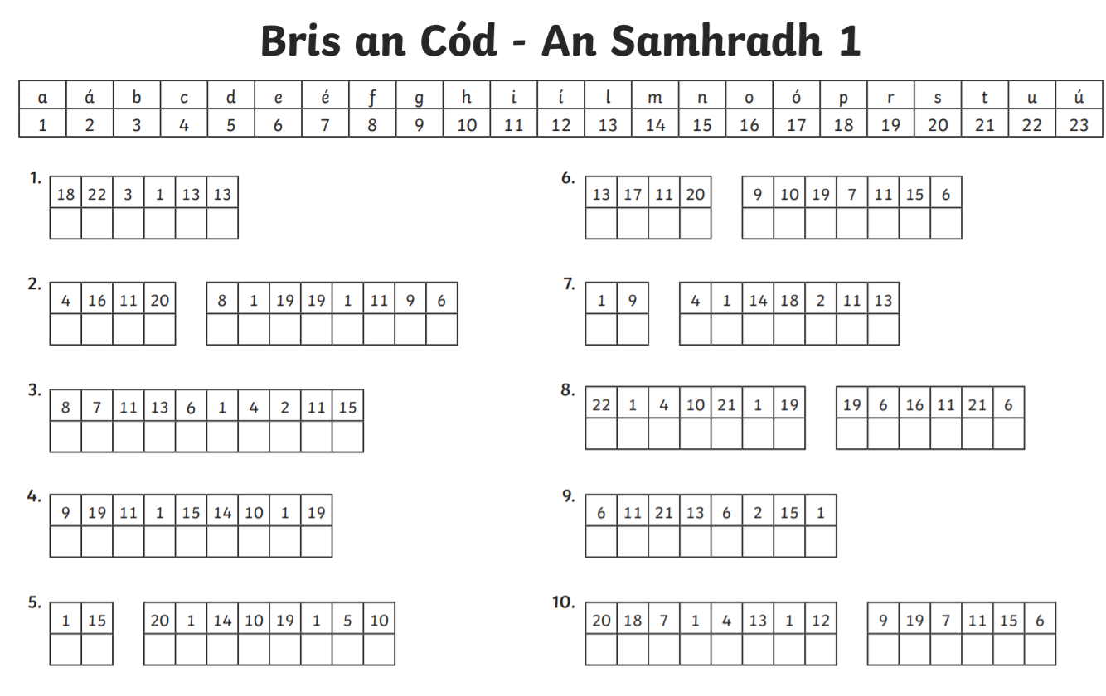
Bris an Cód: An Samhradh

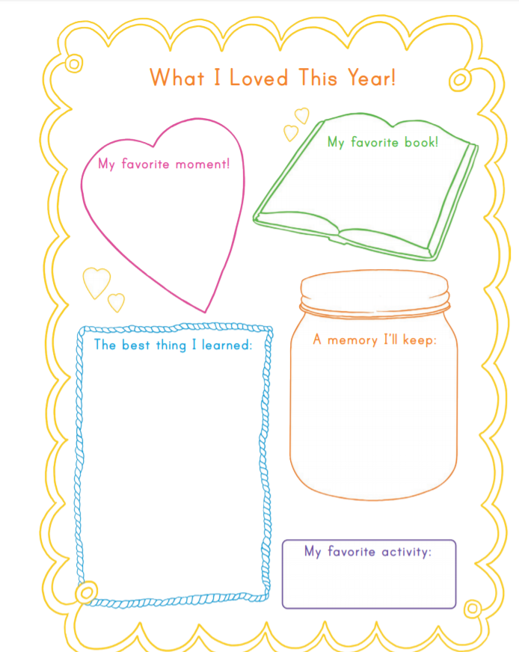
End of year memories writing activity:
Mindfulness Colouring activity:

