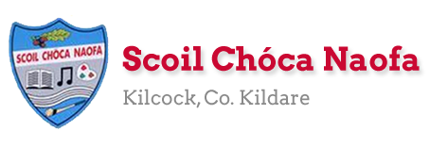
Dear 4th Class,
I hope you and your family are safe and well this week. Last week was Sports Week and I hope you used this chance to get outside and get active. I hope you enjoyed it. I am sure you will agree that the sports videos on the school website were brilliant.
It was so lovely to see you all again last week on our Weekly Zoom Assembly. I enjoyed catching up with you and hearing what you were up to during Sports Week. I would like to commend you on your wonderful behaviour during the meeting. You were fantastic. Details of the next zoom call will be sent to your parents in the coming days. I am looking forward to it already.
This week you are going to be going on some Virtual School Tours. Click the link in the lesson plan. Enjoy. Our zoom call next week will be based on the virtual tours. I’ll be asking your opinion on which one you enjoyed the most.
School Reports were sent to your parent/guardian last Friday at 12pm. If your parent/guardian did not receive your report, please ask your parent/guardian to contact me via my school email address.
You parents are invited into the school next Tuesday at 12 pm to collect and return your books/belongings etc. Your parent/guardian will also receive your booklist and this may include details of the name of your teacher for next year.
A massive thank you to you and your parents for sending me pictures of your work again this week. I love seeing what you have been getting up to and I am so pleased with all of the work you have been doing at home. Please continue to send the work you are most proud of to mstierney@scoilchoca.ie. Have a look at the website each week to see some pictures of the fantastic work being done at home.
Ms. Heffernan would be delighted to hear from those children who work with her. Her email address is msheffernan@scoilchoca.ie .

Enjoy the virtual school tours,
Ms. Tierney
mstierney@scoilchoca.ie
Wishing Grace Mc Gearty a happy birthday as she celebrates her 11th birthday on Sunday. Let’s all sing happy birthday to Grace as we wash our hands at home.

Work for Ms. Tierney’s 4th Class:
Monday 15/06/20 – Friday 19/06/20
Monday | English:  - ‘Summer in Ireland’ Reading Comprehension: Read & answer the questions.  Maths:  - Maths Matters: Pg. 156  Virtual School Tour: Tayto Park  https://www.youtube.com/watch?v=6UQmS5dHb6U&feature=youtu.be
Tuesday | Irish:  - Léigh sa Bhaile: Lch 9 Léigh agus freagair na ceisteanna  Maths:  - Maths Matters: Pg. 157  Virtual School Tour: Le Louvre  https://www.louvre.fr/en/visites-en-ligne (Click launch virtual tour)
Wednesday | English:  - ‘My Summer Bucket List’ writing activity (See below)  P.E: Toss a Teabag challenge  - Click the icon below to watch Mr. Bracken’s wonderful demonstration of tossing a teabag into a cup. (Ms. Tierney & Ms. Smith failed miserably). Give it a try.  Virtual School Tour: Minecraft Digital Escape Room  https://docs.google.com/forms/d/e/1FAIpQLSfKkueafhM5Glhz2MesjhWtnrGrvP24BqaX8ijUM1IGln_xMQ/viewform
Thursday | Irish:  - Léigh sa Bhaile: Lch 10 Léigh agus freagair na ceisteanna  Art:  - Snorkelling Self-Portrait: Use markers/colouring pencils/crayons to draw and colour your own portrait (See example below)  Virtual School Tour: Aquarium of the Pacific Webcam Tour  http://www.aquariumofpacific.org/exhibits/webcams (Click on some of the live webcams)
Friday | Maths:  - Maths Matters: Pg. 158  Virtual School Tour: Harry Potter Digital Escape Room  https://docs.google.com/forms/d/e/1FAIpQLSflNxNM0jzbZJjUqOcXkwhGTfii4CM_CA3kCxImbY8c3AABEA/viewform?fbclid=IwAR3wMMa5PwPM_eoXaDVipqrwSC194-eVq3m5oleIbo_wJapQRMLoI59VHdQ

Teacher: Ms. Heffernan
Note: SEN teachers have added work on to the teachers’ plan. Children can decide to do this work instead of something the teacher has assigned. It is not extra work. Also, we would be delighted if you could email on a picture of something that your child has done and is proud of so we can see their lovely work again!
Language | This week we are going to try to talk for 30 seconds about one of the following topics. https://rainbow3to6.cjfallon.ie/class/fourth/units/10/lesson/4/slide/2  You could try playing the Alphabet game, where you pick a group of headings such as boy’s name, girl’s name, country, food, song or whatever topics you like and choose a letter of the alphabet. Try to get a word for each heading. For example B: Brian, Barbara, Brazil, beans, Baa, Baa, Black Sheep.  Would you like to try some anagram riddles? See the worksheet below.  Keep reading!  If anybody needs any more reading material, please let me know. If you’ve read or listened to a story, I’d love to hear what you thought about it.  Send me an email to let me know how you’re getting on-I’d love to hear from you!
Contact SEN Teacher: msheffernan@scoilchoca.ie

Reading Comprehension: Summer in Ireland

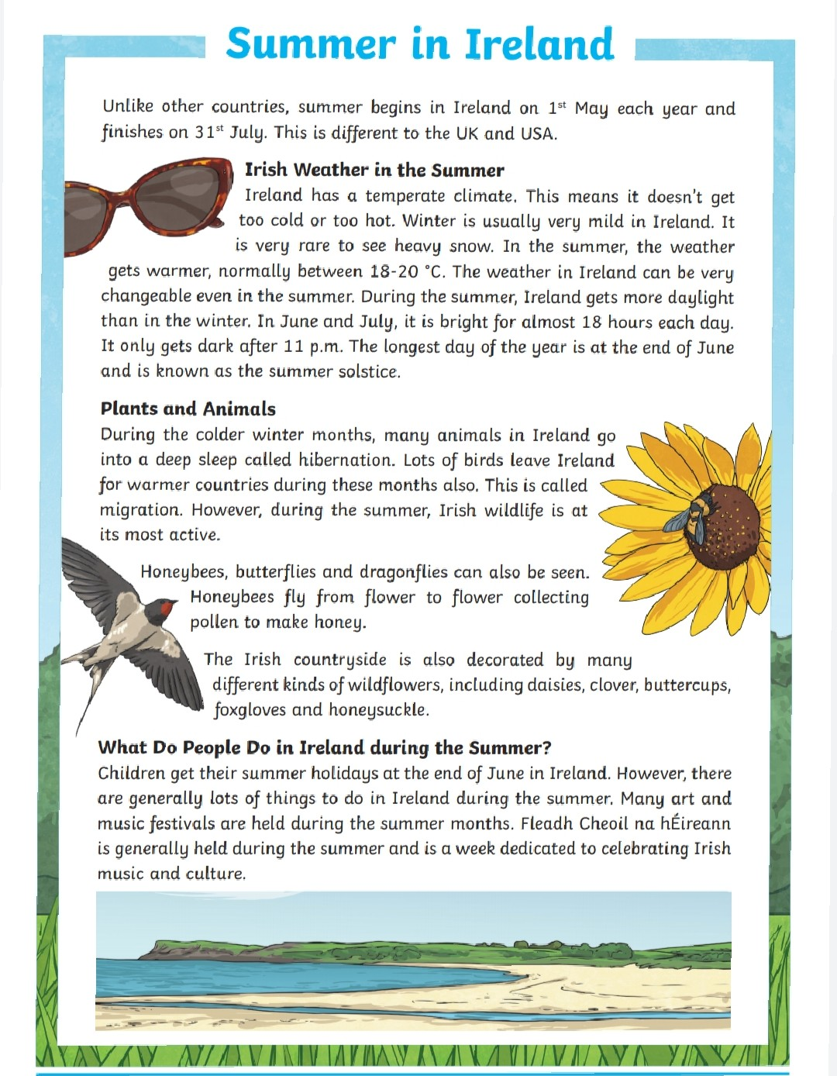

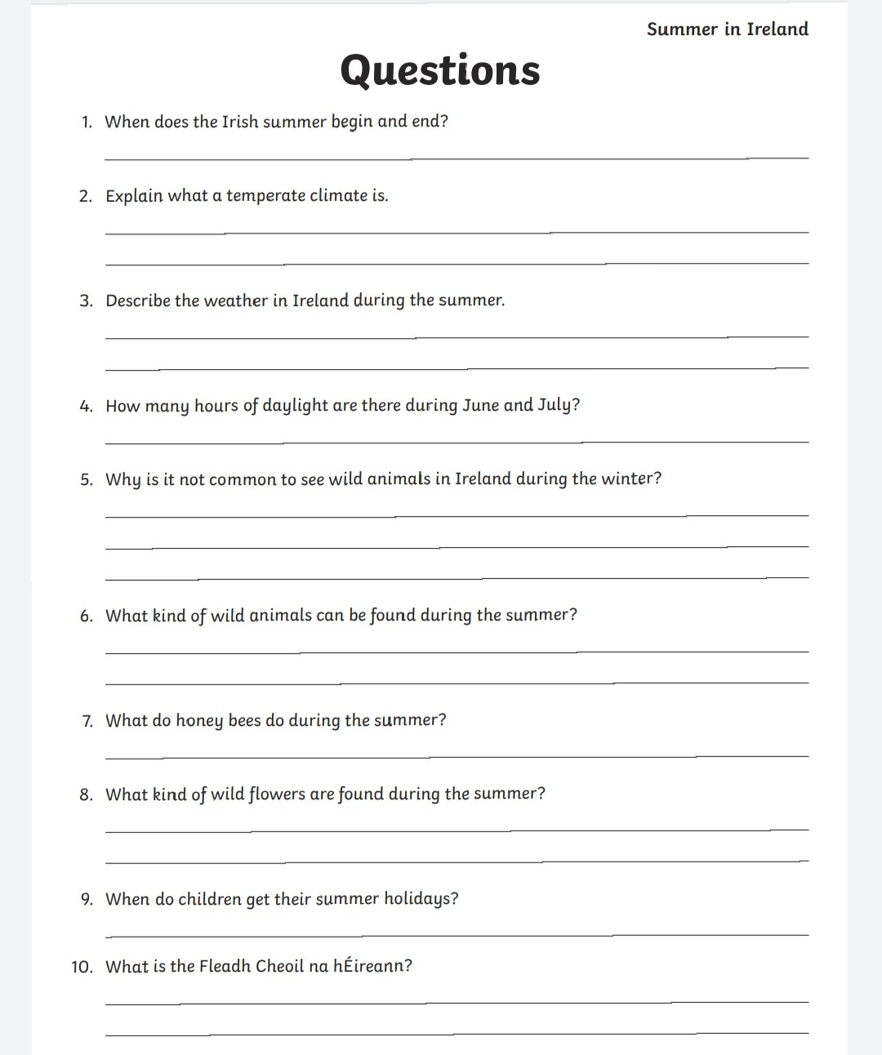

‘My Summer Bucket List’ writing activity:

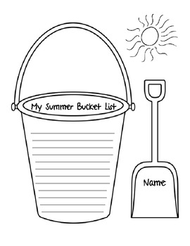

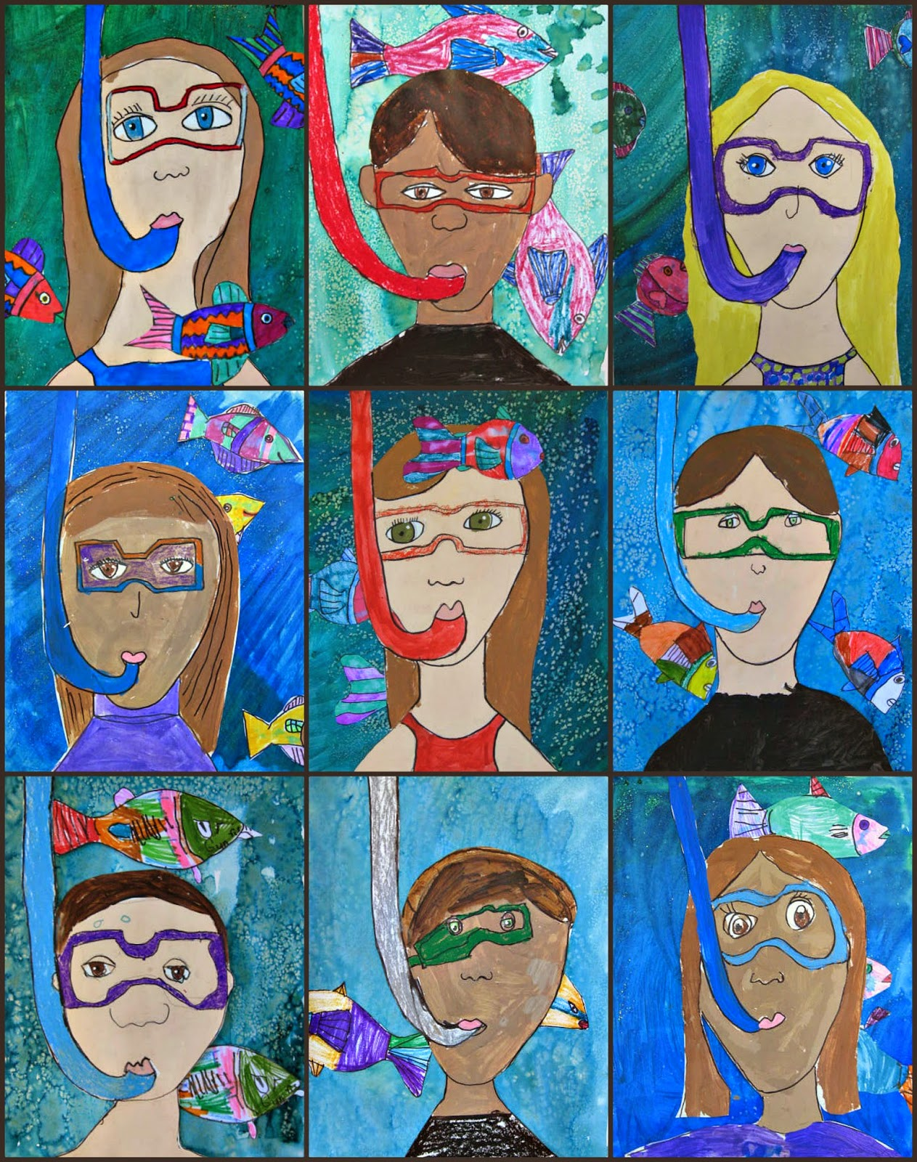
Art: Snorkelling Self-Portraits

Léigh sa Bhaile- Lch 9

