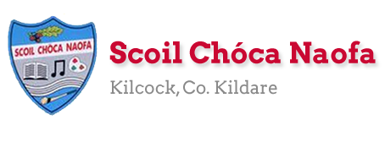
Dear 3rd Class,
I hope you and your family are safe and well this week. Last week was Sports Week and I hope you used this chance to get outside and get active. I hope you enjoyed it. I am sure you will agree that the sports videos on the school website were brilliant.
It was so lovely to see you all again last week on our Weekly Zoom Assembly. I enjoyed catching up with you and hearing what you were up to during Sports Week. I would like to commend you on your wonderful behaviour during the meeting. You were fantastic. Details of the next zoom call will be sent to your parents in the coming days. I am looking forward to it already.
This week you are going to be going on some Virtual School Tours. Click the link in the lesson plan. Enjoy. Our zoom call next week will be based on the virtual tours. I’ll be asking your opinion on which one you enjoyed the most.
School Reports were sent to your parent/guardian last Friday at 12pm. If your parent/guardian did not receive your report, please ask your parent/guardian to contact me via my school email address.
You parents are invited into the school next Tuesday at 12 pm to collect and return your books/belongings etc. Your parent/guardian will also receive your booklist and this may include details of the name of your teacher for next year.
A massive thank you to you and your parents for sending me pictures of your work again this week. I love seeing what you have been getting up to and I am so pleased with all of the work you have been doing at home. Please continue to send the work you are most proud of to mstierney@scoilchoca.ie. Have a look at the website each week to see some pictures of the fantastic work being done at home.
Ms. Curran is working this week and would be delighted to hear from those children who work with her. Her email address is mscurran@scoilchoca.ie .

Enjoy the virtual school tours,
Ms. Tierney
mstierney@scoilchoca.ie
Wishing Grace Mc Gearty a happy birthday as she celebrates her 11th birthday on Sunday. Let’s all sing happy birthday to Grace as we wash our hands at home.

Work for Ms. Tierney’s 3rd Class:
Monday 15/06/20 – Friday 19/06/20
Monday | English:  - ‘Summer in Ireland’ Reading Comprehension: Read & answer the questions.  Maths:  - Maths Matters: Pg. 149  Virtual School Tour: Tayto Park  https://www.youtube.com/watch?v=6UQmS5dHb6U&feature=youtu.be
Tuesday | Irish:  - Léigh sa Bhaile: Léigh agus freagair na ceisteanna  Maths:  - Maths Matters: Pg. 150  Virtual School Tour: Le Louvre  https://www.louvre.fr/en/visites-en-ligne (Click launch virtual tour)
Wednesday | English:  - ‘My Summer Bucket List’ writing activity (See below)  P.E: Toss a Teabag challenge  - Click the icon below to watch Mr. Bracken’s wonderful demonstration of tossing a teabag into a cup. (Ms. Tierney & Ms. Smith failed miserably). Give it a try.  Virtual School Tour: Minecraft Digital Escape Room  https://docs.google.com/forms/d/e/1FAIpQLSfKkueafhM5Glhz2MesjhWtnrGrvP24BqaX8ijUM1IGln_xMQ/viewform
Thursday | Irish:  - Léigh sa Bhaile: Léigh agus freagair na ceisteanna  Art:  - Snorkelling Self-Portrait: Use markers/colouring pencils/crayons to draw and colour your own portrait (See example below)  Virtual School Tour: Aquarium of the Pacific Webcam Tour  http://www.aquariumofpacific.org/exhibits/webcams (Click on some of the live webcams)
Friday | Maths:  - Maths Matters: Pg. 151  Virtual School Tour: Harry Potter Digital Escape Room  https://docs.google.com/forms/d/e/1FAIpQLSflNxNM0jzbZJjUqOcXkwhGTfii4CM_CA3kCxImbY8c3AABEA/viewform?fbclid=IwAR3wMMa5PwPM_eoXaDVipqrwSC194-eVq3m5oleIbo_wJapQRMLoI59VHdQ

SEN/EAL work 3rd/4th Class OT June 15th -19th Teachers: Ms. McCabe & Ms.Curran. Contact SEN Teachers: msmccabe@scoilchoca.ie mscurran@scoilchoca.ie
Note: PLEASE email on a picture of something that your child has done recently, we miss them so much! Also keep reading and learning your tables daily. This week, revise division tables: ÷3,÷4 tables and practice saying them at the same speed back down as going up! This week you should continue being active. COUNT YOUR SKIPS. COUNT YOUR KEEPIE UPPIES. COUNT EVERYTHING. BACKWARDS AND FORWARDS FOR THE FUN. TAKE TURNS COUNTING. CATCH EACH OTHER OUT. COUNT IN 2’s, 3’s, 4’s, 5’s.
EAL: Local and Wider Community | ORAL: Talk to your parents about the town of Kilcock, the streets, the estate names, the important buildings.  WRITE: 5 sentences about where you live, name of the area, your address. Draw a map of your local area. Take a photo and send it on. Use lots of colours to mark the road you live on, your house and your neighbours houses
Speech and Language | Play the ‘What Is It Game’ for 5 minutes each day this week.  Explain the idioms ‘at loggerheads’ and ‘face the music’.....to your family.  Conversation Starters – Continue with these, one per day.
Literacy A & B | SNIP programme (session 14)..... 3 pages for the week.  Phonics/Digraphs (blended sounds): Read from Beach....to... Watch.  http://theschoolhouse.us/lessons/lesson55.html  Cloze procedure :How we Move. Try another one of the Memory Activities!  Please keep up the reading, every day!  https://www.oxfordowl.co.uk/for-school/oxford-owl-ebook-collection  These are free ebooks and you can find your level.
Toe by Toe | Next SNIP session (session 24)..... 3 pages for the week.  Cloze procedure:How we Move. (Sports Week)  Try one of the Memory Activities!  Please read and ask an adult to read with you.
SEN Individuals | Cloze procedure :How we Move.  Challenge for June: Learn how to tie laces!! Practice 3 times per day.  Continue with new picture sequence – Up, Up & Away.  Try one of the Memory Activities!  Fry’s Words: Continue with the list you are on.  Start Lesson 2 of the following(Learning from home)  https://www.twinkl.ie/resource/social-situations-to-help-children-during-the-coronavirus-pandemic-t-s-2548781  Do the card on Other People’s Feelings:  https://www.twinkl.ie/resource/t-s-1272-other-peoples-feelings-thought-cards-set-2
Ms. Curran is working this week, Monday- Friday
Reading Comprehension: Summer in Ireland

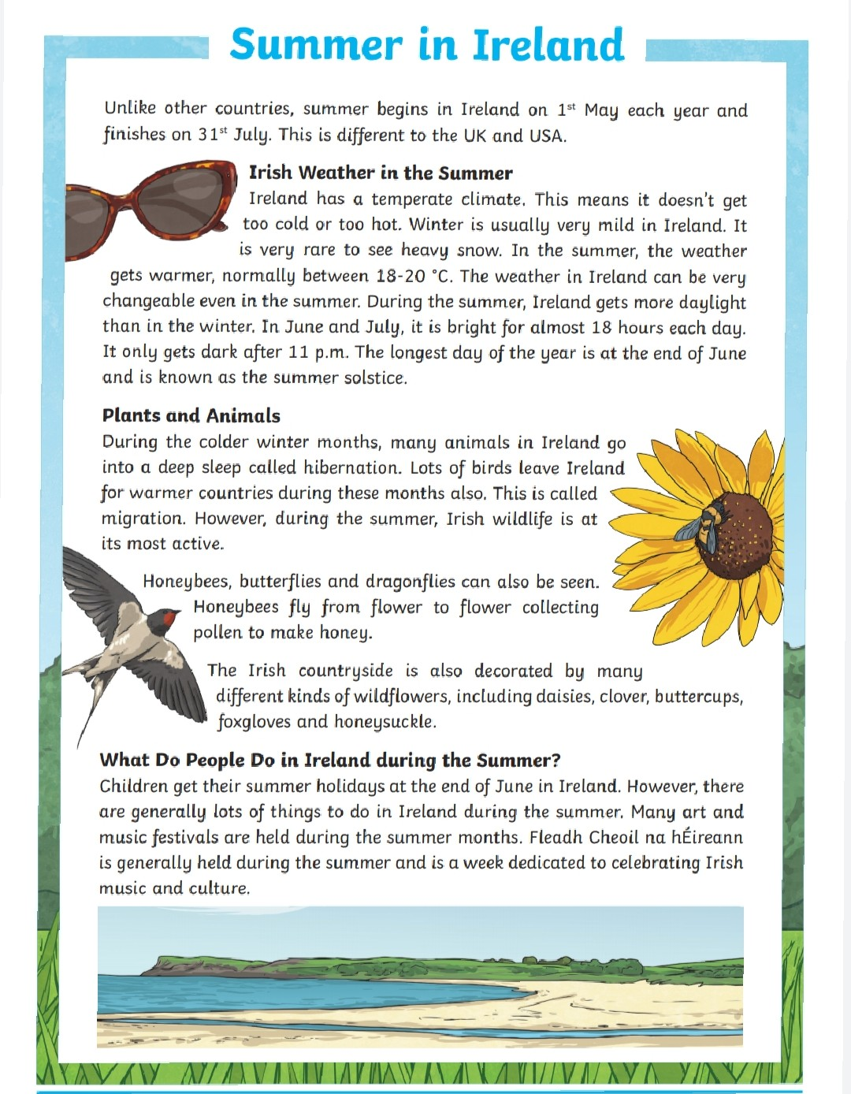

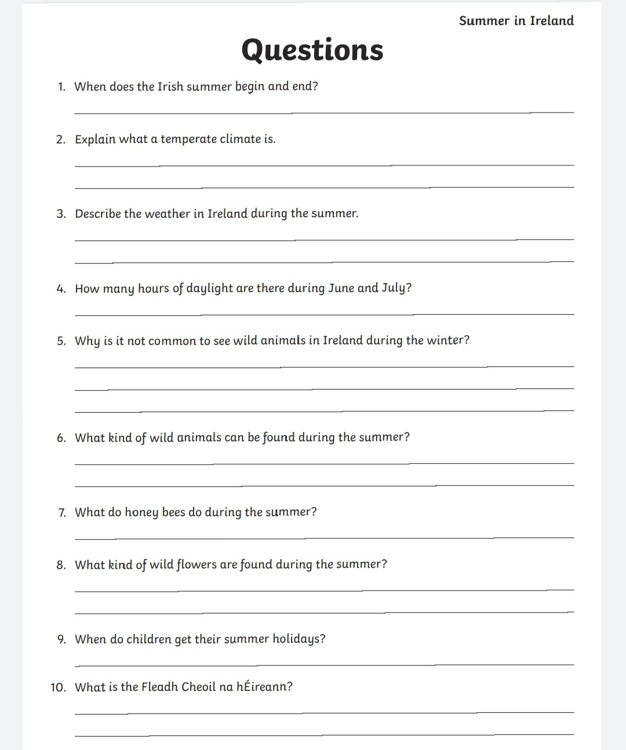

‘My Summer Bucket List’ writing activity:

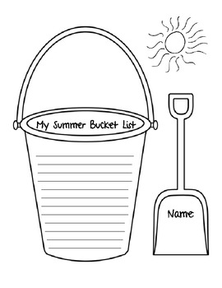

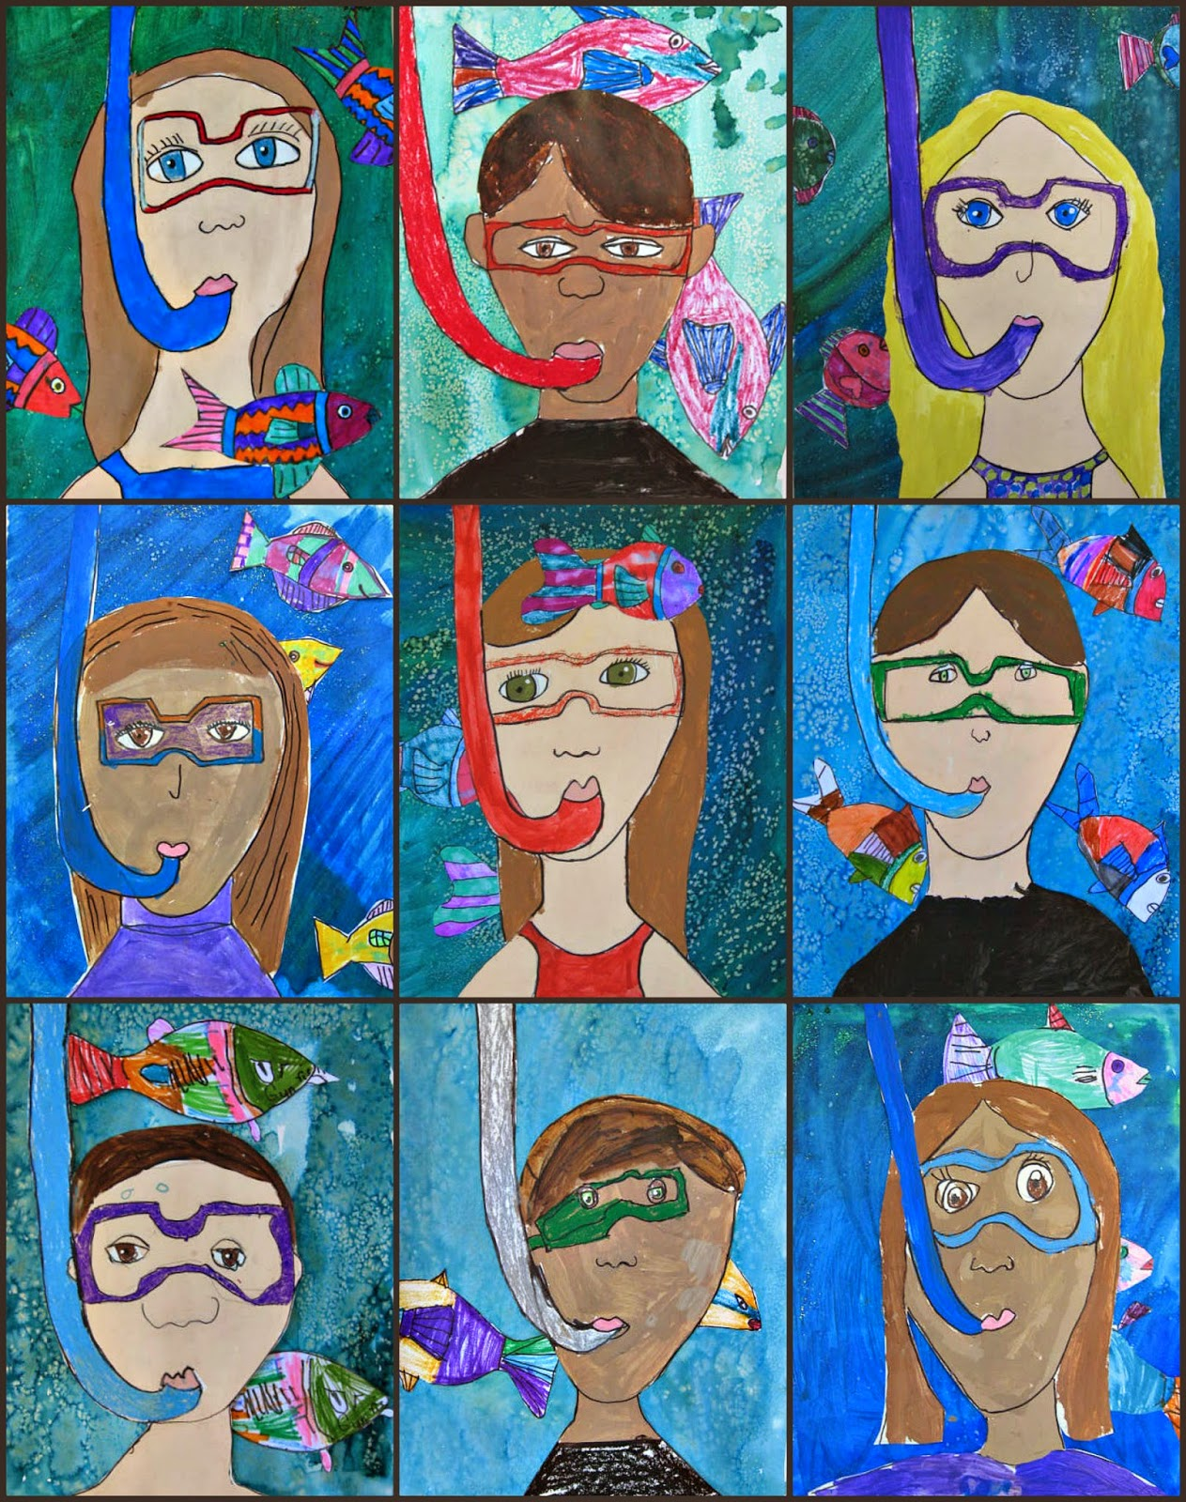
Art: Snorkelling Self-Portraits

