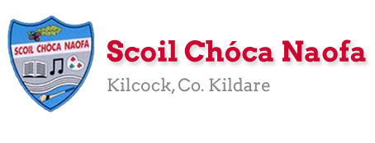
Work for Fifth Class: 22nd – 30th of June 2020
It’s the last week of school work!! CONGRATULATIONS girls. We are super proud of you!
We have included the last 2 days of school in this plan (next Monday and Tuesday).
This week we are asking you to bake something to participate in The Great Irish Bake event which raises money for Temple Street Hospital. Have a chat with your parents about this! Donations (optional) can be made to Temple Street Hospital on their website: https://www.templestreet.ie/event/great-irish-bake/
Ms. Heffernan’s and Ms. Tone’s groups will find work for them attached to the end of this plan. Those not doing Gaeilge please access your TTRS account
Please send us pictures of 2 pieces of work you are proud of if you can. We love hearing from you!
Our e-mail addresses are msfield@scoilchoca.ie and msmahon@scoilchoca.ie
Mon | English | - Research a recipe for the ‘Scoil Chóca Great Irish Bake’. Use recipe books at home or look online.  - Discuss the recipe with a parent and make a plan for what you want to bake.
 | Maths | - List the ingredients needed and make a shopping list for ingredients.  - Go shopping. Ask permission to do this, gather the ingredients needed in the shop, estimate the cost, pay and check your change.
 | Gaeilge | - Watch TG4 @ 10:00-10:30 Cúla 4 ar Scoil  nó  - Cur na focail san órd ceart (Put the words in the correct order)  - https://seideansi.ie/rang1/gniomhaiocht-2/L1/1/V1/Ceim1/AmLoinarscoil/  - https://seideansi.ie/rang1/gniomhaiocht-2/L1/1/V1/Ceim1/Cehiadseo/
 | P.E. | - Sit up challenge. How many can you do in 1 minute.  - Press up challenge. How many can you do in 1 minute.  - Run 500m, 1km, 1.5km or 2km. Choose a distance.
 | Other | - Read a book for 10 minutes (or more)  - Write a short story based on the characters in your book – write them a new story.
Tue | English | - Bake the cake/buns. Ask parental permission.  - Take a photo of what you decided to bake.
 | Maths | - Measure out the ingredients.  - Heat oven to required temperature.  - Be aware of the cooking time and cooling time.
 | Gaeilge | - Watch TG4 @ 10:00-10:30 Cúla 4 ar Scoil  nó  - Imir an cluiche beir ar na bolgáin (Play the game catch the bubbles)  Press/tap on the screen to swim up.  - https://seideansi.ie/rang1/gniomhaiocht-1/1/m/ceim1/
 | P.E. | - Wheelie bin challenge .Try to throw or kick the ball into the bin from 5 metres, 10 metres, 15 metres. Have 10 attempts each distance. Good luck!
 | Other | - Use a camera and take some interesting photographs of inside and outside your house. Have a look at the photography tips below to see what you can do. Remember, you need someone’s permission to photograph them.
Wed | English | - Procedure Writing. List the ingredients needed. List the utensils you needed. Write a detailed procedure how to bake/cook your chosen recipe.  - Illustrate it.
 | Maths | - Learn your Mum or Dad’s phone number off by heart.  - This is very important in an emergency situation.  - If you want a challenge go to Maths Matters p. 192 and complete the chapter (we have not covered the topics after Q45)
 | Gaeilge | - Watch TG4 @ 10:00-10:30 Cúla 4 ar Scoil  nó  - Cur na focail san órd ceart (Put the words in the correct order)  - https://seideansi.ie/rang1/gniomhaiocht-2/L1/1/V2/Ceim2/MoMhalaScoile/  - https://seideansi.ie/rang1/gniomhaiocht-2/L1/1/V2/Ceim2/RaicsaSiopa/
 | P.E. | - Go 5km on wheels…bike, scooter, roller blades
 | Other | - Kite Making and Sing Along to Oh, Let’s Go Fly a Kite  https://www.rte.ie/learn/2020/0611/1146787-5th-and-6th-class-kite-making/
Thurs | English | - Primary Aquatic Water Safety (PAWS) 5th /6th class. This is a very important safety topic leading into the summer holidays. The document is 24 pages long but it’s really important to read this. Important information is given on water safety at home, on the farm, in pools, at beaches, on boats and on inland waterways.  - https://watersafety.ie/wp-content/uploads/2019/10/PAWS-4-Presentation.pdf
 | Maths | - Learn the phone number to contact the emergency services  - 112  - If you want a challenge go to Maths Matters p. 192 and complete the chapter (we have not covered the topics after Q45)
 | Gaeilge | - Watch TG4 @ 10:00-10:30 Cúla 4 ar Scoil  nó  - Imir an cluiche beir ar na bolgáin (Play the game catch the bubbles)  Press/tap on the screen to swim up.  - https://seideansi.ie/rang1/gniomhaiocht-1/1/m/ceim1/
 | P.E. | - Ninja Fitness Rocks are back in the Bawnogue in Kilcock. They are spaced out around the 1km loup with loads of fun exercises for all.
 | Other | - Take a virtual tour through President Michael D. Higgins’ house – Áras an Uachtarán. Keep an eye out for his dogs Bród and Shadow!  - https://president.ie/en/explore-visit/interactive-tour
Fri | English | - Online interactive challenges suited to 5th/6th class on PAWS  - http://paws.edco.ie/fifth-and-sixth-classes/
 | Maths | - Learn your home Eircode off by heart.  - This is vital to know in case of an emergency at home.  - If you want a challenge go to Maths Matters p. 192 and complete the chapter (we have not covered the topics after Q45)
 | Gaeilge | - Watch TG4 @ 10:00-10:30 Cúla 4 ar Scoil  nó  - Cur na focail san órd ceart (Put the words in the correct order)  - https://seideansi.ie/rang1/gniomhaiocht-2/L1/1/V3/Ceim%203/PeataBeir/
 | P.E. | - Go outside and be active for 30 minutes.  - Go for a walk, run or cycle with a friend.
 | Other | - Zoom Call with your class. Check e-mail for invite and time.
Mon 29th | English | - Write a letter to your 6th class teacher. If you send it to us we can give it to them. Tell them about yourself, what you enjoy, dislike, find easy or find hard about school.
 | Maths | - Make a timeline of your school year. Include all the nice things you can remember from the year (Marathon, trip to Carton, BT Young Scientist, spooky walk, pageant…)
 | Gaeilge | - Éist leis agus can an t-amhrán (Listen to and sing the song)  - https://www.youtube.com/watch?v=Hz63M3v11nE
 | P.E. | - Go somewhere new for a walk, run or cycle with a family member or friend  - Take some time to look at the plants and creatures that you pass
 | Other | - Have a look at your book list for September and make a shopping list of what you need to buy. Check if you already have some of the items from this year or if an older sibling/cousin has any.
Tues 30th | English | - Write an e-mail to your teacher to say goodbye until September!
 | Maths | - Research the prices of the items on your booklist for September. Add up the total cost of everything you need.
 | Gaeilge | - Déan an cuardach focal (Do the wordsearch)  - See below.
 | P.E. | - Go outside and be active for 30 minutes  - Suggestions: Walk, jog, run, trampoline, cycle, scoot, play games (chasing, hide and seek, tip the can, capture the flag)
 | Other | - Pack away and tidy up all your school items from the year. Clean out your schoolbag and wash it if needed. Sort through your pencils, pens and colours. Make sure your name is still on everything and they are all ready to go for September.
Extra Activities - Optional
Inside  - Collect and count up any coins you have – make a plan for what you will buy  - Build a fort using pillows, sheets and blankets. Bring your book inside and relax | Outside  - Watch the clouds pass by, how many shapes/objects can you see?  - Play some music and have a dance
Free eBooks access: https://www.oxfordowl.co.uk/for-home/find-a-book/library-page/?view=image&query=&type=book&age_group=Age+9-11&level=&level_select=&book_type=&series=#

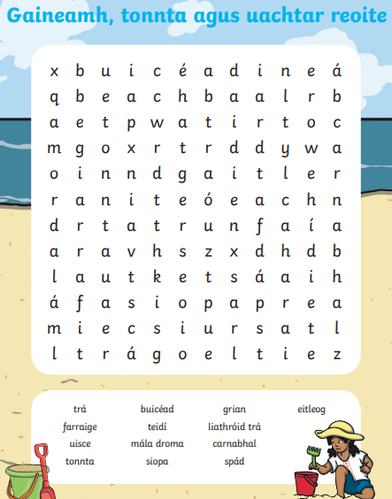

Photography Tips
- Take your time. Make sure the camera is focused on the object you want to photograph.
- Look back at your photographs and see if you’re happy with them.
- Use zoom to take extreme close ups.
- Experiment with the flash to see if it improves your photograph.
- Don’t take too many photographs – delete any you don’t like/need.
- Experiment with which section of your photograph the object will be in – the middle/top right corner/bottom left.
- Experiment with the height you take your photographs at/the angle you point the camera at. Try taking the photograph from below/above the object.
- Have a look at the effects on your camera – can you add black and white/soft focus/retro effect?
- Don’t be afraid to tilt your camera left and right – experiment with line and angle.
- Investigate lighting – do your photos look better when the object has light behind it? Do they look better when the light is coming from behind you and the camera? (Light can be a window, door, lamp or ceiling light).

SEN work 5th Class week beginning 22nd June 2020
Teacher: Ms. Heffernan
Note: SEN teachers have added work on to the teachers’ plan. Children can decide to do this work instead of something the teacher has assigned. It is not extra work. Also, we would be delighted if you could email on a picture of something that your child has done and is proud of so we can see their lovely work again!
Literacy | Try the Baking word search below.  Did you like the anagrams? See the worksheet below for some more.  Keep reading! If any of you need more reading material, just let me know. If you’ve read or listened to a story, let me know what you thought about it.  Write/record five things you’ve enjoyed while learning from home.  Do a little writing every day. Keep a diary. Keep a gratitude journal-write down 3 things you are grateful for each day.  Use www.writereader.com to create your own book.  Keep practising your TTRS. See if you can still type while covering your hands with a towel!  Send me an email to let me know how you’re getting on-I’d love to hear from you!
Numeracy | If you participate in the Scoil Chóca Great Irish Bake Off for Temple Street you will be practising lots of your mathematical skills-weighing, measuring, time so I’ve included an easy peasy recipe! (See below)  Keep doing your Mathletics.  Keep practising your mental maths.  https://www.topmarks.co.uk/maths-games/hit-the-button  https://www.topmarks.co.uk/maths-games/daily10  Send me an email to let me know what you have done or if you need help.
Contact SEN Teacher: msheffernan@scoilchoca.ie

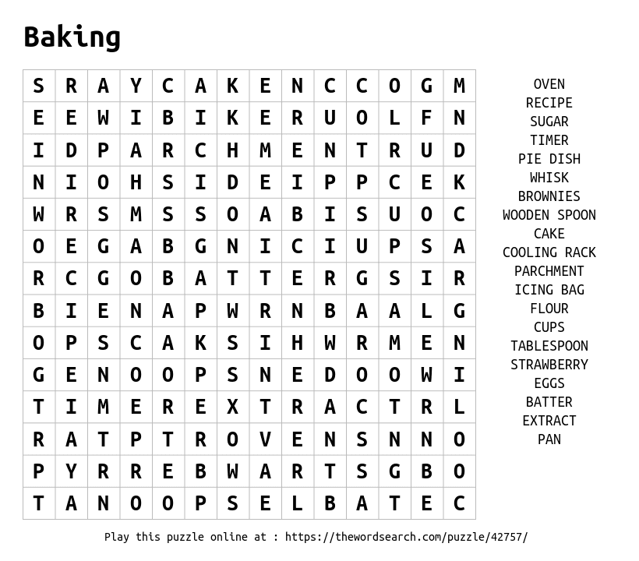

Anagrams are words that contain the same letters but arranged in a different order. For example, act is an anagram of cat. The answers to the clues below are anagram pairs.

Ex) | A person who makes bread. |  | The opposite of repair.
1. | What you call a person. |  | Hair around a lion’s neck.
2. | What superheroes wear. |  | A place to see stars and planets.
3. | Beef or pork. |  | A group of athletes.
4. | Another word for strange. |  | Less narrow.
5. | One of the four directions. |  | A place to sit.
6. | A place to grow flowers. |  | Something to be careful of.
7. | Another word for big. |  | An angry stare.
8. | What polite people say. |  | Not awake.
9. | A time when things are cheap. |  | A marine mammal.
10. | Person who fibs. |  | A dragon’s home.

3 Ingredient Cookies

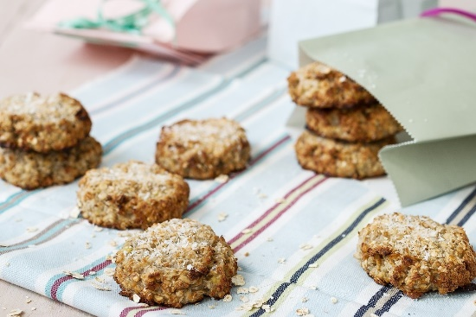

What you need:
- 125g/4oz Porridge Oats (or Gluten Free Porridge Oats)
- 50g/2oz Coconut
- 2-3 medium Bananas, mashed (the riper the better!)
How to:
- Preheat oven to 180°C/350°F/Gas 4. Lightly grease a flat baking tray.
- Combine the oats, coconut and mashed bananas in a bowl.
- Place spoonfuls of the mixture on the baking tray and flatten to form cookies.
- Bake for 10-15 minutes until golden brown.
- Enjoy warm from the oven or cool completely and store in an airtight container.

Notes
- For a gluten free version, make sure your porridge oats are gluten free.
- Also delicious with chocolate chips, chopped nuts or dried fruit.

SEN work
Teacher: Ms Tone

Note: SEN teachers have added work on to the teachers’ plan. Children can decide to do this work instead of something the teacher has assigned. It is not extra work. Also, we would be delighted if you could email on a picture of something that your child has done, so we can see their lovely work again!

Literacy | Theme: Scoil Chóca Great Irish Bake  Type up/Write out a recipe of something you like to bake. Include the ingredients and the method.  Decorate or draw a picture.  - Keep a diary to record what you are doing each day. Write 3 sentences. Draw a picture in your diary.  - Word Challenge: Can you figure out these dingbats (word puzzles)?  LEM ADE I STAND  pig pig pig i i BAG BAG  - I am including two recipes by Roald Dahl that you might like to try. See below.
Numeracy | - Percentages: See worksheet below.  Send me an email if you need any help: mstone@scoilchoca.ie

From Charlie and the Chocolate Factory

Whipple-Scrumptious Fudgemallow Delight

You will need:
- an adult to help you
- a saucepan
- a large bowl of your favourite ice-cream ready in the fridge
- 60g dark chocolate
- 1 Cadbury's Crunchie or similar chocolate bar
- 60g butter
- 80g dark brown sugar
- 150ml double cream
- 8 marshmallows

What you need to do:
- Break the chocolate and Crunchie into large chunks and set to one side.
- In a saucepan, over a low heat, melt together the butter, sugar and cream.
- Stir until all the sugar is dissolved and then turn the heat up. Continue stirring for 10 minutes. Be careful, as it gets very hot and can splutter. Use a very long wooden spoon or a tall adult with a long arm.
- Turn the heat down again and get your bowl of ice-cream from the fridge.
- Put the marshmallows, chocolate and Crunchie into the saucepan, stir around once and pour over your ice-cream.

From Matilda’s How to be Brave

Bruce’s Bravery Cake
Serves 1 to 8
You will need:
• 20cm (8 inches) round cake tin
• baking paper
• glass bowl
• small saucepan
• large mixing bowl
• heavy-bottomed saucepan
• wire rack

Cake Ingredients:
• 225g chocolate
• 170g unsalted butter, softened
• 225g plus 2 extra tablespoons caster sugar
• 35g plain flour
• 6 eggs, separated, yolks lightly beaten

Icing Ingredients:
- 225g chocolate
- 225g heavy cream

Directions:
1. Preheat the oven to 180° C, (350°F).
2. Line the cake tin with baking paper and butter the bottom and sides of the paper.
3. Ask a grown-up to help you melt the chocolate in a glass bowl set over a saucepan of simmering water. Or use a microwave on a low heat. Mix in the butter and stir until melted.
4. Transfer to a large bowl and add the sugar, flour and lightly beaten egg yolks.
5. Whisk the egg whites until stiff. Gently fold half of the whites into the chocolate mixture, blending thoroughly. Then fold in the remaining whites.
6. Pour the batter into the cake tin and bake for about 35 minutes. There will be a thin crust on top of the cake and if tested with a toothpick, the inside will appear undercooked. (Don’t worry. The cake will get firmer as it cools.) Remove from the oven, and cool in the tin on a wire rack.
7. While the cake is cooling, make the icing. Melt the chocolate with the cream in a heavy-bottomed saucepan over the lowest heat. Stir occasionally until the chocolate is fully melted and blended with the cream. Remove from the heat and cool slightly.
8. When the cake is cool enough to handle, remove it from the tin and discard the baking paper. The cake may sink slightly in the middle, so flip it upside down before icing it. Do this by placing a plate on top of the cake tin and carefully turning over the cake and plate together.
9. Carefully spread chocolate icing all over cake with a spatula.

Percentages: Remember!

In a sale, you might see a sign with 10% off.

A jacket costs €50. What is the sale price?

How do you work out 10%?

You change 10% into a fraction. Put it over 100 = 10

100

Remember! 10 = 1

100 10

Find 1 by dividing by 10: €50 ÷ 10 = €5
10
- 10% off means €50 - €5 = €45

What is 25% of? 25% = 25 = 1
100 4

16 ___ 24 ___ 32 ___ 48 ___

What is 50% of? 50% = 50 = 1
100 2

18 ___ 26 ___ 34 ___ 52 ___

What is the sale price?
€36 with 25% off ____ €72 with 50% off ____
€60 with 25% off ____ €80 with 50% off ____

