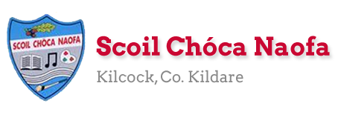
Dear 3rd Class,
I hope you and your family are safe and well this week and that you have been making the most of the fine weather we are having. Last week, you completed the RSE programme at home. Well done
We had our first zoom call last week. It was so lovely to see you all again. I enjoyed catching up with you and hearing what you have been up to. I would like to commend you on your wonderful behaviour during the meeting. Details of the next zoom call will be sent to your parents in the coming days. I am looking forward to it already.
This week is Sports Week. I would like to you to get outside in the fresh air and get active. Play some ball games, do some skipping, go for a walk/cycle/run, even create your own game. There are 3 videos on the school website: a school staff video and 2 videos of some famous sportspeople you might recognise. If you haven’t seen them yet, make sure to check them out.
I would love to see some photos of you being active this week. A gentle reminder that photos with your face in them will not be used on the school website. A certificate is attached at the end of this document for you to print off on completion of Sports Week. Best of luck
A massive thank you to you and your parents for sending me pictures of your work again this week. I love seeing what you have been getting up to and I am so pleased with all of the work you have been doing at home. Please continue to send the work you are most proud of to mstierney@scoilchoca.ie. Have a look at the website each week to see some pictures of the fantastic work being done at home.
Ms. McCabe is working this week and would be delighted to hear from those children who work with her. Her email address is msmccabe@scoilchoca.ie .

Enjoy Sports Week,
Ms. Tierney
mstierney@scoilchoca.ie

Work for Ms. Tierney’s 3rd Class:
Monday 08/06/20 – Friday 12/06/20
Monday | English:  - Sports Star fact-file writing activity- Research your favourite sports star.  Irish:  - Cuardach Focal/Wordsearch: Lá Spóirt/Sports Day  P.E: Sports Week  - 100 points challenge  - Video: Choose one of the videos below as a daily bonus activity.
Tuesday | English:  - The Terrible Trip Up Reading Comprehension: Read & answer the questions  Maths:  - Angles scavenger hunt  P.E: Sports Week  - 100 points challenge  - Video: Choose one of the videos below as a daily bonus activity.
Wednesday | Maths:  - Make a map challenge- Draw a plan of the area of your house and garden. Plan a treasure hunt/maths trail for your family giving them different clues to solve.  Art:  - Outdoor Art: Get creative with chalk (see ideas below) / Mindfulness art  P.E: Sports Week  - 100 points challenge  - Video: Choose one of the videos below as a daily bonus activity.
Thursday | English:  - Active Week Acrostic Poem  Irish:  - Léigh ‘Foireann na Scoile’ agus freagair na ceisteanna.  P.E: Sports Week  - 100 points challenge  - Video: Choose one of the videos below as a daily bonus activity.
Friday | Maths:  - Outdoor Maths Challenge: Build a bug hotel (See below for details)  English:  - Sports Day Word Unscramble  PE: Sports Week  - 100 points challenge  - Video: Choose one of the videos below as a daily bonus activity.
SEN/EAL work 3rd/4th Class OT June 8-12th Teachers: Ms. McCabe & Ms.Curran.
Note: PLEASE email on a picture of something that your child has done recently, we miss them so much! All groups can look at a calendar and answer questions about the month of June e.g. how many Mondays/Fridays in June? Also keep reading and learning your tables daily. This week, revise division tables: ÷1,÷2 tables and practice saying them at the same speed backdown as going up!
EAL: People Who Help Us | ORAL: Talk to your parents about what you would like to be when you grow up.  WRITE: Prepare questions for an interview, with your parent, about their job. (5-6 questions only). Write down the questions and answers to that interview. Please send it on to us!
Speech and Language | Play Meanings Game for 5 minutes each day.  Also, start the What Is It Game, this week.  Explain the idiom...It’s raining cats and dogs.....to your family.  Conversation Starters – Continue with these, one per day.
Literacy A & B | SNIP programme (session 13)..... 3 pages for the week.  Phonics/ Digraphs (blended sounds) Read from Chain...to...Choose.  http://theschoolhouse.us/lessons/lesson55.html  Cloze procedure : The Sun. Try another one of the Memory Activities!  Please keep up the reading, every day!  https://www.oxfordowl.co.uk/for-school/oxford-owl-ebook-collection  These are free ebooks and you can find your level.
Toe by Toe | Next SNIP session (session 23)..... 3 pages for the week.  Cloze procedure: The Sun.  Try one of the Memory Activities!  Please read and ask an adult to read with you.
SEN Individuals | Cloze procedure : The Sun.  Challenge for June: Learn how to tie laces!!  Begin New picture sequence – Up, Up & Away.  Try one of the Memory Activities!  Fry’s Words: Continue with the list you are on.  Finish SC booklet and start Lesson 1 of the following(Helping in the House)  https://www.twinkl.ie/resource/social-situations-to-help-children-during-the-coronavirus-pandemic-t-s-2548781  Do the second card on Other People’s Feelings:  https://www.twinkl.ie/resource/t-s-1272-other-peoples-feelings-thought-cards-set-2
Contact SEN Teachers: msmccabe@scoilchoca.ie mscurran@scoilchoca.ie

Ms Mc Cabe is working this week, Monday-Friday
Sports Week 100 Points Challenge:
Sports Week
STAY ACTIVE CHALLENGE
BUILD YOUR POINTS WITH EXERCISE
What I have to do: Every day you have to accumulate 100 points by completing a variety of different activities. Each activity gives you different points. The Daily Bonus Activity can be any other activity that is not listed. Some suggestions might be a training session from your GAA or Soccer club, a dance class, a gymnastics class or even a family workout!
Outdoor Challenges
Running (15 minutes) | 60 points
Cycle (30 minutes) | 60 points
Walk (30 minutes) | 50 points
Kick about | 40 points
Trampoline (20 minutes) | 40 points
Skipping (10 minutes) | 40 points
Basketball games (20 minutes) | 40 points
Puck around | 40 points
Hopscotch (5 minutes) | 10 points
Indoor Challenges
Running up and down stairs x 5 | 40 points
Online yoga class | 50 points
Online dance class | 50 points
Pressups x 20 | 20 points
Squats/Frog Jumps x 20 | 20 points
Hula Hooping x 20 | 20 points
Table Tennis | 20 points
Balloon keepie uppie (15 min game) | 20 points
Plank Hold (30 seconds x 5) | 30 points
***Daily Bonus Activity*** 100 points

Sports videos for a daily bonus activity:
https://www.youtube.com/watch?v=xB0sg8nQXDc&list=PLt3aHDpWcOx0KJFmNWegn4eTv50f9Qgu_&index=2&t=0s
This is a family dance class.

https://www.youtube.com/channel/UC_4CVGZ-aQH2V6cLGYmKMAg
This is a video with soccer skills suitable for primary school children.

https://www.youtube.com/watch?v=hmMobq5velU
This is a dance to “Sorry” by Justin Beiber.
https://www.facebook.com/180216932023233/videos/895787854180836/
This is Triathlon Ireland Fitness Video for kids.
https://www.facebook.com/SportIrelandCampusFitness/videos/311157616522289/
This is Sport Ireland’s family PE at Home Workout.
https://www.youtube.com/watch?v=M5ffOxDIcwc&amp;list=RDCMUCyqR7WkL8i1b6xtSssDmW9w&amp;index=4
This is a dance to ‘Can’t stop this feeling’ by Justin Timberlake.

Sports Star Fact File:
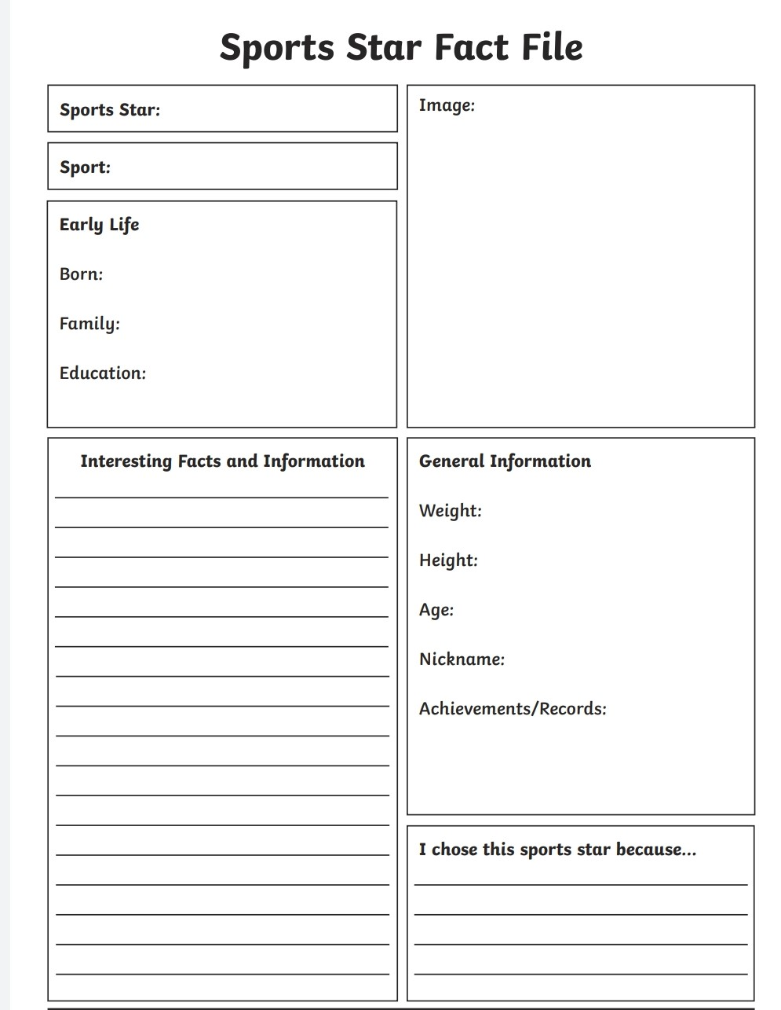

Cuardach Focal- Lá Spóirt:
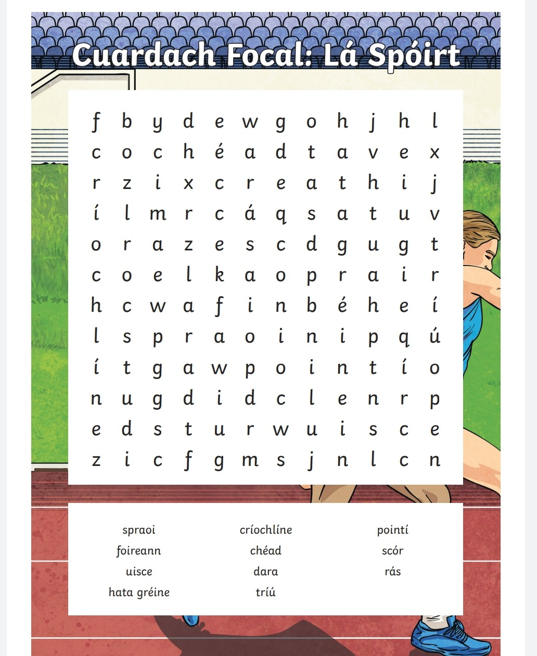

spraoi=fun críochlíne= finish line pointí= points
foireann=team chéad= 1st scór= score
uisce=water dara= 2nd rás= race
hata gréine= sunhat tríú= 3rd
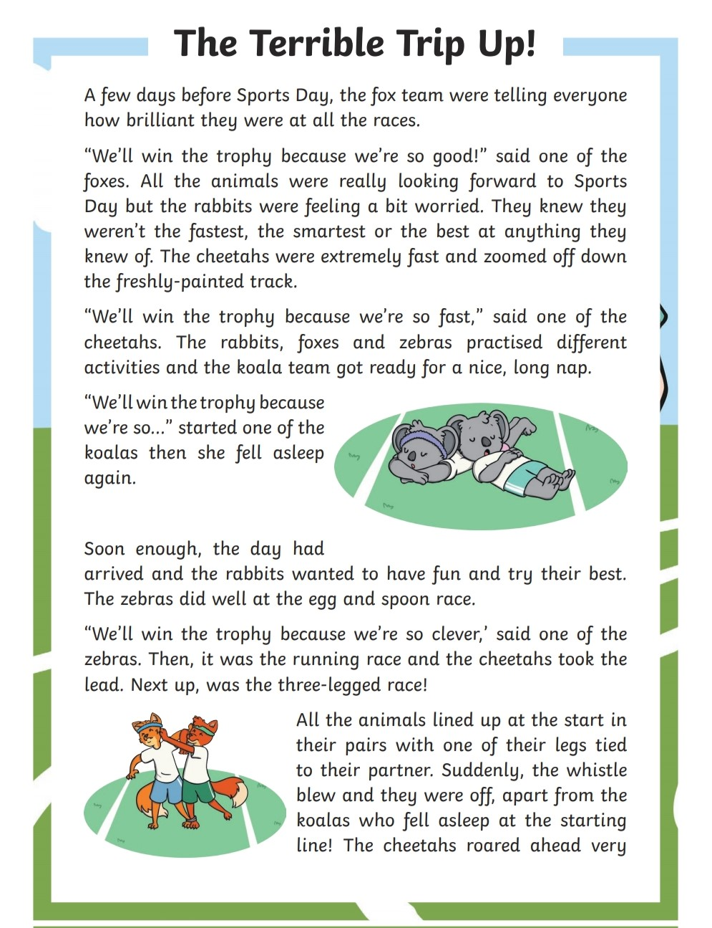
Reading Comprehension

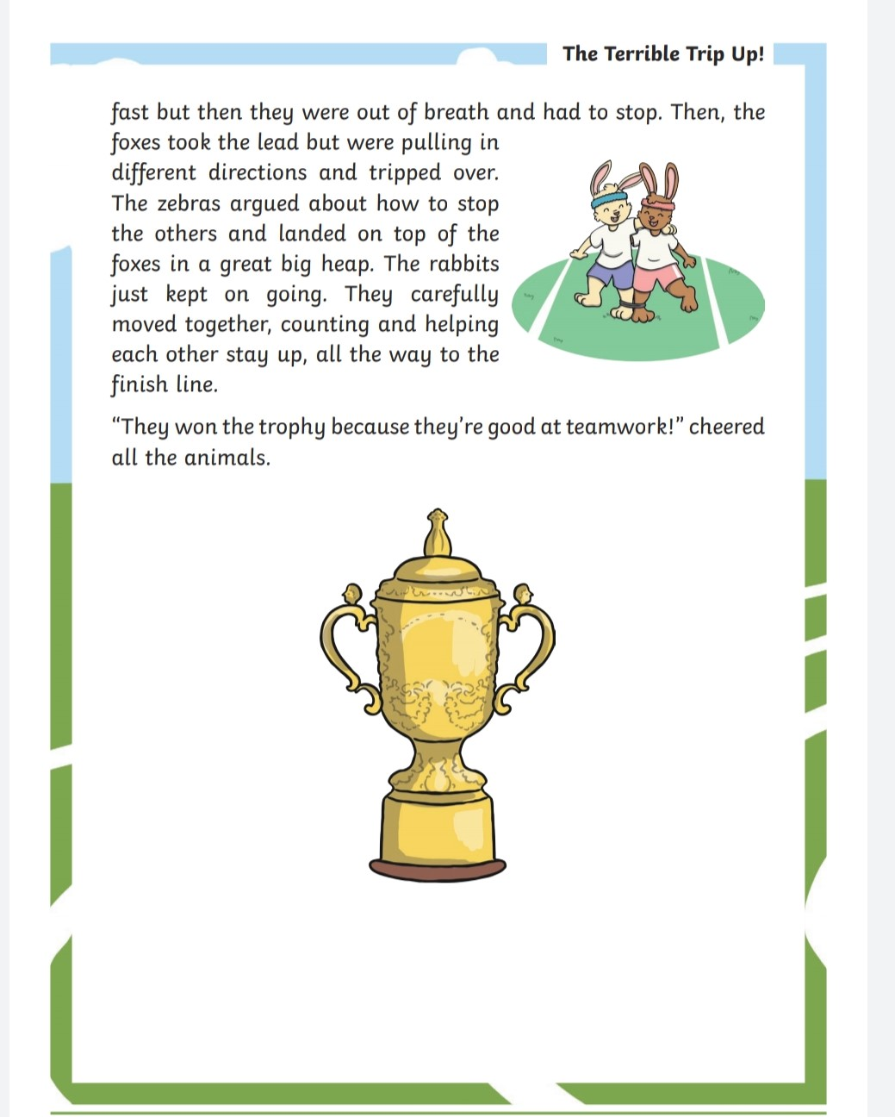

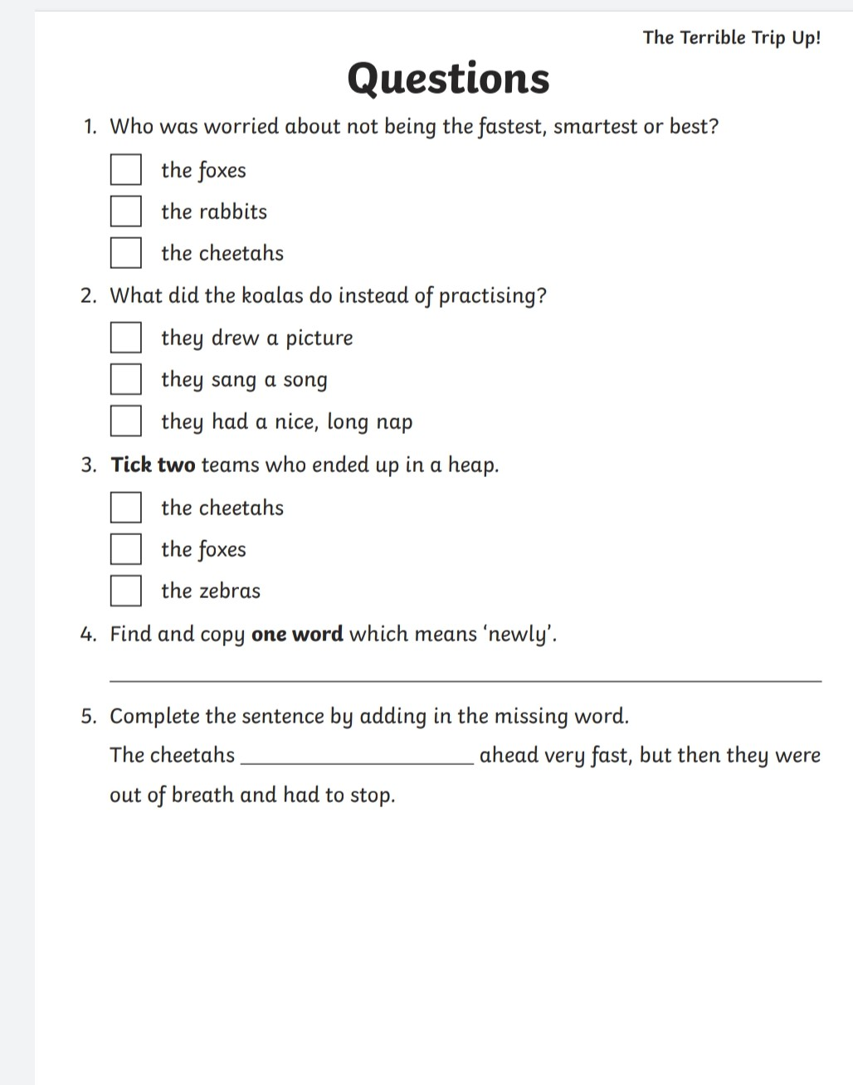

Angles Scavenger Hunt
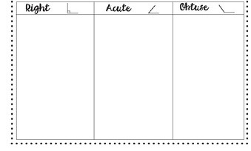

Outdoor Art Ideas Using Chalk:

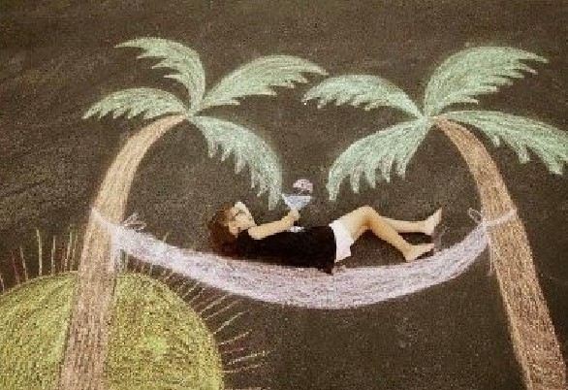

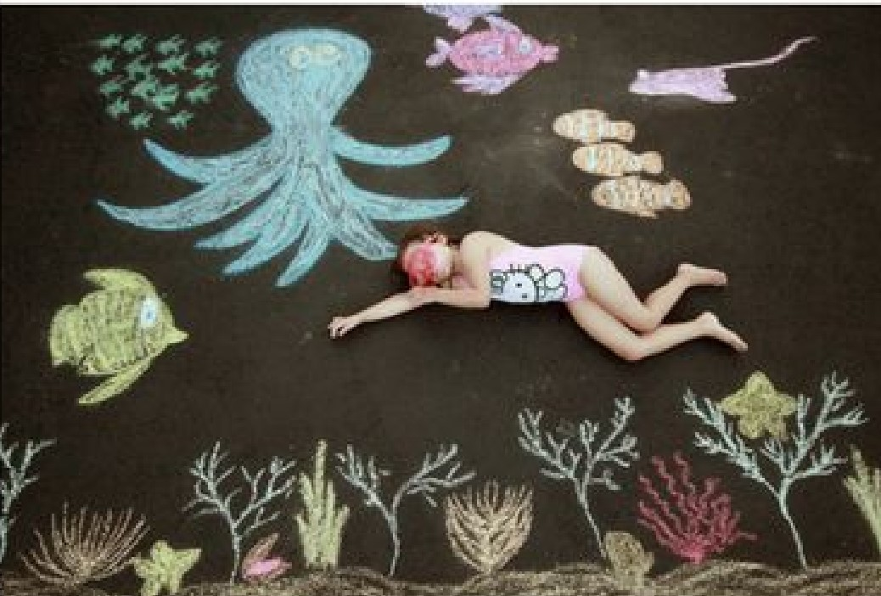

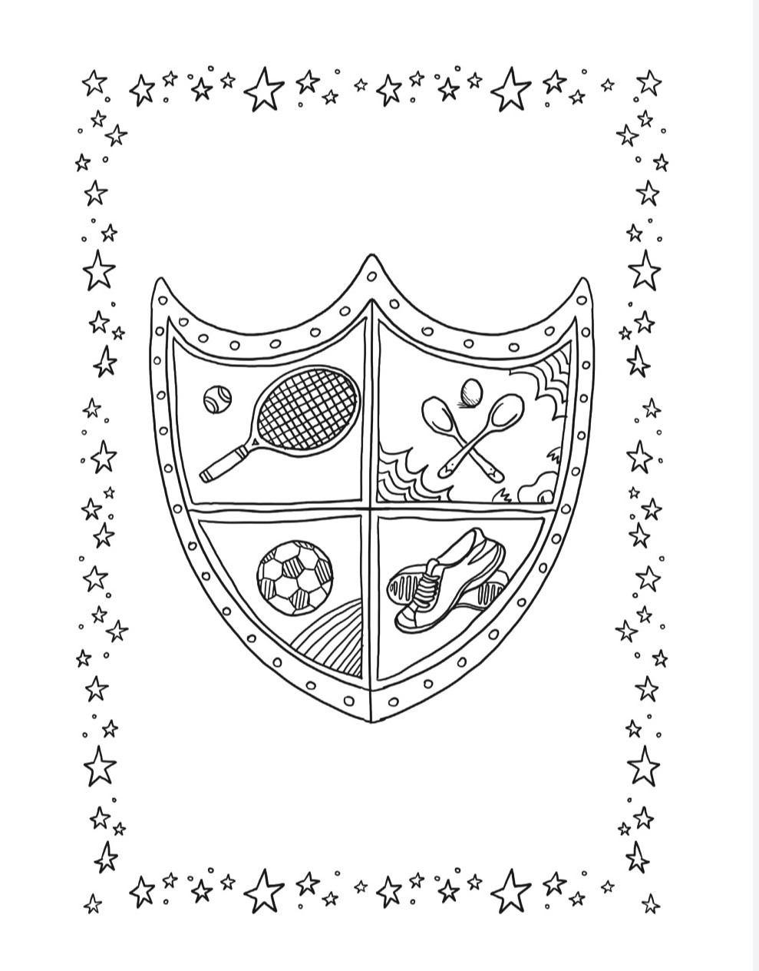
Mindfulness Art:

Active Week Acrostic Poem:
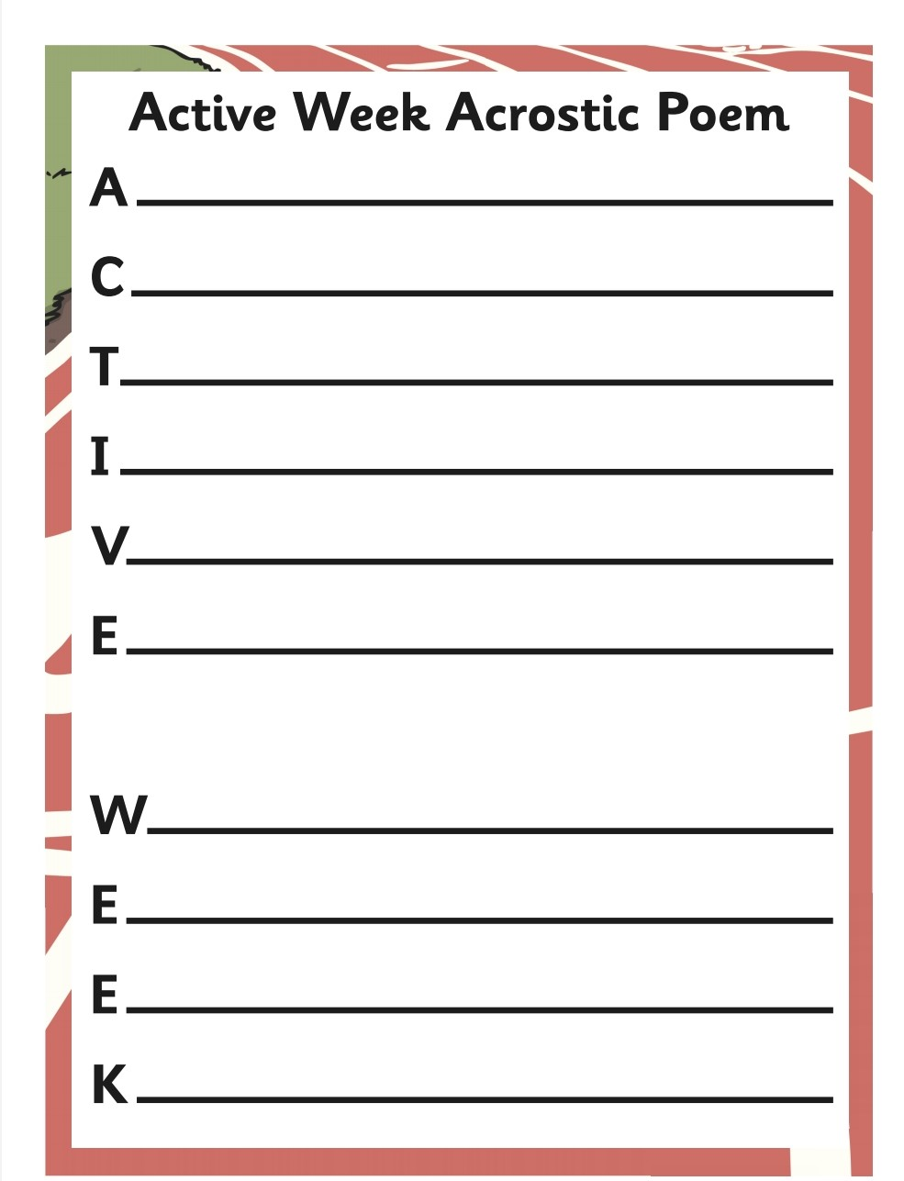

Léigh sa Bhaile- Foireann na Scoile
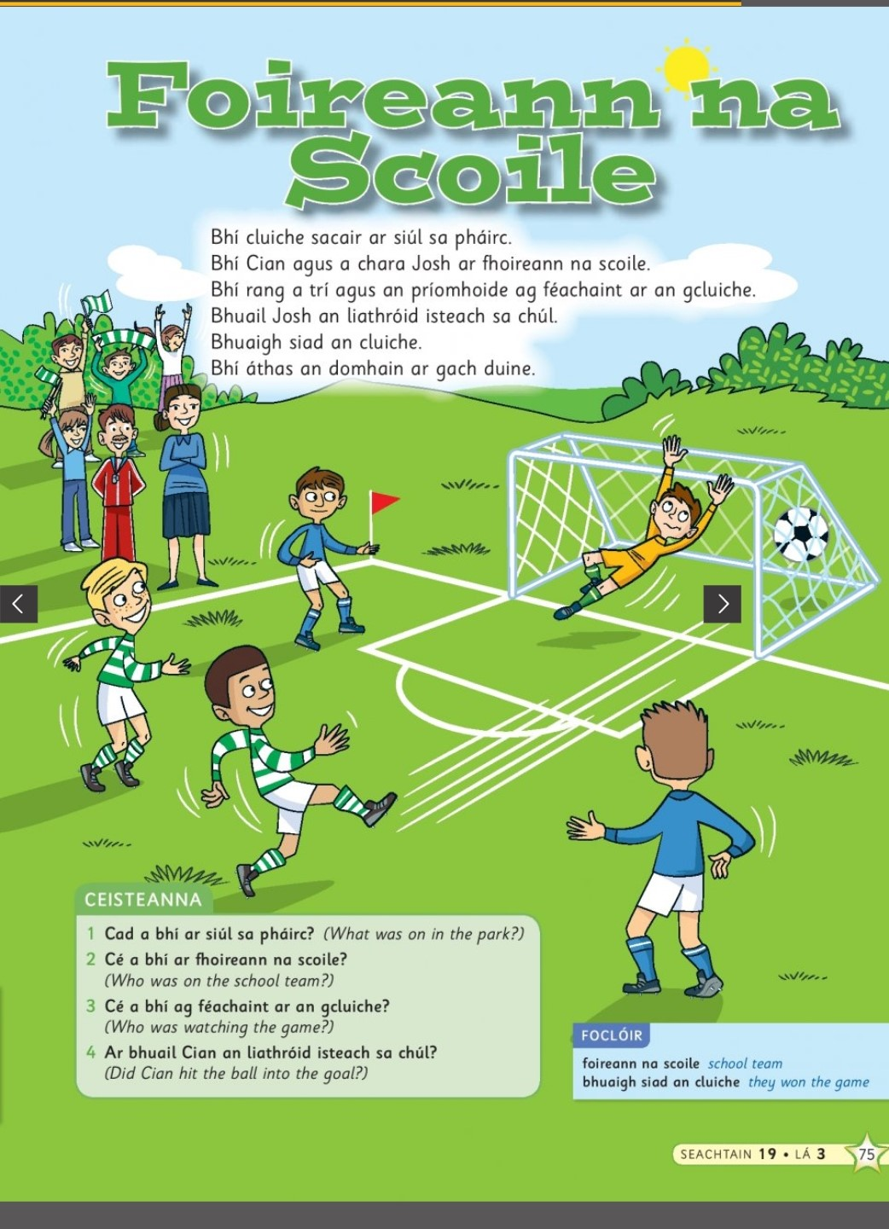

(Double click the icon to listen to the story)

Outdoor Maths Challenge: Build a Bug Hotel
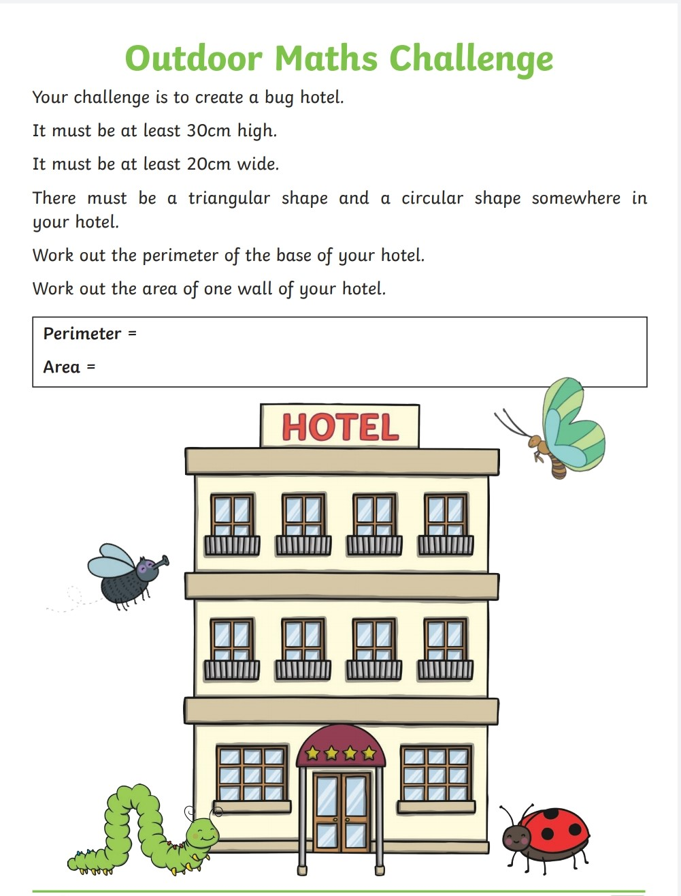

Sports Day Word Unscramble:
throw, javelin, sack race, hurdles, egg and spoon, relay, target, skipping, races, running, long jump, sport
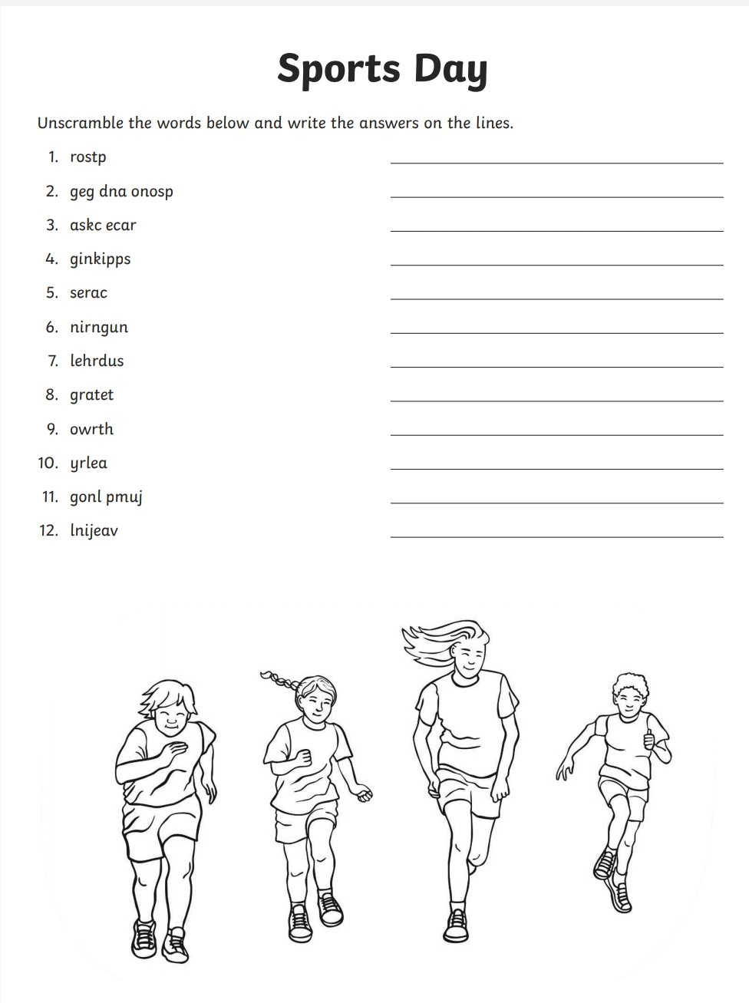
  - Scoil chÓca Naofa

_______________________

Congratulations on taking part in Sports Week

June 2020

