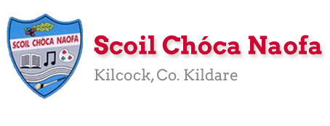
Work for Fifth Class: 15th of June – 19th of June 2020
Please remember: You are encouraged to complete one hour of work. The work we have given may take longer than one hour. If you want to do more than one hour that is fine but please don’t feel you have to. Do what you can and keep smiling! :)
Ms. Heffernan’s and Ms. Tone’s groups will find work for them attached to the end of this plan. Those not doing Gaeilge please access your TTRS account
Please send us pictures of your maths work and 2 other pieces of work you are proud of if you can. We would love to hear from you!
Our e-mail addresses are msfield@scoilchoca.ie and msmahon@scoilchoca.ie
Mon | English | - Starlight: Unit 15b: There’s Snow Better Holiday. Read pg. 176-178.  - Do exercise A on pg. 179
 | Maths | - Maths Matters: pg. 159 - read the green box at the top of the page. Complete Questions 1-12
 | Gaeilge | - Léigh sa Bhaile: lch. 109 –An Ghaeltacht. Léigh agus freagair na ceisteanna 1-5 i do chóipleabhar
 | P.E. | - Go to www.youtube.com and type in P.E with Joe Monday 15th June  2020 in the search bar. Click on the video with this title.
 | Other | - Create a time capsule. See link for ideas. You can pause this and play it when it suits you :https://www.youtube.com/watch?v=P2ba7qa97C4
Tue | English | - Starlight: Unit 15b: There’s Snow Better Holiday. Read pg. 176-178.  - Do exercises C on pg. 179 and exercise D on pg. 180
 | Maths | - Maths Matters pg. 160 Read the green box at the top of the page and answer Q. 1 & 2
 | Gaeilge | - See below: Worksheet: An Samhradh Ord Aibítire (Alphabetical order)
 | P.E. | - GAA Skill challenges  - Pick any of the skill challenges on https://learning.gaa.ie/gogamesskillchallenges  The challenges can be taken either individually or with a partner almost anywhere.
 | Other | - Music: Today we are going to learn about body percussion using 'The Cup Song’. Follow the link to revise the words of that song and then you can add the percussion routine that is shown so you can perform it for friends and family.  - https://www.rte.ie/learn/2020/0605/1145685-5th-and-6th-class-music/
Wed | English | - Have a read through Primary Planet June edition  - https://online.flowpaper.com/7a630787/TPP93online/#page=36
 | Maths | - Maths Matters pg. 161 Q. 1-6 (Remember to underline the key words)
 | Gaeilge | - Watch TG4 @ 10:00-10:30 Cúla 4 ar Scoil
 | P.E. | - Go outside and be active for at least 30 minutes.  - Suggestion: Skipping skills (Coach Mark)  https://skipnrope.com/a-beginners-guide-to-double-unders/
 | Other | - Choose an animal mentioned in the primary planet. Write 5-8 facts about the animal and draw this animal.
Thurs | English | - Read a novel or listen to an audiobook of choice or  Read Primary planet and answer the following questions based on p1-10  - 1. How many novels did Charles Dickens write?  - 2. Achill Island is in which county?  - 3. This European country is experimenting with herd immunity.  - 4. Middleton is in which Irish county?  - 5. In which Irish county is Lough Ennell?  - 6. What age is Kane Tanaka?  - 7. Where is Badain Jaran Desert?  - 8. What was the name of the Parnell estate in Co. Wicklow?  - 9. George Geary was Graham Walter’s __________.  - 10. What is the name of the actress who plays the part of Hua Mulan?
 | Maths | - Maths Matters pg. 162 Read the green boxes and do Q. 1 & 2
 | Gaeilge | - I do chóipleabhar, tarraing agus cuir lipéad ar na héadaí a chaiteann tú i rith an samhradh. (In your copy draw and label the clothes you wear during the summer – in Irish)
 | P.E. | Look up:  - https://family.gonoodle.com/channels/ntv-noodle-television  - Pick some songs that you would like to dance to  - Try as best you can to learn the choreography  - Can you make up your own dance moves to a song?
 | Other | - Look at the section Positivity Rocks on p 41-49 of the Primary planet for ideas. Create a positivity rock of your own. Take a picture of it and send it into us. (The link is in the English box from Wednesday)
Fri | English | - Read a novel or listen to an audiobook of choice  - Write 5 interesting facts about the Lourve Museum (See ‘Other’ box)
 | Maths | - Maths Matters: pg. 162 Q. 3
 | Gaeilge | - Watch TG4 @ 10:00-10:30 Cúla 4 ar Scoil
 | P.E. | - Go outside and be active for 30 minutes  - Go for a walk, run or cycle with a friend.
 | Other | - School Tour!! Virtual Tour of La Louvre in France.  - Select English as your language on the top right of the screen, explore the collections and learn about the art; Click on  - https://www.louvre.fr/en/visites-en-ligne?tab=1#tabs  - Name five pieces of art you like, try and draw a picture of one of them

Extra Activities - Optional
Inside  - Create a word search  - Write a letter to a grandparent/grand friend | Outside  - Make art from nature  - Make a bug hotel
Free eBooks access: https://www.oxfordowl.co.uk/for-home/find-a-book/library-page/?view=image&query=&type=book&age_group=Age+9-11&level=&level_select=&book_type=&series=#
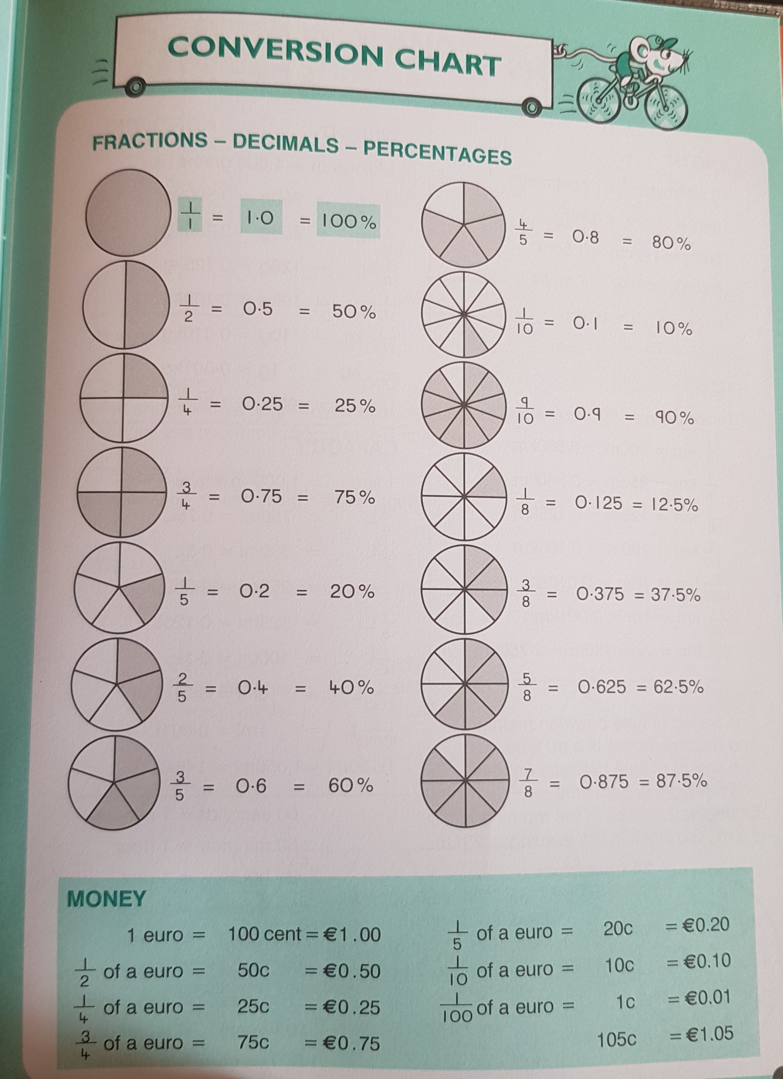
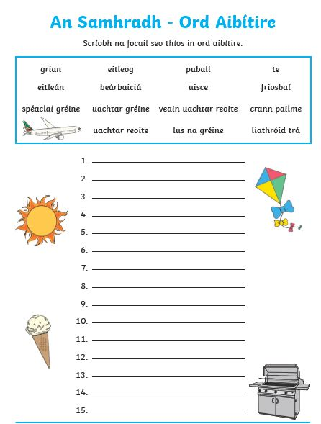

SEN work 5th Class week beginning 15th June 2020
Teacher: Ms. Heffernan
Note: SEN teachers have added work on to the teachers’ plan. Children can decide to do this work instead of something the teacher has assigned. It is not extra work. Also, we would be delighted if you could email on a picture of something that your child has done and is proud of so we can see their lovely work again!
Literacy | Try the Feeling word search below.  Or how about some anagrams? See the worksheet below.  Keep reading! If any of you need more reading material, just let me know. If you’ve read or listened to a story, let me know what you thought about it.  Do a little writing every day. Keep a diary. Keep a gratitude journal-write down 3 things you are grateful for each day.  Use www.writereader.com to create your own book.  Keep practising your TTRS. See if you can still type while covering your hands with a towel!  Send me an email to let me know how you’re getting on-I’d love to hear from you!
Numeracy | Keep doing your Mathletics.  You might like to try these fun summer themed worksheets! Just choose the ones you like. Don’t worry if you don’t have a printer, some of them can be done in your copy.  Keep practising your mental maths.  https://www.topmarks.co.uk/maths-games/hit-the-button  https://www.topmarks.co.uk/maths-games/daily10  Send me an email to let me know what you have done or if you need help.

Contact SEN Teacher: msheffernan@scoilchoca.ie

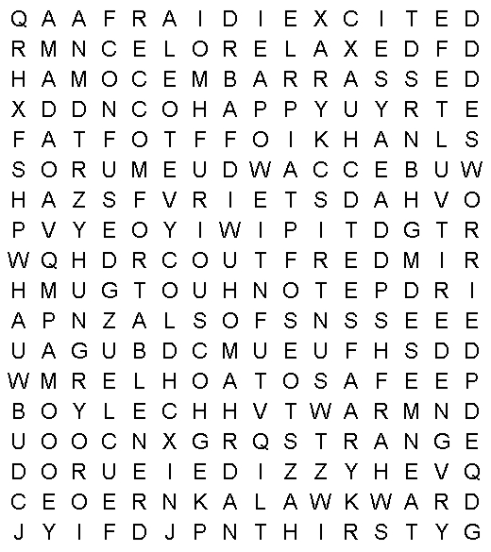 |  |  | Find the words below in the grid to the left.  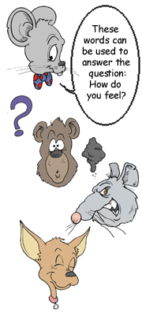
afraid  angry  awkward  bored  cold  comfortable  confident  confused  cool  depressed  dizzy | embarrassed  excited  exhausted  frightened  furious  happy  hot  hungry  itchy  mad  nervous | relaxed  sad  safe  scared  strange  thirsty  tired  uncomfortable  warm  weak  worried

SEN work
Teacher: Ms Tone

Note: SEN teachers have added work on to the teachers’ plan. Children can decide to do this work instead of something the teacher has assigned. It is not extra work. Also, we would be delighted if you could email on a picture of something that your child has done, so we can see their lovely work again!

Literacy | - Re-read the first 3 passages from the story, The Best Thing in the World, (see below). Read the last 3 passages.  Tell the story in your own words.  - Keep a diary to record what you are doing each day. Write 3 sentences. Draw a picture in your diary.  - Word Challenges: What 3-letter word can be placed in front of these words to create a new word?  ___PUT ___BREAK ___SIDE ___STANDING  - Can you figure out these dingbats (word puzzles)?  UNDERSTANDING  MISS
Numeracy | - Percentages: See worksheet below.  Send me an email if you need any help: mstone@scoilchoca.ie

The Best Thing in the World
Mon 15th - Tues 16th June

Once upon a time, there were four brothers who lived in a far-away land. Their father was an old king. One day he said, "I will not live long now. Today you must start out into the world. In a year, bring back the best thing you have found. The one who can pick the best thing shall be the new king." The first brother said, "I will look in every city or town. I will buy the best thing I can for my father." The next two brothers said, "We will both go on fast ships over the sea. We will find something better." The last brother said, "I am going to ask the people here in our own land to tell me the best thing." The other three brothers began to laugh. "Then you will never be king!" they said.

The last brother started off. When he had gone about six miles, he met a man. "What do you carry in those big bags?" he asked. "The best thing in the world," said the man. "These are full of the good nuts which fall from my five nut trees." "I don't think that would work," said the brother to himself, "I must try again." The brother went on another seven miles. He found a small brown bird. It had been hurt, so he put it in his coat where it could keep warm. As he went on, he saw a little girl crying. He ran to meet her.

"Why are you crying?" he asked. "I want to get some water from the well," she said. "We use so much. We drink cold water. We wash the clothes clean with hot water. But I do not know how to pull it up. Please show me." The brother said, "Hold this bird and I will help you. It does not fly around anymore because it got its wing cut." "Thank you. What a pretty bird!" she said. "I wish you would give it to me. If you will let me keep it, I will always be very kind to it. I will take care of it myself. I will make it grow well again." "Yes, you may have it," said the brother. So he gave her the bird and went on.

The Best Thing in the World
Weds 17th June

At night, he went to sleep under a round, yellow haystack. When it was light again, he walked on. Every day, he would walk eight or ten miles. He asked the people about the best thing in the world. Some said it was best to sing. Some said it was best to run and jump and play. Some said the green grass was best. Some liked the red and blue and white flowers best. One man said the best thing was to ride a black horse.
Thurs 18th June
He always stopped to help people who needed it. Soon he made many friends. All the people began to like him. They would say, "See there goes the king's son. He would be just the right kind of king for us." Every door was open to him. The people would call to him to stop. They would ask him to come and eat with them. After he ate, he would sit down and read to the children. After he read, he showed them how to draw and write. Months went by. He still had no beautiful thing to take to his father. Just before the year was done, he went home again.
Fri 19th June
The time came when the king called his sons together. "What did you bring?" he asked them all. The other brothers had many beautiful things. "And what did you bring?" said the king to the last brother. "This is too funny!" said the other brothers. "He has nothing!" But the king was kind to the last brother. "What did you bring me?" the king asked again. "I bring only the friendship of your people," said the last brother. "That is the best thing!" cried his father. "You shall be the new king."

Percentages

In a sale, you might see a sign with 10% off.

A jacket costs €50. What is the sale price?

How do you work out 10%?

You change 10% into a fraction. Put it over 100 = 10

100

Remember! 10 = 1

100 10

Find 1 by dividing by 10: €50 ÷ 10 = €5
10
- 10% off means €50 - €5 = €45

What is 10% of?

30 ___ 50 ___ 60 ___ 80 ___

What is 20% of? 20% = 20 = 1
100 5

15 ___ 35 ___ 55 ___ 90 ___

What is the sale price?
€20 with 10% off ____ €25 with 20% off ____
€40 with 10% off ____ €45 with 20% off ____

