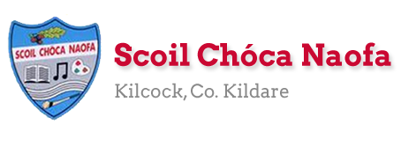
Dear 3rd Class,
I hope you and your family are well and that you are enjoying this glorious weather we are having. I understand it is difficult to do school work when the sun is shining outside. My advice to you is to try your best to get as much work done as you can earlier in the day so that you can get outside and play for the afternoon. This weekend is a bank holiday weekend and I would like you to take a well-deserved break and relax on Monday. I have provided some optional activities for you to try on Tuesday. Try your best with this work, do not worry if you do not get it all completed.
Your parents will have received an email from me outlining the RSE programme to be covered this week. Your parents can access the programme via the link I sent them in the email. Parents must supervise the delivery of these lessons as sensitive issues may arise. If you did not receive this email, please let me know. I am here to support you with this programme in any way I can. Thank you for your co-operation.
On Sunday 7th June, I would like you to watch two videos which will be posted on the school website. These videos are in relation to Sports Week which is happening next week. The videos are very exciting and are not to be missed.
We are discussing the possibility of a class assembly via Zoom call. Ms. Daly will announce more details about this. It may be a chance for us to catch up, share some news with each other and discuss Sports Week.
A massive thank you to you and your parents for sending me pictures of your work again this week. I love seeing what you have been getting up to and I am so pleased with you all of the work you have been doing. Please continue to send the work you are most proud of to mstierney@scoilchoca.ie. Have a look at the website each week to see some pictures of the super work being done at home.
Ms. Curran is working this week and would be delighted to hear from those children who work with her. Her email address is mscurran@scoilchoca.ie .
Have an enjoyable bank holiday weekend,
Stay safe and keep smiling,
Ms. Tierney
mstierney@scoilchoca.ie

Work for Ms. Tierney’s 3rd Class:
Monday 01/06/20 – Friday 05/06/20
Monday | Bank Holiday:  Relax and have a lovely day
Tuesday | All activities are optional:  - Baking: Chocolate Rice Krispie Cakes (Adult supervision required- see recipe below)  - Flip a coin Workout (See below)  - Science experiment: Fun with density (See below)
Wednesday | English:  - Starlight: Read ‘A Plant’s Plea’ pgs. 170-172. Answer q. A in your copy.  - Look up the meanings of any words you do not understand in your dictionary  Maths:  - Maths Matters pg. 146  Irish:  - Léigh sa Bhaile: Read the next page  Freagair na ceisteanna i do chóipleabhar: Answer the questions in your copy.  P.E:  - PE with Joe Wicks on YouTube  Other: SPHE- RSE Programme  - Theme 6 and Theme 7: Pages 69-92  Parent/Guardian supervision required
Thursday | English:  - Starlight: ‘A Plant’s Plea’ pgs. 170-172. Answer q. B in your copy.  Maths:  - Maths Matters pg. 147  Irish:  - Léigh sa Bhaile: Read the next page  - Freagair na ceisteanna i do chóipleabhar: Answer the questions in your copy.  P.E:  - PE with Joe Wicks on YouTube  Other: SPHE- RSE Programme  - Theme 8: Pages 93-102  Parent/Guardian supervision required
Friday  Look at school website for video to kick off  Sports Week | English:  - Starlight: ‘A Plant’s Plea’ pgs. 170-172. Answer q. C in your copy.  Maths:  - Maths Matters pg. 148  Irish:  - Léigh sa Bhaile: Read the next page  Freagair na ceisteanna i do chóipleabhar: Answer the questions in your copy.  Other: SPHE- RSE Programme  - Theme 9 pages 103-112  Parent/Guardian supervision required
SEN/EAL work 3rd/4th Class OT June 1-5th Teachers: Ms. McCabe & Ms.Curran.
Note: SEN teachers posted workpacks to their students last week. It is not extra work. Also, PLEASE email on a picture of something that your child has done recently, so we can see their lovely work again! All groups can look at the calendar and answer questions about the month of June eg how many days/weeks/Tuesdays in June? Also keep reading and learning your tables daily. This week do 10x multiplication tables and practice counting up and down the ladder in 10s....the same speed backdown as going up!
EAL: People Who Help Us | ORAL: Think about one person who helps in the neighbourhood (eg Lollipop Lady).  WRITE: Write 10 sentences about this person and draw a picture of him/her at work.
Speech and Language | Play Meanings Game for 5 minutes each day.  Practice STARTING sentences with a new phrase: Believe it or not/In my opinion/Perhaps.....  Conversation Starters – Continue with these, one per day.
Literacy A & B | SNIP programme – session 12..... 3 pages per week.  Phonics/Final Blends: Read the sentences starting with’ Is it best to ask for help if the task is too hard?’daily.http://www.theschoolhouse.us/lessons/lesson57.html  Cloze: Looking After My Wellbeing  Try one of the Memory Activities  Please keep up the reading, every day! https://www.oxfordowl.co.uk/for-school/oxford-owl-ebook-collection  These are free ebooks and you can find your level.
Toe by Toe | Next SNIP (session 22)..... 3 pages for the week.  Try one of the Memory Activities!  Please read and ask an adult to read with you.
SEN Individuals | Cloze:Looking After My Wellbeing.  Do 2 pages of new booklet (S C)  Continue with picture sequencing (What’s at the Zoo?)  Try one of the Memory Activities!  Fry’s Words: Continue with the list you are on.  Do one card per day on Other People’s Feelings:  https://www.twinkl.ie/resource/t-s-1272-other-peoples-feelings-thought-cards-set-2
Contact SEN Teachers: msmccabe@scoilchoca.ie mscurran@scoilchoca.ie

Ms Curran is working this week, Tuesday-Friday
Resources
Useful websites for this week:
- Maths: Tables revision games- https://www.topmarks.co.uk/maths-games/7-11-years/multiplication-and-division
- PE: Joe Wicks’ Live Daily PE workouts: https://www.youtube.com/
- General: Twinkl: Worksheets/Powerpoints available: Free access if you use code CVDTWINKLHELPS
- RTE’s Home School Hub. If you miss it, you might be able to watch it back on RTE Player. https://www.rte.ie/player/

Recipe for baking:
Method/Instructions:
- Put the chocolate into a heatproof bowl with the butter and golden syrup and ask a parent to melt it in the microwave, stirring until smooth.
- Add in the rice krispies, coating them with the chocolate until they are all covered.
- Divide the mixture into bun cases and leave to set in the fridge for 1 hour.
- Drizzle with melted chocolate and decorate with sweets, dried fruit or nuts while they are still wet enough to stick them on.
- Enjoy.

Chocolate Rice Krispie Cakes
Ingredients:
- 100 g milk chocolate (broken up)
- 50 g dark chocolate (broken up)
- 100 g butter
- 4 tbsp. golden syrup
- 100 g rice krispies
To decorate:
- 50 g melted chocolate
- Sprinkles/marshmallows/nuts/smarties/dried
fruit/white chocolate buttons

Flip a coin workout
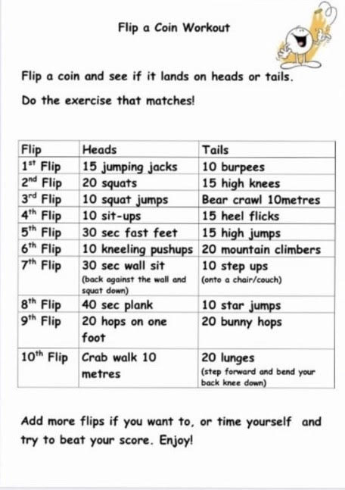

Science experiment: Fun with Density
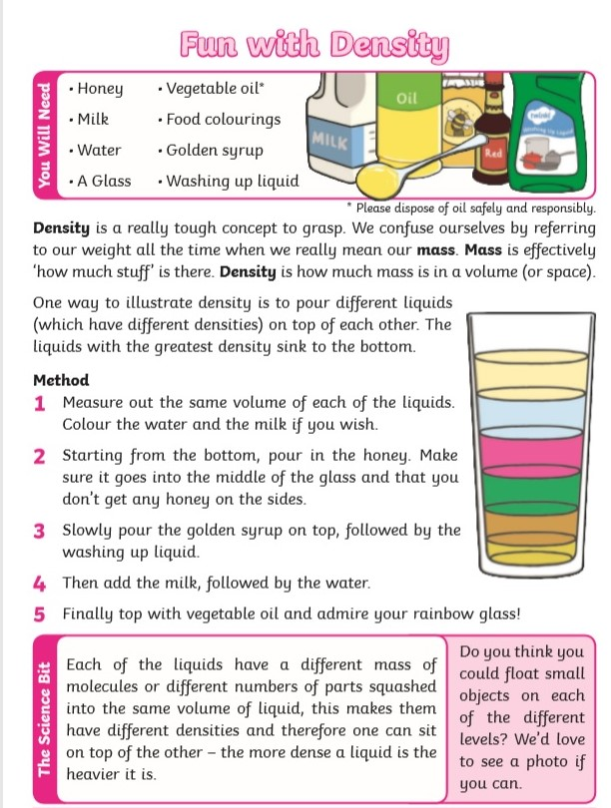

Maths: Area
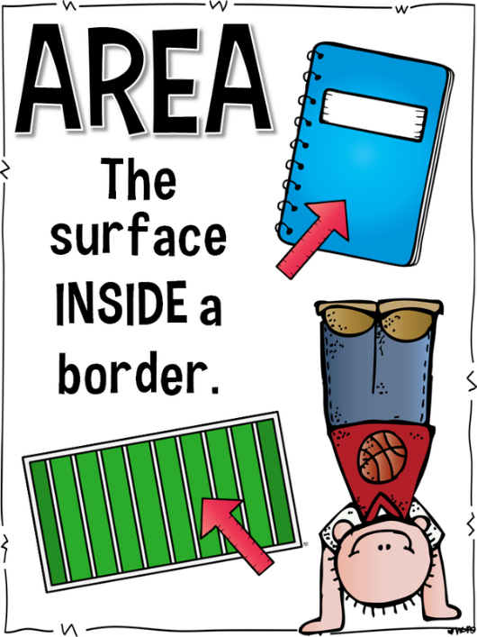

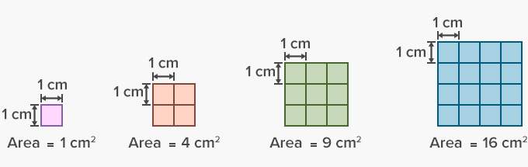

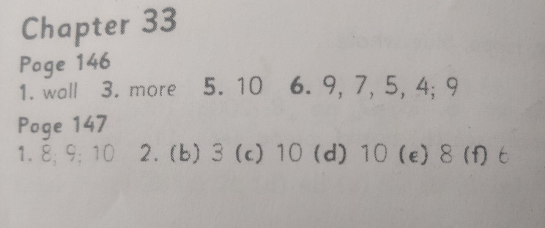
Maths Matters Answers: Please try to self-correct where possible

