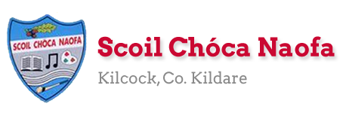

Work for Senior Infants Class : Week of Monday 8th June
*Note Sports Week
STAY ACTIVE CHALLENGE
BUILD YOUR POINTS WITH EXERCISE
What I have to do: Every day you have to accumulate 100 points by completing a variety of different activities. Each activity gives you different points. The Daily Bonus Activity can be any other activity that is not listed. Some suggestions might be a training session from your GAA or Soccer club, a dance class, a gymnastics class or even a family workout! Please send us photos of your activities (without your face in the photo).
Monday | English: Draw a picture of your favourite sport/activity. Write a sentence about it (use your cursive writing)- Example: I like to play ___. I like to run. It is fun to play__.  Sports Activity Outdoor Challenge:  Go outside and make animal movements (kangaroo, rabbit, snake, bird, frog, crab, donkey kicks, crocodile, monkey, dog). Hop on one leg 20 times and swap over (10 minutes 30 points). Cycle your bike for 10 minutes (30 points).  Sports Activity Indoor Challenge: Family dance challenge with Ms Trisha (40 Points)  https://www.youtube.com/watch?v=xB0sg8nQXDc&list=PLt3aHDpWcOx0KJFmNWegn4eTv50f9Qgu_&index=2&t=0s  Daily Bonus Activity (100 points): Send us some photos of your bonus activity.  Maths: Count while you exercise- 5 hops, 10 arm swings, 6 squats, 7 sit ups, 11 leg kicks Planet Maths pg. 103
Tuesday | English: https://www.gillexplore.ie/gill-explore-resources/over-the-moon-senior-infants-skills-book - Oral language and interactive resources Unit 9 Oral Language poster The Campsite. Listen to the story about the campsite. Go to page 115 Skills book. Click on sound icon on the page to hear the instructions on what to colour. https://content.yudu.com/web/1yssw/0A224cw/OTMSBSnrInfs/html/index.html?page=118&origin=reader  Sports Activity Outdoor Challenge:  Get your ball. Let’s practice our Gaelic football. Set up some cones (bottles, items of clothes) in a line. Bounce your ball while going in and out of the cones. Then practice soloing the ball around the cones (60 points). Example here: https://www.youtube.com/watch?v=BWCfcz8dhvI&list=PLbAvjLA-cZu0UAeYVH6-gy1G3h60NXs73&index=3&t=0s  Sports Activity Indoor Challenge: 5 squats, 5 press ups, 10 jumping jacks, 10 criss- cross feet, 10 leg kicks, 5 sit ups (40 points).  Daily Bonus Activity (100 points): Send us some photos of your bonus activity.  Irish: Song ‘Teidí ar a Rothar’. Sing along and do the actions to this song we previously learned in school. https://youtu.be/ZFW0kN9Nabc Focus on the sentence
Wednesday | English: Revise our ‘or’, ‘ar’, ‘er’ sounds. Page 116 Skills book. Extend this (if wanted) by asking your child to write a sentence using some words that have these blends.  Sports Activity Outdoor Challenge:  Have an egg and spoon race. Choose where your race will start and finish. Balance an egg on a spoon. Try not to drop the egg!! (30 points).  Practice your hand passing and punt kick. Maybe with a parent/sibling or just against the wall. Check out the videos by coach Val before you start.(On the school website) (30 points)Here is another examplehttps://www.youtube.com/watch?v=jhCo_NP8T_A  Sports Activity Indoor Challenge: Yoga Minecraft Adventure https://www.youtube.com/watch?v=T_0P5grVoyg  Daily Bonus Activity (100 points): Send us some photos of your bonus activity.  Maths: Measures: Can you measure how tall you are? Ask someone at home to help measure your height using non-standard measurement (lie on the ground use your shoes/runners/books/lego/mammy or daddy’s hands to see how tall you are). Planet maths page 104.
Thursday | Art: Can you design a jersey? It can be for your favourite sport/team or for a brand new sport you have just invented. Send us a photo of this we can’t wait to see them!  Irish: New song: Istigh sa Zú- https://youtu.be/pcNIkuFP_14  Focus on new words ‘cangarú’- kangaroo, leon- lion, tíogar- tiger, nathair- snake’. Dhathaigh mé____sa zú. I colour ___in the zoo. Bua na Cainte pg. 47  Sports Activity Outdoor Challenge:  Make an obstacle course in your garden- things to jump over, crawl under, hop through etc. (30 points).  Let’s practice our soccer skills. Get your ball and practice passing with both feet. Use a wall or a curb here is an example (30 points ): https://www.youtube.com/watch?v=1AQAfI6RZxM  Sports Activity Indoor Challenge: Train like a Ninja (40 points) https://www.youtube.com/watch?v=djvxkPwwCeY  Daily Bonus Activity (100 points): Send us some photos of your bonus activity.
Friday | Maths: Measurement: Discussion around the language: bigger, shorter, longer, smaller, taller. Give some examples; Mammy is taller than me. I am shorter than my brother. The orange is smaller than my ball etc. Planet maths pg.105  SPHE: Discuss healthy/unhealthy food choices. Can you make a healthy snack today? You will need it after all of your great exercise this week. Maybe you could ask for help to make a fruit salad, yogurt with some granola, banana on toast or something you think of. Send us a picture of what you made. (Extend this if wanted by writing about/drawing the steps you took to make your snack.)  Sports Activity Outdoor Challenge:  Go for a walk/cycle with your family (30 points).  Get a bucket and a ball/pegs. Let’s practice throwing them into the bucket. See how many you can get in then take a step back as you improve. Take out your skipping rope and skip for 5 minutes. (30 points)  Sports Activity Indoor Challenge: Guided meditation/mindfulness for children (30 points) https://www.youtube.com/watch?v=wf5K3pP2IUQ  Daily Bonus Activity (100 points): Send us some photos of your bonus activity.  CHOICE BOARD Have a look at this week’s choice board if you have time.

CHOICE BOARD Here is your fun choice board for the week.

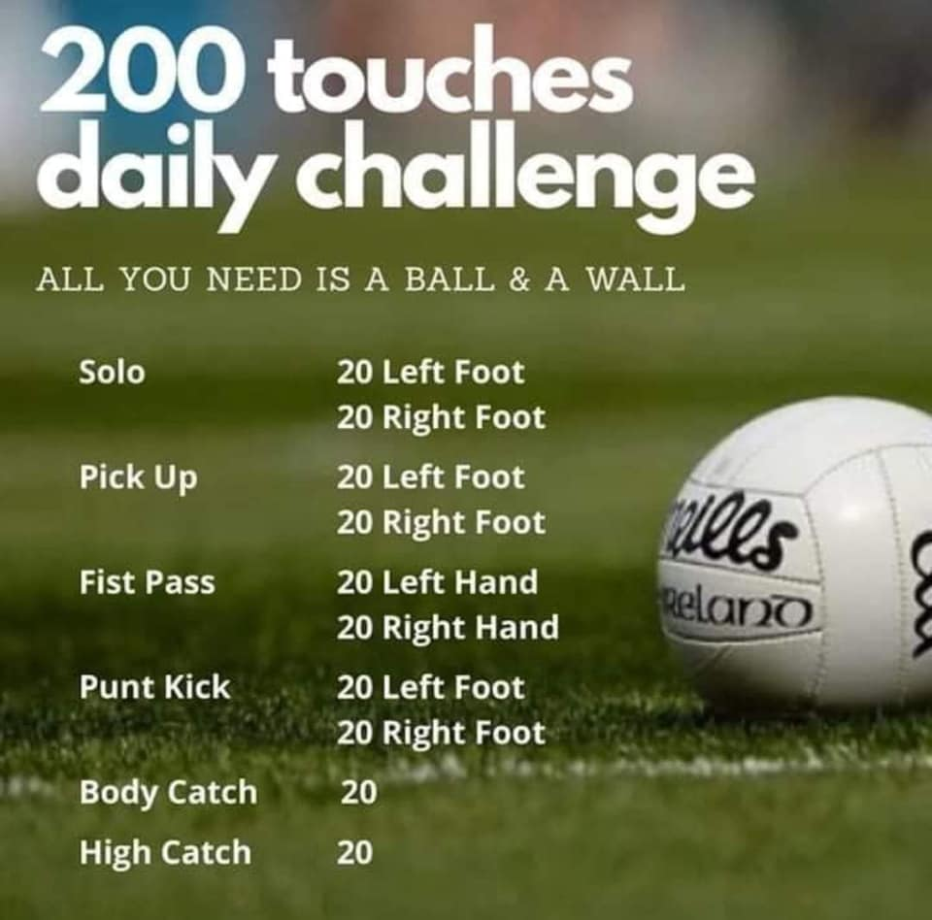

Useful Websites for this week: (supplemental work – if needed)
- Athletics Ireland :https://www.athleticsireland.ie/clubs/little-athletics/
- Art Some lovely resources from an illustrator https://www.tarsilakruse.com/resources
- Maths Games: IXL Games – Senior Infants https://ie.ixl.com/?partner=google&campaign=10099673253&adGroup=105313051390&gclid=Cj0KCQjwzZj2BRDVARIsABs3l9KgunMsc2JEy3gxMEtMf4liWVmLGaZnkZDdcAfdVFbnPz1CAl5qfEkaAq7nEALw_wcB
- Story/song : The Hare and the Tortoise https://www.youtube.com/watch?v=WF8iaqRqI60
- Extra English Resources: https://www.gillexplore.ie/gill-explore-resources/over-the-moon-senior-infants-skills-book?Chapters=0&ResourceTypes=11535 – There are lots of activities connected to our English work here unit 9.
- Reading/phonics: https://www.starfall.com/h/ltr-classic/
- More sports video links: GAA training : https://www.youtube.com/watch?v=BWCfcz8dhvI&list=PLbAvjLA-cZu0UAeYVH6-gy1G3h60NXs73&index=3&t=0s
- Check out the school website for great videos by Coach Val.

Contact Teacher: msbyrne@scoilchoca.ie msmeehan@scoilchoca.ie
Contact support teacher:
Ms. Meehan’s class: msnidhalaigh@scoilchoca.ie
Ms Byrne’s class: mswilson@scoilchoca.ie
Children who attend EAL (English as an additional Language)
EAL work
Note: SEN teachers have added work on to the teachers’ plan. Children can decide to do this work instead of something the teacher has assigned. It is not extra work. Also, we would be delighted if you could email on a picture of something that your child has done and is proud of so we can see their lovely work again!

EAL work 8/6/2020

Teachers: Ms Wilson / Ms Tone

EAL | Theme – Myself – Sports and Hobbies  This week is Sports Week. We are going to learn about different sports. We are learning to name different sports and what we need to play the sport. You can do this at home as you play sports this week.  - Encourage your child to talk about the sport he/she is playing and what is being used to play the sport. Use words like throw, catch, walk, run, sprint, jog, jump, skip, hop, stand, freeze, etc. as you play together.  - Use the activities below to go over the names of different sports and equipment used.  - Above all ENJOY sports week!

Contact SEN Teachers:

Please send Ms Meehan’s EAL work to Ms Wilson: mswilson@scoilchoca.ie

Please send Ms Byrne’s EAL work to Ms Tone: mstone@scoilchoca.ie

Match the picture to the name of the sport/activity.
 | hurling/camogie
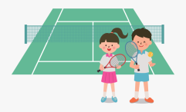 | tennis
 | basketball
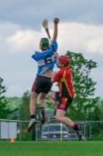 | canoeing
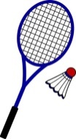 | football
 | swimming
 | bowling
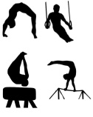 | badminton.
 | dance
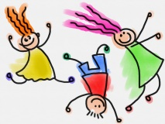 | gymnastics

Draw a picture of your favourite sport in this box. Finish the sentence below.

_____________is my favourite sport because __________________________
________________________________________________________________________________________________________________________________
Name the Sport
Talk about the equipment needed for different sports.
Show your child these picture clues. Ask your child to guess which sport goes with the picture.
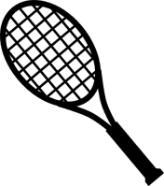  racket | 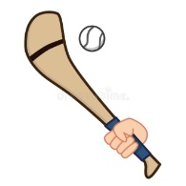  hurley
basketball hoop | 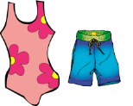  goggles and togs
shuttlecock | beam
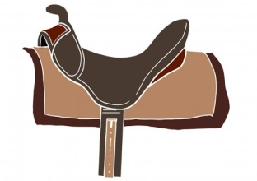  saddle | 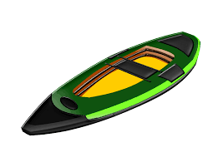  canoe

