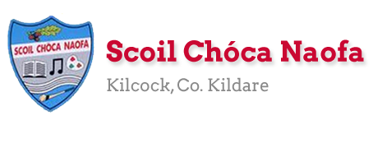

Work for Senior Infants Class : Week of Monday 22nd June
Monday | English: Poem ‘ Camping’ (see below). Read poem to your child and discuss. Discuss words used in the poem to describe sounds. What were all the different sounds? Have you ever heard these sounds when camping/outside? Complete page 122 Skills Book.  Maths: Money: Take some coins out again this week. Practise identifying coins. Trace some money to bring on our Virtual School Tour! How much do you think we might need to bring? Maths book pg.109 Colour the correct amount of money needed to buy items.  Irish: https://youtu.be/1QqGC5YRlyI Cad a chonaic tú? (What did you see?) Chonaic mé(I saw) Tarracóir (tractor), leoraí (lorry), carr (car), bus (bus), rothar (bicycle), veain (van), eitleán (airplane).  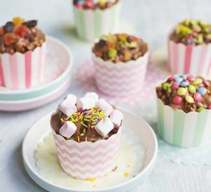  Scoil Chóca Naofa Bake Off: Recipe below  Challenge 1: Chocolate Rice Krispies Cakes  Send us photos of your creations!
Tuesday | English: Real or nonsense words: Game to practise- Interactive resources Unit 9 sorting interactive activity. Skills book pg.123  https://www.gillexplore.ie/gill-explore-resources/over-the-moon-senior-infants-skills-book?Chapters=0&ResourceTypes=11535  Maths: Money: Can you save some money each week? Maybe if you complete some chores for your Mammy and Daddy you could earn some money. You could; empty the dishwasher each day, sweep the floor, help hang out the washing, hoover the living areas. https://www.youtube.com/watch?v=n6EqkwYqEDo&feature=youtu.be Combine coins to make different amounts (like in video above). Maths book pg.110 how much have you in your piggy bank?  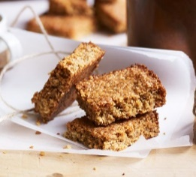  Irish: https://youtu.be/1QqGC5YRlyI Cad a chonaic tú? (What did you see?) Chonaic mé(I saw) Tarracóir (tractor), leoraí (lorry), carr (car), bus (bus), rothar (bicycle), veain (van), eitleán (airplane).Revise and focus on the prhase ‘Chonaic mé___’ (I see__). Bua na Cainte pg. 49  Scoil Chóca Naofa Bake Off: Recipe below  Challenge 2: Yummy Flapjacks  Send us photos of your creations!
Wednesday | English: Listen to the story ‘Herman’s Holiday’ by Tom Percival. https://www.youtube.com/watch?v=APmWmvA0T8k Skills book: Read Herman and Henry’s packing lists. Write or draw your own packing list if you were going on holiday or going camping pg. 124  Maths: Money: Maths book page 111. Complete these money problems. https://ie.ixl.com/math/sr-infants Practise these money games.  Irish: https://youtu.be/tJ9Z_mwNT1g Chuaigh Niamh go dtí an siopa bréagán. (Niamh went to the toy shop). Bhí sí ag siopadóireacht. (She was shopping.) Fuair sí liathróid (ball), cluiche (game), scútar (scooter) nua. Bua na cainte pg.50  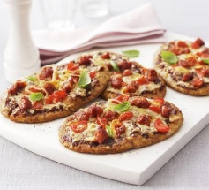  Scoil Chóca Naofa Bake Off: Recipe below  Challenge 3: Pitta Pizzas  Send us photos of your creations!
Thursday | Get ready to take off on our Virtual School Tour!!
Friday | Continue with our Virtual School Tour Activities  Make a card for your Dad, granddad or someone you love.
Monday 29th | Finish off chosen activities in your books.  CHOICE BOARD If you have time pick a fun activity to complete. We would love to see photos of it.
Tuesday  30th | Last day of school: Draw a picture of your favourite memory of Senior Infants  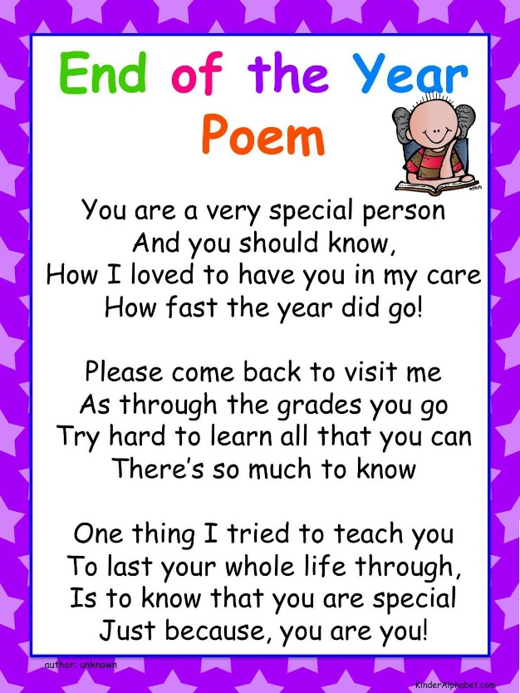  Make a card/picture/drawing for one of your friends. Maybe you could post it to them.  From Ms. Byrne & Ms. Meehan

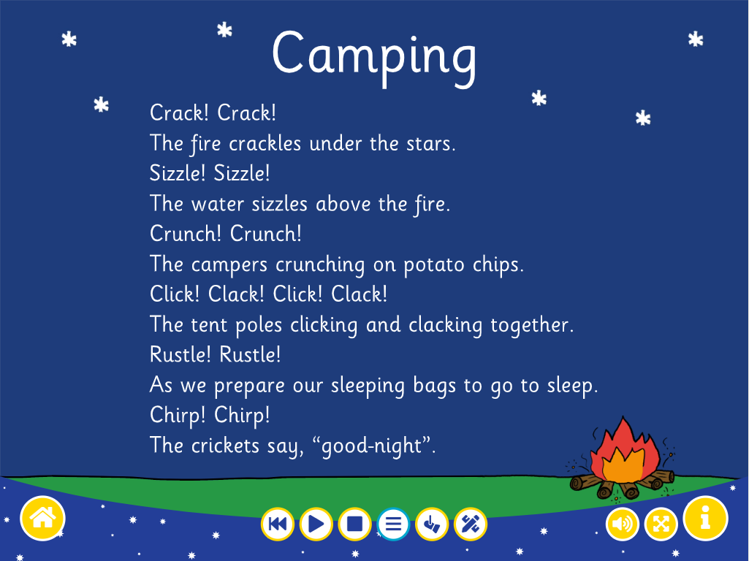

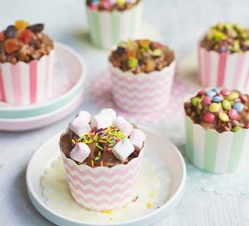
NOTE: Baking activities are Adult assisted only.
Chocolate Rice Krispies cakes
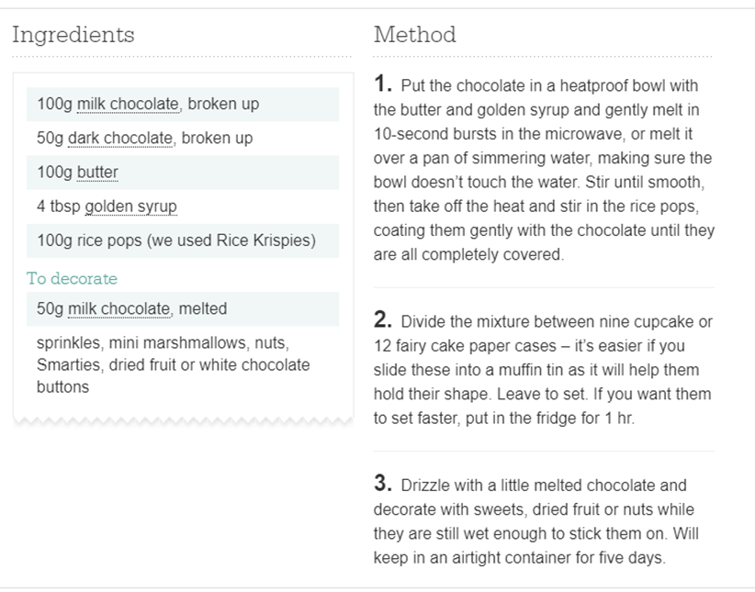

Yummy Flapjacks

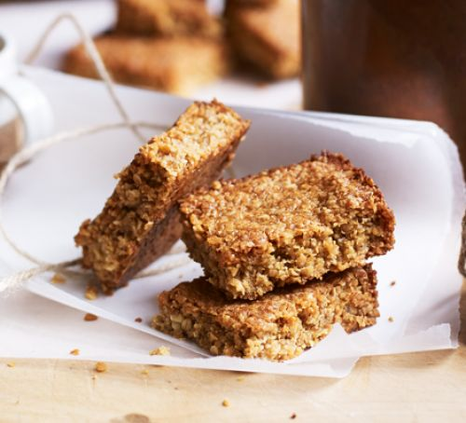

Pitta Pizzas
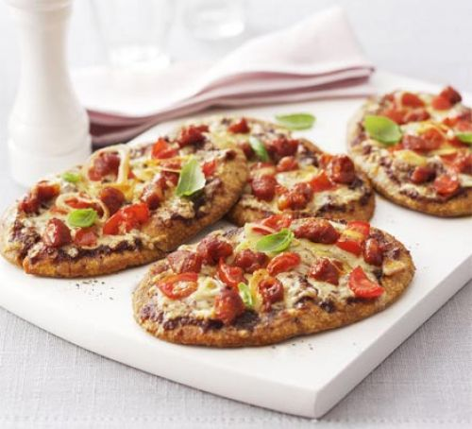

Bear on Toast

Bear on Toast

CHOICE BOARD Here is your fun choice board for the week. Pick one thing to do every week from the board. Send us a pic. We would love to see which one you chose?!

Useful Websites for this week: (supplemental work – if needed)
- SESE :https://www.youtube.com/watch?v=cN1wYdotUQ8 Story about differences
- PE: https://www.youtube.com/watch?v=oe_HDfdmnaM Pirate work out.
- English: Dictation lists. Call out these words and ask your child to write them independently (using cursive writing). https://stmatts.ie/wp-content/uploads/2014/10/S.I-Spellings-T2.pdf
- Reading books: https://www.oxfordowl.co.uk/for-home/find-a-book/library-page/?view=image&query=&type=book&age_group=Age+5-6&level=&level_select=&book_type=&series=#
- Maths Games: IXL Games – Senior Infants https://ie.ixl.com/?partner=google&campaign=10099673253&adGroup=105313051390&gclid=Cj0KCQjwzZj2BRDVARIsABs3l9KgunMsc2JEy3gxMEtMf4liWVmLGaZnkZDdcAfdVFbnPz1CAl5qfEkaAq7nEALw_wcB
- Extra English Resources: https://www.gillexplore.ie/gill-explore-resources/over-the-moon-senior-infants-skills-book?Chapters=0&ResourceTypes=11535 – There are lots of activities connected to our English work here unit 9.
- Contact Teacher: msbyrne@scoilchoca.ie msmeehan@scoilchoca.ie
Contact support teacher:
Ms. Meehan’s class: msnidhalaigh@scoilchoca.ie Ms Byrne’s class: mswilson@scoilchoca.ie

EAL work 22/6/2020

Teachers: Ms Wilson / Ms Tone

EAL | Theme – Food - Baking  Your teachers told us that you will be doing some baking this week.  We thought it might be a good idea to cover some vocabulary relating to baking.

Contact SEN Teachers:

Please send Ms Meehan’s EAL work to Ms Wilson: mswilson@scoilchoca.ie

Please send Ms Byrne’s EAL work to Ms Tone: mstone@scoilchoca.ie

Think of different types of cakes, biscuits or pastries we bake at home or see in the bakery. Ask your child to try to remember the names of nice things he/she has baked at home or bought in the shop. The list below might help.

Nice things we can bake
tarts  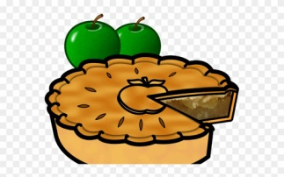 | cup cakes/buns | éclairs  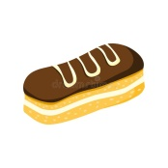
scones  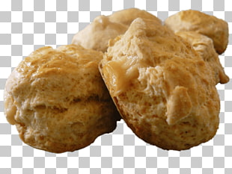 | croissants | cookies/biscuits  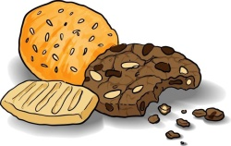
doughnut | pavlova  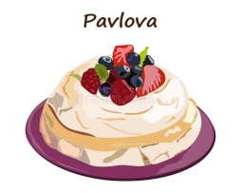 | meringue  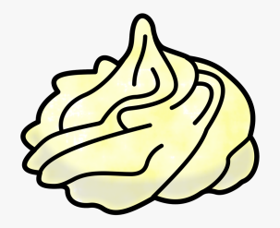

Go over the names of different ingredients we use for baking. (see below).
See if you can find any of these ingredients at home. Tick the ones you find.
flour  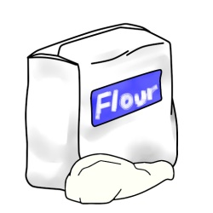 | eggs  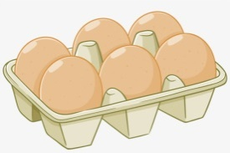 | milk  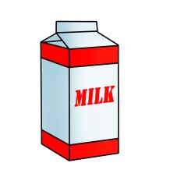
sugar  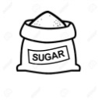 | butter/margarine  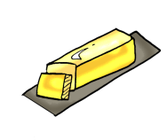 | spices  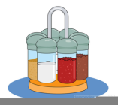
chocolate  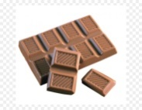 | honey  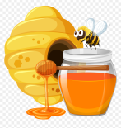 | golden syrup  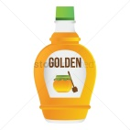
jam  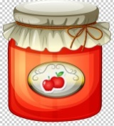 | cream | fruit  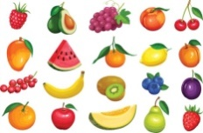
nuts  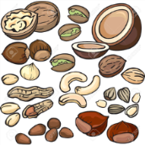 | baking soda  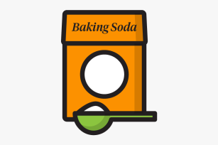 | cocoa  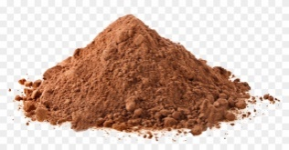
yeast  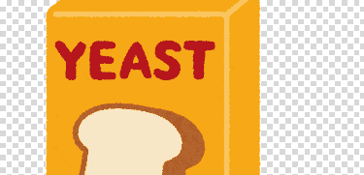 | vanilla extract | salt  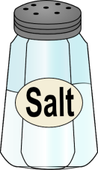

Ask your child to think of something he/she has baked at home.
- First draw the ingredients used. Write the names of the ingredients.
- Next draw what was baked. Write the name of what was baked under the picture.
Picture of ingredients

Names of ingredients _________________________________________________________________________.
___________________________________________________________________________________________________________________________________________________________________________________________________________________________.

Picture of my baking.

I baked ________________________________________________________ at home.

