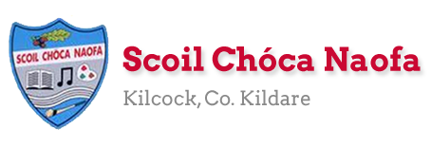

Work for Senior Infants Class : Week of Monday 15th June
Monday | English: https://www.gillexplore.ie/gill-explore-resources/over-the-moon-senior-infants-skills-book - Genre story e-books Unit 9 Fun at the campsite. Listen to the story and discuss. Complete page 117 Skills Book.  Maths: Measures: Lets measure with objects. Here is a game https://ie.ixl.com/math/sr-infants/measure-using-objects. Can you measure the items in your book? You can use paper clips, cubes, blocks, pasta, coins (the same size) to help you. Maths book pg. 106 When you pick what you are using to measure then take a good guess (estimate) before you start. An estimate doesn’t have to be correct remember it’s just a good guess.  Irish: Ag siopadóireacht (shopping). What this video https://youtu.be/QJZtGZesb-4.  Tá na páistí sa bhaile mór.(The children are in the town). Tá _ sa bhaile mór. (_ is in the town). Siopa éadaí (clothes shop), siopa bia (food shop), siopa bréagán (toy shop), teach (house), scoil (school), séipéal (church), zú (zoo). Tá Niamh ag dul go dtí an síopa éadaí. (Niamh is going to the clothes shop).  PE: Practise your hand passing outside. This video will help you before you go out. https://www.youtube.com/watch?v=XfQq-rdC-eE  Other: SESE: Can you build a fort? It could be inside or outside. Send us a photo we would love to see it.
Tuesday | English: Question marks- discuss when we might use them. Can you draw a few question marks? Practise using question marks. Skills book pg. 118. Game to practise- Interactive resources Unit 9 complete the sentence activity  https://www.gillexplore.ie/gill-explore-resources/over-the-moon-senior-infants-skills-book?Chapters=0&ResourceTypes=11535  Maths: More measuring today. Take out your paper clips to measure the distance from Betsy to her toys. Remember to estimate your answer before you start. Maths book pg. 107. Can you measure other things in your house?  Irish: Listen to the story again. Focus on these words: Siopa éadaí (clothes shop), siopa bia (food shop), siopa bréagán (toy shop), teach (house), scoil (school), séipéal (church), zú (zoo). Focus on saying this sentence: Tá mé ag dul go dtí an síopa éadaí. ( I am going to the clothes shop).  PE: 10 x star-jumps, Run on the spot, Jump on one leg x 10, bunny hop x 20 – Repeat. Can you make up your own routine?  Other: Music: Listen to and sing along; Summer time song: https://www.youtube.com/watch?v=mVhh0oATqBI
Wednesday | English: Rhyming words: Listen to and sing along to familiar nursery rhymes. Discuss the words rhyme e.g. wall, fall, Jill, hill, cat, fat etc. https://www.youtube.com/watch?v=0n_J2z-ILXo Skills book pg. 119 substituting sounds.  Maths: Money: Let’s get used to handling money. Ask your parents to give you some coins. Take a look at them closely. What is on the front and back of them? What does the number mean? What colour are they? Get your coins and make some rubbings with them using your pencil or crayons. (1c, 2c, 5c, 10c, 20c). Extend this asking how many 1c coins are in 10c etc.  Irish: Revise counting in Irish. https://www.youtube.com/watch?v=qpYIa4iReRc  SESE: Habitats Story Harry and the Cactus (see below)Read this story to your child. It introduces children to the cactus: a plant that differs in a number of ways from plants that the children are already familiar with. Children learn to distinguish between cacti and other plants and are encouraged to consider what a plant needs to be properly cared for. SESE book page.70 & 71
Thursday | English Have you ever gone camping? Maybe you camped in the back garden during nice weather. Can you draw some pictures of your camping trip (real or imaginary) and write a postcard to tell Ella about your trip- what you saw, what the weather was like, what you ate etc. Skills book page 120 (use your cursive writing).  Maths: Money: Set up a shop in your house. What can you sell? How much are they going to cost? Make some price tags to put on the items. Take your coins out from yesterday and use in your pretend shop. Maybe you want to cut out your coin rubbings to use at your shop. Or you could design your own coin.  Irish: Comhair na hainmhite (count the animals) Watch this video https://youtu.be/CI0KUV2cXFo Bua na Cainte pg. 48  PE: Practice some of the skills and games we did for sports week. Can you do this challenge outside? https://www.youtube.com/watch?v=FXTcCNR8WNs  SESE: Take a virtual tour around San Diego Zoo. You can see some animals on the live cameras. https://zoo.sandiegozoo.org/live-cams or visit Disneyland for a virtual tour of the worlds. Maybe you have been there or hope to go some time? https://www.visitorlando.com/en/things-to-do/virtual-tours
Friday | English: Revise reading words. Interactive resources Unit 9 sorting interactive activity (sort real and nonsense words) Skills book pg.121  Maths: Match the correct amount to the correct coin. Planet maths pg. 108  Irish: Revise new words this week and sing Istigh sa Zú https://youtu.be/pcNIkuFP_14 agus Teidí ar a rothar https://youtu.be/ZFW0kN9Nabc  Art: Have a look at the plants/flowers in your garden. Could you draw or paint one. Take a look (Below) at this famous painting by Vincent Van Gough called Sunflowers.  PE: Kids dance challenge with Ms Trisha https://www.youtube.com/watch?v=4FWk_TstHOU&list=PLt3aHDpWcOx0OBuDv6x7BT-ZsxiI2bwkv  CHOICE BOARD If you have time pick a fun activity to complete.We would love to see photos of it.

SESE Story: Harry and the Cactus
One day Harry and his mammy went to the florist’s shop to buy some flowers. Looking around, Harry noticed a really strange plant. His mammy explained that it was a cactus. ‘It’s a very special plant that grows in very dry places called deserts where other plants can’t grow. Their special bodies can even hold water. They have thick, waxy skin so the water doesn’t dry out. They have spines to keep wild animals from breaking them,’ she explained. ‘And because they’re so different, they’re special.’ Harry’s mammy then bought the cactus and put it in the living room window. Harry didn’t like it much and thought it looked ugly. He put out his finger to touch it and pricked his finger. ‘Ouch!’ he yelled, trying to fight back the tears. ‘I don’t like that cactus plant,’ he told his mammy. ‘It doesn’t have pretty flowers or nice leaves. There’s nothing special about it, it’s just ugly!’ All evening Harry did not go back into the living room.
That night, while Harry was tucked up in bed, he had a dream. He dreamt he was a cactus, living in a hot desert. All day long he stood and enjoyed the sunshine. His body held lots of water so he never dried out. His roots held him firm in the soil. One day, this cactus said, ‘I don’t like being a cactus. I wish I had a long stem instead of this thick body. I wish I had lovely green leaves and pretty flowers instead of these prickly spines. Oh, I wish I could change myself.’ That evening, a huge black rat came by. ‘Oh no,’ thought the cactus. ‘I’m going to get eaten!’ He stood strong and whenever the rat tried to touch him, his spines pricked the nasty rat. The rat kept trying, but the spines of the cactus kept pricking him. At last the rat gave up and moved on. ‘Phew!’ thought the cactus, ‘I am so glad to be a cactus.’ Next morning when Harry got up, he went to look at the cactus again. A little flower had blossomed on the cactus during the night. ‘I understand now why you look like you do. You are really strong and you just want to survive. You are not ugly after all. You are quite beautiful and rather special!’ Harry took good care of the cactus after that and gave it little drops of water to keep it happy, beautiful and strong.
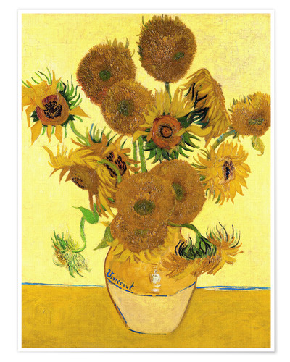

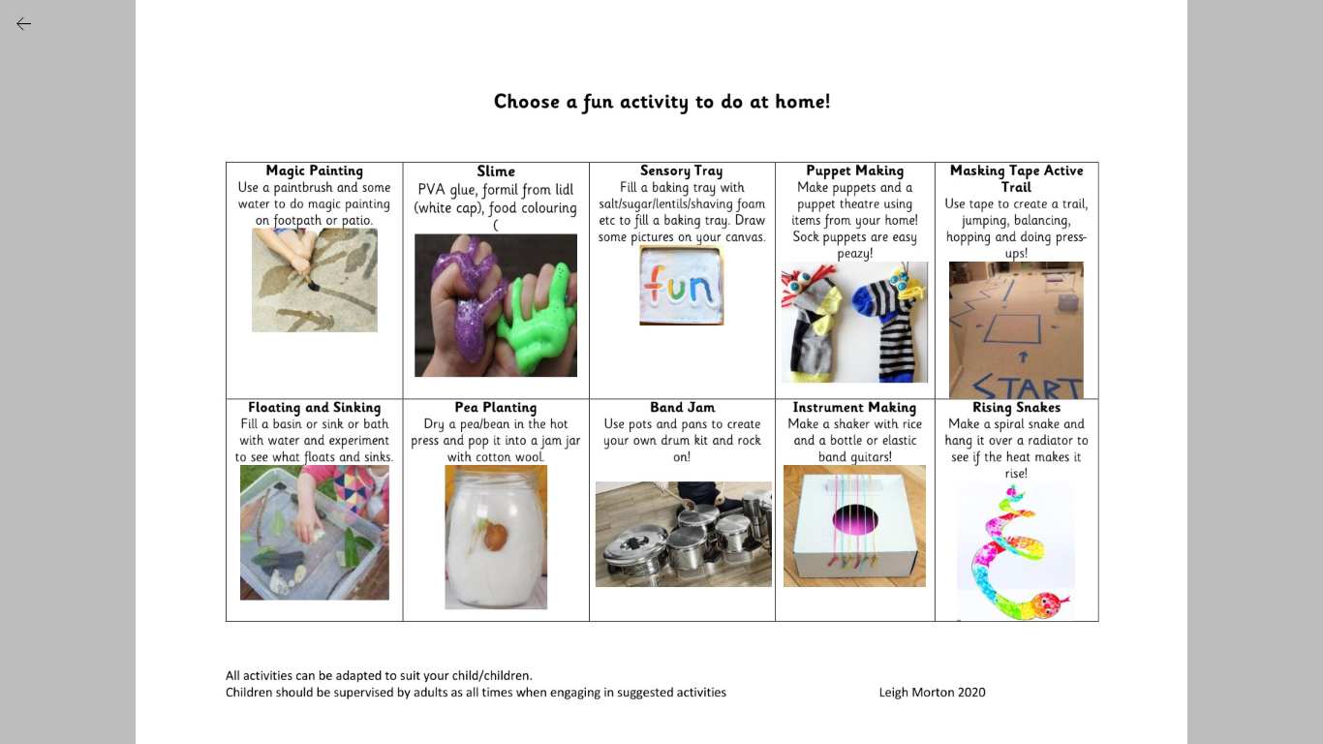
CHOICE BOARD Here is your fun choice board for the week. Pick one thing to do every week from the board. Send us a pic. We would love to see which one you chose?!

Useful Websites for this week: (supplemental work – if needed)
- PE: Athletics: https://youtu.be/gv3CHKPDJGo Let’s get up our skills. ABC Challenge Balance (Rope/Broom Handle), Speed Bounce, Standing Long Jump
- Art ideas and pintables. https://www.tarsilakruse.com/resources
- National art gallery. https://www.nationalgallery.ie/explore-and-learn
- Reading books: https://www.oxfordowl.co.uk/for-home/find-a-book/library-page/?view=image&query=&type=book&age_group=Age+5-6&level=&level_select=&book_type=&series=#
- Maths Games: IXL Games – Senior Infants https://ie.ixl.com/?partner=google&campaign=10099673253&adGroup=105313051390&gclid=Cj0KCQjwzZj2BRDVARIsABs3l9KgunMsc2JEy3gxMEtMf4liWVmLGaZnkZDdcAfdVFbnPz1CAl5qfEkaAq7nEALw_wcB
- Extra English Resources: https://www.gillexplore.ie/gill-explore-resources/over-the-moon-senior-infants-skills-book?Chapters=0&ResourceTypes=11535 – There are lots of activities connected to our English work here unit 9.
- SESE: Live interactive safari experienceshttps://wildearth.tv/kids/

- Contact Teacher: msbyrne@scoilchoca.ie msmeehan@scoilchoca.ie
Contact support teacher:
Ms. Meehan’s class: msnidhalaigh@scoilchoca.ie Ms Byrne’s class: mswilson@scoilchoca.ie

EAL work

Teachers: Ms Wilson / Ms Tone (Ms Clancy)

Note: SEN teachers have added work on to the teachers’ plan. Children can decide to do this work instead of something the teacher has assigned. It is not extra work. Also, we would be delighted if you could email on a picture of something that your child has done and is proud of so we can see their lovely work again!

EAL | People and Places In Other Areas  - Can you read these words?  Spain Poland Ireland  India France England  - Talk to a parent about the country they are from.  What is the weather like?  What food do they eat?  What sports do they play?  Do they know any songs from their country?  - Complete the matching exercise below.

Contact SEN Teachers:
Please send Ms Meehan’s EAL work to Ms Wilson: mswilson@scoilchoca.ie
Please send Ms Byrne’s EAL work to Ms Tone: mstone@scoilchoca.ie

 | Italy
 | France
 | India
 | America
 |  | Australia
 |  | England
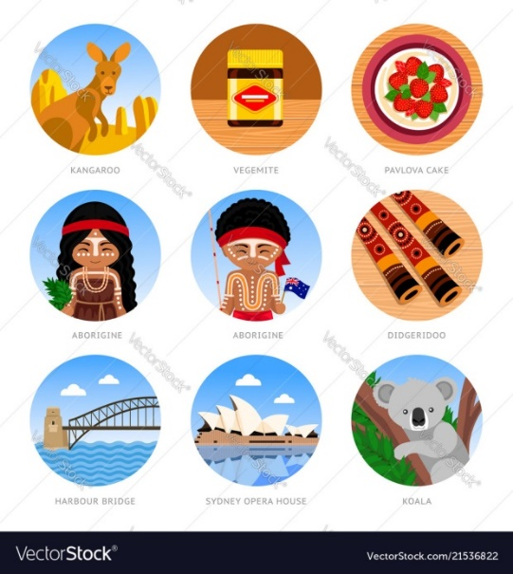 |  | Ireland
 |  | Spain

