Work for Second Class : Monday 8th June 2020
We hope you are all keeping well. We have outlined some activities which you can carry out daily. Extra activities, work from the SEN teachers, English and SPHE pages are all contained on this document. We loved getting to see so many familiar faces on Zoom last week! This week we will be continuing our Zoom assemblies. A link will be made available the day before.
This week is Sports Week! We would love to see some pictures of you doing your Sports Week activities. Please ensure that your face is not visible so we can select some images to put on the school website.
Kind regards, Ms. Carr and Ms. O’ Grady
mscarr@scoilchoca.ie mslogrady@gmail.com
Monday | English: Word Wizard, pg. 100- Phonics  Maths: Cracking Maths pg. 145 Money 2  Gaeilge: New Vocabulary ‘Caitheamh Aimsire’ (Hobbies) See sheet below (email teacher if you would like an audio file of the teacher pronouncing the words.)  P.E: * Stay Active Challenge* (See below for full details)  Other: What is your favourite hobby? Write 5 sentences about it and draw a picture.
Tuesday | English: Word Wizard, pg. 99 part C, Oral Language (Retell someone at home the story of the poem ‘The Dinosaur’s Dinner’ in your own words.)  Maths: Cracking Maths pg. 146 Money 2  Gaeilge: Oral language question  An maith leat sacar? Is/ Ní maith liom sacar. (I like/don’t like soccer)  P.E: * Stay Active Challenge* (See Below for full details)  Other: Who is your favourite sport’s star? Write 5 sentences about why you admire this person.
Wednesday | English: Write an Acrostic Poem about Active Week (see sheet 1. below) An acrostic is a poem is a poem in which the first letter of each line spells out a word or message. For example A- Athletic or All children love Sports Week.  Maths: Cracking Maths pg. 147 Money 2  Gaeilge: Oral language question  Cén caitheamh aimsire atá agat? Is maith liom bheith ag _____. (Is maith liom bheith ag snámh)  (What hobby do you have? I like .... I like swimming)  P.E.: * Stay Active Challenge* (See Below for full details)  Other: It is important to exercise and eat well in order to stay healthy. Look at Sheet 4 below based on healthy eating.
Thursday | English: My Active Week Journal (see sheet 2)  Maths: Skip counting in 4s while skipping/hopping  Gaeilge: Oral language question  Cén caitheamh aimsire is fearr leat? Is fearr liom a bheith ag léamh.  (What hobby do you prefer? I prefer reading)  P.E: * Stay Active Challenge* (See Below for full details)  Other: Sheet 5 below- Be Wise- Exercise.
Friday | English: My Active Week Journal (see sheet 3)  Maths: Add up the points for all your activities this week to find your final score. (Email your points to teacher in order to receive your ‘Sports Week Certificate’.)  Gaeilge: Oral language question  Cén caitheamh aimsire nach maith leat? Ní maith liom a bheith ag rith.  (What hobby do you nit like? I don’t like running)  P.E: * Stay Active Challenge* (See Below for full details)  Other: Art- How to draw a soccer player https://mail.google.com/mail/u/0/#inbox/KtbxLvhRZFpLcQhvPLTPLbsJchbXMFgRQB?projector=1

Extra activities if required including useful websites (For Self – directed Learning)
- RTE are providing a fun learning programme from 11-12 daily. Watch out for it @ https://www.rte.ie/learn/
- TG4 are providing an Irish learning programme from 10-11 daily. Watch out for it @ https://www.cula4.com/en/shows/cula4-ar-scoil/

Maths
- Master Your Maths and Cracking Maths- Complete any pages which were left blank- work at your own pace.

English
Story- Have You Thanked An Inventor Today?
Listen as far as 4.54 to hear the story- https://www.youtube.com/watch?v=Dcwvzg07PUY
Answer these questions after listening to the story.
- Who was your favourite inventor and why?
- If you were to become a famous inventor, what do you think you would have invented?
- Can you think of something else you use every day? Find out who invented it.

P.E. (Suggestions for extra activities for Stay Active Challenge)
You might see some familiar faces in these videos!
Family Dance class from Trisha McDermott
https://www.youtube.com/watch?v=xB0sg8nQXDc&list=PLt3aHDpWcOx0KJFmNWegn4eTv50f9Qgu_&index=2&t=0s

Soccer Skills with Eoghan
https://www.youtube.com/channel/UC_4CVGZ-aQH2V6cLGYmKMAg

Dance and conditioning warm ups sent by Excel Gymnastics
- https://www.youtube.com/watch?v=f6wm2g682JM
- https://www.youtube.com/watch?v=p_nZePWZo3M
- https://www.youtube.com/watch?v=VZOBjI-Vm8w&list=RDCMUCyqR7WkL8i1b6xtSssDmW9w&index=3
- https://www.youtube.com/watch?v=M5ffOxDIcwc&list=RDCMUCyqR7WkL8i1b6xtSssDmW9w&index=4
- https://www.youtube.com/watch?v=T30jzEYLvTk&list=RDCMUCyqR7WkL8i1b6xtSssDmW9w&index=8
Gaelic Skills with Val
- 2. 3. 4.
5.

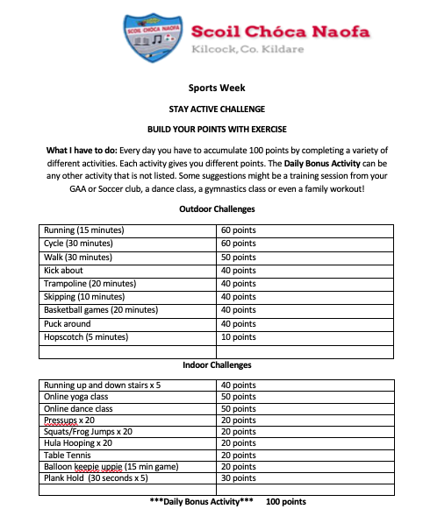
*NB* This is a guide for the children. Feel free to get creative during Sports Week, for example have your own Sports Day, make an obstcle course, play with you scooters, cycling, running etc.
EAL work 8/6/2020

Teachers: Ms Wilson / Ms Tone

Note: SEN teachers have added work on to the teachers’ plan. Children can decide to do this work instead of something the teacher has assigned. It is not extra work. Also, we would be delighted if you could email on a picture of something that your child has done and is proud of so we can see their lovely work again!

EAL | Theme -Myself – Sports and Hobbies  As this week is sports week our focus will be on Sport.  I would like you to think of the names of different sports and the equipment needed to play these sports. After that try a piece of procedural writing. Try to describe how to play a sport of your choice. See the activity below.

Contact SEN Teachers:

- Please send Ms Carr’s EAL work to Ms Wilson: mswilson@scoilchoca.ie

- Please send Ms O’Grady’s EAL work to Ms Tone: mstone@scoilchoca.ie

EAL WORK
Sport
- Name 8 sports that you have played. Think of more than 8 if you can.
________________________________________________________________________________________________________________________________________________

- Look at the pictures of sports equipment below.
Name each item. Say what sport or activity it is used for. Say where the sport or activity is played.

Picture | Name | Sport | Location
 | tennis racket | tennis | tennis court
Now think of a sport that you have played. Pretend that you have to describe how to play this sport to a friend.
- Name the sport.
- Mention what equipment you need.
- Describe where the sport is played.
- Write how many are on a team if it is a team sport.
- Mention how you win/score.
- Write down three or four rules.
When you are finished draw a picture or attach a photo of the sport.
_________________________________________________________________________________________________________________________________________________________________________________________________________________________________________________________________________________________________________________________________________________________________________________________________________________________________________________________________________________________________________________________________________________________________________________

Irish Vocabulary- Caitheamh Aimsire

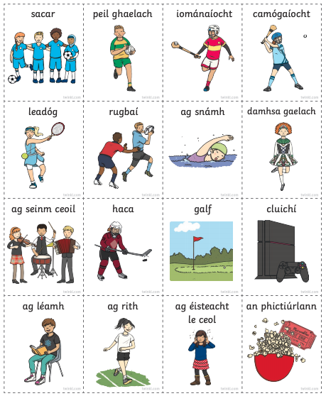

English- Sheet 1- Wednesday Activity
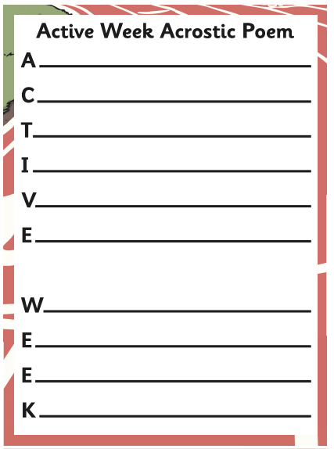

English- Sheet 2- Thursday Activity
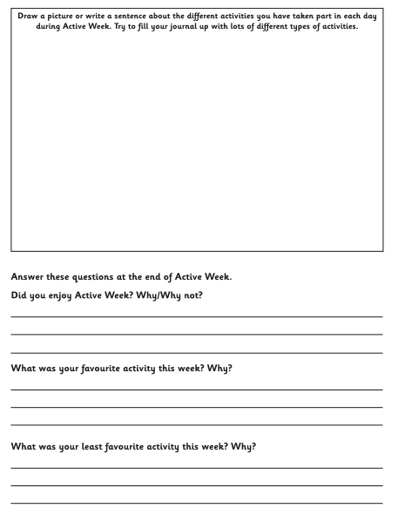

English- Sheet 3- Friday Activity
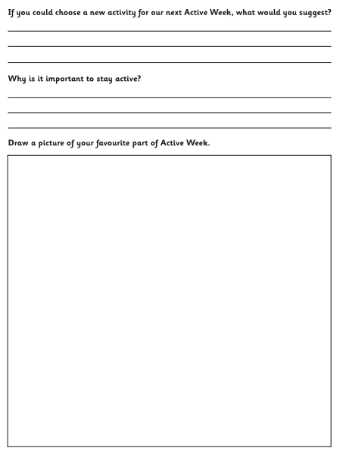

Sheet 5 – Healthy Eating- Wednesday

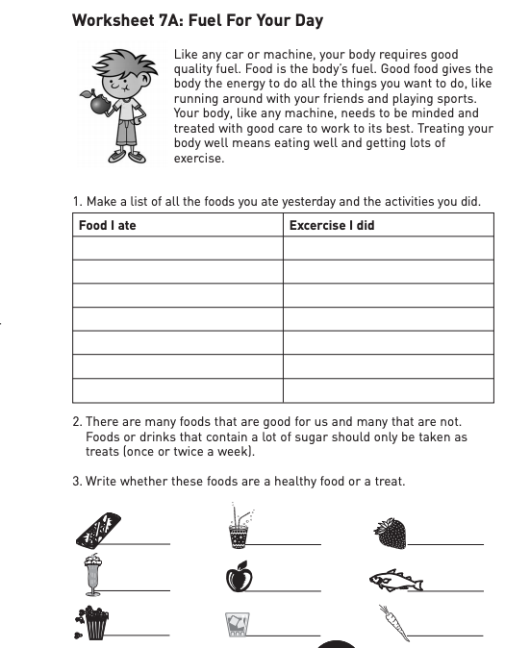

Sheet 6 - Be Wise- Exercise – Thursday
