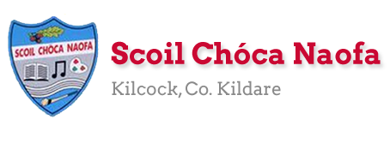
Work for Second Class : Monday 22nd June 2020
We hope you are all keeping well. We have outlined some activities which you can carry out daily. Work from the SEN teachers, Irish and extra activity pages are all contained on this document. The focus for this week is ‘The Great Irish Bake for Temple Street’ https://www.templestreet.ie/event/great-irish-bake/. If we were in school we would normally fundraise for Temple Street around this time of year. Do not feel any pressure to donate but our activities are based on baking and recipes this week. This week we will be continuing our Zoom assemblies. A link will be made available the day before. We are picking two pieces of work from each class for the school website each week and would love for you to send in work you are proud of. Feel free to contact us if you have any questions.
Kind regards, Ms. Carr and Ms. O’ Grady
mscarr@scoilchoca.ie mslogrady@gmail.com
Monday | English: Word Wizard, pg. 104 Revison: Grammar and phonics- Day 3 and 4  Maths: Cracking Maths pg. 152- Solve the Riddles  Gaeilge: New Words- Sheet 1  P.E: https://rtejr.rte.ie/10at10/  Other: Talk and discussion about baking- Sheet 5
Tuesday | English: Word Wizard, pg. 105- Phonics  Read library book for 5 mins.  Maths: Cracking Maths pg. 153 Q1 (Page to be completed tomorrow)  Gaeilge: New Words- Sheet 2  P.E: Joe Wicks on Youtube.  Other: Think about your favourite recipe- why is this your favourite? (Preparation for Thursday Zoom- see Thursday for details)
Wednesday | English: Word Wizard, pg. 106- Read Story ‘Grandad’s Mad Garden’  Word Wizard pg. 107 Part C- Vocabulary  Maths: Cracking Maths pg. 153 Q.2  Gaeilge: Word search  P.E.: Walk, run or cycle.  Other: Write a recipe that you enjoy making/ would like to try to make.
Thursday | English: Word Wizard pg. 107: Answer the questions Part A and B  Maths: Cracking Maths pg. 154- Word Problems  Gaeilge: Ar an trá – Sheet 4  P.E: Go Noodle online  Other: Zoom- talking about different recipes- children can bring a baked good or have a recipe in mind to share with their classmates.
Friday | English: Word Wizard pg. 108 Assessment: Grammar  Read library book for 5 mins.  Maths: Cracking Maths pg. 155- Check-up 5  Gaeilge: An maith leat an trá? (Do you like the beach?)  Is/ Ní maith liom an trá.  P.E: Joe Wicks on Youtube.  Other: Art- https://www.nhm.ac.uk/discover/how-to-press-flowers.html
Monday | Design your own Flip Flop- Sheet 6  Game- I spy- Sheet 7  5 minute meditation  Joe Wicks on YouTube
Tuesday  (1/2 day) | Summer Wordsearch- Sheet 8  Mindfulness Colouring Sheet – Sheet 9

Extra activities if required including useful websites (For Self – directed Learning)
- RTE are providing a fun learning programme from 11-12 daily. Watch out for it @ https://www.rte.ie/learn/
- TG4 are providing an Irish learning programme from 10-11 daily. Watch out for it @ https://www.cula4.com/en/shows/cula4-ar-scoil/

EAL work 22/6/2020 Teachers: Ms Wilson / Ms Tone
EAL | Theme –Food – Baking  Your teachers told us that you will be doing some baking this week.  We thought it might be a good idea to cover some vocabulary relating to baking.

Contact SEN Teachers:

- Please send Ms Carr’s EAL work to Ms Wilson: mswilson@scoilchoca.ie

- Please send Ms O’Grady’s EAL work to Ms Tone: mstone@scoilchoca.ie

Look at the list below of common ingredients we use when we are baking.
flour | eggs | milk
sugar | fat | spices
chocolate | honey | golden syrup
jam | cream | fruit
nuts | baking soda | cocoa
yeast | vanilla extract | salt
Now answer the questions below about these ingredients.
(Check at home in your press. You might find some of the answers).
Name three types of chocolate
e.g. milk chocolate, white chocolate, cooking chocolate.
Name four types of flour.

Name three spices you can use when baking.

Name three different types of nuts.

Name five types of jam.

Name three types of fat you can use when baking.

Name two things you can put into a baking mixture to make it rise in the oven.

What is vanilla extract used for?

When might you use yeast?

Name three types of sugar.

Name three things you could bake using fruit.

Sometimes bakers use food colourings. Why do they do this?

Name three types of milk.

Cocoa can be used to bake cakes. What else can you make with cocoa?

Name a cake/pastry/biscuit you have baked at home.
Write the list of ingredients you used and describe how you made it.

Monday- Sheet 1
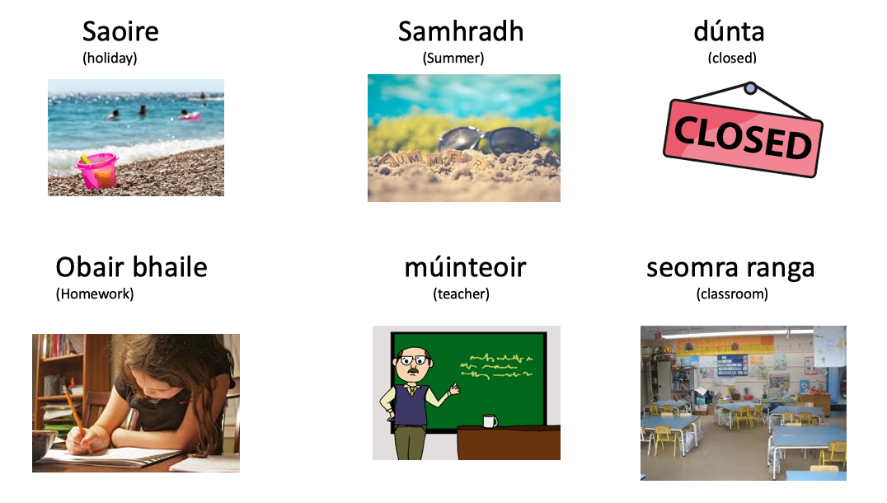

Tuesday- Sheet 2
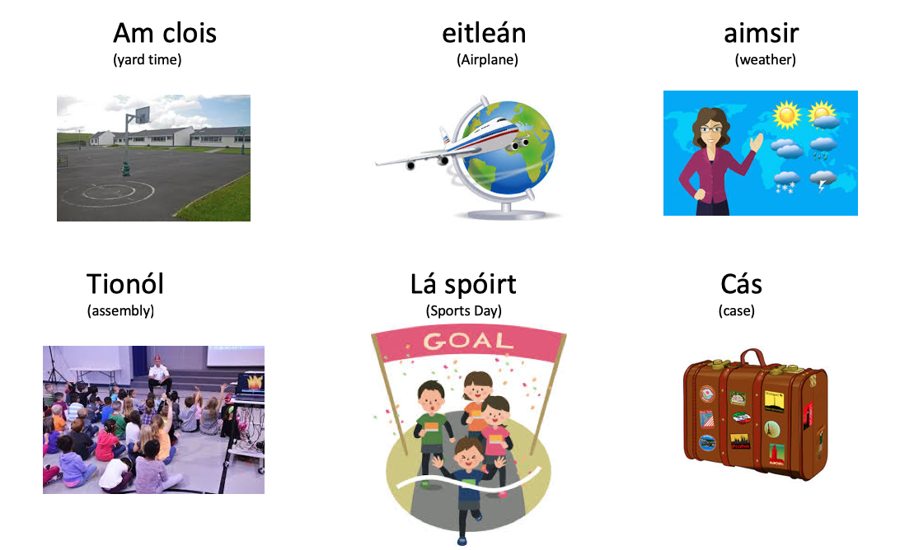

Wednesday- Word search- Sheet 3
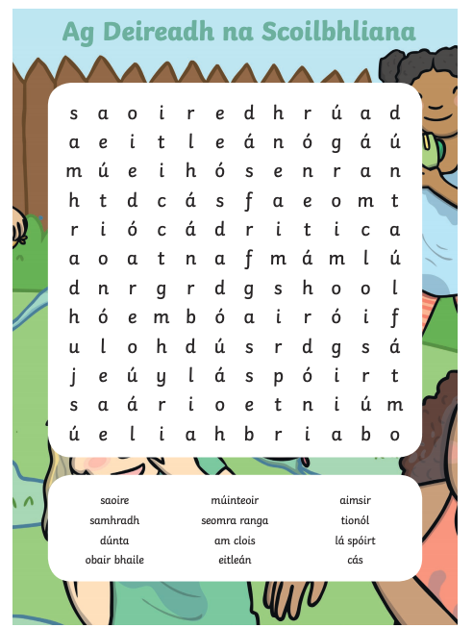

Friday – Ar an Trá -Sheet 4

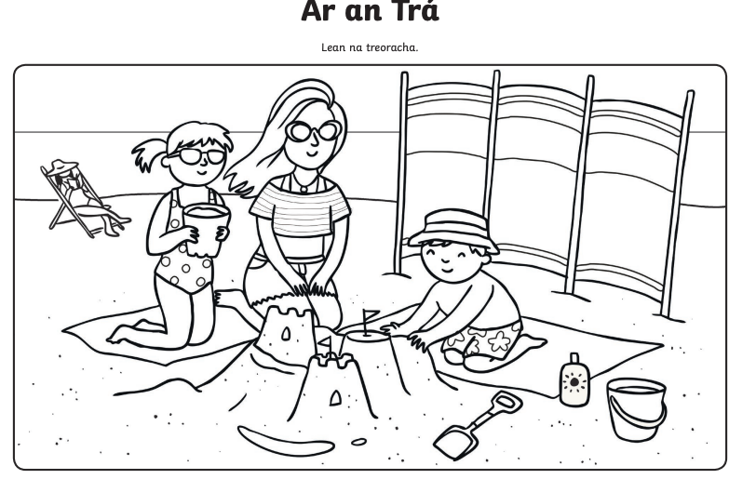

Sheet 5- Monday- Talk and Discussion- Baking

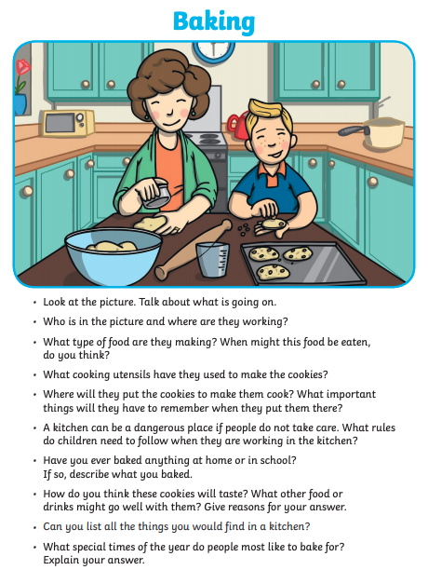

Sheet 6
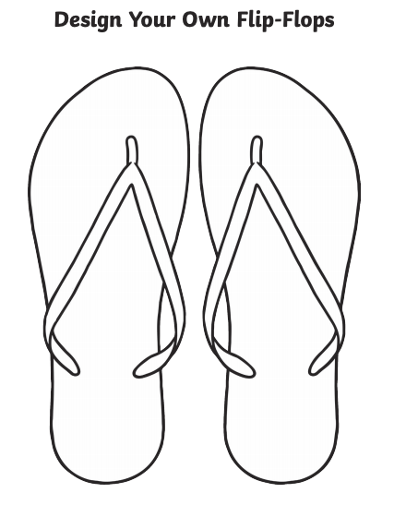

Sheet 7
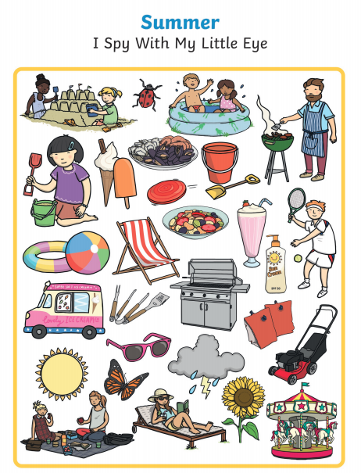

Sheet 8
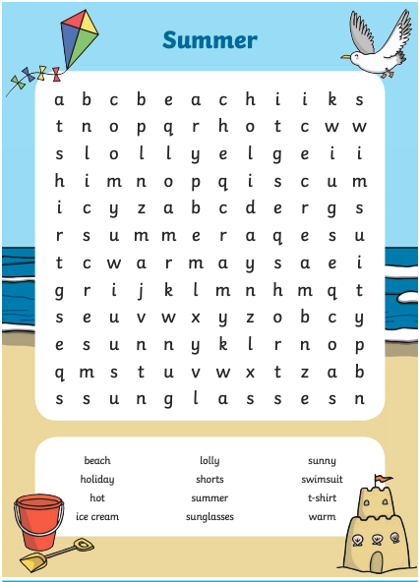

Sheet 9
