

**Work for Second Class : Monday 15th June 2020**

We hope you are all keeping well. We have outlined some activities which you can carry out daily. Extra activities, work from the SEN teachers, English, Irish and SESE pages are all contained on this document. This week we will be continuing our Zoom assemblies. A link will be made available the day before. We are picking **two pieces of work from each class for the school website each week** and would love for you to send in work you are proud of. Feel free to contact us if you have any questions.

Kind regards, Ms. Carr and Ms. O’ Grady

[mscarr@scoilchoca.ie](mailto:mscarr@scoilchoca.ie) [mslogrady@gmail.com](mailto:mslogrady@gmail.com)

|  |  |
| --- | --- |
| **Monday** | **English:** Word Wizard, pg. 101- Grammar – Tired words – ‘said’  Read library book for 5 mins.  **Maths:** Cracking Maths pg. 148  **Gaeilge:** Revise vocabulary from last week (see below)  **P.E:** <https://rtejr.rte.ie/10at10/>  **Other:** Sporting Hero – Sheet 1 (See below) |
| **Tuesday** | **English:** Word Wizard, pg. 102 A– Plan a story about an imaginary creature coming to school.  Read library book for 5 mins.  **Maths:** Cracking Maths pg. 149 (See explanation below)  **Gaeilge:** Scéal (story) – Léigh (Read) Peil - At the  bottom of this plan. (Email class teacher if you would like  an audio of teacher reading the story)  **P.E:** Joe Wicks on Youtube.  **Other:** Summer – Sheet 2 (See below) |
| **Wednesday** | **English:** Word Wizard, p.102 B- Write the story by yourself using your plan. Remember to use your connecting words, capital letters and full stops. Make your story more interesting by using other words for ‘said’.  Read library book for 5 mins.  **Maths:** Cracking Maths pg. 150 Addition and Subtraction Word Problems  **Gaeilge:** Scéal- Peil- Freagair na ceisteanna (Answer  the questions)  **P.E.:** Walk, run or cycle  **Other:** Summer – Sheet 3 – Read the comprehension (See below) |
| **Thursday** | **English:** Word Wizard p. 103 Revision and Assessment Day 1  Read library book for 5 mins.  **Maths:** Cracking Maths p.151 Row 1,2 and 3 (Finishing the page tomorrow)  **Gaeilge:** Sheet 3 -Léigh an scéal agus freagair na ceisteanna (Read the story and answer the questions) Email class teacher if you would like an audio of teacher reading the story.  **P.E:** Go Noodle online  **Other:** Summer – Sheet 3 – Answer these questions based on the comprehension (which you read yesterday)   1. When does the Irish summer begin and end? 2. Describe the weather in Ireland during the summer. 3. What kinds of animals can be found during the summer? 4. What kind of wild flowers can be found in Ireland during the summer? |
| **Friday** | **English:** Word Wizard p. 103 Revision and Assessment Day 2  Read library book for 5 mins.  **Maths:** Cracking Maths p.151 (Row 4 and 5)  **Gaeilge:** Sheet 4 -Bí ag léamh (Read the sentences) Email class teacher if you would like an audio of teacher reading the sentences  **P.E:** Joe Wicks on Youtube.  **Other:** <https://www.youtube.com/watch?v=sx7_wKaLfhY>  Summer beach drawing |

**Extra activities if required including useful websites (For Self – directed Learning)**

* **RTE** are providing a fun learning programme from 11-12 daily. Watch out for it @ <https://www.rte.ie/learn/>
* **TG4** are providing an Irish learning programme from 10-11 daily. Watch out for it @ <https://www.cula4.com/en/shows/cula4-ar-scoil/>

|  |
| --- |
| **Maths** |
| * **Master Your Maths and Cracking Maths-** Complete any pages which were left blank- work at your own pace. |
| **English** |
| <https://www.youtube.com/watch?v=loaLRKmRcCA>  Layla’s Happiness by Maria Hadessa Ekere Tallie  Read the story and answer these questions.   1. Name 3 things that make Layla happy. 2. What is happiness to you? (Name 3 things that make you happy) |
| **Gaeilge** |
| 1. An maith leat peil ghaelach? Is/ Ní maith liom peil ghaelach. (I like/don’t like gaelic football) 2. Cén caitheamh aimsire atá agat? Is maith liom bheith ag _____. (Is maith liom bheith ag **éisteacht le ceol**)   (What hobby do you have? I like .... I like listening to music)   1. Cén caitheamh aimsire is fearr leat? Is fearr liom a bheith ag **snámh.**   (What hobby do you prefer? I prefer swimming)   1. Cén caitheamh aimsire nach maith leat? Ní maith liom a bheith ag **imirt galf.**   (What hobby do you nit like? I don’t like playing golf) |

|  |  |  |
| --- | --- | --- |
| **EAL work**  **Teachers:** Ms Wilson /Ms Tone (Ms Clancy)  **Note:** SEN teachers have added work on to the teachers’ plan. Children can decide to do this work instead of something the teacher has assigned. It is not extra work. Also, we would be delighted if you could email on a picture of something that your child has done and is proud of so we can see their lovely work again!   |  |  | | --- | --- | | **EAL** | **People and Places In Other Areas**  This week we are talking about different countries.   * Talk to a parent about the country they are from. * Fill in the table below. * Complete the worksheet. |   **Contact SEN Teachers:**   * Please send Ms Carr’s EAL work to Ms Wilson:[**mswilson@scoilchoca.ie**](mailto:mswilson@scoilchoca.ie) * Please send Ms O’Grady’s EAL work to Ms Tone:[**mstone@scoilchoca.ie**](mailto:mstone@scoilchoca.ie) |

Country:______________

|  |
| --- |
| Flag |
| Food |
| Weather |
| Sport |
| Places to visit |
| Clothes |

Name the country.

|  |  |
| --- | --- |
| C:\Program Files (x86)\Microsoft Office\MEDIA\CAGCAT10\j0157763.wmf |  |
| C:\Program Files (x86)\Microsoft Office\MEDIA\CAGCAT10\j0199036.wmf |  |
| pizza free clipart 20 free Cliparts | Download images on ... |  |
| Cartoon kangaroo Royalty Free Vector Image - VectorStock |  |
| Set Of England Cartoon Icons Isolated Stock Vector - Illustration ... |  |

**Maths Explanation for pg.149 Tuesday**

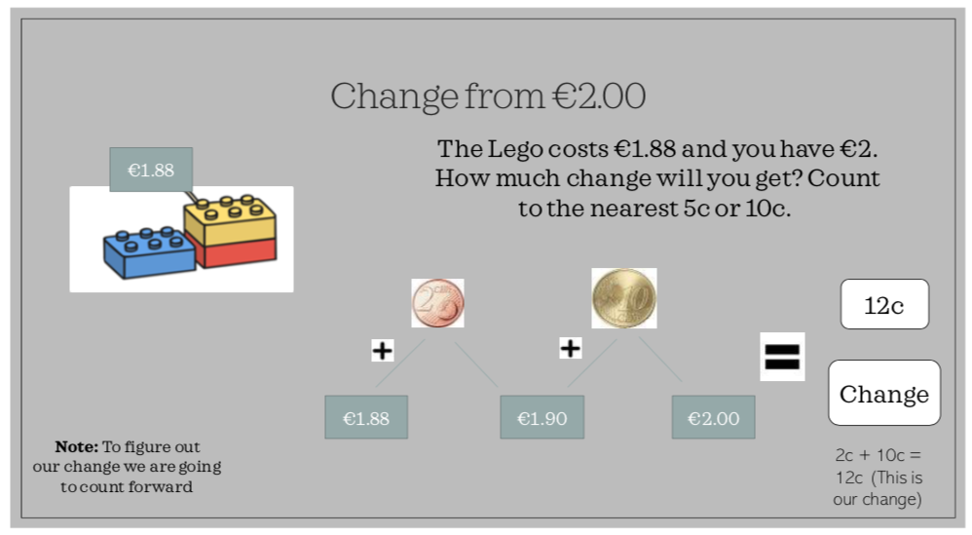

When you are finding your change from €2 you need to count on to the nearest 5c or 10c. For example, the lego costs €1.88. I need to count on to the nearest 10c which is €1.90. That is 2c change. Now I can count on to €2, that is 10c change. 10c+2c=12c. This is your change.

**Irish Vocabulary- Caitheamh Aimsire – Sheet 1**

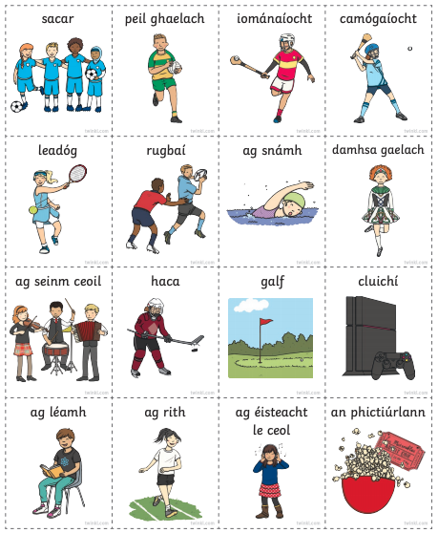

**Scéal – Peil – Sheet 2**

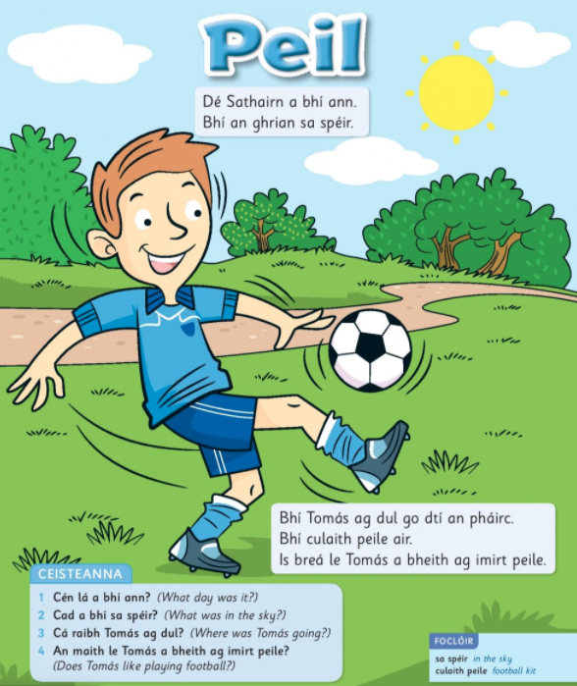

**Sheet 3**

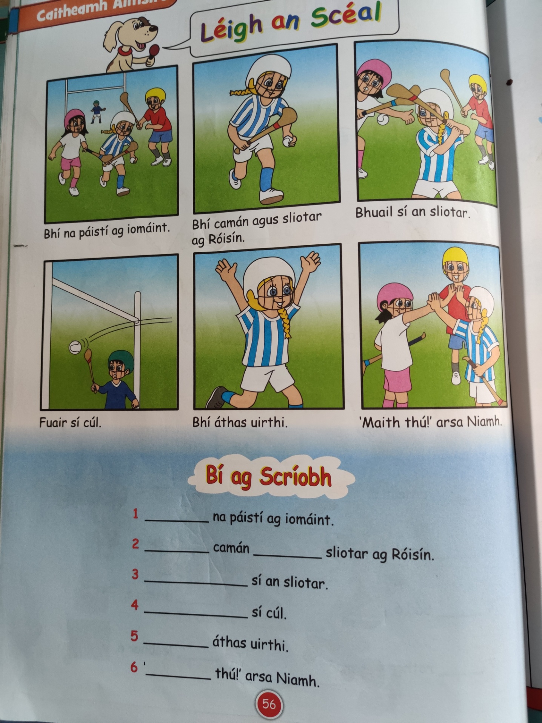

**Sheet 4**

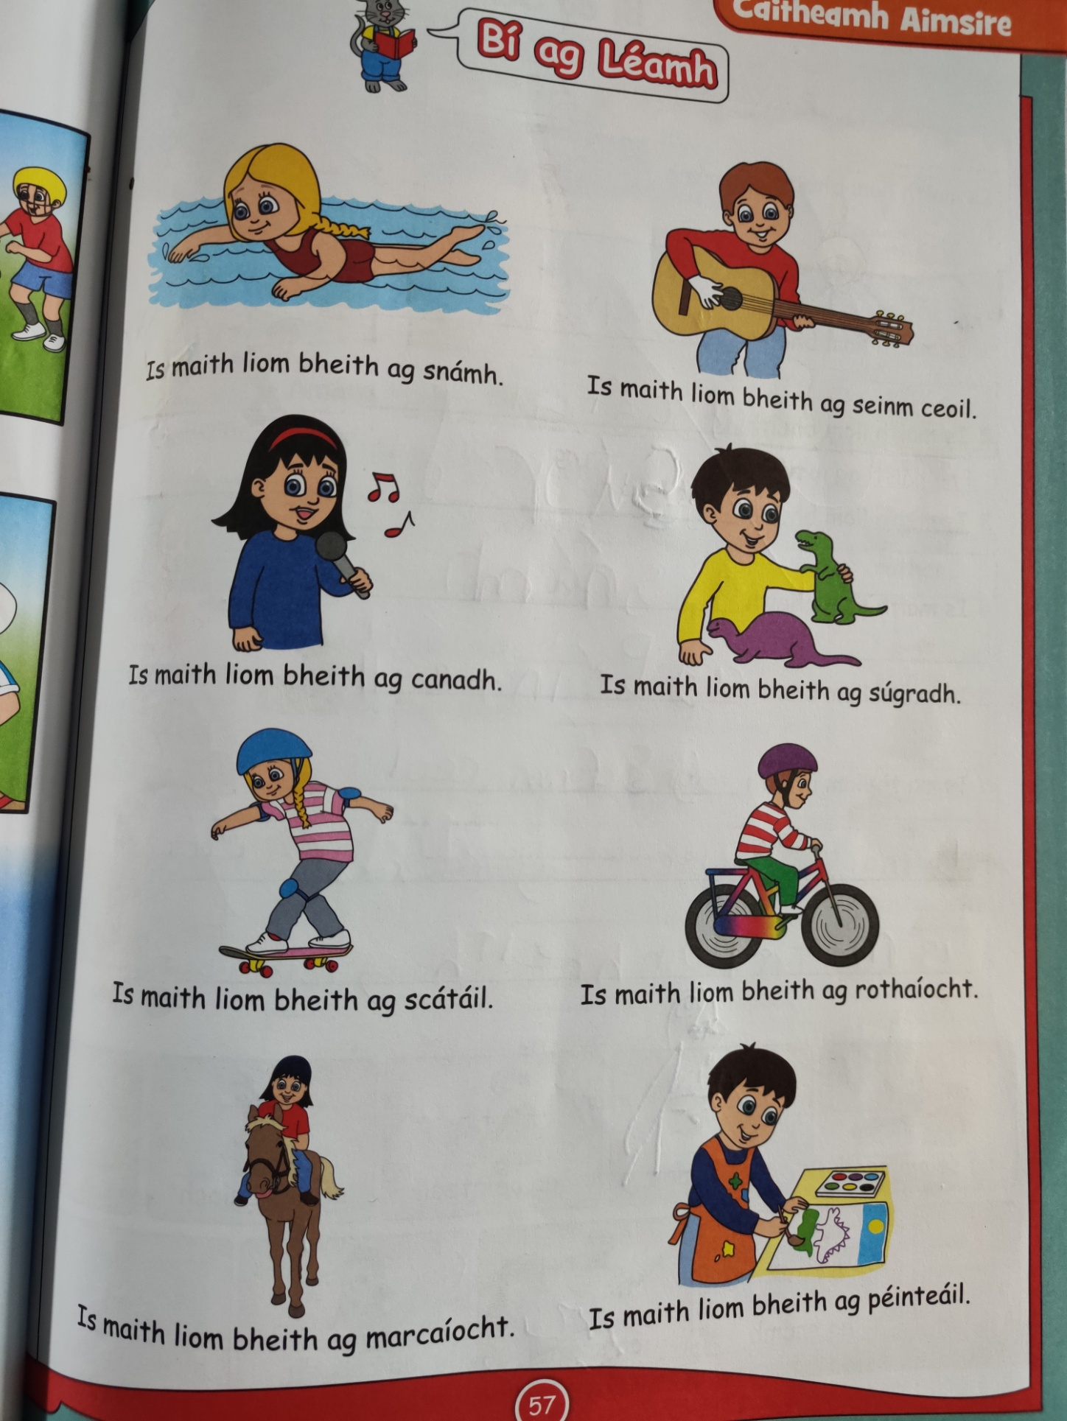

**S.E.S.E**

**Sheet 1**

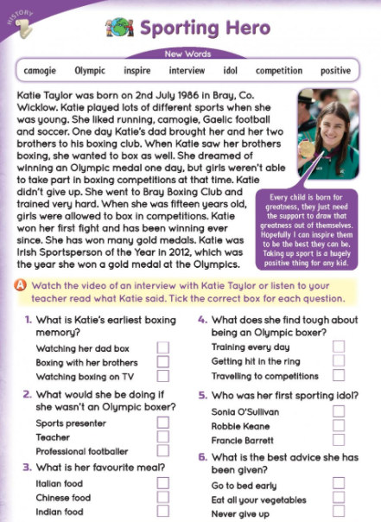

**Sheet 2**

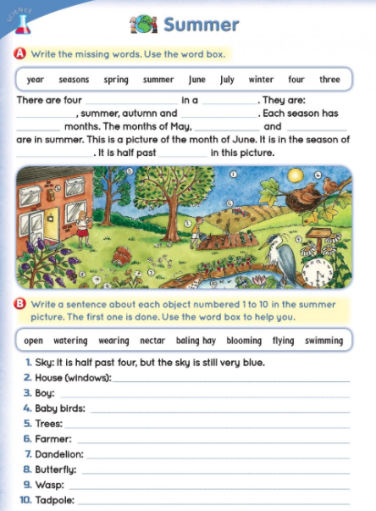

**Sheet 3**

