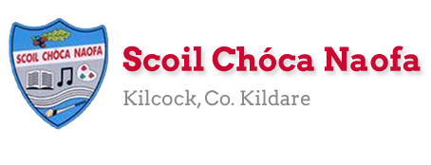
Work for 6th class : Week of Monday 15th June 2020
Over the next fortnight we will be asking you to fill out two booklets. These will really help with your transition into secondary school. You can print it out or copy pages into your S.E.S.E book. As always we love to see your work, please keep sending it in.
Please correct your Maths Assessment. We will e-mail answers to you on Friday
Ms Conboy’s and Ms Tone’s work is attached to the end of this plan. This can be worked through at your child’s own pace. On days you decide to do some of the work they have set please do so instead of something the teacher has set. It is not extra work.
Remember our email addresses are below if you need any help. Have a great week!
msdiggin@scoilchoca.ie mssoden@scoilchoca.ie
Monday | English | - Read a novel or listen to an audiobook of choice  - Have a read through Primary Planet June edition  - https://online.flowpaper.com/7a630787/TPP93online/#page=36
 | Maths | - Maths Assessment Book End of Year Assessment Part One p29 1-23
 | Gaeilge | - Watch TG4 @ 10:00-10:30 Cúla 4 ar Scoil
 | P.E. | - Go to www.youtube.com and type in P.E with Joe Monday 15th June  2020 in the search bar. Click on the video with this title.
 | Other | - My memories of Primary School Booklet- See below

Tuesday | English | - Read a novel or listen to an audiobook of choice or  Read Primary planet and answer the following questions based on p1-10  - 1. How many novels did Charles Dickens write?  - 2. Achill Island is in which county?  - 3. This European country is experimenting with herd immunity.  - 4. Middleton is in which Irish county?  - 5. In which Irish county is Lough Ennell?  - 6. What age is Kane Tanaka?  - 7. Where is Badain Jaran Desert?  - 8. What was the name of the Parnell estate in Co. Wicklow?  - 9. George Geary was Graham Walter’s __________.  - 10. What is the name of the actress who plays the part of Hua Mulan?
 | Maths | - End of Year Assessment Part One p 30 25-40
 | Gaeilge | - Watch TG4 @ 10:00-10:30 Cúla 4 ar Scoil
 | P.E. | - GAA Skill challenges  - Pick any of the skill challenges on https://learning.gaa.ie/gogamesskillchallenges  - The challenges can be taken either individually or with a partner almost anywhere. Maybe you could record yourself and send your efforts in to us.
 | Other | - My Memories of Primary School Booklet –See Below

Wednesday | English | - Read a novel or listen to an audiobook of choice  - Watch news2day and discuss it with your parents  - Write a report about an issue that interested you
 | Maths | - End of year Assessment Part Two p 31 41-47
 | Gaeilge | - Watch TG4 @ 10:00-10:30 Cúla 4 ar Scoil
 | P.E. | - Go outside and be active for at least 30 minutes.  - Suggestion: Skipping skills (Coach Mark)  - https://skipnrope.com/a-beginners-guide-to-double-unders/
 | Other | - Music: Today we are going to learn about body percussion using 'The Cup Song’. Follow the link to revise the words of that song and then you can add the percussion routine that is shown so you can perform it for friends and family.  - https://www.rte.ie/learn/2020/0605/1145685-5th-and-6th-class-music/

Thursday | English | - Read a novel or listen to an audiobook of choice  - https://www.theprimaryplanet.ie/news/posts/paragraph-project-june-16/  - Click on the link write a paragraph based on the opening two lines given
 | Maths | - End of Year Assessment Part Two p 32 and 33
 | Gaeilge | - Watch TG4 @ 10:00-10:30 Cúla 4 ar Scoil
 | P.E. | - Look up  - https://family.gonoodle.com/channels/ntv-noodle-television  - Pick some songs that you would like to dance to  - Try as best you can to learn the choreography  - Can you make up your own dance moves to a song?
 | Other | - Look at the section Positivity Rocks on p 41-49 of the Primary planet for ideas. Create a positivity rock of your own. Take a picture of it and send it into us.

Friday | English | - Read a novel or listen to an audiobook of choice  - Write 5 interesting facts about the Lourve Museum
 | Maths | - End of Year Assessment Part two p34 and 35  - We will email the answers for this test to self-correct it.
 | Gaeilge | - Watch TG4 @ 10:00-10:30 Cúla 4 ar Scoil
 | P.E. | - Go outside and be active for 30 minutes  - Go for a walk, run or cycle with a friend.
 | Other | - School Tour!! Virtual Tour of La Louvre in France.  - Select English as your language on the top right of the screen, explore the collections and learn about the art; Click on  - https://www.louvre.fr/en/visites-en-ligne?tab=1#tabs  - Name five pieces of art you like, try and draw a picture of one of them

Insert Sc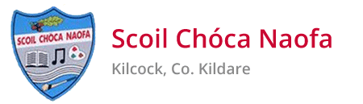hool Crest
Here.
My Primary School memories book

By: ________________________________________

MY PRIMARY SCHOOL
(Draw or insert a picture Here)

SCHOOL NAME:________________________________________________
ADDRESS:______________________________________________________
PRINCIPAL:_____________________________________________________
SECRETARY:___________________________________________________
CARETAKER:____________________________________________________
OTHER HELPERS:________________________________________________
MY FAVOURITE SPOT:____________________________________________

_________________________________________________________

PEOPLE IN MY CLASS WERE:
(Write a list, Get some signatures, Draw some images or stick in some photos of your classmates)

CLASS of 2020!

MY TEACHERS WERE:

JUNIOR INFANTS:________________________________

SENIOR INFANTS:________________________________

1ST CLASS:______________________________________

2ND CLASS:______________________________________

3RD CLASS:______________________________________

4TH CLASS:________________________________________

5TH CLASS:________________________________________

6th CLASS:________________________________________
OTHER TEACHERS WHO HELPED ME: ________________________________________________________________________________________________________________________________________________________________________________________________________________________________________________________________________________________________________________________________________________________________________________________________________________

USE THE NEXT FEW PAGES TO WRITE ABOUT SOME OF YOUR FAVOURITE MEMORIES-AND ILLUSTRATE THEM!

(your first day at school, the best school tour ever, a concert, a sports match, a science experiment, an art project, a school play, something you did that you’re especially proud of)

The 4 things I’m going to write about on the next few pages are:

- __________________________________________________________________________

- __________________________________________________________________________

- __________________________________________________________________________

- __________________________________________________________________________

FAVOURITE MEMORY 1:

________________________________________________________________________________________________________________________________________________________________________________________________________________________________________________________________________________________________________________________________________________________________________________________________________________________________________________________________________________________________________________________________________________________________________________

FAVOURITE MEMORY 2:
________________________________________________________________________________________________________________________________________________________________________________________________________________________________________________________________________________________________________________________________________________________________________________________________________________________________________________________________________________________________________________________________________________________________________________

FAVOURITE MEMORY 3:
________________________________________________________________________________________________________________________________________________________________________________________________________________________________________________________________________________________________________________________________________________________________________________________________________________________________________________________________________________________________________________________________________________________________________________

FAVOURITE MEMORY 4:
________________________________________________________________________________________________________________________________________________________________________________________________________________________________________________________________________________________________________________________________________________________________________________________________________________________________________________________________________________________________________________________________________________________________________________

MOMENTS YOU ENJOYED:
(WRITE ABOUT OR DRAW A PICTURE OF A FUNNY, PROUD, EMBARRASSING, KIND, BRAVE, SILLY, CLEVER MOMENT YOU REALLY ENJOYED)
________________________________________________________________________________________________________________________________________________________________________________________________________________________________________________________________________________________________________________________________________________________________________________________________________________________________________________________________________________________________________________________________________________________________________________

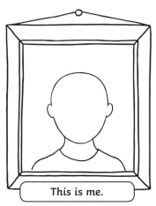
HOW TO REMEMBER THIS TIME: Me in 2020!
FAVOURITE MUSIC:

FAVOURITE MOVIES:

FAVOURITE BOOKS:

CLOSEST FRIENDS:

HOBBIES:

MY FAVOURITE INSPIRATIONAL QUOTE:

THE PEOPLE YOUADMIRE MOST AND WHY:
1. ___________________________________________________________________________________________
2. ___________________________________________________________________________________________
3. ___________________________________________________________________________________________
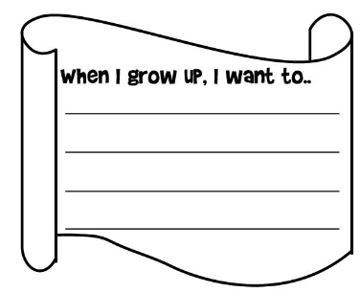
MY DREAM FOR THE FUTURE:

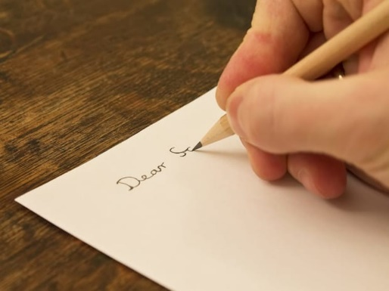
WRITE A LETTER
(TO YOUR PARENTS, TO YOUR FRIEND, TO YOUR TEACHER OR PRINCIPAL, TO THE PERSON YOU ADMIRE MOST, TO YOUR FUTURE SELF!)

Dear ………………….,
________________________________________________________________________________________________________________________________________________________________________________________________________________________________________________________________________________________________________________________________________________________________________________________________________________________________________________________________________________________________________________________________________________________________________________________________________________________________________________________________________________________________________________________________________________________________________________________________________________

LOOKING FORWARD
(WRITE ABOUT THE SECONDARY SCHOOL YOU’RE GOING TO)

________________________________________________________________________________________________________________________________________________________________________________________________________________________________________________________________________________________________________________________________________________________________________________________________________________________________________________________________________________________________________________________________________________________________________________________________________________________________________________________________________________________________________________________________________________________________________________________________________________

FINAL THOUGHTS
(ANY FINAL THOUGHTS FOR YOUR PRIMARY SCHOOL BOOK OF MEMORIES? WRITE THEM, OR DRAW A PICTURE, OR PUT IN SOME PHOTOGRAPHS)

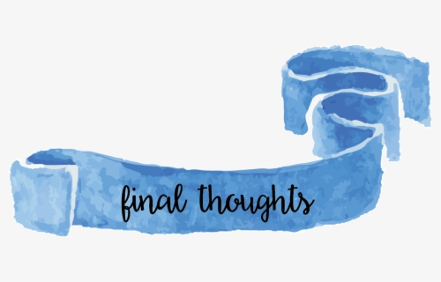

Teacher: Ms. Conboy
Note: SEN teachers have added work on to the teachers’ plan. Children can decide to do this work instead of something the teacher has assigned. It is not extra work. Also, I would be delighted if you could email on a picture of something that your child has done and is proud of so I can see their lovely work again!
Speech and Language | https://www.twinkl.ie/resource/t-l-1142-name-5-things-challenge-cardsYou will need an adult to help you. Let me know if you have a problem opening the link.
Literacy | Read the story below to an adult.  https://www.twinkl.ie/resource/the-koala-differentiated-reading-comprehension-activity-roi2-e-2800  Answer the first set of questions. You do not have to write the answers you can answer them orally.
Exemption | Instead of doing the Irish work your teacher has assigned you can:  Read page 48 of “A Way with Words” and do Q1-5 on page 49  Word search: https://www.twinkl.ie/resource/roi-l-726-sand-waves-and-ice-cream-word-search  Continue your SNIP (dont forget your Friday revision) and ‘Item missing’  Please remember to do some TTRS also, I will send your details by email.
Numeracy | Follow the above work from your teacher. If your child is in my maths class and is having difficulty doing the work please contact me.
Computer class | Write a report, on a topic of your choice, in font 12 in microsoft. All your headings must be in bold and underlined. Email me the final product.

Contact SEN Teacher: msconboy@scoilchoca.ie

Plean Seachtaine: 15^{ú} –19^{ú} Meitheamh

Múinteoir: Ms Tone

Class Group: 6th EAL

Child: LS Teacher: Ms Diggin

EAL work
Teacher: Ms Tone

Note: SEN teachers have added work on to the teachers’ plan. Children can decide to do this work instead of something the teacher has assigned. It is not extra work. Also, we would be delighted if you could email on a picture of something that your child has done, so we can see their lovely work again!

EAL | People and Places in Other Areas  - Compare life in Ireland to life in Croatia. See table below.

Contact SEN Teacher: mstone@scoilchoca.ie

Ireland Croatia
Flag | Flag
Food | Food
School | School
Weather | Weather
Sport | Sport

