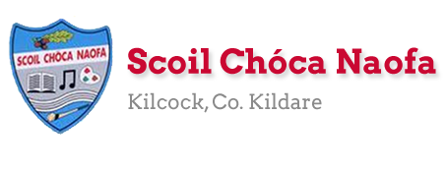
Work for First Class : 15th – 19th June 2020
Dear Parents: It was lovely to see all the children on Zoom last Thursday. On next Thursday's Zoom, we would like the children to show us either their favourite book or a piece of art and tell us why they like it.
Please only do as much as your child can manage of the scheme below. Prioritise the reading. If you have any queries or questions don’t hesitate to email us.
See work from Ms. Sheil & Ms. Ní Dhalaigh below
Monday | English: Continue Read at Home Book  Please note we are skipping Unit 6b pg 50 in Starlight this week as we want to cover it next week in line with next week’s theme.  Starlight: Pg 54 Underline and talk about new words. Say them in another sentence to help with understanding.  Write a story ‘Our Sports Week’ - 5 lines or more if you like. (Remember capital letters and full-stops.)  Maths: Cracking Maths: Pg. 40 & 41 – Doubles: Add the doubles first to increase speed. If you need to, look at the top of the page for the answers to the doubles to help you.  Please learn the doubles up to 20 by heart. See the Doubles Rap below the scheme which we performed for Maths Week. This should help with learning them.  Another idea would be a Doubles Game for two players:  - Write the doubles up to 20 on individual cards in one colour e.g. 1+1, 2+2..  - Write the answers to the doubles on individual cards in another colour e.g. 2,4…  - Place all the cards upside down on the table and have turns picking two cards each time trying to find a double and its correct answer.  - When you find a match you keep the cards.  - Whoever has the most cards at the end wins.  Some children will know the doubles by heart already but for others they may need a lot of practice over the next couple of weeks.  Gaeilge: Bua na Cainte: Finish Lch 77 : Do 5 – 10 Is fearr liom ___. (I prefer ____.)  PE: Soccer: Louise Quinn, soccer player for Ireland and Arsenal, guides us through a turn and pass skills challenge: https://www.youtube.com/watch?v=WUiXpnBEZYs
Tuesday | English: Continue Read at Home Book  Starlight: Read Pg.54 again revising the new words  Do Pg. 55  Maths: Cracking Maths Pg. 42 & 43 On pg 43 the children are learning about near doubles – for example 2 + 3 is a near double to 2+ 2. We know 2+ 2 = 4 so 2+3 is one more so the answer is one more = 5 Discuss other examples of near doubles eg. 3+ 4 is a near double to 3 + 3….If your child finds this hard to understand it will be covered again in Second Class and upwards.  Gaeilge: Bua na Cainte Lch 78 Practise: Cheannaigh Niamh (Niamh bought) Cheannaigh Liam (Liam bought) camán (hurl) bád (boat) leabhar (book) carr (car) liathróid (ball)  PE:Tennis Ball Game @  https://www.eenymeeny.net/games/ball%20games/Sevens.html
Wednesday | English: Continue Read at Home Book  The Broken Sleigh: First revise reading pg 40 & 41 as we read them over a week ago  : Read Pg. 42 also  Starlight: Do Pg.48  Maths: Firstly today revise what ‘near doubles’ are. Ask your child to give you examples.  Cracking Maths Pg. 44 Find the numbers that make 10 first and then add the third number. Remember put the bigger number in your head and count on. We have practised this a lot in the classroom so hopefully your child will remember it.  Gaeilge: Bua na Cainte: Lch 78 Do 1- 3  - Cé a cheannaigh an carr?(Who bought the car?) Cheannaigh Niamh an carr. (Niamh bought the car.)  - Cé a cheannaigh an bád? (Who bought the boat?) Cheannaigh _____ an bád. (_____ bought the boat.)  - Cé a cheannaigh an liathróid? (Who bought the ball?) Cheannaigh _____ an liathróid.( _____ bought the ball.)  PE: Fun Activity: Trish Mc Dermott, our Dance Teacher, guides us through a family dance challenge. You can put your new moves to any pop song you like! https://www.youtube.com/watch?v=xB0sg8nQXDc&list=PLt3aHDpWcOx0KJFmNWegn4eTv50f9Qgu_&index=2&t=0s
Thursday | English: Continue Read at Home Book  The Broken Sleigh: Pg. 43 & 44  Starlight: Do pg. 56  Maths: Cracking Maths: Pg 45 Try not to use the number line. As you did yesterday, put the bigger number in your head and count on.  Gaeilge: Bua na Cainte: Lch 78 - Do 4 & 5  - Cé a cheannaigh an camán ? (Who bought the hurley?) Cheannaigh ______ an camán. ( _______ bought the hurley.)  - Cé a cheannaigh an leabhar. (Who bought the book?) Cheannaigh _____ an leabhar. ( _____ bought the book.)  PE: GAA Catching Challenge: https://www.youtube.com/watch?v=ImP6UmzbnZY&list=PLbAvjLA-cZu3wHQQvoXnW0iYnmGT4OYUN&index=6&t=0s
Friday | English: Continue Read at Home Book  The Broken Sleigh Pg. 45 & 46  Go with the Flow: One page or two if you like  Maths: Cracking Maths Pg.46  Master your Maths: Next two tests  Gaeilge: Bua na Cainte: Lch 79 Comhair (Count) 1 – 10 A haon (one) a dó (two)….  Art: Draw and Colour/Paint a summer picture showing signs of the season
Useful Website for this week: RTE Home School hub continues at www.rte.ie/learn/
- Contact Teacher: msgoggin@scoilchoca.ie
Doubles Rap
It’s the doubles rap, baby
Let’s go! Let’s go!
It’s the doubles rap, baby
And we’ll start with zero!
0 + 0 =0 Yo!
1 + 1 = 2 Oooh!
2 + 2 = 4 More!
3 + 3 = 6 Kicks
4 + 4 = 8 That’s great
5 + 5 = 10 Again!
6 + 6 = 12 That’s swell
7 + 7 = 14 Let’s lean
8 + 8 = 16 You’re supreme
9 + 9 = 18 Jellybean
10 + 10 = 20 That’s plenty

Note: SEN teachers have added work on to the teachers’ plan. Children can decide to do this work instead of something the teacher has assigned. It is not extra work. Also, we would be delighted if you could email on a picture of something that your child has done and is proud of so we can see their lovely work again! Also ,try to watch the School Hub daily on RTE at 11.00 am...it is very good!
SEN Teacher 1: Ms. Sheil mssheil@scoilchoca.ie

Literacy | Please complete the following stories, By the Sea and At the Seaside.  Check that you can read all the words on page 22. Also go on to the second sheet of words –Fry’s list –try to read 10 words each day.
Numeracy | I am sending you a revision workbook. Some of the questions are easy and others are a bit tricky. Try to do them on your own and then get your mum/dad to correct them.

Contact SEN Teacher: mssheil@scoilchoca.ie

SEN Teacher 2: Ms. Ní Dhálaigh msnidhalaigh@scoilchoca.ie 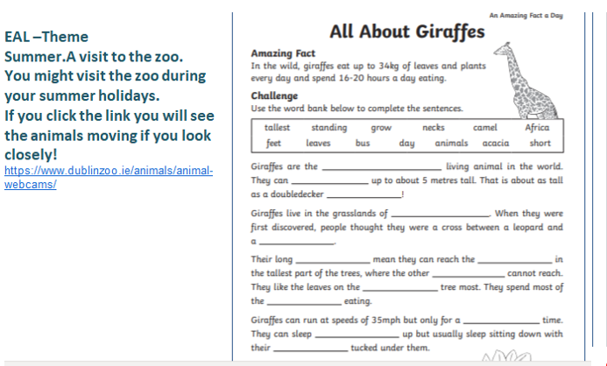
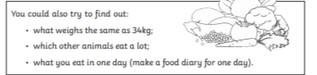
Contact SEN Teacher: msnidhalaigh@scoilchoca.ie

