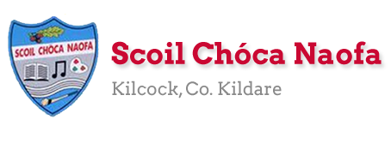

Work for Senior Infants Class : Week of Monday 4th May
Monday | No school work today.
Tuesday | Optional work:  Yoga: We are going on a bear hunt. https://www.youtube.com/watch?v=KAT5NiWHFIU  Art: Use an old sock to create a puppet. Can you put on a puppet show for your family?  SESE: Take a virtual tour around Dublin Zoo. What animals do you see? https://www.dublinzoo.ie/virtual-tours-2/. Draw some animals.  Other: Have a teddy bears picnic outside (weather permitting).
Wednesday | English: https://www.gillexplore.ie/gill-explore-resources/over-the-moon-senior-infants-skills-book?Chapters=0&ResourceTypes=0. Drop down menu ‘All Resource types’ click on Oral Language & interactive resources. Click on unit 8 and Oral Language Poster then click story mode. Click play and listen to ‘The Zoo’. Skills Book pg 102 A busy day at the zoo. Discuss the animals at the zoo. What would you hear, see, feel, smell, touch if you visit the zoo?  Maths: Discussion of positional words: on, in, under, beside, between, over. Ask your child to put their hands on, over, above an object.  Irish: New words: An Teilifís- The television, bord- table, lampa- lamp, tolg- sofa/couch.  P.E: Go outside on a nature hunt around your garden collect things like sticks, leaves, flowers etc.  Other: Music: Listen to and sing along to ‘We are going to the Zoo’. https://youtu.be/IulnEx2Cn7M
Thursday | English: Phonics – revise sounds ai, ee, oa, ie. Use them in the middle of a word. Skills book page 103.  Maths: Planet maths pg. 89  Irish: An Teilifís New words: tine- fire, fuinneog- window, ríomhaire- computer, doras- door  P.E: Create a small obstacle course in your garden. Complete it 4 times.  Art: Using the items you collected on your nature hunt create a picture/collage. (See examples below)Take a photo of it and send it to us this week
Friday | English: https://www.gillexplore.ie/gill-explore-resources/over-the-moon-senior-infants-skills-book?Chapters=0&ResourceTypes=11314 Click on Life in the Zoo. Listen to the story and discuss. Ask your child questions about the story.  Maths: Planet Maths pg. 90  Irish: Uimhreacha- numbers: https://youtu.be/a-t5NzoxdfE  PE: Practice throwing and catching a ball (a stuffed toy/sock will do if you have no ball). Use a bucket or large bowl and try to throw your ball into it taking a step back each time.  Other: ’The magic moment trick’- poem & colouring sheet about dealing with emotions https://cbi-anpost.s3-eu-west-1.amazonaws.com/ImagineNation_Breslin_Dempsey.pdf

Any parents who may have changed email addresses or not provided the school with one we would appreciate if you emailed us an update. Thank you!
Contact Teacher: msbyrne@scoilchoca.ie msmeehan@scoilchoca.ie
Useful Websites for this week: (supplemental work – if needed)
- Maths song: https://www.youtube.com/watch?v=idJYhjGyWTU&list=PLisGMvEDQqYvdNtbcofKhzRk5FWAAtJUu&index=12
- Extra English Resources: https://www.gillexplore.ie/gill-explore-resources/over-the-moon-senior-infants-skills-book?Chapters=0&ResourceTypes=11535 – There are lots of activities connected to our English work here unit 8.
- Phonics sounds songs: https://www.youtube.com/watch?v=U2HYM9VXz9k
- Social story about the corona virus for any children who might be feeling anxious or worried. https://nursedottybooks.com/dave-the-dog-is-worried-about-coronavirus-2/
- Cosmic yoga https://www.youtube.com/watch?v=pTQcOLQeEbU
Contact support teacher: Ms. Meehan’s class: msnidhalaigh@scoilchoca.ie
Ms Byrne’s class: mswilson@scoilchoca.ie

Art (ideas)
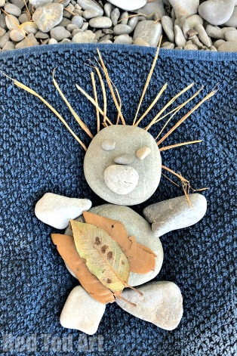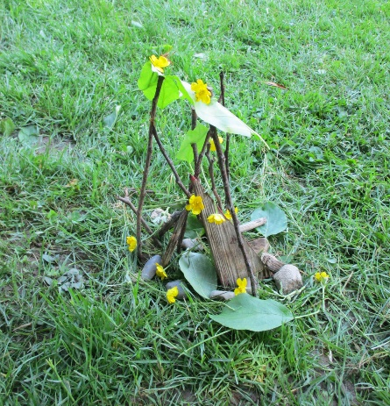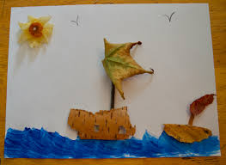

Children who attend EAL (English as an additional Language)
EAL work
Note: SEN teachers have added work on to the teachers’ plan. Children can decide to do this work instead of something the teacher has assigned. It is not extra work. Also, we would be delighted if you could email on a picture of something that your child has done and is proud of so we can see their lovely work again!
Senior Infants: Ms Byrne / Ms Meehan

EAL work
Teacher: Ms Wilson / Ms Tone / Ms Clancy
Note: SEN teachers have added work on to the teachers’ plan. Children can decide to do this work instead of something the teacher has assigned. It is not extra work. Also, we would be delighted if you could email on a picture of something that your child has done and is proud of so we can see their lovely work again!
EAL | People Who Help Us  - Look at the worksheet below.

Contact SEN Teacher:

Please send Ms Meehan’s EAL work to Ms Wilson: mswilson@scoilchoca.ie

Please send Ms Byrne’s EAL work to Ms Tone: mstone@scoilchoca.ie

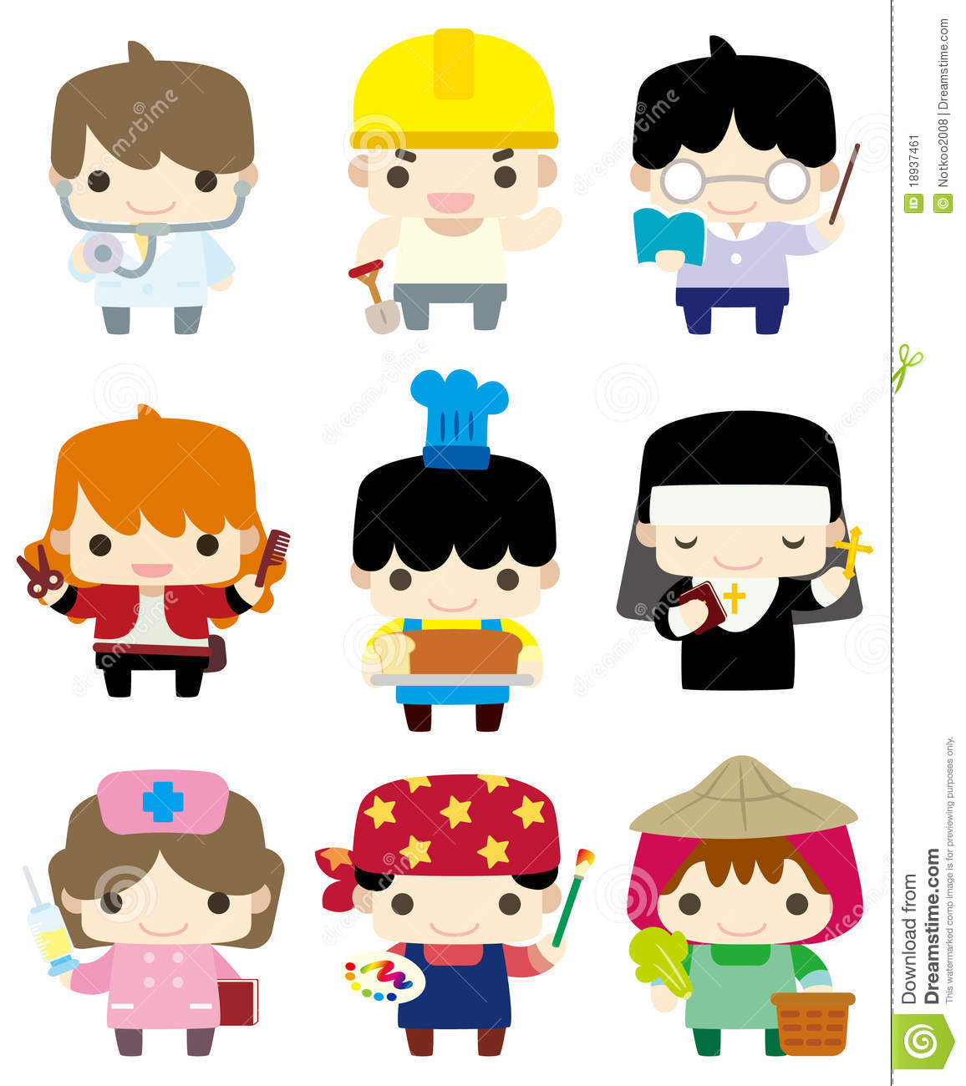

Talk about the people in the pictures:

- Who are they?
- Where do they work?
- What do they do?
- What are they wearing?

What would you like to be when you grow up? Draw a picture.

