Dear 4th class,
I hope all is well with you and your loved ones this week.
Last week, you completed the Stay Safe programme. Well done
We finished our ‘Read At Home’ readers last week. Spend 10 minutes reading other books/articles/cookbooks etc. with an adult daily.
This week, I have given you some music and art activities to complete. Have fun and try your best.
Please continue to send the work you are most proud of to mssmith@scoilchoca.ie
While the weather is fine, make sure to get outside in the fresh air and get active. Lend a helping hand at home with the cooking/cleaning/gardening if you can.
Have a look at the school website each week to see some pictures of the super work being done at home.
Take care and keep smiling,
Ms. Smith

Work for Ms. Smith’s 4th Class : Week 9 Starting 25.05.2020 – 29.05.2020
Monday | English:  - Starlight 15b ‘It’s your environment, so get involved’ Complete A Comprehension: Fact Finding and B Comprehension: Read Between the lines in copy pg. 179  - Use your dictionary to look up any new words  - Recite the poem: Be Glad Your Nose is on Your Face (Appendix 1)  Maths:  - Maths Matters pg 162 q1 and q2 in book.  - Count up and down in multiples from 2-20, 3-30, 4-40  - Mathletics Activities  Irish:  - Bua na Cainte 4 lch 134. Answer the questions in your copy. Fill in the grid in your book.  - Watch Cúla ar scoil on TG4 @10.  Music/Art  - Make your own musical instrument.  - You could make a shaker, a drum or something else of your own choice.  - You could use kitchen roll/elastic bands/ plastic or paper cups/ lentils/rice/ tissue paper/ scissors/ glue/ tape- Use your imagination!  - Perform an at-home concert for your family using your new musical instrument.  - There is a video clip below to help you.
Tuesday | English:  - Starlight 15b ‘It’s your environment, so get involved’ Complete C Vocabulary in copy pg. 179  - Recite the poem: Be Glad Your Nose is on Your Face  Maths:  - Maths Matters pg 162 q3 and q4 in book.  - Count up and down in multiples from 5-50, 6-60  - Mathletics Activities  Irish:  - Leabhar Litrithe lch 40  - Watch Cúla ar scoil on TG4 @10.  Music  - Click the link below to listen to a famous classical piece of music called ‘The Carnival of the Animals.’  - Does this music sound like any animals you know?  - Draw/write about what you think is happening in the music- it might be a lion running through the jungle or an elephant stomping through the Savannah.  - The clip is 20 minutes long (you only need to listen for around 3 minutes)
Wednesday | English:  - Starlight 15b ‘It’s your environment, so get involved’ Complete D Vocabulary in copy pg. 180  - Recite the poem: Be Glad Your Nose is on Your Face  Maths:  - Maths Matters pg 163 q3 and q5 in book.  - Use you calculator to check your answers.  - Count up and down in multiplies from 7-70, 8-80  - Mathletics Activities  Irish:  - Leabhar Litrithe lch 41.  - Watch Cúla ar scoil on TG4 @10.  SESE  - Click the link below to watch Dublin Zoo’s virtual tour and look at the amazing animals.  - Can you name any of the animals you see in the video?  - Draw a picture of your favourite animal from the video.  - Use the website below to find some facts on your favourite animal and create a fact-file (Appendix 5).
Thursday | English:  - Starlight 15b ‘It’s your environment, so get involved’ Complete E Grammar pg. 180  - Recite the poem: Be Glad Your Nose is on Your Face  Maths:  - Maths Matters pg 164  - Count up and down in multiples from 9-90, 10-100  - Mathletics Activities  Irish:  - Bua na Cainte lch 139. Scríobh an Scéal. Write the story in your copy.  - Watch Cúla ar scoil on TG4 @10  Science  - ‘Fireworks in a Glass’ experiment – see below (Appendix 3).
Friday | English:  - Starlight 15b ‘It’s your environment, so get involved’ Complete F Writing Skills pg 181  - Recite the poem: Be Glad Your Nose is on Your Face  Maths:  - Maths Matters pg 165  - Use your calculator to check your answers.  - Count up and down in multiples from 11-110, 12-120  - Mathletics Activities  Irish:  - Bua na Cainte 4 lch 139. Finish this page. Bí ag Scríobh (in your copy) agus Roghnaigh an Focal Ceart. Use lch 138 to help you fill in the blanks.  - Watch Cúla ar scoil on TG4 @10  Science:  - ‘Lava Lamp’ experiment – see below (Appendix 4).

Useful websites for this week:
- Music/Art: Musical instrument ideas https://www.youtube.com/watch?v=7sUNXA4NYKI#action=share
- Music: The Carnival of the Animals https://www.youtube.com/watch?v=k2RPKMJmSp0
- SESE: Dublin Zoo’s virtual tour https://www.youtube.com/watch?v=w5xhyJADQys&feature=youtu.be
- SESE: Information on animals https://www.nationalgeographic.com/animals/
- Maths: Tables revision games- https://www.topmarks.co.uk/maths-games/7-11-years/multiplication-and-division
- PE: Joe Wicks’ Live Daily PE workouts
- General: Twinkl: Worksheets/Powerpoints available: Free access if you use code CVDTWINKLHELPS
- RTE’s Home School Hub. If you miss it, you might be able to watch it back on RTE Player. https://www.rte.ie/player/

Teacher: Ms. Wilson

Note: SEN teachers have added work on to the teacher’s plan. Children can decide to do this work instead of something the teacher has assigned. It is not extra work. Also, we would be delighted if you could email on a picture of something that your child has done and is proud of so we can see their lovely work again!

Literacy Group
If you remember last week I mentioned that we would try some creative writing this week.

You can try to write a report, a poem, a riddle, your news, a diary entry, a recipe, a story, instructions for a game or a book review. You can descibe your favoutrite toy, your favourite hobby or a person who is special. Maybe you could write about a nice holiday that you had or something funny that happened to you.

I don’t mind. You can pick.

If you email me with your ideas I can help you with it. Looking forward to hearing from you all.
EAL Group – Ms Wilson (continued from May 18th)

Theme : The Local and Wider Community
- Design a brochure or leaflet about Kilcock. Use the following headings to help you.

- Location –Country and county. Name towns that are nearby as well.
- Shops/Business – Name local newsagents, supermarkets, garages, bookshops, florists, butchers, banks, hairdressers etc.
- Schools /Colleges – Name the local schools –primary and secondary. Mention Maynooth University which is nearby.
- Places to eat – name local restaurants, take-away and cafes
- Things to do – mention GAA, golf, rugby, canoeing, walking, cycling, basketball, athletics etc.
- Places to see in Kilcock and nearby – mention The Royal Canal and Greenway, Art Gallery, The Library, The Old Bog Road, The Little Chapel, Pet Farms, Forest Parks.

I would suggest that you gather the information you need on the first week. The grid below might help you with this.
If you are out for a walk with an adult take note of what you see. Maybe ask the adult to take some photos of places that you like in Kilcock. If this is not possible try to think of the places in Kilcock that are near you. If you can’t take photos don’t worry. It is fine to use drawings.

On the second week use the information you have gathered for your brochure. Add photos and drawings. Try to present it as well as you can.
Contact SEN Teacher: mswilson@scoilchoca.ie
Kilcock
EAL GROUP-Ms. Wilson Fill in this grid.
Supermarkets

Petrol Stations/ Garages

Banks/Credit Union
Hairdressers/
Barbers
Bookshops

Butchers

Schools

Sports facilities

Churches

Restaurants
Cafes
Take - aways
Places to see

Places to walk

Interesting places nearby
Towns nearby
Other
What places in Kilcock do you like? Why?
Teacher: Ms. Heffernan
Speech and Language | This week we’re going to try some debating. Choose one of the topics shown below and come up with 3 arguments for/against it. You can write them down or record them on the phone and send them to me. Or you can have a real debate with someone in your family!  https://rainbow3to6.cjfallon.ie/class/fourth/units/8/lesson/2/slide/2  Here’s another online game of articulate with ‘Space’ words. You can choose easy, medium or hard words. Describe the word in the given time without saying the word itself. Good luck!  https://rainbow3to6.cjfallon.ie/class/fourth/units/8/lesson/5/slide/2  Try this listening activity. You will need someone to call out the instructions for you. If you are printing it, only print page 2.  file:///C:/Users/Scoil/AppData/Local/Temp/Temp1_t-s-4399-listen-and-do-activity-pack-.zip/6.%20Higher%20Level/Listen%20and%20Do%201%20-%20Higher%20Level.pdf  Here is a memory task. Do one row of cards each day to build on your memory skills. Someone calls out the list to you and you try to repeat it in the same order.  If you want a challenge, the other person can read out the whole list the first time and leave something out the second time and you have to name the missing item (like we do in school).  file:///C:/Users/Scoil/Desktop/t-s-1230-listen-and-repeat-auditory-memory-cards-_ver_3.pdf  Keep reading!  If anybody needs any more reading material, please let me know. If you’ve read or listened to a story, I’d love to hear what you thought about it.  Send me an email to let me know how you’re getting on-I’d love to hear from you!
Maths | You can keep playing games to help you with your mental maths.  https://www.topmarks.co.uk/maths-games/hit-the-button  https://www.topmarks.co.uk/maths-games/daily10  Or you might prefer some worksheets-100 square number patterns-fill in the missing numbers (no peeking at the answers!) If you’re printing, just print page 1 & 2  file:///C:/Users/Scoil/Desktop/Maths/roi-ms-10-100-square-number-patterns-worksheet_ver_1.pdf  Or challenge yourself, follow the clues to find the number (again, no peeking!!) There are 10 riddles. You don’t have to print them. You can just use your whiteboard marker on your actual 100 square. Good luck!  file:///C:/Users/Scoil/Desktop/Maths/roi-ms-10-100-square-number-riddles-worksheets_ver_1.pdf
Contact SEN Teacher: msheffernan@scoilchoca.ie
Appendix 1 (Monday – Friday)
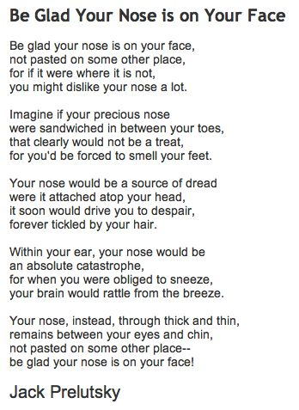

Appendix 2
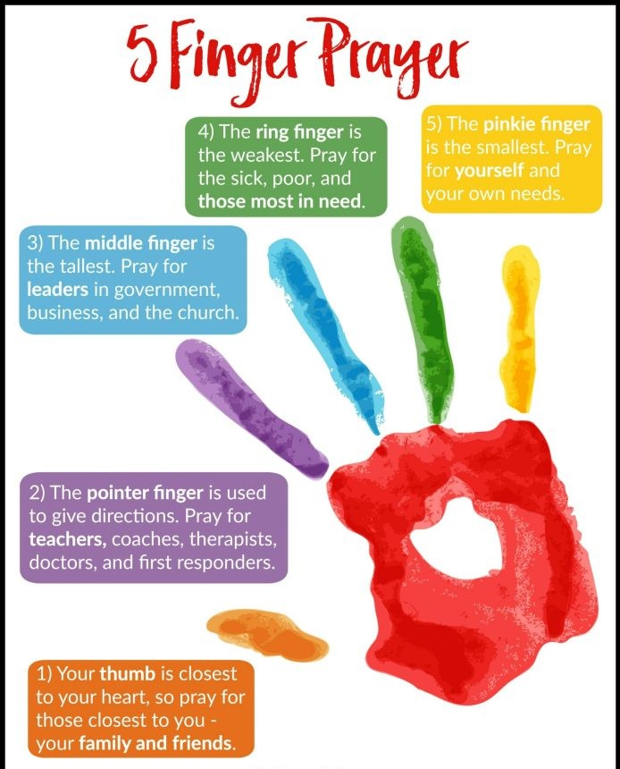

Appendix 3 (Thursday)
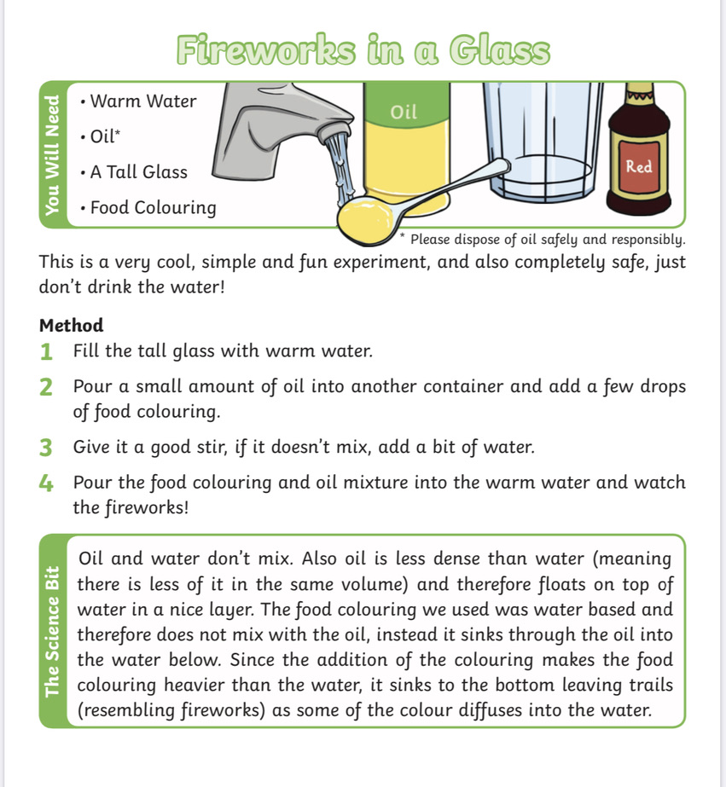

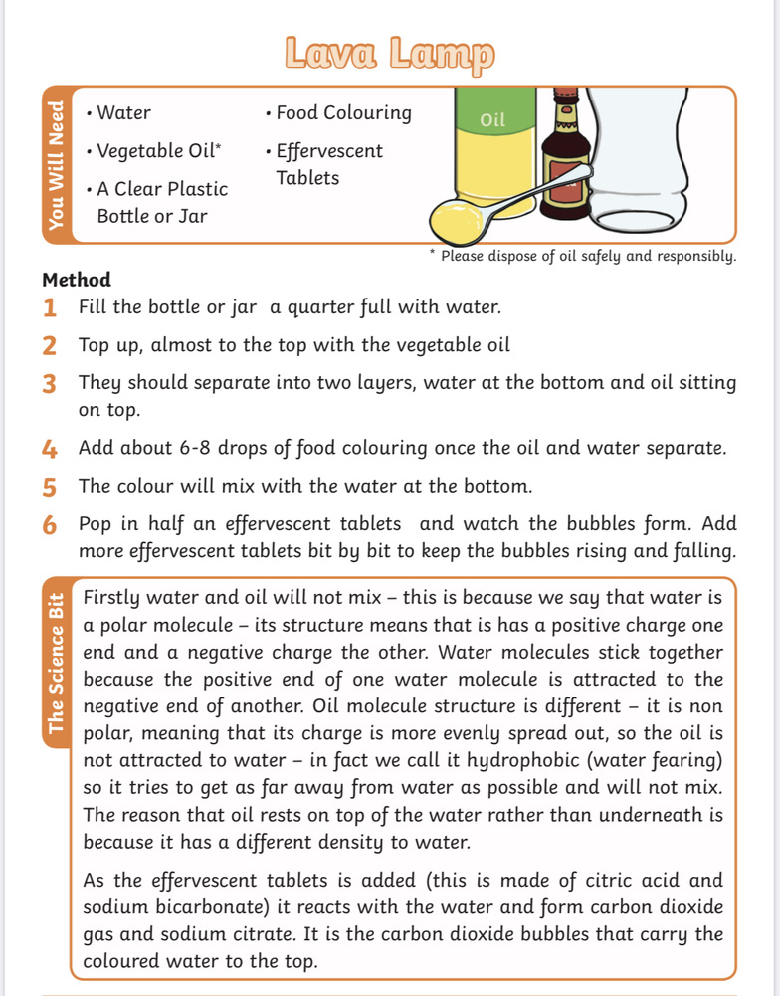
Appendix 4 (Friday)

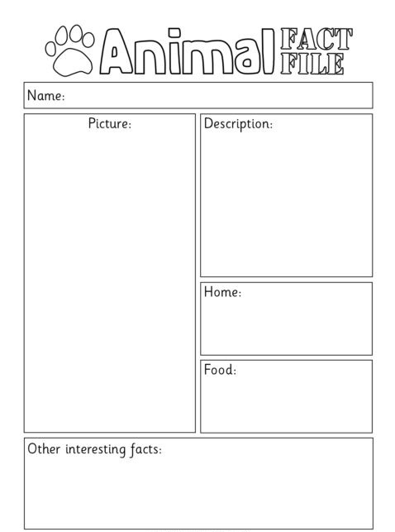
Appendix 5 (Wednesday)

