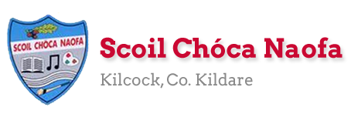
Dear 4th Class,
I hope you enjoyed your well-being and baking activities last week. This week, I would like you to do some science experiments, some art and even a little more baking.
Please continue to send the work you are most proud of to mssmith@scoilchoca.ie. You can email me every few days if you’d like. Ask an adult to send 3-6 pictures of your work per email, if possible. Your parent/guardian can email me more than once throughout the week if they wish to do so - whatever suits your family.
Those children who work with Ms. Wilson and Ms. Heffernan, they would be delighted to hear from you and to hear what you have been up to. Their email addresses are mswilson@scoilchoca.ie and msheffernan@scoilchoca.ie
Stay safe,
Ms. Smith

Wishing Emma Kiely and Leah Connolly a Happy Birthday this week:

Work for Ms. Smith’s 4th Class : Week 7 Starting 11.05.2020 – 15.05.2020
Monday  Encouraging users of the TTRS typing programme to continue working on this at home, if possible. | English:  - Read at Home pg 113  - Starlight 14b ‘Babe the Blue Ox’ Complete A Comprehension: Fact Finding and B Comprehension: Read Between the lines in copy pg. 167  - Use your dictionary to look up any new words  Maths:  - Maths Matters pg 147 in book.  - Use a calculator to correct your answers.  - Count up and down in multiples from 2-20, 3-30, 4-40  Irish:  - Bua na Cainte Interactive programme: Click Éadaí (Aonad 1). Click ceacht 1. Click cómhra. Listen to the conversation. Play a game.  - Bua na Cainte lch 128  Science:  - Choose 1 experiment to carry out. Write down your prediction (what you think will happen) and the results of your experiment (what happened). Can you explain the science behind why this happened? (Refer to Appendix 1).
Tuesday  Encouraging users of the TTRS typing programme to continue working on this at home, if possible. | English:  - Read at Home pg 114  - Starlight 14a ‘Babe the Blue Ox’ Complete C Vocabulary in copy pg. 167  Maths:  - Maths Matters pg 148 Q1 (i – p) and Q2 (m- t)  - Correct your answers using a calculator  - Count up and down in multiples from 5-50, 6-60  Irish:  - Bua na Cainte Interactive programme: Click Éadaí (Aonad 1). Click ceacht 2. Click cómhra. Listen to the conversation. Play a game.  - Bua na Cainte lch 130.  Science/Maths:  - Have fun baking (See suggestions below) *Adult supervision required* (Refer to Appendix 2).
Wednesday | English:  - Read at Home pg 115  - Starlight 14b ‘Babe the Blue Ox’ Complete D Vocabulary in copy pg. 168  Maths:  - Maths Matters pg 149 in book.  - Use you calculator to check your answers.  - Count up and down in multiplies from 7-70, 8-80  Irish:  - Watch Cúla ar scoil on TG4 @10.  Science:  - Choose 1 experiment to carry out. Write down your prediction (what you think will happen) and the results of your experiment (what happened). Can you explain the science behind why this happened?  (Refer to Appendix 3).
Thursday | English:  - Read at Home pg 116  - Starlight 14b ‘Babe the Blue Ox’ Complete E Grammar pg. 168  Maths:  - Maths Matters pg 150 in book.  - Count up and down in multiples from 9-90, 10-100  Irish:  - Leabhar Litrithe lch 38. Ceacht 1 section.  - Watch Cúla ar scoil on TG4 @10  Religion:  - Say a decade of the rosary prayer (see below).  - Using pipe cleaners/beads/daisies, you can make rosary beads for your May altar or for yourself. (Refer to Appendix 4).
Friday | English:  - Read at Home pg 117  - Starlight 14a ‘Babe the Blue Ox’ Complete F Writing Skills pg 169  Maths:  - Maths Matters pg 152.  - Use your calculator to check your answers.  - Count up and down in multiples from 11-110, 12-120  Irish:  - Leabhar Litrithe lch 38. Ceacht 2 section.  - Watch Cúla ar scoil on TG4 @10  Visual Arts:  ‘Sunflowers’ by Vincent Van Gogh  - Examine the painting ‘Sunflowers.’  - Design and create your own version of the painting.  - After you use a pencil to draw it, add some colour.  - Paint/colouring-pencils/crayons/pastels/whatever you have at home.  - Feel free to use your imagination to make it your own. (Refer to Appendix 5)

Useful web links for this week:

- Maths: https://www.mathletics.com/uk/
- Maths: Tables revision games- https://www.topmarks.co.uk/maths-games/7-11-years/multiplication-and-division
- PE: Joe Wicks’ Live Daily PE workouts: https://www.youtube.com/
- General: Twinkl: Worksheets/Powerpoints available: Free access if you use code CVDTWINKLHELPS
- RTE’s Home School Hub. If you miss it, you might be able to watch it back on RTE Player. https://www.rte.ie/player/

Teacher: Ms. Wilson
Note: SEN teachers have added work on to the teacher’s plan. Children can decide to do this work instead of something the teacher has assigned. It is not extra work. Also, we would be delighted if you could email on a picture of something that your child has done and is proud of so we can see their lovely work again!
Literacy Group

- Word of the Day (One per day Mon, Tues, Wed. Revise Thurs)
(Taken from this week’s class reading - Starlight- Babe the Blue Ox p.164 + 165).

- Look up the meaning of the following three words; sapling, felled, capsized.
- Talk about the word. Draw/find a picture to represent the word.
- Write each word in a sentence that shows the meaning of the word.
- Say the word in different voices to help you to remember the word e.g. robot voice, monster voice, alien voice.

- Continue with SNIP Literacy and Gratitude Journal. (Don’t forget to keep your Gratitude Journal once a week).

If you have completed the SNIP sessions printed out in your pack go to the following website and print out the next session.
http://www.snip-newsletter.co.uk/pdfs/downloads/literacy_programme_1.pdf.

Start on SNIP Programme 2 if you have finished Programme 1.
http://www.snip-newsletter.co.uk/pdfs/downloads/literacy_programme_part_2.pdf

- Revision of the digraph “ch”
http://theschoolhouse.us/lessons/lesson10.html

- Continue with independent reading for enjoyment. Email me and let me know which books you have enjoyed. (If you are reading other books that is fine too. Just let me know).
https://www.oxfordowl.co.uk/for-home/find-a-book/library-page/

- You may prefer to listen to a story. Try one of these this week.
https://stories.audible.com/discovery/enterprise-discovery-21122352011?ref=adbl_ent_anon_ds_ds_dccs_sbtp-0-5

- If you want to learn/ improve typing skills try games on this website.
https://www.education.com/resources/?q=typing+games
OR
- Continue with TTRS if you have been using it in school already.

EAL Group
Theme : Transport and Travel in Kilcock
- Name five different ways we can travel to and from Kilcock. See some clues in the pictures below. You might also think of other ways to travel to Kilcock.

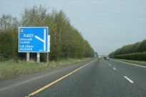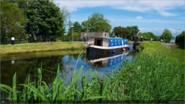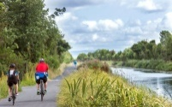

- What is your favourite way to travel around Kilcock?

- What types of travel are best for the environment?

- Think of an interesting journey you made to or from Kilcock. Write about it. Say where you were travelling to or from. Describe how you travelled. Mention who you were with and how long it took
Contact SEN Teacher: mswilson@scoilchoca.ie
Teacher: Ms. Heffernan
Speech and Language | See if you can name three....  https://rainbow3to6.cjfallon.ie/class/fourth/units/6/lesson/1/slide/3  Or talk about....  https://rainbow3to6.cjfallon.ie/class/fourth/units/6/lesson/2/slide/2  Try this listening activity. You will need someone to call out the instructions for you. If you are printing it, only print page 2.  file:///C:/Users/Scoil/AppData/Local/Temp/Temp1_t-s-4399-listen-and-do-activity-pack-.zip/5.%20Five%20Word%20Level/Listen%20and%20Do%202%20-%20Five%20Word%20Level.pdf  You could try some memory games like we play in school. Again, you need somebody to help you. Memory Master quizzes players on what they see. You stare at a picture in a magazine or child’s book for sixty seconds. After the time is up, ask somebody to quiz you about what you can remember eg. What colour was the girl’s hair? How many buttons were on her dress? Etc  Keep reading!  If anybody needs any more reading material, please let me know. If you’ve read or listened to a story, I’d love to hear what you thought about it.  Send me an email to let me know how you’re getting on-I’d love to hear from you!
Maths | Here are some games to help you with your mental maths.  https://www.topmarks.co.uk/maths-games/hit-the-button  https://www.topmarks.co.uk/maths-games/daily10  Or if you would like to practise using money, try completing these worksheets.  https://www.sess.ie/sites/default/files/Resources/Cirricular_Material/Money_worksheet_3_coin_equivalence.pdf  https://www.sess.ie/sites/default/files/Resources/Cirricular_Material/Money_worksheet_8_shoppingchange.pdf  Or Send me an email to let me know what you have done or if you need help.

Contact SEN Teacher: msheffernan@scoilchoca.ie

Appendix 1(Monday):
Option 1 (You can use a speaker instead of a musical instrument for this experiment):
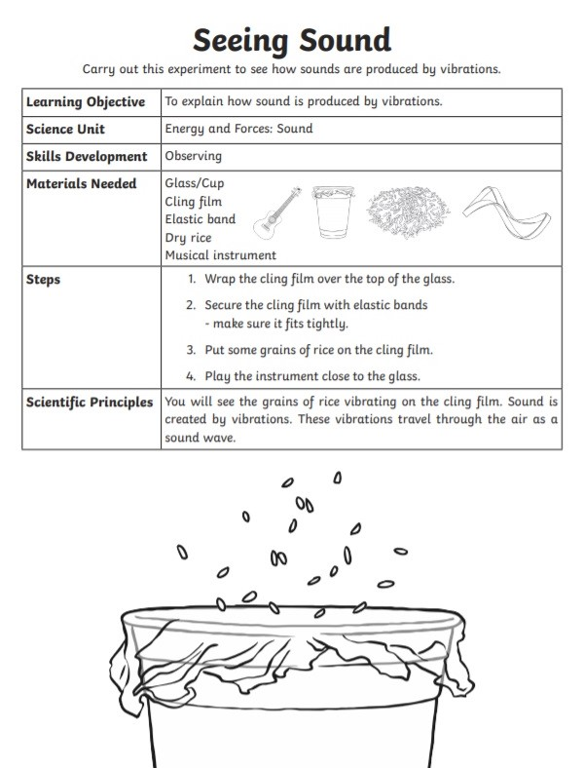

Option 2

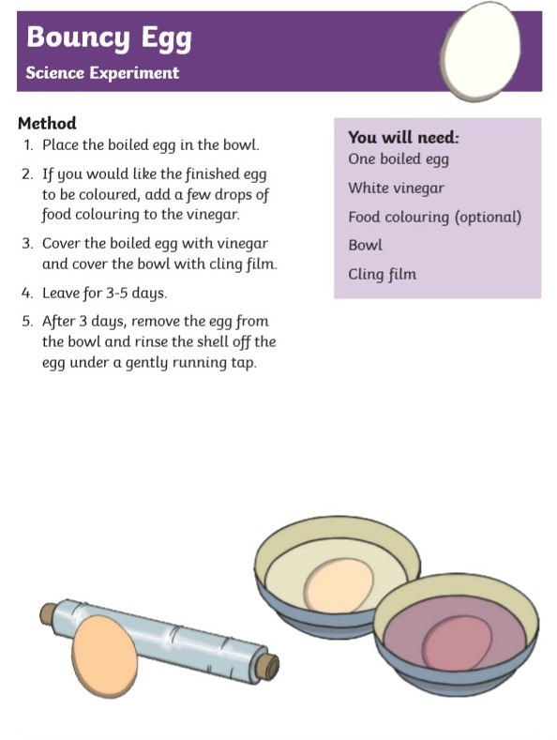

Appendix 2 (Tuesday):
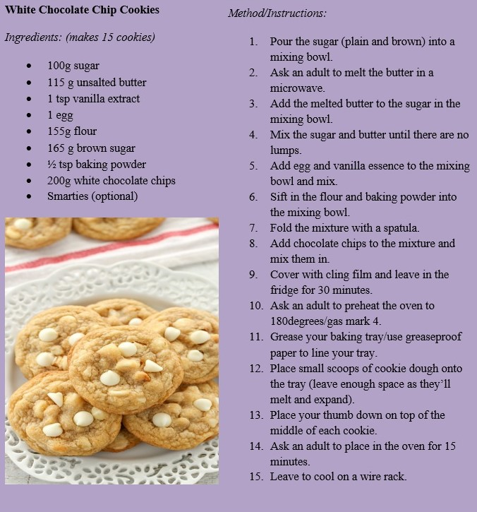
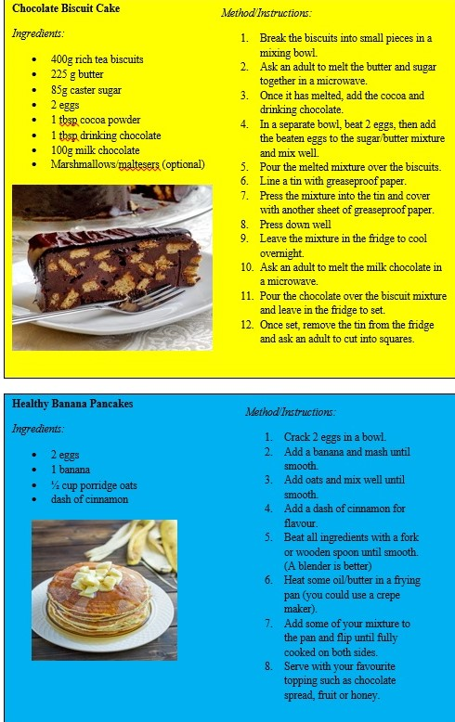

Appendix 3 (Wednesday):
Option 1
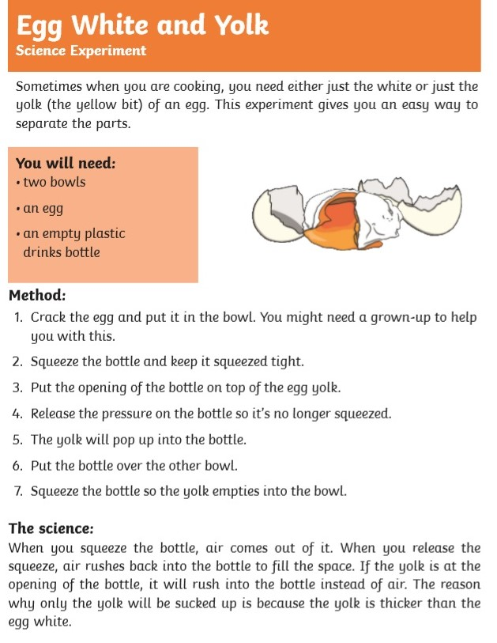

Option 2:
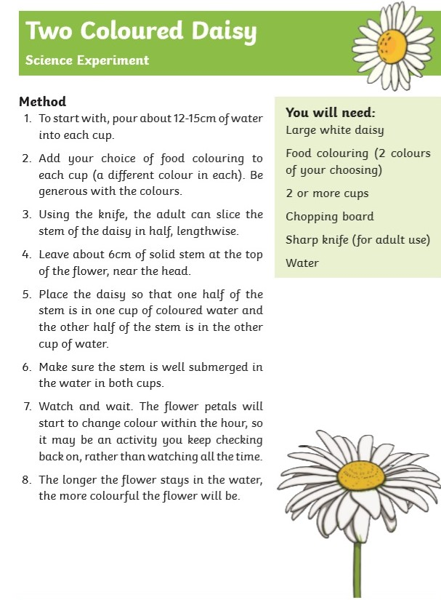

Appendix 4 (Thursday):
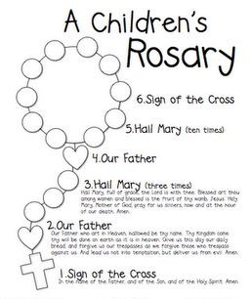

Appendix 5 (Friday):

Appendix 6:

Appendix 7 (Tuesday):

Appendix 5 (Friday):

Appendix 9 (PE Activity for the week):
