Dear 4th Class,
This week is a bank holiday weekend. I would like you to take a well-deserved break and relax on Monday. I have provided some optional activities for you to try on Tuesday. I want you to focus on mindfulness and wellbeing this week. Try your best with your work and don’t worry if you don’t get all the activities completed. If you started to keep a personal diary, I would like you to carry on with this as best as you can, recording your thoughts and feelings and what you are getting up to each day.
Ask an adult to send 3-6 pictures of your work per email, if possible. Your parent/guardian can email me more than once throughout the week if they wish to do so - whatever suits your family. Ask an adult to email: mssmith@scoilchoca.ie
Parents, I will be sending out ‘Friendship Lists’ in the coming weeks. I will require an up-to-date email address from all parents/guardians. Please email me your preferred email address if you haven’t already done so. Thank you in advance.
I allocated Bua na Cainte interactive games again this week. Please follow the instructions below (Appendix 1). The company who created this programme is working remotely and if you are experiencing problems downloading this programme to a PC/MAC please email support@edcolearning.ie. This is optional, I understand if this isn’t possible for families. Please let me know if you are having trouble accessing the material.

Take care,
Ms. Smith

Wishing Candice Lawrence a Happy Birthday this week!

Work for Ms. Smith’s 4th Class : Week 6 Starting 05.05.2020 – 08.05.2020
Monday | Bank Holiday  Relax and have a lovely day
Tuesday  (We were due to have this day off.  All activties are optional) | Mindfulness and Wellbeing:  - Read and discuss ‘Kind Mind’ (Appendix 2).  - Draw a ‘Kind Mind’ (Appendix 3).  - Ask an adult to email me a picture of your May altar if you created one.  Challenge:  - Bake or cook something with your family (eg, mars bar squares/oat cookies). Write down the ingredients and method you used in your copy. Use whatever you have in your kitchen. (adult supervision required-suggestions/ideas below) (Appendix 9)
Wednesday | English:  - Read at Home pg 110  Maths:  - Complete Mathletics Activties  - Maths pg 155  Irish:  - Bua na Cainte PC app: Click an tEarrach. Click ceacht 3. Listen to comhrá 3.1 and comhrá 3.2. Play a game.  Mindfulness and Wellbeing:  - Light up the world with kindness challenge (Appendix 4).  - Keep track (Appendix 5).
Thursday | English:  - Read at Home pg 111  Maths:  - Complete Mathletics Activities  - Maths pg 156  Irish:  - Watch Cúla ar Scoil an TG4 @10am  - Leabhar Litrithe lch 37 (Ceacht 3 section)  Mindfulness and Wellbeing:  - Feeling positive emotions (Appendix 6).
Friday | English:  - Read at Home pg 112  Maths:  - Complete Mathletics Activties  - Maths pg 157  Irish:  - Bua na Cainte PC app: Click an tEarrach. Click ceacht 4. Listen to comhrá 4.1 and comhrá 4.2. Play a game.  - Leabhar Litrithe lch 37 (Ceacht 4 section)  Mindfulness and Wellbeing:  - Acrostic poem (Appendix 7)

Teacher: Ms. Wilson
Note: SEN teachers have added work on to the teachers’ plan. Children can decide to do this work instead of something the teacher has assigned. It is not extra work. Also, we would be delighted if you could email on a picture of something that your child has done and is proud of so we can see their lovely work again!
Literacy -4th Class | This week would have been a short school week. I would like to give you a choice. You can continue with the work described in my plan last week  OR  You can take time this week to walk slowly through nature, study and observe. Make sure an adult is with you. Take a photo of something you notice/draw a picture or write about it. Email me to tell me about it.  These are two things I observed this week.  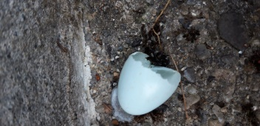  I saw a starling’s egg broken on my doorstep.  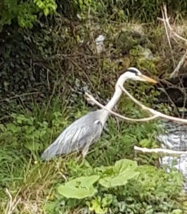  I noticed a heron standing on the banks of a stream.  Let me know what you observe this week. It could be a butterfly, an insect, a bird or a flower. Look around you and see what you notice.
EAL - 4th Class | This week would have been a short school week. I would like to give you a choice. You can continue with the work on transport and travel described below  Theme : Transport and Travel  This week you can read an article about transport from world book online.  - Go to the link below and read the article on transportation. Use the speaker on the website to read for you if some of the words are tricky. Double click on new words and the meaning of the word should appear.  https://www.worldbookonline.com/kids/home#article/ar832001  - Click on the tab to the left of the article that says “more information”. Go to questions and answer the four questions here about the article.  OR  You can take time this week to walk slowly through nature, study and observe  See literacy section above for details.
Contact SEN Teacher: mswilson@scoilchoca.ie
Teacher: Ms. Heffernan
Speech and Language | Here are some interview questions. You can answer them yourself or why not phone a relative or friend and ask them.  https://rainbow3to6.cjfallon.ie/class/fourth/units/3/lesson/4/slide/1  Or what about an online game of Articulate? You have to describe the word without saying it!  https://rainbow3to6.cjfallon.ie/class/fourth/units/3/lesson/5/slide/3  Try this listening activity. You will need someone to call out the instructions for you.  file:///C:/Users/Scoil/AppData/Local/Temp/Temp1_t-s-4399-listen-and-do-activity-pack-.zip/5.%20Five%20Word%20Level/Listen%20and%20Do%201-%20Five%20Word%20Level.pdf  You could try some memory games like we play in school. Ask someone to call out 4 digits forwards or backwards and see if you can write them down.  Keep reading!  If anybody needs any more reading material, please let me know. If you’ve read or listened to a story, I’d love to hear what you thought about it.  Send me an email to let me know how you’re getting on-I’d love to hear from you!
Here are some games to help you with your mental maths.
https://www.topmarks.co.uk/maths-games/hit-the-button
https://www.topmarks.co.uk/maths-games/daily10
Or if you would like to learn more about angles
https://www.mathsisfun.com/acute.html
Or symmetry
https://www.mathsisfun.com/geometry/symmetry-reflection.html
Send me an email to let me know what you have done or if you need help.
Contact SEN Teacher: msheffernan@scoilchoca.ie

Appendix 1

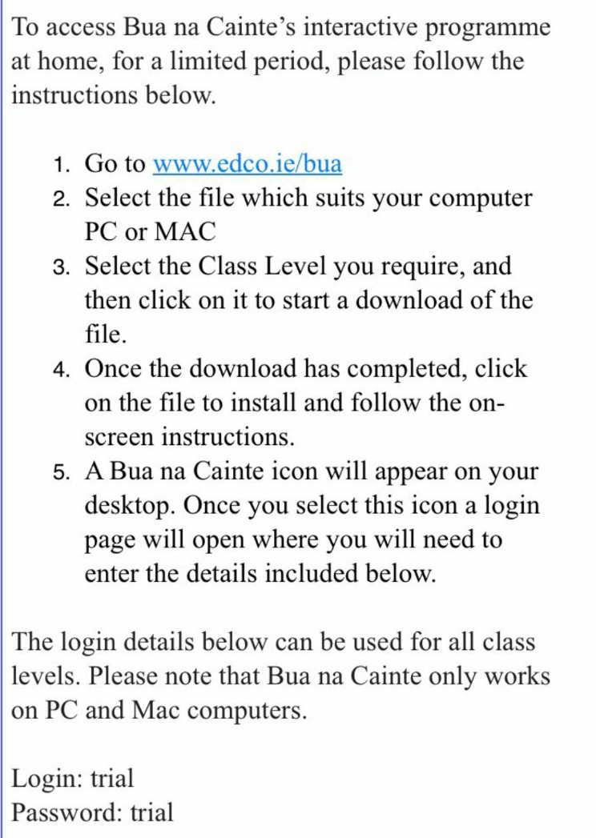

Appendix 2
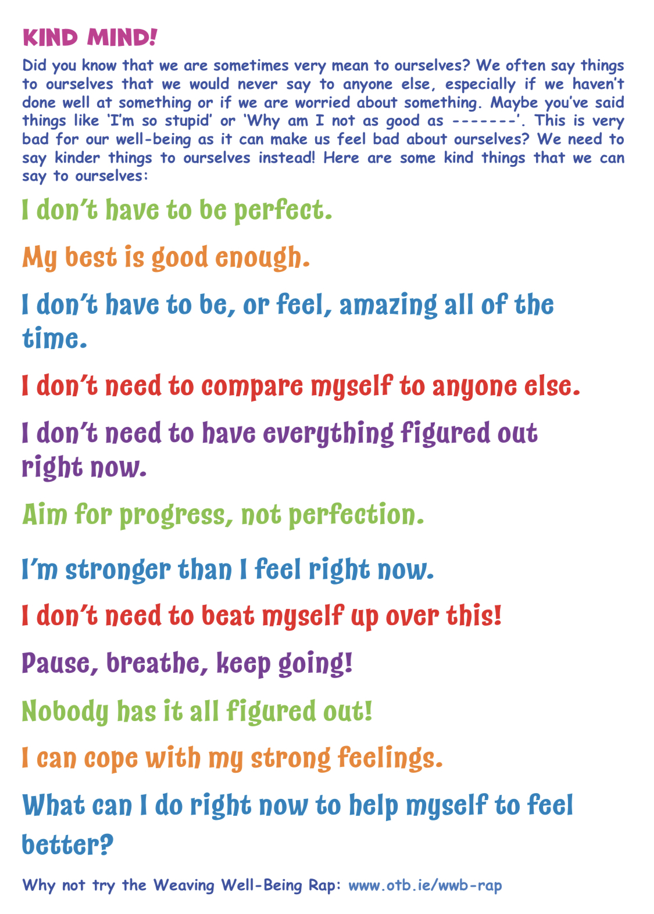

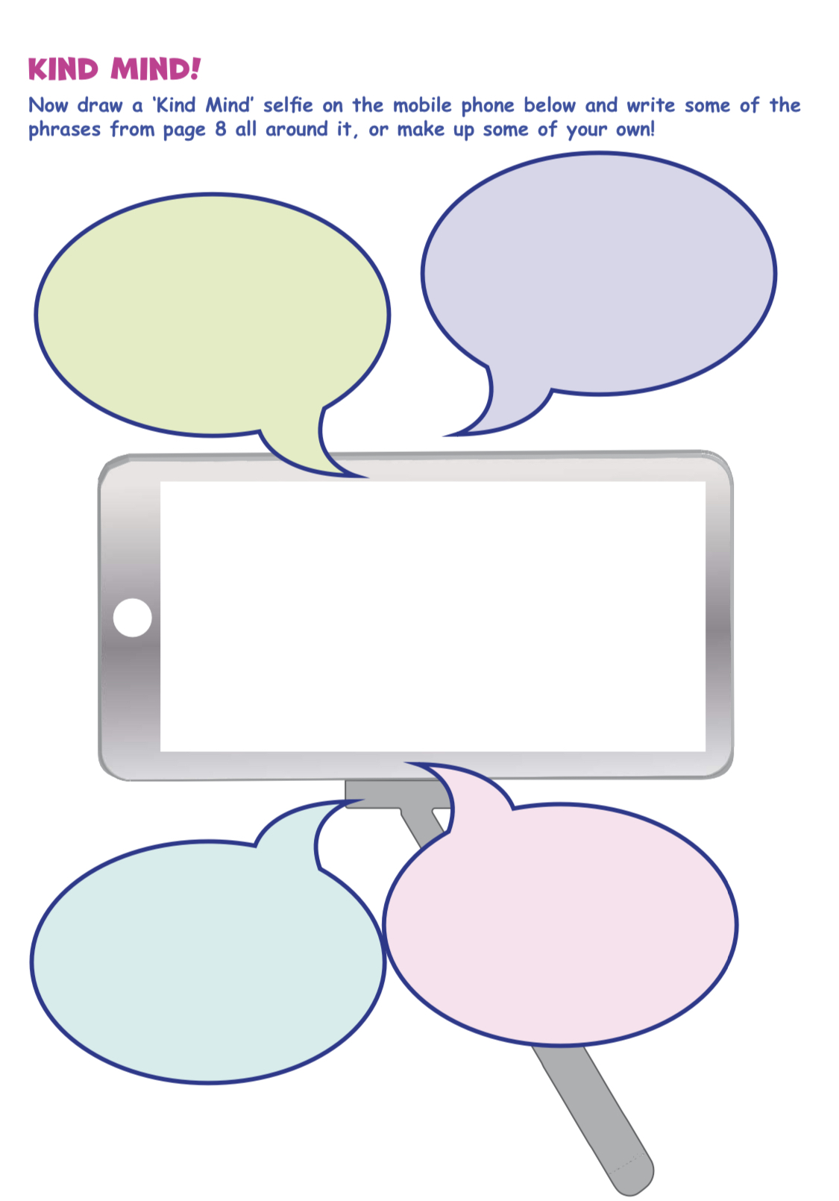
Appendix 3

Appendix 4
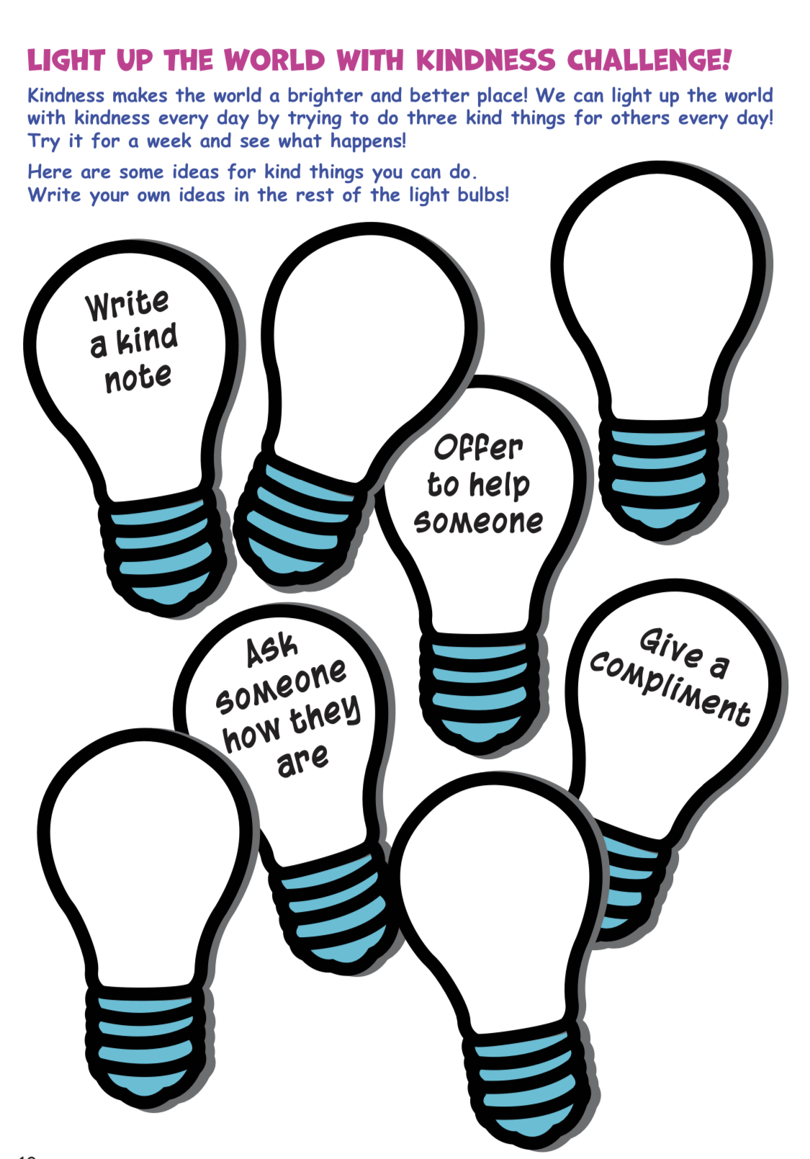

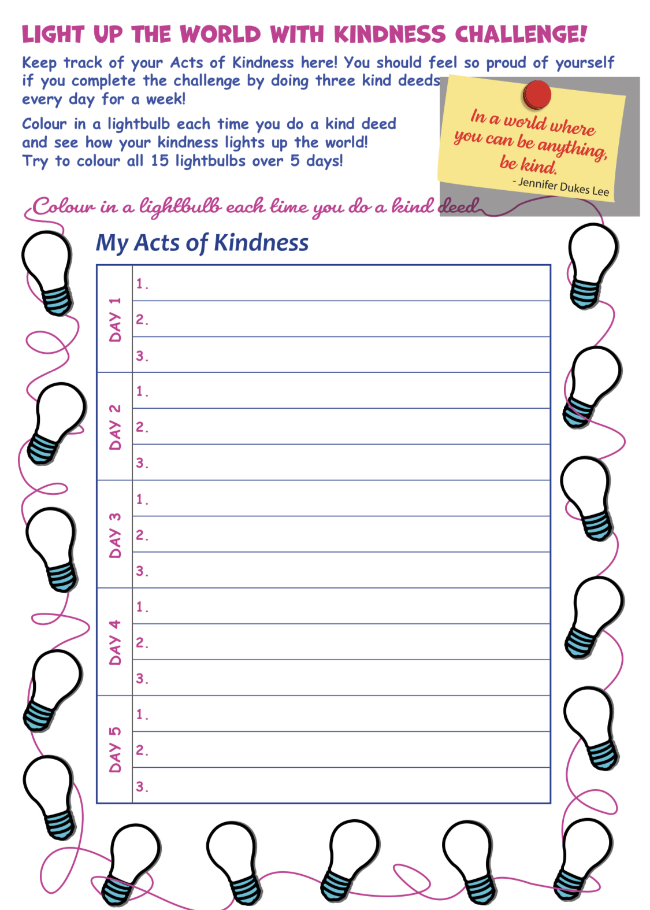
Appendix 5

Appendix 6

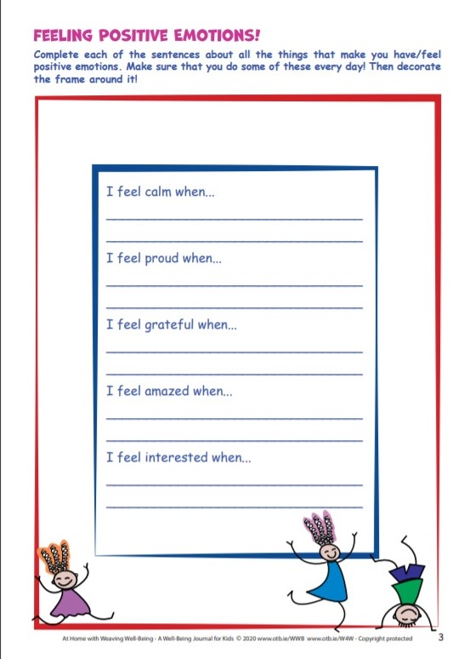

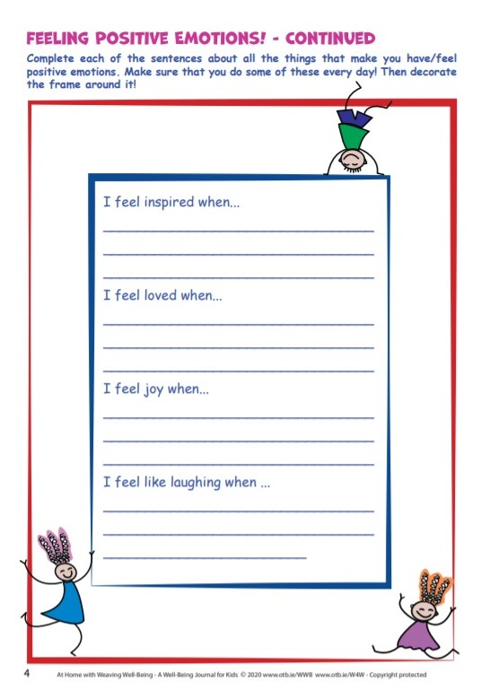

Appendix 7
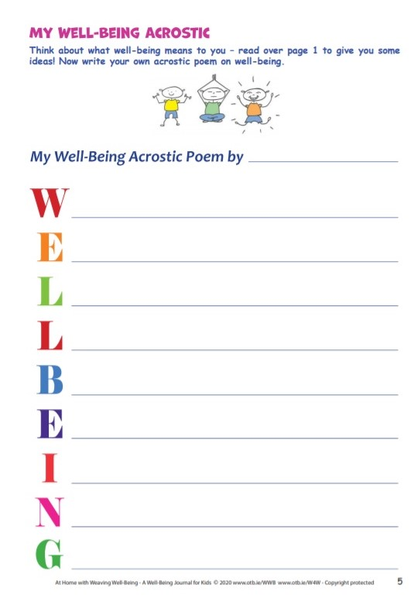

Appendix 8

Appendix 9

