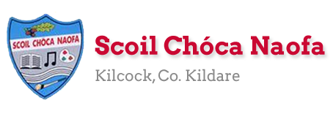
Dear 4th Class and families,
This week has a bank holiday weekend. I would like you to take a well-deserved break and relax on Monday. I have provided some optional activities for you to try on Tuesday. Try your best with your work and don’t worry if you don’t get all the activities completed. If you started to keep a personal diary, I would like you to carry on with this as best as you can, recording your thoughts and feelings and what you are getting up to each day.
We are discussing the possibility of a virtual class assembly. Ms. Daly will announce more details about this.
Ask an adult to send 3-6 pictures of your work per email, if possible. Your parent/guardian can email me more than once throughout the week if they wish to do so - whatever suits your family. Ask an adult to email: mssmith@scoilchoca.ie
Sports Week is happening from June 8th to June 12th. There will also be a video message from a famous sports star/TV personality on Friday, June 5th, to give you a taste of what is to come. Make sure you look at the school website from 9am on that day. On Sunday 7th June, I would like you to watch two videos which will be posted on the school website. These videos are in relation to Sports Week.
Parents, I sent an email last week outlining the RSE programme. You can access the programme via the link I sent in that email. I am here to support you with this programme in any way I can.
All teachers have referred to this programme in the lesson plans this week, however the link has not been put into the lesson plans. We do not want the children accessing this content without your input first. Please refer to the email which I sent last week. If you did not receive an email, please let me know. Thank you for your co-operation.

We appreciate that you are all very busy under the current circumstances. This programme is completed in our school every year. Whilst this is a recommended part of the distance learning, please don't be worried if you cannot get it all covered.

Take care,
Ms. Smith
Wishing Xochi Oosterveld a Happy Birthday this week!

Work for Ms. Smith’s 4th Class : Week 10 Starting 02.06.2020 – 05.06.2020
Monday | Bank Holiday  Relax and have a lovely day
Tuesday  (We were due to have this day off.  All activities are optional) | - Flip the coin challenge (Refer to Appendix 1)  and/or  - Science Experiment (Refer to Appendix 2)  and/or  - Baking challenge *Parent/Guardian supervision required* (Refer to Appendix 3)
Wednesday | English:  - Starlight 16a ‘Blake’s Tyger – Revisted’ Complete A Comprehension: Fact Finding and B Comprehension: Read Between the lines in copy pg. 183  - Use your dictionary to look up any new words  Maths:  - Maths Matters pg 167  - Count up and down in multiples from 2-20, 3-30, 4-40  Irish:  - Watch Cúla ar scoil on TG4 @10.  - Bua na Cainte lch 143. Bí ag leamh. Answer the questions in your copy.  RSE Programme:  Themes 6 and 7 (refer to pages 169 – 181 of the RSE book)  *Parent/Guardian supervison required*
Thursday | English:  - Starlight 16a ‘Blake’s Tyger – Revisted’ Complete C Vocabulary in copy pg. 183  Maths:  - Maths Matters pg 168  - Count up and down in multiples from 5-50, 6-60  Irish:  - Watch Cúla ar scoil on TG4 @10.  - Leabhar Litrithe lch 44  RSE Programme:  Theme 8 (refer to pages 195 – 206 of the RSE book)  *Parent/Guardian supervison required*
Friday  Make sure you check the school website today from 9am for a message from a famous sports star! There will be two longer videos with teachers and other sports stars on the website on Sunday. | English:  - Starlight 16a ‘Blake’s Tyger – Revisted’ Complete D Vocabulary in copy pg. 184  Maths:  - Maths Matters pg 169  - Count up and down in multiplies from 7-70, 8-80  Irish:  - Watch Cúla ar scoil on TG4 @10.  - Leabhar Litrithe lch 45  RSE Programme:  Theme 9 (refer to pages 207 – 220 of the RSE book)  *Parent/Guardian supervison required*

Teacher: Ms. Wilson 2/6/2020

Note: SEN teachers have added work on to the teacher’s plan. Children can decide to do this work instead of something the teacher has assigned. It is not extra work. Also, we would be delighted if you could email on a picture of something that your child has done and is proud of so we can see their lovely work again!

Literacy Group
Each of you should have received a pack of work in the post. Please refer to this pack for the work assigned below.
This week I would like you to:
- Try Brain Break Breathing – Try the Bubble Breaths or the Bumble Bee Breaths
- 15 Minute Memory Activities – Try number 3 – Brain Yoga.
- Complete the next session of SNIP.
- Complete the Cloze Reading Exercise – Looking after My Wellbeing.
- Newell Literacy
- p.50 – Go over –ing, -ang, -ong, -ung sounds on the chart.
- P.51 Written Spelling. Ask an adult to call out spellings nos 7-12 at the bottom of the page. See if you can write them. (Some of these spellings are nonsense words).

Continue reading and let me know what you are reading. I’d love to hear about books you have enjoyed.
It is ok if you don’t get to everything assigned here. I know that you are busy. Just try to do a little bit each day.
EAL Group – Ms Wilson.

Theme : Caring for your Locality – The Royal Canal.
This week I would like you to think about ways which we can care for The Royal Canal in Kilcock.
Lots of people use the canal for walks and leisure activities.

Can you think of a list of guidelines/rules which would help us to keep the canal and walkways clean and safe. How do we protect the habitats along the canal? (A habitat is the home of an animal or a plant).
Try to think of at least four rules. Write them down.
Next design a poster to illustrate these rules.

Hints:
Refer to litter, clean water, protection of habitats for wildlife, safety for small children near water, guideines for sports played on the canal.

Contact SEN Teacher: mswilson@scoilchoca.ie
Teacher: Ms. Heffernan
Speech and Language | This week we’re going to try some more debating. Choose one of the topics shown below and come up with 3 arguments for/against it. You can write them down or record them on the phone and send them to me. Or you can have a real debate with someone in your family!  https://rainbow3to6.cjfallon.ie/class/fourth/units/8/lesson/4/slide/2  Try this listening activity. You will need someone to call out the instructions for you. If you are printing it, only print page 2.  file:///C:/Users/Scoil/AppData/Local/Temp/Temp1_t-s-4399-listen-and-do-activity-pack-.zip/6.%20Higher%20Level/Listen%20and%20Do%202%20-%20Higher%20Level.pdf  Can you name 5 of each thing?  Keep reading!  If anybody needs any more reading material, please let me know. If you’ve read or listened to a story, I’d love to hear what you thought about it.  Send me an email to let me know how you’re getting on-I’d love to hear from you!
Maths | You can keep playing games to help you with your mental maths.  https://www.topmarks.co.uk/maths-games/hit-the-button  https://www.topmarks.co.uk/maths-games/daily10  Or here’s some information to help you with your topic-Symmetry-this week  https://www.mathsisfun.com/geometry/symmetry.html  Mandalas have lots of geometric patterns and lines of symmetry. You might like to colour one.  https://content.twinkl.co.uk/resource/90/21/roi-t-20162321-mandalathemed-mindfulness-colouring-pages.pdf?__token__=exp=1590408113~acl=%2Fresource%2F90%2F21%2Froi-t-20162321-mandalathemed-mindfulness-colouring-pages.pdf%2A~hmac=a2baf83bf466ff810c7ef247ffc3f20ae50b17e82a5a6af780e209b545e2ef5b
Contact SEN Teacher: msheffernan@scoilchoca.ie

Appendix 1 (Monday)
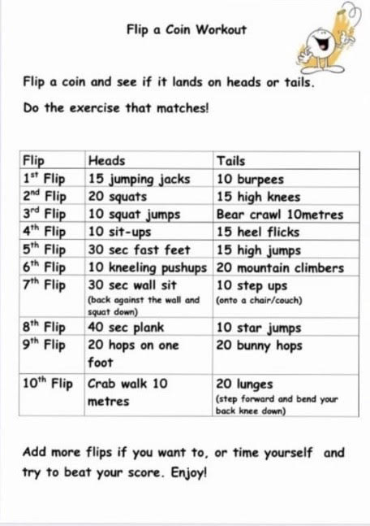

Appendix 2 (Monday)
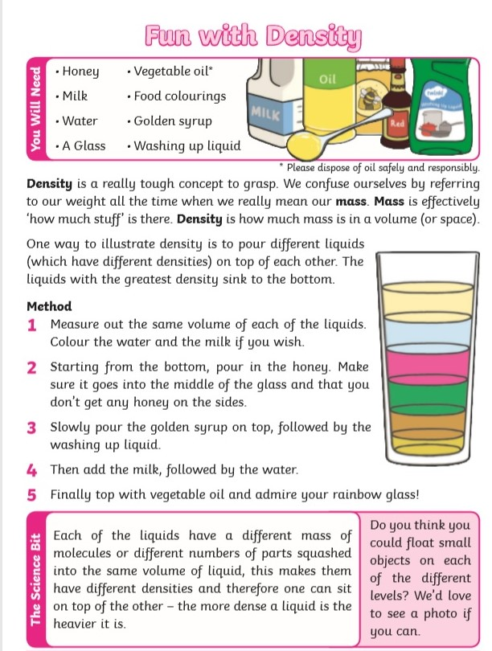

Appendix 3 (Monday)
