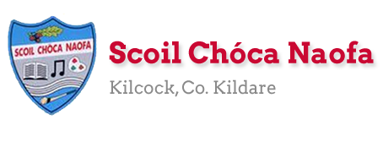
Work for Mr. Bracken’s 3rd Class: Monday 25/05/20 – Friday 29/05/20
Dear 3rd Class,
I hope you and your family are keeping safe and well. Well done on completing your work with the Stay Safe programme last week.
Thank you and your parents so much for sending me pictures of your work again last week. I know I say that I’m impressed with your work each week but I genuinely mean it. I have a fantastic class and you’re all very lucky to have such fantastic parents. I know it is getting harder now to engage with the school work but we are nearly there. June is just around the corner and there will be some nice things to do over the last few weeks. Maybe even some surprises! You can find me at mrbracken@scoilchoca.ie Keep up the great work.
This week you will be doing some music and art activities. There are videos to help you, be as creative as you like! This links in with the English work in Starlight this week, ‘Electric Guitars’. Some of the words you will come across like ‘onomatopoeia’ and ‘alliteration’ are poetic techniques you have learned already.
Mrs McCabe is working this week, she would be delighted to hear from you and to see what you have been up to: msmccabe@scoilchoca.ie .
Have a look at the website each week to see some pictures of the great work being done at home.
While the weather is fine, make sure to get outside in the fresh air and get active. Lend a helping hand at home with the cooking/cleaning/gardening if you can.
Happy birthday to Emilia this week (27th), we all hope you enjoy your special day!!
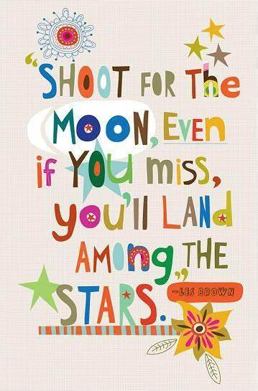
Have a great week.

All the best,
Mr Bracken

Monday | English:  - Starlight 16A – ‘Electric Guitars’ – Read the text & complete part A in your copy  - Diary entry/voice recording  - Read your Home Book  Maths:  - Maths Matters pg 138. For Q.1 instead of “looking around the classroom” look around the room you’re in. See below for help.  - Mathletics Activities  Irish:  - Léigh sa Bhaile: Read the next page. Freagair na ceisteanna: Answer the 5 questions at the bottom of the page in your spare copy  - If anyone needs a page from Léigh sa Bhaile read out so you can listen to pronunciations let me know and I can email you a voice clip.  - Cúla ar scoil @10am https://www.cula4.com/en/  - Dán (poem) – ‘Ceisteanna’ – read  PE: Activity - see below  Other: Music/Art  - Make your own musical instrument.  - You could make a shaker, a drum or something else of your own choice.  - You could use kitchen roll/elastic bands/ plastic or paper cups/ lentils/rice/ tissue paper/ scissors/ glue/ tape- Use your imagination!  - Perform an at-home concert for your family using your new musical instrument.  There is a video clip below to help you.
Tuesday | English:  - Starlight 16A – ‘Electric Guitars’ – Read the text & complete part B in your copy  - Diary entry/voice recording  - Read your Home Book  Maths:  - Maths Matters pg 139  - Mathletics activities  Irish:  - Léigh sa Bhaile: Read the next page. Freagair na ceisteanna: Answer the 5 questions at the bottom of the page in your spare copy  - If anyone needs a page from Léigh sa Bhaile read out so you can listen to pronunciations let me know and I can email you a voice clip.  - Cúla ar scoil @10am https://www.cula4.com/en/  - Dán (poem) – ‘Ceisteanna’ – read  PE: Activity – see below  Other: Music  - Listen to a famous classical piece of music called ‘The Carnival of the Animals.’  - Does this music sound like any animals you know?  - Draw/write about what you think is happening in the music- it might be a lion running through the jungle or an elephant stomping through the Savannah.  The clip is 20 minutes long (you only need to listen to around 3 minutes)
Wednesday | English:  - Starlight 16A – ‘Electric Guitars’ – Read the text & complete part C in your copy  - Diary entry/voice recording  - Read your Home Book  Maths:  - Maths Matters pg 140  - Mathletics activities  Irish:  - Léigh sa Bhaile: Read the next page. Freagair na ceisteanna: Answer the 5 questions at the bottom of the page in your spare copy  - If anyone needs a page from Léigh sa Bhaile read out so you can listen to pronunciations let me know and I can email you a voice clip.  - Cúla ar scoil @10am https://www.cula4.com/en/  - Dán (poem) – ‘Ceisteanna’- read  PE: Activity – see below  Other: SESE  - Click the link below to watch Dublin Zoo’s virtual tour and look at the amazing animals.  - Can you name any of the animals you see in the video?  - Draw a picture of your favourite animal.  - Use the website below to find some facts on your favourite animal and create a fact-file (attached below)
Thursday | English:  - Starlight 16A – ‘Electric Guitars’ – Read the text & complete part D in your copy  - Diary entry/voice recording  - Read your Home Book  Maths:  - Maths Matters pg 141  - Mathletics activities  Irish:  - Léigh sa Bhaile: Read the next page. Freagair na ceisteanna: Answer the 5 questions at the bottom of the page in your spare copy  - If anyone needs a page from Léigh sa Bhaile read out so you can listen to pronunciations let me know and I can email you a voice clip.  - Cúla ar scoil @10am https://www.cula4.com/en/  - Dán – ‘Ceisteanna’ - read  PE: Activity – see below  Other: Science  - ‘Fireworks in a Glass’ experiment – see below
Friday | English:  - Read the comprehension attached below based on Tigers and answer the questions that follow!  - Diary entry/voice recording  - Read your Home Book  Maths:  - Maths Matters pg 142  - Maths problem solving activity – see below  Irish:  - Léigh sa Bhaile: Read the next page. Freagair na ceisteanna: Answer the 5 questions at the bottom of the page in your spare copy  - If anyone needs a page from Léigh sa Bhaile read out so you can listen to pronunciations let me know and I can email you a voice clip.  - Cartún ar TG4  - Dán – ‘Ceisteanna’ - read  PE: Activity – see below  Other: Science  - ‘Lava Lamp’ experiment – see below

Useful websites for this week:
- Music/Art: Musical instrument ideas https://www.youtube.com/watch?v=7sUNXA4NYKI#action=share
- Music: The Carnival of the Animals https://www.youtube.com/watch?v=k2RPKMJmSp0
- Music: Me and My Instrument – The Saxophone: https://youtu.be/E5_N-EJZc2Q
- SESE: Dublin Zoo’s virtual tour https://www.youtube.com/watch?v=w5xhyJADQys&feature=youtu.be
- SESE: Information on animals https://www.nationalgeographic.com/animals/
- Maths: https://www.mathletics.com/uk/
- Maths: Tables revision games- https://www.topmarks.co.uk/maths-games/7-11-years/multiplication-and-division
- Baking: very good website: https://www.supercook.com/#/recipes - you can put in the ingredients you have at home and it will generate something to bake for you.

Mrs McCabe is working this week, Monday - Friday
SEN/EAL work 3rd class EB May 25-29th. Teachers: Ms. McCabe & Ms.Curran.
Note: SEN teachers posted workpacks to their students, this week. It is not extra work. Also, PLEASE email on a picture of something that your child has done recently, so we can see their lovely work again! All groups can look at the clock and tell the time 3 times per day. Also keep reading and learning your tables daily. This week, do 9x multiplication tables and practice counting up and down the ladder in 9s....the same speed backdown as going up!
EAL: People Who Help Us. | ORAL: Record yourself naming all the people who help us and say what job they do. Think about people who help at school, at home, and in the neighbourhood.  WRITE: Draw a mindmap of people who help us at home, at school, in the neighbourhood, and even people who help us during the Covid crisis.  https://www.twinkl.ie/resource/us2-e-53-mind-map-writing-template
Speech and Language | Play Meanings Game for 5 minutes each day.  Enjoy this guessing game!  https://www.twinkl.ie/resource/t-s-890-what-am-i-guessing-game-cards-animal-themed  Conversation Starters – Continue with these, one per day.
Literacy A & B | SNIP programme (session 11)..... 3 pages for the week.  Phonics/Final Blends: Read the following 5 lists of blends -rk –lt –lf –pt –ft -ct http://www.theschoolhouse.us/lessons/lesson57.html  Cloze: Understanding the Internet. Try one of the Memory Activities!  Please keep up the reading, every day!  https://www.oxfordowl.co.uk/for-school/oxford-owl-ebook-collection  These are free ebooks and you can find your level.
Toe by Toe | Next SNIP session (session 21)..... 3 pages for the week.  Cloze: Understanding the Internet. Try one of the Memory Activities!  Please read and ask an adult to read with you.
SEN Individuals | Do one Mindful Brain Break Activity each day:  https://www.twinkl.ie/resource/us-p-12-mindful-minute-brain-break-cards  Fry’s Words: Continue with the list you are on.  Write Reader: Write your diary entry daily. 5 or 6 sentences  Cloze: Understanding the Internet.  Do 2 pages of new booklet (S C)  Start one picture sequencing (What’s at the Zoo?)  Try one of the Memory Activities!
Contact SEN Teachers: msmccabe@scoilchoca.ie mscurran@scoilchoca.ie

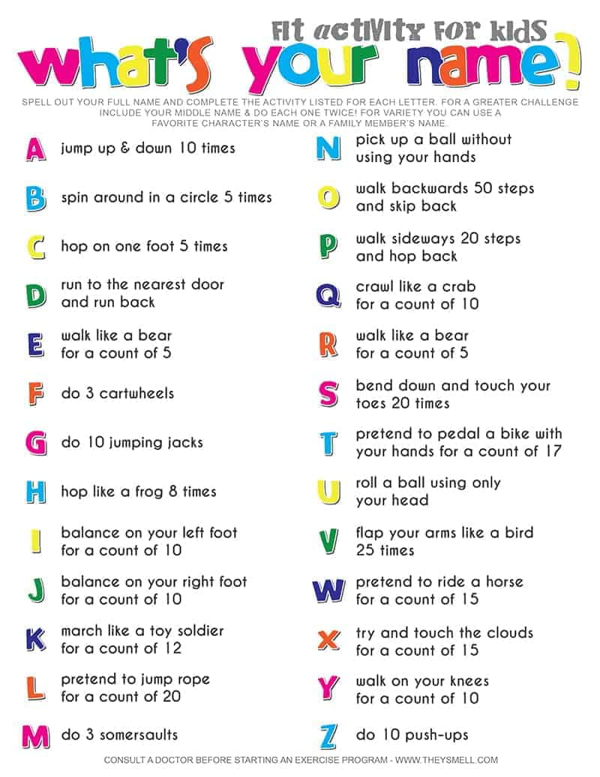
PE Activity for the week

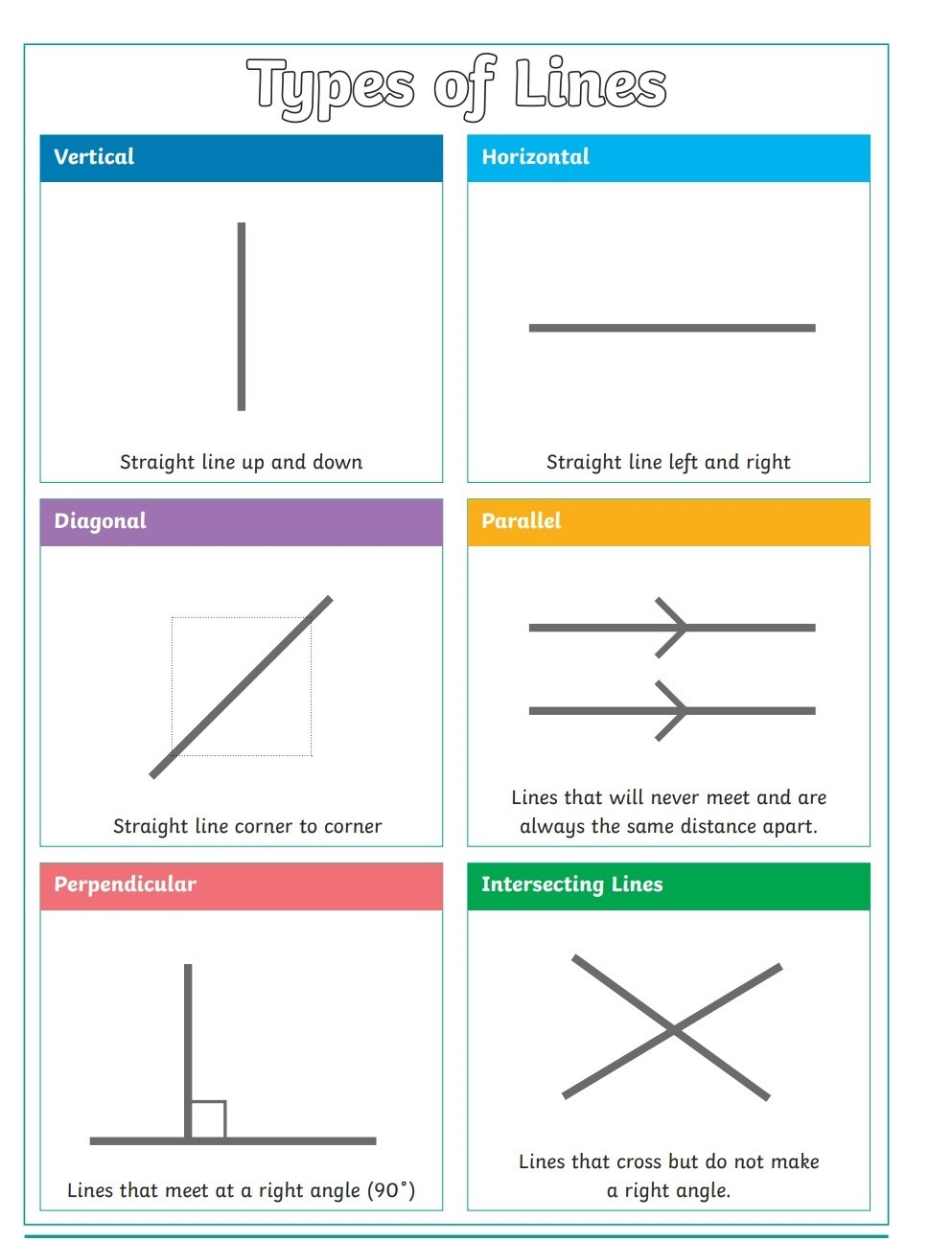
Maths: Lines

Maths: Problem solving activity
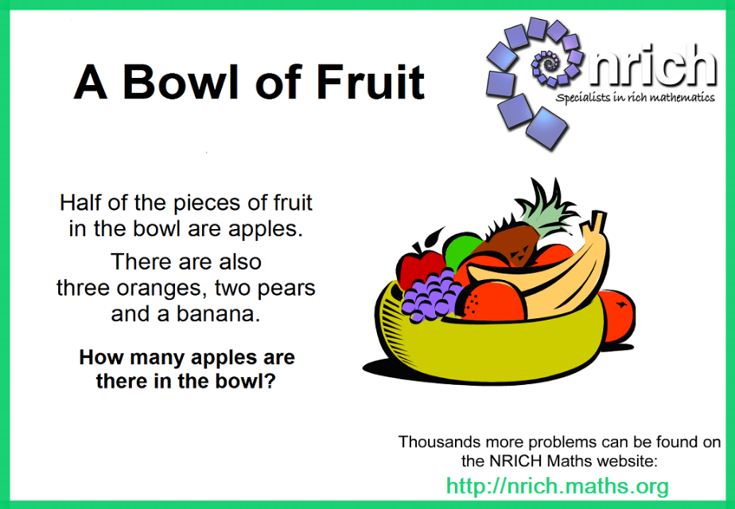
Gaeilge – poem to read each day
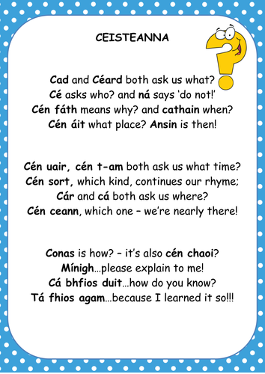

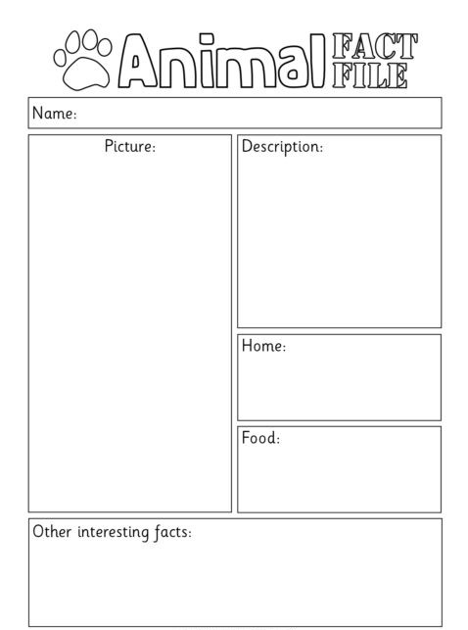
SESE – Wednesday – Animal Fact File

English – Friday

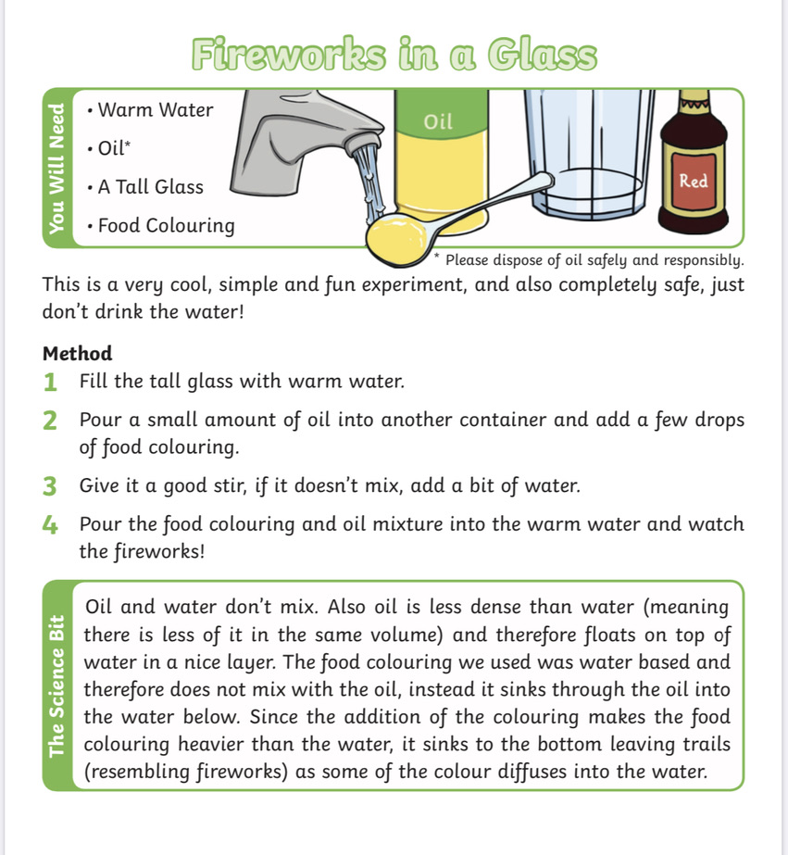
Science Experiment – Thursday
Science Experiment - Friday
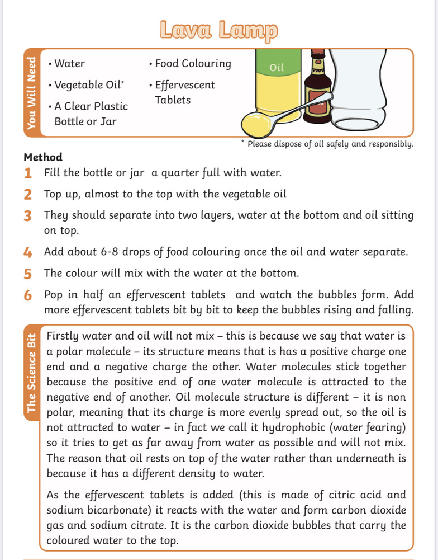
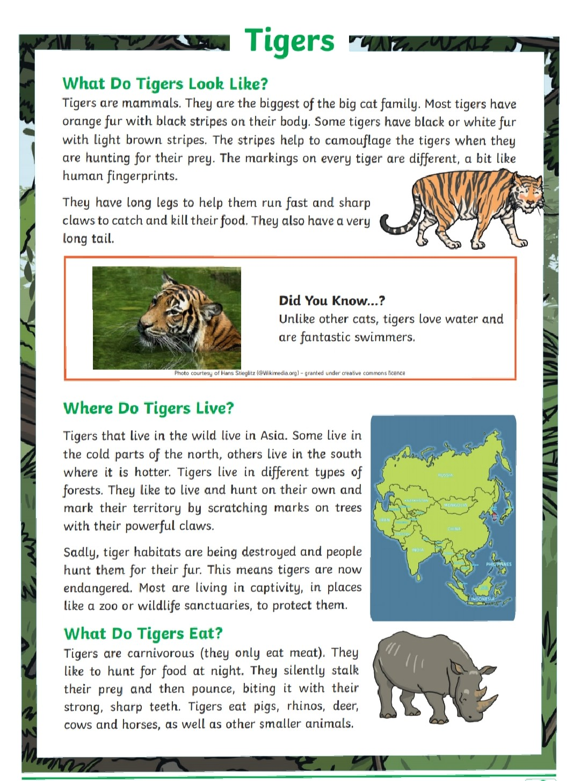
English - Friday

English - Friday
