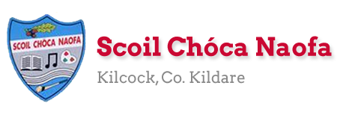
Dear 4th Class,
I hope all is well with you and your family this week. Last week, you completed the Stay Safe programme. Well done. This week, I have given you some music, science and art activities to complete. Have fun and try your best
A massive thank you to you and your parents for sending me pictures of your work again this week. I know it is getting harder now to engage with the school work but we are nearly there. June is just around the corner and there will be some nice things to do over the last few weeks. Maybe even some surprises! You are doing so well at keeping up with your school work at home. I am so impressed.
Please continue to send the work you are most proud of to mstierney@scoilchoca.ie. Have a look at the website each week to see some pictures of the super work being done at home.
Ms. Heffernan would be delighted to hear from those children who work with her. Her email address is msheffernan@scoilchoca.ie .
While the weather is fine, make sure to get outside in the fresh air and get active. Lend a helping hand at home with the cooking/cleaning/gardening if you can.
Have a great week.
Stay safe and keep smiling,
Ms. Tierney
mstierney@scoilchoca.ie

Happy Birthday to Nataniel Fortune (3rd Class) and Janelle Ligue (4th Class).
Let’s all sing happy birthday as we wash our hands at home.

Work for Ms. Tierney’s 4th Class:
Monday 25/05/20 – Friday 29/05/20
Monday | English:  - Starlight: Read Pg 164-166 ‘Babe the Blue Ox’  Answer Part A in your copy  Look up the definitions of any words you do not know in your dictionary.  - Recite the poem: Be Glad Your Nose is on Your Face  Maths:  - Maths Matters Pg. 151  - Mathletics activities  - Count up and down in multiples 2-20,3-30,4-40  Irish:  - Léigh sa Bhaile: Leathanach 1 (Page 1)- Buachaill Nua  Léigh agus freagair na ceisteanna/Read and answer the questions (see below)  - Abair an dán/say the poem: Pianta na Scoile  - Watch Cúla4 ar scoil on TG4 at 10 a.m.  P.E:  - PE with Joe Wicks on YouTube  Other: Music/Art  - Make your own musical instrument.  - You could make a shaker, a drum or something else of your own choice.  - You could use kitchen roll/elastic bands/ plastic or paper cups/ lentils/rice/ tissue paper/ scissors/ glue/ tape- Use your imagination!  - Perform an at-home concert for your family using your new musical instrument.  - There is a video clip below to help you.
Tuesday | English:  - Starlight: Read Pg. 164-166 ‘Babe the Blue Ox’  Answer Part B in your copy  - Recite the poem: Be Glad Your Nose is on Your Face  Maths:  - Maths Matters Pg. 152  - Mathletics activities  - Count up and down in multiples 5-50, 6-60, 7-70  Irish:  - Léigh sa Bhaile lch 2 (Pg 2)- Scoil Uí Riada  - Abair an dán: Pianta na Scoile  - Watch Cúla4 ar scoil on TG4 at 10 a.m.  P.E:  - PE with Joe Wicks on YouTube  Other: Music  - Click the link below to listen to a famous classical piece of music called ‘The Carnival of the Animals.’  - Does this music sound like any animals you know?  - Draw/write about what you think is happening in the music- it might be a lion running through the jungle or an elephant stomping through the Savannah.  - The clip is 20 minutes long (you only need to listen to around 3 minutes)
Wednesday | English:  - Starlight: ‘Babe the Blue Ox’ Answer C + D in your copy  - Recite the poem: Be Glad Your Nose is on Your Face  Maths:  - Maths Matters pg 153 q1-6  - Mathletics Activities  - Count up and down in multiplies from 8-80, 9-90  Irish:  - Léigh sa Bhaile lch 3 (Pg 3)- Mo Theach  - Abair an dán: Pianta na Scoile  - Watch Cúla4 ar scoil on TG4 at 10 a.m.  P.E:  - PE with Joe Wicks on YouTube  Other: SESE  - Click the link below to watch Dublin Zoo’s virtual tour and look at the amazing animals.  - Can you name any of the animals you see in the video?  - Draw a picture of your favourite animal from the video.  - Use the website below to find some facts on your favourite animal and create a fact-file.
Thursday | English:  - Reading Comprehsion: Read and answer questions on ‘Tigers’  - Recite the poem: Be Glad Your Nose is on Your Face  Maths:  - Maths Matters pg 153 q 7-12  - Mathletics Activities  - Count up and down in multiples from 10-100, 11-110, 12-120  Irish:  - Léigh sa Bhaile lch 4- Ag Obair ar an bhFeirm  - Abair an dán: Pianta na Scoile  - Watch Cúla4 ar scoil on TG4 at 10 a.m.  P.E:  - PE with Joe Wicks on YouTube  Other: SESE-Science  - Fireworks in a glass experiment (See below)
Friday | English:  - Finish reading comprehension on Tigers  - Recite the poem: Be Glad Your Nose is on Your Face  Maths:  - Maths worksheet: Money  - Maths problem-solving activity  Irish:  - Léigh sa Bhaile lch 5- Mé Féin  - Abair an dán: Pianta na Scoile  - Watch Cúla4 ar scoil on TG4 at 10 a.m  P.E:  - PE with Joe Wicks on YouTube  Other: SESE- Science  - Lava lamp experiment (See below)

Here is a prayer for you to say:
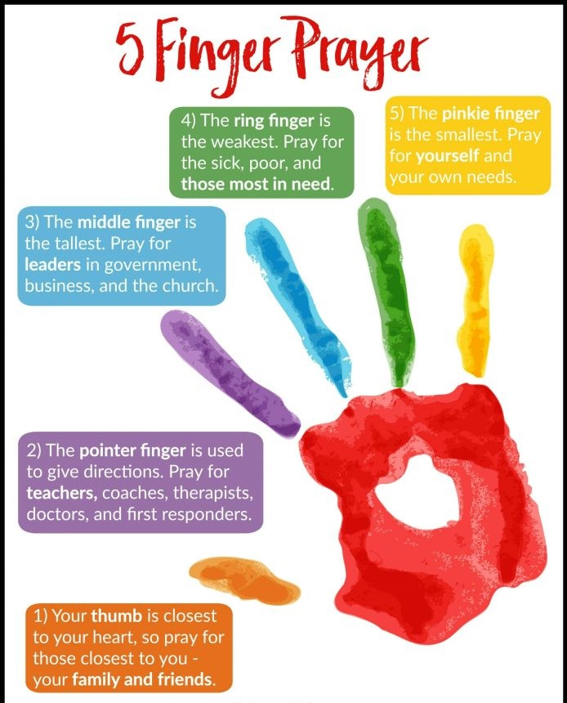

Teacher: Ms. Heffernan
Note: SEN teachers have added work on to the teachers’ plan. Children can decide to do this work instead of something the teacher has assigned. It is not extra work. Also, we would be delighted if you could email on a picture of something that your child has done and is proud of so we can see their lovely work again!
Language | This week we’re going to try some debating. Choose one of the topics shown below and come up with 3 arguments for/against it. You can write them down or record them on the phone and send them to me. Or you can have a real debate with someone in your family!  https://rainbow3to6.cjfallon.ie/class/fourth/units/8/lesson/2/slide/2  Here’s another online game of articulate with ‘Space’ words. You can choose easy, medium or hard words. Describe the word in the given time without saying the word itself. Good luck!  https://rainbow3to6.cjfallon.ie/class/fourth/units/8/lesson/5/slide/2  Try this listening activity. You will need someone to call out the instructions for you. If you are printing it, only print page 2.  file:///C:/Users/Scoil/AppData/Local/Temp/Temp1_t-s-4399-listen-and-do-activity-pack-.zip/6.%20Higher%20Level/Listen%20and%20Do%201%20-%20Higher%20Level.pdf  Here is a memory task. Do one row of cards each day to build on your memory skills. Someone calls out the list to you and you try to repeat it in the same order.  If you want a challenge, the other person can read out the whole list the first time and leave something out the second time and you have to name the missing item (like we do in school).  file:///C:/Users/Scoil/Desktop/t-s-1230-listen-and-repeat-auditory-memory-cards-_ver_3.pdf  Keep reading!  If anybody needs any more reading material, please let me know. If you’ve read or listened to a story, I’d love to hear what you thought about it.  Send me an email to let me know how you’re getting on-I’d love to hear from you!
Contact SEN Teacher: msheffernan@scoilchoca.ie

Resources
Useful websites for this week:
- Music/Art: Musical instrument ideas https://www.youtube.com/watch?v=7sUNXA4NYKI#action=share
- Music: The Carnival of the Animals https://www.youtube.com/watch?v=k2RPKMJmSp0
- SESE: Dublin Zoo’s virtual tour https://www.youtube.com/watch?v=w5xhyJADQys&feature=youtu.be
- SESE: Information on animals https://www.nationalgeographic.com/animals/
- Maths: https://www.mathletics.com/uk/
- Maths: Tables revision games- https://www.topmarks.co.uk/maths-games/7-11-years/multiplication-and-division
- PE: Joe Wicks’ Live Daily PE workouts: https://www.youtube.com/
- General: Twinkl: Worksheets/Powerpoints available: Free access if you use code CVDTWINKLHELPS
- RTE’s Home School Hub. If you miss it, you might be able to watch it back on RTE Player. https://www.rte.ie/player/

English Poem: Be Glad Your Nose is on Your Face
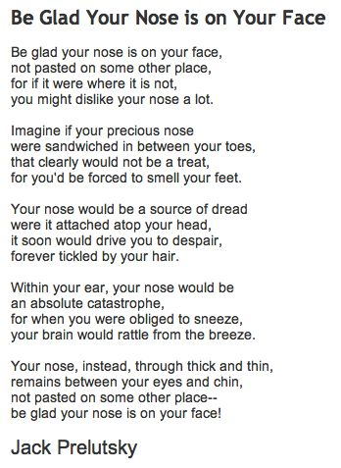

Dán Gaeilge: Pianta na Scoile
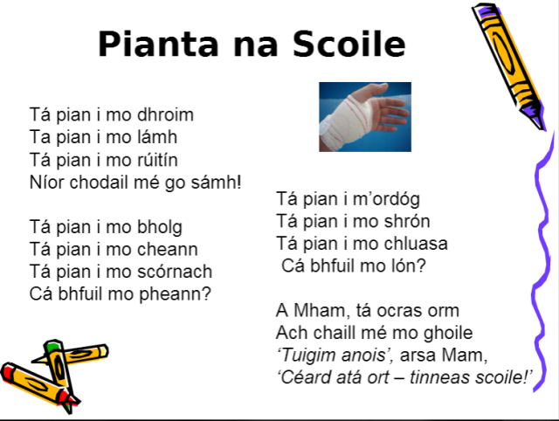

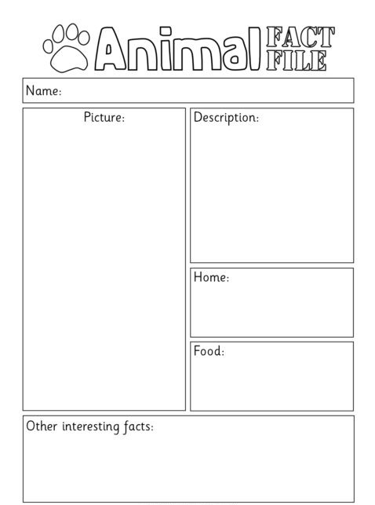
SESE: Animal fact-file

Reading Comprehension: Tigers
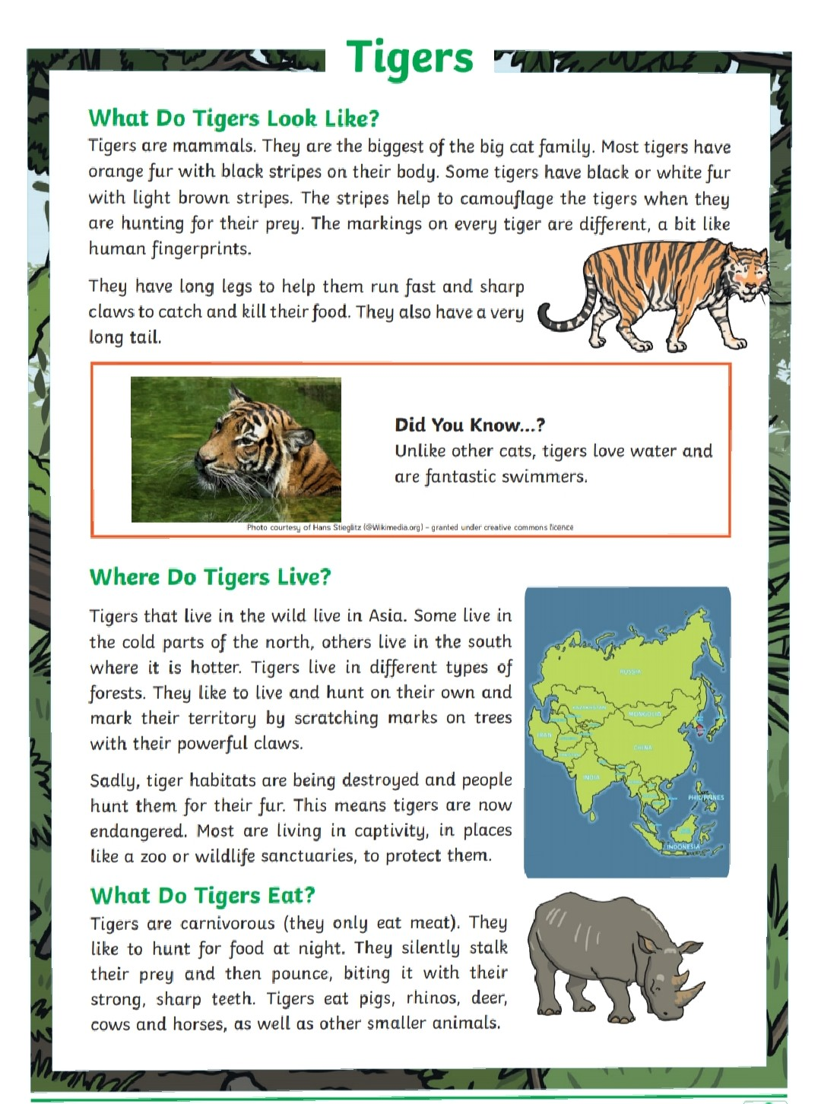

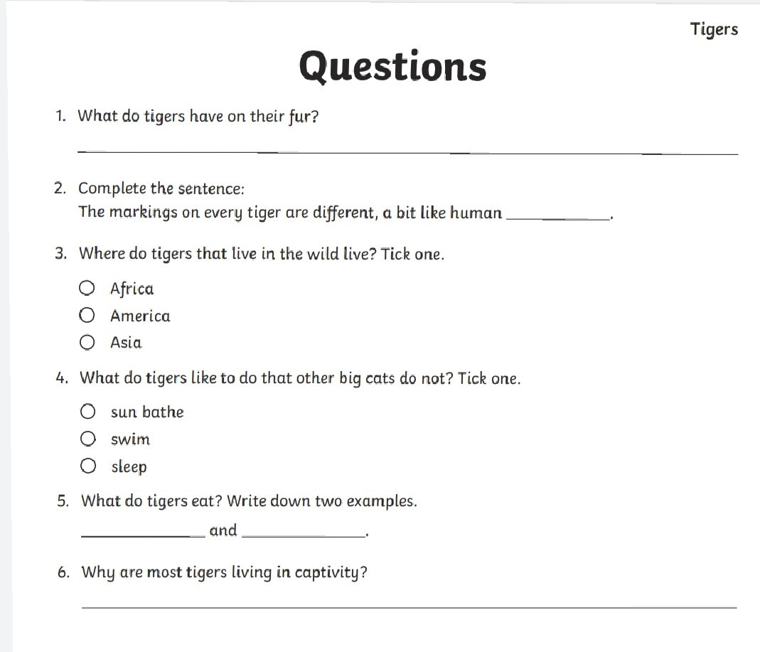

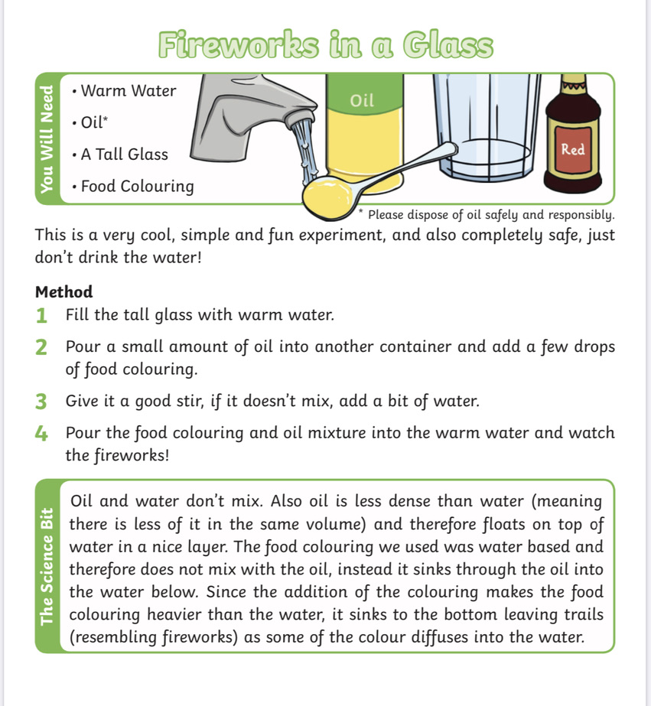
Science Experiment: Fireworks in a glass

Maths Worksheet: Money
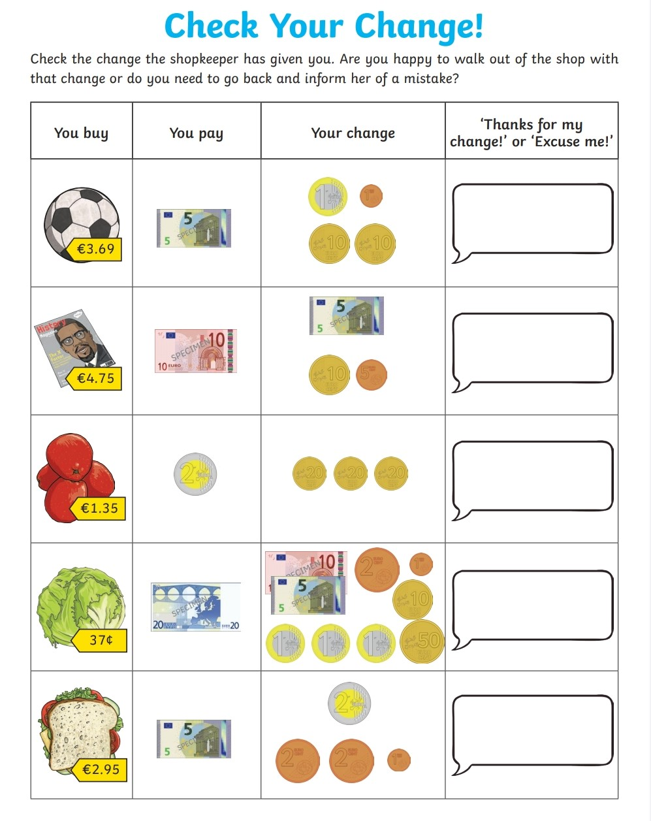

Maths: Problem-solving activity
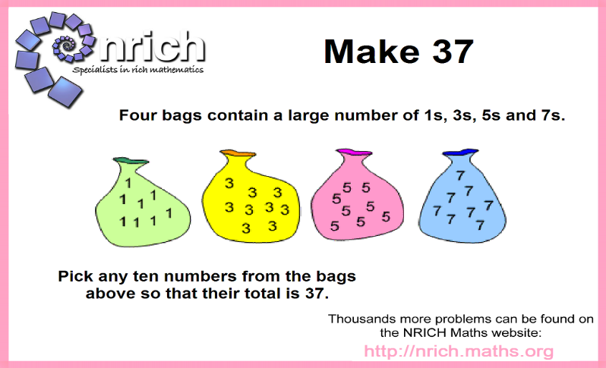
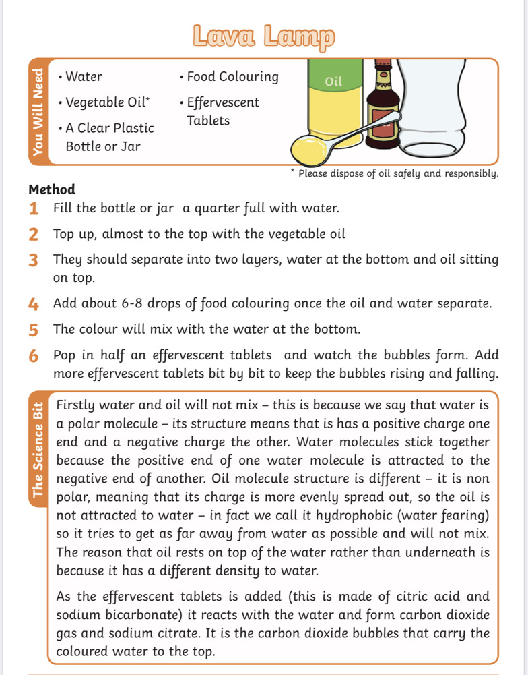
Science Experiment: Lava Lamp
Léigh sa Bhaile: Read and answer the questions in your copy.
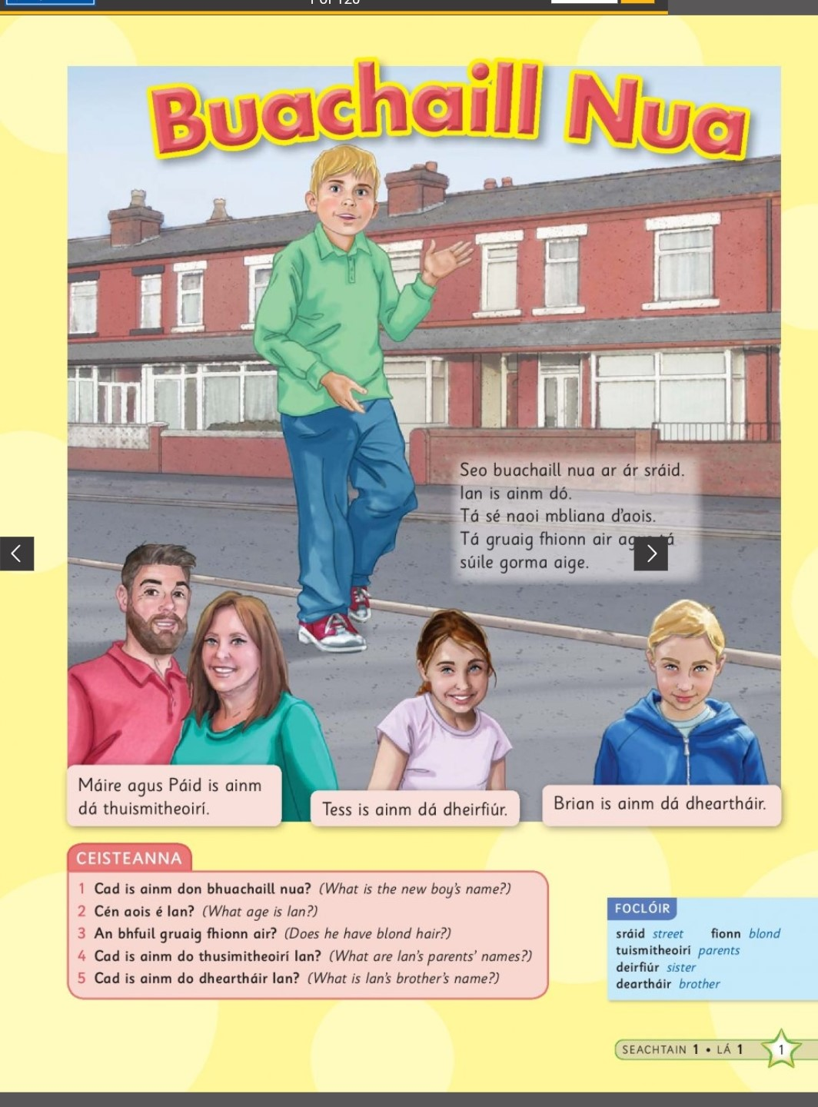

(Click this link to listen to the story being read aloud)
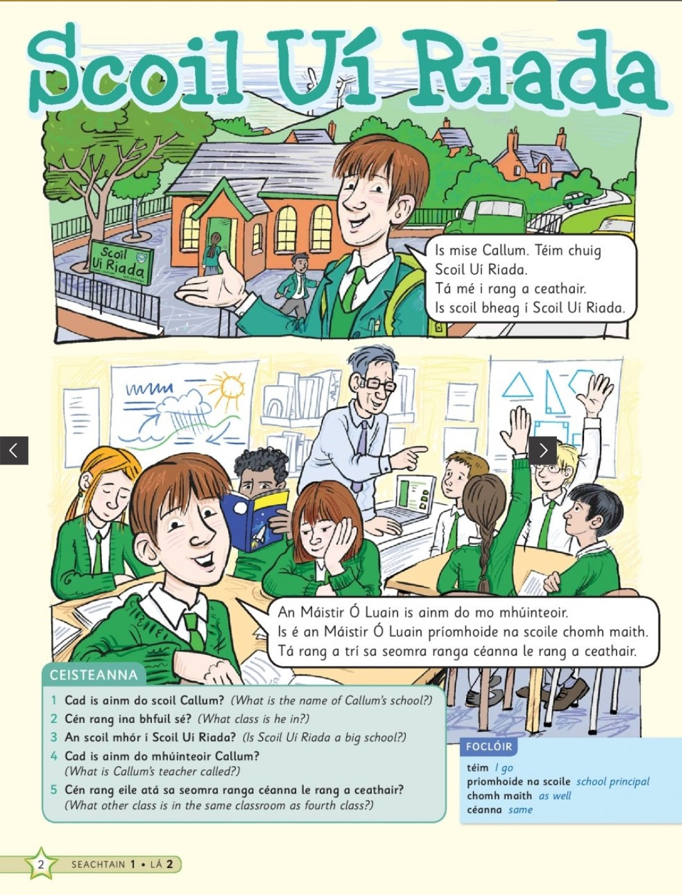

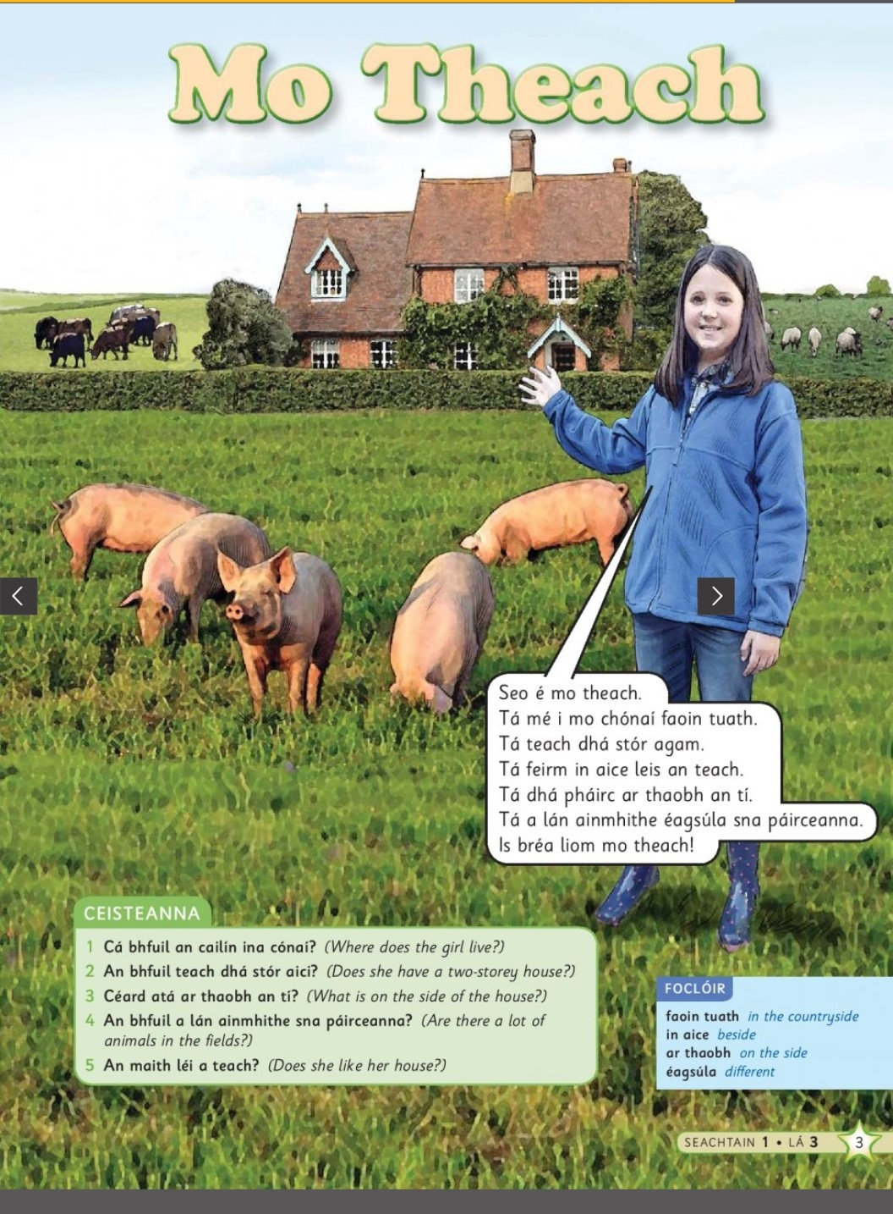

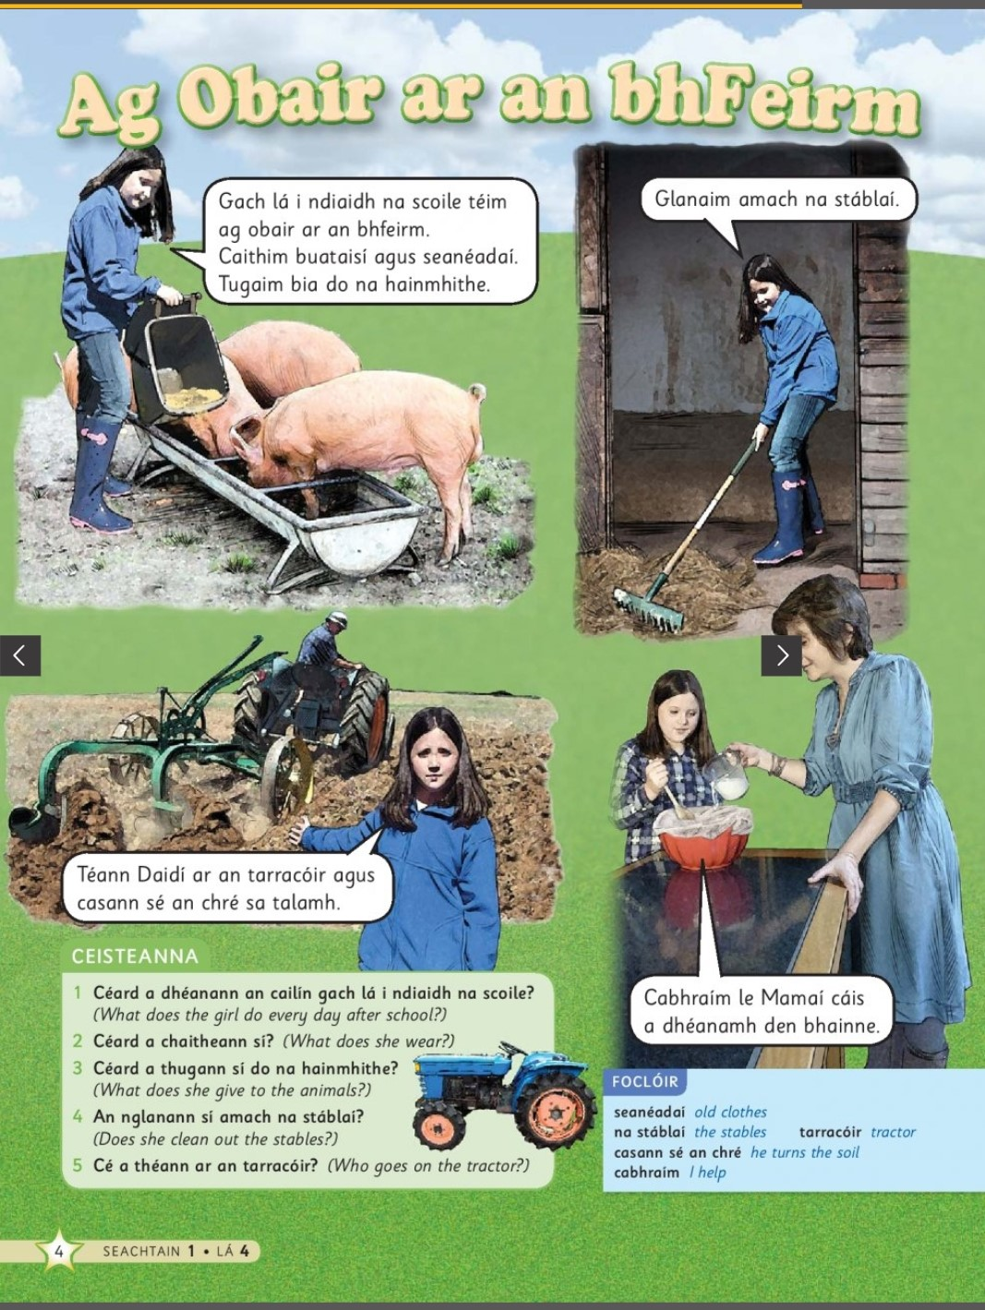

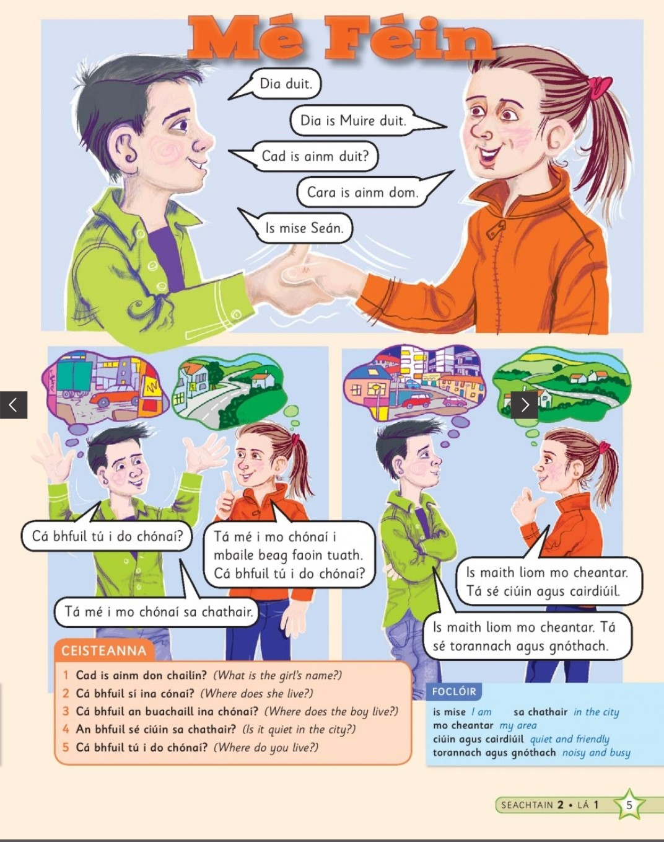

Maths Matters answers for self-correction: Please try to self-correct, where possible.
