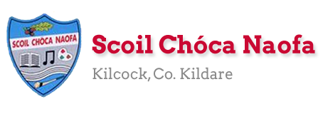
Dear 3rd Class,
I hope all is well with you and your family this week. Last week, you completed the Stay Safe programme. Well done. This week, I have given you some music, science and art activities to complete. Have fun and try your best
A massive thank you to you and your parents for sending me pictures of your work again this week. I know it is getting harder now to engage with the school work but we are nearly there. June is just around the corner and there will be some nice things to do over the last few weeks. Maybe even some surprises! You are doing so well at keeping up with your school work at home. I am so impressed.
Please continue to send the work you are most proud of to mstierney@scoilchoca.ie. Have a look at the website each week to see some pictures of the super work being done at home.
Ms. McCabe is working this week and would be delighted to hear from those children who work with her. Her email address is msmccabe@scoilchoca.ie .
While the weather is fine, make sure to get outside in the fresh air and get active. Lend a helping hand at home with the cooking/cleaning/gardening if you can.
Have a great week.
Stay safe and keep smiling,
Ms. Tierney
mstierney@scoilchoca.ie

Happy Birthday to Nataniel Fortune (3rd Class) and Janelle Ligue (4th Class).
Let’s all sing happy birthday as we wash our hands at home.

Work for Ms. Tierney’s 3rd Class:
Monday 25/05/20 – Friday 29/05/20
Monday | English:  - Starlight: Read Pg 164-166 ‘Babe the Blue Ox’  Answer Part A in your copy  Look up the definitions of any words you do not know in your dictionary.  - Recite the poem: Be Glad Your Nose is on Your Face  Maths:  - Maths Matters Pg. 143  - Mathletics activities  - Count up and down in multiples 2-20,3-30,4-40  Irish:  - Léigh sa Bhaile: Read the next page  Freagair na ceisteanna i do chóipleabhar/Answer the questions in your copy  - Abair an dán/say the poem: Pianta na Scoile  - Watch Cúla4 ar scoil on TG4 at 10 a.m.  P.E:  - PE with Joe Wicks on YouTube  Other: Music/Art  - Make your own musical instrument.  - You could make a shaker, a drum or something else of your own choice.  - You could use kitchen roll/elastic bands/ plastic or paper cups/ lentils/rice/ tissue paper/ scissors/ glue/ tape- Use your imagination!  - Perform an at-home concert for your family using your new musical instrument.  - There is a video clip below to help you.
Tuesday | English:  - Starlight: Read Pg. 164-166 ‘Babe the Blue Ox’  Answer Part B in your copy  - Recite the poem: Be Glad Your Nose is on Your Face  Maths:  - Maths Matters Pg. 144  - Mathletics activities  - Count up and down in multiples 5-50, 6-60, 7-70  Irish:  - Léigh sa Bhaile: Read the next page  Freagair na ceisteanna i do chóipleabhar  - Abair an dán: Pianta na Scoile  - Watch Cúla4 ar scoil on TG4 at 10 a.m.  P.E:  - PE with Joe Wicks on YouTube  Other: Music  - Click the link below to listen to a famous classical piece of music called ‘The Carnival of the Animals.’  - Does this music sound like any animals you know?  - Draw/write about what you think is happening in the music- it might be a lion running through the jungle or an elephant stomping through the Savannah.  - The clip is 20 minutes long (you only need to listen to around 3 minutes)
Wednesday | English:  - Starlight: ‘Babe the Blue Ox’ Answer C + D in your copy  - Recite the poem: Be Glad Your Nose is on Your Face  Maths:  - Maths Matters pg 145  - Mathletics Activities  - Count up and down in multiplies from 8-80, 9-90  Irish:  - Léigh sa Bhaile: Read the next page  Freagair na ceisteanna i do chóipleabhar  - Abair an dán: Pianta na Scoile  - Watch Cúla4 ar scoil on TG4 at 10 a.m.  P.E:  - PE with Joe Wicks on YouTube  Other: SESE  - Click the link below to watch Dublin Zoo’s virtual tour and look at the amazing animals.  - Can you name any of the animals you see in the video?  - Draw a picture of your favourite animal from the video.  - Use the website below to find some facts on your favourite animal and create a fact-file.
Thursday | English:  - Reading Comprehsion: Read and answer questions on ‘Tigers’  - Recite the poem: Be Glad Your Nose is on Your Face  Maths:  - Maths Worksheet: Angles  - Mathletics Activities  - Count up and down in multiples from 10-100, 11-110, 12-120  Irish:  - Léigh sa Bhaile: Read the next page  Freagair na ceisteanna i do chóipleabhar  - Abair an dán: Pianta na Scoile  - Watch Cúla4 ar scoil on TG4 at 10 a.m.  P.E:  - PE with Joe Wicks on YouTube  Other: SESE-Science  - Fireworks in a glass experiment (See below)
Friday | English:  - Finish reading comprehension on Tigers  - Recite the poem: Be Glad Your Nose is on Your Face  Maths:  - Use lollipop sticks/pipe cleaners/whatever you have at home to make a right, acute and obtuse angle as well as horizontal, vertical, intersecting, parallel and perpendicular lines.  - Maths problem-solving activity  Irish:  - Léigh sa Bhaile: Read the next page  Freagair na ceisteanna i do chóipleabhar  - Abair an dán: Pianta na Scoile  - Watch Cúla4 ar scoil on TG4 at 10 a.m  P.E:  - PE with Joe Wicks on YouTube  Other: SESE- Science  - Lava lamp experiment (See below)

Here is a prayer for you to say:
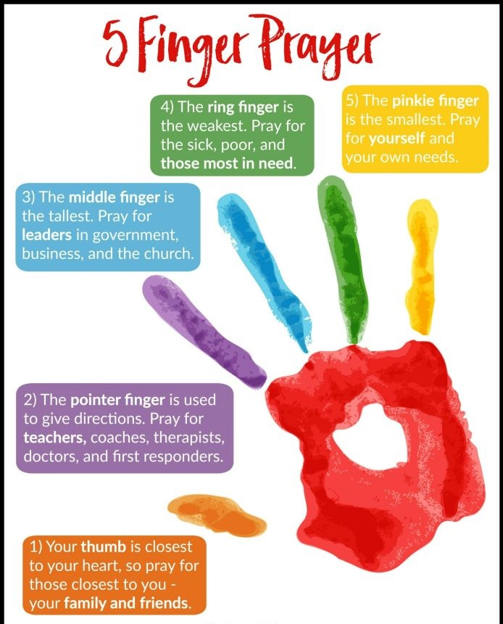

SEN/EAL work 3rd/4th Class OT May 25-29th Teachers: Ms. McCabe & Ms.Curran.
Note: SEN teachers posted workpacks to their students, this week. It is not extra work. Also, PLEASE email on a picture of something that your child has done recently, so we can see their lovely work again! All groups can look at the clock and tell the time 3 times per day. Also keep reading and learning your tables daily. This week do 9x multiplication tables and practice counting up and down the ladder in 9s....the same speed backdown as going up!
EAL: People Who Help Us | ORAL: Record yourself naming all the people who help us and say what job they do. Think about people who help at school, at home, and in the neighbourhood.  WRITE: Draw a mindmap of people who help us at home, at school, in the neighbourhood, and even people who help us during the Covid crisis.  https://www.twinkl.ie/resource/us2-e-53-mind-map-writing-template
Speech and Language | Conversation Starters – Continue with these, one per day.  Practice your “V” words on flashcards.  Enjoy this guessing game!  https://www.twinkl.ie/resource/t-s-890-what-am-i-guessing-game-cards-animal-themed
Literacy A & B | SNIP programme – session 11..... 3 pages per week.  Phonics/Final Blends: Read the following 5 lists of blends -rk –lt –lf –pt –ft -ct  Cloze: Understanding the Internet. Try one of the Memory Activities  http://www.theschoolhouse.us/lessons/lesson57.html  Please keep up the reading, every day! https://www.oxfordowl.co.uk/for-school/oxford-owl-ebook-collection  These are free ebooks and you can find your level.
Toe by Toe | Next SNIP (session 21)..... 3 pages for the week.  Cloze: Understanding the Internet. Try one of the Memory Activities!  Please read and ask an adult to read with you.
SEN Individuals | Cloze: Understanding the Internet.  Do 2 pages of new booklet (S C)  Start one picture sequencing (What’s at the Zoo?)  Try one of the Memory Activities!  Fry’s Words: Continue with the list you are on.  Do one card per day on Other People’s Feelings:  https://www.twinkl.ie/resource/t-s-1272-other-peoples-feelings-thought-cards-set-2
Contact SEN Teachers: msmccabe@scoilchoca.ie mscurran@scoilchoca.ie

Ms McCabe is working this week, Monday-Friday
Resources
Useful websites for this week:
- Music/Art: Musical instrument ideas https://www.youtube.com/watch?v=7sUNXA4NYKI#action=share
- Music: The Carnival of the Animals https://www.youtube.com/watch?v=k2RPKMJmSp0
- SESE: Dublin Zoo’s virtual tour https://www.youtube.com/watch?v=w5xhyJADQys&feature=youtu.be
- SESE: Information on animals https://www.nationalgeographic.com/animals/
- Maths: Angles song https://www.youtube.com/watch?v=NVuMULQjb3o&t=10s
- Maths: https://www.mathletics.com/uk/
- Maths: Tables revision games- https://www.topmarks.co.uk/maths-games/7-11-years/multiplication-and-division
- PE: Joe Wicks’ Live Daily PE workouts: https://www.youtube.com/
- General: Twinkl: Worksheets/Powerpoints available: Free access if you use code CVDTWINKLHELPS
- RTE’s Home School Hub. If you miss it, you might be able to watch it back on RTE Player. https://www.rte.ie/player/

English Poem: Be Glad Your Nose is on Your Face
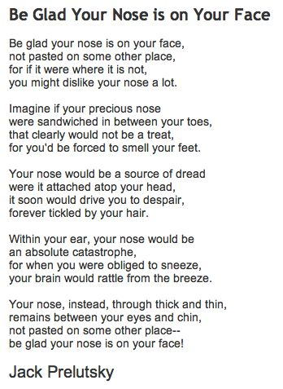

Dán Gaeilge: Pianta na Scoile
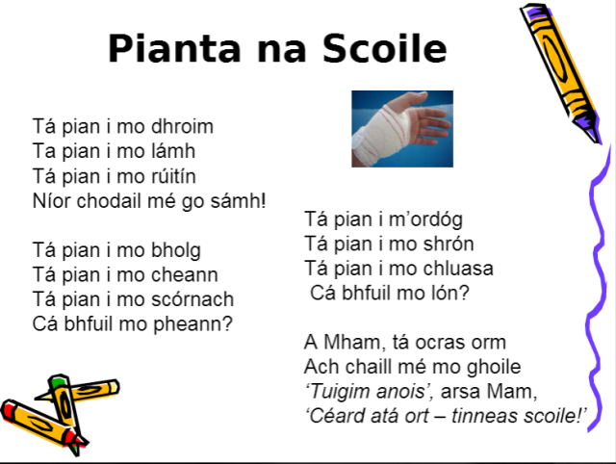

Maths: Lines & Angles
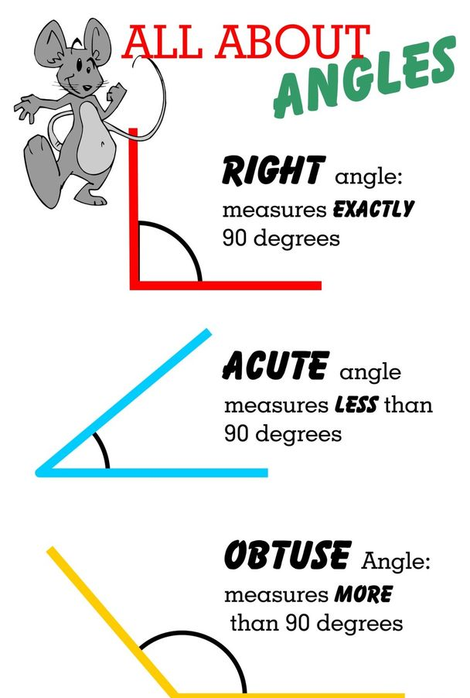

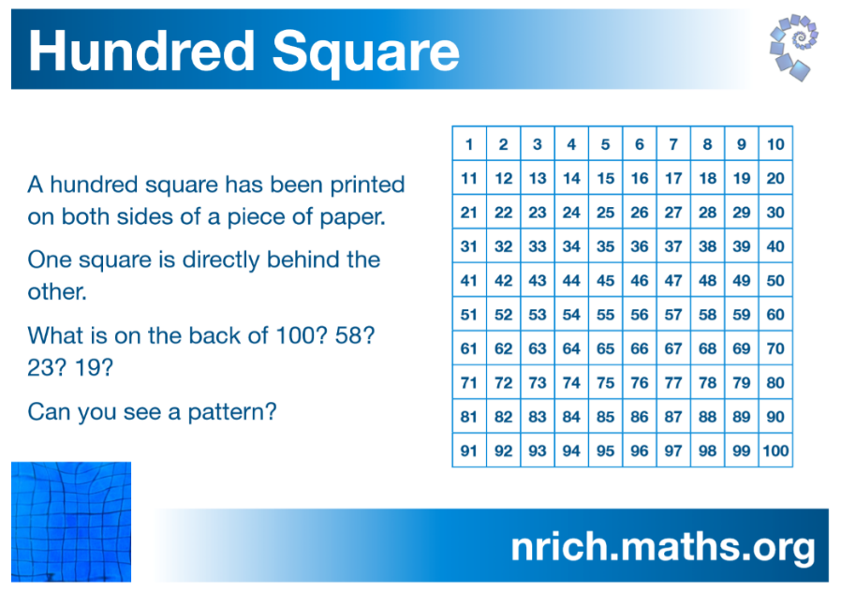
Maths: Problem-solving activity

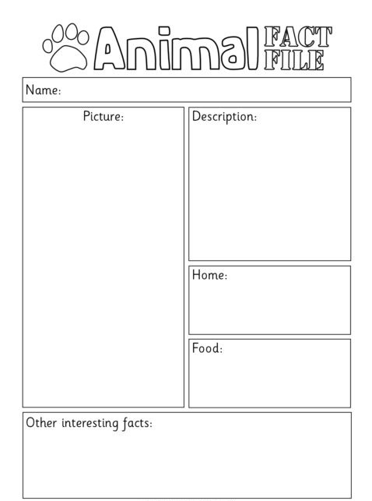
SESE: Animal fact-file

Reading Comprehension: Tigers
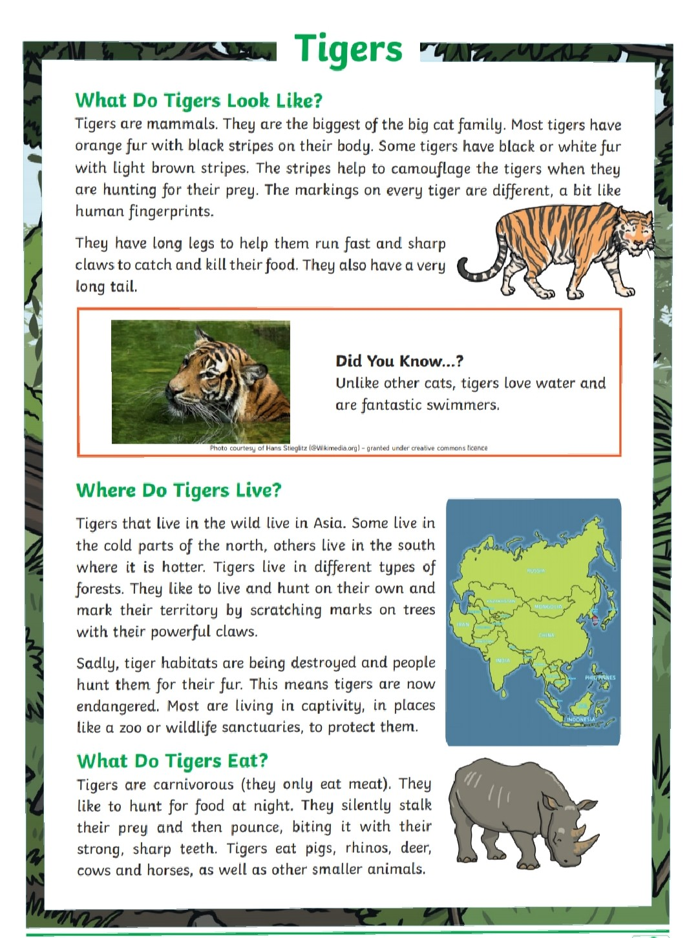

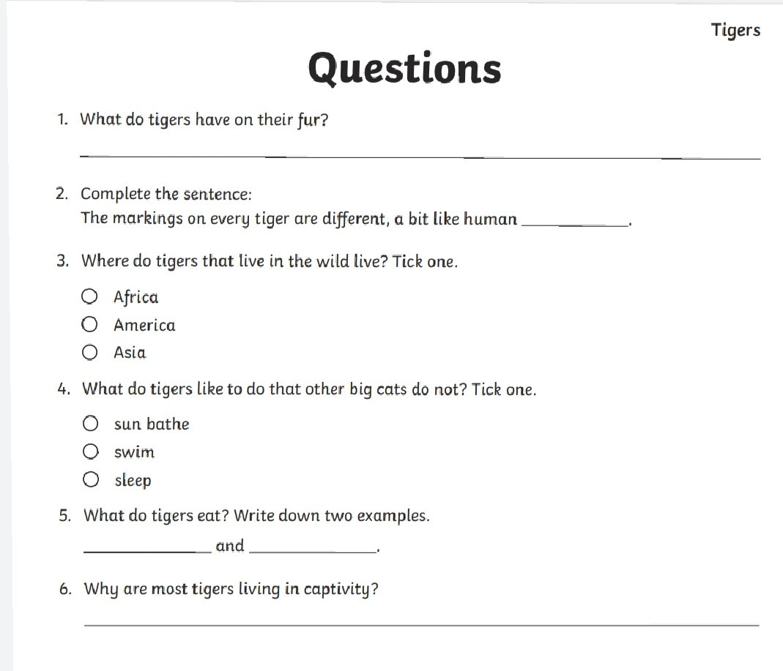

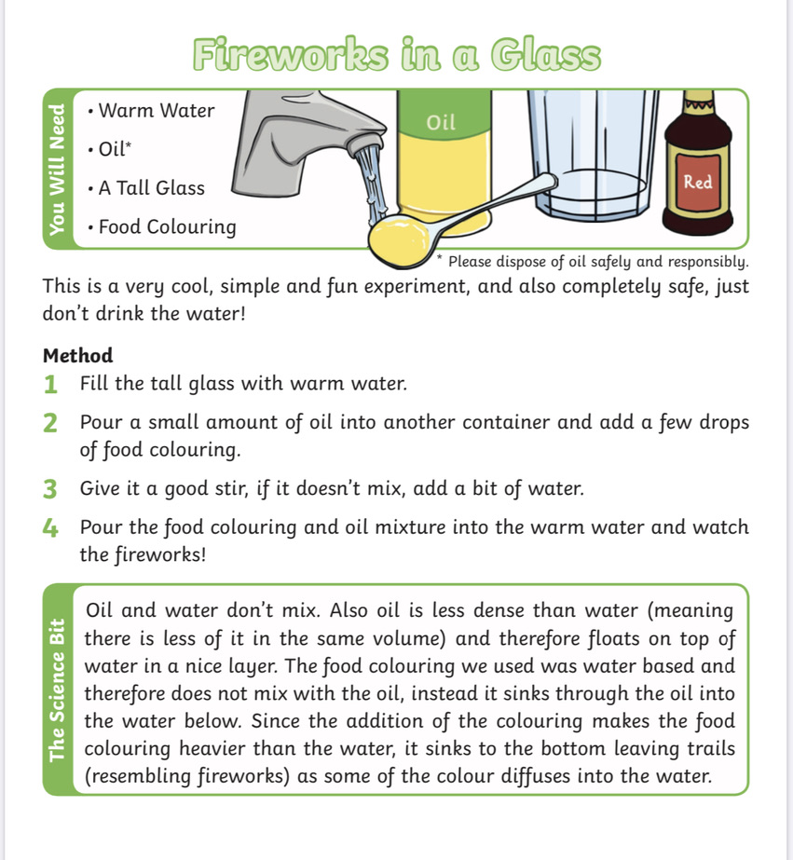
Science Experiment: Fireworks in a glass

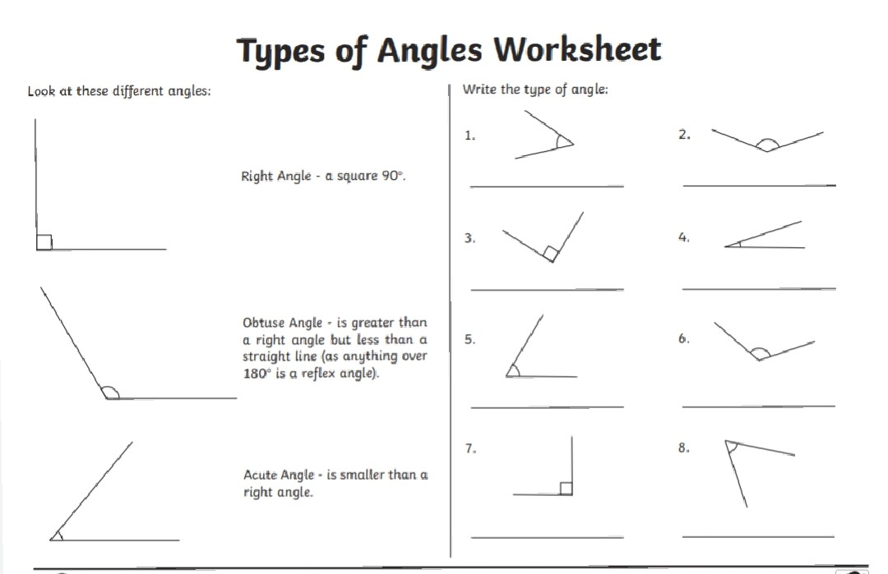
Maths Worksheet: Angles

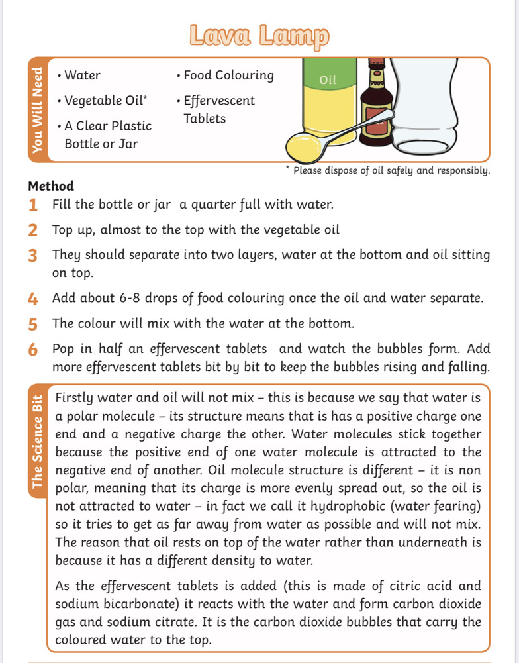
Science Experiment: Lava Lamp

