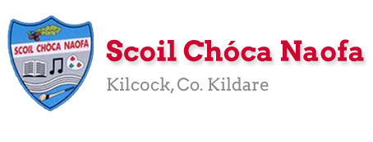
Work for Fifth Class: 2nd of June – 5th of June 2020
Please remember: You are encouraged to complete one hour of work. The work we have given may take longer than one hour. If you want to do more than one hour that is fine but please don’t feel you have to. Do what you can and keep smiling! :)
Ms. Heffernan’s and Ms. Tone’s groups will find work for them attached to the end of this plan. Those not doing Gaeilge please access your TTRS account
Please send us pictures of your maths work and 2 other pieces of work you are proud of if you can. We would love to hear from you!
Our e-mail addresses are msfield@scoilchoca.ie and msmahon@scoilchoca.ie
Mon | English | Enjoy
 | Maths | The
 | Gaeilge | Bank
 | P.E. | Holiday
 | Other | Weekend
Tue  Optional You were meant to have this day off on the school calendar | English | - 3,2,1 Diary Entry: Three new skills I’ve learnt during the lock down, Two things I am enjoying about the lock down and one person I cannot wait to see after the lockdown (if it’s more than one, that’s okay).  - D.E.A.R Time
 | Maths | - Mathletics or Maths Challenge 55
 | Gaeilge | - Duolingo: Collect 10XP
 | P.E. | https://www.youtube.com/watch?v=hmMobq5velU  This is a gymnastics warm up dance to “Sorry” by Justin Bieber
Wed | English | - Spellbound: Unit 35 pg.72 Exercise 1  - Starlight: pg. 170 – 172 Read. Pg. 173 Exercise A & C  - Reading: 10 minutes (or longer if you wish)
 | Maths | - Mathletics or Maths Challenge 56  - Maths Matters: p.149 Q.1 + Q.2 (Use the conversion chart below to help you find the equivalent fraction)  - Remember ‘OF’ means divide by the bottom, multiply by the top.  Eg 1: What is 50% of €6? First I look at the chart and see 50% is the same as ½  So the question is what is ½ of €6. OF – divide by the bottom, multiply by the top.  6 divided by 2 (bottom) is 3. 3 multiplied by 1 (top) is 3. The answer is €3  Eg 2: What is 75% of €24. Looking at the chart I will see 75% = ¾  What is ¾ of €24. OF – divide by the bottom, multiply by the top.  24 divided by 4 (bottom) is 6. 6 multiplied by 3 (top) is 18. The answer is €18
 | Gaeilge | - Duolingo: Collect 10XP  - Léigh sa Bhaile: lch 97 Cuairt mo chol ceathear (2) - Léigh agus freagair na ceisteanna i do chóipleabhar
 | P.E. | http://www.rosactive.org/events/kids-dance-challenge/  This is Kids Dance Challenge with Trisha Mc Dermott
 | Other | S.P.H.E: RSE Programme (To be completed with a parent/legal guardian) – See Ms. Daly’s email
Thurs | English | - Spellbound: Unit 35 pg.72 Exercise 2  - Starlight: pg. 170 – 172 Read. Pg. 174 Exercise D and pg. 175 Exercise F  - Reading: 10 minutes (or longer if you wish)
 | Maths | - Mathletics or Maths Challenge 57  - Maths Matters: p.150 Q.1 - 5
 | Gaeilge | - Duolingo: Collect 10XP  - Léigh sa Bhaile: lch 107 Imríonn Larry Leadóg - Léigh agus freagair na ceisteanna i do chóipleabhar
 | P.E. | https://www.facebook.com/180216932023233/videos/895787854180836/  This is Triathlon Ireland Fitness Video for kids
 | Other | S.P.H.E: RSE Programme (To be completed with a parent/legal guardian) – See Ms. Daly’s email
Fri | English | - Starlight: pg. 175 Exercise G  - Reading: 10 minutes (or longer if you wish)
 | Maths | - Maths Matters: p.151 Q.1 -11
 | Gaeilge | - Duolingo: Collect 10XP  - Léigh sa Bhaile: lch 119 Club na bpáistí - Léigh agus freagair na ceisteanna i do chóipleabhar
 | P.E. | https://www.facebook.com/SportIrelandCampusFitness/videos/311157616522289/  This is Sport Ireland Family PE at Home Workout
 | Other | S.P.H.E: RSE Programme (To be completed with a parent/legal guardian) – See Ms. Daly’s email

Extra Activities - Optional
Inside  - Build a bridge using blocks/lego  - Write a poem about Summer | Outside  - Go outside and draw some summer flowers to go with your summer poem.
Free eBooks access: https://www.oxfordowl.co.uk/for-home/find-a-book/library-page/?view=image&query=&type=book&age_group=Age+9-11&level=&level_select=&book_type=&series=#

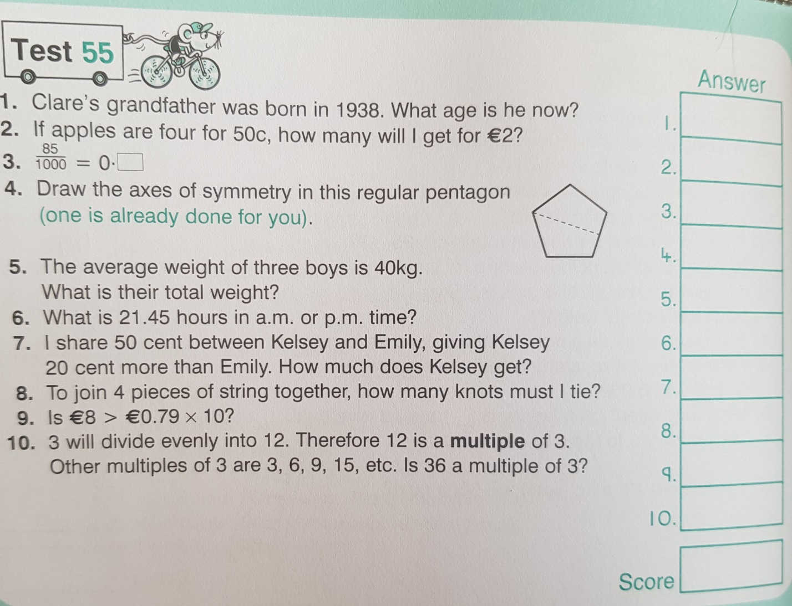

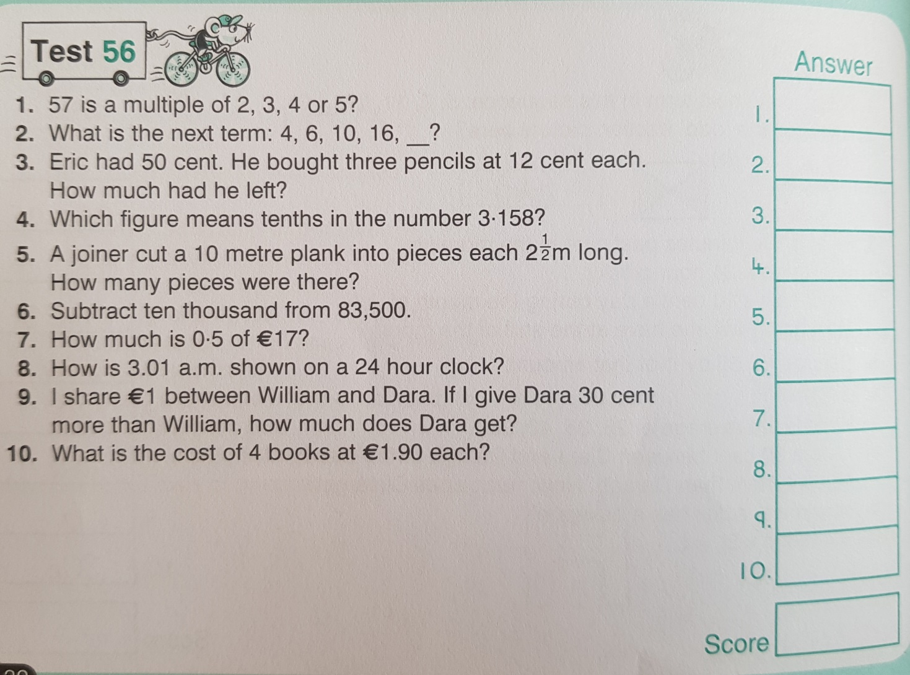

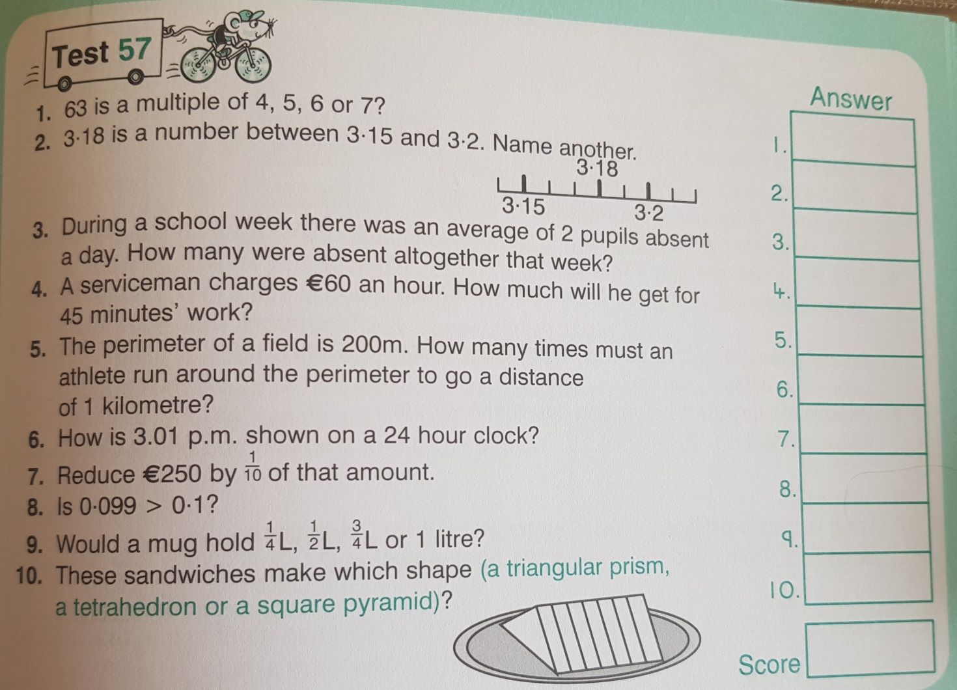

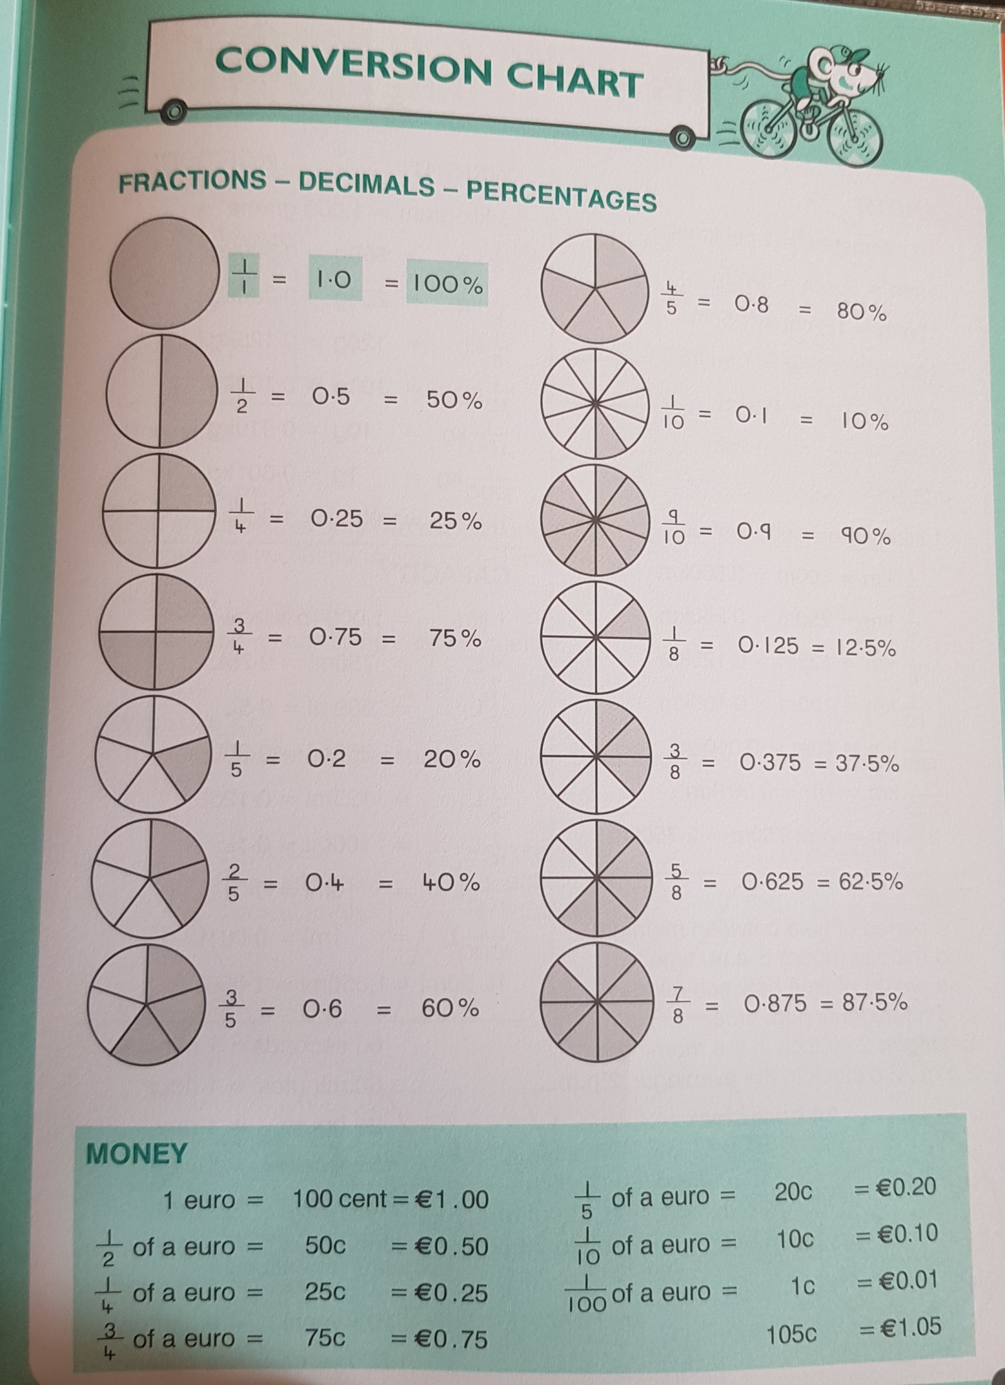

SEN work 5th Class week beginning 2nd June 2020
Teacher: Ms. Heffernan
Note: SEN teachers have added work on to the teachers’ plan. Children can decide to do this work instead of something the teacher has assigned. It is not extra work. Also, we would be delighted if you could email on a picture of something that your child has done and is proud of so we can see their lovely work again!
Literacy | Keep reading! If any of you need more reading material, just let me know. If you’ve read or listened to a story, let me know what you thought about it.  Do a little writing every day. Keep a diary. Keep a gratitude journal-write down 3 things you are grateful for each day.  Use www.writereader.com to create your own book.  Keep practising your TTRS. See if you can still type while covering your hands with a towel!  Try the cloze procedure below about clothes.  Or see how many words you can make out of watermelon.  Send me an email to let me know how you’re getting on-I’d love to hear from you!
Numeracy | Keep doing your Mathletics or you could also try https://www.mathsisfun.com/percentage-menu.html to help you with your percentages work this week.  You might like to try these worksheets!  They are about making number sentences. In the first one you have to choose between addition and subtraction and for the second, choose between multiplication or division.  Keep practising your mental maths.  https://www.topmarks.co.uk/maths-games/hit-the-button  https://www.topmarks.co.uk/maths-games/daily10  Send me an email to let me know what you have done or if you need help.
Contact SEN Teacher: msheffernan@scoilchoca.ie

SEN work

Teacher: Ms Tone

Note: SEN teachers have added work on to the teachers’ plan. Children can decide to do this work instead of something the teacher has assigned. It is not extra work. Also, we would be delighted if you could email on a picture of something that your child has done and is proud of so we can see their lovely work again!

Literacy | - Keep reading!  - Each day, read a passage from the story below, The Best Thing in the World.  - Write a few sentences to explain what happened in the story.  - Word challenge: How many little words can you find in the word ‘complicated’? e.g. come  - Word challenge: How many words can you make using these letters?  A T R E S M C N D I  - Keep a diary to record what you are doing each day. Write 3 sentences. Draw a picture in your diary.
Numeracy | - Percentages: See worksheet below.  Send me an email if you need any help.

Contact SEN Teacher: mstone@scoilchoca.ie

The Best Thing in the World
Weds 3rd June

Once upon a time, there were four brothers who lived in a faraway land. Their father was an old king. One day, he said, "I will not live long now. Today you must start out into the world. In a year, bring back the best thing you have found. The one who can pick the best thing shall be the new king." The first brother said, "I will look in every city or town. I will buy the best thing I can for my father." The next two brothers said, "We will both go on fast ships over the sea. We will find something better." The last brother said, "I am going to ask the people here in our own land to tell me the best thing." The other three brothers began to laugh. "Then you will never be king!" they said.

Thurs 4th June

The last brother started off. When he had gone about six miles, he met a man. "What do you carry in those big bags?" he asked. "The best thing in the world," said the man. "These are full of the good nuts which fall from my five nut trees." "I don't think that would work," said the brother to himself, "I must try again." The brother went on another seven miles. He found a small brown bird. It had been hurt, so he put it in his coat where it could keep warm.

Fri 5th June

As he went on, he saw a little girl crying. He ran to meet her. "Why are you crying?" he asked. "I want to get some water from the well," she said. "We use so much. We drink cold water. We wash the clothes clean with hot water. But I do not know how to pull it up. Please show me." The brother said, "Hold this bird and I will help you. It does not fly around anymore because it got its wing cut." "Thank you. What a pretty bird!" she said. "I wish you would give it to me. If you will let me keep it, I will always be very kind to it. I will take care of it myself. I will make it grow well again." "Yes, you may have it," said the brother. So he gave her the bird and went on.
Percentages

In a test, you might get 80
100
- Another way of saying this is 80%
- % means per cent or per hundred
- 55 is 55 % 28 is 28%

100 100

Can you figure out these percentages?
15 = ___% 37 = ___% 63 = ___%
100 100 100

6 = ___% 49 = ___% 71 = ___%
100 100 100

Can you figure out these fractions?
9% = ___ 21% = ___ 53% = ___
100 100 100

85% = ___ 99% = ___ 16% = ___
100 100 100

