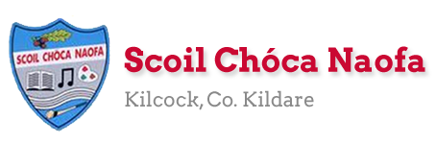
Work for Mr. Bracken’s 3rd Class: Monday 18/05/20 – Friday 22/05/20
Dear 3rd Class,
I hope you and your family are keeping safe and well. I hope you enjoyed carrying out some science experiments, doing some art and even a little more baking last week. If you started to keep a diary/daily voice recording, I would like you to continue with this, recording your days and how you’re feeling right now.
You may remember that we started the Stay Safe programme before the school closure. We completed Theme 1 which looked at ‘Feeling Safe and Unsafe’ This week we are completing the programme. The Stay Safe programme is part of the Social, Personal and Health Education Curriculum which all primary schools are required to implement. Parents must supervise the delivery of these lessons as sensitive issues may arise. Examples of SPHE work do not have to be sent to the class teacher if you would prefer to keep the content private. Please do not hesitate to contact me if you wish to discuss the programme further. Thank you in advance for your co-operation.

Thank you so much for sending me pictures of your work this week. I am so impressed with you for keeping up with your school work at home. Please continue to send the work you are most proud of to mrbracken@scoilchoca.ie You can email me every few days if you’d like.
I want to acknowledge the incredible work that your parents are doing at home with you. I understand the delicate balance of trying to teach and also work from home. A sincere thank you to you all. We have fantastic parents in our school and we are fortunate to be teaching your children.
Those children who work with Ms. Curran & Ms. McCabe, they would be delighted to hear from you and to hear what you have been up to. Their email addresses are mscurran@scoilchoca.ie and msmccabe@scoilchoca.ie .
I would like to take this opportunity to congratulate all the girls and boys for playing their part in helping Scoil Chóca Naofa to achieve its 8th Green Flag and in particular the members of our Green School’s Committee, Conor Twohig and Madonna McPartlan. Well done on a massive achievement. Here is a link to a post on the school website where you can read more about this exciting news: http://www.scoilchoca.ie/our-8th-green-flag/

All the best,
Mr Bracken

Monday | English: This week’s English is an example of Persuasive Text, ask yourself what the purpose of a review for a play or musical performance is.  - Starlight 15B – ‘Watch This!’ – Read the book reviews & complete part A in your copy  - Diary entry/voice recording  - Read your Home Book  Maths:  - Maths Matters pg 134 – 3D Shapes - see below for help  - Mathletics Activities  Irish:  - Léigh sa Bhaile: Read the next page. Freagair na ceisteanna: Answer the 5 questions at the bottom of the page in your spare copy  - If anyone needs a page from Léigh sa Bhaile read out so you can listen to pronunciations let me know and I can email you a voice clip.  - Cúla ar scoil @10am https://www.cula4.com/en/  PE: Activity - see below  Other: SPHE  - Stay Safe: Topic 2 ‘Friendship and Bullying’- Lessons 1 and 2  - Worksheet 4/HSL: Friend Poem  - TR4-TR8: Listen and discuss  Worksheet 5/HSL: Bullying Definition Worksheet
Tuesday | English:  - Starlight 15B – ‘Watch This!’ – Read the text & complete part B in your copy  - Diary entry/voice recording  - Read your Home Book  Maths:  - Maths Matters pg 135 Q’s 1, 2 & 3 – you might not have the shapes at home, use the information at the bottom of the document to help.  - Mathletics activities  Irish:  - Léigh sa Bhaile: Read the next page. Freagair na ceisteanna: Answer the 5 questions at the bottom of the page in your spare copy  - If anyone needs a page from Léigh sa Bhaile read out so you can listen to pronunciations let me know and I can email you a voice clip.  - Cúla ar scoil @10am https://www.cula4.com/en/  PE: Activity – see below  Other: SPHE  - Stay Safe: Topic 2 ‘Friendship and Bullying’ - Lessons 3 and 4  - Worksheet 6: What do I know about bullying?  - TR 9 + TR 10: Listen and discuss  Worksheet 7: Stop, Block, Tell
Wednesday | English:  - Starlight 15B – ‘Watch This!’ – Read the text & complete part C in your copy  - Diary entry/voice recording  - Read your Home Book  Maths:  - Maths Matters pg 136 Q.1 & Q.2 – you may not have 3D shapes at home, answer the questions based on your knowledge.  - Mathletics activities  Irish:  - Léigh sa Bhaile: Read the next page. Freagair na ceisteanna: Answer the 5 questions at the bottom of the page in your spare copy  - If anyone needs a page from Léigh sa Bhaile read out so you can listen to pronunciations let me know and I can email you a voice clip.  - Cúla ar scoil @10am https://www.cula4.com/en/  PE: Activity – see below  Other: SPHE  - Stay Safe: Topic 2 ‘Friendship and Bullying’ – Lessons 5 and 6  - TR 11- TR 13: Listen and discuss  - Worksheet 8/HSL: Our Class Agreement  Worksheet 9: Keeping our agreement
Thursday | English:  - Starlight 15B– ‘Watch This!’ – Read the text & complete part D in your copy  - Diary entry/voice recording  - Read your Home Book  Maths:  - Maths Matters pg 137 – you won’t have the materials to build shapes, use your best guess  - Mathletics activities  Irish:  - Léigh sa Bhaile: Read the next page. Freagair na ceisteanna: Answer the 5 questions at the bottom of the page in your spare copy  - If anyone needs a page from Léigh sa Bhaile read out so you can listen to pronunciations let me know and I can email you a voice clip.  - Cúla ar scoil @10am https://www.cula4.com/en/  PE: Activity – see below  Other: SPHE  - Stay Safe: Topic 3 ‘Touches’ – Lessons 1 and 2  - TR 14: Listen and discuss  - Worksheet 10: What if  - Worksheet 11/HSL 11: Touches I like, Touches I don’t like  - TR 15-TR17: Listen and discuss  Worksheet 12/HSL: Never keep a touch secret
Friday | English:  - Read the comprehension attached below based on Roald Dahl and answer the questions that follow!  - Diary entry/voice recording  - Read your Home Book  Maths:  - Mathletics activities  - Revise 8 times tables – going up the ladder and down the ladder  Irish:  - Léigh sa Bhaile: Read the next page. Freagair na ceisteanna: Answer the 5 questions at the bottom of the page in your spare copy  - If anyone needs a page from Léigh sa Bhaile read out so you can listen to pronunciations let me know and I can email you a voice clip.  - Cartún ar TG4  PE: Activity – see below  Other: SPHE  - Stay Safe: Topic 4 ‘Secrets and Telling’  - TR 18: Listen and discuss  - Worksheet 13/HSL: Good or bad secrets  - Stay Safe: Topic 5 ‘Strangers’  - Tr 19 + Tr 20: Listen and discuss  - Worksheet 14: What would you do?  Worksheet 15/HSL: Stranger rules

Useful websites for this week:
- Maths: https://www.mathletics.com/uk/
- Maths: Tables revision games- https://www.topmarks.co.uk/maths-games/7-11-years/multiplication-and-division
- Baking: very good website: https://www.supercook.com/#/recipes - you can put in the ingredients you have at home and it will generate something to bake for you.
Ms.Curran is working this week Monday-Friday.
SEN/EAL work 3rd class EB May 18-22nd Teachers: Ms. McCabe & Ms.Curran.
Note: SEN teachers have added work on to the teachers’ plan. Children can decide to do this work instead of something the teacher has assigned. It is not extra work. Also, we would be delighted if you could email on a picture of something that your child has done and is proud of, so we can see their lovely work again! All groups can look at the clock and tell the time 3 times per day. Also keep reading and learning your tables daily. This week do 8x multiplication tables and practice counting up and down the ladder in 8s....the same speed backdown as going up!
EAL: Transport&Travel | ORAL: Record yourself giving description of your favourite car/airplane/train.  Use descriptive words eg colour, size etc. Give a reason why it’s your favourite.  WRITE: Mindmap Models of Cars/ Types of trains  https://www.twinkl.ie/resource/us2-e-53-mind-map-writing-template
Speech and Language | Conversation Starters – Continue with these, one per day.  Continue with activities from Speech & Language therapist pack or  enjoy this guessing game!  https://www.twinkl.ie/resource/t-s-890-what-am-i-guessing-game-cards-animal-themed
Literacy A & B | SNIP programme – session 10..... 3 pages per week.  Phonics/Final Blends: Read the following 5 lists of blends -st -sk -sp -nd -nt http://www.theschoolhouse.us/lessons/lesson57.html  Please keep up the reading, every day!  https://www.oxfordowl.co.uk/for-school/oxford-owl-ebook-collection  These are free ebooks and you can find your level.
Toe by Toe | Next SNIP session (session 20)..... 3 pages for the week.  Please read and ask an adult to read with you.
SEN Individuals | Do one Mindful Brain Break Activity each day:  https://www.twinkl.ie/resource/us-p-12-mindful-minute-brain-break-cards  Fry’s Words: Continue with the list you are on.  Write Reader: Write your news daily. 5 or 6 sentences  Conversation Starter daily.
Contact SEN Teachers: msmccabe@scoilchoca.ie mscurran@scoilchoca.ie

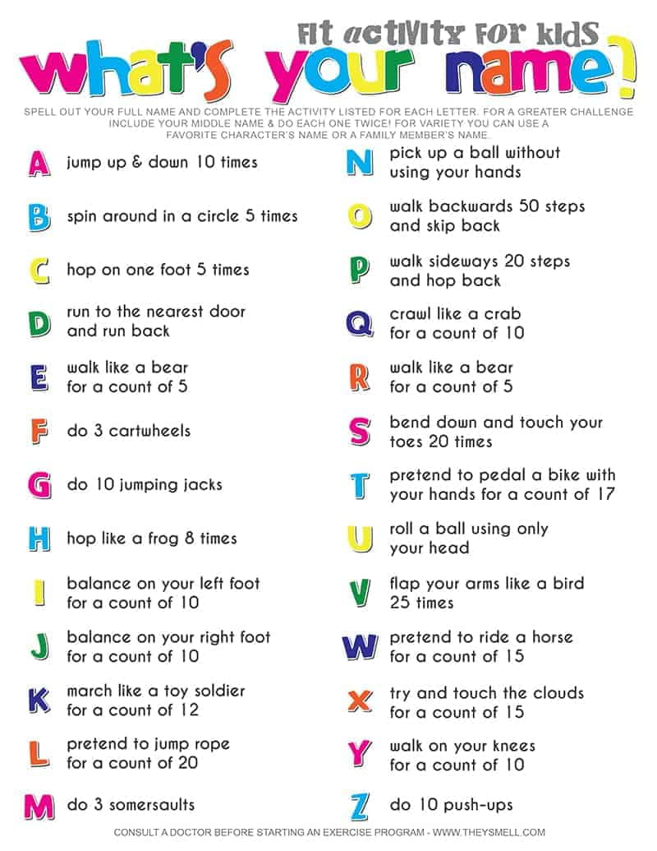
PE Activity for the week

Maths: 3-D shapes
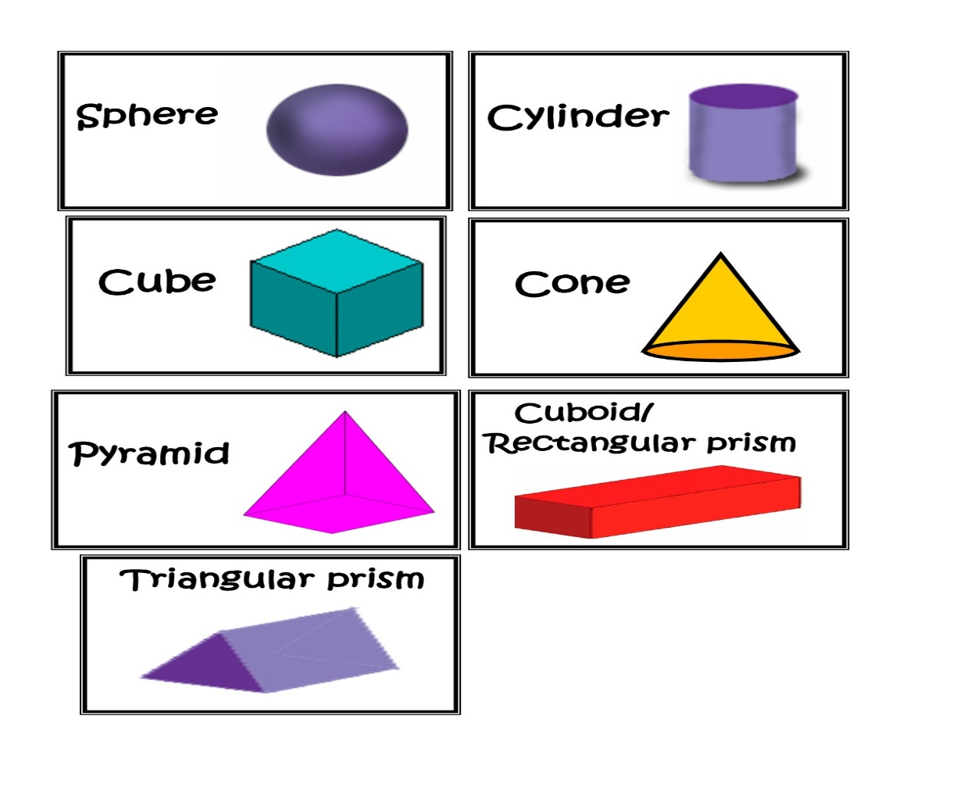
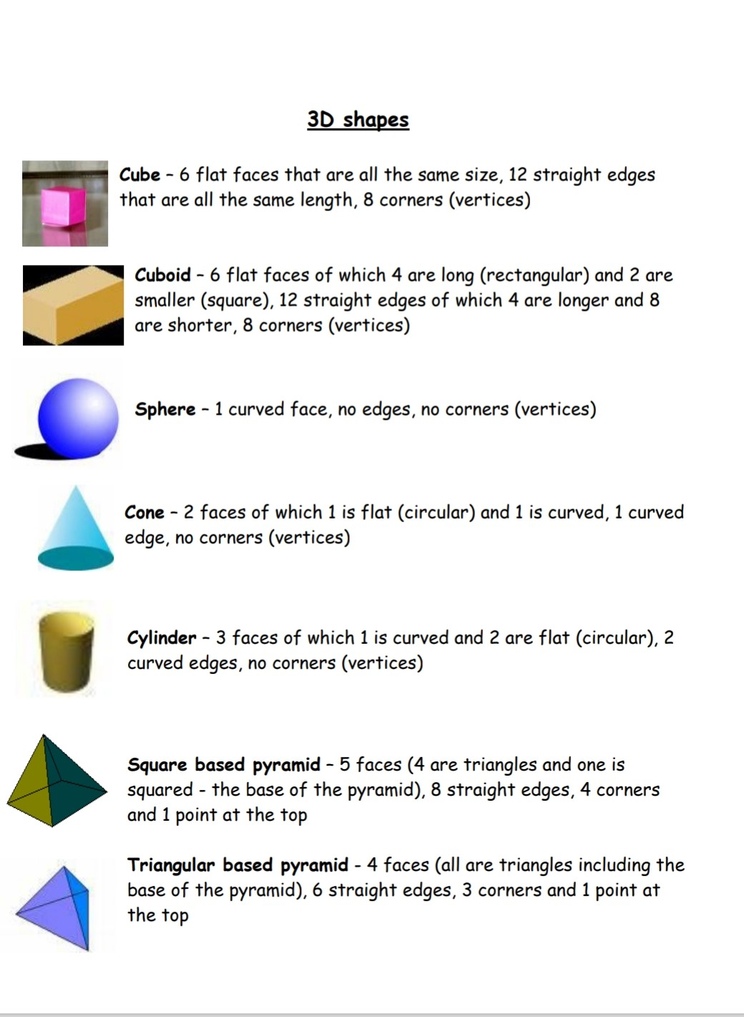

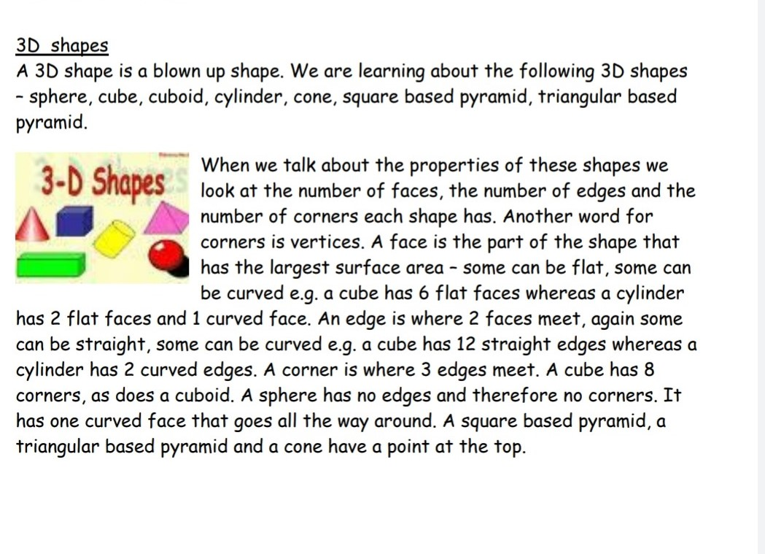

English - Friday
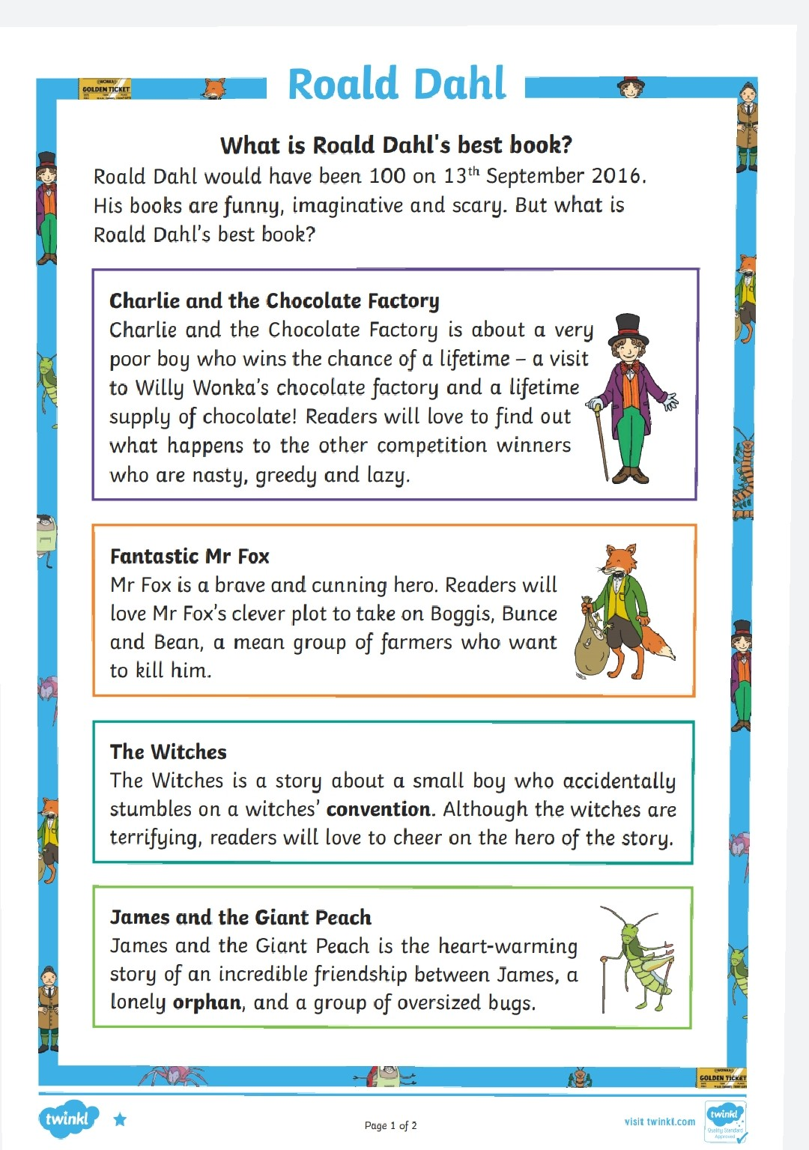

English - Friday
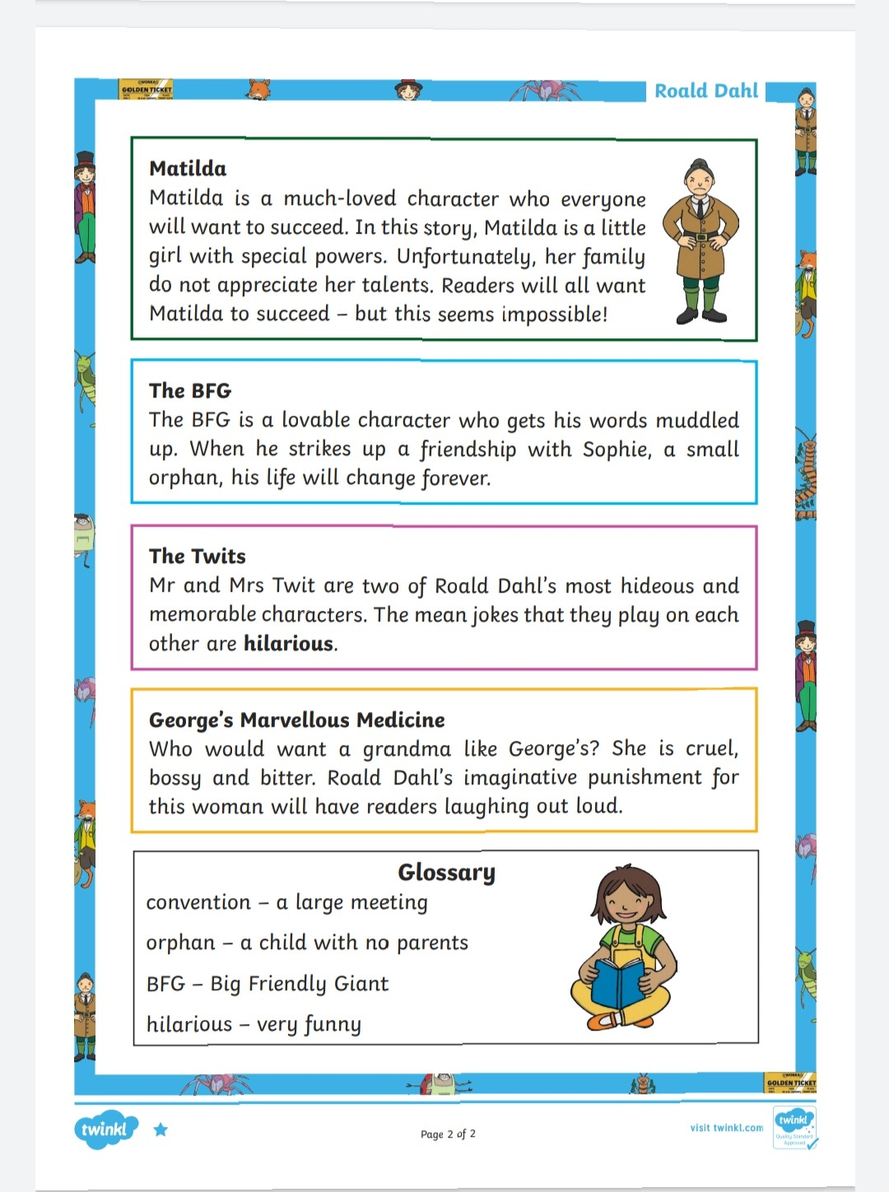

English - Friday
