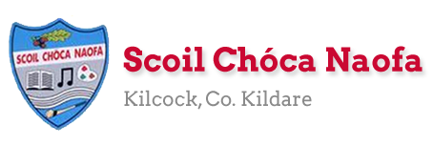
Dear 4th Class,
I hope you and your family are keeping safe and well. I hope you enjoyed carrying out some science experiments, getting creative with art and cooking up a storm in the kitchen last week. If you started to keep a diary, I would like you to continue with this, recording your days and how you’re feeling right now.
You may remember that we started the Stay Safe programme before the school closure. The Stay Safe programme is part of the Social, Personal and Health Education Curriculum which all primary schools are required to implement. We have already completed Theme 1 which looked at ‘Feeling Safe and Unsafe’ This week, the children will be completing the programme. Parents must supervise the delivery of these lessons as sensitive issues may arise. Thank you for your co-operation.

Thank you so much for sending me pictures of your work this week. I am so impressed with you for keeping up with your school work at home. Please continue to send the work you are most proud of to mstierney@scoilchoca.ie. You can email me every few days if you’d like. I will try to respond as soon as I can. Each week, I will be posting some samples of work that children have completed on the school website. If there is a piece of work which you would not like me to share on the website, please state this in your email. Work with names or pictures of children will not be published.
I want to acknowledge the incredible work that your parents are doing at home with you. I understand the delicate balance of trying to teach and also work from home. A sincere thank you to you all. We have fantastic parents in our school and we are fortunate to be teaching your children.
Ms. Heffernan would be delighted to hear from those children who work with her. Her email address is msheffernan@scoilchoca.ie
I would like to take this opportunity to congratulate all the girls and boys for playing their part in helping Scoil Chóca Naofa to achieve its 8th Green Flag, and in particular the members of our Green School’s Committee, Luella (3rd Class) and Emma (4th Class). Well done on a massive achievement. We are so proud of you all. Here is a link to a post on the school website where you can read more about this exciting news: http://www.scoilchoca.ie/our-8th-green-flag/

Stay safe and keep smiling,
Ms. Tierney
mstierney@scoilchoca.ie

Work for Ms. Tierney’s 4th Class:
Monday 18/05/20 – Friday 22/05/20
Monday | English:  - Read at Home pg 118  - Starlight: Read Pg 158-160 ‘Ms. Trunchball’  Answer Part A in your copy  Look up the definitions of any words you do not know in your dictionary.  - Recite the poem: My Teacher’s Going Crazy  Maths:  - Maths Matters Pg. 147 (Answers attached at end of document)  - Mathletics activities  - Count up and down in multiples 2-20,3-30,4-40  Irish:  - Abair an dán: Ceisteanna  - Watch Cúla4 ar scoil on TG4 at 10 a.m.  - Imir cluichí ar Duolingo/Play games on Duolingo app  P.E:  - PE with Joe Wicks on YouTube  Other: SPHE  - Stay Safe: Topic 2 ‘Friendship and Bullying’- Lessons 1 and 2  - Worksheet 4/HSL: Friend Poem  - TR4-TR8: Listen and discuss  - Worksheet 5/HSL: Bullying Definition Worksheet
Tuesday | English:  - Read at Home Pg. 119  - Starlight: Read Pg 158-160 ‘Ms. Trunchball’  Answer Part B in your copy  - Recite the poem: My Teacher’s Going Crazy  Maths:  - Maths Matters Pg. 148 question 1 (Answers attached at end of document)  - Mathletics activities  - Count up and down in multiples 5-50, 6-60, 7-70  Irish:  - Abair an dán: Ceisteanna  - Watch Cúla4 ar scoil on TG4 at 10 a.m.  - Imir cluichi ar Duolingo  P.E:  - PE with Joe Wicks on YouTube  Other: SPHE  - Stay Safe: Topic 2 ‘Friendship and Bullying’ - Lessons 3 and 4  - Worksheet 6: What do I know about bullying?  - TR 9 + TR 10: Listen and discuss  - Worksheet 7: Stop, Block, Tell
Wednesday | English:  - Read at Home pg 120  - Starlight: ‘Ms. Trunchball’ Answer C + D in your copy  - Recite the poem: My Teacher’s Going Crazy  Maths:  - Maths Matters pg. 148 question 2(Answers attached at end of document)  - Mathletics Activities  - Count up and down in multiplies from 8-80, 9-90  Irish:  - Abair an dán: Ceisteanna  - Watch Cúla4 ar scoil on TG4 at 10 a.m.  - Imir cluichí ar Duolingo  P.E:  - PE with Joe Wicks on YouTube  Other: SPHE  - Stay Safe: Topic 2 ‘Friendship and Bullying’ – Lessons 5 and 6  - TR 11- TR 13: Listen and discuss  - Worksheet 8/HSL: Our Class Agreement  - Worksheet 9: Keeping our agreement
Thursday | English:  - Reading Comprehension: Roald Dahl (Read and answer the questions)  - Recite the poem: My Teacher’s Going Crazy  Maths:  - Maths Matters pg. 149 (Answers attached at end of document)  - Mathletics Activities  - Count up and down in multiples from 10-100, 11-110, 12-120  Irish:  - Abair an dán: Ceisteanna  - Watch Cúla4 ar scoil on TG4 at 10 a.m.  - Imir cluichí ar Duolingo  P.E:  - PE with Joe Wicks on YouTube  Other: SPHE  - Stay Safe: Topic 3 ‘Touches’ – Lessons 1 and 2  - TR 14: Listen and discuss  - Worksheet 10: What if  - Worksheet 11/HSL 11: Touches I like, Touches I don’t like  - TR 15-TR17: Listen and discuss  - Worksheet 12/HSL: Never keep a touch secret
Friday | English:  - Finish reading comprehension on Roald Dahl  - Recite the poem: My Teacher’s Going Crazy  Maths:  - Maths Matters pg. 150 (Answers attached at end of document)  - Maths problem-solving activity  Irish:  - Abair an dán: Ceisteanna  - Watch Cúla4 ar scoil on TG4 at 10 a.m  - Imir cluichí ar Duolingo  P.E:  - PE with Joe Wicks on YouTube  Other: SPHE  - Stay Safe: Topic 4 ‘Secrets and Telling’  - TR 18: Listen and discuss  - Worksheet 13/HSL: Good or bad secrets  - Stay Safe: Topic 5 ‘Strangers’  - Tr 19 + Tr 20: Listen and discuss  - Worksheet 14: What would you do?  - Worksheet 15/HSL: Stranger rules

Here is a prayer for you to say:
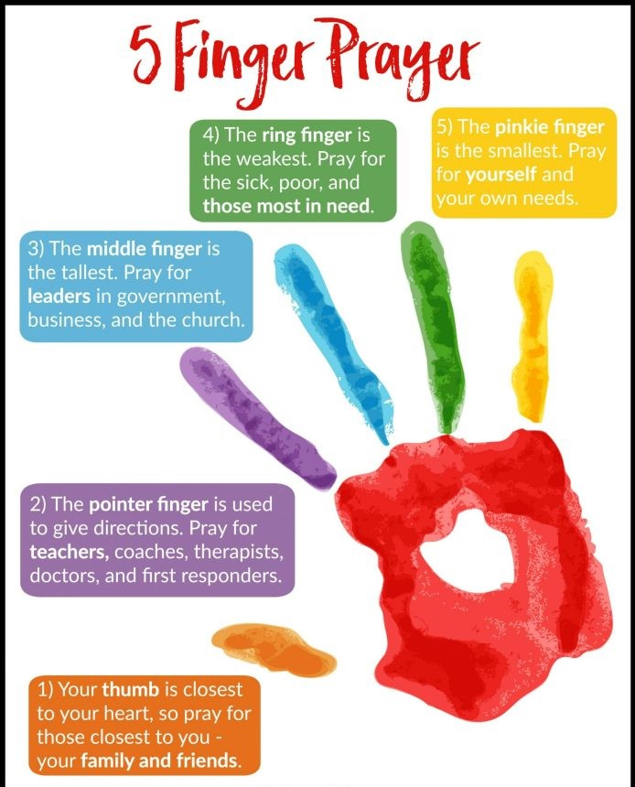

Teacher: Ms. Heffernan
Note: SEN teachers have added work on to the teachers’ plan. Children can decide to do this work instead of something the teacher has assigned. It is not extra work. Also, we would be delighted if you could email on a picture of something that your child has done and is proud of so we can see their lovely work again!
Language | This week we’re going to practise giving instuctions. Try these or you can come up with your own  https://rainbow3to6.cjfallon.ie/class/fourth/units/7/lesson/4/slide/3  I would love if you could send a recording of yourself giving instructions for one item.  You could try this game. You will need a piece of paper and a pencil and one other person to play with.  You can sit back to back or away from each other as long as you can’t see each other’s pages.  Now start taking turns to give instructions eg. Draw a large circle in the middle of your page...  At the end, see if you both drew what the other person described-there might be some funny drawings!  Maybe you could send me a photo!  Try this listening activity. You will need someone to call out the instructions for you. If you are printing it, only print page 2.  file:///C:/Users/Scoil/AppData/Local/Temp/Temp1_t-s-4399-listen-and-do-activity-pack-%20(1).zip/5.%20Five%20Word%20Level/Listen%20and%20Do%203%20-%20Five%20Word%20Level.pdf  You could try some memory games like we play in school. Again, you need somebody to help you. Memory Master quizzes players on what they see. You stare at a picture in a magazine or child’s book for sixty seconds. After the time is up, ask somebody to quiz you about what you can remember eg. What colour was the girl’s hair? How many buttons were on her dress? Etc  Keep reading!  If anybody needs any more reading material, please let me know. If you’ve read or listened to a story, I’d love to hear what you thought about it.  Send me an email to let me know how you’re getting on-I’d love to hear from you!
Contact SEN Teacher: msheffernan@scoilchoca.ie
Resources
Useful websites for this week:
- Maths: https://www.mathletics.com/uk/
- Maths: Tables revision games- https://www.topmarks.co.uk/maths-games/7-11-years/multiplication-and-division
- PE: Joe Wicks’ Live Daily PE workouts: https://www.youtube.com/
- General: Twinkl: Worksheets/Powerpoints available: Free access if you use code CVDTWINKLHELPS
- RTE’s Home School Hub. If you miss it, you might be able to watch it back on RTE Player. https://www.rte.ie/player/

English Poem: My Teacher’s Going Crazy

Dán Gaeilge: Ceisteanna
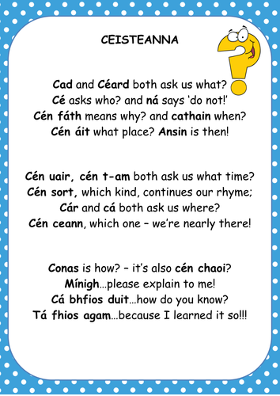
Maths: Problem-solving activity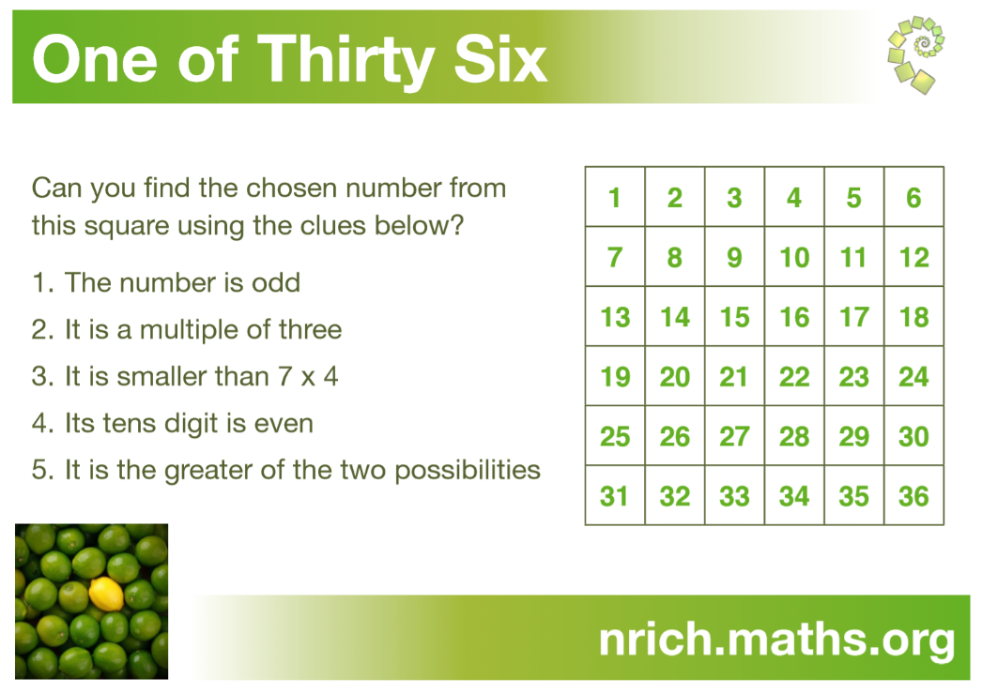

Reading Comprehension: Roald Dahl
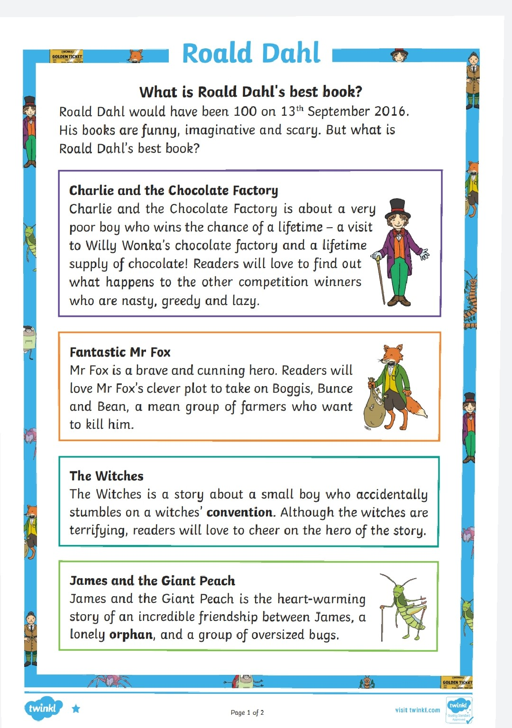

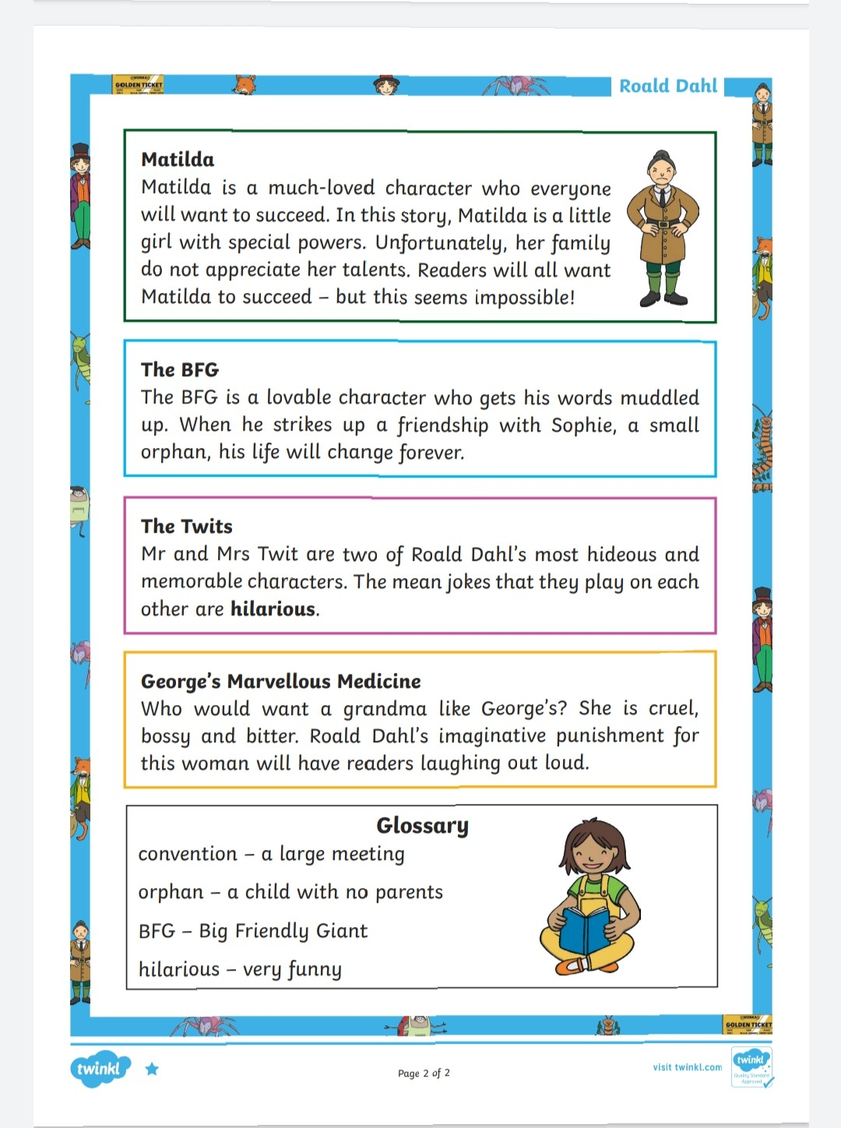

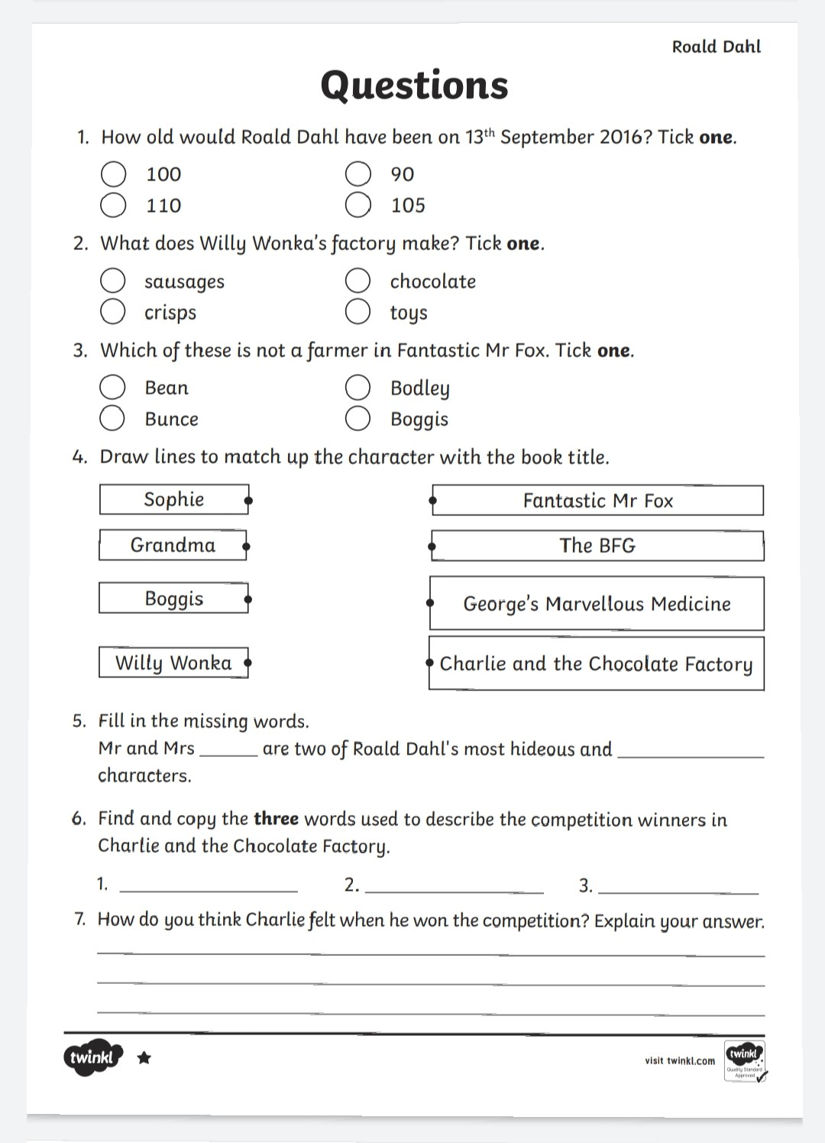

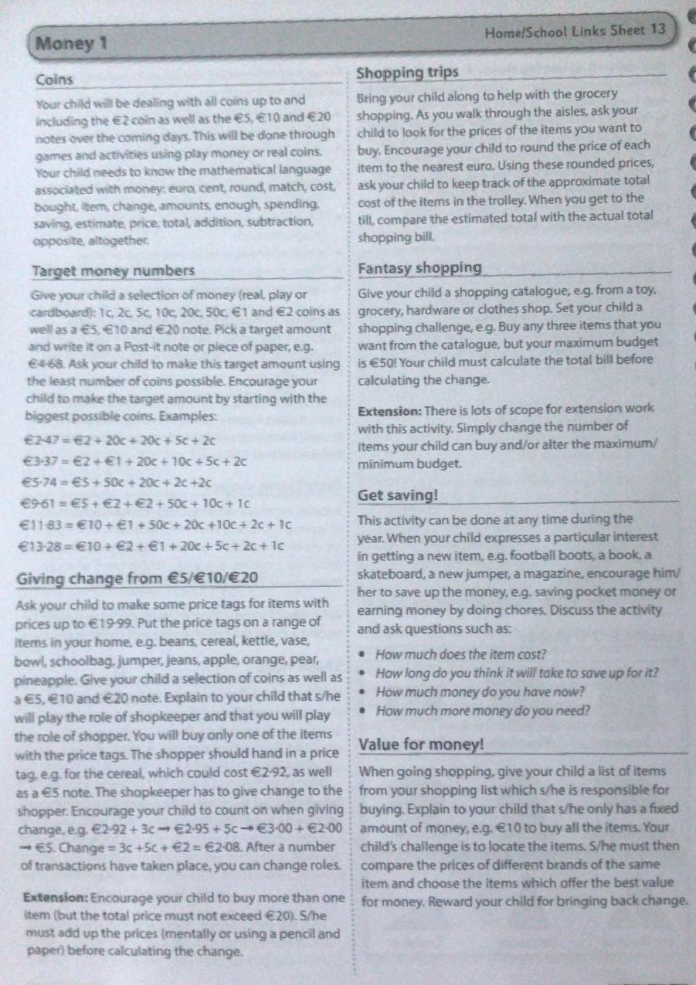
Maths: Ideas for supporting your child with ‘Money’

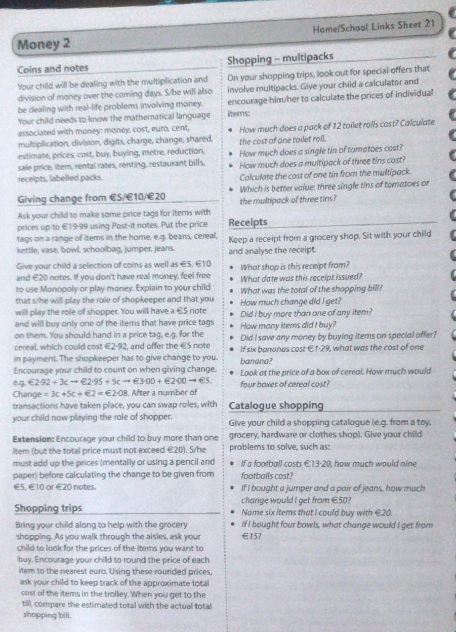

Maths Matters answers for self-correction: Please try to self-correct, where possible.
