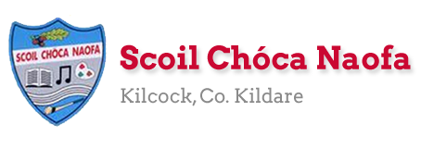
Dear 3rd Class,
I hope you and your family are keeping safe and well. I hope you enjoyed carrying out some science experiments, getting creative with art and cooking up a storm in the kitchen last week. If you started to keep a diary, I would like you to continue with this, recording your days and how you’re feeling right now.
You may remember that we started the Stay Safe programme before the school closure. The Stay Safe programme is part of the Social, Personal and Health Education Curriculum which all primary schools are required to implement. We have already completed Theme 1 which looked at ‘Feeling Safe and Unsafe’ This week, the children will be completing the programme. Parents must supervise the delivery of these lessons as sensitive issues may arise. Thank you for your co-operation.

Thank you so much for sending me pictures of your work this week. I am so impressed with you for keeping up with your school work at home. Please continue to send the work you are most proud of to mstierney@scoilchoca.ie. You can email me every few days if you’d like. I will try to respond as soon as I can. Each week, I will be posting some samples of work that children have completed on the school website. If there is a piece of work which you would not like me to share on the website, please state this in your email. Work with names or pictures of children will not be published.
I want to acknowledge the incredible work that your parents are doing at home with you. I understand the delicate balance of trying to teach and also work from home. A sincere thank you to you all. We have fantastic parents in our school and we are fortunate to be teaching your children.
Ms. Curran & Ms. McCabe would be delighted to hear from those children who work with them. Their email addresses are mscurran@scoilchoca.ie and msmccabe@scoilchoca.ie .
I would like to take this opportunity to congratulate all the girls and boys for playing their part in helping Scoil Chóca Naofa to achieve its 8th Green Flag, and in particular the members of our Green School’s Committee, Luella (3rd Class) and Emma (4th Class). Well done on a massive achievement. We are so proud of you all. Here is a link to a post on the school website where you can read more about this exciting news: http://www.scoilchoca.ie/our-8th-green-flag/

Stay safe and keep smiling,
Ms. Tierney
mstierney@scoilchoca.ie

Work for Ms. Tierney’s 3rd Class:
Monday 18/05/20 – Friday 22/05/20
Monday | English:  - Read at Home pg 118  - Starlight: Read Pg 158-160 ‘Ms. Trunchball’  Answer Part A in your copy  Look up the definitions of any words you do not know in your dictionary.  - Recite the poem: My Teacher’s Going Crazy  Maths:  - Maths Matters Pg. 138  - Mathletics activities  - Count up and down in multiples 2-20,3-30,4-40  Irish:  - Léigh sa Bhaile: Read the next page  Freagair na ceisteanna i do chóipleabhar/Answer the questions in your copy  - Abair an dán/say the poem: Ceisteanna  - Watch Cúla4 ar scoil on TG4 at 10 a.m.  P.E:  - PE with Joe Wicks on YouTube  Other: SPHE  - Stay Safe: Topic 2 ‘Friendship and Bullying’- Lessons 1 and 2  - Worksheet 4/HSL: Friend Poem  - TR4-TR8: Listen and discuss  - Worksheet 5/HSL: Bullying Definition Worksheet
Tuesday | English:  - Read at Home Pg. 119  - Starlight: Read Pg. 158-160 ‘Ms. Trunchball’  Answer Part B in your copy  - Recite the poem: My Teacher’s Going Crazy  Maths:  - Maths Matters Pg. 139  - Mathletics activities  - Count up and down in multiples 5-50, 6-60, 7-70  Irish:  - Léigh sa Bhaile: Read the next page  Freagair na ceisteanna i do chóipleabhar  - Abair an dán: Ceisteanna  - Watch Cúla4 ar scoil on TG4 at 10 a.m.  P.E:  - PE with Joe Wicks on YouTube  Other: SPHE  - Stay Safe: Topic 2 ‘Friendship and Bullying’ - Lessons 3 and 4  - Worksheet 6: What do I know about bullying?  - TR 9 + TR 10: Listen and discuss  - Worksheet 7: Stop, Block, Tell
Wednesday | English:  - Read at Home pg 120  - Starlight: ‘Ms. Trunchball’ Answer C + D in your copy  - Recite the poem: My Teacher’s Going Crazy  Maths:  - Maths Matters pg 140  - Mathletics Activities  - Count up and down in multiplies from 8-80, 9-90  Irish:  - Léigh sa Bhaile: Read the next page  Freagair na ceisteanna i do chóipleabhar  - Abair an dán: Ceisteanna  - Watch Cúla4 ar scoil on TG4 at 10 a.m.  P.E:  - PE with Joe Wicks on YouTube  Other: SPHE  - Stay Safe: Topic 2 ‘Friendship and Bullying’ – Lessons 5 and 6  - TR 11- TR 13: Listen and discuss  - Worksheet 8/HSL: Our Class Agreement  - Worksheet 9: Keeping our agreement
Thursday | English:  - Reading Comprehsion: Roald Dahl (Read and answer the questions)  - Recite the poem: My Teacher’s Going Crazy  Maths:  - Maths Matters pg 141  - Mathletics Activities  - Count up and down in multiples from 10-100, 11-110, 12-120  Irish:  - Léigh sa Bhaile: Read the next page  Freagair na ceisteanna i do chóipleabhar  - Abair an dán: Ceisteanna  - Watch Cúla4 ar scoil on TG4 at 10 a.m.  P.E:  - PE with Joe Wicks on YouTube  Other: SPHE  - Stay Safe: Topic 3 ‘Touches’ – Lessons 1 and 2  - TR 14: Listen and discuss  - Worksheet 10: What if  - Worksheet 11/HSL 11: Touches I like, Touches I don’t like  - TR 15-TR17: Listen and discuss  - Worksheet 12/HSL: Never keep a touch secret
Friday | English:  - Finish reading comprehension on Roald Dahl  - Recite the poem: My Teacher’s Going Crazy  Maths:  - Maths Matters pg 142  - Maths problem-solving activity  Irish:  - Léigh sa Bhaile: Read the next page  Freagair na ceisteanna i do chóipleabhar  - Abair an dán: Ceisteanna  - Watch Cúla4 ar scoil on TG4 at 10 a.m  P.E:  - PE with Joe Wicks on YouTube  Other: SPHE  - Stay Safe: Topic 4 ‘Secrets and Telling’  - TR 18: Listen and discuss  - Worksheet 13/HSL: Good or bad secrets  - Stay Safe: Topic 5 ‘Strangers’  - Tr 19 + Tr 20: Listen and discuss  - Worksheet 14: What would you do?  - Worksheet 15/HSL: Stranger rules

Here is a prayer for you to say:
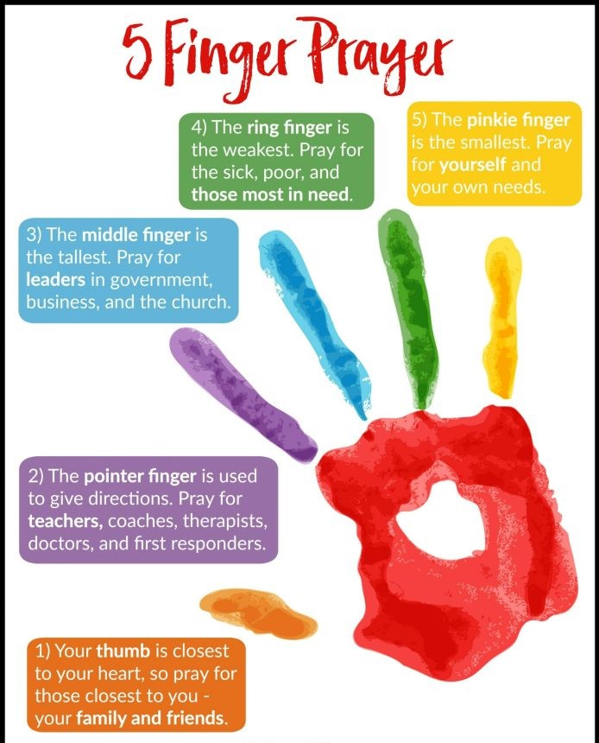
SEN/EAL work 3rd/4th Class OT May 18 – 22ndTeachers: Ms. McCabe & Ms.Curran.
Note: SEN teachers have added work on to the teachers’ plan. Children can decide to do this work instead of something the teacher has assigned. It is not extra work. Also, we would be delighted if you could email on a picture of something that your child has done and is proud of, so we can see their lovely work again! All groups can look at the clock and tell the time 3 times per day. Also keep reading and learning your tables daily. This week do 8x multiplication tables and practice counting up and down the ladder in 8s ....the same speed backdown as going up!
EAL: Transport&Travel | ORAL: Record yourself giving description of your favourite car/airplane/train. Use descriptive words eg colour, size etc. Give a reason why it’s your favourite.  WRITE: Mindmap Models of Cars/ Types of trains  https://www.twinkl.ie/resource/us2-e-53-mind-map-writing-template
Speech and Language | Conversation Starters – Continue with these, one per day.  Continue with activities from Speech & Language therapist pack or enjoy this guessing game!  https://www.twinkl.ie/resource/t-s-890-what-am-i-guessing-game-cards-animal-themed
Literacy A & B | SNIP programme – session 10..... 3 pages per week.  Phonics/Final Blends: Read the following 5 lists of blends -st -sk -sp -nd -nt 3 times each http://www.theschoolhouse.us/lessons/lesson57.html  Please keep up the reading, every day! https://www.oxfordowl.co.uk/for-school/oxford-owl-ebook-collection  These are free ebooks and you can find your level.
Toe by Toe | Next SNIP (session 20)..... 3 pages for the week.  Please read and ask an adult to read with you.
SEN Individuals | Record some facts and also your feelings about Covid 19.  Fry’s Words: Continue with the list you are on.  Do one card per day on Other People’s Feelings: https://www.twinkl.ie/resource/t-s-1272-other-peoples-feelings-thought-cards-set-2
Contact SEN Teachers: msmccabe@scoilchoca.ie mscurran@scoilchoca.ie

Ms Curran is working this week, Monday-Friday

Resources
Useful websites for this week:
- Maths: https://www.mathletics.com/uk/
- Maths: Tables revision games- https://www.topmarks.co.uk/maths-games/7-11-years/multiplication-and-division
- PE: Joe Wicks’ Live Daily PE workouts: https://www.youtube.com/
- General: Twinkl: Worksheets/Powerpoints available: Free access if you use code CVDTWINKLHELPS
- RTE’s Home School Hub. If you miss it, you might be able to watch it back on RTE Player. https://www.rte.ie/player/

English Poem: My Teacher’s Going Crazy

Dán Gaeilge: Ceisteanna
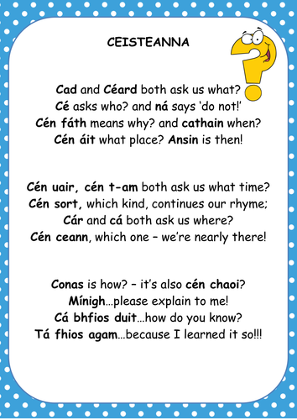

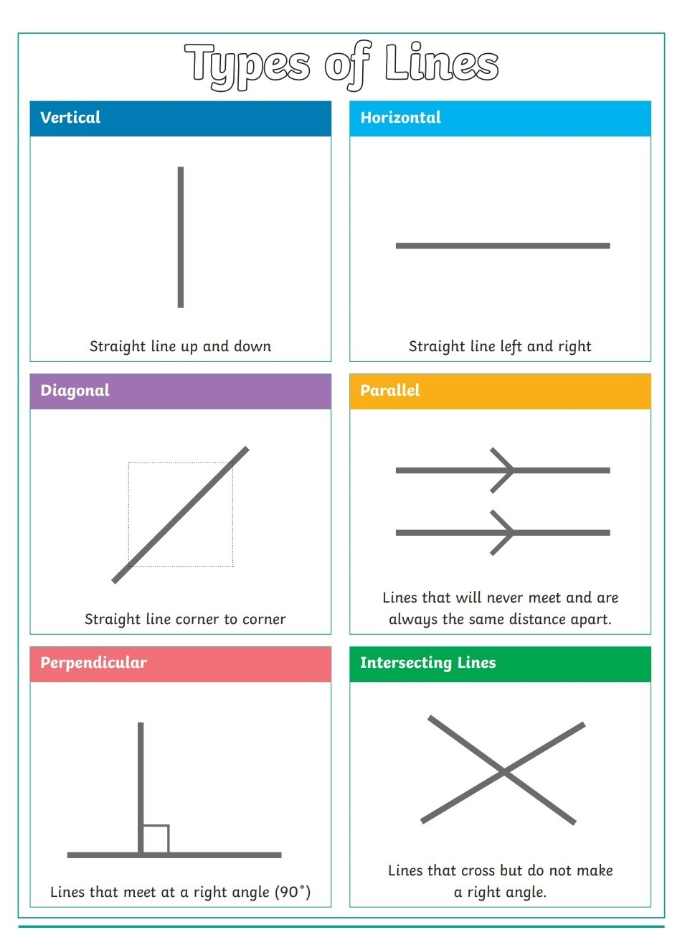
Maths: Lines & Angles

Maths: Problem-solving activity

Maths: Problem-solving activity
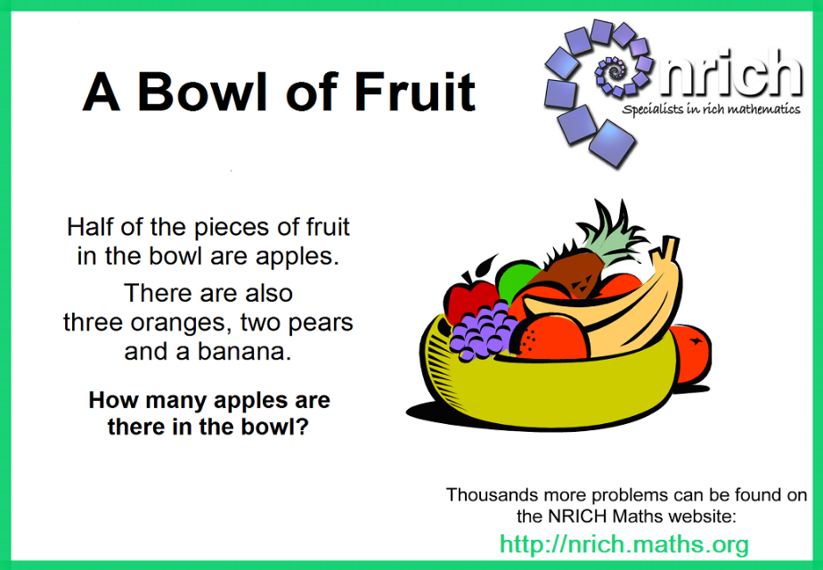
Reading Comprehension: Roald Dahl
