Work for Fifth Class: 25th of May – 29th of May 2020
Please remember: You are encouraged to complete one hour of work. The work we have given may take longer than one hour. If you want to do more than one hour that is fine but please don’t feel you have to. Do what you can and keep smiling! :)
Ms. Heffernan’s and Ms. Tone’s groups will find work for them attached to the end of this plan. Those not doing Gaeilge please access your TTRS account
Please send us pictures of your maths work and 2 other pieces of work you are proud of if you can. We would love to hear from you!
Our e-mail addresses are msfield@scoilchoca.ie and msmahon@scoilchoca.ie
Mon | English | - Spellbound: Unit 34 page 70 exercise 1 (sound them out clearly)  - Starlight: Unit 14b: The Fossil Hunter. Read pages 164-166. Complete p.167 A
 | Maths | - Maths Matters pg. 145 Read the green box carefully. Percent = Out of 100.  - Maths Matters pg. 145 Q1 (Watch this video on percentages to help)  https://www.khanacademy.org/math/pre-algebra/pre-algebra-ratios-rates/pre-algebra-intro-percents/v/describing-the-meaning-of-percent  - Maths Matters pg. 146 Q1 : Look at the black numbers under the pictures for the answers. The green box on p.145 will help you fill in the blanks.
 | Gaeilge | - Léigh sa bhaile: lch.22 Rás Rothaíochta  - Béal Beo lch. Léigh an bosca buí. Déan an tasc: Tarraing tú féin ag imirt trí spórt. (Draw yourself playing three sports) e.g. Tá mé ag imirt cispheil.
 | P.E. | - Go outside and be active for at least 30 minutes  - Have a look at Scoilnet Beyond the Classroom. Links below  - https://www.scoilnet.ie/pdst/physlit/beyond/  - https://vimeo.com/403344557 Throwing Home Activity C  - https://vimeo.com/403344817 Ag Caitheamh (Throwing as gaeilge)
 | Other | Cow Parsley: Have a read of the page on Cow Parsley attached below  Pick out 5 interesting/key facts and write them into your SESE copy  Title: Cow Parsley. Date 25/05/20. Cursive writing please
Tue | English | - Spellbound: Unit 34 page 70 exercise 2  - Starlight: Unit 14b: The Fossil Hunter. Read p. 164-166. Complete p.167 B+C
 | Maths | - Mathletics or Maths Challenge Test 51  - Maths Matters pg. 146 Q2 & p.147 Q1+Q2  Remember: ½ = $\frac{50}{100}$ ¼ = $\frac{25}{100}$ $\frac{1}{5}$= $\frac{20}{100} \frac{3}{4}$=$\frac{75}{100}$ $\frac{2}{10}$= $\frac{20}{100}$
 | Gaeilge | - Duolingo: Collect 10XP  - Léigh sa bhaile: lch.53 Ranganna Snámha
 | P.E. | - Go outside and be active for at least 30 minutes  - Have a look at Scoilnet Beyond the Classroom. Links below  - https://vimeo.com/404412589 Running Home Activity C  - https://vimeo.com/404412677 Ag rith (Running as Gaeilge)
 | Other | Cow Parsley: Do a sketch of the cow parsley plant onto the page that contains your facts.  Go for a walk (with an adult) and see can you spot any cow parsley on the side of the road or in a local field. If you get a chance to pick a sample, why not press it between the pages of a book for a week or two and then stick it onto your page?
Wed | English | - Spellbound: Unit 34 page 70 exercise 3  - Starlight: Unit 14b: Complete p.168 D+E
 | Maths | - Mathletics or Maths Challenge Test 52  - Maths Matters pg. 147 Q3 ½=$\frac{50}{100}$ ¼=$\frac{25}{100}$ $\frac{1}{5}$=$\frac{20}{100} \frac{3}{4}$=$\frac{75}{100}$ $\frac{2}{10}$=$\frac{20}{100}$  - Maths Matters pg.148 Q1 Percentages are out of 100 e.g. 50% = $\frac{50}{100}$  - https://www.khanacademy.org/math/pre-algebra/pre-algebra-ratios-rates/pre-algebra-percent-decimal-conversions/v/representing-a-number-as-a-decimal-percent-and-fraction
 | Gaeilge | - Béal Beo: Léigh lch.153. Déan ceist 1-6 ar lch.154.  - Duolingo: Collect 10XP
 | P.E. | - Go outside and be active for 30 minutes  - Look up look up 30 Days of Yoga with Adrienne  - https://www.youtube.com/playlist?list=PLui6Eyny-UzwxbWCWDbTzEwsZnnROBTIL  - Choose a day and complete lesson
 | Other | Music: Using your recorder, start on a low D and play a scale: D, E, F#, G, A, B, C#, D. Practise some of the warm ups Laura does with you every week. Play your favourite recorder piece of the year start to finish. Record yourself and listen back if you can.
Thurs | English | - Spellbound: Unit 35 page 71 exercise 4  - Starlight: Unit 14b: Complete p.169 F
 | Maths | - Mathletics or Maths Challenge Test 53  - Maths Matters pg. 148 Q2 30% = 0.30 = 0.3 25% = 0.25  - Maths Matters pg. 148 Q3 0.5 = 50% = $\frac{50}{100}$
 | Gaeilge | - Léigh sa bhaile: lch.76 Fógra  - Duolingo: Collect 10XP
 | P.E. | - Go outside and be active for at least 30 minutes  - Have a look at Scoilnet Beyond the Classroom. Links below.  - https://vimeo.com/412282658 Catching Home Activity C  - https://vimeo.com/412283472 Gabháil (Catching as Gaeilge)
 | Other | Art: Collect some petals, strands of grass, leaves and seeds that you can find outside. Create a piece of art using them. See below for a few ideas/inspiration.  Don’t take too many flowers or the bees will be annoyed!
Fri | English | - Spellbound: Unit 35 page 71 exercise 5 (homynyms = words that are spelled the same but mean different things)  - Starlight: Unit 14b: Complete p.169 G
 | Maths | - Mathletics or Maths Challenge Test 54  - Maths Matters pg. 148 Q4 (Use pg. 147 Q4 and pg. 148 Q1+Q2 to help you)
 | Gaeilge | - Béal Beo: lch 156 Dathaigh an pictiúr. Cad is brí leis an seanfhocal? (What does the seanfhocal mean?)  Béal Beo: lch.157 líon na bearnaí.  - Duolingo: Collect 10XP
 | P.E. | - Go outside and be active for at least 30 minutes  - Have a look at Scoilnet Beyond the Classroom. Links below  - https://vimeo.com/409589781Balancing Home Activity C
 | Other | SPHE: Listen to and follow along with this podcast. It involves a grounding meditation. https://app.kidslisten.org/ep/Peace-Out-Time-to-Pause-Tuesday#/
Extra Activities – Optional
Inside  - Bake something delicious (get an adult to help with the hot parts)  - Find a match for all the lonely odd socks in the house | Outside  - Look for an area you could plant some seeds/set up a flower pot and go for it!
Free eBooks access: https://www.oxfordowl.co.uk/for-home/find-a-book/library-page/?view=image&query=&type=book&age_group=Age+9-11&level=&level_select=&book_type=&series=#

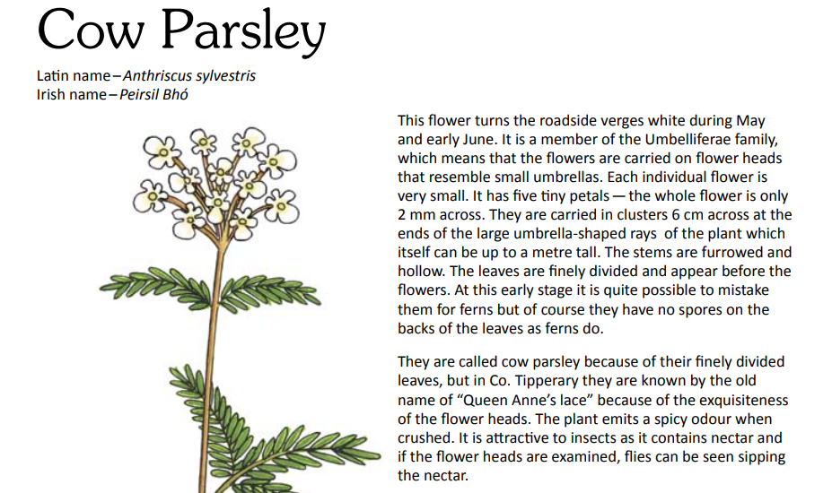
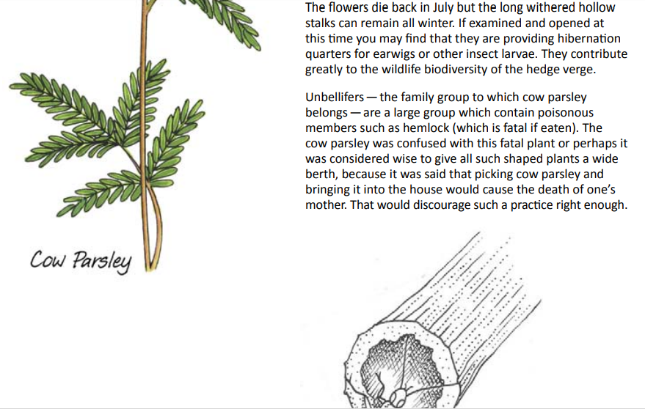

Art Inspiration
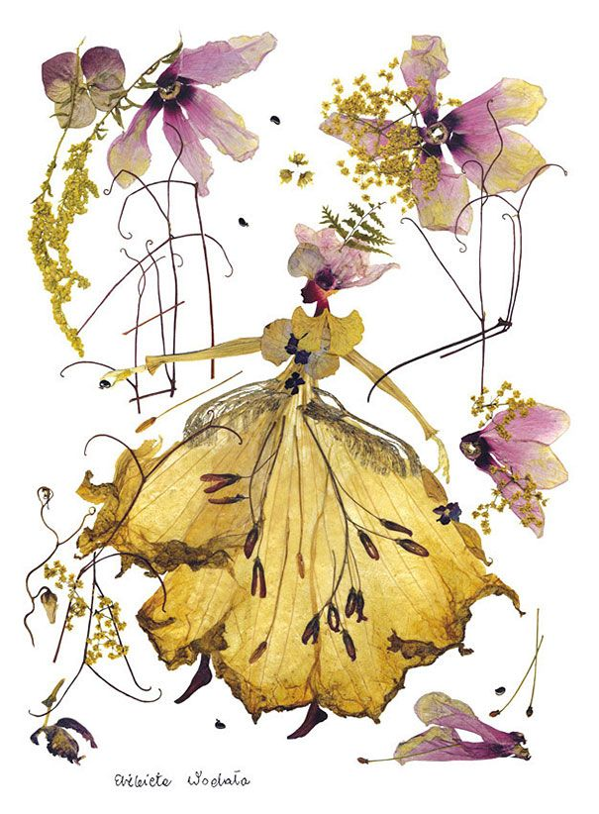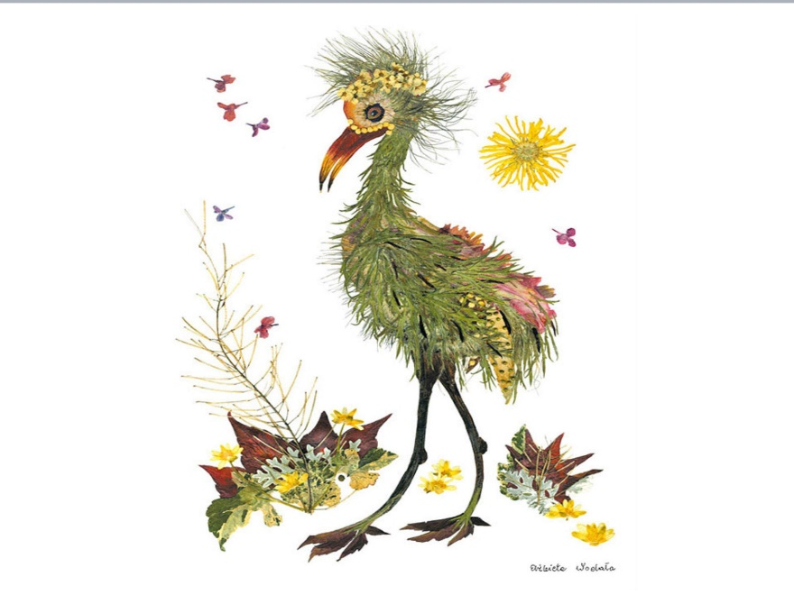
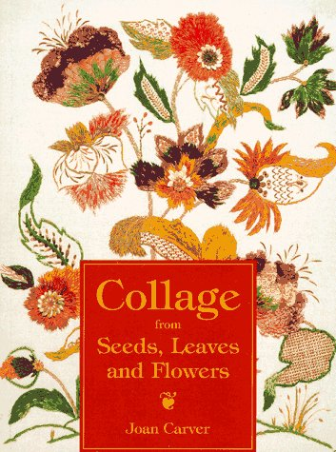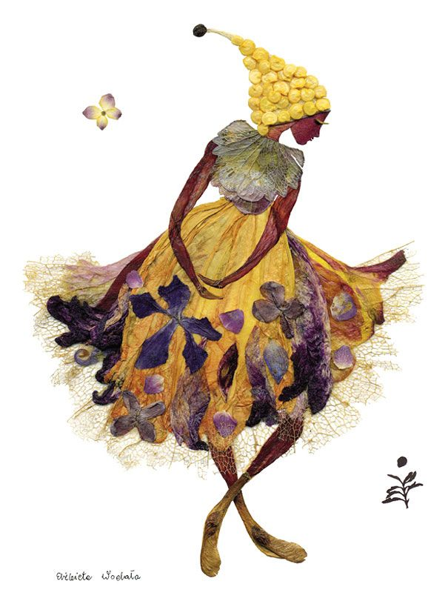

SEN work 5th Class week beginning 25th May 2020
Teacher: Ms. Heffernan
Note: SEN teachers have added work on to the teachers’ plan. Children can decide to do this work instead of something the teacher has assigned. It is not extra work. Also, we would be delighted if you could email on a picture of something that your child has done and is proud of so we can see their lovely work again!
Literacy | Keep reading!  If any of you need more reading material, just let me know.  If you’ve read or listened to a story, let me know what you thought about it.  Do a little writing every day.  Keep a diary.  Keep a gratitude journal-write down 3 things you are grateful for each day.  Use www.writereader.com to create your own book.  Here is a reading comprehension about Summer in Ireland. You can choose your level-easy, medium, difficult. No peeking at the answers until you are finished. https://content.twinkl.co.uk/resource/a1/60/roi2-e-2672-summer-in-ireland-differentiated-reading-comprehension-activity_ver_4.pdf?__token__=exp=1589972305~acl=%2Fresource%2Fa1%2F60%2Froi2-e-2672-summer-in-ireland-differentiated-reading-comprehension-activity_ver_4.pdf%2A~hmac=6f676f2aaf565414850807e56ab3b5fea0e3ed3866188f80c0fd0ceca0188855  Keep practising your TTRS. See if you can still type while covering your hands with a towel!  Send me an email to let me know how you’re getting on-I’d love to hear from you!
Numeracy | Keep doing your Mathletics or you could also try https://www.mathsisfun.com/percentage-menu.html to help you with your percentages work this week.  You might like to test yourself with these worksheets!  The first one is filling in sections of the hundred square. The second one has 10 riddles for you to solve on the hundred square. There’s no need to print them out. You can use your whiteboard marker on your own 100 square. (No peeking at answers until you’re finished!)  file:///C:/Users/Scoil/Desktop/Maths/roi-ms-10-100-square-number-patterns-worksheet_ver_1.pdf  file:///C:/Users/Scoil/Desktop/Maths/roi-ms-10-100-square-number-riddles-worksheets_ver_1.pdf  Keep practising your mental maths.  https://www.topmarks.co.uk/maths-games/hit-the-button  https://www.topmarks.co.uk/maths-games/daily10  Send me an email to let me know what you have done or if you need help.
Contact SEN Teacher: msheffernan@scoilchoca.ie

SEN work

Teacher: Ms Tone (Ms Clancy)

Note: SEN teachers have added work on to the teachers’ plan. Children can decide to do this work instead of something the teacher has assigned. It is not extra work. Also, we would be delighted if you could email on a picture of something that your child has done and is proud of so we can see their lovely work again!

Literacy | - Keep reading!  - Choose a story from Starlight. Write a few sentences to explain what happened in the story.  - Word challenge: How many little words can you find in the word ‘contradicted’? e.g. dart  - Word challenge: eat – top – pet – tar – rob  Finish this pattern: rob – bit - ____ - ____ - ____  - Keep a diary to record what you are doing each day. Write 3 sentences. Draw a picture in your diary.
Numeracy | - Time: See clocks worksheet below.  Send me an email if you need any help.

Contact SEN Teacher: mstone@scoilchoca.ie

Time: Remember!

It takes the big hand 5 minutes to move from one number to the next.
When the big hand points to 1 - it is five past
2 - it is ten past
3 - it is 15 minutes past (quarter past)
4 - it is 20 past
5 - it is 25 past
6 - it is 30 minutes past (half past)

The small hand points after the number.

What time is it?

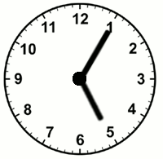
It is five past 5.
- Draw 4 clocks. Show these times: ten past 2, a quarter past 4, twenty past 9, half past 11.
- What time is it on the clocks?

