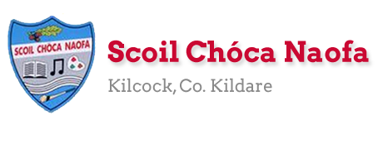
Work for Mr. Bracken’s 3rd Class: Monday 11/05/20 – Friday 15/05/20
Thought for the week: What goes around the world while staying in the corner?
Dear 3rd class,
Thank you for continuing to send examples of work every few days. I’m very proud of you all. I hope you enjoyed the baking and mindfulness activities last week, if you chose to do them. There are some baking options this week too as well as some simple science experiments. Make sure to clean up afterwards!
On Wednesday of this week you will be finishing your Read at Home book. Well done! Going forward I will ask you to pick books from home to read as part of your schoolwork. I will call it your ‘Home Book’. In Starlight this week the chapter is based on a book review, you can use it as help to show you what to do when you finish your Home Book. It shows you how to structure a review, what the headings are, how to break it into paragraphs, and so on. This won’t be until next week: it might just get you thinking beforehand. You’ll have a few days to choose a book. I’ll tell you more about it next week.
Some of you have been showing me examples of what you are getting up to in your free time, how creative you’re being, what you’re doing to help out at home, learning a new skill/instrument/hobby and I just want to say that you and your families are to be admired. I’m very proud of my class.
Anybody who works with Ms Curran & Ms McCabe, they would be delighted to hear from you with regard to the work you’re doing, too. Their email addresses are attached to their document below.
I want to wish Abigail a very happy birthday this week (12/05) We hope you enjoy your day and we will be thinking of you.

Mr. Bracken

Monday | English:  - Read at Home pg 118 – ‘Mines’ – Read and answer questions orally  - Starlight 15A – ‘Read This!’ – Read the book reviews & complete part A in your copy  - Diary entry/voice recording  Maths:  - Maths Matters pg 130 – ‘Heavy and Light’  Irish:  - Léigh sa Bhaile: Read the next page. Freagair na ceisteanna: Answer the 5 questions at the bottom of the page in your spare copy  - Cúla ar scoil @10am https://www.cula4.com/en/  PE: Activity - see below  Science – experiment  - Bouncy Egg experiment – see below
Tuesday | English:  - Read at Home pg 119 - ‘Animal World Records’ – Read and answer questions orally.  - One of the animals mentioned is the smallest bird in the world, the Bee Hummingbird. Here’s a really interesting short video on the bird: https://youtu.be/fRw3zaV5ynE  - Starlight 15A – ‘Read This!’ – Read the book reviews & complete part B in your copy  - Diary entry/voice recording  Maths:  - Maths Matters pg 131 Q’s 1 & 2 – adding kilogrammes and grammes  Irish:  - Léigh sa Bhaile: Read the next page. Freagair na ceisteanna: Answer the 5 questions at the bottom of the page in your spare copy  - Cúla ar scoil @10am https://www.cula4.com/en/  PE: Activity – see below  Baking:  - You’ve three options, shown below, bake whatever you’d prefer to eat.
Wednesday | English:  - Read at Home pg 120 ‘Dublin Zoo’ - Read & answer questions orally. Congratulations, you’ve finished the book!  - Starlight 15A – ‘Read This!’ – Read the book reviews & complete part C in your copy  - Diary entry/voice recording  Maths:  - Maths Matters pg 132 – Subtraction of Kilogrammes and grammes Q’s 1 & 2  - Maths Booklet pg 10 – adding money  Irish:  - Léigh sa Bhaile: Read the next page. Freagair na ceisteanna: Answer the 5 questions at the bottom of the page in your spare copy  - Cúla ar scoil @10am https://www.cula4.com/en/  PE: Activity – see below  Science – experiment  - Two options, choose one
Thursday | English:  - Starlight 15A – ‘Read This!’ – Read the book reviews & complete part D in your copy  - Diary entry/voice recording  Maths:  - Maths Matters pg 133 – word problems  - Maths booklet pg 11 – clock faces – revision  Irish:  - Léigh sa Bhaile: Read the next page. Freagair na ceisteanna: Answer the 5 questions at the bottom of the page in your spare copy  - Cúla ar scoil @10am https://www.cula4.com/en/  PE: Activity – see below  RE: Rosary activity  - Using pipe cleaners and some beads you can make rosary beads for your May altar or for yourself. See an example below.  - You could also make a daisy chain and use ten daisies to make a nature inspired rosary bead
Friday | English:  - Starlight 15A – ‘Read This!’ – Read the book reviews & complete part E in your copy – this is a revision exercise based on apostrophes. Remember that apostrophes are used to:  - Show possession  - To replace a letter/abbreviation e.g. She is = she’s or do not = don’t  - Diary entry/voice recording  Maths:  - Maths booklet pg 12 – clock faces, shapes & pattern. Booklet finished!  Irish:  - Léigh sa Bhaile: Read the next page. Freagair na ceisteanna: Answer the 5 questions at the bottom of the page in your spare copy  - Cartún ar TG4  PE: Activity – see below  Art:  - Look at the Sunflowers painting by Vincent Van Gough attached below. Design & create your own version of the painting. Feel free to use your imagination and to make it your own! After you use a pencil to draw it you could use:  - Paint  - Colouring pencils  - Crayons  - Whatever you have at home

Useful websites for this week:
- Maths: Tables revision games- https://www.topmarks.co.uk/maths-games/7-11-years/multiplication-and-division
- Baking: very good website: https://www.supercook.com/#/recipes - you can put in the ingredients you have at home and it will generate something to bake for you.

Ms McCabe is working, this week, Monday-Friday.
SEN/EAL work 3rd class EB May 11-15th Teachers: Ms.Curran & Ms. McCabe.
Note: SEN teachers have added work on to the teachers’ plan. Children can decide to do this work instead of something the teacher has assigned. It is not extra work. Also, we would be delighted if you could email on a picture of something that your child has done and is proud of, so we can see their lovely work again! All groups can look at the clock and tell the time 3 times per day. Also keep reading and learning your tables daily. This week do 6x/7x multiplication tables and practice counting up and down the ladder in 6s and 7s....the same speed backdown as going up!
EAL: Transport&Travel | ORAL: I Spy Transport Game: https://www.twinkl.ie/resource/t-tp-1226-transport-i-spy-and-count-activity  WRITE: Modes of Transport. Write 5 sentences about how you or your family travel from place to place.
Speech and Language | Conversation Starters – Continue with these, one per day.  Continue with activities from Speech & Language therapist pack or enjoy this challenge game!  https://www.twinkl.ie/resource/t-l-1142-name-5-things-challenge-cards
Literacy A & B | SNIP programme – session 9..... 3 pages per week.  Phonics: Read the next 3 lists of blends (st-,sw-, tw-). Also, read the 9 dictation after the lists, 3 times each:  http://www.theschoolhouse.us/lessons/lesson56.html  Please keep up the reading, every day! https://www.oxfordowl.co.uk/for-school/oxford-owl-ebook-collection  These are free ebooks and you can find your level.
Toe by Toe | Next SNIP session (session 19)..... 3 pages for the week.  Please read and ask an adult to read with you.
SEN Individuals | Write Reader: Continue writing about Taking my Dog for a walk in Laragh.  Fry’s Words: Continue with the list you are on.  Cloze Sheet: https://www.twinkl.ie/resource/looking-after-my-wellbeing-cloze-activity-roi-sphe-15  Conversation Starter daily.  Do pages 3 and 4 of this: https://www.otb.ie/wp-content/uploads/2020/04/At-Home-with-Weaving-Well-being-A-Mental-Health-Journal-for-Kids.pdf
Contact SEN Teachers: msmccabe@scoilchoca.ie mscurran@scoilchoca.ie

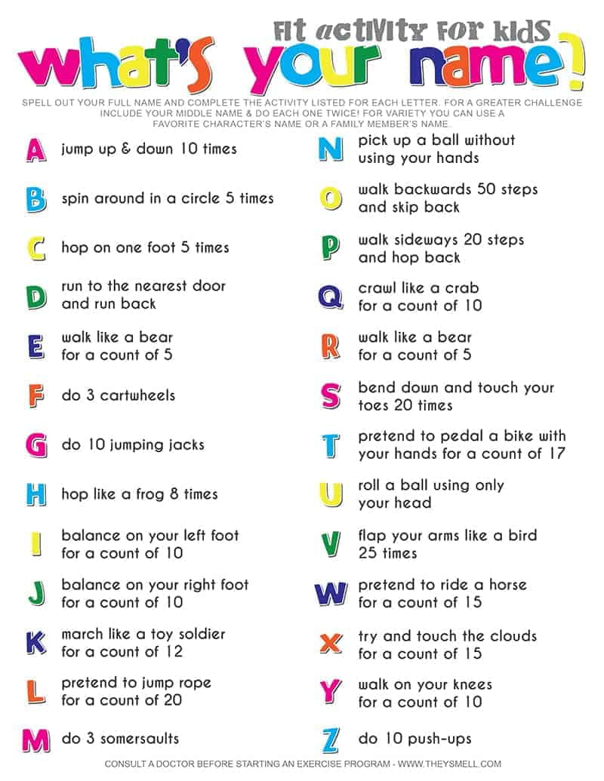
PE Activity for the week

Monday – Experiment
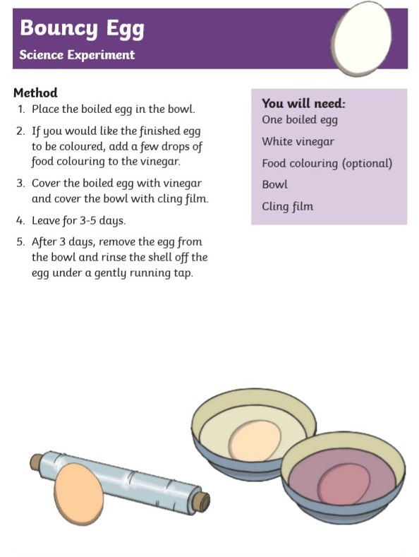

Tuesday – Baking – 3 options
Healthy Banana Pancakes
Ingredients:
- 2 eggs
- 1 banana
- ½ cup porridge oats
- dash of cinnamon
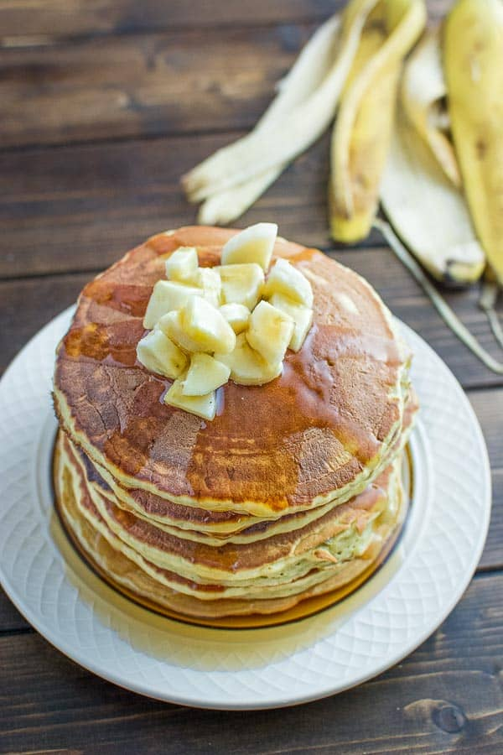

White Chocolate Chip Cookies
Ingredients: (makes 15 cookies)
- 100g sugar
- 115 g unsalted butter
- 1 tsp vanilla extract
- 1 egg
- 155g flour
- 165 g brown sugar
- ½ tsp baking powder
- 200g white chocolate chips
- Smarties (optional)
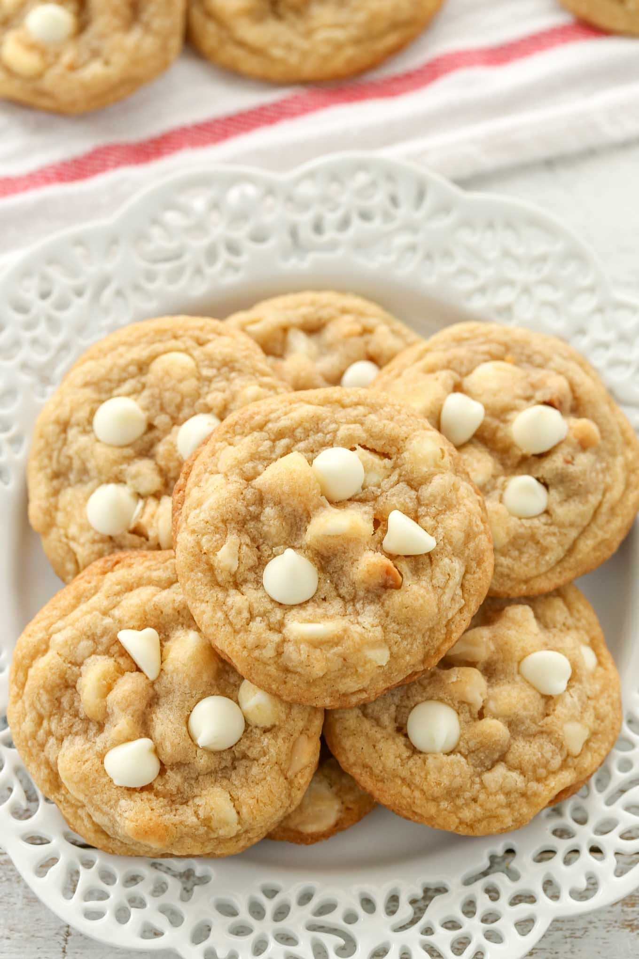

Chocolate Biscuit Cake
Ingredients:
- 400g rich tea biscuits
- 225 g butter
- 85g caster sugar
- 2 eggs
- 1 tbsp cocoa powder
- 1 tbsp drinking chocolate
- 100g milk chocolate
- Marshmallows/maltesers (optional)
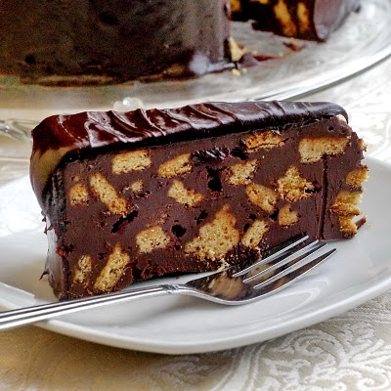

Wednesday – Experiment – Option 1
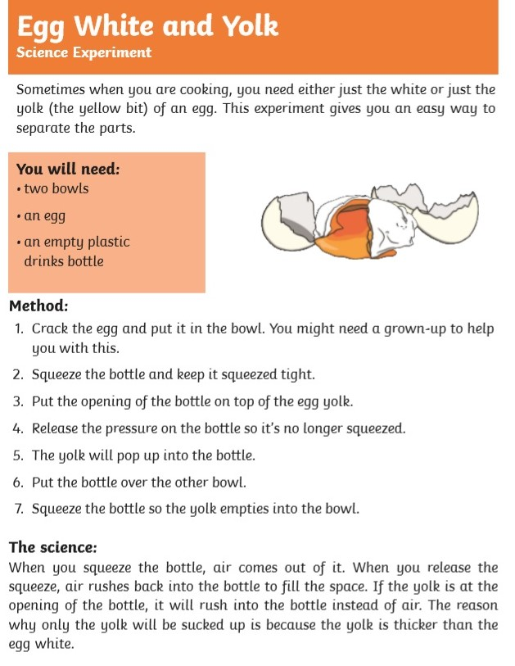

Wednesday – Experiment – Option 2
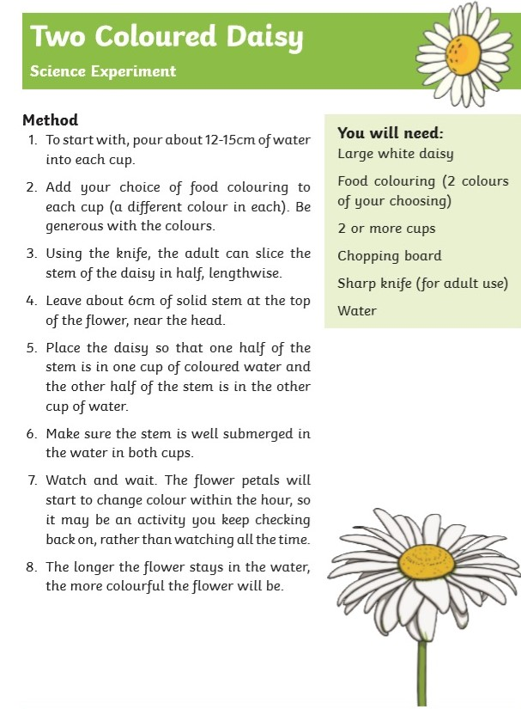

Thursday – RE – rosary activity
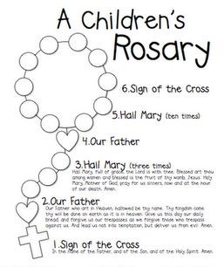

Friday – Art
‘Sunflowers’ by Vincent Van Gough

