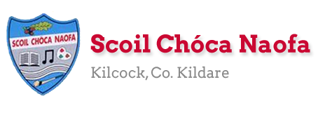
Dear 3rd Class,
I hope you and your family are keeping safe and well. Thank you so much for sending me pictures of your work this week. I am so proud of and impressed with you for keeping up with your school work at home. Give yourself a clap on the back.
I hope you enjoyed your well-being and baking activities last week. This week, I would like you to do some science experiments, some art and even a little more baking. If you started to keep a diary, I would like you to continue with this, recording your days and how you’re feeling right now.
Please continue to send the work you are most proud of to mstierney@scoilchoca.ie. You can email me every few days if you’d like. I will try to respond as soon as I can.
Those children who work with Ms. Curran & Ms. McCabe, they would be delighted to hear from you and to hear what you have been up to. Their email addresses are mscurran@scoilchoca.ie and msmccabe@scoilchoca.ie .

Stay safe and keep smiling,
Ms. Tierney
mstierney@scoilchoca.ie

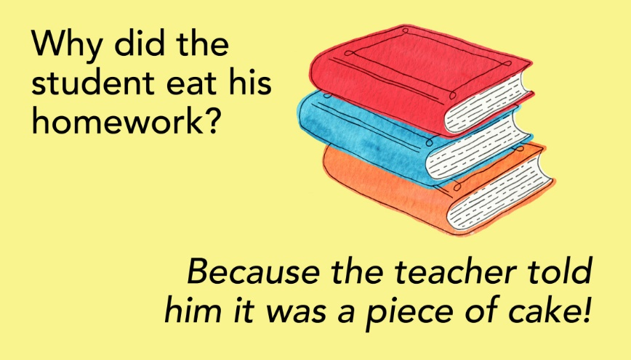

Work for Ms. Tierney’s 3rd Class:
Monday 11/05/20 – Friday 15/05/20
Monday | English:  - Read at Home pg 113  - Starlight: Read ‘Why Do We Laugh?’ pg 152-154  Use a dictionary to look up the meaning of any words you don’t understand.  Answer exercise A in your copy.  - Recite the poem: Why English is so Hard  Maths:  - Maths Matters Pg. 134 (Answers attached at end of document)  - Mathletics activities  - Count up and down in multiples 2-20,3-30,4-40  Irish:  - Léigh sa Bhaile: Read the next page  Freagair na ceisteanna i do chóipleabhar  - Can an t-amhrán/Sing the song: Samhradh Samhradh  - Watch Cúla4 ar scoil on TG4 at 10 a.m.  P.E:  - PE with Joe Wicks on YouTube  Other: Science  - Choose 1 experiment to carry out. Write down your prediction (what you think will happen) and the results of your experiment (what happened). Can you explain the science behind why this happened?
Tuesday | English:  - Read at Home Pg. 114  - Starlight Read ‘Why Do We Laugh?’ pg 152-154  Answer exercise B in your copy.  Write a short paragraph (5/6 lines) about a time you could not stop laughing.  - Recite the poem: Why English is so Hard  Maths:  - Maths Matters Pg. 135 (Answers attached at end of document)  - Mathletics activities  - Count up and down in multiples 5-50, 6-60, 7-70  Irish:  - Léigh sa Bhaile: Read the next page  Freagair na ceisteanna i do chóipleabhar  - Can an t-amhrán/Sing the song: Samhradh Samhradh  - Watch Cúla4 ar scoil on TG4 at 10 a.m.  P.E:  - PE with Joe Wicks on YouTube  Other:  - Have fun baking (See suggestions below)- Adult supervision required
Wednesday | English:  - Read at Home pg 115  - Starlight: ‘Why Do We Laugh?’ Answer exercises C and D in your copy.  - Recite the poem: Why English is so Hard.  Maths:  - Maths Matters pg 136 (Answers attached at end of document)  - Mathletics Activities  - Count up and down in multiplies from 8-80, 9-90  Irish:  - Léigh sa Bhaile: Read the next page  Freagair na ceisteanna i do chóipleabhar  - Can an t-amhrán/Sing the song: Samhradh Samhradh  - Watch Cúla4 ar scoil on TG4 at 10 a.m.  P.E:  - PE with Joe Wicks on YouTube  Other: Science  - Choose 1 experiment to carry out. Write down your prediction (what you think will happen) and the results of your experiment (what happened). Can you explain the science behind why this happened?
Thursday | English:  - Read at Home pg 116  - Starlight: ‘Why do We Laugh?’. Answer exercise E in your copy.  - Recite the poem: Why English is so Hard.  Maths:  - Maths Matters pg 137 (Answers attached at end of document)  - Mathletics Activities  - Count up and down in multiples from 10-100, 11-110, 12-120  Irish:  - Léigh sa Bhaile: Read the next page  Freagair na ceisteanna i do chóipleabhar  - Can an t-amhrán/Sing the song: Samhradh Samhradh  - Watch Cúla4 ar scoil on TG4 at 10 a.m.  P.E:  - PE with Joe Wicks on YouTube  Other: Religion  Rosary  - Say a decade of the rosary prayer (see below).  - Using pipe cleaners/beads/daisies, you can make rosary beads for your May altar or for yourself.
Friday | English:  - Read at Home pg 117  - Research and write a brief explanation of a naturally recurring process in our body for example: Why we breathe? Why do we need teeth?  - Recite the poem: Why English is so Hard.  Maths:  - 3-D Shape Hunt: Find some 3-D shapes in your house/garden.  (See below for details)  Irish:  - Léigh sa Bhaile: Read the next page  Freagair na ceisteanna i do chóipleabhar  - Can an t-amhrán/Sing the song: Samhradh, Samhradh  - Watch Cúla4 ar scoil on TG4 at 10 a.m  P.E:  - PE with Joe Wicks on YouTube  Other: Art  ‘Sunflowers’ by Vincent Van Gogh  - Examine the painting ‘Sunflowers.’  - Design and create your own version of the painting.  - After you use a pencil to draw it, add some colour using paint/colouring pencils/crayons/pastels/whatever you have at home.  - Feel free to use your imagination to make it your own.
SEN/EAL work 3rd/4th Class OT May 11-15th Teachers: Ms. McCabe & Ms.Curran.
Note: SEN teachers have added work on to the teachers’ plan. Children can decide to do this work instead of something the teacher has assigned. It is not extra work. Also, we would be delighted if you could email on a picture of something that your child has done and is proud of, so we can see their lovely work again! All groups can look at the clock and tell the time 3 times per day. Also keep reading and learning your tables daily. This week do 6x/7x multiplication tables and practice counting up and down the ladder in 6s and 7s....the same speed backdown as going up!
EAL: Transport&Travel | ORAL: I Spy Transport Game: https://www.twinkl.ie/resource/t-tp-1226-transport-i-spy-and-count-activity  WRITE: Modes of Transport. Write 5 sentences about how you or your family travel from place.
Speech and Language | Conversation Starters – Continue with these, one per day.  Continue with activities from Speech & Language therapist pack or enjoy this challenge game!  https://www.twinkl.ie/resource/t-l-1142-name-5-things-challenge-cards.
Literacy A & B | SNIP programme – session 9..... 3 pages per week.  Phonics: Read the next 3 lists of blends (st-,sw-, tw-). Also, read the 9 dictation after the lists, 3 times each:  http://www.theschoolhouse.us/lessons/lesson56.html  Please keep up the reading, every day! https://www.oxfordowl.co.uk/for-school/oxford-owl-ebook-collection  These are free ebooks and you can find your level.
Toe by Toe | Next SNIP session (19)..... 3 pages for the week.  Please read and ask an adult to read with you.
SEN Individuals | Write Reader: Continue with A Scavenger Hunt.  Fry’s Words: Continue with the list you are on.  Cloze Procedure: https://www.twinkl.ie/resource/looking-after-my-wellbeing-cloze-activity-roi-sphe-15  Do pages 3 and 4 of this: https://www.otb.ie/wp-content/uploads/2020/04/At-Home-with-Weaving-Well-being-A-Mental-Health-Journal-for-Kids.pdf
Contact SEN Teachers: msmccabe@scoilchoca.ie mscurran@scoilchoca.ie

Ms McCabe is working this week, Monday-Friday

Resources
Useful websites for this week:
- Maths: https://www.mathletics.com/uk/
- Maths: Tables revision games- https://www.topmarks.co.uk/maths-games/7-11-years/multiplication-and-division
- Gaeilge: Can an t-amhrán/sing the song: https://www.youtube.com/watch?v=VjE33BQ7aJ4
- PE: Joe Wicks’ Live Daily PE workouts: https://www.youtube.com/
- General: Twinkl: Worksheets/Powerpoints available: Free access if you use code CVDTWINKLHELPS
- RTE’s Home School Hub. If you miss it, you might be able to watch it back on RTE Player. https://www.rte.ie/player/
- Art: Information on Sunflowers: https://www.youtube.com/watch?v=SEf7Y8UtEsM

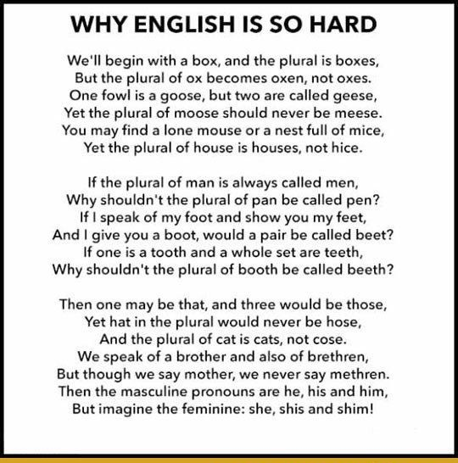
English Poem:

Gaeilge: Amhrán
Irish song: Samhradh Samhradh
Samhradh, samhradh, bainne na ngamhna,
Thugamar féin an samhradh linn.
Samhradh buí na nóinín glégeal,
Thugamar féin an samhradh linn.
Thugamar linn é ón gcoill chraobhaigh,
Thugamar féin an samhradh linn.
Samhradh buí ó luí na gréine,
Thugamar féin an samhradh linn.

Samhradh, samhradh… is cé bhainfeadh dínn é?

Bábóg na Bealtaine, maighdean an tSamhraidh,
Suas gach cnoc is síos gach gleann,
Cailíní maiseacha bán-gheala glégeal,
Thugamar féin an samhradh linn.
Cuileann is coll is trom is caorthann
Thugamar féin an samhradh linn.
An fuinseog ghléigeal bhéil an Átha
Thugamar féin an samhradh linn.

Maths: 3-D shapes
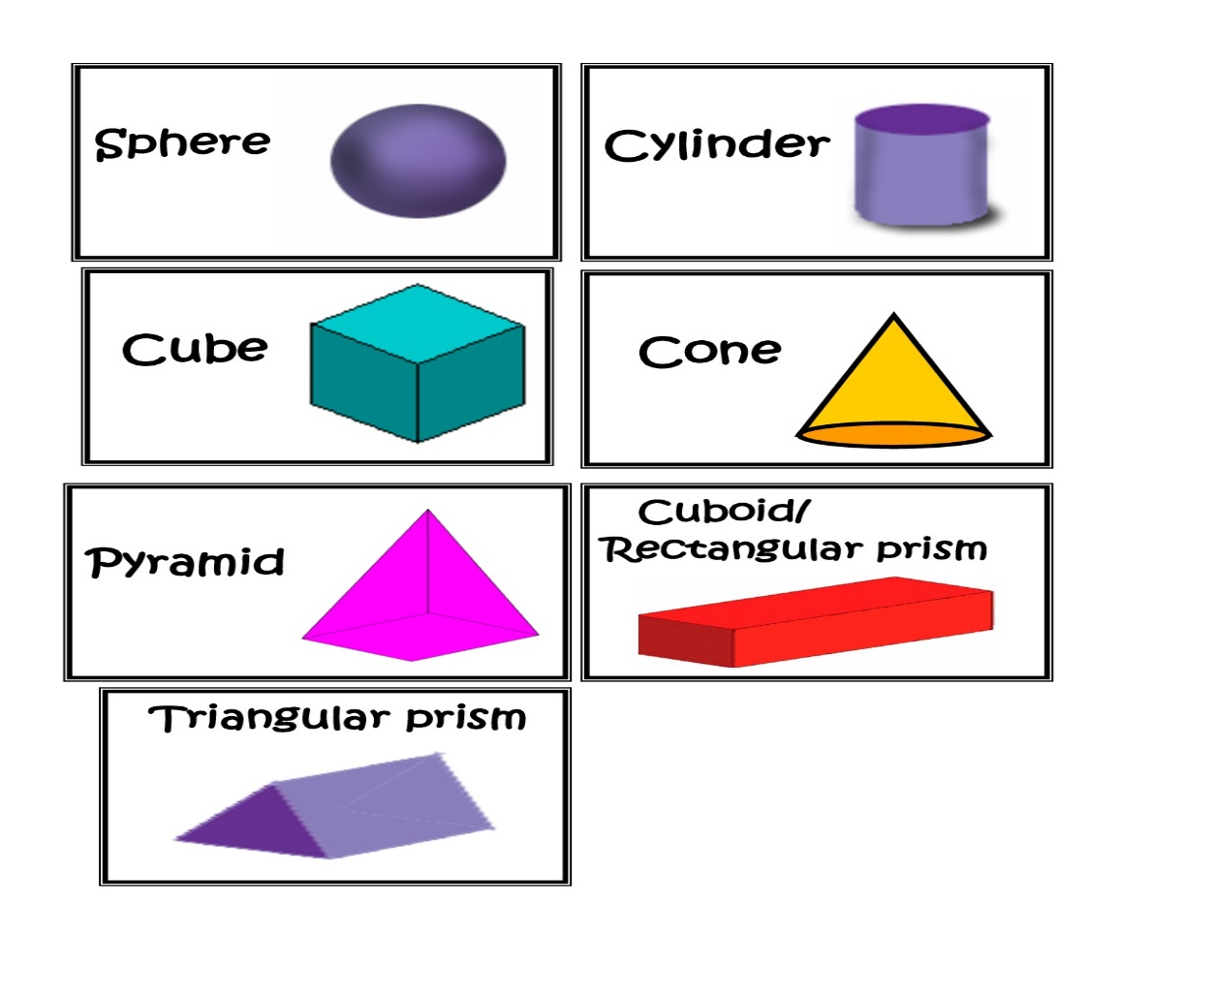

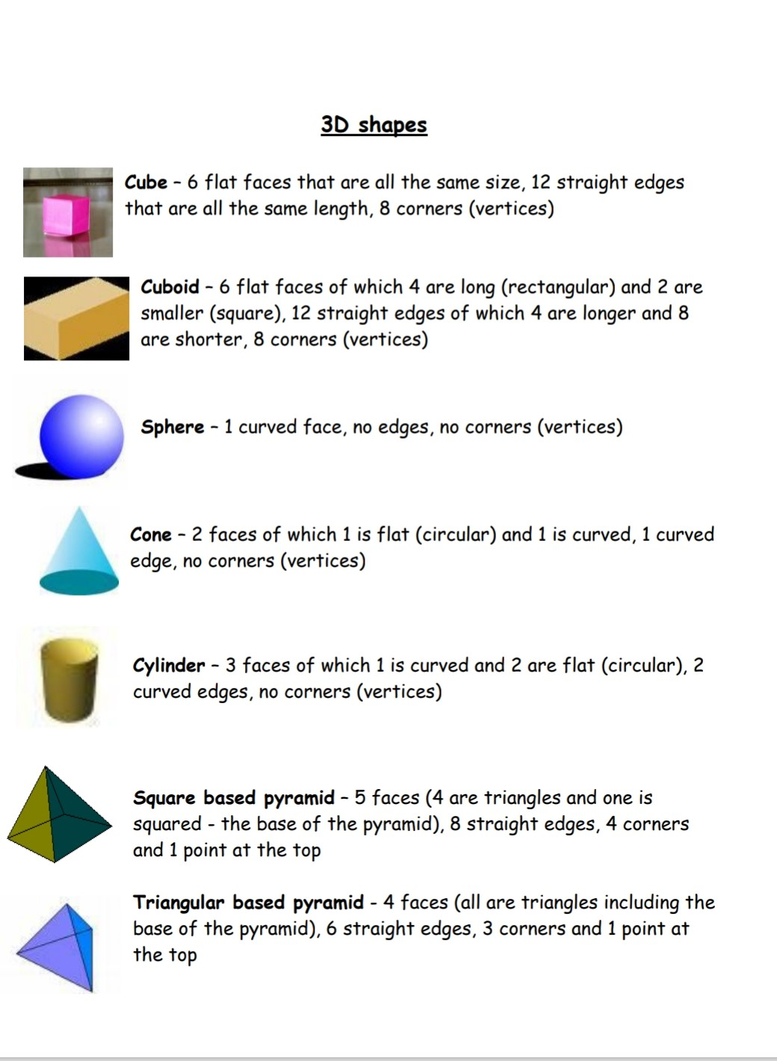

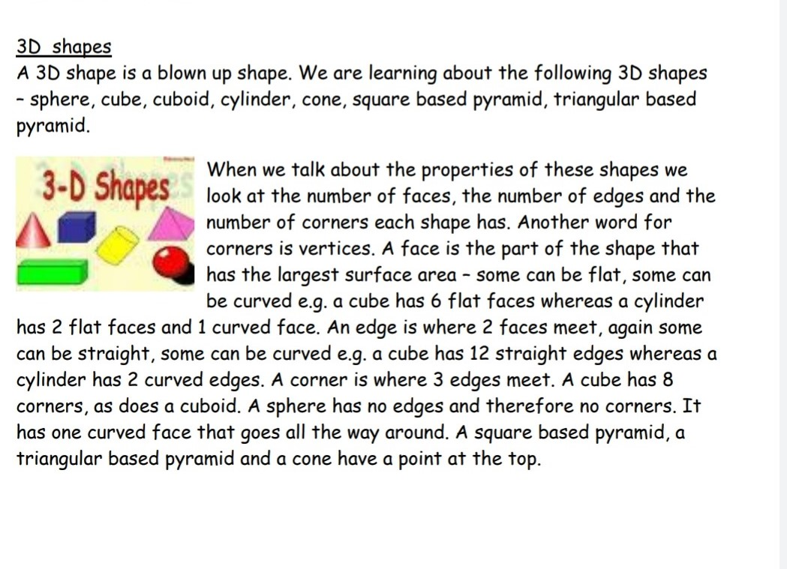

Monday & Wednesday:
Science experiments:
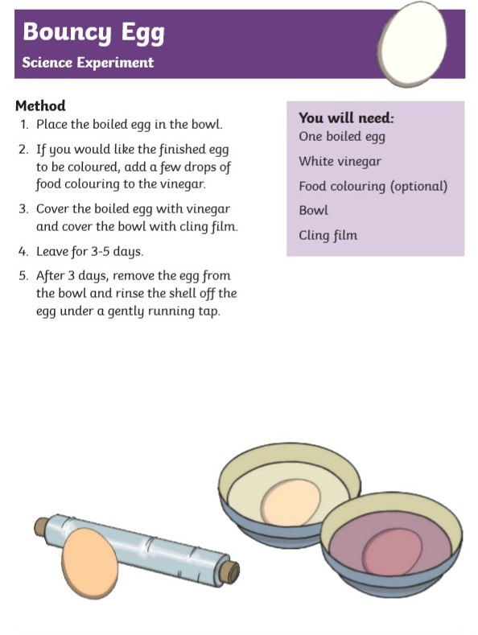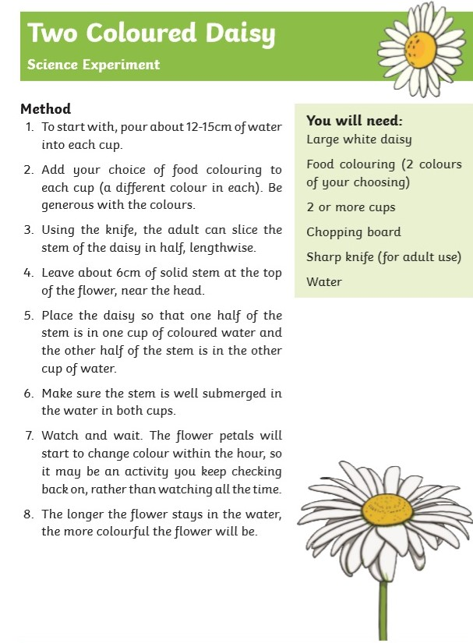
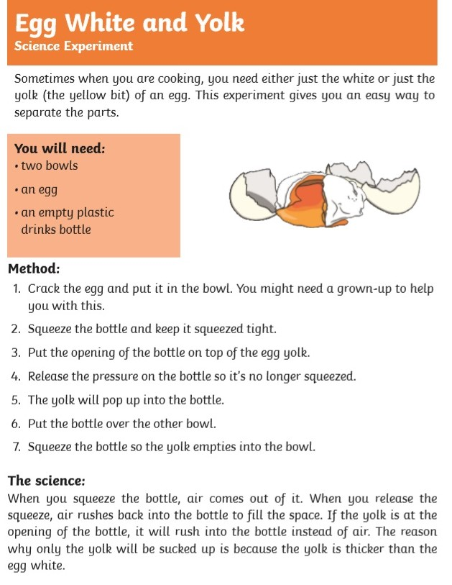
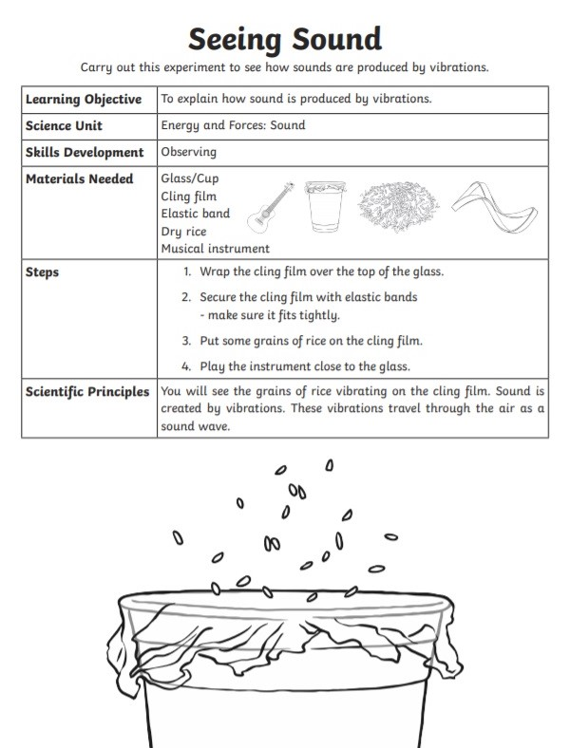

Note: Experiment works better if you place glass/mug beside loudspeaker.

Tuesday:
Suggested recipes for baking/cooking:
Method/Instructions:
- Pour the sugar (plain and brown) into a mixing bowl.
- Ask an adult to melt the butter in a microwave.
- Add the melted butter to the sugar in the mixing bowl.
- Mix the sugar and butter until there are no lumps.
- Add egg and vanilla essence to the mixing bowl and mix.
- Sift in the flour and baking powder into the mixing bowl.
- Fold the mixture with a spatula.
- Add chocolate chips to the mixture and mix them in.
- Cover with cling film and leave in the fridge for 30 minutes.
- Ask an adult to preheat the oven to 180degrees/gas mark 4.
- Grease your baking tray/use greaseproof paper to line your tray.
- Place small scoops of cookie dough onto the tray (leave enough space as they’ll melt and expand).
- Place your thumb down on top of the middle of each cookie.
- Ask an adult to place in the oven for 15 minutes.
- Leave to cool on a wire rack.
White Chocolate Chip Cookies
Ingredients: (makes 15 cookies)
- 100g sugar
- 115 g unsalted butter
- 1 tsp vanilla extract
- 1 egg
- 155g flour
- 165 g brown sugar
- ½ tsp baking powder
- 200g white chocolate chips
- Smarties (optional)
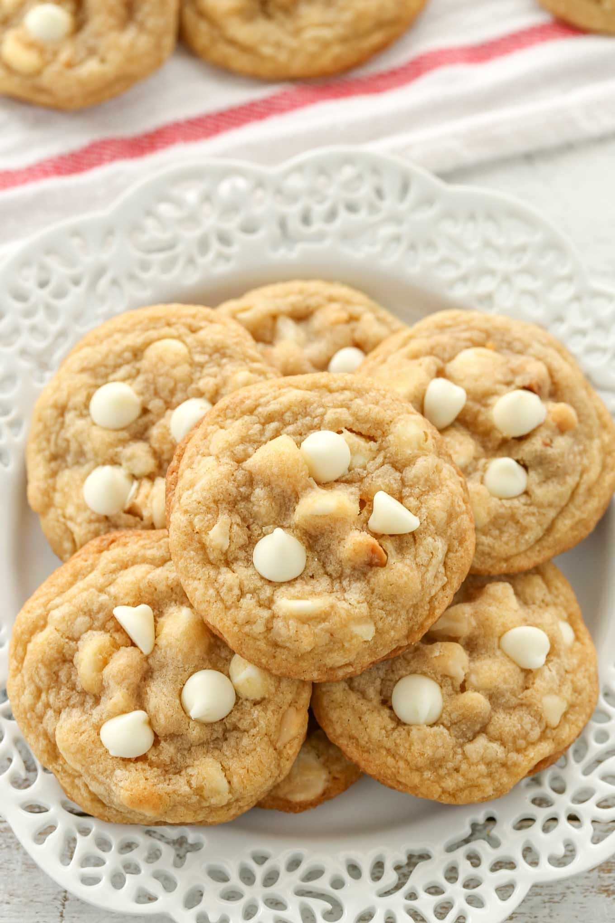

Method/Instructions:
- Break the biscuits into small pieces in a mixing bowl.
- Ask an adult to melt the butter and sugar together in a microwave.
- Once it has melted, add the cocoa and drinking chocolate.
- In a separate bowl, beat 2 eggs, then add the beaten eggs to the sugar/butter mixture and mix well.
- Pour the melted mixture over the biscuits.
- Line a tin with greaseproof paper.
- Press the mixture into the tin and cover with another sheet of greaseproof paper.
- Press down well
- Leave the mixture in the fridge to cool overnight.
- Ask an adult to melt the milk chocolate in a microwave.
- Pour the chocolate over the biscuit mixture and leave in the fridge to set.
- Once set, remove the tin from the fridge and ask an adult to cut into squares.
Chocolate Biscuit Cake
Ingredients:
- 400g rich tea biscuits
- 225 g butter
- 85g caster sugar
- 2 eggs
- 1 tbsp cocoa powder
- 1 tbsp drinking chocolate
- 100g milk chocolate
- Marshmallows/maltesers (optional)
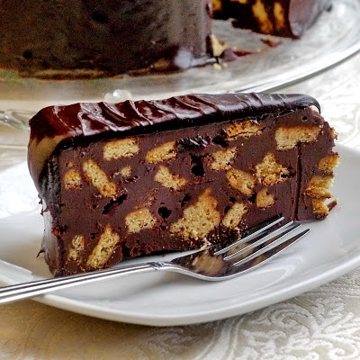
Method/Instructions:
- Crack 2 eggs in a bowl.
- Add a banana and mash until smooth.
- Add oats and mix well until smooth.
- Add a dash of cinnamon for flavour.
- Beat all ingredients with a fork or wooden spoon until smooth. (A blender is better)
- Heat some oil/butter in a frying pan (you could use a crepe maker).
- Add some of your mixture to the pan and flip until fully cooked on both sides.
- Serve with your favourite topping such as chocolate spread, fruit or honey.
Healthy Banana Pancakes
Ingredients:
- 2 eggs
- 1 banana
- ½ cup porridge oats
- dash of cinnamon
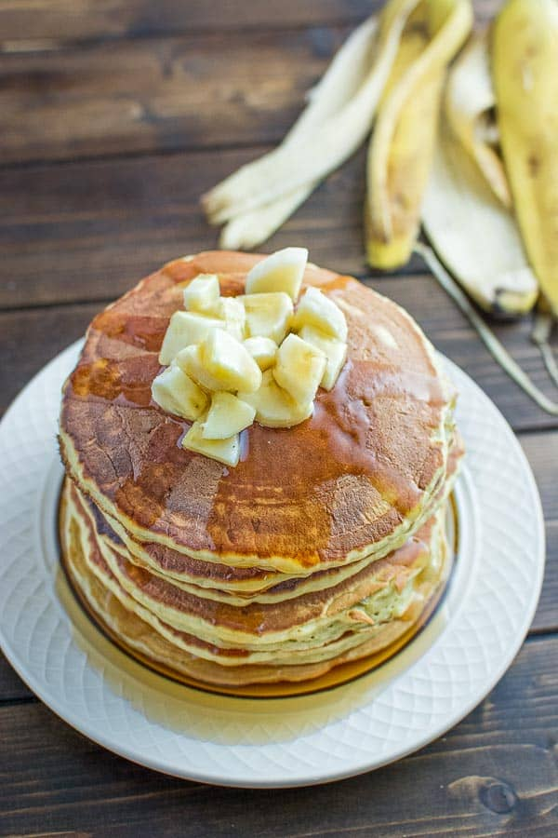

Thursday:
Rosary:
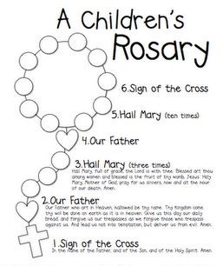

Friday:
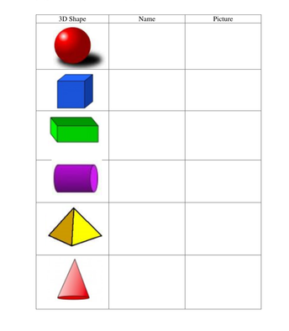
Maths shape hunt:

Art: ‘Sunflowers’ by Vincent Van Gogh

Maths Matters answers for self-correction:
Page 134
1a. a red sphere b. a ____cone c. a ____ triangular prism d. a ____ cube e. a ____ cuboid
f. a ____ cylinder g. a _____ pyramid (choose a different colour for each shape)
2. teacher/parent check
Page 135
- cube, 6 faces, 8 corners/vertices
- cube b. 8 c. flat faces
- cube= 6 faces, 8 vertices
cuboid= 6 faces, 8 vertices
triangular prism= 5 faces, 6 vertices
pyramid= 5 faces, 5 vertices
- a. cube, 6 squares
b. cuboid, 4 rectangles
c. pyramid, 1 square, 4 triangles
d. triangular prism, 2 triangles, 3 rectangles
Page 136
- cylinder=2flat faces, 1 curved face. cone=1 flat face, 1 curved face
pyramid, 5 flat faces, 0 curved faces
- cube= roll x stack √ slide √
cuboid= roll x stack √ slide √
triangular prism= roll x stack √ slide √
pyramid= roll x stack x slide √
sphere= roll roll √ stack x slide x
cone= roll √ stack x slide √
cylinder= roll √ stack √ slide
Page 137
1a. rectangle b. 5
2.8 3. 27 4. cuboid 5. 21

