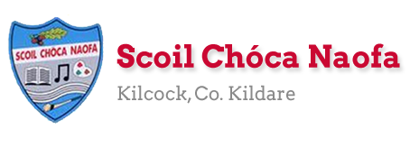

Dear 4th Class,
I hope you and your family are keeping safe and well. A lot of you got in touch this week and I was so happy to hear from you. I was so impressed with all of the wonderful work you have completed to date. Well done to you and your families. I know it takes a different kind of effort.
This week is a bank holiday weekend. I would you like to take a well-deserved break and to relax on Monday. I have provided some optional activities for you to try on Tuesday. This week I would like you to focus on your health and wellbeing. Try your best with your work and don’t worry if you don’t get all activities completed. If you started to keep a personal diary, I would like you to carry on with this as best as you can, recording your thoughts and feelings and what you are getting up to each day.
Please continue to send the work you are most proud of to mstierney@scoilchoca.ie. You can email me every few days if you’d like. I will try to respond as soon as I can. Parents, could you please send me an up-to-date email address at your earliest convenience as I need to email you all a class preference document/friendship list. Thank you in advance.

Stay safe and keep smiling,
Ms. Tierney

Here is a short prayer for you to say this week.

Work for Ms. Tierney’s 4th Class:
Monday 04/05/20 – Friday 08/05/20
Monday | Bank Holiday  Relax and have a lovely day
Tuesday | All activities are optional  - Kind mind activity. (See below)  - Bake something for your family (adult supervision required-suggestions/ideas below)  Write out your recipe in your copy: include your ingredients and method (remember your bossy verbs)  - Send me a picture of your May altar if you created one. Say a prayer to Mary.  - Read your own library book  - What’s your name? Fit activity for kids (see below)
Wednesday | English:  - Read at Home pg 110  - Read Chapter 18 in your novel ‘The Boy in the Dress.’  - Design your own book cover for the novel.  Maths:  - Maths Matters pg 140 (Answers at end of document). Find the length of different items in your home instead of school items.  - Mathletics Activities  - Count up and down in multiplies from 2-20,3-30,4-40,5-50, 6-60  Irish:  - Léigh Scuab Fiacal Danny  - Can an t-amhrán/Sing the song: Samhradh Samhradh  - Watch Cúla4 ar scoil on TG4 at 10 a.m.  - Imir cluichí ar duolingo  P.E:  - PE with Joe Wicks on Youtube  Other:  SPHE: Wellbeing/Mindfulness  - Light up the world with kindness activity (see below)
Thursday | English:  - Read at Home pg 111  - Read Chapter 19 in your novel ‘The Boy in the Dress.’  - Write a book report (see template below)  Maths:  - Maths Matters pg 141 (Answers at end of document)  - Mathletics Activities  - Count up and down in multiples from 7-70, 8-80, 9-90, 10-100  Irish:  - Léigh Scuab Fiacal Danny  - Can an t-amhrán/Sing the song: Samhradh Samhradh  - Watch Cúla4 ar scoil on TG4 at 10 a.m.  - Imir cluichí ar Duolingo  P.E:  - PE with Joe Wicks on YouTube  Other:  SPHE: Wellbeing/Mindfulness  - Feeling positive emotions activity (see below)
Friday | English:  - Read at Home pg 112  - Read Chapter 20, in your novel ‘The Boy in the Dress.’  - Write an alternative/different ending for the novel.  Maths:  - Maths Matters page 142 (Answers at end of document)  - Count up and down in multiples from 11-110, 12-120  Irish:  - Léigh Scuab Fiacal Danny  - Can an t-amhrán/Sing the song: Samhradh, Samhradh  - Watch Cúla4 ar scoil on TG4 at 10 a.m  - Imir cluichí ar Duolingo  P.E:  - PE with Joe Wicks on YouTube  Other:  SPHE: Wellbeing/Mindfulness  - Acrostic poem activity (see below)

Useful websites for this week:
- Maths: https://www.mathletics.com/uk/
- Maths: Tables revision games- https://www.topmarks.co.uk/maths-games/7-11-years/multiplication-and-division
- Gaeilge: Can an t-amhrán/sing the song: https://www.youtube.com/watch?v=VjE33BQ7aJ4
- PE: Joe Wicks’ Live Daily PE workouts: https://www.youtube.com/
- General: Twinkl: Worksheets/Powerpoints available: Free access if you use code CVDTWINKLHELPS
- RTE’s Home School Hub. If you miss it, you might be able to watch it back on RTE Player. https://www.rte.ie/player/
- https://ark.ie/events/view/online-far-away (6th May-50 minutes of theatre)

Gaeilge Resources:
Irish song: Samhradh Samhradh
Samhradh, samhradh, bainne na ngamhna,
Thugamar féin an samhradh linn.
Samhradh buí na nóinín glégeal,
Thugamar féin an samhradh linn.
Thugamar linn é ón gcoill chraobhaigh,
Thugamar féin an samhradh linn.
Samhradh buí ó luí na gréine,
Thugamar féin an samhradh linn.

Samhradh, samhradh… is cé bhainfeadh dínn é?

Bábóg na Bealtaine, maighdean an tSamhraidh,
Suas gach cnoc is síos gach gleann,
Cailíní maiseacha bán-gheala glégeal,
Thugamar féin an samhradh linn.
Cuileann is coll is trom is caorthann
Thugamar féin an samhradh linn.
An fuinseog ghléigeal bhéil an Átha
Thugamar féin an samhradh linn.

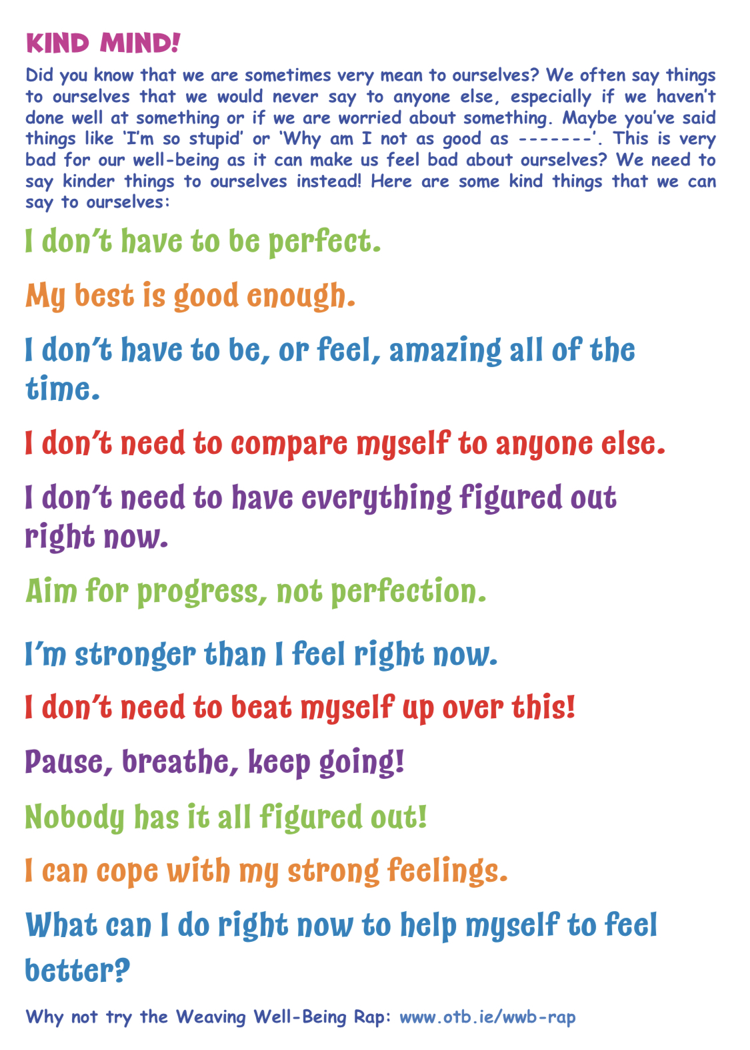
Tuesday

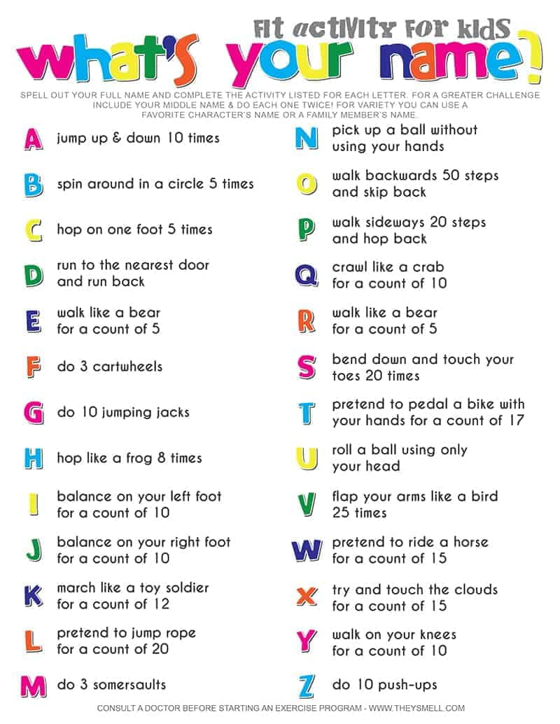

Sample Recipes:
Healthy Oaty Crunchers
Ingredients:
- 100 g butter (at room temperature)
- 100 g caster sugar
- 2 tbsp honey
- 2 eggs
- 160 g porridge oats
- 100 g wholemeal flour
- 1 tsp baking powder
- 2 tsp ground cinnamon or ginger (optional)
- Berries/nuts/chocolate chips (optional)
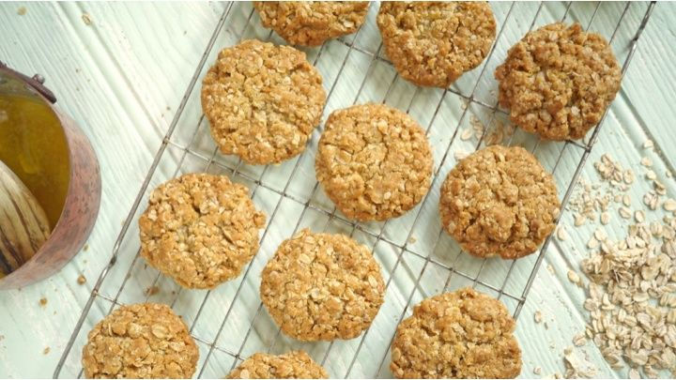
Method/Instructions:
- Ask a parent to heat the butter, golden syrup and 3 of the mars bars in the microwave.
- Add the rice krispies to the bowl and stir it with the remaining mars bar.
- Pour the mixture into a greased baking tray and press down firmly. (use a potato masher)
- Ask a parent to heat the milk chocolate in a bowl in the microwave.
- Pour on top of the rice krispy mixture.
- Ask a parent to melt the white chocolate in a bowl in the microwave.
- Drizzle the white chocolate on top of the rice krispy mixture.
- Use a skewer to drag forward and back the mixture to create a feathered effect.
- Place the baking tray in the fridge to chill.
- Ask an adult to cut into squares.
Yummy Mars Bar Squares
Ingredients:
- 100g butter (unsalted/softened)
- 4 mars bars (chopped)
- 1 ½ tbsp golden syrup
- 150g rice krispies
- 350g milk chocolate
- 50g white chocolate
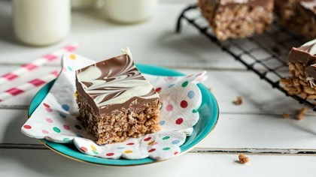
Method/Instructions:
- Ask an adult to preheat the oven to200֯ Celsius/gas mark 6.
- Measure out all of your ingredients.
- Put the butter and sugar in a mixing bowl. Beat them with a wooden spoon until they’re soft and light.
- Beat in the honey.
- Break the egg into a small bowl/mug. Lightly whisk it with a fork.
- Add the whisked egg to the mixing bowl. Beat them all together.
- Add the oats, flour, baking powder and spices if you are using them. Stir well to combine.
- Grease your baking tray/use parchment paper and drop tablespoons of your mixture onto the baking tray.
- Bake for 10-12 minutes in the oven.
- Ask an adult to take the trays out of the oven.
- Leave to cool for 2 minutes before transferring onto a wire rack.
- Enjoy your biscuits with a glass of milk for extra protein.
Method/Instructions:
- Ask an adult to heat the oven to 180֯c/Gas mark 4.
- Mix all ingredients in order into a mixing bowl and stir well to combine.
- Pour mixture into a greased tin.
- Cook for 10-15 minutes
- Ask an adult to remove the baking tin from the oven.
- Allow to cool before transferring to a wire rack.
- When cooled fully, ask an adult to cut into slices.
- Enjoy with some hot chocolate for extra
chocolatiness.
Quick and Easy Chocolate Brownies
Ingredients:
- 200g caster sugar
- 115 g butter (melted)
- 30 g cocoa powder
- ½ tsp vanilla extract
- 2 eggs
- 115g plain flour
- pinch baking powder
- pinch salt
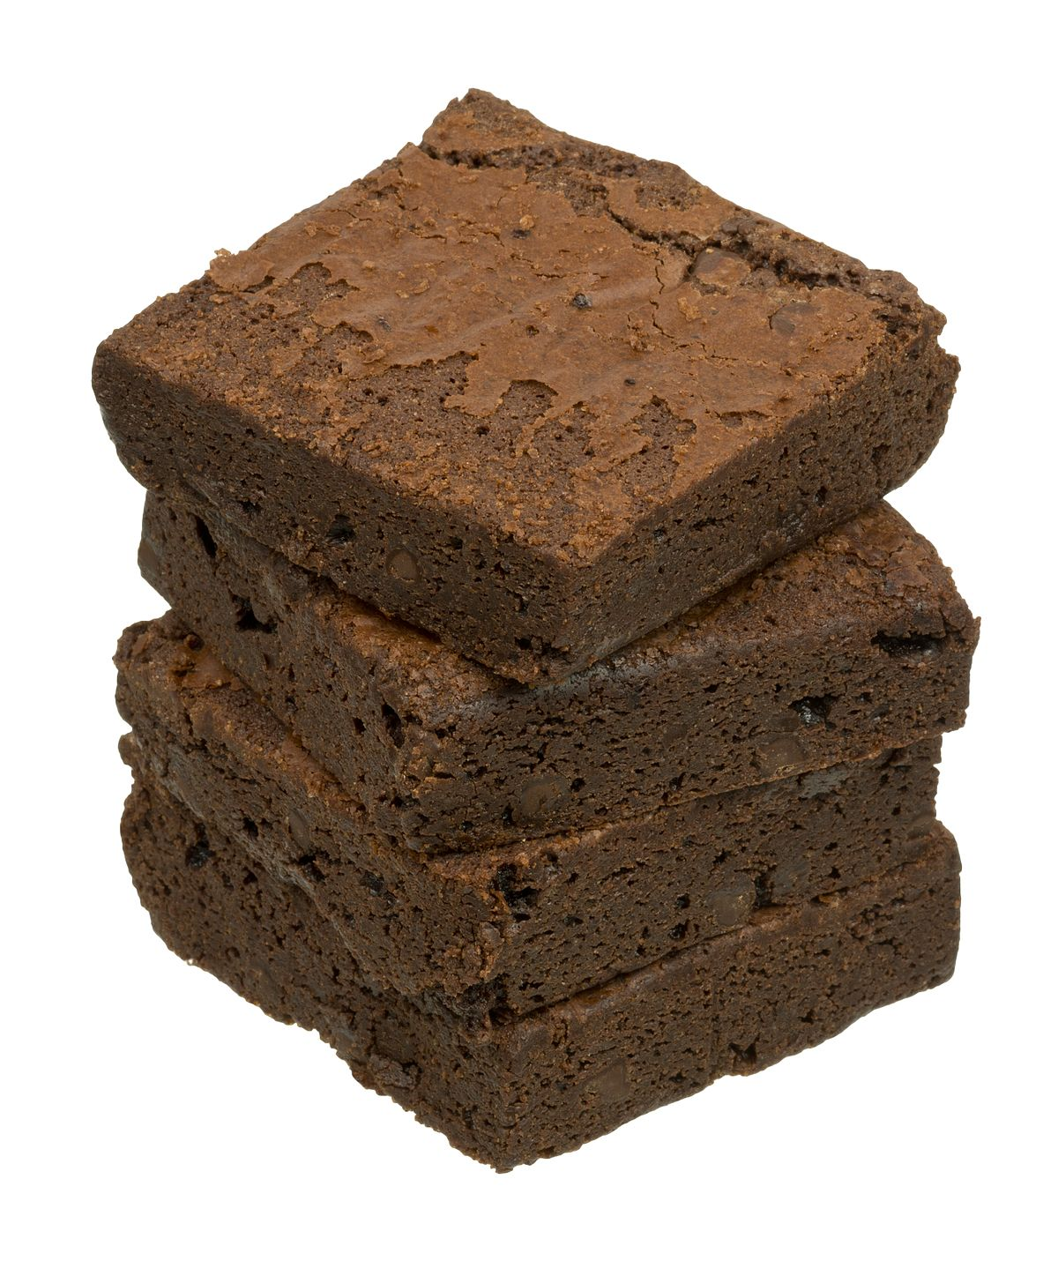
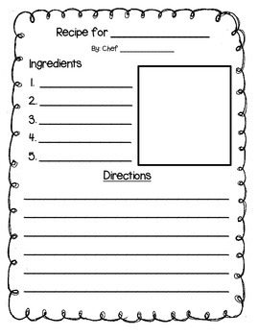

Wednesday:
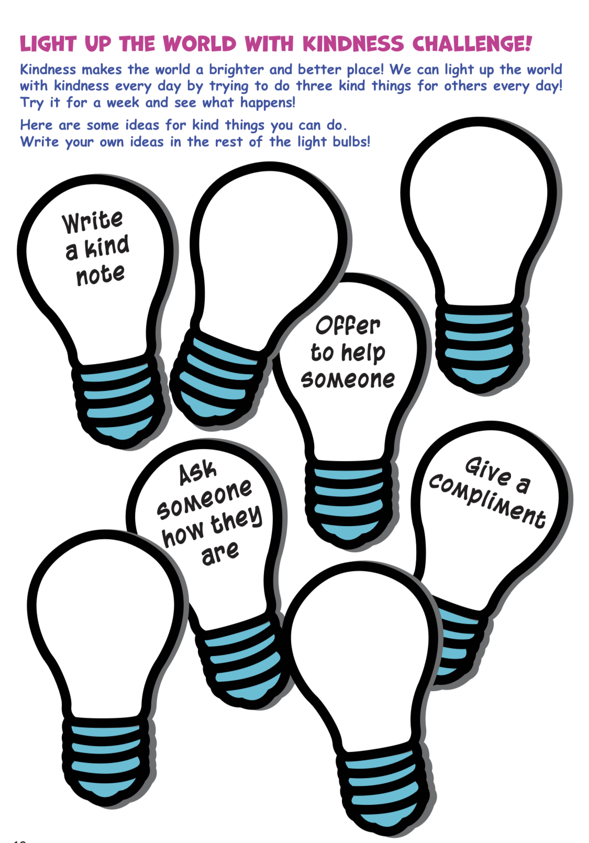

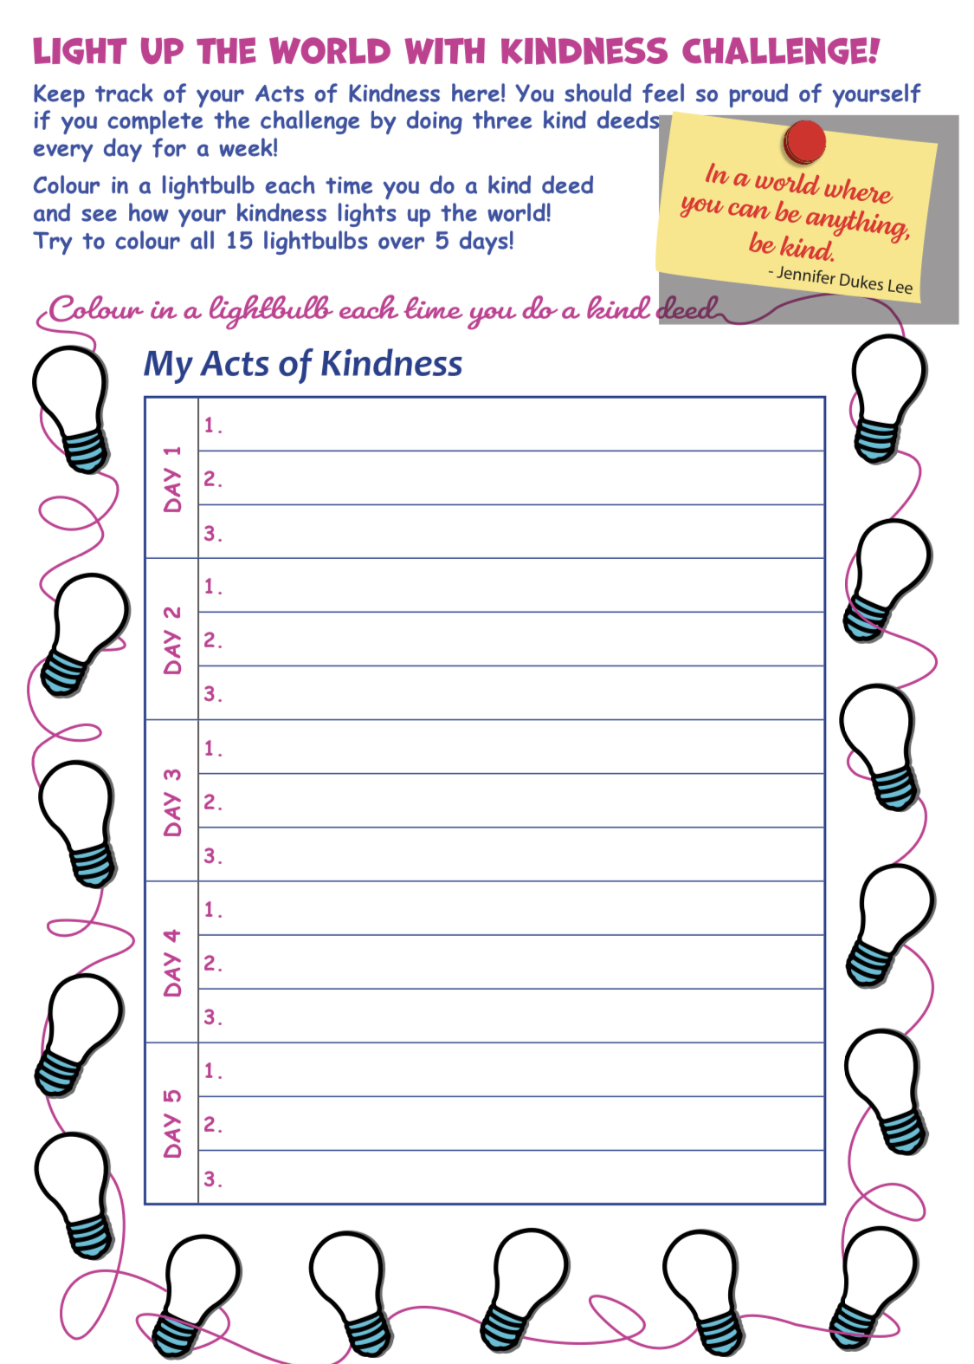

Thursday:
Book Report Template
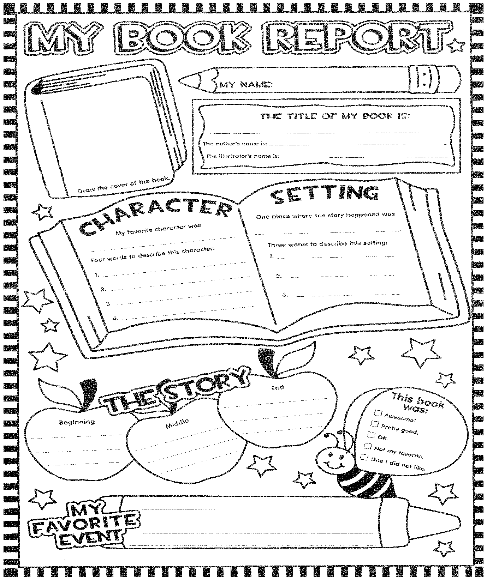

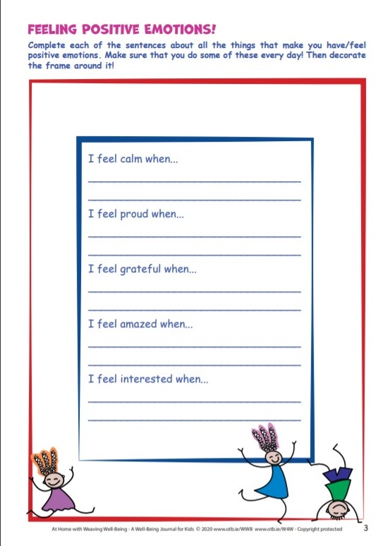

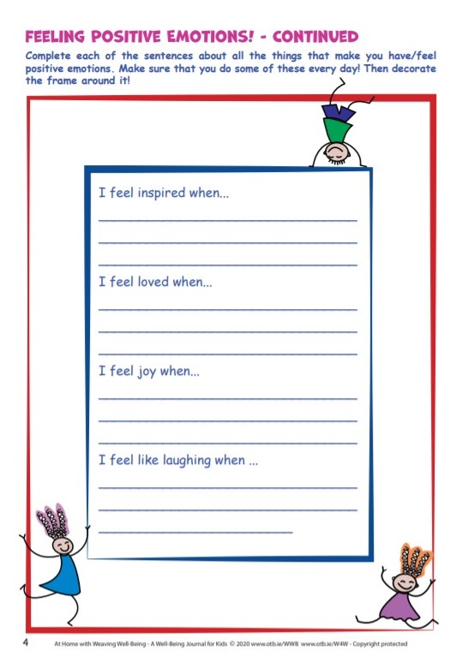

Friday:

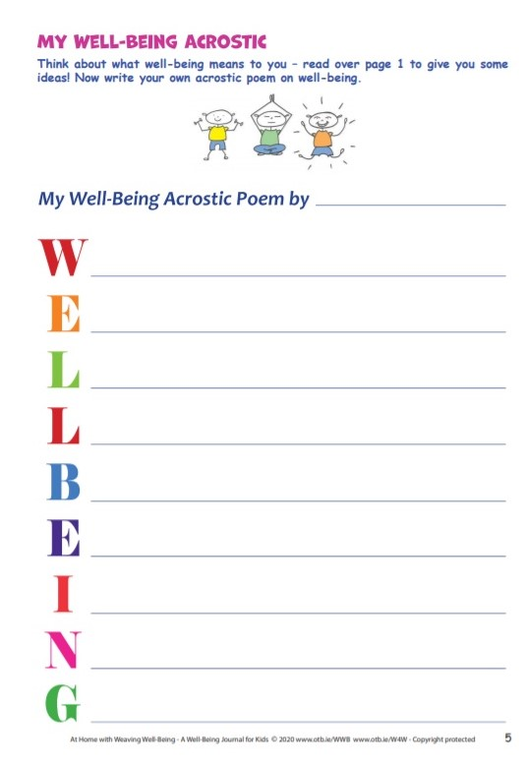
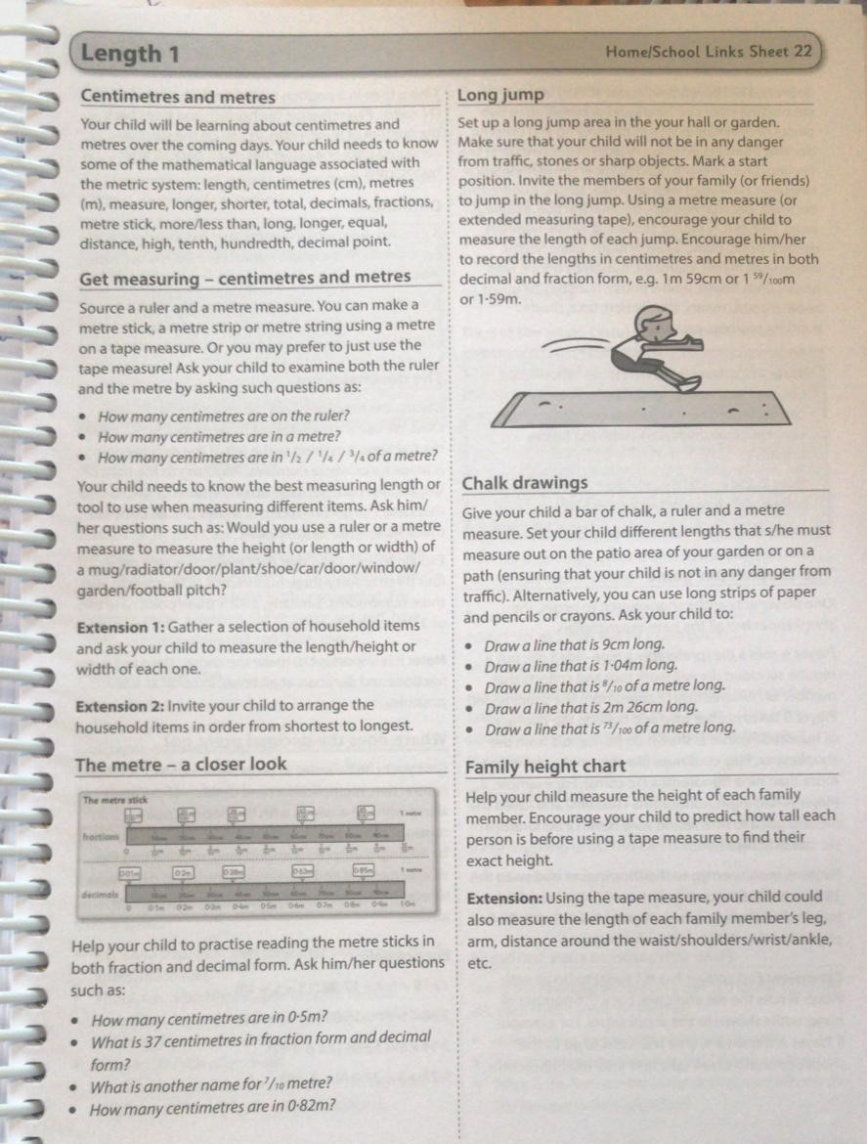

Maths answers for self-correction
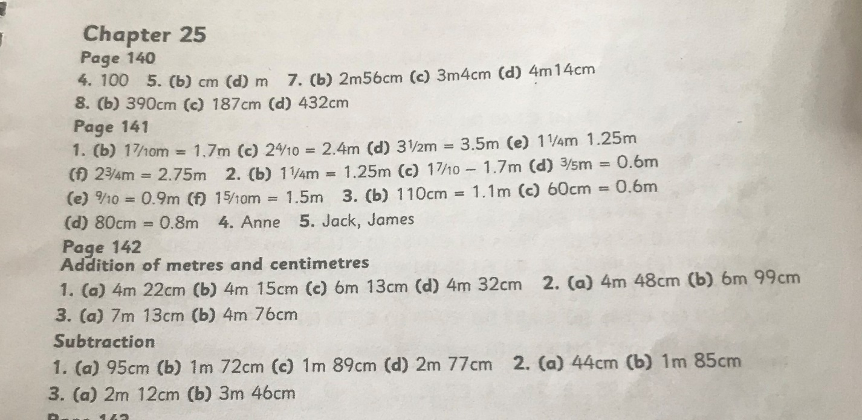

*See below for Ms. Heffernan’s work

Teacher: Ms. Heffernan

Note: SEN teachers have added work on to the teachers’ plan. Children can decide to do this work instead of something the teacher has assigned. It is not extra work. Also, we would be delighted if you could email on a picture of something that your child has done and is proud of so we can see their lovely work again!
Language | Here are some interview questions. You can answer them yourself or why not phone a relative or friend and ask them.  https://rainbow3to6.cjfallon.ie/class/fourth/units/3/lesson/4/slide/1  Or what about an online game of Articulate? You have to describe the word without saying it!  https://rainbow3to6.cjfallon.ie/class/fourth/units/3/lesson/5/slide/3  Try this listening activity. You will need someone to call out the instructions for you.  file:///C:/Users/Scoil/AppData/Local/Temp/Temp1_t-s-4399-listen-and-do-activity-pack-.zip/5.%20Five%20Word%20Level/Listen%20and%20Do%201-%20Five%20Word%20Level.pdf  You could try some memory games like we play in school. Ask someone to call out 4 digits forwards or backwards and see if you can write them down.  Keep reading!  If anybody needs any more reading material, please let me know. If you’ve read or listened to a story, I’d love to hear what you thought about it.  Send me an email to let me know how you’re getting on-I’d love to hear from you!
Contact SEN Teacher: msheffernan@scoilchoca.ie

