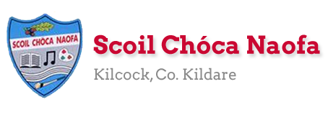

Dear 3rd Class,
I hope you and your family are keeping safe and well. A lot of you got in touch this week and I was so happy to hear from you. I was so impressed with all of the wonderful work you have completed to date. Well done to you and your families. I know it takes a different kind of effort.
This week is a bank holiday weekend. I would you like to take a well-deserved break and to relax on Monday. I have provided some optional activities for you to try on Tuesday. This week I would like you to focus on your health and wellbeing. Try your best with your work and don’t worry if you don’t get all activities completed. If you started to keep a personal diary, I would like you to carry on with this as best as you can, recording your thoughts and feelings and what you are getting up to each day.
Please continue to send the work you are most proud of to mstierney@scoilchoca.ie. You can email me every few days if you’d like. I will try to respond as soon as I can. Parents, could you please send me an up-to-date email address at your earliest convenience as I need to email you all a class preference document/friendship list. Thank you in advance.

Stay safe and keep smiling,
Ms. Tierney

Here is a short prayer for you to say this week.

Work for Ms. Tierney’s 3rd Class:
Monday 04/05/20 – Friday 08/05/20
Monday | Bank Holiday  Relax and have a lovely day
Tuesday | All activities are optional  - Kind mind activity. (See below)  - Bake something for your family (adult supervision required-suggestions/ideas below)  Write out your recipe in your copy: include your ingredients and method (remember your bossy verbs)  - Send me a picture of your May altar if you created one. Say a prayer to Mary.  - Read your own library book  - What’s your name? Fit activity for kids (see below)
Wednesday | English:  - Read at Home pg 110  - Read Chapter 18 in your novel ‘The Boy in the Dress.’  - Design your own book cover for the novel.  Maths:  - Maths Matters pg 131 question 3 in your copy,  pg 132 question 1 in your book (Answers at end of document)  - Mathletics Activties  - Count up and down in multiplies from 2-20,3-30,4-40,5-50, 6-60  Irish:  - Léigh sa Bhaile: Read the next page  - Freagair na ceisteanna i do chóipleabhar/Answer questions in your copy.  - Can an t-amhrán/Sing the song: Samhradh Samhradh  - Watch Cúla4 ar scoil on TG4 at 10 a.m.  P.E:  - PE with Joe Wicks on Youtube  Other:  SPHE: Wellbeing/Mindfulness  - Light up the world with kindness activity (see below)
Thursday | English:  - Read at Home pg 111  - Read Chapter 19 in your novel ‘The Boy in the Dress.’  - Write a book report (see template below)  Maths:  - Maths Matters pg 132 q 2 in your book,  q 3 in your copy (Answers at end of document)  - Mathletics Activities  - Count up and down in multiples from 7-70, 8-80, 9-90, 10-100  Irish:  - Léigh sa Bhaile: Read the next page  - Freagair na ceisteanna i do chóipleabhar  - Can an t-amhrán/Sing the song: Samhradh Samhradh  - Watch Cúla4 ar scoil on TG4 at 10 a.m.  P.E:  - PE with Joe Wicks on YouTube  Other:  SPHE: Wellbeing/Mindfulness  - Feeling positive emotions activity (see below)
Friday | English:  - Read at Home pg 112  - Read Chapter 20, in your novel ‘The Boy in the Dress.’  - Write an alternative/different ending for the novel.  Maths:  - Maths Matters page 133-work out the questions in your copy and then write the answers into your book (Answers at end of document)  - Count up and down in multiples from 11-110, 12-120  Irish:  - Léigh sa Bhaile: Read the next page  - Freagair na ceisteanna i do chóipleabhar  - Can an t-amhrán/Sing the song: Samhradh, Samhradh  - Watch Cúla4 ar scoil on TG4 at 10 a.m  P.E:  - PE with Joe Wicks on YouTube  Other:  SPHE: Wellbeing/Mindfulness  - Acrostic poem activity (see below)

Useful websites for this week:
- Maths: https://www.mathletics.com/uk/
- Maths: Tables revision games- https://www.topmarks.co.uk/maths-games/7-11-years/multiplication-and-division
- Gaeilge: Can an t-amhrán/sing the song: https://www.youtube.com/watch?v=VjE33BQ7aJ4
- PE: Joe Wicks’ Live Daily PE workouts: https://www.youtube.com/
- General: Twinkl: Worksheets/Powerpoints available: Free access if you use code CVDTWINKLHELPS
- RTE’s Home School Hub. If you miss it, you might be able to watch it back on RTE Player. https://www.rte.ie/player/
- https://ark.ie/events/view/online-far-away (6th May-50 minutes of theatre)

Gaeilge Resources:
Irish song: Samhradh Samhradh
Samhradh, samhradh, bainne na ngamhna,
Thugamar féin an samhradh linn.
Samhradh buí na nóinín glégeal,
Thugamar féin an samhradh linn.
Thugamar linn é ón gcoill chraobhaigh,
Thugamar féin an samhradh linn.
Samhradh buí ó luí na gréine,
Thugamar féin an samhradh linn.

Samhradh, samhradh… is cé bhainfeadh dínn é?

Bábóg na Bealtaine, maighdean an tSamhraidh,
Suas gach cnoc is síos gach gleann,
Cailíní maiseacha bán-gheala glégeal,
Thugamar féin an samhradh linn.
Cuileann is coll is trom is caorthann
Thugamar féin an samhradh linn.
An fuinseog ghléigeal bhéil an Átha
Thugamar féin an samhradh linn.

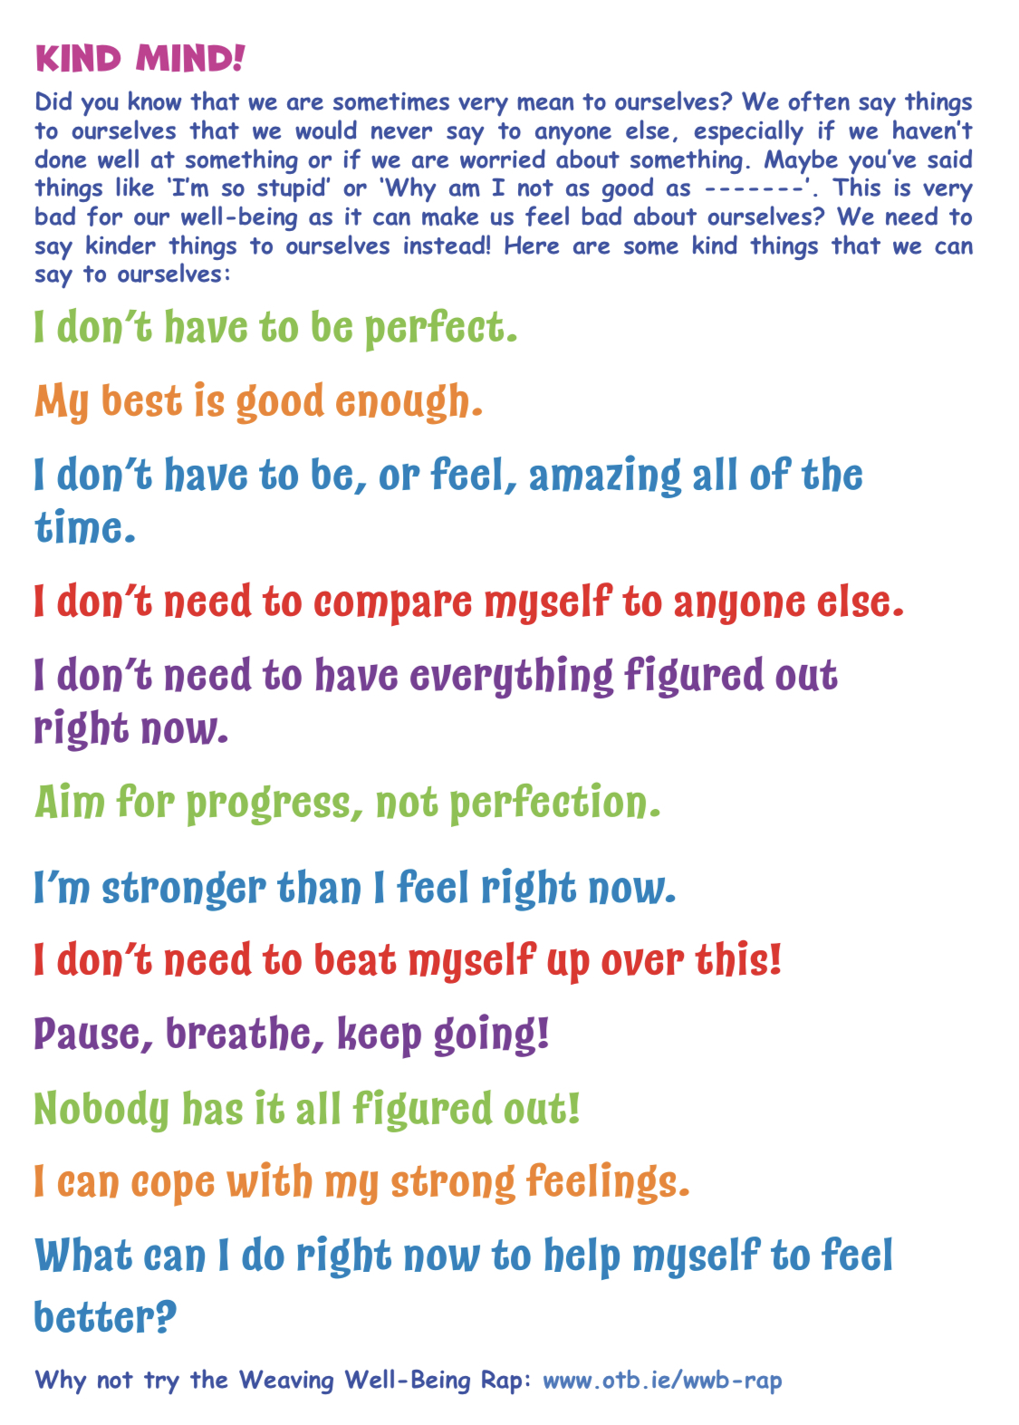
Tuesday
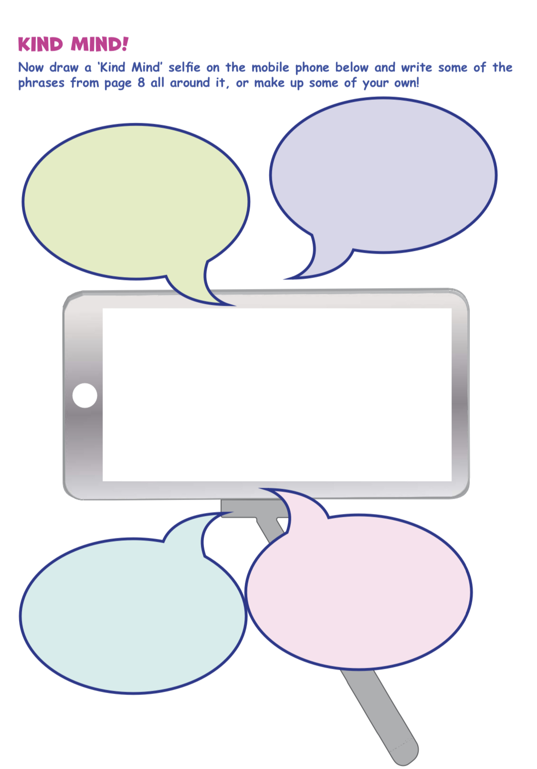

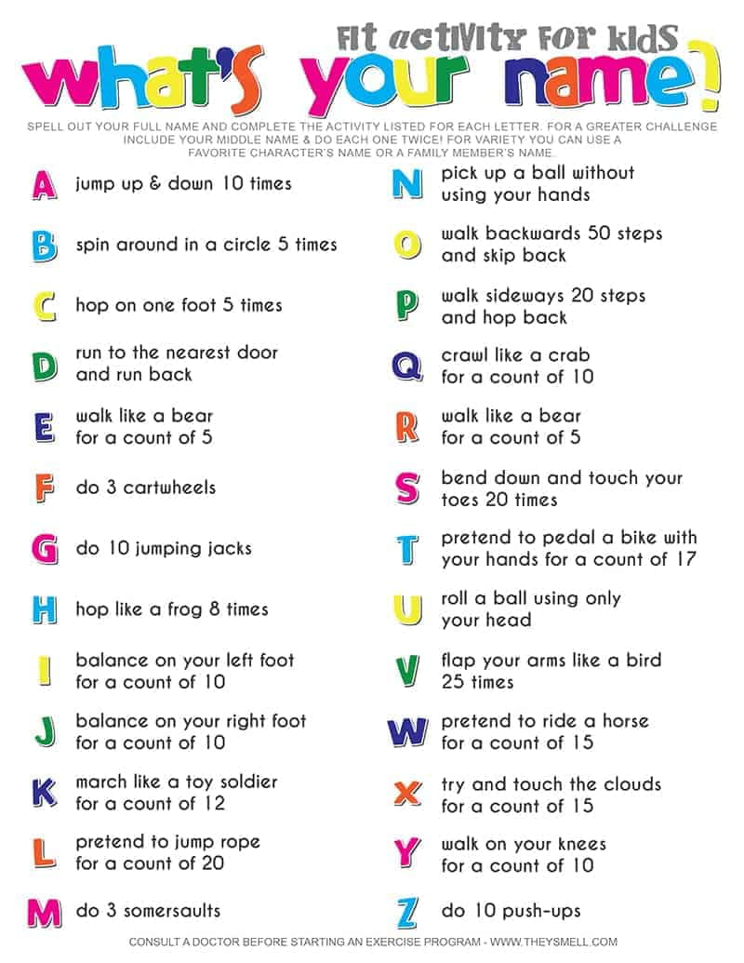

Sample Recipes:
Healthy Oaty Crunchers
Ingredients:
- 100 g butter (at room temperature)
- 100 g caster sugar
- 2 tbsp honey
- 2 eggs
- 160 g porridge oats
- 100 g wholemeal flour
- 1 tsp baking powder
- 2 tsp ground cinnamon or ginger (optional)
- Berries/nuts/chocolate chips (optional)
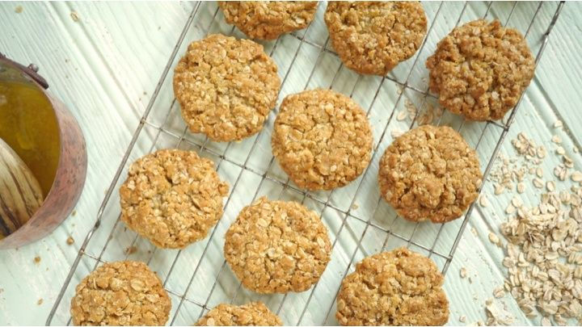
Method/Instructions:
- Ask a parent to heat the butter, golden syrup and 3 of the mars bars in the microwave.
- Add the rice krispies to the bowl and stir it with the remaining mars bar.
- Pour the mixture into a greased baking tray and press down firmly. (use a potato masher)
- Ask a parent to heat the milk chocolate in a bowl in the microwave.
- Pour on top of the rice krispy mixture.
- Ask a parent to melt the white chocolate in a bowl in the microwave.
- Drizzle the white chocolate on top of the rice krispy mixture.
- Use a skewer to drag forward and back the mixture to create a feathered effect.
- Place the baking tray in the fridge to chill.
- Ask an adult to cut into squares.
Yummy Mars Bar Squares
Ingredients:
- 100g butter (unsalted/softened)
- 4 mars bars (chopped)
- 1 ½ tbsp golden syrup
- 150g rice krispies
- 350g milk chocolate
- 50g white chocolate
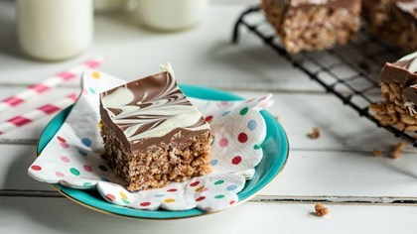
Method/Instructions:
- Ask an adult to preheat the oven to200֯ Celsius/gas mark 6.
- Measure out all of your ingredients.
- Put the butter and sugar in a mixing bowl. Beat them with a wooden spoon until they’re soft and light.
- Beat in the honey.
- Break the egg into a small bowl/mug. Lightly whisk it with a fork.
- Add the whisked egg to the mixing bowl. Beat them all together.
- Add the oats, flour, baking powder and spices if you are using them. Stir well to combine.
- Grease your baking tray/use parchment paper and drop tablespoons of your mixture onto the baking tray.
- Bake for 10-12 minutes in the oven.
- Ask an adult to take the trays out of the oven.
- Leave to cool for 2 minutes before transferring onto a wire rack.
- Enjoy your biscuits with a glass of milk for extra protein.
Method/Instructions:
- Ask an adult to heat the oven to 180֯c/Gas mark 4.
- Mix all ingredients in order into a mixing bowl and stir well to combine.
- Pour mixture into a greased tin.
- Cook for 10-15 minutes
- Ask an adult to remove the baking tin from the oven.
- Allow to cool before transferring to a wire rack.
- When cooled fully, ask an adult to cut into slices.
- Enjoy with some hot chocolate for extra
chocolatiness.
Quick and Easy Chocolate Brownies
Ingredients:
- 200g caster sugar
- 115 g butter (melted)
- 30 g cocoa powder
- ½ tsp vanilla extract
- 2 eggs
- 115g plain flour
- pinch baking powder
- pinch salt
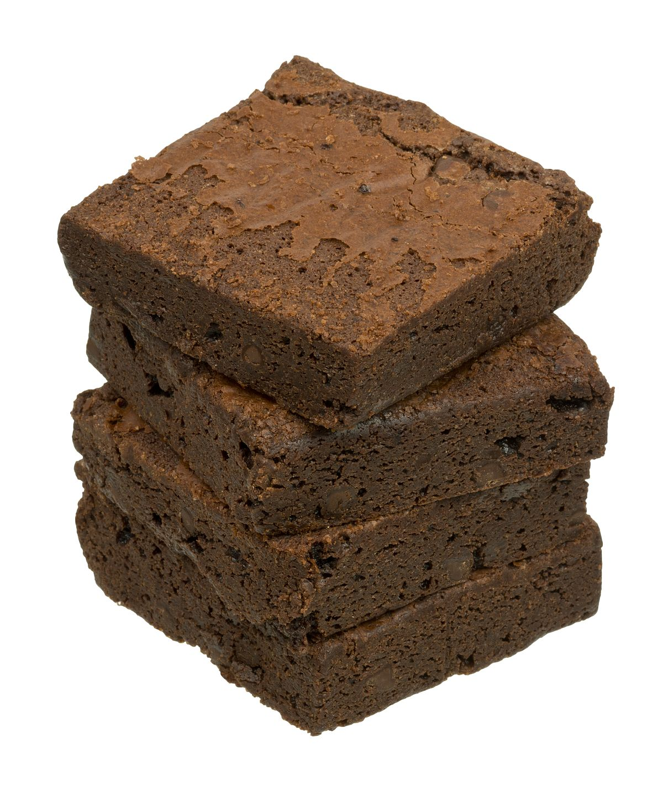
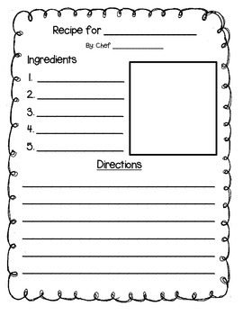

Wednesday:
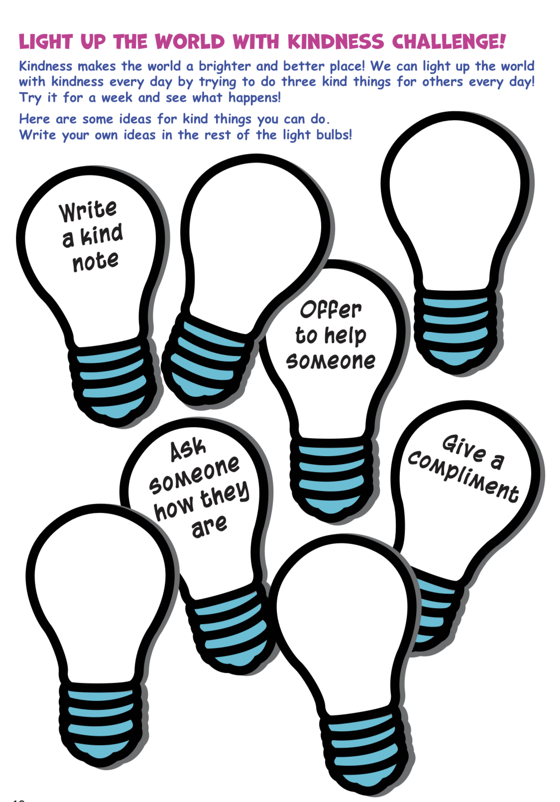

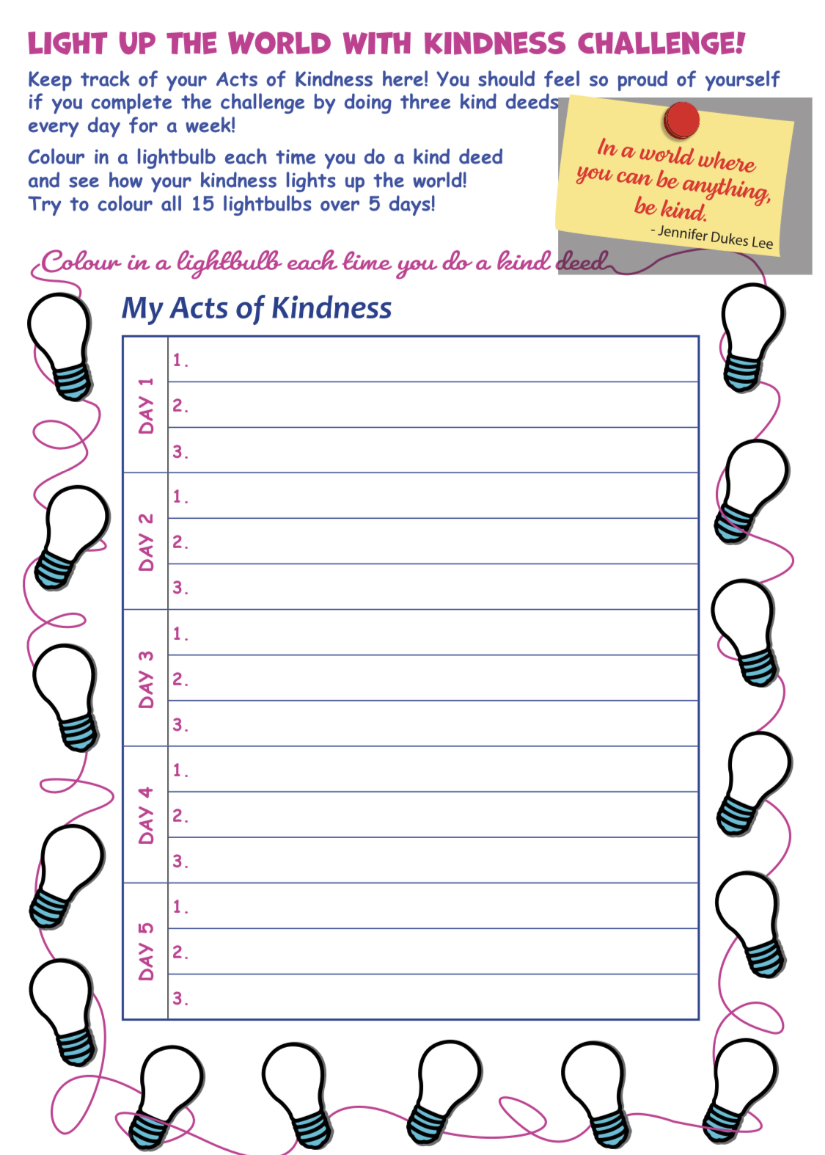

Thursday:
Book Report Template
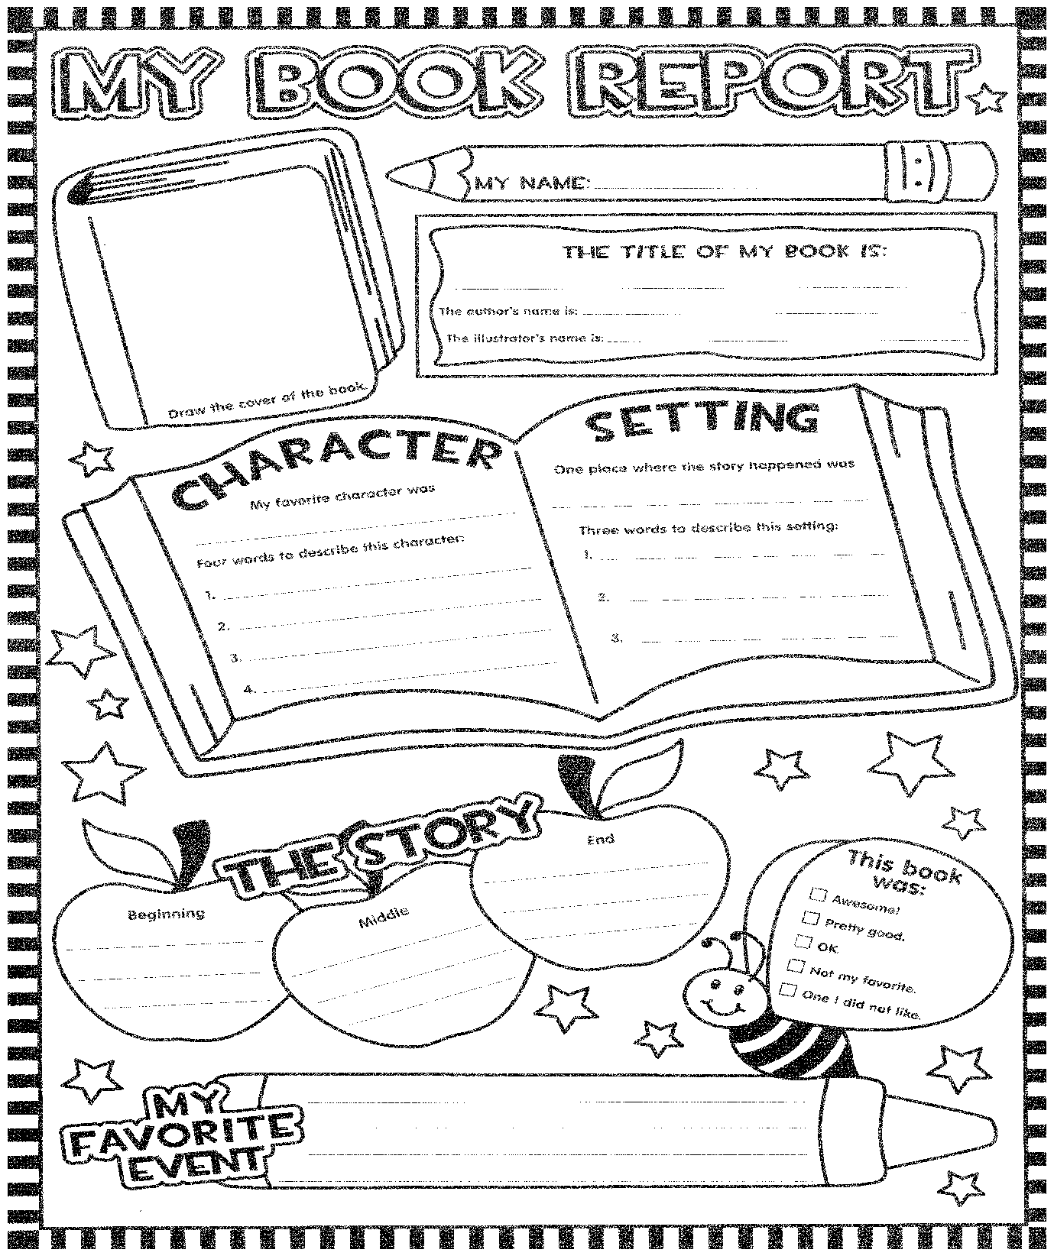

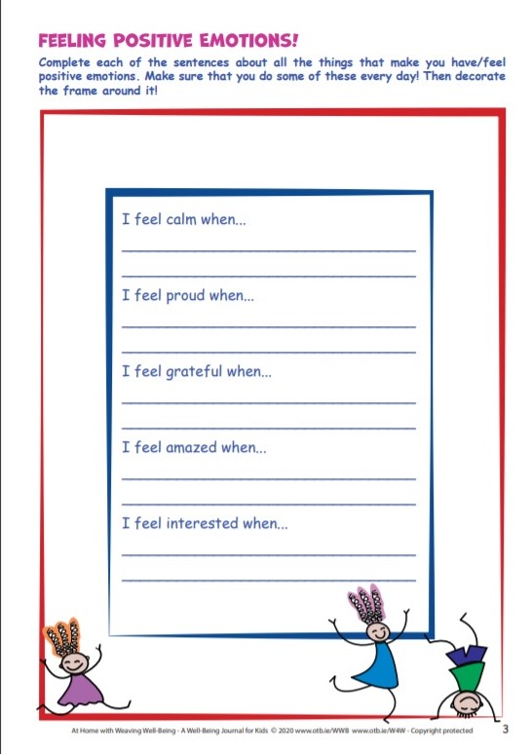

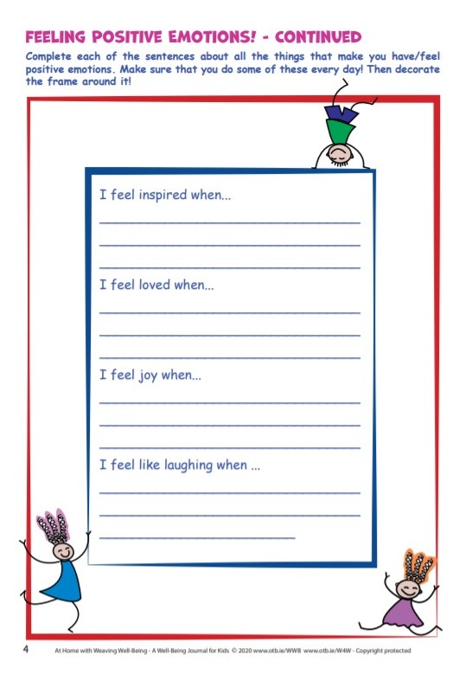

Friday:

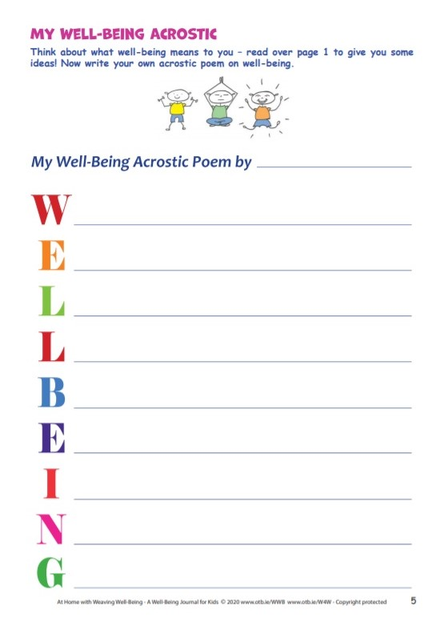

Maths Matters answers for self-correction:
Page 131
3a. 6 kg 458 g b. 10 kg 69g c. 7 kg 868g d. 12 kg 68g e. 10 kg 84 g f. 8kg 974 g
Page 132
1a. 2 kg 531g b. 2 kg 512g c. 1 kg 721g d. 2 kg 883g e. 1 kg 678g f. 2 kg 564g
g. 3 kg 524g h. 5 kg 464g
2a. 1 kg 241g b. 1 kg 634g c. 2 kg 160g d. 4 kg 915g
3a. 1 kg 904g b. 1 kg 694g c. 1 kg 630g d. 4 kg 500g e. 4 kg 205 g f. 8 kg 50 g
Page 133
- 8kg 110 g 2. 1 kg 800g 3. 5 kg 200g 4. 1 kg 750g 5. 1 kg350g
Did you know? They both weigh the same. They’re both 10kg.

*See below for Ms. Curran/Ms. McCabe’s work.

SEN/EAL work 3rd/4th Class OT May 5-8 Teachers: Ms. McCabe & Ms.Curran
Note: SEN teachers have added work on to the teachers’ plan. Children can decide to do this work instead of something the teacher has assigned. It is not extra work. Also, we would be delighted if you could email on a picture of something that your child has done and is proud of, so we can see their lovely work again!
All groups can look at the clock and tell the time 3 times per day. Also keep reading and learning your tables daily. This week do multiplication tables to 5x and practice counting up and down the ladder in 2’s, 3’s, 4’s and 5’s.
EAL: Transport&Travel | ORAL: Name as many ways possible for moving from place to place eg walk, Luas etc...  WRITE: Modes of Transport.Write above on a mindmap(draw)  https://www.twinkl.ie/resource/us2-e-53-mind-map-writing-template  Watch Powerpoint : https://www.twinkl.ie/resource/t-h-064-the-wright-brothers-information-powerpoint
Speech and Language | Conversation Starters – Continue with these, one per day.  Continue with activities from Speech & Language therapist pack or play this game  https://www.twinkl.ie/resource/t-s-892-what-am-i-guessing-game-cards-household-objects
Literacy A & B | SNIP programme – the next session. 3 pages per week.  Read the next 6 blends lists tr/sc/sm/sk/sn/sp at least 3 times each from below link:  http://www.theschoolhouse.us/lessons/lesson56.html  Please keep up the reading, every day! https://www.oxfordowl.co.uk/for-school/oxford-owl-ebook-collection  These are free ebooks and you can find your level.
Toe by Toe | Next SNIP session (18)..... 3 pages for the week.  Please read and ask an adult to read with you.
SEN Individuals | Write Reader: Write about A Scavenger Hunt or How to make Crepes.  Fry’s Words: Continue with the list you are on.  Cloze Sheet: Number 3/ Conversation Starter daily.  Do page 1 and 2 of this: https://www.otb.ie/wp-content/uploads/2020/04/At-Home-with-Weaving-Well-being-A-Mental-Health-Journal-for-Kids.pdf
Contact SEN Teachers: msmccabe@scoilchoca.ie mscurran@scoilchoca.ie
Ms Curran is working this week, Monday-Friday.

