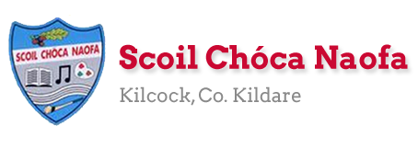
Work for Mr. Bracken’s 3rd Class: Monday 04/05/20 – Friday 08/05/20
Thought for the week: “Absence is the highest form of presence” - James Joyce
Dear 3rd class,
I was very impressed with the work last week. A lot of you got in touch and I appreciate it, well done to every one of you and your families. I know that it takes a different kind of effort. Continue to send emails of the work you’re proudest of to mrbracken@scoilchoca.ie You can email every few days, if you’d like. Keep up the great work!
This week has a Bank Holiday Monday and we were due to have Tuesday (05/05/20) off school. There is no work assigned for Monday and Tuesday’s work is all optional. Enjoy the well - earned break
Well done with your work on the nature scrapbook in particular. I hope you found it interesting. This week we are going to focus on Wellbeing & Mindfulness. In maths we are moving on to ‘Weight’. This ties in with the baking that is assigned for this week.
In Starlight this week the story is an extract from a novel by D. K. Smith. Ask yourself what the opening words in italics tells you. Based on the opening, predict what you think the problem in this story will be.
Parents, could you please send me an up-to-date email address to mrbracken@scoilchoca.ie, at your earliest convenience. I need to email you all a class preference document/friendship list. Thank you in advance.
Stay safe and look after each other,
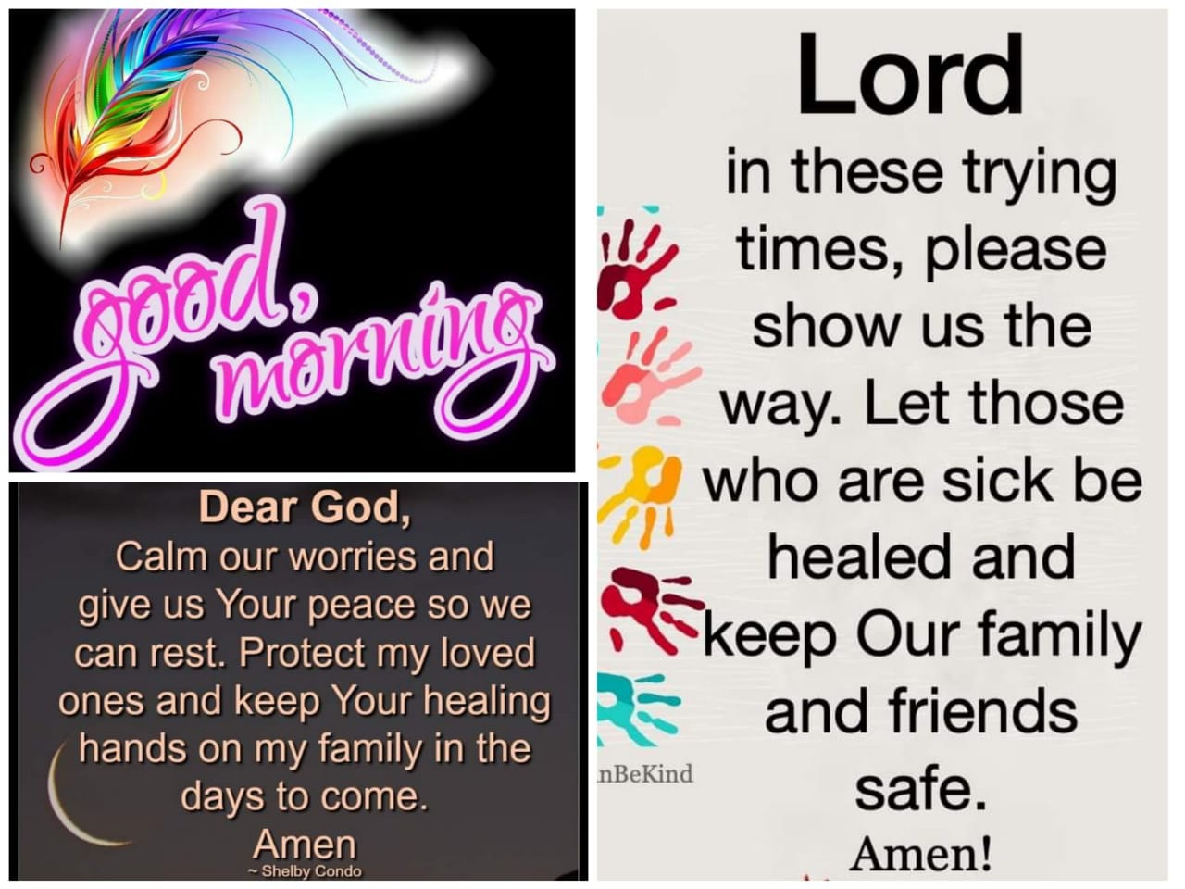
Mr. Bracken

Monday – Bank Holiday | You deserve a break from schoolwork today
Tuesday – All work is optional | - Kind Mind activity – see below  - Bake something for your family  - Write down your ingredients and the method you used  - Your options are:  - Mars bar squares  - Oat cookies  - Chocolate brownies  - https://www.supercook.com/#/recipes - see below  - Look at the end of the document for recipes  - Send me a picture of your May altar  - Diary entry – if you would prefer you can record voice messages of your day and keep them for when you are older, instead of writing.  - PE Activity – see below
Wednesday | English:  - Read at Home pg 115 ‘The Sun’ - Read & answer questions orally  - Starlight 14B ‘The Hedgehog’ - Complete part A in your copy.  - Diary entry (optional)  Maths:  - Maths Matters pg 127 - Fun With Numbers  Irish:  - Léigh sa Bhaile: Read the next page. Freagair na ceisteanna: Answer the 5 questions at the bottom of the page in your spare copy  - Cúla ar scoil @10am https://www.cula4.com/en/  Wellbeing & Mindfulness:  - Light up the World with Kindness activity – see below
Thursday | English:  - Read at Home pg 116 - ‘The Lady of the Lamp’ - Read & answer questions orally  - Starlight 14B ‘The Hedgehog’ – Complete part B  - Diary entry (optional)  Maths:  - Maths Matters pg 128 – ‘Weight’ – link in with optional baking from Tuesday!  Irish:  - Léigh sa Bhaile: Read the next page. Freagair na ceisteanna: Answer the 5 questions at the bottom of the page in your spare copy  - Cúla ar scoil @10am https://www.cula4.com/en/  Wellbeing & Mindfulness:  - Feeling Positive Emotions – see below
Friday | English:  - Read at Home pg 117 - ‘Up in a Cloud’ - Read & answer questions orally  - Starlight 14B ‘The Hedgehog’ – complete part C in copy  - Diary entry (optional)  Maths:  - Maths Matters pg 129 – Kilogrammes and grammes - Skip question 2, just do the tables in Q’s 1 & 3 and Q. 4  Irish:  - Léigh sa Bhaile: Read the next page. Freagair na ceisteanna: Answer the 5 questions at the bottom of the page in your spare copy  - Cartún ar TG4  Wellbeing & Mindfulness:  - Acrostic Poem – see below
Useful websites for this week:
- Maths: Tables revision games- https://www.topmarks.co.uk/maths-games/7-11-years/multiplication-and-division
- Baking: very good website: https://www.supercook.com/#/recipes - you can put in the ingredients you have at home and it will generate something to bake for you.
- The Ark @ Home are streaming a recorded live performance of 'Far Away From Me' until the 6th of May. It's a theatre show of 50 mins duration for ages 6+. They also have a weekly schedule of online arts activities, resources etc.
- Mindfulness links: https://youtu.be/O29e4rRMrV4 & https://youtu.be/1ZP-TMr984s

SEN/EAL work 3rd class EB May 5-8 Teachers: Ms.Curran & Ms. McCabe
Note: SEN teachers have added work on to the teachers’ plan. Children can decide to do this work instead of something the teacher has assigned. It is not extra work. Also, we would be delighted if you could email on a picture of something that your child has done and is proud of, so we can see their lovely work again!
All groups can look at the clock and tell the time 3 times per day. Also keep reading and learning your tables daily. This week do multiplication tables to 5x and practice counting up and down the ladder in 2’s, 3’s, 4’s and 5’s.
EAL: Transport&Travel | ORAL: Name as many ways possible for moving from place to place eg walk, Luas etc...  WRITE: Modes of Transport.Write above on a mindmap(draw)  https://www.twinkl.ie/resource/us2-e-53-mind-map-writing-template  Watch Powerpoint : https://www.twinkl.ie/resource/t-h-064-the-wright-brothers-information-powerpoint
Speech and Language | Conversation Starters – Continue with these, one per day.  Continue with activities from Speech & Language therapist pack or play this game  https://www.twinkl.ie/resource/t-s-892-what-am-i-guessing-game-cards-household-objects
Literacy A & B | SNIP programme – the next session. 3 pages per week.  Read the next 6 blends lists tr/sc/sm/sk/sn/sp at least 3 times each from below link:  http://www.theschoolhouse.us/lessons/lesson56.html  Please keep up the reading, every day! https://www.oxfordowl.co.uk/for-school/oxford-owl-ebook-collection  These are free ebooks and you can find your level.
Toe by Toe | Next SNIP session (18)..... 3 pages for the week.  Please read and ask an adult to read with you.
SEN Individuals | Write Reader: Write about Taking my Dog for a walk in Laragh  Fry’s Words: Continue with the list you are on.  Cloze Sheet: Number 3/ Conversation Starter daily.  Do page 1 and 2 of this: https://www.otb.ie/wp-content/uploads/2020/04/At-Home-with-Weaving-Well-being-A-Mental-Health-Journal-for-Kids.pdf
Contact SEN Teachers: msmccabe@scoilchoca.ie mscurran@scoilchoca.ie

mscurran@scoilchoca.ie msmcabe@scoilchoca.ie
MsCurran is working, this week Monday-Friday
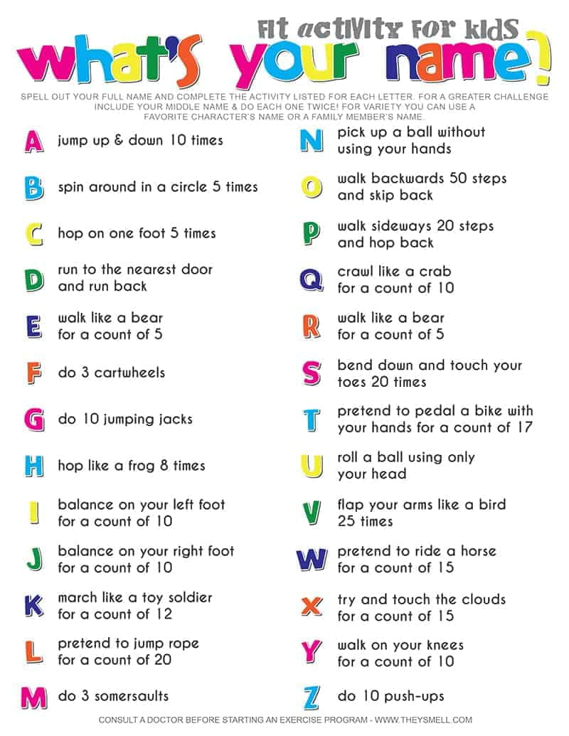
PE Activity for the week

Tuesday – Recipes – optional
Healthy Oaty Crunchers
Ingredients:
- 100 g butter (at room temperature)
- 100 g caster sugar
- 2 tbsp honey
- 2 eggs
- 160 g porridge oats
- 100 g wholemeal flour
- 1 tsp baking powder
- 2 tsp ground cinnamon or ginger (optional)
- Berries/nuts/chocolate chips (optional)
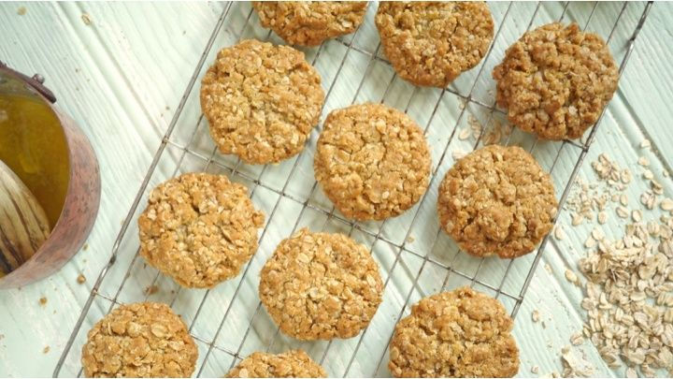

Yummy Mars Bar Squares
Ingredients:
- 100g butter (unsalted/softened)
- 4 mars bars (chopped)
- 1 ½ tbsp golden syrup
- 150g rice krispies
- 350g milk chocolate
- 50g white chocolate
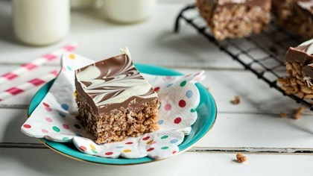
Quick and Easy Chocolate Brownies
Ingredients:
- 200g caster sugar
- 115 g butter (melted)
- 30 g cocoa powder
- ½ tsp vanilla extract
- 2 eggs
- 115g plain flour
- pinch baking powder
- pinch salt
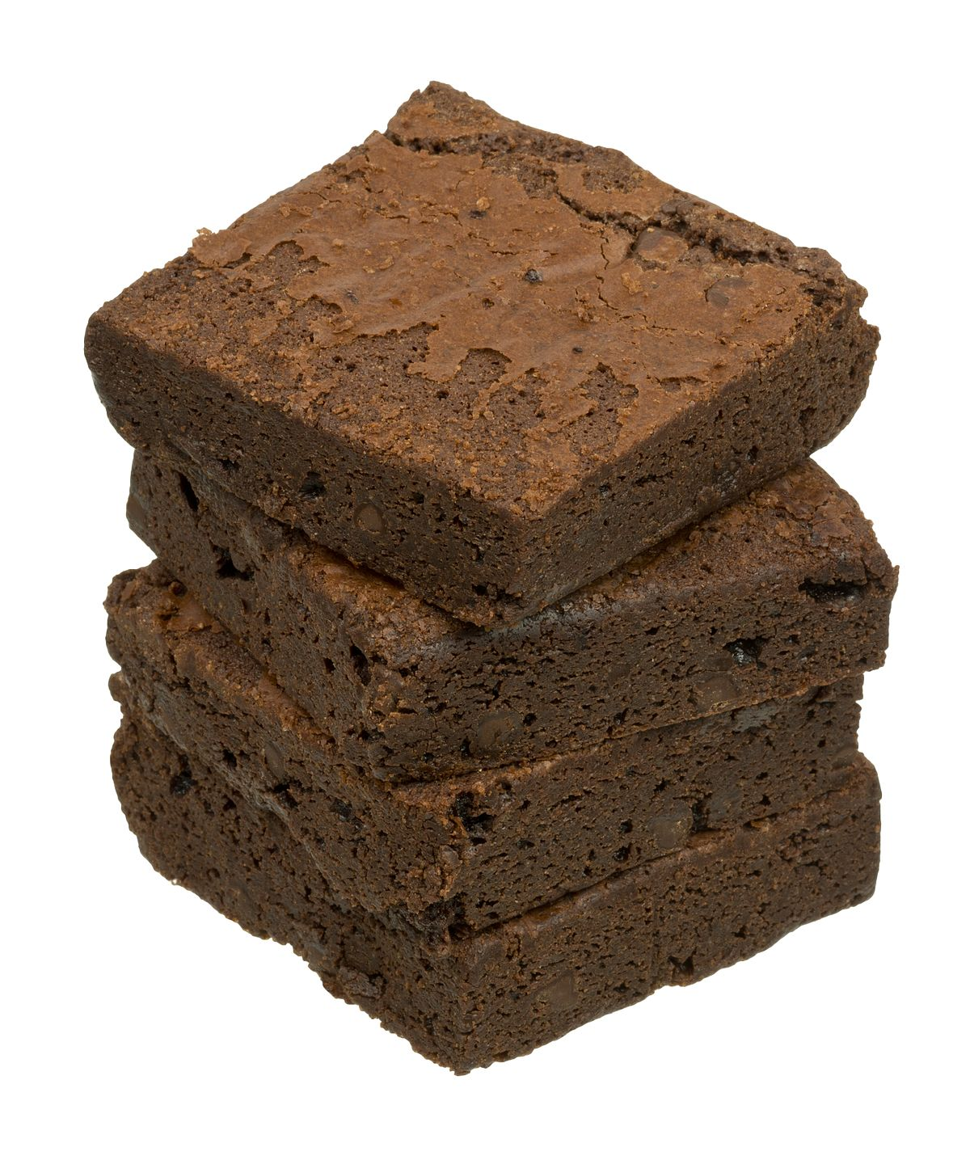

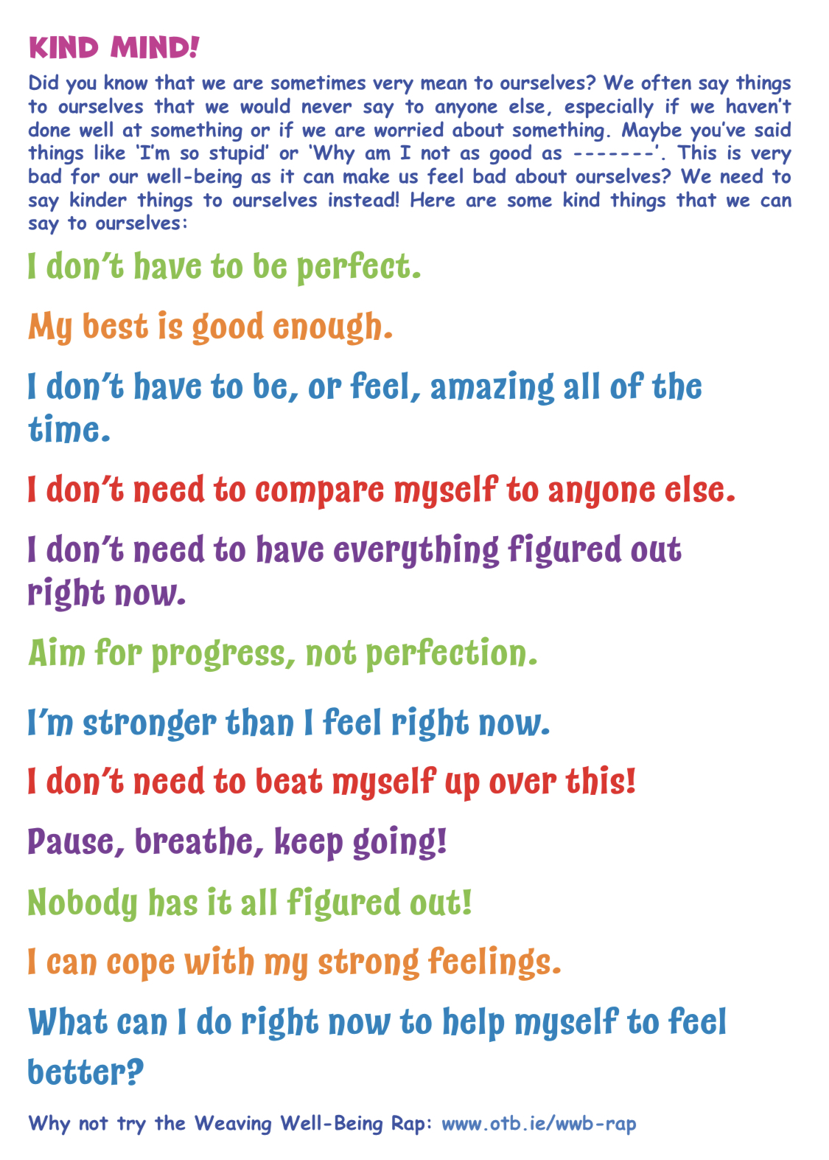
Tuesday – Wellbeing and Mindfullness

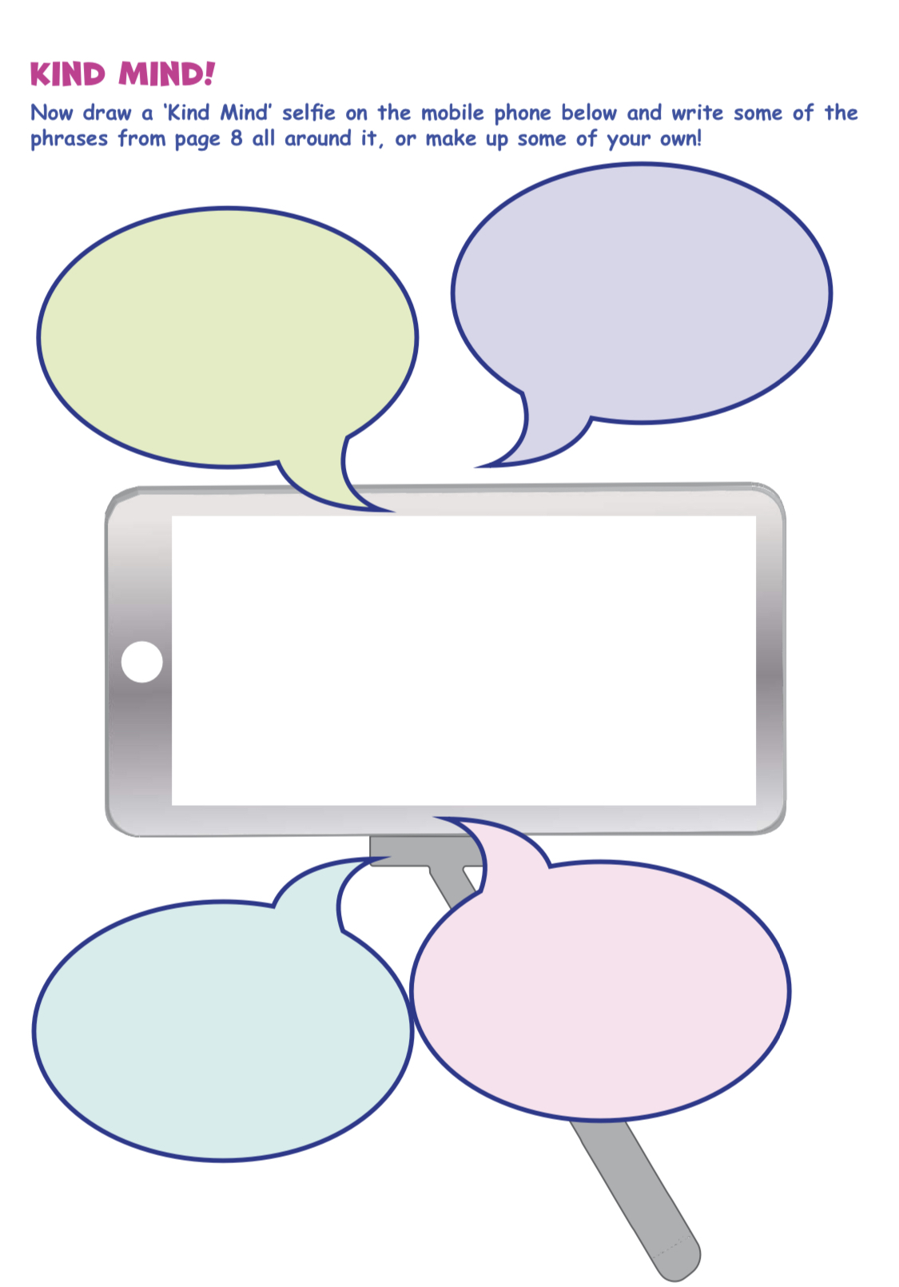
Tuesday: Wellbeing & Mindfulness

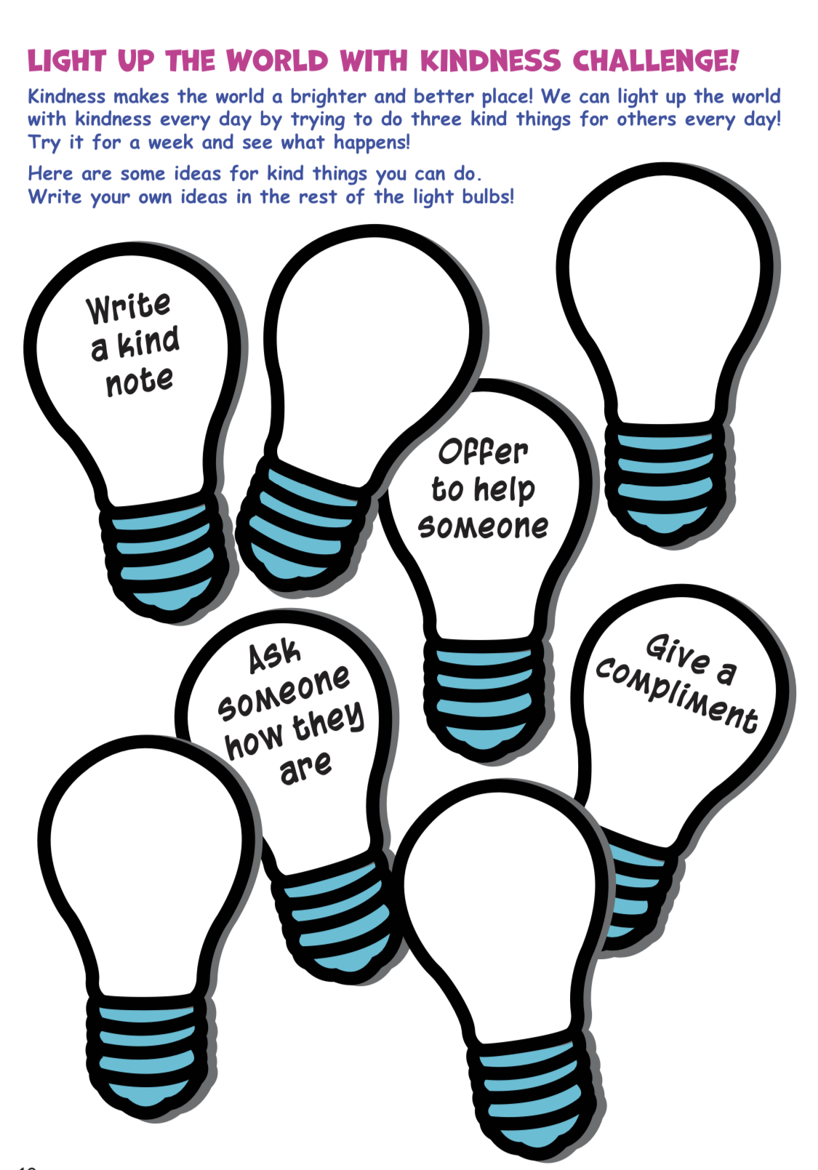
Wednesday: Wellbeing & Mindfulness

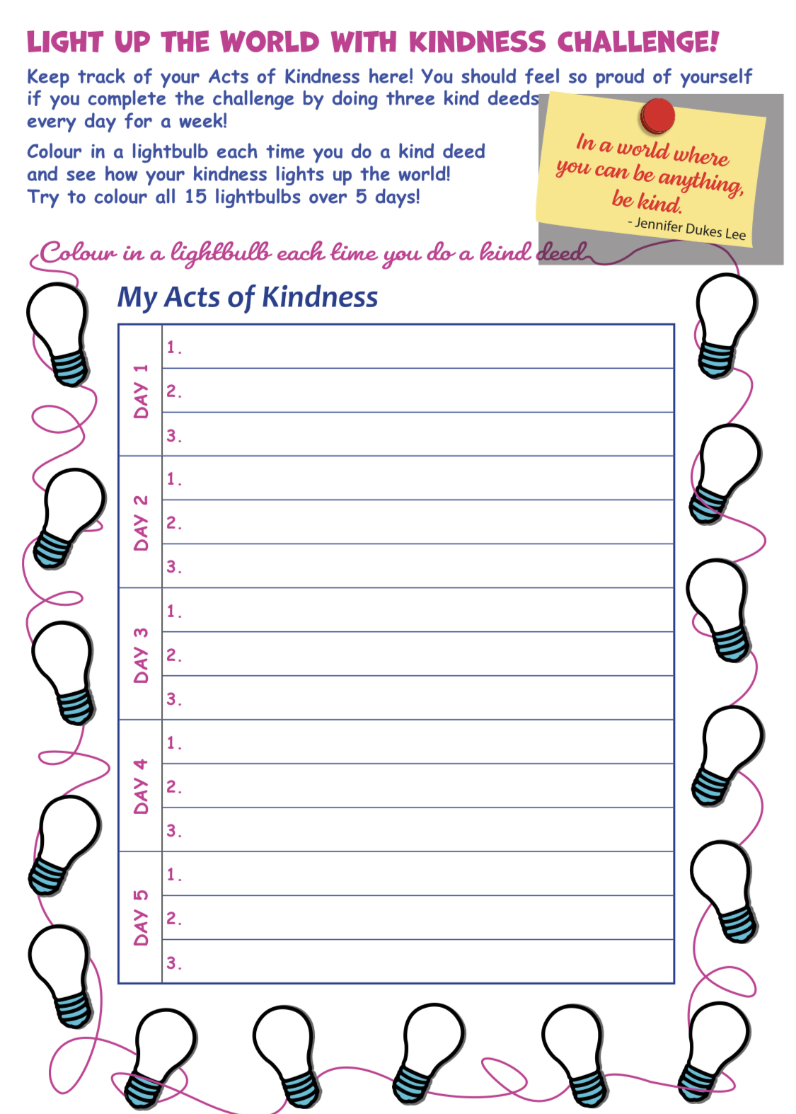
Wednesday: Wellbeing & Mindfulness

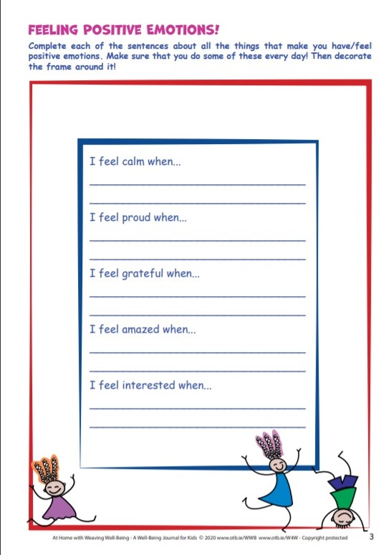
Thursday – Wellbeing & Mindfulness

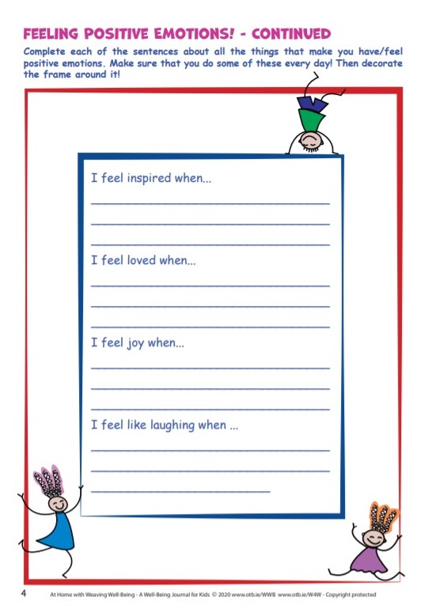

Friday – Wellbeing & Mindfulness
