Work for Fifth Class: 18th of May – 22nd of May 2020
Please remember: You are encouraged to complete one hour of work. The work we have given may take longer than one hour. If you want to do more than one hour that is fine but please don’t feel you have to. Do what you can and keep smiling! :)
Ms. Heffernan’s and Ms. Tone’s groups will find work for them attached to the end of this plan. Those not doing Gaeilge please access your TTRS account
Please send us pictures of your maths work and 2 other pieces of work you are proud of if you can. We would love to hear from you!
Our e-mail addresses are msfield@scoilchoca.ie and msmahon@scoilchoca.ie
Mon | English | - Spellbound: Unit 33 page 68 exercise 1  - Starlight: Unit 14a: The Bad Thing. Read pages 158 – 160. Complete p.161 A&C
 | Maths | - Mathletics or Maths Challenge Test 46  - Maths Matters pg. 138 Q 1, 2 & 3  - Watch this video on the 24 hour clock (last week revision) to help with pg. 138 https://www.youtube.com/watch?v=YQus7CvyHzA
 | Gaeilge | - Léigh sa bhaile: lch.8 Spórt – Léigh  - Béal Beo lch. 146 Léigh an bróisiúr (brochure) agus déan an tasc: Déan do bhróisiúr féin faoi champa don samhradh seo chugainn
 | P.E. | - Go outside and be active for at least 30 minutes  - Have a look at Scoilnet Beyond the Classroom. Links below  - https://www.scoilnet.ie/pdst/physlit/beyond/  - https://vimeo.com/402212771 Throwing Home Activity B  https://vimeo.com/402213090 Ag Caitheamh (Throwing as gaeilge)
 | Other | S.P.H.E: Please see Ms. Daly’s email - Stay Safe Programme (To be completed with a parent/guardian) Topic 3: Touches (T17 Discuss)
Tue | English | - Spellbound: Unit 33 page 68 exercise 2  - Starlight: Unit 14a: Read pages 158 – 160. Complete p.161 B & p.162 D
 | Maths | - Mathletics or Maths Challenge Test 47  - Maths Matters pg. 138 Q 4
 | Gaeilge | - Duolingo: Collect 10XP  - Léigh sa bhaile: lch.12 Fleadh Cheoil – Léigh agus freagair na ceisteanna i do chóipleabhar
 | P.E. | - Go outside and be active for at least 30 minutes  - Have a look at Scoilnet Beyond the Classroom. Links below  - https://vimeo.com/404404521 Running Home Activity B  - https://vimeo.com/404411732 Ag rith (Running as Gaeilge)
 | Other | S.P.H.E: Please see Ms. Daly’s email - Stay Safe Programme (To be completed with a parent/guardian) Topic 3: Touches T18 Emma’s Dilemma, discuss - Worksheet 7: Stay Safe Rules
Wed | English | - Spellbound: Unit 33 page 68 exercise 3  - Starlight: Unit 14a: Complete p.162 E
 | Maths | - Mathletics or Maths Challenge Test 48  - Maths Matters pg. 139 Q 1 - 6
 | Gaeilge | - Béal Beo: Léigh lch 147 & 148. Freagair ceisteanna 1 – 5 i do chóipleabhar  - Duolingo: Collect 10XP
 | P.E. | - Go outside and be active for 30 minutes  - Look up look up 30 Days of Yoga with Adrienne  - https://www.youtube.com/playlist?list=PLui6Eyny-UzwxbWCWDbTzEwsZnnROBTIL  - Choose a day and complete lesson
 | Other | S.P.H.E: Please see Ms. Daly’s email - Stay Safe Programme (To be completed with a parent/guardian) Topic 4 Secrets and Telling TR 19: Colm’s Story – listen and discuss Worksheet 8/HSL: Secrets and Telling- Discuss
Thurs | English | - Spellbound: Unit 33 page 69 exercise 4  - Starlight: Unit 14a: Complete p.163 F
 | Maths | - Mathletics or Maths Challenge Test 49  - See Bus Timetable below
 | Gaeilge | - Léigh sa bhaile: lch.17 Ag Snámh – Léigh agus freagair na ceisteanna i do chóipleabhar  - Duolingo: Collect 10XP
 | P.E. | - Go outside and be active for at least 30 minutes  - Have a look at Scoilnet Beyond the Classroom. Links below.  - https://vimeo.com/412274551 Catching Home Activity B  - https://vimeo.com/412274718 Gabháil (Catching as Gaeilge)
 | Other | S.P.H.E: Please see Ms. Daly’s email - Stay Safe Programme (To be completed with a parent/guardian) Topic 5 Strangers TR 21: Strangers – What would you do? Discuss - TR 22: Tony’s Story: Listen and discuss
Fri | English | - Spellbound: Unit 33 page 69 exercise 5  - Starlight: Unit 14a: Complete p.163 G
 | Maths | - Mathletics or Maths Challenge Test 50  - See Train Timetable below
 | Gaeilge | - Béal Beo:lch 149 An Briathar ‘Imir’ - Léigh an bosca buí agus scríobh na freagraí agus na ceisteanna.  - Duolingo: Collect 10XP
 | P.E. | - Go outside and be active for at least 30 minutes  - Have a look at Scoilnet Beyond the Classroom. Links below  - https://vimeo.com/409588960 Balancing Home Activity B  - https://vimeo.com/409588436 Cothromaíocht (Balancing as Gaeilge)
 | Other | S.P.H.E: Please see Ms. Daly’s email - Stay Safe Programme (To be completed with a parent/guardian) Topic 5 Strangers. TR 23: Strangers on the Internet; Listen and discuss. TR 24: Stand Up/Sit Down .Worksheet 9/HSL: Safe Use of the Internet: Discuss.
Extra Activities – Optional
Inside  - Make a mini town using lego and blocks  - Create your own comic strip | Outside  - Pretend to give a weather report

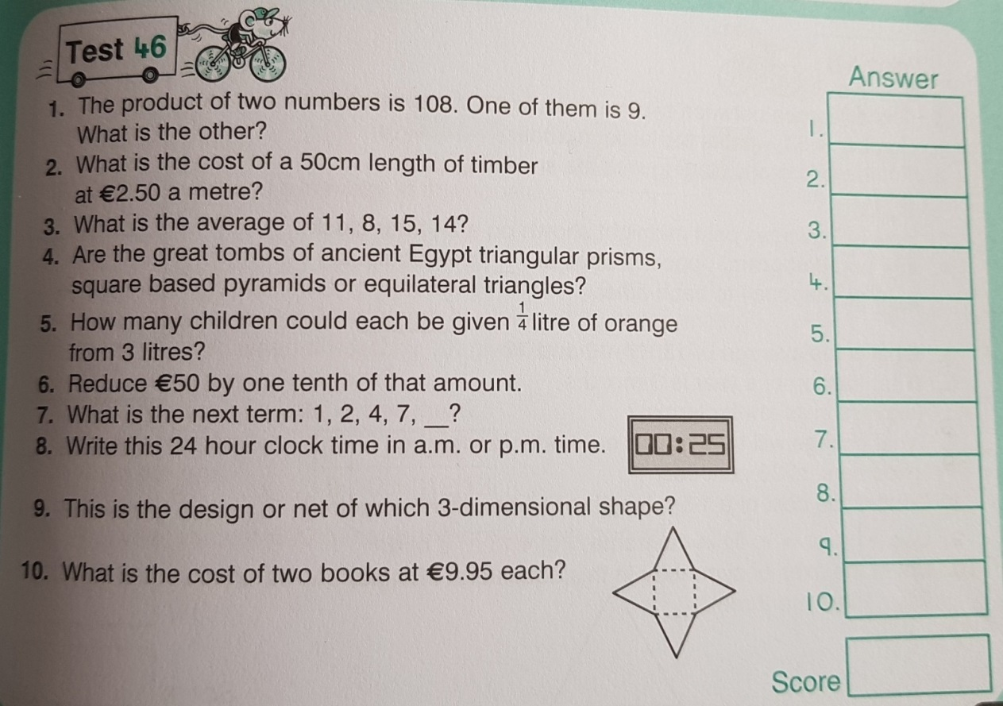
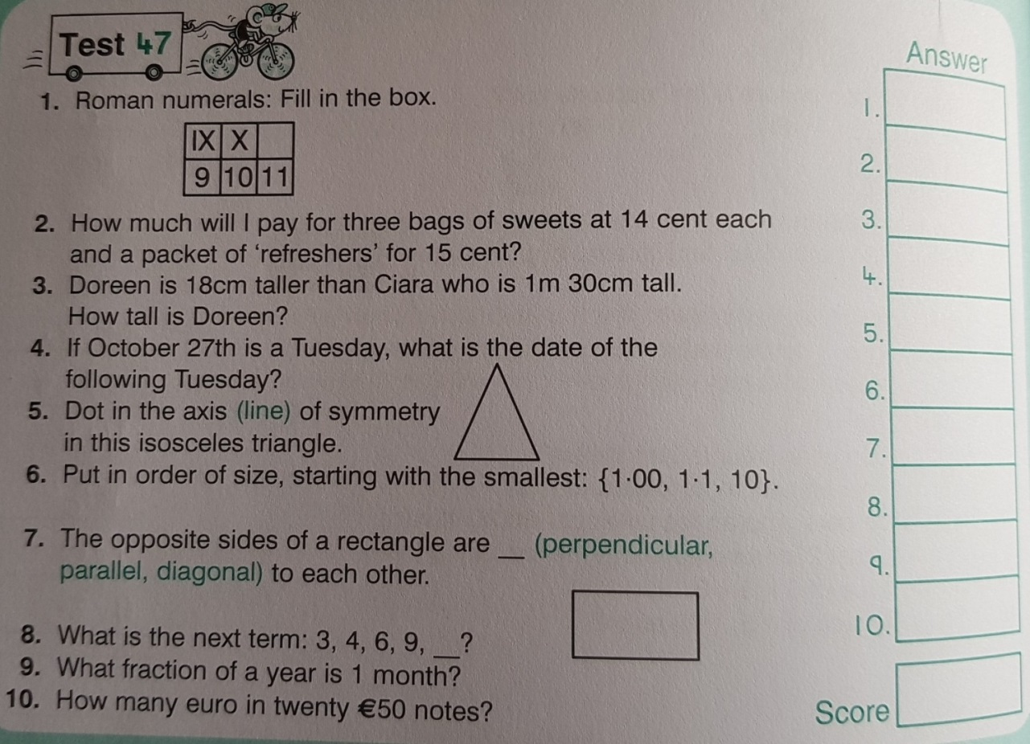
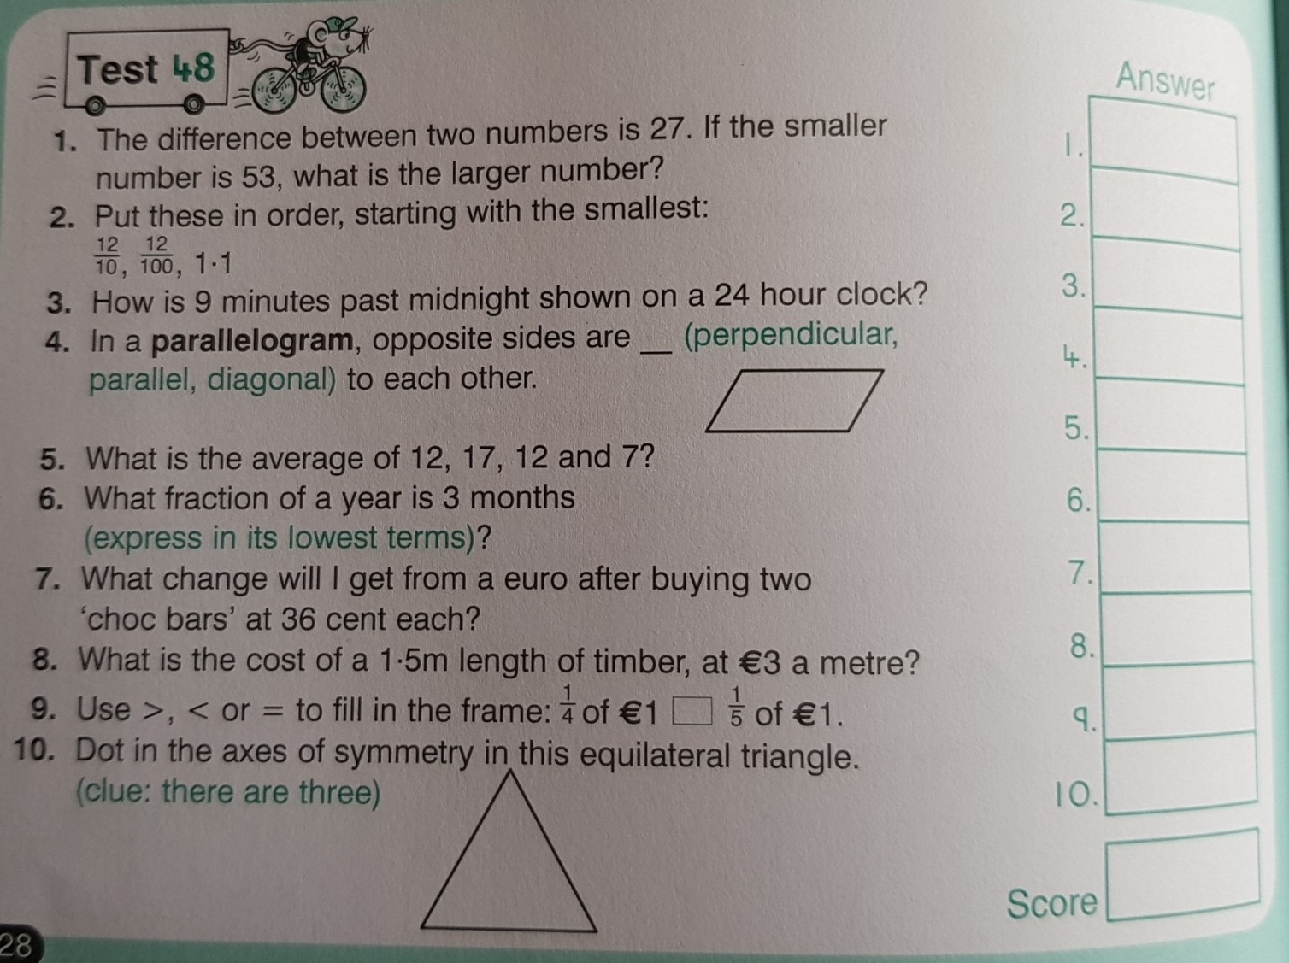
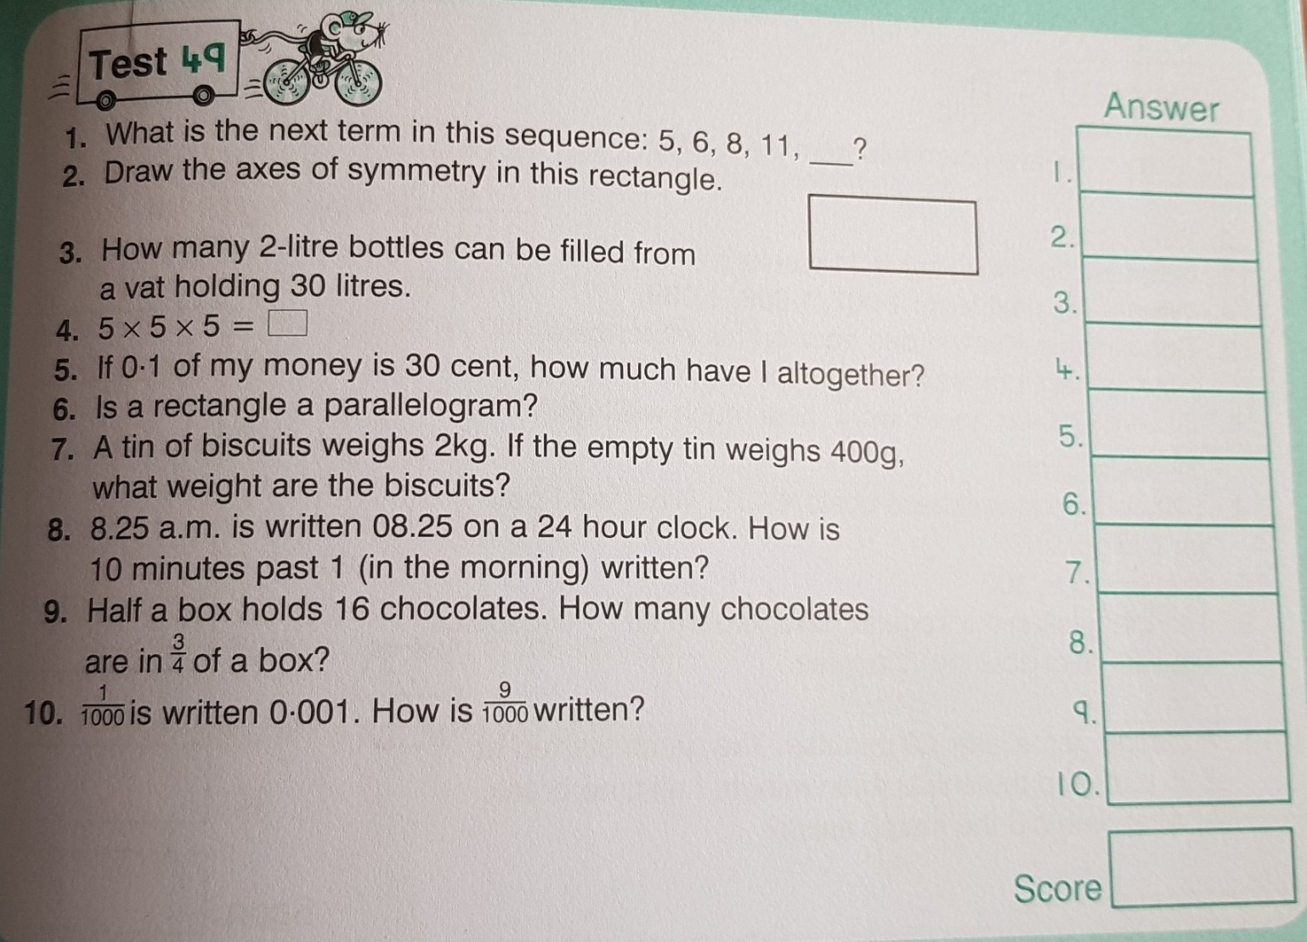
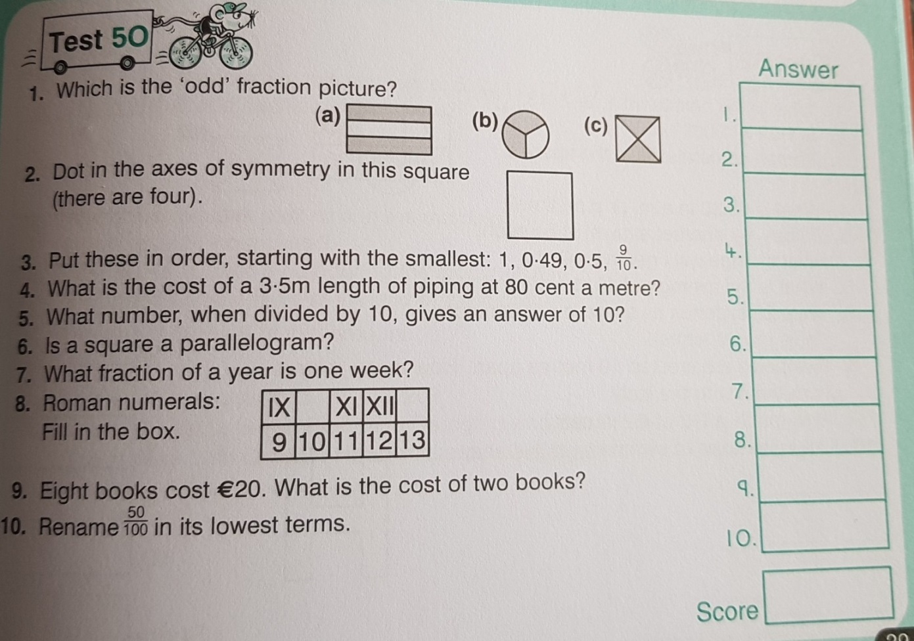

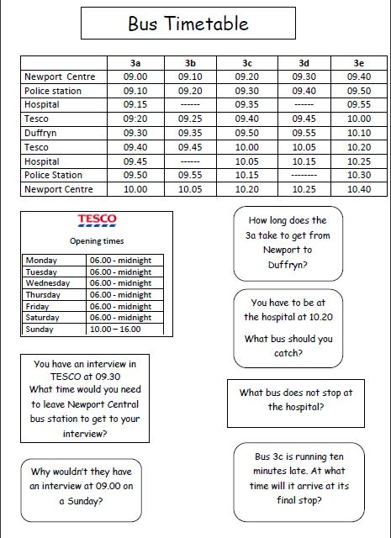

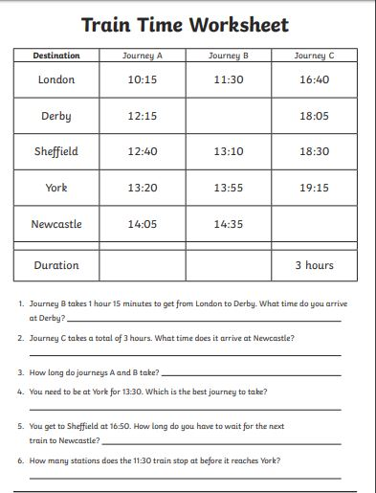

SEN work
Teacher: Ms. Heffernan
Note: SEN teachers have added work on to the teachers’ plan. Children can decide to do this work instead of something the teacher has assigned. It is not extra work. Also, we would be delighted if you could email on a picture of something that your child has done and is proud of so we can see their lovely work again!
Literacy | Keep reading!  If any of you need more reading material, just let me know.  If you’ve read or listened to a story, let me know what you thought about it.  Do a little writing every day.  Keep a diary.  Keep a gratitude journal-write down 3 things you are grateful for each day.  Use www.writereader.com to create your own book.  Please try the attached cloze procedure about camping. Send me a photo of your completed work.  Keep practising your TTRS. See if you can still type while covering your hands with a towel!  Send me an email to let me know how you’re getting on-I’d love to hear from you!
Numeracy | Keep doing your Mathletics or you could also try https://www.mathsisfun.com/time-clocks.html to help you with telling the time.  Here is an interactive clock you can practise with. You can click and drag the hands. If you click ‘24’ in the box at the bottom right, it will show you the time in the middle of the clock in 24hr time. Give it a go!  https://toytheater.com/clock/#  Or you might find this one easier to manage.  https://www.topmarks.co.uk/time/teaching-clock  You might like to test yourself with these worksheets!  https://www.mathsisfun.com/worksheets/print.php?w=206&ID=7075  https://www.mathsisfun.com/worksheets/print.php?w=173&ID=7075  Here are 2 other games to help with your mental maths.  https://www.topmarks.co.uk/maths-games/hit-the-button  https://www.topmarks.co.uk/maths-games/daily10  Send me an email to let me know what you have done or if you need help.
Contact SEN Teacher: msheffernan@scoilchoca.ie

SEN work

Teacher: Ms Tone (Ms Clancy)

Note: SEN teachers have added work on to the teachers’ plan. Children can decide to do this work instead of something the teacher has assigned. It is not extra work. Also, we would be delighted if you could email on a picture of something that your child has done and is proud of so we can see their lovely work again!

Literacy | - Keep reading!  - Choose another story from My Read at Home. Write a few sentences to explain what happened in the story.  - Word challenge: How many little words can you find in the word ‘entertainment’? e.g. neat  - Word challenge: You can use all the letters in ‘team’ to make new words: Team – Tame – Meat - Mate  Can you make 2 new words from ‘rate’?  Can you make 2 new words from ‘dare’?  - Keep a diary to record what you are doing each day. Write 3 sentences. Draw a picture in your diary.
Numeracy | - Time: See clocks worksheet below.  Send me an email if you need any help.

Contact SEN Teacher: mstone@scoilchoca.ie

Time: Remember!

The big hand points to 9 at a quarter to.
A quarter to means 15 minutes to the next hour.

The small hand tells us the hour.
The small hand points before the number.

What time is it?

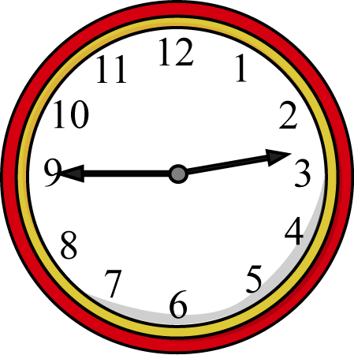
It is a quarter to 3.
Draw 4 clocks. Show these times: a quarter to 2, a quarter to 5, a quarter to 9, a quarter to 10.

What time is it on the clocks? The first one shows a quarter to 3.

