Work for Fifth Class: 11th– 15th of May 2020
Please remember: You are encouraged to complete one hour of work. The work we have given may take longer than one hour. If you want to do more than one hour that is fine but please don’t feel you have to. Do what you can and keep smiling!
Ms. Heffernan’s and Ms. Clancy’s (Now Ms. Tone’s) groups will find work for them attached to the end of this plan. Those not doing Gaeilge please access your TTRS account
Please send us pictures of your maths work and 2 other pieces of work you are proud of if you can. We would love to hear from you!
Our e-mail addresses are msfield@scoilchoca.ie and msmahon@scoilchoca.ie
Mon | English | - Spellbound: p. 66 – Revision. Exercise 1  - Starlight Unit 13b What is a Submarine? Read p. 152-154. Complete p. 155 A
 | Maths  Hints | - Mathletics or Maths Challenge Test 43 (Please write a clear title: Test 43) If you don’t have the book please see below.  - Maths Matters p.135: Cinema Timetable. Please email us if you are stuck.  White Knight: 1st screening is at 2:25, 2nd screening is at 4:40, 3rd screening is at 6:55, 4th screening is at 9:20  Wind Walkers: 1st screening is at 1:15, 2nd screening is at 3:55, 3rd screening is at 6:35, last screening is at 9:15  Time Traveller: Starts the earliest. Its 1st screening is at 1:10.
 | Gaeilge | - Duolingo: Collect 10XP  - Léigh sa Bhaile lch 65: Cluiche a Chonaic mé le mo Dhaidí. Léigh an scéal agus freagair na cesiteanna i do chóipleabhar.
 | P.E. | - Go to https://vimeo.com/402212771 and complete the throwing activity. Déan as Ghaeilge é https://vimeo.com/402213090
 | Other | S.E.S.E: See information box below

Tue | English | - Spellbound: p. 66 – Revision. Exercise 2  - Starlight Unit 13b What is a Submarine? Read p.152-154. Complete p.155 B& C
 | Maths | - Watch this video on a.m. and p.m. https://www.youtube.com/watch?v=wv3mtG_wGWw  - Read a.m. and p.m. paragraph in Maths Matters on p.135  - Watch this video on a.m. and p.m. https://www.youtube.com/watch?v=xrwQIYmoYhs  - Maths Matters p.136. Q1 Fill in the blank spaces around the circle & Q2 Fill in the times. Please email us if you are stuck.
 | Gaeilge | - Duolingo: Collect 10XP  - Béal Beo lch. 141. Léigh na feidhmeanna teanga sa bhosca bhuí.
 | P.E. | - Go to https://vimeo.com/404404521 and complete the running activity. Déan as Ghaeilge é https://vimeo.com/404411732.
 | Other | S.E.S.E: See information box below

Wed | English | - Spellbound: p. 66 – Revision. Exercise 3  - Starlight Unit 13b. Complete p.156 D & E
 | Maths | - Mathletics or Maths Challenge Test 44  - Maths Matters p.136 Q3 & Q4  - Q3: Use the picture in Q1 to help you. Put your finger on the start time and count how many jumps to the end time.  a) How many jumps around the circle does your finger make starting from 8:00am and moving to 1:00pm? 5 jumps! So  the answer is 5 hours. Please email us if you are stuck.
 | Gaeilge | - Béal Beo lch. 142: Cá Bhfuil Rícó? Léigh agus scríobh na freagraí  - Duolingo: Collect 10XP
 | P.E. | - Go to https://vimeo.com/409588960 and complete the balancing activity. Déan as Ghaeilge é https://vimeo.com/409588436.
 | Other | Music: Using your recorder, start on a low D and play a scale: D, E, F#, G, A, B, C#, D. Practise some of the warm ups Laura does with you every week. Play your favourite recorder piece of the year start to finish. Record yourself and listen back if you can.

Thurs | English | - Spellbound: p. 67 – Revision. Exercise 4  - Starlight Unit 13b. Complete p.156 F
 | Maths | - Maths Matters pg. 137. Q1 & Q2. Please email us if you are stuck  - Look at the timeline on the left that goes from the top of the page to the bottom. Count how many hours there are, using your finger to jump along the times. You should get 24 jumps, so there are 24 hours. 1 day!  - Q1: Use the pictures and sentences that move down alongside the timeline to help you.  Remember; 1:05 a.m. is only one hour and five minutes after midnight!  - Q2: Watch this video again if you are stuck https://www.youtube.com/watch?v=xrwQIYmoYhs
 | Gaeilge | - Duolingo: Collect 10XP  - Béal Beo lch. 145 (https://www.teanglann.ie/ga/)
 | P.E. | - Go to https://vimeo.com/412274551 and complete the catching activity. Déan as Ghaeilge é https://vimeo.com/412274718.
 | Other | Art: Design and (if possible) create using recycled materials, a detailed plan for your dream future home. Include as much or as little as you want but try to keep it realistic. Send us pictures if you can – we’ll be waiting.  You can use this virtual home tour for inspiration: https://matterport.com/industries/gallery/pro2-cap-adriano-villa

Fri | English | - Spellbound: p. 67 – Revision. Exercise 5  - Starlight: Unit 13a. Complete p. 151 G
 | Maths | - Mathletics or Maths Challenge Test 45  - Maths Matters pg. 137. Q3: Read the paragraph  - Move your finger down the timeline on the right that goes from the top of the page to the bottom.  - If you count each jump, you count using the same numbers that are written beside this timeline in black.  - Those are the numbers we use when counting in 24-hour time!  - Instead of stopping at 12:00 we count on! 13:00-14:00-15:00-16:00-17:00-18:00-19:00-20:00-21:00-22:00-23:00  - Here is an interesting video showing one day passing by on 2 different clocks. Remember, a day is always 24 hours long!  https://www.youtube.com/watch?v=YQus7CvyHzA
 | Gaeilge | - Léigh sa Bhaile lch 67: Clubanna Spóirt. Léigh an scéal agus freagair na cesiteanna i do chóipleabhar.  - Duolingo: Collect 10XP
 | P.E. | - Get outdies in the fresh air for at least 30 minutes. Suggestion: Do 5 x 30 seconds of the following; jumping jacks, squats, burpees, hopping on right leg, hopping on left leg. Take 30 second rest after each exercise. Repeat x 6
 | Other | - SPHE: See Wellbeing activity below

S.E.S.E Project Information and Useful Links
- On a clear evening look up at the sky just after the sun sets. Try to find the extremely bright star that shines. You should be looking in the same direction as the sunset. Research this star – find out what it is. Let us know if you find out.
- Write the definition of a constellation into your copy. Have a look at this image to see what constellations are on view from Ireland this month https://www.skymania.com/wp/northern-hemisphere-sky-chart/
- Draw a diagram of two or three of the constellations on view from Ireland this month into your copy. Label each one with its name. See if you can spot any in the sky before you go to bed.
- Draw a labelled diagram showing the planets in order moving away from the sun. Use this website to help https://www.timeanddate.com/astronomy/planets/size
- Select one of the planets and complete a mini-project on it. Use this website to help you start off: https://www.dkfindout.com/uk/search/planets/

Extra Activities – Optional
Inside  - Make a puppet with old socks and buttons. Put on a puppet show!  - Do a collage using old magazines | Outside  - Do some bird watching  - Plant some seeds

SEN work

Teacher: Ms Tone / Ms Clancy

Note: SEN teachers have added work on to the teachers’ plan. Children can decide to do this work instead of something the teacher has assigned. It is not extra work. Also, we would be delighted if you could email on a picture of something that your child has done and is proud of so we can see their lovely work again!

Literacy | - Keep reading!  - Choose your favourite story from My Read at Home. Write a few sentences to explain what happened in the story.  - Word challenge: Can you think of 6 words that have the word ‘one’ in them? e.g. bone  - Word challenge: Can you think of 8 words that have the word ‘at’ in them? e.g. late  - Keep a diary to record what you are doing each day. Write 3 sentences. Draw a picture in your diary.
Numeracy | - Time: See clocks worksheet below.  - Send me an email if you need any help.

Contact SEN Teacher: mstone@scoilchoca.ie

Time: Remember!

The big hand points to 3 at a quarter past.
A quarter past means 15 minutes past.

The small hand tells us the hour.
The small hand points after the number.
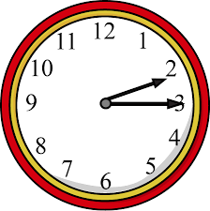
What time is it?

A quarter past 2

Draw 4 clocks. Show these times: a quarter past 3, a quarter past 4, a quarter past 9, a quarter past 11.

What time is it on the clocks? The first one shows a quarter past 1.

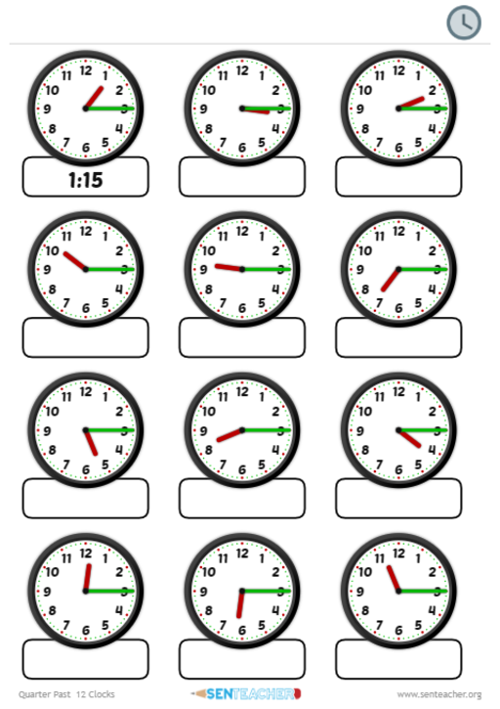

SEN work
Teacher: Ms. Heffernan
Note: SEN teachers have added work on to the teachers’ plan. Children can decide to do this work instead of something the teacher has assigned. It is not extra work. Also, we would be delighted if you could email on a picture of something that your child has done and is proud of so we can see their lovely work again!
Literacy | Keep reading!  If any of you need more reading material, just let me know.  If you’ve read or listened to a story, let me know what you thought about it.  Do a little writing every day.  Keep a diary.  Keep a gratitude journal-write down 3 things you are grateful for each day.  Use www.writereader.com to create your own book.  Here’s a cloze procedure about the sun-no peeking at the answers until you’re finished!!  file:///C:/Users/Scoil/Desktop/Cloze/roi-sc-93-the-sun-cloze-activity-worksheet_ver_4.pdf  Keep practising your TTRS. See if you can still type while covering your hands with a towel!  Send me an email to let me know how you’re getting on-I’d love to hear from you!
Numeracy | Keep doing your Mathletics or you could also try https://www.mathsisfun.com/time-clocks.html to help you with telling the time.  Here is an interactive clock you can practise with. You can click and drag the hands. If you click ‘24’ in the box at the bottom right, it will show you the time in the middle of the clock in 24hr time. Give it a go!  https://toytheater.com/clock/#  Here are 2 other games to help with your mental maths.  https://www.topmarks.co.uk/maths-games/hit-the-button  https://www.topmarks.co.uk/maths-games/daily10  Send me an email to let me know what you have done or if you need help.
Contact SEN Teacher: msheffernan@scoilchoca.ie
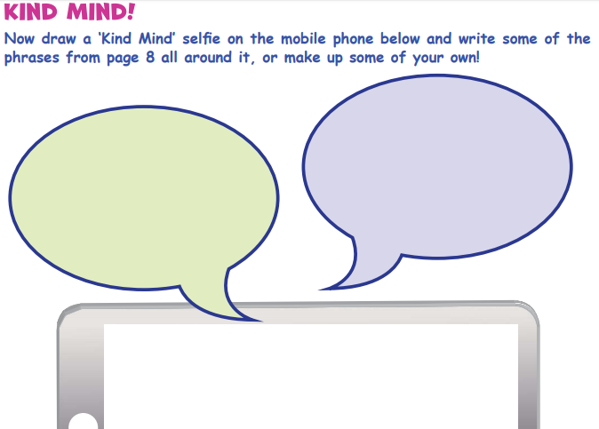
Well Being Activity

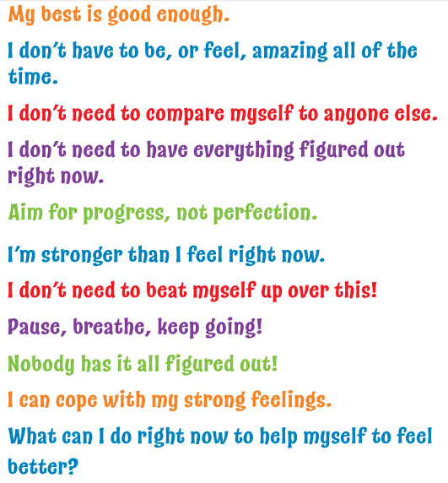

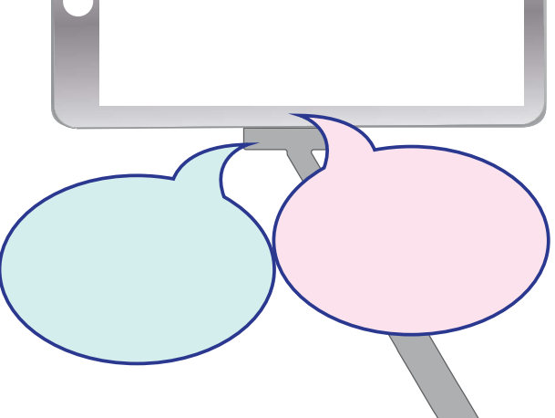

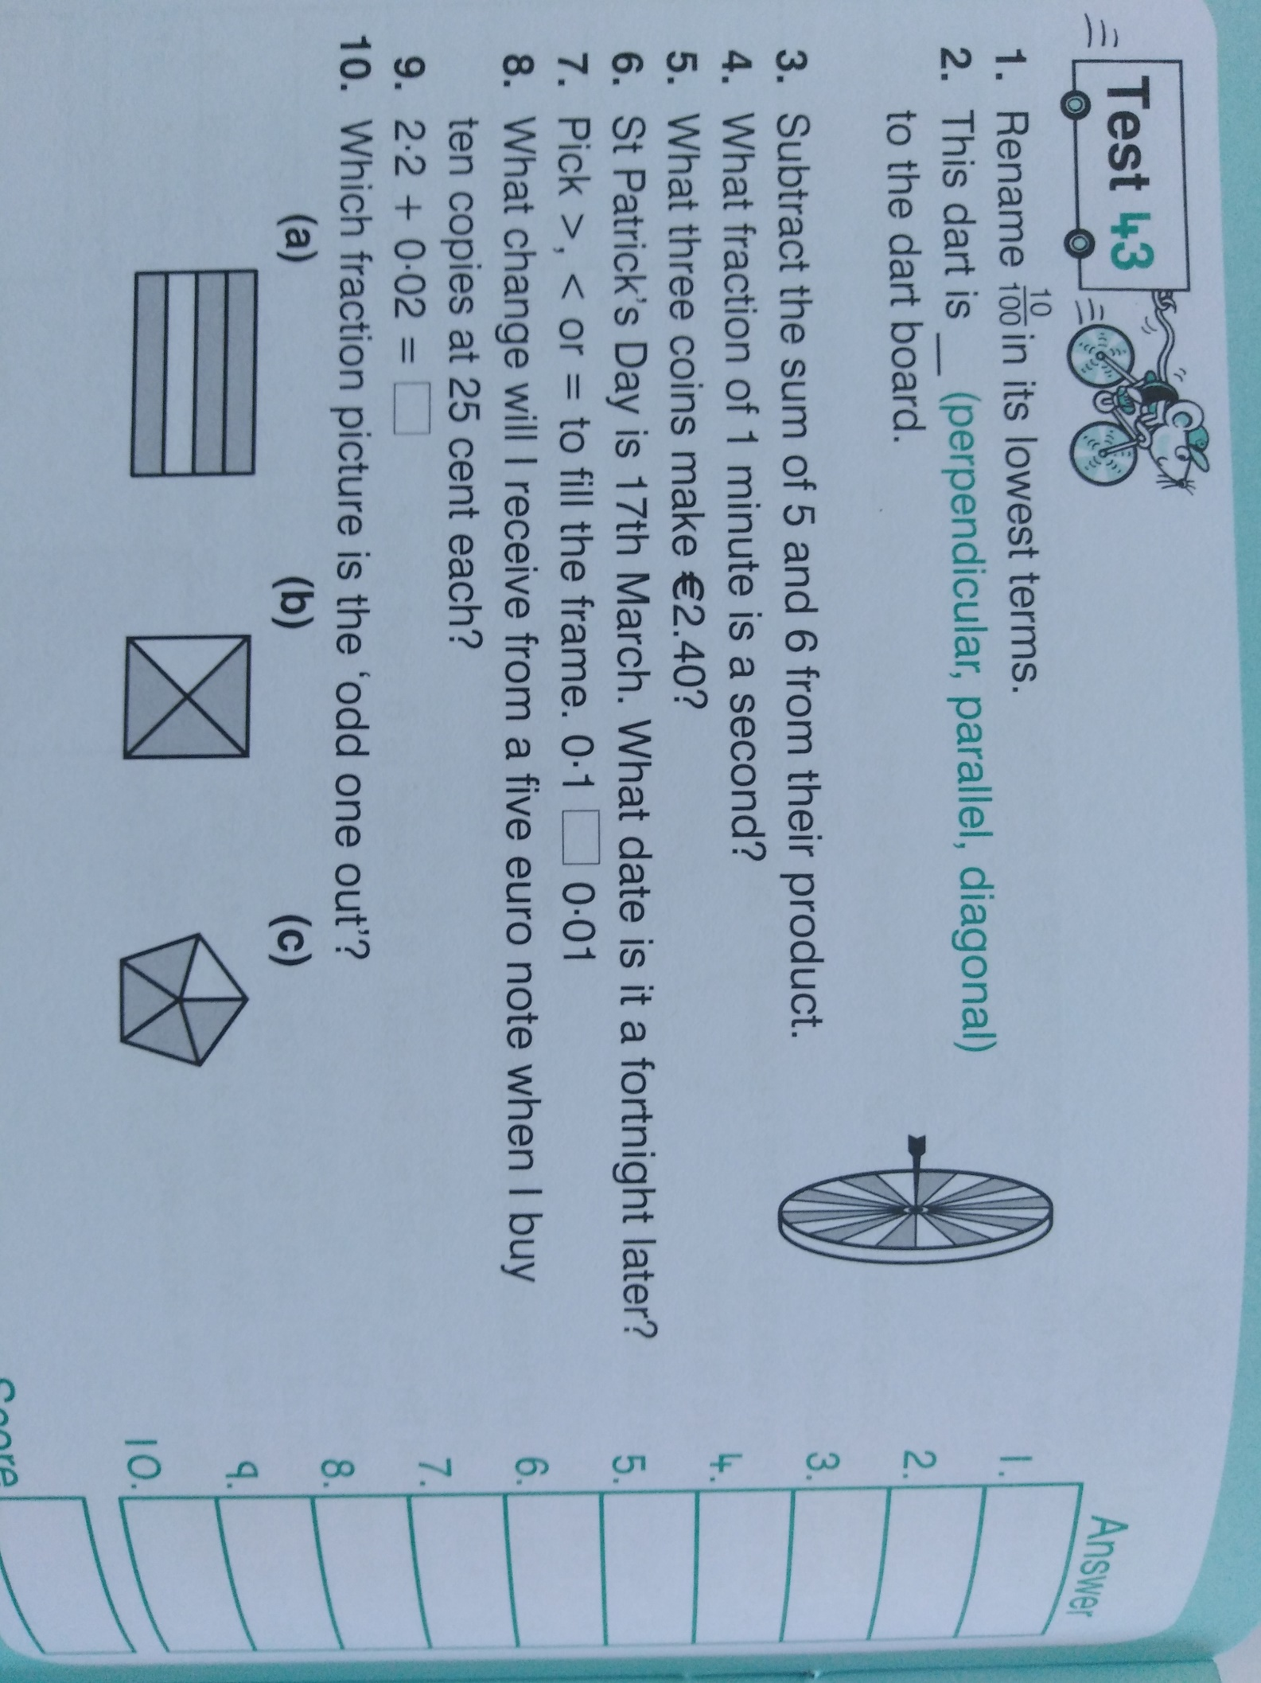
Maths Challenge Test 43, 44, 45

