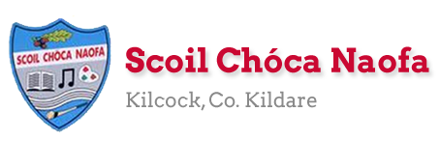
Work for Mr. Bracken’s 3rd Class: Monday 01/06/20 – Friday 05/06/20
Dear 3rd Class,
I hope you’re well and enjoying the great weather we’re having. It’s getting even harder to do schoolwork now, I know. My advice is to get outside as often as you can and to make the most of it.
Things may be a little different from now on. We are discussing the possibility of having a class Zoom Call. It could be at the same time every week until school finishes at the end of June. We would be catching up, talking about the upcoming Sports Week and more. You will get an email from Ms Daly about this with more information and a possible time for the weekly Zoom call.
This Monday, June 1st, is a Bank Holiday and you have no work We were also due to have Tuesday off school and as such all work on Tuesday is optional.
Your parents will have received an email from me outlining the RSE programme to be covered this week. The link to the programme is in the same email. I am here to help in any way I can. A lot of it will be a discussion between you and your parent(s)/guardian where you can talk through some topics.
Sports Week is happening from June 8th to 12th. It is going to be a very different week for you and I hope you will really enjoy it. I will give more information next week and in the Zoom call. There are going to be two videos on the school website on Sunday, June 7th, one with the teachers from our school and one with famous sports stars to give you some tips and motivation for the week. Make sure you look at the videos! There will also be a video message from a famous sports star/TV personality on Friday, June 5th, to give you a taste of what is to come. Make sure you look at the school website from 9am on that day.
Thank you for continuing to send me examples of your work to mrbracken@scoilchoca.ie I am so aware of how hard all of this is on you as children. You have to be more grown up and mature now than would normally be the case. Send me work when you can but equally send me pictures of you enjoying the weather and what you’re getting up to. I miss you all.
Ms Curran is working this week, she would be delighted to hear from you and to see what you have been up to: mscurran@scoilchoca.ie
Happy birthday to Bianka this week (6th June)!! We all hope you enjoy your special day!! Let’s all sing Happy Birthday to Bianka as we wash our hands.
All the best,
Mr Bracken

Monday | Bank Holiday – Enjoy your well - earned break!
Tuesday  All work is optional | Maths:  - 100 square activity – see below  - Angles worksheet – see below  - Flip the coin challenge – see below  - Science experiment – fun with density – see below
Wednesday | English:  - Starlight 16B – ‘The Sound Collector’ – Read the poem & complete part A in your copy  - Read your Home Book  Maths:  - Maths Matters pg 143  Irish:  - Léigh sa Bhaile: Read the next page. Freagair na ceisteanna: Answer the 5 questions at the bottom of the page in your spare copy  Other: RSE  - Themes 6 & 7
Thursday | English:  - Starlight 16B – ‘The Sound Collector’ – Read the poem & complete part B in your copy  - Read your Home Book  Maths:  - Maths Matters pg 144  Irish:  - Léigh sa Bhaile: Read the next page. Freagair na ceisteanna: Answer the 5 questions at the bottom of the page in your spare copy  Other: RSE  - Theme 8
Friday | Make sure you check the school website today from 9am for a message from a famous sports star! There will be two longer videos with teachers and other sports stars on the website on Sunday.  English:  - Starlight 16B – ‘The Sound Collector’ – Read the poem & complete part C in your copy  - Read your Home Book  Maths:  - Maths Matters pg 145  Irish:  - Léigh sa Bhaile: Read the next page. Freagair na ceisteanna: Answer the 5 questions at the bottom of the page in your spare copy  Other: RSE  - Theme 9

Useful websites for this week:
- Maths: https://www.mathletics.com/uk/
- Maths: Tables revision games- https://www.topmarks.co.uk/maths-games/7-11-years/multiplication-and-division
- Baking: very good website: https://www.supercook.com/#/recipes - you can put in the ingredients you have at home and it will generate something to bake for you.

Ms.Curran is working, this week, Tuesday-Friday
SEN/EAL work 3rd class EB June 1-5th. Teachers: Ms. McCabe & Ms.Curran.
Note: SEN teachers posted workpacks to their students last week. It is not extra work. Also, PLEASE email on a picture of something that your child has done recently, so we can see their lovely work again! All groups can look at a calendar and answer questions about the month of June eg how many days/weeks/Tuesdays in June? Also keep reading and learning your tables daily. This week, do 10x multiplication tables and practice counting up and down the ladder in 10s....the same speed backdown as going up!
EAL: People Who Help Us. | ORAL: Think about one person who helps in the neighbourhood (eg Lollipop Lady).  WRITE: Write 10 sentences about this person and draw a picture of him/her at work.
Speech and Language | Play Meanings Game for 5 minutes each day.  Practice STARTING sentences with a new phrase: Believe it or not/In my opinion/Perhaps.....  Conversation Starters – Continue with these, one per day.  Practice your “V” words on flashcards.
Literacy A & B | SNIP programme (session 12)..... 3 pages for the week.  Phonics/Final Blends: Read the sentences starting with’ Is it best to ask for help if the task is too hard?’daily. http://www.theschoolhouse.us/lessons/lesson57.html  Cloze: Look After My Wellbeing. Try another one of the Memory Activities!  Please keep up the reading, every day!  https://www.oxfordowl.co.uk/for-school/oxford-owl-ebook-collection  These are free ebooks and you can find your level.
Toe by Toe | Next SNIP session (session 22)..... 3 pages for the week.  Try one of the Memory Activities!  Please read and ask an adult to read with you.
SEN Individuals | Do one Mindful Brain Break Activity each day:  https://www.twinkl.ie/resource/us-p-12-mindful-minute-brain-break-cards  Fry’s Words: Continue with the list you are on.  Write Reader: Continue to write your diary entry daily. 5 or 6 sentences  Cloze:Look After My Wellbeing  Do another 2 pages of new booklet (S C)  Finish the picture sequencing (Who’s At The Zoo?)  Try one of the Memory Activities!
Contact SEN Teachers: msmccabe@scoilchoca.ie mscurran@scoilchoca.ie

PE - Flip a Coin Challenge – Enjoy the weather!!
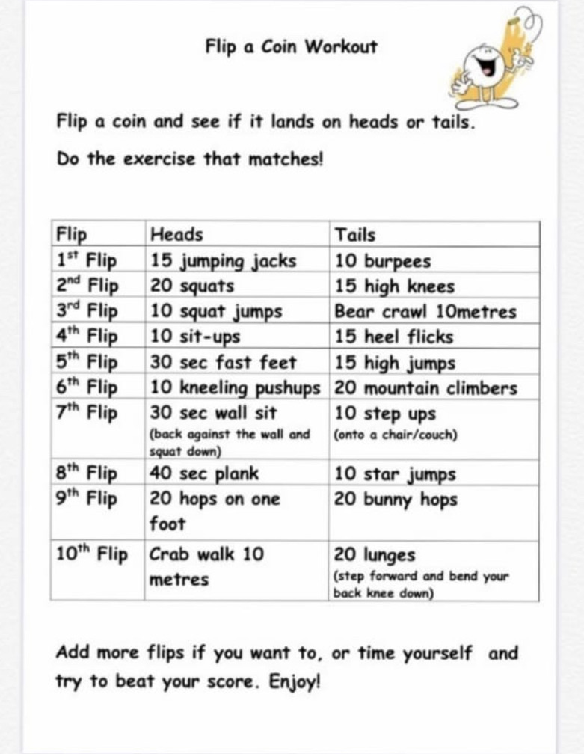

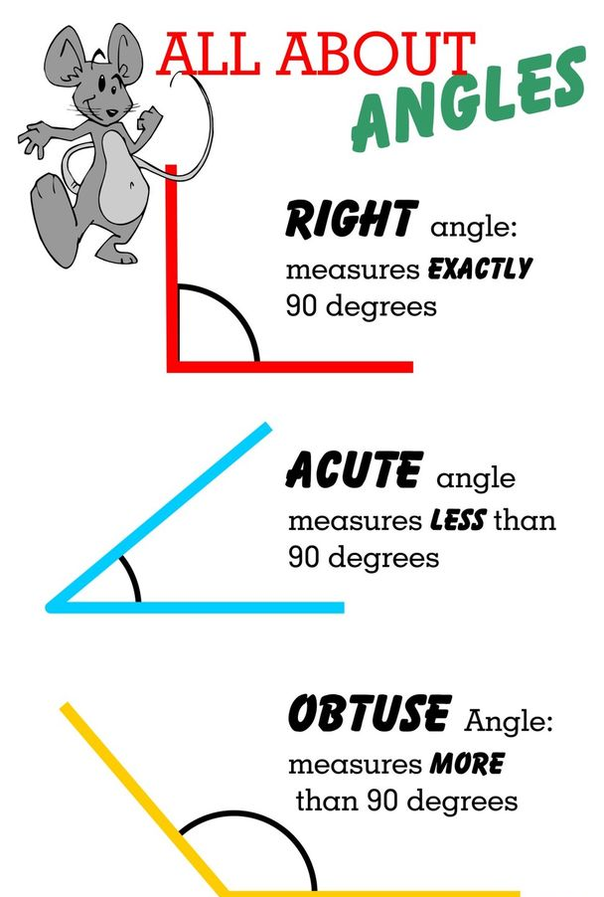
Maths: Angles

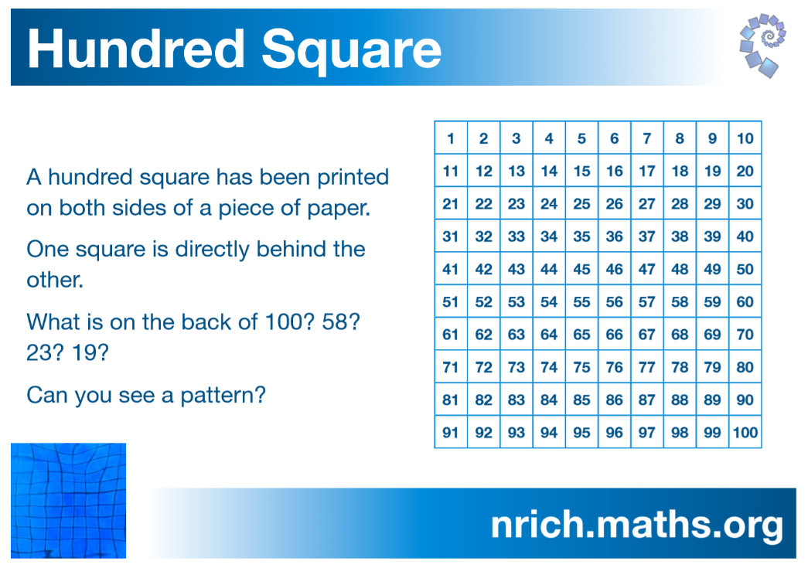
Maths: Problem solving activity – Tuesday - Optional

Maths: Tuesday - Optional
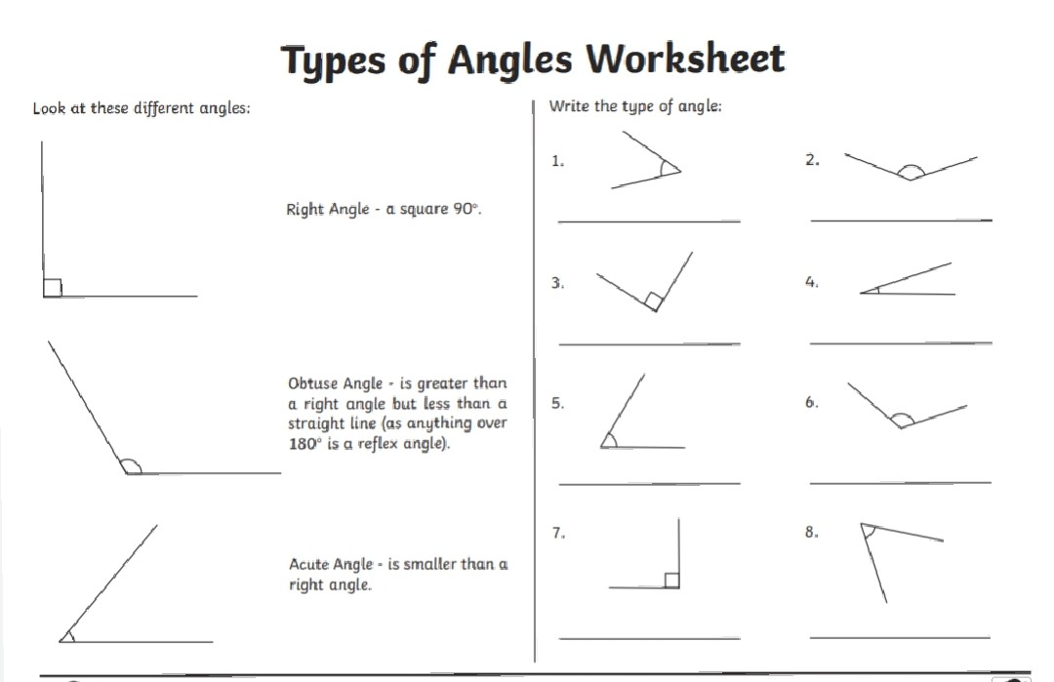

Tuesday – Science Experiment - optional
