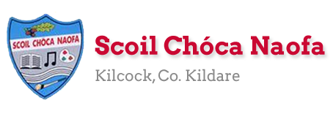

Work for Senior Infants Class : Week of Monday 11th May 2020
Monday | English: Skills book pg. 104 Discuss the facts we know about Lions. Match the facts and write your own (try to use your joined writing ).  Maths: Number 10. Count forwards and backwards to 10. Make a group of 10 items. https://www.sheppardsoftware.com/mathgames/earlymath/BalloonCount10.htm  Irish: Bua Na Cainte pg. 41.  SESE: Look around your garden. What flowers can you see? What is growing around you?  Other: Music: Close your eyes and listen to sounds in your environment. Identify and describe the sounds you hear. Are the sounds indoor or outdoor? The children can also imitate these sounds. Song: Walking in the Jungle https://www.youtube.com/watch?v=GoSq-yZcJ-4
Tuesday | English: Sight words https://sightwords.com/sight-words/flash-cards/#1up Use this site to access sight word flashcards. Practice next 10 from kindergarten set. Extension activity could be to call out word and child will write down.  Maths: Planet Maths pg. 91  Irish: Story: Eoin ar an teilifís –Eoin on the TV. https://www.seideansi.ie/dep/files/munster/Eoin_ar_an_Teilifis.html  P.E: Dance video https://www.youtube.com/watch?v=gCzgc_RelBA  Other: Unlocking SESE: Pg. 60 – What plants need to grow.  How is your plant? Send us a picture of your plant and how you are looking after it.
Wednesday | English: Take out your handwriting book and complete a page or two. Remember to check posture and correct pencil grip. Extend this if wanted by asking your child to think of and write some words with the letters revised in them.  Maths: Count forwards and backwards to 20. Ask your child what number comes before and after a number e.g. What comes before 9= 8. What comes after 9=10 Planet Maths pg. 92  Irish: Cad atá sa seomra suí? (What is in the sitting room?). Tá __sa seomra suí? The _ is in the sitting room. Lampa (Lamp), tolg (couch/sofa), cófra (press/cupboard), teilifís (TV). Bua na Cainte pg.42.  PE: Yoga –Squish the fish https://www.youtube.com/watch?v=LhYtcadR9nw
Thursday | English: Revise sounds/blends. https://www.starfall.com/h/ltr-classic/ - game number 11. Skills book page 106  Maths: Count to 20 forwards and backwards. Count out a group of 10 things. Use these things to check how many ways you can make 10 e.g. 1 +9, 9+1. Planet Maths pg. 93  Irish: Revise words. Watch TV channel Cúla 4 for 10 minutes.  PE: Go outside and play on your scooter, bicycle, go-cart, roller blades.  Other: SESE: Unlocking SESE pg. 62 Daisy to the rescue
Friday | English: Skills book pg. 105 Revise your capitals and full stops. Try to use your joined writing and refer to your writing strip/writing book if you forget the formation.  Maths: Cut up 10 pieces of paper (any size). Write the numbers 1-10 on them. Mix them all up and reorder them 1-10, 10-1 correctly. Mum/dad take a number. Child guesses what’s missing? Make a plus + and equals = sign on a piece of paper each. Use these to make sums with the numbers you have cut out. Can you remember how many ways to make 10? 5+5=10, 2+8=10 etc. Planet Maths pg. 93  Irish: Ar an teilifís (On the television) video from Bua na Cainte. Watch and try to say the words. https://www.youtube.com/watch?v=Q5CKFTyGdI0  Art: Can you create an animal using items found around your house? (Cardboard, toilet roll holder, paper, old boxes, containers, wool, fabric etc.). You could make your favourite zoo animal, pet, imaginary animal. (Ideas below). Please send us a picture of this. We would love to see all your creations  PE: Workout with Joe Wicks followed by five minute mindfulness exercise https://www.youtube.com/watch?v=Wsy2L9VvX90

Useful Websites for this week: (supplemental work – if needed)
- Reading books: https://www.oxfordowl.co.uk/for-home/find-a-book/library-page/?view=image&query=&type=book&age_group=Age+5-6&level=&level_select=&book_type=&series=#
- Tricky words songs: https://www.youtube.com/watch?v=TvMyssfAUx0
- Maths song: https://www.youtube.com/watch?v=FNEJXKTSkYM
- Extra English Resources: https://www.gillexplore.ie/gill-explore-resources/over-the-moon-senior-infants-skills-book?Chapters=0&ResourceTypes=11535 – There are lots of activities connected to our English work here unit 8.
- Thank the frontline heroes printable colouring page https://cbi-anpost.s3-eu-west-1.amazonaws.com/ImagineNation_Murphy.pdf
- Contact Teacher: msbyrne@scoilchoca.ie msmeehan@scoilchoca.ie
Contact support teacher:
Ms. Meehan’s class: msnidhalaigh@scoilchoca.ie Ms Byrne’s class: mswilson@scoilchoca.ie
Art (ideas/inspiration)
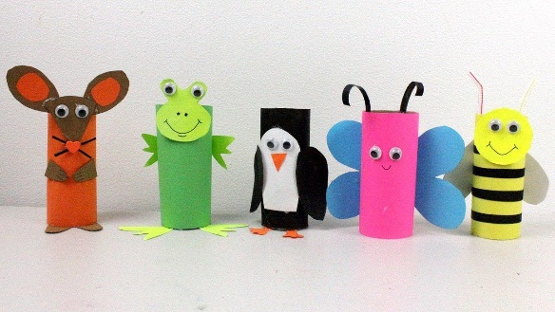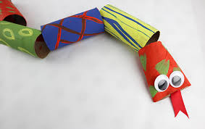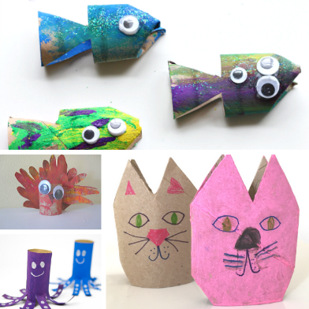

Senior Infants: Ms Byrne / Ms Meehan

EAL work May 11th 2020

Teacher: Ms Wilson / Ms Tone / Ms Clancy

Note: SEN teachers have added work on to the teachers’ plan. Children can decide to do this work instead of something the teacher has assigned. It is not extra work. Also, we would be delighted if you could email on a picture of something that your child has done and is proud of so we can see their lovely work again!
EAL | Transport and Travel  - Look at the worksheet below.

Contact SEN Teacher:
Please send Ms Meehan’s EAL work to Ms Wilson: mswilson@scoilchoca.ie

Please send Ms Byrne’s EAL work to Ms Tone: mstone@scoilchoca.ie

- Have a look at the videos and photos on the world book online about the different ways we can travel. (car, bus, motorbike, train, helicopter etc.)
https://www.worldbookonline.com/wbel/#/contentWorld;category=transportation
- Complete the activity below.
Draw pictures in the boxes below of four different ways to travel.

My favourite way to travel is by__________________________

- Name the different ways you can travel to and from Kilcock. Look at the clues in these pictures.
