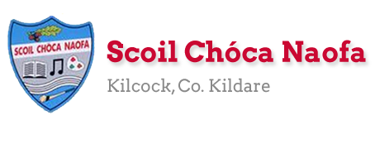

**Work for Senior Infants Class : Week of Monday 25th May 2020**

**\*\* Note 🡪 this week marks the last of our Stay Safe programme --> Below you will find the lessons that would have been completed in class with children this week. Use the same link from last week to access the resources and lessons. \*\***

|  |  |
| --- | --- |
| Monday | **English**: <https://www.gillexplore.ie/gill-explore-resources/over-the-moon-senior-infants-skills-book> *- Oral language and interactive resources 🡪 Unit 8 🡪 interactive Poem 🡪 the Zoo.* Listen to poem and complete page 109 Skills Book.  **Maths:** Revise number work on number line from last week. Practice counting on using number line. Use language ‘’what 3 more than 4…”, “Count on 2 from 6”. Planet Maths pg 97 (use cubes/blue-tack/play-dough/number-line)  **Irish**: ***New song*** <https://www.youtube.com/watch?v=4d6WSDL0GXM> ***– Cad atá sa seomra suí. Listen to the song and sing along. What does the song mean? New words 🡪 Tolg (sofa), Teilifís (TV), Tine (fire), Ríomhaire (computer).***  PE: Exercise like a ninja…. <https://www.youtube.com/watch?v=5AA2R-Dk-Ug>  **Other:** **Stay Safe Programme:** Topic 5 Lesson 1 – Strangers. What is a stranger? (*note: explain to children that a stranger is not necessarily a bad person but we cannot tell what kind of person they are by looking at them*). Read Maria’s story and answer q’s. Complete worksheet 11 – The Playground. |
| Tuesday | **English:** Phonics and writing 🡪 Practice sounds ‘or’, ‘ng’, ‘oo’. Think of words that contain these sounds. Write them out. Practice. Can you make a sentence with these words.  **Maths**: Planet Maths pg. 98 (draw spots in different ways).  **Irish:** Sing Song. New words (capall – horse, eilifint – elephant, seilide – snail, luch – mouse). Bua na Cainte page 44  PE: 10 x star-jumps, Run on the spot, Jump on one leg x 10, bunny hop x 20 – Repeat. Can you make up your own routine?  **Other:** **Stay Safe Programme: T**opic 5 Lesson 2 – Strangers. Recap on what is a stranger. Make a set of rules in your home for dealing with strangers. |
| Wednesday | **English:** Revise sounds and words from yesterday. Pg 110 Skills Book.  **Maths**: Take out number line that you made last week (or make a new one). Show your pointing finger and make sure you always use that finger to show your starting number. Follow the instructions on page 99 Planet maths and write answers.  **Irish:** <https://www.youtube.com/watch?v=Q1HmLdzZx4Y> Revise colours (glas, gorm, dearg, buí, oráiste, corcra). Can you sing our new song with the volume low?  **Choice Board**: See Choice Board below.  **SESE: SESE 🡪 Habitats 🡪 What is a habitat? Watch video** <https://www.youtube.com/watch?v=CxrlEajA398> Draw the habitat you think a monkey lives in? What about a dolphin? Finally what about a beetle? |
| Thursday | English 🡪 Story Time …. ‘’Dear Greenpiece’’. <https://www.youtube.com/watch?v=Qz6zULKr6kE> Discussion point: Did you enjoy the story? Why/why not? What was your favourite part?  **Maths**: Number line work. Page 100 Planet Maths. This time you also have to write out the sum you have completed eg 🡪 2 + 3 = 5.  **Irish:** Bua na Cainte page 45.  **PE:** Go on a nature walk outside. Have a look around. What do you see? What do you hear? What do you smell?  **SESE:** Based on your nature walk today. Complete page 67 (Unlocking SESE). |
| Friday | **English:** Skills book pg 111. Revise story from yesterday and complete page in book.  Maths: Numberline games <https://ie.ixl.com/math/sr-infants>  Do game c.17 and c.18 (Numbers and counting to 10)  **Irish:** Revise songs and new words this week. Bua na Cainte page 46.  Art: Whale themed art. Create your very own whale. Name him (depending on what materials you have at home you can chose which way you would like to create your whale) Here are some ideas. <https://littlefishblog.com/15-whale-themed-arts-and-crafts-for-kids/>  Pe: Yoga – Tiny the T-Rex <https://www.youtube.com/watch?v=rnlDBKD2S78> |

**CHOICE BOARD 🡪 Here is your fun choice board for the week. Pick one thing to do every week from the board. Send us a pic. We would love to see which one you chose?!**

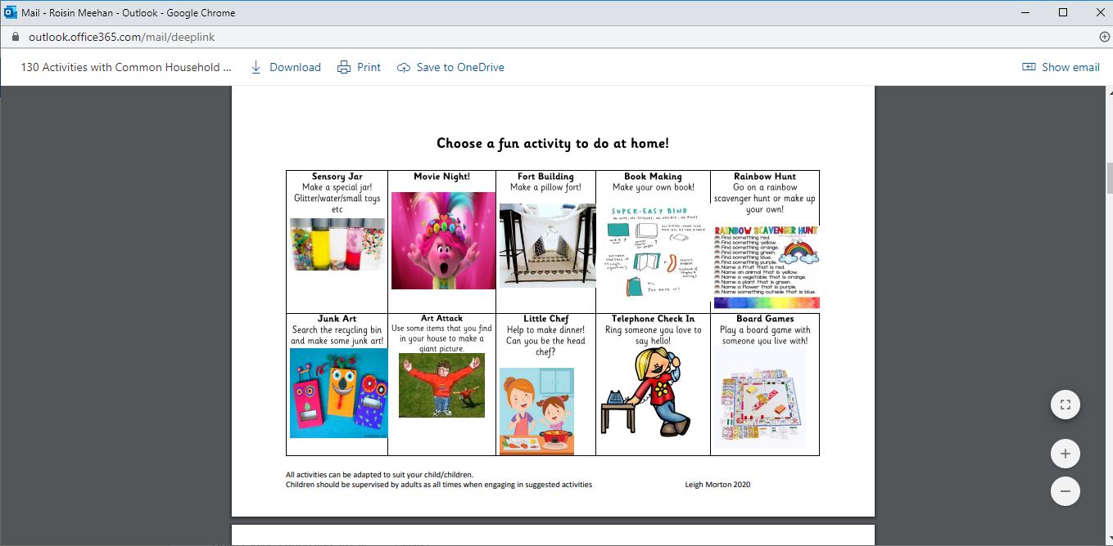

**Useful Websites for this week: (supplemental work – if needed)**

* **Reading books:** [https://www.oxfordowl.co.uk/for-home/find-a-book/library-page/?view=image&query=&type=book&age_group=Age+5-6&level=&level_select=&book_type=&series=#](https://www.oxfordowl.co.uk/for-home/find-a-book/library-page/?view=image&query=&type=book&age_group=Age+5-6&level=&level_select=&book_type=&series=)
* **Maths Games: IXL Games – Senior Infants** <https://ie.ixl.com/?partner=google&campaign=10099673253&adGroup=105313051390&gclid=Cj0KCQjwzZj2BRDVARIsABs3l9KgunMsc2JEy3gxMEtMf4liWVmLGaZnkZDdcAfdVFbnPz1CAl5qfEkaAq7nEALw_wcB>
* **BBC Radio – Songs, Dances, Nursery Rhymes, Stories to keep the children busy** <https://www.bbc.co.uk/programmes/p007g5y4>
* **Extra English Resources**: <https://www.gillexplore.ie/gill-explore-resources/over-the-moon-senior-infants-skills-book?Chapters=0&ResourceTypes=11535> – There are lots of activities connected to our English work here unit 8.
* **Contact Teacher:** [**msbyrne@scoilchoca.ie**](mailto:msbyrne@scoilchoca.ie)[**msmeehan@scoilchoca.ie**](mailto:msmeehan@scoilchoca.ie)

**Contact support teacher:**

**Ms. Meehan’s class:** [msnidhalaigh@scoilchoca.ie](mailto:msnidhalaigh@scoilchoca.ie) **Ms Byrne’s class:** [mswilson@scoilchoca.ie](mailto:mswilson@scoilchoca.ie)

**Senior Infants: Ms Byrne / Ms Meehan**

|  |  |  |
| --- | --- | --- |
| **EAL work 25/5/2020**  **Teacher:** Ms Wilson **/** Ms Tone  **Note:** SEN teachers have added work on to the teachers’ plan. Children can decide to do this work instead of something the teacher has assigned. It is not extra work. Also, we would be delighted if you could email on a picture of something that your child has done and is proud of so we can see their lovely work again!   |  |  | | --- | --- | | **EAL** | **The Local and Wider Community**  This week we are talking about places we see in Kilcock.   * If you are walking in the village with your child point to local places as you pass by e.g. the supermarket, the Royal Canal, the church, the hardware store, the railway station, the schools etc. * Complete the matching activity attached. –Match the clue to the picture. * Draw a picture of five places in Kilcock. Name the places.  1. A place to shop. 2. A place to get a haircut. 3. A place to pray. 4. A place to play. 5. A place to eat. |   **Contact SEN Teacher:**  **Please send Ms Meehan’s EAL work to Ms Wilson:** [**mswilson@scoilchoca.ie**](mailto:mswilson@scoilchoca.ie)    **Please send Ms Byrne’s EAL work to Ms Tone:** [**mstone@scoilchoca.ie**](mailto:mstone@scoilchoca.ie) |

**Match the Clue to the Place in Kilcock**

|  |  |
| --- | --- |
| Praying Hands Clipart Cartoon Prayer Hands Clipart (With images ...  **This place is old. (160 years old)**  **It is named after St Coca.**  **We pray here.** | Rye River Walk location  **The Royal Canal** |
| Clipart book reading, Clipart book reading Transparent FREE for ...  **We read a book in this place.** | Kilcock GAA Club - Paul Byrne Architects  **Kilcock GAA** |
| Free School Clipart - Clip Art Pictures - Graphics for Teachers ...  **We learn things in this place.** | Kilcock & Newtown Parish – Co. Kildare, Ireland  **St Coca’s Church** |
| Canal Boat Stock Illustrations – 1,560 Canal Boat Stock ...  **We see boats on the water here.** | [Shalom | This beautiful building is now a nursing home for n… | Flickr](https://www.google.com/url?sa=i&url=https://www.flickr.com/photos/bbusschots/9334998759&psig=AOvVaw1Wxl1ZNQG-3NJMFfM-FcdX&ust=1589448497958000&source=images&cd=vfe&ved=0CAIQjRxqFwoTCIiMppvDsOkCFQAAAAAdAAAAABAE)  **The Convent** |
| Gaa Football ClipartLatest News « Portarlington GAA Club  **We play football, camogie and hurling here.** | New opening hours for Kilcock Community Library to come into ...  **The Library** |
| Free Nun Cliparts, Download Free Clip Art, Free Clip Art on ...  **The nuns live here.** | Scoil Chóca Naofa - Home | Facebook  **Scoil Choca Naofa** |