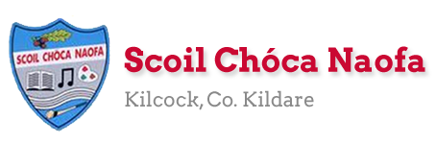
Work for Second Class : Monday 4th May 2020
We hope you are all keeping well during this time. We have outlined some activities which you can carry out daily. Extra activities, Irish pages and a message from the SEN teachers are all contained on this document. The focus for this week is Wellbeing and Mindfulness so we have included a daily activity based on this. Please do not feel pressure to complete everything. We would be delighted if you could all email on 2 pictures of work that your child has completed and is proud of so we can see their lovely work again! Feel free to contact us if you have any questions.
Kind regards, Ms. Carr and Ms. O’ Grady
mscarr@scoilchoca.ie mslogrady@gmail.com
Monday | Bank Holiday  No work assigned
Tuesday | P.E: Create an obstacle course or Fitness Alphabet. Make up your own exercise for each letter and spell your name. Or see Google for ideas.  Other: The Ark @ Home are streaming a recorded live performance of ‘Far Away From Me’ until the 6th of May. It’s a theatre show of 50 minutes duration. https://ark.ie/events/view/online-far-away  Mindfulness colouring sheet ‘April showers bring May flowers’, see below. https://www.youtube.com/watch?v=qFZKK7K52uQ  Using the same video can you meditate for 5 minutes.  *Optional work
Wednesday | English: Word Wizard: Phonics: p.85  Read library book for 10 minutes.  Maths: Revise Near Doubles 1+2=, 2+3=, 3+4=, 4+5=, 5+6=, 6+7=  Cracking Maths p.121  Gaeilge: See vocabulary at the bottom of this plan.  Practice oral language questions:  - Cá bhfuil tú i do chónaí?  - Ainmnigh na seomraí i do theach. Tá cistin, seomra codlata, seomra suite agus seomra folctha (bathroom) i mo theach.  - Cá bhfuil an chistin? Tá an cistin thíos staighre (downstairs). Tá an seomra codlata thuas staighre (upstairs).  P.E: Joe Wicks on YouTube or https://rtejr.rte.ie/10at10/  Other: Brain break breathing: Rainbow breaths  Keep a wellbeing journal for the week: The picture at the bottom of the plan is an idea of what could do. Feel free to change it.
Thursday | English: Word Wizard: The Gingerbread Man p.86: Read comprehension  Read library book for 10 minutes.  Maths: Revise Near Doubles 7+8=, 8+9=, 9+10=, 10+11=, 11+12=, 12+13=  Cracking Maths: Area: p.133  Gaeilge: Scéal (story) – Léigh (Read) Teach Nua- At the  bottom of this plan.  P.E: Practice one of the skills shown (throwing, catching, running and balancing) using Beyond the Classroom PE at home: https://www.scoilnet.ie/pdst/physlit/beyond/  Other: Brain break breathing: Butterfly breaths  Wellbeing Journal
Friday | English: Word Wizard: P.87: Answer A&B  Read library book for 10 minutes.  Maths: Cracking Maths: p.134  Revise Doubles and Near Doubles  Gaeilge: Scéal- Teach Nua- Freagair na ceisteanna (Answer  the questions)  P.E: Go outside for a walk or run or cycle  Other: Brain break breathing: Sun breaths  Wellbeing Journal

Extra activities if required including useful websites (For Self – directed Learning)
- RTE are providing a fun learning programme from 11-12 daily. Watch out for it @ https://www.rte.ie/learn/
- TG4 are providing an Irish learning programme from 10-11 daily. Watch out for it @ https://www.cula4.com/en/shows/cula4-ar-scoil/
Maths- Focus on Addition
- Click Area Games for Grade 3 https://www.splashlearn.com/area-games?adCampaign=9777538682&adGroup=100207410699&adTag=&adID=429686439589&ipad_blocker_disabled=1&gclid=Cj0KCQjwka_1BRCPARIsAMlUmEqR6ZcGIMm3Qxlpg0ri3GNS8VqNl4JmfwNJnmLCIOyZmCJJzyh2eMwaAsNDEALw_wcB
- https://ie.ixl.com/math/class-2/select-figures-with-a-given-area
- Hit the Button interactive game- children can practice their doubles and halves. https://www.topmarks.co.uk/maths-games/hit-the-button
- Cracking Maths Counting and Numeration p.132
English
- Continue Handwriting book
- Free Writing – Create a story using this line as your starting point: ‘’The evil witch has stolen all your powers turning you into a human.’’
Gaeilge
- Wordsearch Seomra Codlata: see below

EAL work

Teacher: Ms Wilson / Ms Tone / Ms Clancy

Note: SEN teachers have added work on to the teachers’ plan. Children can decide to do this work instead of something the teacher has assigned. It is not extra work. Also, we would be delighted if you could email on a picture of something that your child has done and is proud of so we can see their lovely work again!

EAL | People Who Help Us  - Look at the worksheets below.

Contact SEN Teachers:

- Please send Ms Carr’s EAL work to Ms Wilson: mswilson@scoilchoca.ie

- Please send Ms O’Grady’s EAL work to Ms Tone: mstone@scoilchoca.ie

Match the names to the people:

Artist Hairdresser Baker

Teacher Gardener Nurse

Builder Nun Doctor

Read and finish these sentences:
- A nurse works in a _______________.
- A builder works on a _______________.
- A baker wears _______________.
- A hairdresser cuts your hair with a _______________.
- A doctor gives you _______________ if you are sick.
- A gardener uses a _______________ to dig.
- A nun lives in a _______________.
- An artist uses a _______________.
- A teacher teaches _______________ in a classroom.

Interview someone in your family about their job.
Ask them questions:

- What is your job?
- Where do you work?
- What do you do?
- Do you have a uniform?

Contact SEN Teacher: mstone@scoilchoca.ie mswilson@scoilchoca.ie

Irish pages
Vocabulary – Sa Bhaile
Story-Teach Nua
Wordsearch
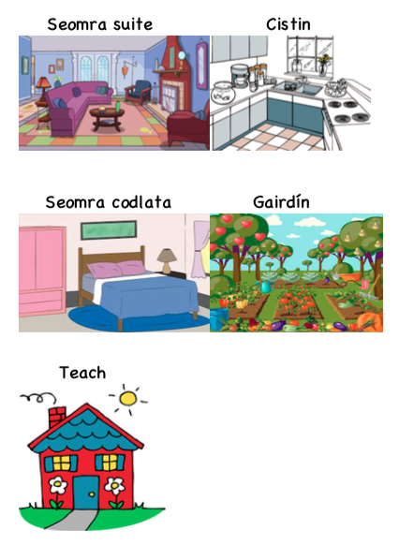
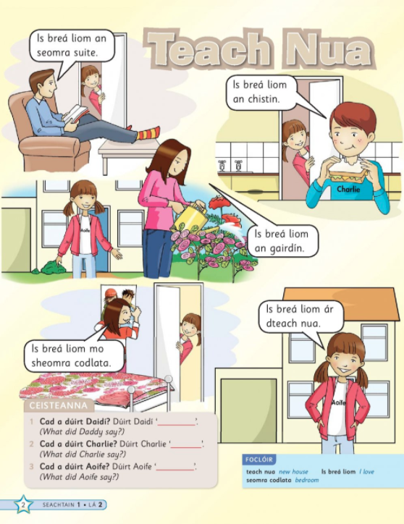

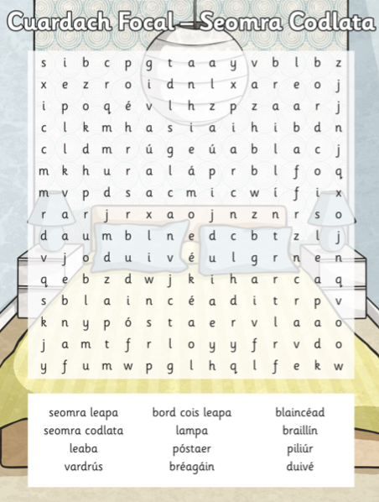

Wellbeing and Mindfulness
Mindfulness Colouring

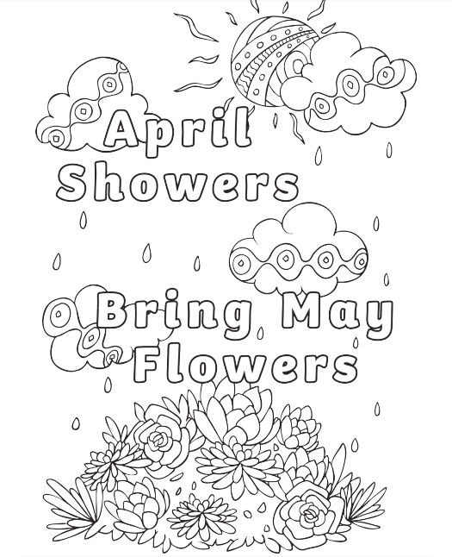

Wellbeing Journal
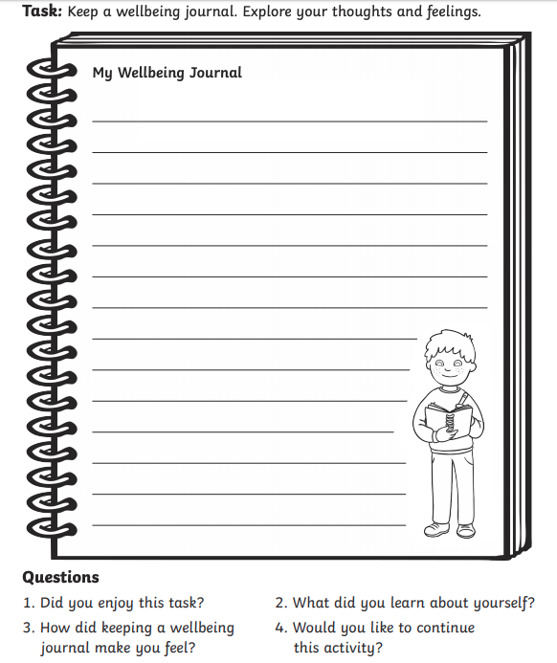

Brain Break Breathing
