Work for Second Class : Monday 25th May 2020
We hope you are all keeping well. We have outlined some activities which you can carry out daily. Extra activities, work from the SEN teachers, English, Irish and SESE pages are all contained on this document. Please do not feel pressure to complete everything. We are picking two pieces of work from the each class for the school website each week and would love for you to send in work you are proud of. Feel free to contact us if you have any questions.
Kind regards, Ms. Carr and Ms. O’ Grady
mscarr@scoilchoca.ie mslogrady@gmail.com
Monday | English: Read a Library Book- 5 mins  Word Wizard pg. 94- Phonics  Maths: Cracking Maths- Subtraction- pg. 138  Mental Maths- Times 4  https://www.youtube.com/watch?v=VrSevv3DI2E  Gaeilge: Revision of spellings and phonics- ‘dathanna’  Children look and listen to the spelling/ sound and click the  correct spelling, then select the ‘?’ to reveal the answer.  Website: http://www.leighleat.com/rang-2-seachtain18.html  P.E: 10 @10 https://rtejr.rte.ie/10at10/  Other: SESE (Sci) Sheet- Butterfly Bush- Read about the Butterfly Bush and fill in the fact file.
Tuesday | English: Read a Library Book- 5 mins  Word Wizard- pg. 95- Grammar - Speech Marks  Maths: Cracking Maths- Capacity pg. 139  Mental Maths- Times 4  https://www.youtube.com/watch?v=VrSevv3DI2E  Gaeilge: An Teilifís - See vocabulary at the bottom of this plan.  P.E: Joe Wicks on YouTube  Other: SESE (History) Bealtaine- See Sheet Part A and B
Wednesday | English: Read a Library Book- 5 mins  Sheet-Connecting words are another way of describing  conjunctions. We practiced these on pg. 89 of our Word  Wizard. Try the Conjections Sheet below to revise  connecting words/conjuctions.  Maths: Cracking Maths- Capacity- pg. 140  Mental Maths- Times 4  https://www.youtube.com/watch?v=VrSevv3DI2E  Gaeilge: Scéal (story) – Léigh (Read) An Teilifís - At the  bottom of this plan. (Email class teacher if you would like  an audio of teacher reading the story)  P.E: Go Noodle (online)  Other: SESE (History) Bealtaine- See Sheet- Read Part C
Thursday | English: Read a Library Book- 5 mins  Word Wizard- pg. 96- Part A: Story Planner- Using the  information planner, plan your story.  Maths: Cracking Maths- Capacity- Pg. 141  Mental Maths- Times 4- Game- Hit the Button-  Click Times Tables, select tables up to 10, Press hit the answer For x4- https://www.topmarks.co.uk/maths-games/hit-the-button  Gaeilge: Scéal- An Teilifís- Freagair na ceisteanna (Answer  the questions)  P.E: Go on a nature walk.  Other: SESE (Science) Go on a nature walk. See can you find any May flowers.
Friday | English: Word Wizard- pg. 96- Part B: Using your plan from  yesterday write your own story.  Challange: Can you include speech marks and connecting  words in your story?  Maths: Cracking Maths- Capacity- Pg. 142  Gaeilge: Sheet at the bottom of the plan- ‘Cad atá ar an Teilifís?’ (What is on the television?)  P.E: Joe Wicks on YouTube  Other: Art- Do your own cut-outs using coloured paper to make art like Matisse after watching this short video from The Tate Modern. Have fun! https://www.tate.org.uk/kids/explore/kids-view/meet-matisse

Extra activities if required including useful websites (For Self – directed Learning)
- RTE are providing a fun learning programme from 11-12 daily. Watch out for it @ https://www.rte.ie/learn/
- TG4 are providing an Irish learning programme from 10-11 daily. Watch out for it @ https://www.cula4.com/en/shows/cula4-ar-scoil/
Maths
- Master Your Maths- Complete any pages which were left blank- work at your own pace.

English
Listen to the audio of ‘Today I wore a Costume’ by Kenn Nesbitt, then read the poem yourself and answer the following questions.
https://www.poetry4kids.com/poems/today-i-wore-a-costume/
Questions:
- Did you like the poem? Explain your answer.
- Find the rhyming words in the poem.
- How do you think the poet was feeling? Why?
- Draw a picture of your favourite image from the poem.
- Re-read the last two lines. Has something like this ever happened to you?

Gaeilge
Practice these oral language questions:
- An maith leat cartún? Is maith liom cartún/ Ní maith liom cartún. (Do you like cartoons?)
- Cén clár teilifíse is fearr leat? Is fearr liom _____. (Which T.V programme do you prefer?)

EAL work

Teachers: Ms Wilson / Ms Tone

Note: SEN teachers have added work on to the teachers’ plan. Children can decide to do this work instead of something the teacher has assigned. It is not extra work. Also, we would be delighted if you could email on a picture of something that your child has done and is proud of so we can see their lovely work again!

EAL | The Local Community  This week the focus of our language work is on places in the local community.  - Introduce this topic informally. If you are on a walk point to buildings/places in the community e.g. the church, The Royal Canal, the credit union, supermarkets, hardware shops, schools, butchers, churches etc.  - Next look at and complete the activity attached.

Contact SEN Teachers:

- Please send Ms Carr’s EAL work to Ms Wilson: mswilson@scoilchoca.ie

- Please send Ms O’Grady’s EAL work to Ms Tone: mstone@scoilchoca.ie

Match the place to the picture
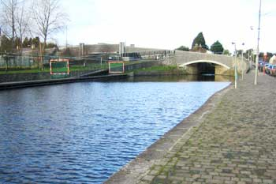 | Kilcock GAA Club
 | St Coca’s Church
 | The Royal Canal
 | The Library
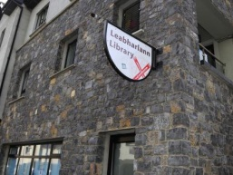 | Scoil Choca Naofa
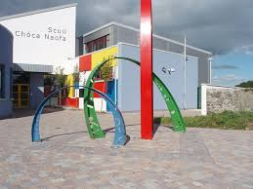 | The Convent

Now write a little about these places. Name the place. Say why you might go there. Say what you think of each place.
This is the ____________________________.
I can go there when __________________________________________.
I think that ______________________________________________
This is the ________________.
I go there when _________________________________________.
I think that _____________________________________________.

This is the _____________________.
I go there when ____________________________________________.
I think ____________________________________________________.

- 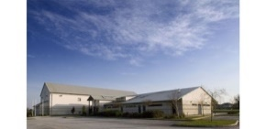
This is _______________________.
I can go there if_________________________________________.
I think ________________________________________________.

- 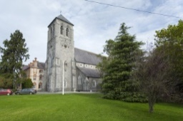
This is the __________________________.
I can go there if ___________________________________________
I think that _______________________________________________.
Now write about another place you visit in Kilcock. Say why you go there. Say what you think of it. (It could be a shop, a play area, a club). Draw a picture or attach a photo.

You pick the place you wish to write about.
________________________________________________________
________________________________________________________
________________________________________________________
_______________________________________________________
________________________________________________________
_________________________________________________________
_________________________________________________________

English- Conjuctions/ Connecting Words
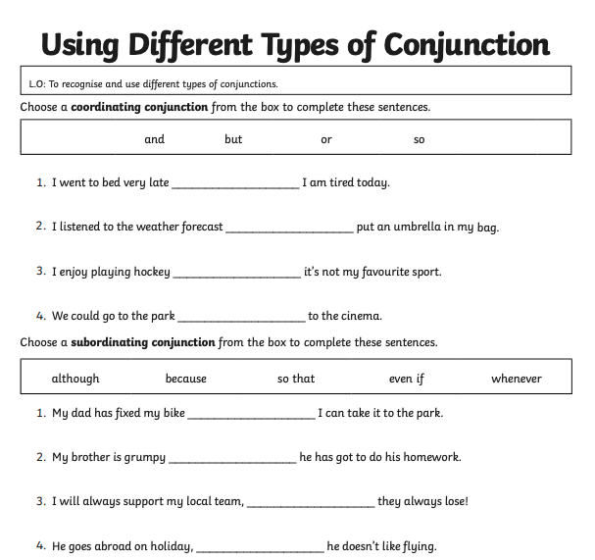
Irish pages
Vocabulary
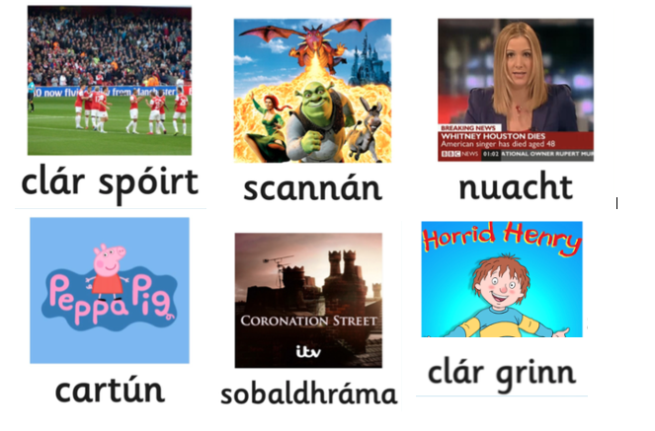
Scéal- An Teilifís
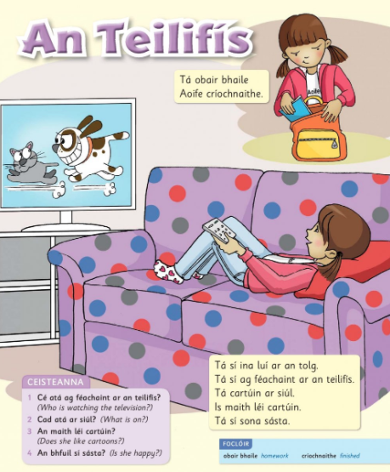

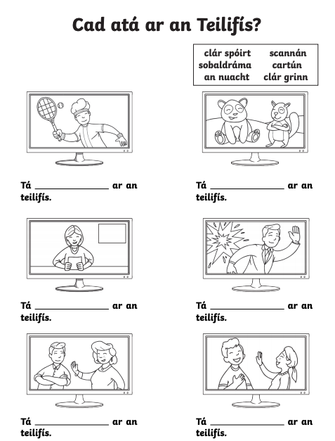

SESE- The Butterfly Bush (Monday)

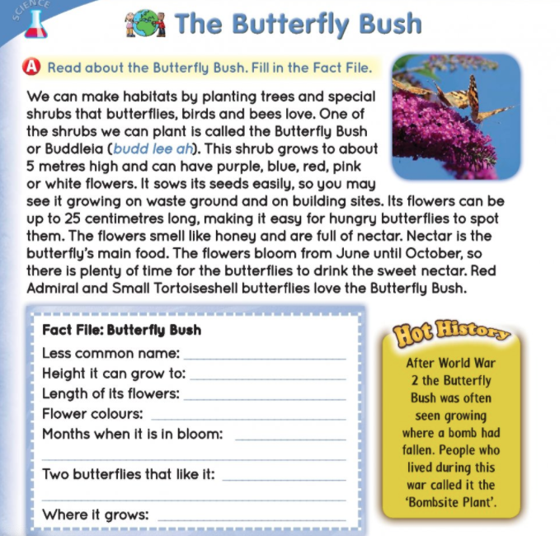

SESE- Bealtaine (Part A and B- Tuesday, Part C- Wednesday)
