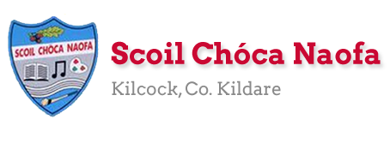
Work for Second Class : Monday 1st June 2020
We hope you are all keeping well. We have outlined some activities which you can carry out daily. Extra activities, work from the SEN teachers, English, Irish and Maths pages are all contained on this document. This week our activity is the RSE Programme. If we were in school, this would be the time of year when we would teach this programme. You would have received an email from the school about the RSE Programme. The link to the book are available in this email. It’s quite a content heavy programme. In our weekly plan we will guide through some of the important conversations you could have this week. Please do not feel pressure to complete everything. This week we will be starting our Zoom assemblies. A link will be made available the day before. We are picking two pieces of work from the each class for the school website each week and would love for you to send in work you are proud of. Feel free to contact us if you have any questions.
Kind regards, Ms. Carr and Ms. O’ Grady
mscarr@scoilchoca.ie mslogrady@gmail.com
Monday | Bank Holiday  No work assigned
Tuesday | P.E: https://www.youtube.com/watch?v=Zz653fZXslw  The Floor is Lava – We would advise adult assistance with this activity.  Other: Mindfulness colouring  https://www.youtube.com/user/ArtforKidsHub This link contains lots of art ideas. Perhaps you could pick one and give it a go.  *Optional work
Wednesday | English: Read a Library Book- 5 mins  Word Wizard – p.97 Vocabulary – Revision of Homophones  Maths: Cracking Maths- Capacity- pg. 143  Mental Maths- Times 5  https://www.youtube.com/watch?v=FQtZMVDJkB8  Gaeilge: Scéal (story) – Léigh (Read) Clár Teilifíse - At the  bottom of this plan. (Email class teacher if you would like  an audio of teacher reading the story)  P.E: Joe Wicks on Youtube.  Other: RSE Programme – Conversation - Other people are special – Discussing how people are similar or different using the questions P.111  Conversation about what being a good friend means P.116  Discussion Q1-8 What would a friend do? P.117  Discussion based on personal decisions P.189
Thursday | English: Read a Library Book- 5 mins  Word Wizard- pg. 98- The Dinosaur’s Dinner – Read the story.  Maths: Cracking Maths- Capacity- Pg. 144  Mental Maths- Times 5  https://www.youtube.com/watch?v=FQtZMVDJkB8  Gaeilge: Scéal- Clár Teilifíse- Freagair na ceisteanna (Answer  the questions)  P.E: https://rtejr.rte.ie/10at10/  Other: RSE Programme – Keeping Safe P.139  Conversation about ways we sometimes feel. P.143 and 144
Friday | English: Word Wizard- pg. 99 A&B  Maths: Capacity Worksheet (see below)  Mental Maths- Times 5- Game- Hit the Button-  Click Times Tables, select tables up to 10, Press hit the answer For x5- https://www.topmarks.co.uk/maths-games/hit-the-button  Gaeilge: Wordsearch – Clár Teilifíse – See sheet at the bottom of this plan.  P.E: Go on a walk, run, or cycle.  Other: RSE Programme – Let’s investigate how our bodies work P.166  Let’s talk about things we say and the way we say them P.167  Discussion – The Story of my Life and Changes in my life as I grow P.175 and 176  *N.B. Look at the school website from 9am to see a message from a famous sports star.  Two more videos will go live on the school website on Sunday night June 7th.

Extra activities if required including useful websites (For Self – directed Learning)
- RTE are providing a fun learning programme from 11-12 daily. Watch out for it @ https://www.rte.ie/learn/
- TG4 are providing an Irish learning programme from 10-11 daily. Watch out for it @ https://www.cula4.com/en/shows/cula4-ar-scoil/
Maths
- Master Your Maths and Cracking Maths- Complete any pages which were left blank- work at your own pace.

English
https://parsleymimblewood.files.wordpress.com/2020/04/pmimblewood_book_v3.pdf
Read this story (It is quite long so don’t worry if you don’t get a chance to read it all.)

Gaeilge
Practice these oral language questions:
- An maith leat clár grinn? Is maith liom clár grinn/ Ní maith liom clár grinn. (Do you like funny programmes?)
- Cén clár teilifíse nach maith leat? Ní maith liom _____. (Which T.V programme do you not like?)

EAL work

Teachers: Ms Wilson / Ms Tone (Ms Clancy)

Note: SEN teachers have added work on to the teachers’ plan. Children can decide to do this work instead of something the teacher has assigned. It is not extra work. Also, we would be delighted if you could email on a picture of something that your child has done and is proud of so we can see their lovely work again!

EAL | The Local Community  - Talk about a place you like to visit in Kilcock. Where is it? Why do you like to go there? What do you do there?  - Complete the worksheets below.

Contact SEN Teachers:

- Please send Ms Carr’s EAL work to Ms Wilson: mswilson@scoilchoca.ie

- Please send Ms O’Grady’s EAL work to Ms Tone: mstone@scoilchoca.ie

Kilcock
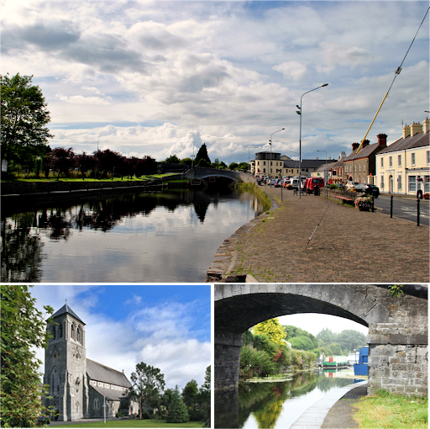

- What places do you like to visit in Kilcock? E.g. canal, square.
_______________________________________________

- What do you do there?
______________________________________________________________________________________________
- Why do you like to go there?
_______________________________________________ ________ _______________________________________

- Write five sentences about Kilcock.
What shops does it have?
Where can you go to eat?
What sports can you play?
Does it have a library / police station / factory?
- Draw a picture.

______________________________________________________________________________________________________________________________________________________________________________________________________________________________________________________________________________________________________________________________________________________________________________________________________________________________________________________________________________________________________________________________________________________________________

Mindfulness Colouring

Maths Worksheet
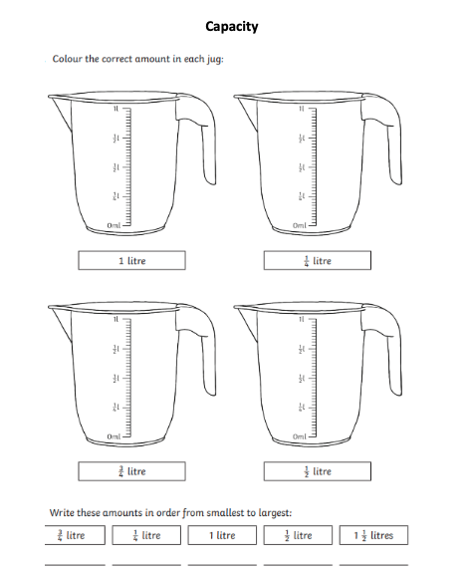

Irish pages
Scéal – Clár Teilifíse
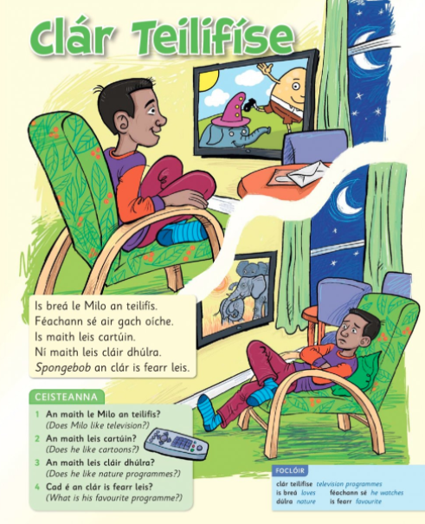

Wordsearch – Clár Teilifíse
