

**Work for Second Class : Monday 18th May 2020**

We hope you are all keeping well during this time. We have outlined some activities which you can carry out daily. Extra activities, Irish pages, SESE pages and a message from the SEN teachers are all contained on this document. This week our activity is the Stay Safe Programme. If we were in school, this would be the time of year when we would teach this programme. If your child misses out on the programme this year, it will be covered again next year. You would have received an email from Ms Daly about the Stay Safe Programme. The links to the website are available in this email. Please do not feel pressure to complete everything.We would be delighted if you could **all email on 2 pictures of work that your child has completed** and is proud of so we can see their lovely work again! Feel free to contact us if you have any questions.

Kind regards, Ms. Carr and Ms. O’ Grady

[mscarr@scoilchoca.ie](mailto:mscarr@scoilchoca.ie) [mslogrady@gmail.com](mailto:mslogrady@gmail.com)

|  |  |
| --- | --- |
| **Monday** | **English:** Read at Home pg. 117  Word Wizard pg. 91- Phonics  **Maths:** Master Your Maths- Week 30 Monday.  Mental Maths- Times 3  <https://www.youtube.com/watch?v=MyqWKt89Je4>  **Gaeilge:** Revision of spellings and phonics- ‘n’  Children look and listen to the spelling/ sound and click the  correct spelling, then select the ‘?’ to reveal the answer.  Website: <http://www.leighleat.com/rang-2-seachtain3.html>  **P.E:** Joe Wicks on Youtube  **Other:** Stay Safe Programme 1st and 2nd class Lessons Topic 2 Friendship and Bullying Lesson 1 and 2 (refer to Ms Daly’s email on the Stay Safe programme) |
| **Tuesday** | **English:** Read at Home pg. 118  Word Wizard- pg. 92 Horrid Henry’s Holiday – Read the story  **Maths:** Master Your Maths- Week 30 Tuesday.  Mental Maths- Times 3  <https://www.youtube.com/watch?v=MyqWKt89Je4>  **Gaeilge:** Dathanna - See vocabulary at the bottom of this plan.  **P.E:** Go Noodle (See online)  **Other:** Stay Safe Programme 1st and 2nd class Lessons Topic 2 Friendship and Bullying Lesson 3 and 4 (refer to Ms Daly’s email on the Stay Safe programme) |
| **Wednesday** | **English:** Read at Home pg. 119  Word Wizard- pg. 93- Answer the Questions - A&B  **Maths:** Master Your Maths- Week 30 Wednesday.  Mental Maths- Times 3  <https://www.youtube.com/watch?v=MyqWKt89Je4>  **Gaeilge:** Scéal (story) – Léigh (Read) An Zú - At the  bottom of this plan.  **P.E:** <https://www.youtube.com/watch?v=VmK3fd96T2Y> This is an example of an obstacle course, you can make your own.  **Other:** Stay Safe Programme 1st and 2nd class Lessons Topic 3 Touches Lesson 1 and 2 (refer to Ms Daly’s email on the Stay Safe programme) |
| **Thursday** | **English:** Read at Home pg. 120  Word Wizard: Vocabulary pg. 93 C  **Maths:** Master Your Maths- Week 30 Thursday.  Mental Maths- Times 3- Game- Hit the Button-  Click Times Tables, select tables up to 10, Press hit the answer For x3- <https://www.topmarks.co.uk/maths-games/hit-the-button>  **Gaeilge:** Scéal- An Zú- Freagair na ceisteanna (Answer  the questions)  **P.E:** 10@ 10 <https://rtejr.rte.ie/10at10/>  **Other:** Stay Safe Programme 1st and 2nd class Lessons Topic 4 Secrets and Telling Lesson 1 (refer to Ms Daly’s email on the Stay Safe programme) |
| **Friday** | **English:** Word Wizard: Oral Language – Orally Telling an Imaginative Story (see below)  **Maths:** Master Your Maths- Week 30 Test.  **Gaeilge:** Dathanna -Cuir an dath ceart ar gach phota péinte (Colour the correct paint pot) – See below  **P.E:** Go for a walk, run or cycle.  **Other:** Stay Safe Programme 1st and 2nd class Lessons Topic 5 Strangers Lesson 1 (refer to Ms Daly’s email on the Stay Safe programme) |

**Extra activities if required including useful websites (For Self – directed Learning)**

* **RTE** are providing a fun learning programme from 11-12 daily. Watch out for it @ <https://www.rte.ie/learn/>
* **TG4** are providing an Irish learning programme from 10-11 daily. Watch out for it @ <https://www.cula4.com/en/shows/cula4-ar-scoil/>

|  |
| --- |
| **Maths- Focus on Subtraction** |
| **NB Explanation for renaming**: 20-12= If there is more on the floor go next door and rename. 0-2 (more on the floor so you have to go next door/ 0-2 I cannot do so I must rename) Rename your 2 tens, now you have one ten. Carry your 1 ten over to your units. Now you 10 units- 2 units. This equals 8 units. In your tens column 1ten- 1 ten = 0 tens. Your answer is 8.   1. **Cracking Maths** pg. 125   **Explanation for Question 1:** When the first number of the sum is missing you have to use the opposite sign to find the missing number. _-4=15 I must add 15+4 to find the missing number.   1. **Cracking Maths** pg. 126 2. **Cracking Maths** pg. 136 Subtraction with the 101-200 square. 3. **Cracking Maths** pg. 137 |
| **English** |
| Everybody Worries by John Burgerman <https://en.calameo.com/read/000777721945cfe5bb9cc?authid=Xu9pcOzU3TQx>  Read the story and answer these questions:   * Is it okay to worry? * Which character do you think you’re most like? Look at the pictures to see. * What can you do to make you feel better when you’re worried? * Do you have a favourite page in the book? Pick it out and say why. * What is the moral of the story? (What is the lesson in the story?) |
| **Gaeilge** |
| 1. **An Zú – Dathaigh agus Scríobh (Colour and answer the questions): see below** |

|  |  |  |
| --- | --- | --- |
| **EAL work**  **Teachers:** Ms Wilson /Ms Tone (Ms Clancy)  **Note:** SEN teachers have added work on to the teachers’ plan. Children can decide to do this work instead of something the teacher has assigned. It is not extra work. Also, we would be delighted if you could email on a picture of something that your child has done and is proud of so we can see their lovely work again!   |  |  | | --- | --- | | **EAL** | **Transport and Travel**   * Look at the worksheet below. |   **Contact SEN Teachers:**   * Please send Ms Carr’s EAL work to Ms Wilson:[**mswilson@scoilchoca.ie**](mailto:mswilson@scoilchoca.ie) * Please send Ms O’Grady’s EAL work to Ms Tone:[**mstone@scoilchoca.ie**](mailto:mstone@scoilchoca.ie) |

Fill in the blanks:

Lots of people can travel together on a _________.

People have fun rowing in a __________.

You can visit the moon in a C:\Program Files (x86)\Microsoft Office\MEDIA\CAGCAT10\j0215086.wmf ________ ________.

You can fly in a C:\Program Files (x86)\Microsoft Office\MEDIA\CAGCAT10\j0297707.wmf _____ _____ ____________.

You can drive very fast in a C:\Program Files (x86)\Microsoft Office\MEDIA\CAGCAT10\j0212957.wmf_____________.

* Write five sentences about a fun trip that you had.

Where did you go?

How did you get there?

Who was with you?

What did you do?

* Draw a picture.

|  |
| --- |
| One day, I went to____________________________  ________________________________________________________________________________________________________________________________________________________________________________________________________________________________________________________________________________________________________________________  _______________________________________ |
|  |

**Irish pages**

**Vocabulary – Dathanna**

**Story- An Zú**

**Dathanna – Cuir an dath ceart ar gach phota péinte**

**An Zú – Dathaigh agus Scríobh**

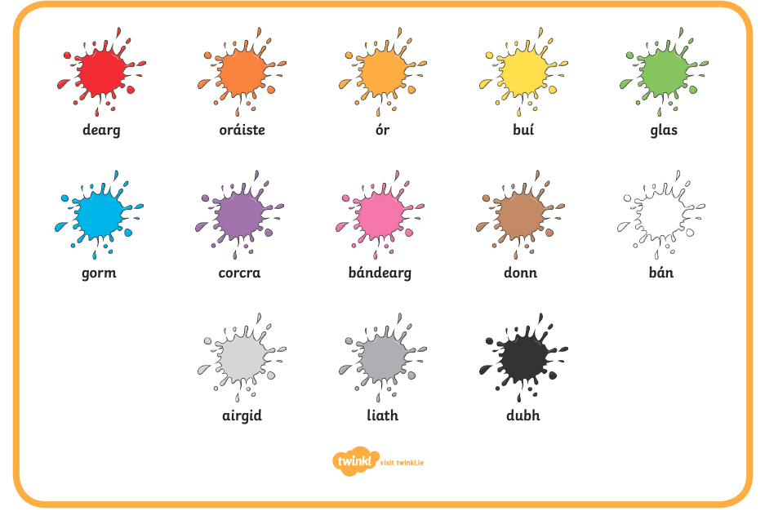

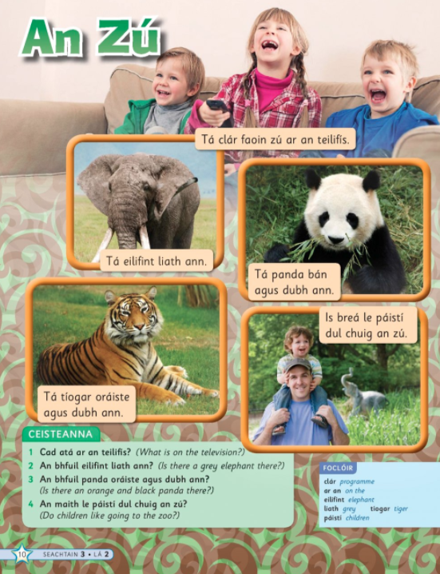

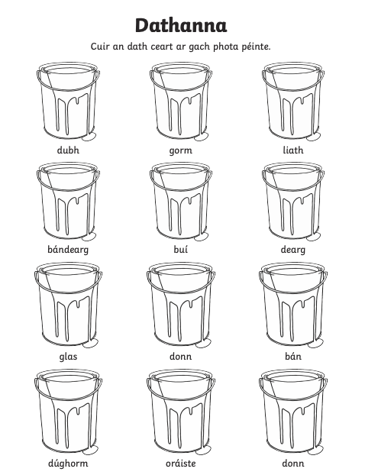

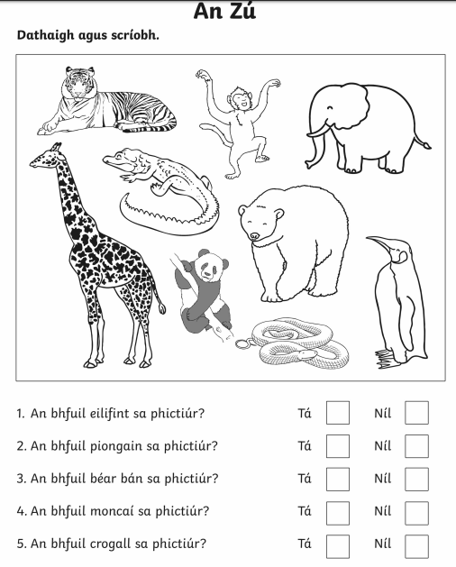

**Oral Language**

