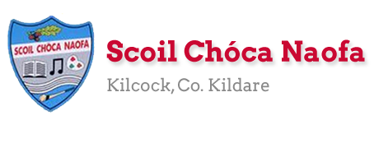
Work for Second Class : Monday 11th May 2020
We hope you are all keeping well during this time. We have outlined some activities which you can carry out daily. Extra activities, Irish pages, SESE pages and a message from the SEN teachers are all contained on this document. Please do not feel pressure to complete everything. We would be delighted if you could all email on 2 pictures of work that your child has completed and is proud of so we can see their lovely work again! Feel free to contact us if you have any questions.
Kind regards, Ms. Carr and Ms. O’ Grady
mscarr@scoilchoca.ie mslogrady@gmail.com
Monday | English: Read at Home pg. 113  Word Wizard pg. 88- Phonics  Maths: Master Your Maths- Week 29 Monday.  Mental Maths- Times 2  https://www.youtube.com/watch?v=L2wBEDDiCzQ  Gaeilge: Revision of spellings and phonics- ‘o’  Children look and listen to the spelling/ sound and click the  correct spelling, then select the ‘?’ to reveal the answer.  Website: http://www.leighleat.com/rang-2-seachtain2.html  P.E: Go Noodle (See online)  Other: SESE (Science) Watch this video about butterflies and write  three facts.  https://www.youtube.com/watch?v=V5RSpMQQOpw
Tuesday | English: Read at Home pg. 114  Word Wizard- pg. 87 C- Vocabulary- Write the correct word.  Maths: Master Your Maths- Week 29 Tuesday.  Mental Maths- Times 2  https://www.youtube.com/watch?v=L2wBEDDiCzQ  Gaeilge: Sa bhaile- Seomra Suí (The Sitting Room) See vocabulary  at the bottom of this plan.  P.E: Joe Wicks on YouTube  Other: SESE(Sci) Read ‘The Lifecycle of a Butterfly’ and answer  the questions. (See Below- SESE Sheet 1 and 2)
Wednesday | English: Read at Home pg. 115  Word Wizard- pg. 89- Grammar- Connecting Words  Maths: Master Your Maths- Week 29 Wednesday.  Mental Maths- Times 2  https://www.youtube.com/watch?v=L2wBEDDiCzQ  Gaeilge: Scéal (story) – Léigh (Read) Sa Seomra Suite - At the  bottom of this plan.  P.E: 10@ 10 https://rtejr.rte.ie/10at10/  Other: SESE (Sci) Write ‘The Lifecycle of a Butterfly’ See SESE Sheet 3 below for template. SESE Sheet 4 below is the answer sheet.
Thursday | English: Read at Home pg. 116  Word Wizard: pg. 90 A&B- Fix the Narrative  Explanation: Part A- The story is jumbled up. Get the children to read the parts of the story and number them in the correct order 1-5.  Part B- Colour the parts of the narrative. For example Colour the number 1 for Title Yellow. Colour part 2 (When, where, who) purple, Colour part 3, the first event green and so on.  Maths: Master Your Maths- Week 29 Thursday.  Mental Maths- Times 2- Game- Hit the Button-  Click Times Tables, select tables up to 10, Press hit the answer For x2- https://www.topmarks.co.uk/maths-games/hit-the-button  Gaeilge: Scéal- Sa seomra suite- Freagair na ceisteanna (Answer  the questions)  P.E: Nature Walk  Other: SESE (Sci) ‘Butterflies of Ireland Poster’- https://www.biodiversityireland.ie/wordpress/wp-content/uploads/Butterfly-Poster.pdf  What butterflies can you find on your walk today?
Friday | English: Word Wizard: P.87: D. Write a few questions you would like to ask the fox. Maybe you could get someone in your house to pretend to be the fox and take part in your interview.  Maths: Master Your Maths- Week 29 Test.  Gaeilge: Tarraing do sheomra suí (Draw and label your sitting room using your Irish vocabulary- see vocabulary sheet below)  P.E: Joe Wicks on YouTube  Other: Art: Butterfly Art- https://www.youtube.com/watch?v=NLWNOafqfh0

Extra activities if required including useful websites (For Self – directed Learning)
- RTE are providing a fun learning programme from 11-12 daily. Watch out for it @ https://www.rte.ie/learn/
- TG4 are providing an Irish learning programme from 10-11 daily. Watch out for it @ https://www.cula4.com/en/shows/cula4-ar-scoil/
Maths- Focus on Subtraction
- Cracking Maths pg. 122 Subtraction 4.
NB Subtraction- Read the problem twice, pick the key words- does it mean subtract or add. Then write out your problem in the box.
Explanation for Question 1: 20-12= If there is more on the floor go next door and rename. 0-2 (more on the floor so you have to go next door/ 0-2 I cannot do so I must rename) Rename your 2 tens, now you have one ten. Carry your 1 ten over to your units. Now you 10 units- 2 units. This equals 8 units. In your tens column 1ten- 1 ten = 0 tens. Your answer is 8.
- Cracking Maths pg. 123
- Cracking Maths pg. 124
NB Read the question carefully. This page is tricky as you don’t always have to rename. Remember only if there are more on the floor do you go next door.
- Cracking Maths pg. 135 Check up 4
English
- Listen to the audio of 'I let my sister cut my hair' by Kenn Nesbitt, then read the poem yourself and answer the following questions.
https://www.poetry4kids.com/poems/i-let-my-sister-cut-my-hair/
Questions:
Did you like this poem? Explain your answer.
Find the rhyming words in the poem.
How old was the sister in the poem.
How do you think the poet was feeling after getting a haircut? Why?
Draw a picture of your favourite image from the poem.
Gaeilge
- Aimsigh na Difríochtaí: see below

EAL work 11/5/2020

Teacher: Ms Wilson / Ms Tone / Ms Clancy

Note: SEN teachers have added work on to the teachers’ plan. Children can decide to do this work instead of something the teacher has assigned. It is not extra work. Also, we would be delighted if you could email on a picture of something that your child has done and is proud of so we can see their lovely work again!

EAL | Transport and Travel  - Look at the worksheets below.

Contact SEN Teachers:

- Please send Ms Carr’s EAL work to Ms Wilson: mswilson@scoilchoca.ie

- Please send Ms O’Grady’s EAL work to Ms Tone: mstone@scoilchoca.ie

As an introduction to this topic open the link below. Look at the pictures and videos about transport. Read about the different forms of transport described here in the world book online.
https://www.worldbookonline.com/wbel/#/contentWorld;category=transportation
Next put these forms of transport into different categories.
(e.g. A helicopter is a form of air transport).
Lorry, Ferry, Helicopter, Van, Cruise Ship, Horse, Yacht, Aeroplane,
Hot Air Balloon, Space Shuttle, Motorbike, Bicycle, Submarine.
Air Transport | Land transport | Sea transport
Helicopter.

Which type of transport is the fastest? _____________________
Which types of transport are best for the environment?

What type of transport is the most exciting? Why do you think so?
______________________________________________________________________________________________________
Draw a picture of your favourite way of travelling. Write a sentence to explain why it is your favourite way to travel.

Irish pages
Story- Sa Seomra Suite
Vocabulary – Sa Seomra Suí (Seomra Suí/ Seomra Suite= sitting room)
Aimsigh na Difríochtaí- Sa Seomra Suí (Spot the Difference)
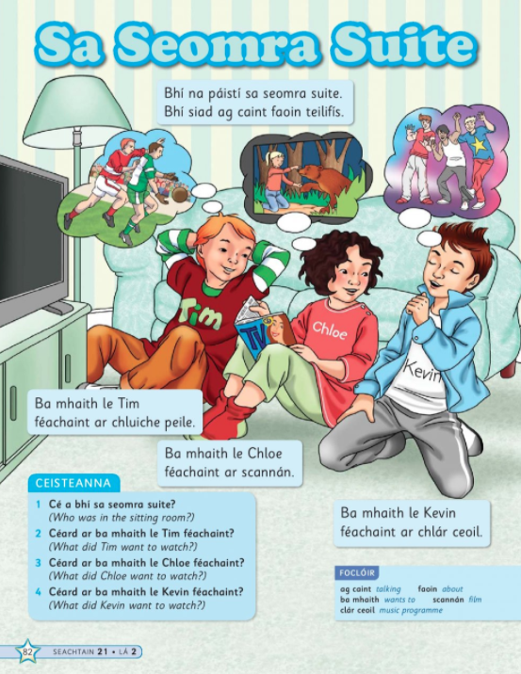

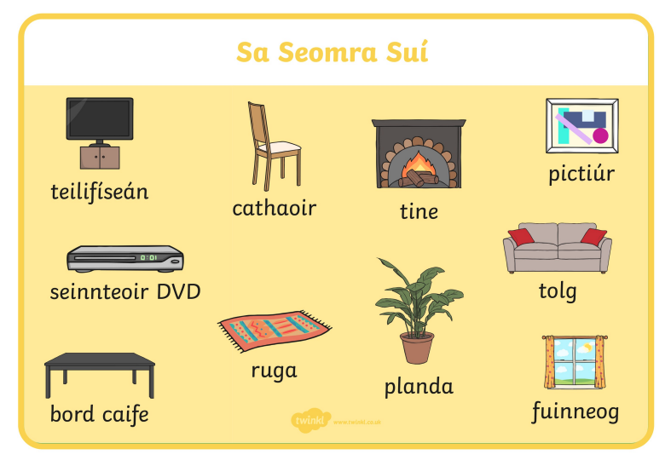
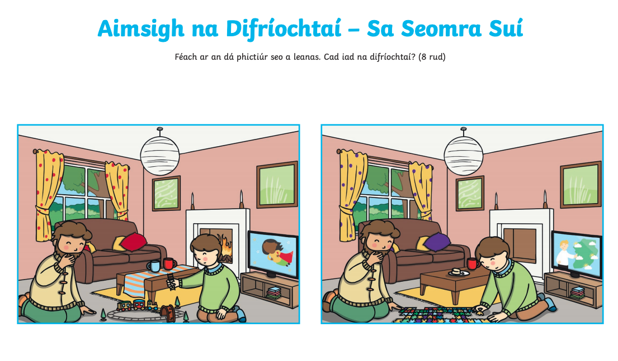

SESE- Page 1 – Tuesday Activity

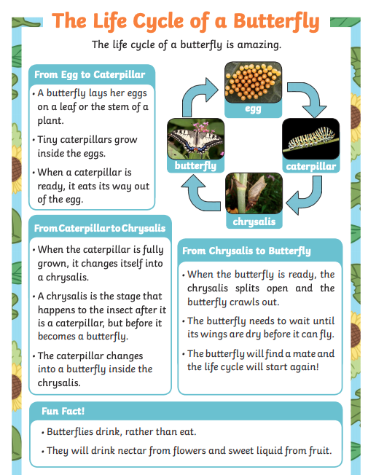

SESE- Sheet 2- Tuesday Activity- Answer the Questions

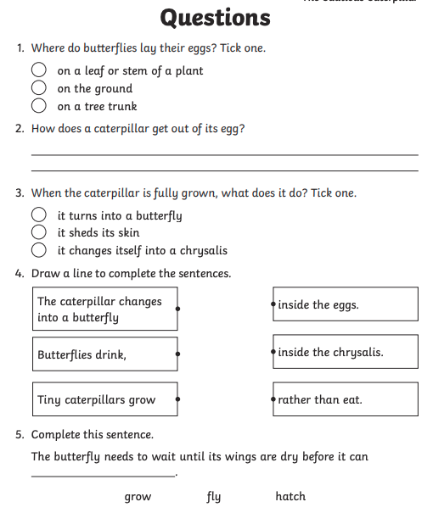

Sheet 3- Wednesday Activity- Using a template like this children write the ‘Life Cycle of a Butterfly’
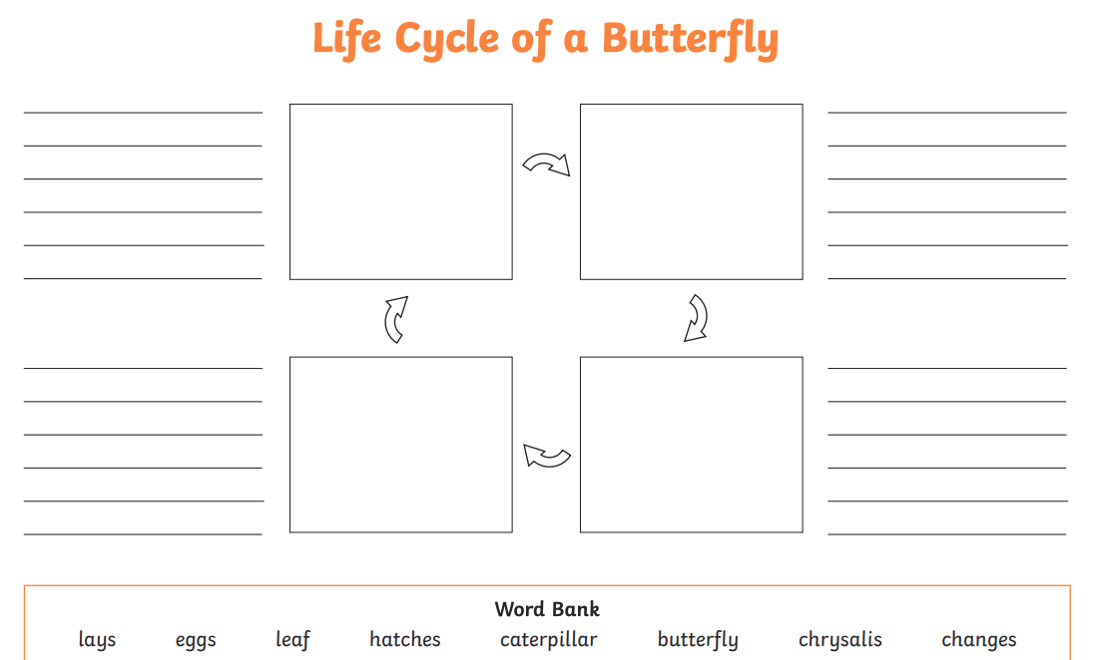
Sheet 4- This is the answer sheet for sheet 3
