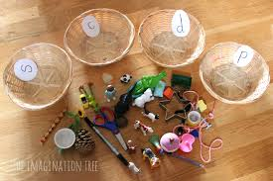  Target phonic sounds. Have a treasure hunt at home and see how many items you can find starting with the sound. | 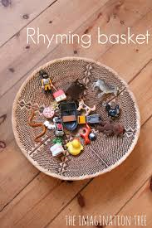  Hearing and spotting rhyming words is really important. Julia Donaldson books are super for this purpose. | 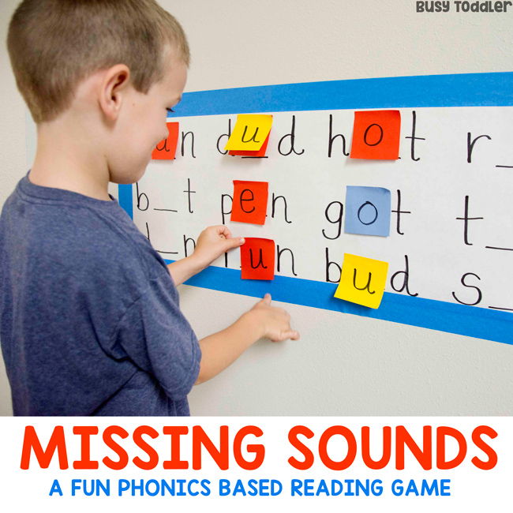
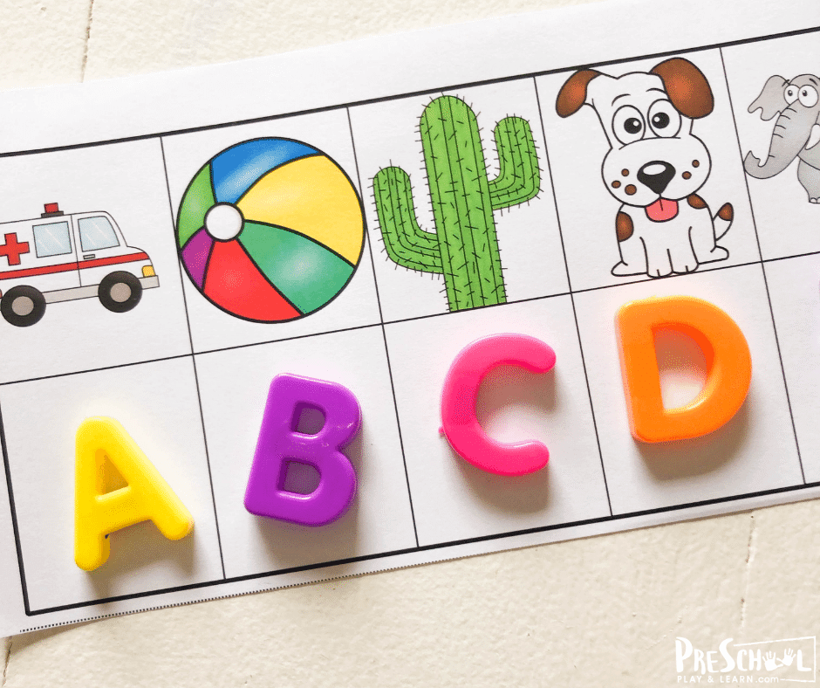  Use real items from home and assign a letter.  Variation: Label the last sound in the word. | 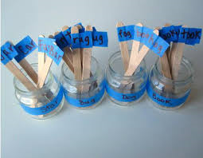  Rhyming words/ blending and reading activity. Could be adapted for practicing sounds too if your child is not sure of some. | 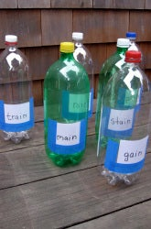  Fun way to revise sounds/ blending words.
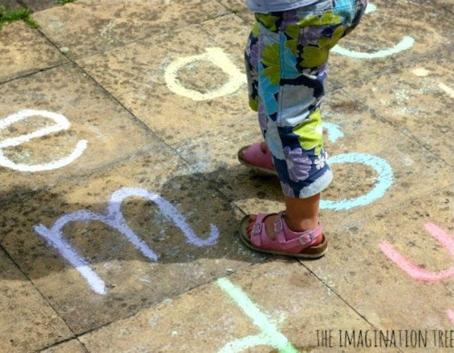  Engaging physically in activities helps to embed the information! | 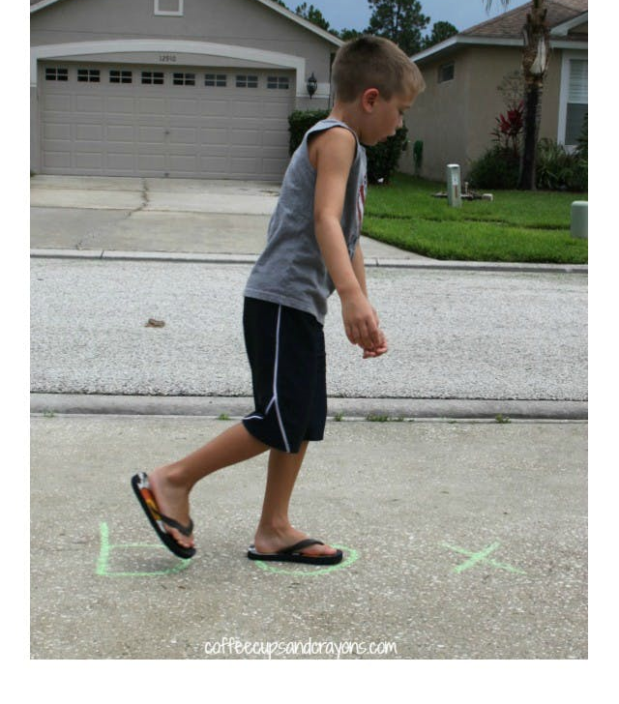 | 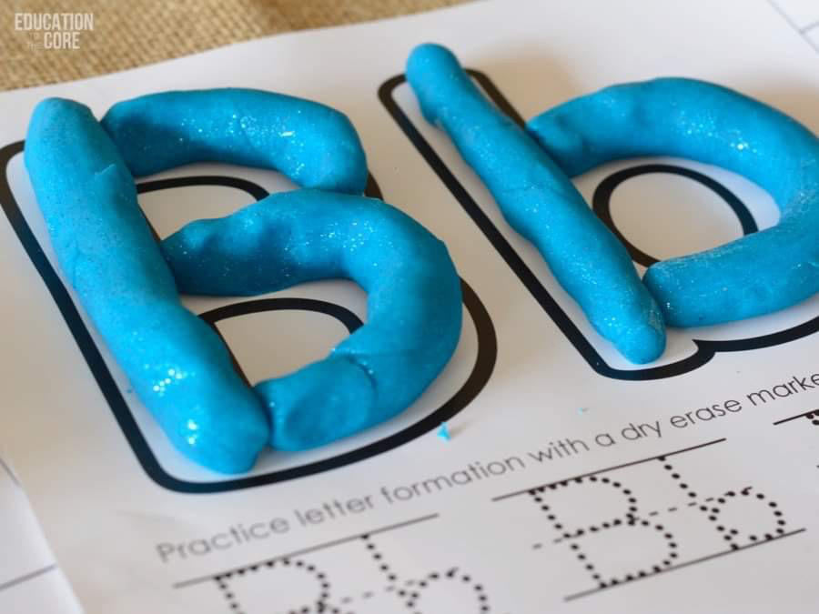  Multi-sensory learning!
Fun activities to support Phonics. (*CVC words are consonant vowel consonant words …cat, dog, hat. Blending means to put individual sounds together to make words)

Some Twinkl resources that may be helpful:
https://www.twinkl.ie/resource/t-l-527053-cvc-word-activity-booklet
https://www.twinkl.ie/resource/t-l-4498-cvc-word-and-picture-matching-worksheets-mixed (Tip: If you put these sheets into plastic folder pockets they can be competed in whiteboard marker, erased and completed again another day. Completing the same activity a couple of times is a great way to practice and build confidence before moving on.)
https://www.twinkl.ie/resource/t-s-3446-workstation-pack-cvc-initial-letter-matching-activity-pack (Your child may need some practice on initial sounds before moving on to building words)
https://www.twinkl.ie/resource/t-l-2217-cvc-words-cut-and-paste-worksheet-a

