

My First Holy Communion

How can I continue to get ready?

Bishop Denis is asking you to do 3 things this month to help you to stay getting ready for your First Holy Communion

- Make your Prayer Space a May Altar

- Pray a Decade of the Rosary

- Go to Mass on livestream

This booklet will help you to do these things

1

- Make your Prayer Space a May Altar

This picture from Scoil Mhuire Jn, Newbridge will help you to design your May Altar. You don’t need everything in the picture or on the list. It’s just to help you get started and you might think of other things to add

Blue or white cloth or coloured paper
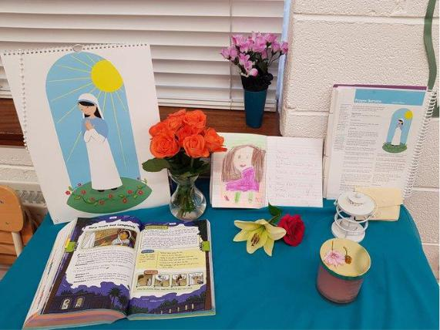

A statue or a picture of Mary. There are 2 pictures of Mary to colour on pages 3 & 4. Choose the one you like best for your Prayer Space

Flowers

Candle

Bible

Take a picture of your May Altar and ask a grown up to send it to the KandLe Facebook Page. https://www.facebook.com/KANDLEi/ Bishop Denis would love to see it.

If you already have a Prayer Space, then you are just going to make some changes. If you are making a new Prayer Space, then have a think about where you would like to put it in your house. Somewhere everyone can see it is good because it reminds everyone in the house that we can always talk to God no matter where we are.

Where can I find some flowers for my May Altar?


What else could I put on my May Altar?

What prayers could I pray to Mary?

What do I know about Mary?

Think

About

2

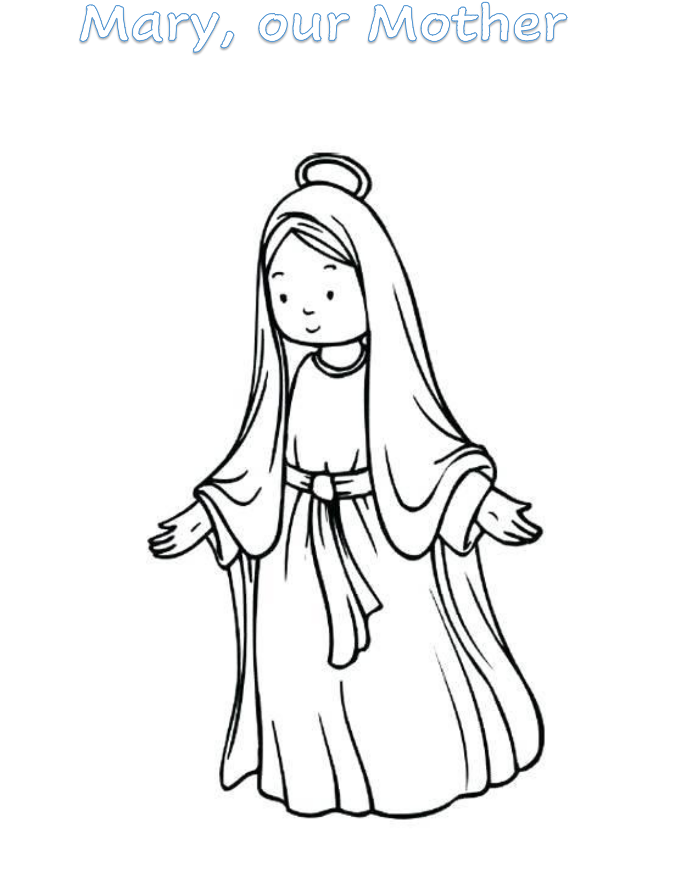

3
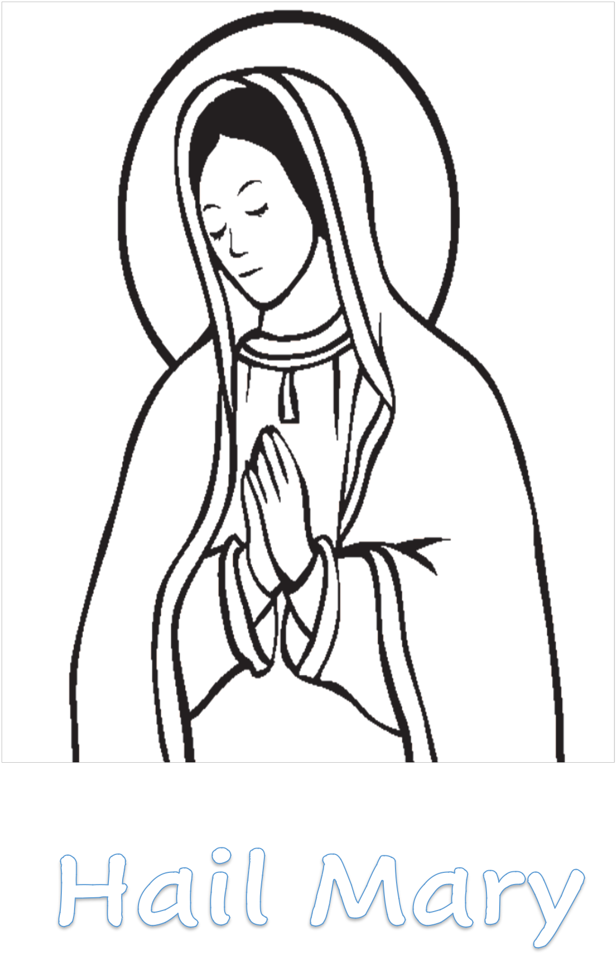

4
What about
the
Mysteries in
the Rosary?
- Pray the Rosary


What is the Rosary?

The Rosary is a prayer that we pray to Mary using a set of beads
called Rosary beads. If you don’t have Rosary Beads you can make some. The beads help us to keep track of the prayer

and they help us to stay focussed on our prayer.


Every time that we pray the Rosary, we remember something about Jesus’s life on earth. The Rosary helps us to think about 20 different parts of Jesus’ life from before he was born until he went back to God in heaven. The

Rosary divides the different parts of Jesus’

story into four groups and calls them Mysteries. Each Mystery has five stories. When we think and pray about one of the stories it is called praying a decade of the Rosary.


What are

the

Mysteries

called?

They are the

- Joyful Mysteries

- Sorrowful Mysteries

- Glorious Mysteries

- Mysteries of Light


You will pray the Joyful Mysteries because you have already talked about these in school and you know all the stories.

- The Annunciation

- The Visitation

- The Birth of Jesus

- The Presentation of Jesus

- The Finding of Jesus in the Temple

The Joyful Mysteries

5


Remembering the Stories

The Annunciation: Luke 1:26-38

This is when the Angel Gabriel came to tell Mary that God wanted her to be Jesus’ mother

Joyful News:

She said ‘yes’

The Visitation

Luke 1:39-56

The Angel Gabriel told Mary that her cousin Elizabeth was going to have a baby too. Mary went to visit her as soon as the Angel Gabriel Left

Joyful News: Elizabeth’s baby was John the Baptist who told everyone that Jesus was coming and baptised Jesus in the River Jordan.

The Nativity

Luke 2:1-21

This mystery tells the story of how Jesus was born

Joyful News: God sent us Jesus to show us how much he loves us. We celebrate this every Christmas

The Presentation of Jesus in the Temple

Luke 2:22-38

All Jewish babies are brought to the temple after they are born just like you were brought to the church to be baptised. Mary and Joseph brought Jesus.

Joyful News: Anna and Simeon had waited in the temple for years to welcome the saviour that God had promised to send. They prayed and worked while they waited. They were so happy when they saw Jesus.

The Finding of the Child Jesus in the Temple Luke 2:41-52

When Jesus was about 12 years old Mary and Joseph brought him to Jerusalem to see the temple for himself. While they were there Jesus got lost

Joyful News:

about God.

They found him in the temple telling the priests all

6

How to Pray One Decade of the Rosary?

We begin by blessing ourselves

In the name of the Father, and of the Son and of the Holy Spirit

- We pray the Our Father

- We pray Ten Hail Marys

- We pray the Glory be to the Father We end by blessing ourselves again
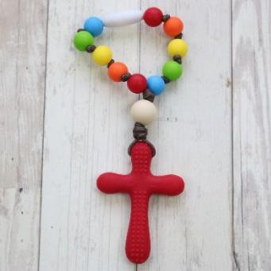

The Decade Rosary Bead help us to pray one decade of the rosary. There are just 11 beads one for the Our Father and the Glory be and 10 for the Hail Marys.

Pray a Decade of the Rosary with your Family

Why not ask the rest of your family to pray one decade of the rosary with you. You could light the candle in your Prayer Space before you begin to pray. One person could take it in turns to lead the rosary.

Bless yourself

- The leader begins by praying the first part of the Our Father and then everyone joins in

- The leader prays the first part of the Hail Mary and everyone prays the second part. We do this ten times.

- The leader prays the first part of the Glory be to the Father and everyone joins in

Take a minute to ask God to take care of anything or anyone that you are worried about. Take a minute to say thank you to God for something good that has happened today

Bless yourself

7
The Prayers of the Rosary

Our Father

Our Father,

Who art in heaven, Hallowed be Thy Name. Thy Kingdom come. Thy Will be done,

on earth as it is in Heaven. Give us this day our daily bread.

And forgive us our trespasses, as we forgive those who trespass against us.

And lead us not into temptation,

but deliver us from evil. Amen.

Hail Mary

Hail Mary full of grace, the Lord is with thee
Blessed are you among women and blessed is the fruit of thy womb, Jesus

Holy Mary, Mother of God,

pray for us sinners now

and at the hour of our death.

Amen

Glory be to the Father

Glory be to the Father,

and to the Son

and to the Holy Spirit

as it was in the beginning

is now and ever shall be

world without end. Amen.

8

Things to Do

Download and colour a picture for each Joyful Mystery

http://www.thecatholickid.com/joyful-mysteries-rosary-coloring-pages/

Watch:

The Annunciation

https://www.youtube.com/watch?v=VrYvuYwPAvU

The Finding of the Child Jesus in the Temple

https://www.youtube.com/watch?v=il9Z39tDhGE

Read:

The Joyful Mystery stories in your bible. They are all in the Luke’s Gospel from Chapter 1, verse 26 to Chapter 2, verse 52.


Make: A One Decade Rosary Beads

https://www.catholicicing.com/easy-rosary-craft-for-kids/

Learn More


You can log into Grow in Love website https://app.growinlove.ie/en/login using the following log in details.

Username : trial@growinlove.ie

Password: growinlove

You will find more about the Rosary in Lesson 1 of the Seasonal Lessons in Second Class.

9

- Go to Mass on Livestream

Going to Mass on Livestream is very different from actually being in the church. But it keeps us connected to our parish and most importantly to God. It is a way of staying together even though we have to be apart at the moment. Mass will probably seem very different when we are looking into the screen on our laptop, phone, television or tablet. The priest might be on his own. There might be someone to read and sing. You can still join in the prayers and listen to the readings and what the priest has to say. Doing this will help you to get ready to celebrate your First holy Communion and will mean that when the time is right you will really understand what it means to receive Jesus, the Bread of Life, for the very first time.

Find out if your parish has Mass online

https://www.kandle.ie/webcam-mass-schedules-during-coronavirus/

If your parish is not online check the list to see if some of your neighbouring parishes are

Decide to go to Mass online on Saturday evening or Sunday

https://www.graiguecullenkilleshin.com/ has a video of the Sunday Gospel

to watch and some fun activities to do

http://catholicmom.com/wp-content/uploads/2020/04/MWS4EasterA.pdf

also has some great resources for helping children and families understand and participate in the Sunday Mass

Revise and Learn the Prayers of the Mass in your Grow in Love Book or on the Grow in Love website using the log in details on page 9.

What Happens at Mass on pages 11-13 will help you understand better the different parts of the Mass.

10

WHAT HAPPENS AT MASS?

It is always better to celebrate with others. It’s not much fun being alone, it’s much better to share special times with family and friends. As members of the church we gather to celebrate that we belong to a special family, a parish or faith community. Everyone in our faith community believes that God loves us very much, that Jesus came to show us how much we are loved by God and that we should live our lives as God would want us to. They also believe that the Holy Spirit helps us to be like Jesus.

As members of this special family we gather every Sunday to celebrate the Eucharist. We come together for Mass.

To help us understand Mass better we can break it up into a number of different parts

1: WE GATHER: THE MASS BEGINS
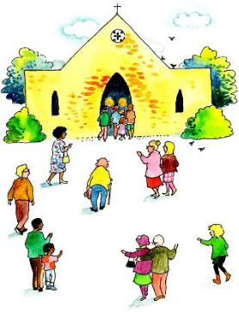

We come together as members of our parish family, to celebrate God’s love for us and our love for God. We remember that Jesus is with us in a very special way at Mass.

Even as we enter the church, we are beginning our mass, we bless ourselves with holy water to remind ourselves of our baptism. Mass usually

begins with a holy song or hymn and a procession. The priest, the servers and sometimes the ministers of word process in from the back of the church as the hymn is sung. We all stand while this happens because we are an important part of this celebration. We are the community of faith, the assembly, and we believe that Jesus is really present in every part of our Mass, particularly in communion but, also in the Word, our priest, our ministers and in each one of us. Our prayers and actions at the beginning of mass are part of the Introductory Rite. This helps us to get ready to celebrate.

The Penitential Act is part of the beginning prayers and helps us to remember that God always loves us and is always ready to forgive us.

We all pray the Gloria together and then listen to the Collect which is led by the priest.

11
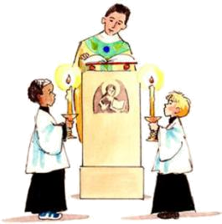
- WE LISTEN TO GOD’S WORD: THE LITURGY OF THE WORD

At Mass we hear the Good News that God loves us when we listen to the readings and gospel.

After the Collect we sit down to listen to the

Word of God. There are usually three readings from the Bible. Between the first and second readings the psalm is sung or prayed. It is how we respond to God’s word. The third reading is called the gospel which means ‘good news.’ Before the gospel we stand and greet the ‘good news’ with a song of joy, the ‘Alleluia.’ After the gospel the priest talks to us. This is called the homily. It helps us to understand more fully the readings that we have heard and also suggests ways that we can live the gospel in our everyday lives. At the end of the homily we stand to profess our faith by praying the Creed. The Liturgy of the Word finishes with the Prayer of the Faithful, when we pray for all those who are in need.

- WE BRING OUR GIFTS, WE REMEMBER, WE GIVE THANKS: THE LITURGY OF THE EUCHARIST
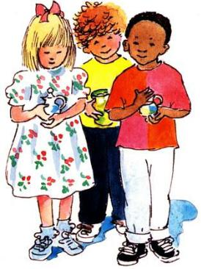

We bring bread and wine to the altar. We remember that God loved us so much that he sent Jesus. We give thanks for the gift of Jesus and we remember what he did at the Last Supper. The gift of bread and wine that we bring to the altar becomes the body and blood of Jesus.

After the Liturgy of the Word some members of the community bring the bread and wine to the priest. At this time there is also a collection when we give money. This money is our way of saying that we are prepared to share what we have, to help the community in which we live. We call this part of our Mass the Liturgy of the Eucharist. The word Eucharist means ‘thanksgiving’ and so at this time we give thanks to God. We remember that God loves us so much that he sent Jesus to save us. We give thanks for this gift and we get ready to share in the Bread of Life. The priest leads us in praying the Eucharistic Prayer. During this prayer we remember what Jesus did at the Last Supper. The priest lifts up the bread so that we can all see it and then he says, ‘This is my body.’ Then he lifts up the chalice and says, ‘This is the chalice of

12
my blood.” The bread and wine become the body and blood of Jesus and we believe that Jesus is really with us.

- WE SHARE IN THE BREAD OF LIFE: THE COMMUNION RITE
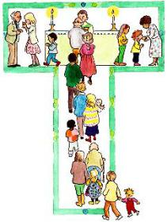

We are invited to the Table of the Lord to share in the Bread of Life.

When we share a meal with others, we come closer together and this is what happens at Mass. Before we go to the table we stand and pray the Our Father together. This is the prayer that Jesus

taught his disciples. We share a sign of peace with each other to show that we are always ready to forgive and make peace. The priest takes the large Host and breaks it just as Jesus broke the bread at the Last Supper. We pray the Lamb of God together. Then we are invited to the altar table to share in Jesus who is the Bread of Life. We spend some time after receiving communion in silent prayer remembering God’s love for us and getting ready to bring that love into the world with us as we leave the church.

- WE GO FORTH TO LOVE AND SERVE THE LORD: DISMISSAL RITE
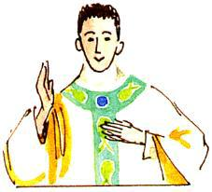

We are sent from Mass with God’s blessing to go and announce the Gospel.

At the end of Mass, we are sent to bring God’s love out into the world. We are asked to go and do what Jesus did, to love one another, to help one another, to care for one

another. We have received the Bread of Life and this helps us to live like Jesus. The priest asks us to stand and we leave the church with God’s blessing.

13

